Background
The Council’s Interoperability Framework is based on the concept of standardising interconnections around what is called a ‘four corner model’. Similar models have emerged from the financial sector (for inter-bank interoperability) and are already being used in many countries for eInvoicing. In Australia, the superannuation sector (via Superstream) also uses a standardised form of the ‘four corner model’.
Under this logical model, businesses can send messages directly to each other (2-corners), via a mutual 3rd party (3-corners) or via two independent external service providers (4-corners).
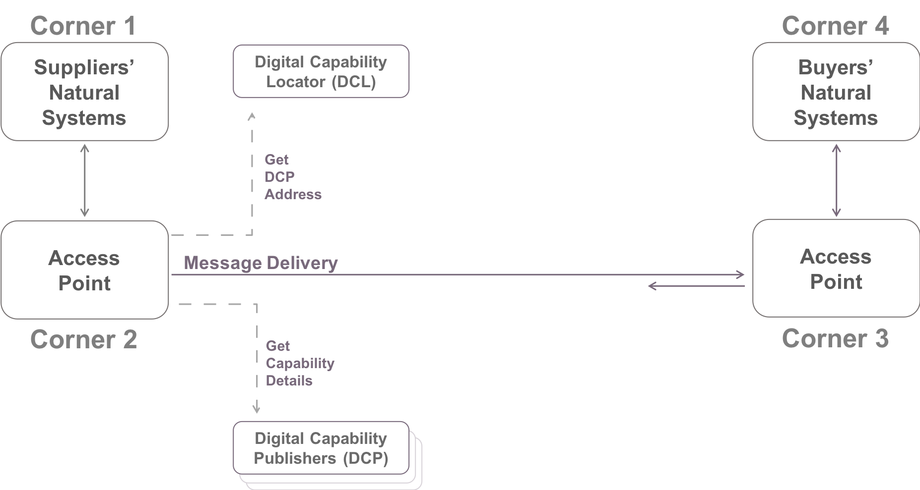
Figure 1 – The 4-Corner Model
As the digital economy grows, the trend is toward the increased use of 4-corner models. However, as with rail networks, telephony systems and other communication technologies, unless standards are introduced, complex and expensive interconnections are required to connect all existing participants. The DBC Framework has proposed standards for the creation of an ‘open’ 4-corner model.
A key requirement for the eInvoicing Interoperability Framework is that a Buyer’s or Supplier’s digital address and digital capabilities may change over time. The associated challenge with using an ‘open’ 4-corner model is finding out what businesses are reachable and what their digital capabilities are. The Framework resolves this by establishing a business discovery service. The idea of using the 4-corner model with business discovery is a well-established and an internationally accepted solution, and an extension to the existing Superstream model.
The DBC has endorsed an interoperability framework that includes a specific set of standards to dynamically discover these business capabilities, using the standard business identifier. These set of standards are designed to support more than procure to pay lifecycles, i.e. the generic B2B exchange of digital document sand messages.
The participants in this model are:
- Buyers: A buyer is a legal person, business entity or organisation who purchases goods and/or services;
- Suppliers: A supplier is a legal person, business entity or organisation who provides goods and/or services;
- Access Point Providers: Software or Gateway providers of a service that sends and receives eInvoices and electronic messages, and passes them onto the respective participants;
- Digital Capability Publishers: Software or Gateway providers of a service for buyers and suppliers to store details of their digital capabilities, and includes the business processes with supported data formats and the digital delivery address to receive the documents; and
- Digital Capability Locator: A service for looking up the digital location of the buyer’s or supplier’s Digital Capability Publisher. In effect, it is an index to the Council’s accredited Digital Capability Publishers.
Using a federated approach by employing/implementing a single Digital Capability Locator supported by a number of Digital Capability Publishers not only suits the existing business arrangements and but it also avoids any potential scalability issues. Business discovery (and therefore the eInvoicing community) relies on the availability and integrity of a Digital Capability Locator.
The standard chosen for querying the Digital Capability Locator provides for a reliable, high performance lookup service, reusing the same technology the Internet uses to find IP addresses for domain names. The Digital Capability Locator has a common Internet domain. Every participating business has a unique URL within that domain. This URL is resolved by the Internet Domain Name Service (DNS) to the Internet address (IP Address) of the Digital Capability Publisher.

A Simplified Messaging Approach
The AS4 protocol supports the concept of document-based data exchange. This is a model where the data exchange does not occur directly between business applications, it is for business applications to exchange data via access points (either deployed within a business’s infrastructure or via a 3rd party/external service provider). This is a standard approach or common practice in the B2B paradigm. Most businesses and organisations deploy off-the-shelf B2B gateway products for access point functionality, while some either custom build or use open source software. The AS4 protocol has been in wide use in Australia since 2012 for the ATO’s SBR programme and the Superstream programme – the technology industry (local and international) have made significant investments in building AS4 capability.
Under the Interoperability Framework the messaging between two access points has been simplified to just a basic messaging service to an extent where any sophisticated features such as authentication, digital signing, encryption and non-repudiation are excluded. This minimalist approach was adopted as it suited the basic requirement for exchanging invoices and the majority of procure to pay lifecycle documents.
The messaging profile does not support payloads in the SOAP body element, all payloads are encoded as MIME parts (attachments) , including the SOAP envelope
This simplified approach which includes addressing of entities, business discovery and message exchange can be considered to be the lowest common denominator in any type of B2B electronic exchange. It is most commonly known as the e-Delivery building block.

Including an end to end encryption building block
At times, there will be circumstances where the minimalist approach is not suited, and advanced features will be required to electronically exchange documents between businesses, such as the ability to optionally (in various combinations):
- Package or bind a bundle of similar or different types of documents including structured, unstructured, images, binary sequences, domain specific XML and others;
- Support a number of qualified signature types
- Support encryption
- Support time-stamping
- Provide authentication
Including the above features into the existing messaging protocol adds complexity, which in-turn obliges organisations to use this protocol, irrespective of whether it is needed by any of its business processes.
An extensible manner of including end to end encryption is for the message attachments to be digitally signed and encrypted using public key cryptography. There are 2 approaches
- Use of S/MIME
- Use of an e-container
The discussion on these 2 approaches is very detailed and outside the scope of this document.

