ETSI TR 103 331 V1.0.1 (2016-06)
CYBER;
Structured threat information sharing

TECHNICAL REPORT

Reference
DTR/CYBER-009
Keywords
Security; threat intelligence; threat analysis

ETSI
650 Route des Lucioles
F-06921 Sophia Antipolis Cedex - FRANCE

Tel.: +33 4 92 94 42 00 Fax: +33 4 93 65 47 16

Siret N° 348 623 562 00017 - NAF 742 C
Association à but non lucratif enregistrée à la
Sous-préfecture de Grasse (06) N° 7803/88

Important notice
The present document can be downloaded from:
http://www.etsi.org
The present document may be made available in electronic versions and/or in print. The content of any electronic and/or print versions of the present document shall not be modified without the prior written authorization of ETSI. In case of any existing or perceived difference in contents between such versions and/or in print, the only prevailing document is the print of the Portable Document Format (PDF) version kept on a specific network drive within ETSI Secretariat.
Users of the present document should be aware that the document may be subject to revision or change of status. Information on the current status of this and other ETSI documents is available at http://portal.etsi.org/tb/status/status.asp
If you find errors in the present document, please send your comment to one of the following services:
http://portal.etsi.org/chaircor/ETSI_support.asp
Copyright Notification
No part may be reproduced or utilized in any form or by any means, electronic or mechanical, including photocopying and microfilm except as authorized by written permission of ETSI.
The content of the PDF version shall not be modified without the written authorization of ETSI.
The copyright and the foregoing restriction extend to reproduction in all media.

© European Telecommunications Standards Institute 2016.
All rights reserved.
DECTTM, PLUGTESTSTM, UMTSTM and the ETSI logo are Trade Marks of ETSI registered for the benefit of its Members.
3GPPTM and LTE™ are Trade Marks of ETSI registered for the benefit of its Members and
of the 3GPP Organizational Partners.
GSM® and the GSM logo are Trade Marks registered and owned by the GSM Association.

Contents
Contents 3
Intellectual Property Rights 4
Foreword 4
Modal verbs terminology 4
Executive summary 4
Introduction 4
1 Scope 6
2 References 6
2.1 Normative references 6
2.2 Informative references 6
3 Definitions, symbols and abbreviations 7
3.1 Definitions 7
3.2 Abbreviations 7
4 Means for exchanging structured cyber threat intelligence 9
4.1 Introduction 9
4.2 OASIS Cyber Threat Intelligence Technical Committee (TC CTI) 9
4.2.1 Introduction 9
4.2.2 CTI STIX Subcommittee 10
4.2.3 CTI TAXII Subcommittee 11
4.2.4 CTI CybOX Subcommittee 12
4.2.5 CTI Interoperability Subcommittee 12
4.3 IETF Managed Incident Lightweight Exchange Working Group (mile) 12
4.4 CSIRTGadgets Collective Intelligence Foundation (CIF) 13
4.5 EU Advanced Cyber Defence Centre (ACDC) 13
4.6 AbuseHelper 14
4.7 OMG Threat Modelling Working Group 14
4.8 ITU-T SG17 14
4.9 Open Threat Exchange™ (OTX™) 15
4.10 OpenIOC Framework 15
4.11 VERIS Framework 15
4.12 ETSI ISI (Information Security Indicators) ISG 15
Annex: Bibliography 17
History 18

Intellectual Property Rights
IPRs essential or potentially essential to the present document may have been declared to ETSI. The information pertaining to these essential IPRs, if any, is publicly available for ETSI members and non-members, and can be found in ETSI SR 000 314: "Intellectual Property Rights (IPRs); Essential, or potentially Essential, IPRs notified to ETSI in respect of ETSI standards", which is available from the ETSI Secretariat. Latest updates are available on the ETSI Web server (http://ipr.etsi.org).
Pursuant to the ETSI IPR Policy, no investigation, including IPR searches, has been carried out by ETSI. No guarantee can be given as to the existence of other IPRs not referenced in ETSI SR 000 314 (or the updates on the ETSI Web server) which are, or may be, or may become, essential to the present document.
The IPR associated with STIX, TAXII, and CybOX in the form of trademarks and copyrights is held by the U.S. Department of Homeland Security – which in turn has made the rights available via a licence that grants “a perpetual, irrevocable, non-exclusive, royalty-free, worldwide copyright license, with the right to sublicense to copy, publish, and distribute the STANDARDS SUITES in any way, to prepare derivative works that are based on or incorporate all or part of the STANDARDS SUITES solely for the purpose of developing and promoting cybersecurity and enabling the use of any of the STANDARDS SUITES or derivative products by sublicensees or other users.” OASIS pursuant to its Memorandum of Understanding with ETSI, establishes an explicit IPR relationship between OASIS TC CTI and ETSI TC CYBER that allows for the inclusion of material from its materials in ETSI documents pursuant to permission that has been obtained.

Foreword
This Technical Report (TR) has been produced by ETSI Technical Committee| CYBER.

Modal verbs terminology
In the present document "shall", "shall not", "should", "should not", "may", "may not", "need", "need not", "will", "will not", "can" and "cannot" are to be interpreted as described in clause 3.2 of the ETSI Drafting Rules (Verbal forms for the expression of provisions).

Executive summary
Cyber threat information sharing – often described as threat intelligence sharing – is one of the most important components of an organization’s cyber security program. It can be obtained internally and from external trusted sources. It is collected, analysed, shared, and leveraged. This Technical Report provides a survey of ongoing activities and the resulting platforms that are aimed at structuring and exchanging cyber threat information. These activities range from those developed among the Computer Emergency Response Teams in the 1990s in the IETF, to cutting-edge new initiatives being advanced in OASIS. Some of the platforms are semi-open commercial product communities. It is possible that the OASIS CTI work could bring about significant interoperability if not integration in this area.

Introduction
The importance of cyber threat information sharing has been underscored recently by the European Union and North America enacting into organic law, combined with major executive level and national initiatives. These actions extend across all information, and infrastructure sectors. Some of the more prominent of these recent actions include:
- EU Network Information Security Directive, approved 18 Dec 2015 [i.1]
- Cybersecurity Information Sharing Act of 2015 (18 Dec 2015) [i.2]
- CPNI, Threat Intelligence: Collecting, Analysing, Evaluating, 23 Mar 2015 [i.3]
- Launch of the Canadian Cyber Threat Exchange, 11 Dec 2015
Against this backdrop of initiatives that included the scaling of Financial Services Information Sharing and Analysis Center (FS-ISAC) and The Depository Trust & Clearing Corporation (DTCC) activities, the OASIS Cyber Threat Intelligence Technical Committee was formed in 2015 to bring together a broad and rapidly growing array of public and private sector organizations to advance a global set of standards for structured threat information sharing.
This Technical Report, describes the known array of existing structured threat information sharing work in diverse bodies, including the developments underway in OASIS TC CYBER which can form the basis for expanded cooperation based on existing ETSI and OASIS collaborative agreements and working relationships among Technical Committees.

1 Scope
The present document provides an overview on the means for describing and exchanging cyber threat information in a standardized and structured manner. Such information includes include technical indicators of adversary activity, contextual information, exploitation targets, and courses of action. The existence and creation of organizations for the exchange of this information are out of scope.

2 References
References are either specific (identified by date of publication and/or edition number or version number) or non-specific. For specific references, only the cited version applies. For non-specific references, the latest version of the referenced document (including any amendments) applies.
Referenced documents which are not found to be publicly available in the expected location might be found at http://docbox.etsi.org/Reference.
NOTE: While any hyperlinks included in this clause were valid at the time of publication ETSI cannot guarantee their long term validity.

2.1 Normative references
The following referenced documents are necessary for the application of the present document.
Not applicable.

2.2 Informative references
The following referenced documents are not necessary for the application of the present document but they assist the user with regard to a particular subject area.
[i.1] DIRECTIVE (EU) 2016/…OF THE EUROPEAN PARLIAMENT AND OF THE COUNCIL concerning measures with a view to achieving for a high common level of security of network and information security systems across the Union, Brussels, 21 April 2016 (5581/16).
[i.2] “Cybersecurity Information sharing act of 2015,” 18 Dec 2015, U.S. Congress. Public Law. 114-113, “Consolidated Appropriations Act, 2016” Division N, Title I. The Department of Homeland Security, The Department of Justice, “Guidance to Assist Non-Federal Entities to Share Cyber Threat Indicators and Defensive Measures with Federal Entities under the Cybersecurity Information Sharing Act of 2015,” February 16, 2016. https://www.us-cert.gov/sites/default/files/ais_files/Non-Federal_Entity_Sharing_Guidance_%28Sec%20105%28a%29%29.pdf
[i.3] CPNI, “Threat Intelligence: Collecting, Analysing, Evaluating,” Center for the Protection of National Infrastructure, https://www.cpni.gov.uk/Documents/Publications/2015/23-March-2015-MWR_Threat_Intelligence_whitepaper-2015.pdf
[i.4] OASIS Specifications, STIX 1.2.1, TAXII 1.1.1, CybOX 2.1.1; draft Specifications STIX 2.0, TAXII 2.0, CybOX 3.0; draft CybOX 3.0 Roadmap, CybOX 3.0 Visualation, https://www.oasis-open.org/committees/tc_home.php?wg_abbrev=cti. See also, OASIS Cyber Threat Intelligence (CTI) TC Wiki, https://wiki.oasis-open.org/cti/; Sean Barnum, Standardizing Cyber Threat Intelligence Information with the Structured Threat Information eXpression (STIX™), MITRE (Feb. 20, 2014).
[i.5] OASIS . Cyber Threat Intelligence (CTI) TC Meeting Notes, OASIS Cyber Threat Intelligence (CTI) TC Documents, https://www.oasis-open.org/apps/org/workgroup/cti/documents.php?folder_id=2978.
[i.7] Internet Engineering Task Force (IETF), Managed Incident Lightweight Exchange (mile) Working Group, https://datatracker.ietf.org/wg/mile/documents/
[i.8] International Telecommunication Telecommunication Standardization Sector (ITU-T), ITU-T X.1500-Series, “Cybersecurity information exchange,” https://www.itu.int/itu-t/recommendations/index.aspx?ser=X
[i.9] ITU-T work progarmme, 2013-2016, SG17, Q4/17, http://www.itu.int/itu-t/workprog/wp_search.aspx?
[i.10] ETSI ISG ISI (Information Security Indicators) initial Terms of Reference, https://portal.etsi.org/ISI/ISI_ISG_ToR_Sep2011.pdf
[i.11] ETSI GS ISI 001-1, “Information Security Indicators (ISI); Indicators (INC)”

3 Definitions, symbols and abbreviations

3.1 Definitions
For the purposes of the present document, the following terms and definitions apply. Reference figure 2, below.
Campaign: A STIX Campaign represents a set of TTPs, Incidents, or Threat Actors that together express a common intent or desired effect. [i.4]
Course of Action: A STIX Course of Action (COA) is used to convey information about courses of action that may be taken either in response to an attack or as a preventative measure prior to an attack. [i.4]
Exploit Target: A STIX Exploit Target conveys information about a vulnerability, weakness, or misconfiguration in software, systems, networks, or configurations that may be targeted for exploitation by an adversary. [i.4]
Incident: A STIX Incident corresponds to sets of related security events affecting an organization, along with information discovered or decided during an incident response investigation. [i.4]
Indicators: The STIX Indicator data model conveys specific Observable patterns combined with contextual information intended to represent artifacts and/or behaviors of interest within a cyber security context. [i.4]
Observables: A STIX Observable represents stateful properties or measurable events pertinent to the operation of computers and networks, and may consist of Observable instances and Observable Patterns. [i.4]
Observable instances: Represent actual specific observations that took place in the cyber domain. [i.4]
Observable patterns: Represent conditions for a potential observation that may occur in the future or may have already occurred and exists in a body of observable instances. [i.4]
Report: A STIX Report defines a contextual wrapper for a grouping of STIX content, which could include content specified using any of the other eight top-level constructs, or even other related Reports. [i.4]
Tactics, Techniques and Procedures: STIX Tactics, Techniques, and Procedures (TTP) are used to represent the behavior or modus operandi of cyber adversaries i. [i.4]
Threat Actor: A STIX Threat Actor is a characterization of malicious actor (or adversary) representing a cyber attack threat including presumed intent and historically observed behavior. [i.4]

3.2 Abbreviations
For the purposes of the present document, the following abbreviations apply:
ACDC Advanced Cyber Defence Centre
API Application Programing Interface
AS Autonomous System
CERT Computer Emergency Response Team
CIF Collection Intelligence Framework
COBIT Control OBjectives for Information and related Technology
CSIRT Computer Security Incidence Response Team
CTI Cyber Threat Intelligence
CYBEX Cybersecurity Information Exchange
CybOX™ Cyber Observable Expression
CPNI Centre for the Protection of National Infrastructure
DoS Denial of Service
DTCC Depository Trust & Clearing Corporation
ENISA European Union Agency for Network and Information Security
EPC Evolved Packet Core
EU European Union
FIRST Forum of Incident Response and Security Teams
FS-ISAC Financial Services ISAC
IANA Internet Assigned Numbers Authority
IDS Identification Detection System
IETF Internet Engineering Task Force
INCH INCident Handling
IODEF Incident Object Description Exchange Format
IP Internet Protocol
ISAC Information Sharing and Analysis Center
ISACA Information Systems Audit and Control Association
ISAO Information Sharing and Analysis Organization
ISG Industry Specification Group
ISI Information Security Indicators
IT Information Technology
ITU-T International Telecommunication Union Telecommunication Standardization
JSON JavaScript Object Notation
LI/RD Lawful Interception/Retained Data
MAEC™ Malware attribute enumeration and characterization
MILE Managed Incident Lightweight Exchange
MVP Minimally-Viable Product
NFV Network Functions Virtualisation
NIS Network and Information Security
NREN National Research and Education Network
OMG Object Management Group
OTX Open Threat eXchange
RID Real-time Inter-network Defense
SIEM Security Information and Event Management
STIX™ Structured Threat Information Expression
TAXII™ Trusted Automated Exchange of Indicator Information
TTP Tactics, Techniques and Procedures
VERIS Vocabulary for Event Recording and Incident Sharing
XML Extensible Markup Language

4 Means for exchanging structured cyber threat intelligence

4.1 Introduction
The need for the exchange of structured cyber threat intelligence grew in the 1990s in conjunction with increasing numbers of discovered exploits of network vulnerabilities and attacks. This led to a diverse array of initiatives and projects to develop structured expressions and associated protocols for the trusted exchange of information concerning those vulnerabilities and attacks, and remediation steps – which are described in the following clauses. These efforts and the resulting platforms have moved forward (or not) at significantly different scales, and involve specialized and sometimes vendor-oriented communities. The Financial Services Information Sharing and Analysis Center (FS-ISAC) and The Depository Trust & Clearing Corporation (DTCC) communities are especially significant and one of the EU NIS essential services sectors. The largest related standards activity – now consists of OASIS Technical Committee on Cyber Threat Intelligence (CT CTI) – and is still rapidly growing and evolving.

4.2 OASIS Cyber Threat Intelligence Technical Committee
(TC CTI)

4.2.1 Introduction
The OASIS Cyber Threat Intelligence (CTI) TC was chartered to define a set of information representations and protocols to address the need to model, analyze, and share cyber threat intelligence. In the initial phase of TC work, three specifications were transitioned from the US Department of Homeland Security (DHS) for development and standardization under the OASIS open standards process: STIX (Structured Threat Information Expression), TAXII (Trusted Automated Exchange of Indicator Information), and CybOX (Cyber Observable Expression). The OASIS CTI Technical Committee remit includes:
- define composable information sharing services for peer-to-peer, hub-and-spoke, and source subscriber threat intelligence sharing models
- develop standardized representations for campaigns, threat actors, incidents, tactics techniques and procedures (TTPs), indicators, exploit targets, observables, and courses of action
- develop formal models that allow organizations to develop their own standards-based sharing architectures to meet specific needs
TC CTI consists of a significant number of companies, government agencies, and institutes from around the world. New OASIS versions of the three initial platforms (STIX, TAXII, and CybOX) were produced and next generation versions being produced. Rather considerable material including running code is hosted on multiple design GitHubs. (https://github.com/STIXProject, https://github.com/TAXIIProject, https://github.com/CybOXProject, https://github.com/MAECProject/. It is expected that MAEC will be conflated into the TAXII. As of June 2016, the deliverables consist of:
- STIX 1.2.1 Specification, Aug 2016
- STIX 2.0 Specification [target Q1 2017]
- TAXII 1.1.1 Specification, Aug 2016
- TAXII 2.0 Specification [target Q1 2017]
- CybOX 2.1.1 Specification, [Sep 2016]
- CybOX 3.0 Specification [target Q1 2017]
- CybOX 3.0 Roadmap
- CybOX 3.0 Visualation
- Interoperability Guidelines
- Interoperability Demonstration Policy

The platforms have significant potential use within Network Functions Virtualization environments. The degree of activity and importance of this work merits more detailed treatment of the principal CTI subcommittees and their work. It presently has four active subcommittees dedicated to specific deliverables that are described below. There is an additional Marketing Group within the TC as well as several informal ad hoc “mini working groups.”

4.2.2 CTI STIX Subcommittee
The objective of the Structured Threat Information Expression (STIX™) effort is to specify, characterize, and capture cyber threat information. STIX addresses a full range of cyber threat use cases – including threat analysis, capture and specification of indicators, management of response activities, and information sharing – to improve consistency, efficiency, interoperability, and overall situational awareness
The four active work products include STIX v1.2.1 language specifications, XML binding specification for STIX v1.2.1, STIX and v2.0 language specifications, including the STIX 1.2.1 JSON Binding Specification 1.0.[i.4] The STIX use cases are depicted in Figure 1, the intelligence model and expression groups in Figure 2, and examples in Figure 3.
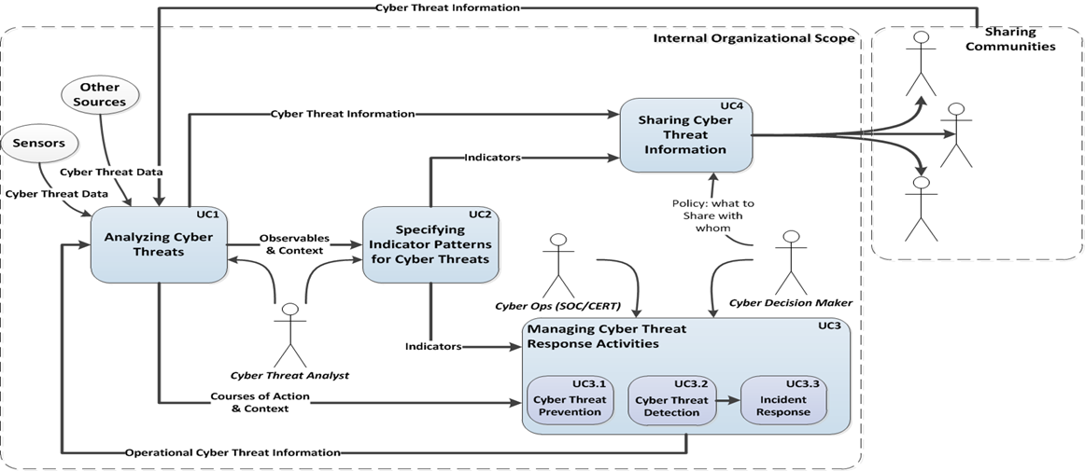
Figure 1: STIX use cases [i.4]
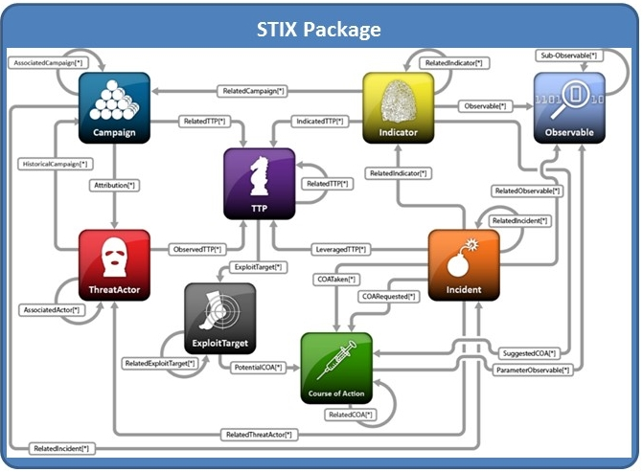
Figure 2: STIX Package encompasses the STIX individual component data models [i.4]
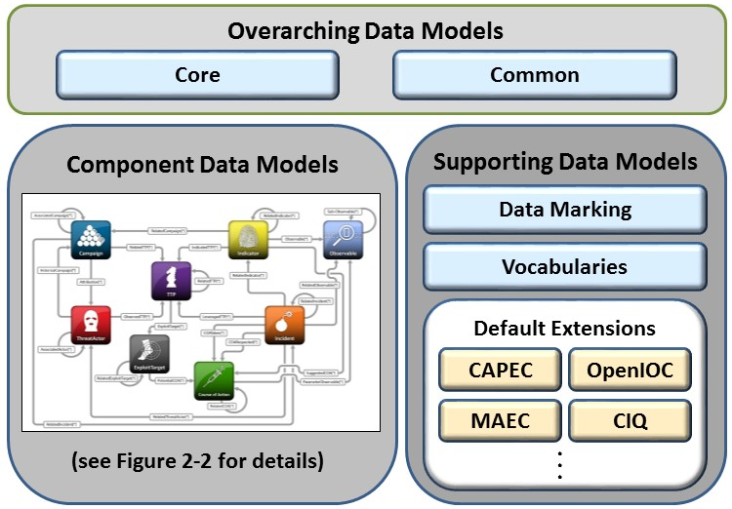
Figure 3: STIX architecture [i.4]
STIX 2.0 features being considered include JSON expressions, Sightings/ Observation/Indicator, Versioning, Indicator Type Vocabulary, Common Object Properties, Packaging, Campaign, TTPs. [i.5]

4.2.3 CTI TAXII Subcommittee
Trusted Automated eXchange of Indicator Information (TAXII™) defines a set of services and message exchanges that, when implemented, sharing of actionable cyber threat information across organization and product/service boundaries. TAXII, through its member specifications, defines concepts, protocols and messages to exchange cyber threat information for the detection, prevention, and mitigation of cyber threats. The models supported by version 1.1.1 as well as the specification components are shown in figures 4 and 5 below
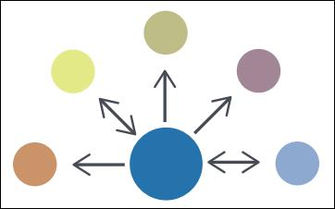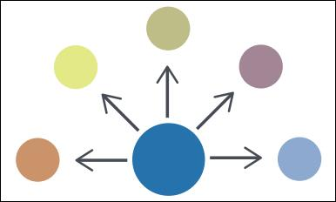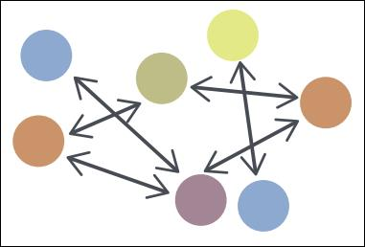
Hub and Spoke Source/ Subscriber Peer to Peer
Figure 4. TAXII models supported [i.4]
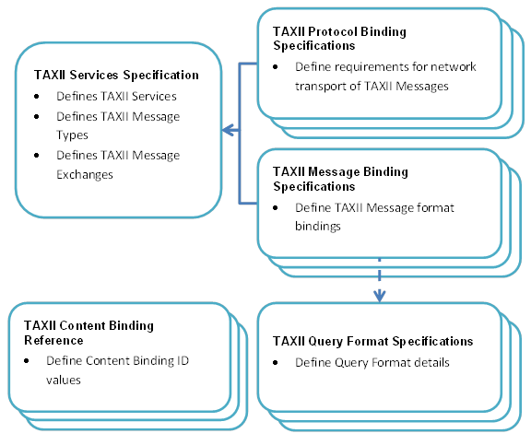
Figure 5. TAXII specification components [i.4]
TAXII 2.0 features being considered include: Publish and Subscribe model over an HTTP RESTful interface; TAXII Servers are plumbing for CTI between TAXII Clients; each TAXII Server has some defined out-of-the box channels that clients can publish or subscribe. The model is depicted in figure 6, below
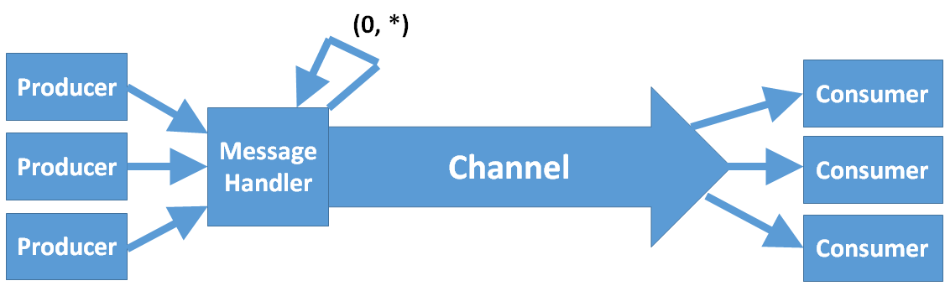
Figure 6. TAXII 2.0 proposed channel architecture [i.5]

4.2.4 CTI CybOX Subcommittee
CybOX provides a common structure for representing cyber observables across and among the operational areas of enterprise cyber security that improves the consistency, efficiency, and interoperability of deployed tools and processes, as well as increases overall situational awareness by enabling the potential for detailed automatable sharing, mapping, detection, and analysis heuristics. The CybOX 2.1.1 objects and relationships are depicted in figure 7, below.
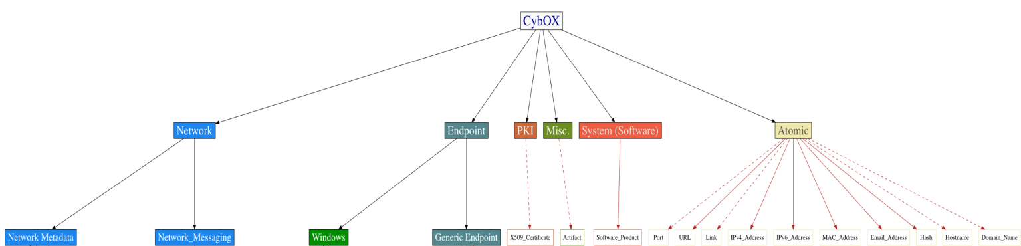
Figure 7. CybOX 2.1.1 objects and relationships [i.4]
CybOX 3.0 features being considered include: High-level Change to create: 1)a Core/Common set ( Separation of Patterns and Instances, First-class Relationships, Cryptographic Hash Capture Refactoring) and 2) Object-related Changes Object Refactoring for Semantic Accuracy, Expansion of "Atomic" Objects). [i.5]

4.2.5 CTI Interoperability Subcommittee
The subcommittee helps guide adherence to CTI TC-promulgated standards and interoperability between CTI TC standards-based implementations, while encouraging standards maturity throughout the industry. It also develops parameters and processes to allow CTI TC members to test/ validate, and where possible measure the maturity of another organization’s implementation. It identifies opportunities and approaches to promoting interoperability with externally-defined cyber threat intelligence standards and frameworks. [i.5]
Its deliverables include guidelines, parameters and processes for testing, validating and measuring implementations' adherence to CTI standards, as well as proposals for promoting interoperability with other, externally-defined cyber threat intelligence standards and frameworks.

4.3 IETF Managed Incident Lightweight Exchange Working Group (mile)
In the 1990s, the various network Computer Emergency Response Teams under the leadership of the Carnegie Mellon CERT, FIRST, SurfNet Netherlands, and similar organizations focussed on the need to structure threat information for exchanging among themselves. Circa 2006 an IETF working group known as INCH (Extended Incident Handling) was established for the purposes of developing specifications. It developed a number of guideline Internet Drafts for an incident description language, transport protocols, and other capabilities that were advanced under the name The Incident Object Description Exchange Format or IODEF. IODEF was also replicated by ITU-T.
In 2011, in response to an increasing need for updates and extensions to IODEF and related new tools, the Managed Incident Lightweight Exchange Working Group (mile) was chartered and has been active since. The working group develops standards to support computer and network security incident management. It describes its role as:
The Managed Incident Lightweight Exchange (MILE) working group develops standards to support computer and network security incident management; an incident is an unplanned event that occurs in an information technology (IT) infrastructure. An incident could be a benign configuration issue, IT incident, a system compromise, socially engineered phishing attack, or a denial-of-service (DoS) attack, etc. When an incident is detected, or suspected, there may be a need for organizations to collaborate. This collaboration effort may take several forms including joint analysis, information dissemination, and/or a coordinated operational response. Examples of the response may include filing a report, notifying the source of the incident, requesting that a third party resolve/mitigate the incident, sharing select indicators of compromise, or requesting that the source be located. By sharing indicators of compromise associated with an incident or possible threat, the information becomes a proactive defense for others that may include mitigation options. [i.7]
Platforms approved within IETF include the following.[i.7]
- RFC 5070, ”Incident Object Description Exchange Format (IODEF)”
- RFC 6545, ”Real-time Inter-network Defense (RID)”
- RFC 6546, ”Transport of Real-time Inter-network Defense (RID) Messages over HTTP/TLS “
- RFC 6684, ”Guidelines and Template for Defining Extensions to IODEF”
- RFC 6685, ”Expert Review for Incident Object Description Exchange Format (IODEF) Extensions in IANA XML Registry”
- RFC 7203,”IODEF-extension for structured cybersecurity information”
- RFC 7495, “IODEF Enumeration Reference Format”
The ITU-T Study Group 17 replicated RFC6046 (RID) as Rec. ITU-T X.1581, and RFC6046 (RID) as Rec. ITU-T X.1581. [i.7][i.8]
Current new platforms being developed by the IETF mile group include the following. [i.7]
- MILE Implementation Report, draft-ietf-mile-implementreport-07
- IODEF Usage Guidance, draft-ietf-mile-iodef-guidance-05
- The Incident Object Description Exchange Format v2, draft-ietf-mile-rfc5070-bis-21
- Resource-Oriented Lightweight Indicator Exchange, draft-ietf-mile-rolie-01
- XMPP Protocol Extensions for Use with IODEF, draft-ietf-mile-xmpp-grid-00
The Implementation Report is useful in understanding the extent to which the IODEF platform has been used.

4.4 CSIRTGadgets Collective Intelligence Foundation (CIF)
The CSIRT Gadgets Foundation was founded with a mission to directly engage both public and private sector CSIRTs as a means for evolving the internet into a more secure and resilient ecosystem. The Foundation has been organized as a non-profit organization in the United States. The Foundation promotes the development and stewardship of assets such as software, algorithms and best common practices that enable CSIRTs execute their missions. One of its existing initiatives is known as the Collective Intelligence Framework funded by the U.S. National Science Foundation for use and development among the university educational community.
CIF allows you to combine known malicious threat information from many sources and use that information for identification (incident response), detection (IDS) and mitigation (null route). The most common types of threat intelligence warehoused in CIF are IP addresses, domains and URLs that are observed to be related to malicious activity. CIF is used by the Research and Education Networking Information Sharing and Analysis Center (REN-ISAC) and the Anti-Phishing Working Group. A Foundation information site is available at http://csirtgadgets.org/.

4.5 EU Advanced Cyber Defence Centre (ACDC)
On an even larger scale than the CIF project described in 4.4 above, the European Commission helped initiate and fund the Advanced Cyber Defence Centre project from early 2013 to mid-2015. The objective was to establish a sustainable European centre for cyber defence, building on 8 networked support centres and one clearing house deployed during the project and enlarging the cyber-protection scope beyond botnets. ACDC unites a community of 28 organisations from 14 countries, including Internet Service Providers, CERTs, law enforcement agencies, IT providers, National Research and Education Networks (NRENs), academia and critical infrastructure operators.
In the initial phase of the projects, there was an active threat information sharing specifications group that made use of existing platforms via a Tool Group. The project ended in July 2015, but Delft University of Technology maintains an information site at http://www.tbm.tudelft.nl/en/research/projects/research-review/advanced-cyber-defense-center-acdc/

4.6 AbuseHelper
AbuseHelper is an open-source project initiated by CERT.FI and CERT.EE with Clarified Networks to automatically process incidents notifications. Its use has been encouraged by ENISA as a modular, potentially scalable and robust framework to help in abuse handling. With Abuse Helper you can retrieve Internet Abuse Handling related information via several sources, you can then aggregate that information based on different keys, such as AS numbers or country codes and send out reports in different formats, via different transports and using different timings. An instructive site is available at www.abusehelper.be.

4.7 OMG Threat Modelling Working Group
The Object Management Group has several initiatives related to the sharing of cyber threat information. The most prominent is a proposal for a combined risk-threat information model that incorporates STIX (among other things). It is expected to cover a broader scope (cyber and physical, threat and risk) in order to coordinate across these domains but does not seek to re-define a model within the domain to the low level that STIX and CybOX. A cross domain Threat and Risk Community site that builds on OASIS CTI platforms exists at www.threatrisk.org.

4.8 ITU-T SG17
The Cybersecurity Rapporteur group within ITU-T Study Group 17 began in 2009 to develop a comprehensive initiative to identify and in some cases replicate structured cybersecurity information sharing platforms. The general framework was designated CYBEX (Cybersecurity Information Exchange) and an extensive series of specifications have been prepared. [i.8]
- X.1500, “Overview of cybersecurity information exchange”
- X.1500.1, “Procedures for the registration of arcs under the object identifier arc for cybersecurity information exchange”
- X.1520, “Common vulnerabilities and exposures”
- X.1521, “Common vulnerability scoring system”
- X.1524, “Common weakness enumeration”
- X.1525, “Common weakness scoring system”
- X.1526, “Language for the open definition of vulnerabilities and for the assessment of a system state”
- X.1528, “Common platform enumeration”
- X.1528.1, “Common platform enumeration naming”
- X.1528.2, “Common platform enumeration name matching”
- X.1528.3, “Common platform enumeration dictionary”
- X.1528.4, “Common platform enumeration applicability language”
- X.1541, “Incident object description exchange format”
- X.1544, “Common attack pattern enumeration and classification”
- X.1546, “Malware attribute enumeration and characterization”
- X.1570, “Discovery mechanisms in the exchange of cybersecurity information”
- X.1580, “Real-time inter-network defence”
- X.1581, “Transport of real-time inter-network defence messages”
- X.1582, “Transport protocols supporting cybersecurity information exchange”
Current new threat information exchange platforms being developed by the ITU-T Cybersecurity group include the following. [i.9]
- X.1542, Session information message exchange format
- X.cogent, Design considerations for improved end-user perception of trustworthiness indicators
- X.metric, Metrics for evaluating threat and resilience in cyberspace
- X.nessa, Access control models for incidents exchange networks

4.9 Open Threat Exchange™ (OTX™)
AlienVault is the developer of the Open Source Security Information Management (OSSIM). Its vision is for companies and government agencies to gather and share relevant, timely, and accurate information about new or ongoing cyberattacks and threats as quickly as possible to avoid major breaches (or minimize the damage from an attack). AlienVault’s Open Threat Exchange™ (OTX) is its principle platform.
NOTE: Open Threat Exchange™ is the trade name of a product supplied by AlienVault. This information is given for the convenience of users of the present document and does not constitute an endorsement by ETSI of the product named. Equivalent products may be used if they can be shown to lead to the same results."
AlienVault OTX™ provides open access to a global community of threat researchers and security professionals. It delivers community-generated threat data, enables collaborative research, and automates the process of updating a security infrastructure with threat data from any source. OTX enables anyone in the security community to actively discuss, research, validate, and share the latest threat data, trends, and techniques, strengthening defences while helping others do the same.

4.10 OpenIOC Framework
The OPenICO framework is an information exchange specification that describes Indicators of Compromise and is managed by an open developer community. OpenIOC addresses a narrow use case (observable patterns for Indicators of Compromise) and represents a partial solution to part of the overall cyber threat information problem, but does not fully address the needs of a holistic cyber threat intelligence information model. The OpenIOC community site is available at www.openioc.org.

4.11 VERIS Framework
Another common language for describing security incidents is the Vocabulary for Event Recording and Incident Sharing (VERIS). It addresses a narrow use case and represents a partial solution to part of the overall cyber threat information problem but does not fully address the needs of a holistic cyber threat intelligence information model. The VERIS community site is available at www.veriscommunity.net. In addition, the published format is available on GitHub at https://github.com/vz-risk/veris.

4.12 ETSI ISI (Information Security Indicators) ISG
In 2011, an Industry Specification Group was created by ETSI to undertake several activities relating to Information Security Indicators, including a Security Event Classification Model and its implementation.[i.10] Preliminary work on information security indicators was done by the French Club R2GS. The first public set of the ISI standards (security indicators list and event model) were released in April 2013 and now includes a set of five specifications.[i.11]
- GS ISI 001-1 Information Security Indicators (ISI); Indicators (INC); Part 1: A full set of operational indicators for organizations to use to benchmark their security posture
- GS ISI 001-2 Information Security Indicators (ISI); Indicators (INC); Part 2: Guide to select operational indicators based on the full set given in part 1
- GS ISI 002 Information Security Indicators (ISI); Event Model A security event classification model and taxonomy
- GS ISI 003 Information Security Indicators (ISI); Key Performance Security Indicators (KPSI) to evaluate the maturity of security event detection
- GS ISI 004 Information Security Indicators (ISI); Guidelines for event detection implementation
- GS ISI 005 Information Security Indicators (ISI); Guidelines for security event detection testing and assessment of detection effectiveness .
Although the term Information Security Indicator is not defined, an “indicator” is defined as a “measure that provides an estimate or evaluation of specified attributes derived from an analytical model with.” These indicators provide the basis to switch from a qualitative to a quantitative culture in IT Security Scope of measurements: External and internal threats (attempt and success), user's deviant behaviours, nonconformities and/or vulnerabilities (software, configuration, behavioural, general security framework). ISO/IEC 27001, 27002 and 27004, plus ISACA COBIT and the Critical Security Controls found in ETSI TR103305 are all normative for implementation of the specifications, and the ISI specifications provide useful descriptions of the relationships among the various terminologies and models. A useful summary of basic terminology are provided in Figure 8, below.
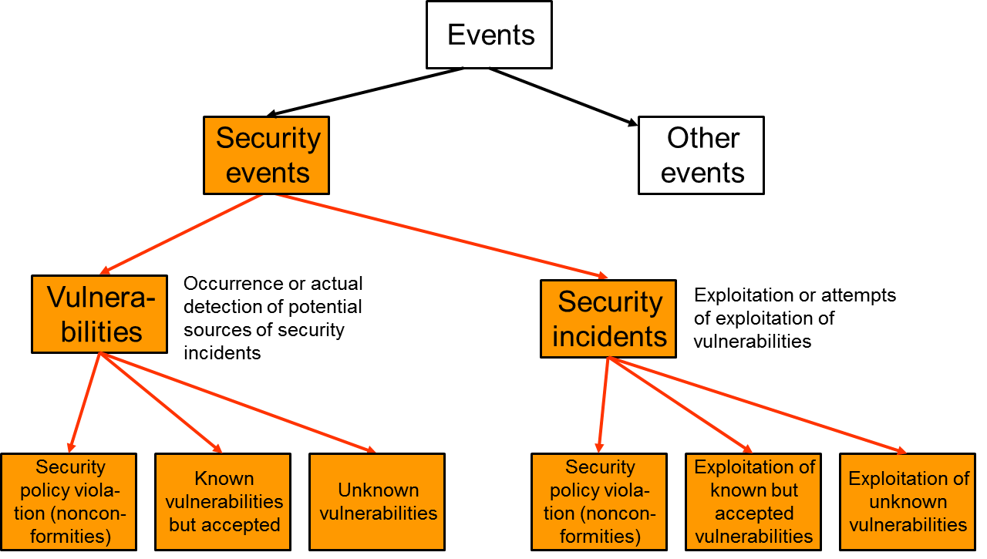

Figure 8: Relationships between different kinds of events [i.11]

Annex: Bibliography

Farnham and Leune, "Tools and Standards for Cyber Threat Intelligence Projects," SANS Institute InfoSec Reading Room, 14 Oct 2013.
Northcutt, “A SANS Survey,” SANS Institute InfoSec Reading Room, Feb 2015.

History
Document history
V0.0.1 | February 2015 | Initial Draft
V0.0.2 | October 2015 | Early Draft
V1.0.0 | February 2016 | Final Draft
V1.0.1 | June 2016 | Final Draft updated

