ebXML Test Framework DRAFT Document
Version 0.91
OASIS ebXML Implementation, Interoperability and Conformance Technical Committee
December 17, 2002

Status of this Document 5
ebXML Participants 5
Introduction 6
1 Summary of Contents of this Document 6
1.1.1 Document Conventions 6
1.1.2 Audience 7
1.1.3 Caveats and Assumptions 7
1.1.4 Related Documents 7
1.2 Minimal Requirements for Conformance 8
Part I: The Test Framework Architecture 9
2 Principles and Methodology of Operations 9
2.1 General Objectives 9
2.2 General Methodology 10
3 The Test Framework Components 11
3.1 A Modular Architecture 11
3.2 The Test Driver 11
3.2.1 Functions 11
3.2.2 Using the Test Driver in Connection Mode 13
3.2.3 Using the Test Driver in Service Mode 14
3.3 The Test Service 15
3.3.1 Functions and Interactions 16
3.3.2 Requestor and Responder Roles 17
3.3.3 Modes of Operation of the Test Service 18
3.3.4 States of the Test Service 19
3.3.5 Test Service Actions 19
3.3.5.1 Common Functions 19
3.3.5.2 Test Service Actions 19
3.3.5.2.1 Mute action 20
3.3.5.2.2 Dummy action 20
3.3.5.2.3 Reflector (or Responder) action 20
3.3.5.2.4 Initiator action 20
3.3.5.2.5 PayloadVerify action 21
3.3.5.2.6 ErrorAppNotify action 21
3.3.5.2.7 ErrorURLNotify action 21
3.3.5.2.8 Configurator action 22
3.3.5.3 Integration with an Implementation 22
3.4 Executing Test Cases 23
3.4.1 Test Case as a Sequence of Test Steps 23
3.4.2 Related Message Data and Message Templates 23
3.4.3 Related Configuration Data 24
Part II: Test Suite Representation 26
4 Test Suite 26
4.1 Conformance vs. Interoperability Test Suite 26
4.2 The Test Suite Document 27
3.3.2 Test Suite Documentation 27
4.2.1 The ConfigurationGroup 28
4.2.3 Test Driver Configuration for ebXML MS Conformance Testing 29
4.2.3.1 Multiple Configuration Declarations within the Test Suite 29
5 Test Requirements 30
5.1 Purpose and Structure 30
5.2 The Test Requirements Document 31
5.3 Specification Coverage 32
6 Test Profiles 33
6.1 The Test Profile Document 33
6.2 Relationships between Profiles, Requirements and Test Cases 34
7 Test Cases 35
7.1 Structure of a Test Case 35
7.1.1 Test Steps 37
7.1.2 Test Step Operations 37
7.1.3 The PutMessage Operation 37
7.1.4 The SetPayload Operation 39
7.1.5 The Dsign Operation 39
7.1.6 The Message Declaration 40
7.1.6.1 Interpreting the MIME portion of the Message Declaration 41
7.1.6.2 Interpreting the SOAP portion of the Message Declaration 42
7.1.6.3 Interpreting the SOAP Header Extension Element Declaration 43
7.1.6.4 Interpreting the ebXML MessageHeader Element Declaration 44
7.1.6.5 Interpreting the ebXML ErrorList Element Declaration 46
7.1.6.6 Interpreting the ebXML SyncReply Element Declaration 47
7.1.6.7 Interpreting the ebXML AckRequested Element Declaration 48
7.1.6.8 Interpreting the ebXML Acknowledgment Element Declaration 49
7.1.6.9 Interpreting the ebXML MessageOrder Element Declaration 51
7.1.6.10 Interpreting the SOAP Body Extension Element Declaration 52
7.1.6.11 Interpreting the ebXML Manifest Element Declaration 52
7.1.6.12 Interpreting the ebXML StatusRequest Element Declaration 53
7.1.6.13 Interpreting the ebXML StatusRequest Element Declaration 54
7.1.7 The GetMessage Operation 55
7.1.8 The TestPreCondition Operation 56
7.1.9 The TestConformanceCondition Operation 57
7.2 Run-Time Coverage of Test Requirements 58
8 Other Test Material 59
8.1.1 Schemas for Test Suite Material Construction 59
8.1.2 Test Framework Collaboration Protocol Profile Agreements (CPPA) 60
8.1.3 Schema for Test Message Payloads 61
8.1.4 Conformance Test Profile Documents 61
Appendices 62
Appendix A (Normative) The ebXML Test Profile Schema 62
Appendix B (Normative) The ebXML Test Requirements Schema 63
Appendix C (Normative) The ebXML Test Suite Schema 65
( and supporting sub-schemas ) 65
Appendix D The “Basic” Testing CPPA 74
Appendix E Terminology 75
References 81
Non-Normative References 81
Contact Information 82
Acknowledgments 82
The OASIS ebXML-MS Technical Committee would like to thank … 82
Disclaimer 83
Copyright Statement 83
Intellectual Property Rights Statement 83

Status of this Document
This document specifies ebXML Testing Procedures for the eBusiness community. Distribution of this document is limited to OASIS ebXML TC members only.
The document formatting is based on the Internet Society’s Standard RFC format converted to Microsoft Word 2000 format.
Note: Implementers of this specification should consult the OASIS Implementation, Interoperability and Conformance Technical Committee web site for current status and revisions to the specification
(http://www.oasis-open.org/committees/ebxml-iic/ ).
Specification
This is a DRAFT version of the specification.
This version
V0.9 – http://www.oasis-open.org/committees/ebxml-iic/documents/ebxmltestframework.doc
Errata to this version
None
Previous version
None

ebXML Participants
The authors wish to acknowledge the support of the members of the Messaging Services Team who contributed ideas, comments and text to this specification by the group’s discussion eMail list, on conference calls and during face-to-face meetings.
(main authors:)

Michael Kass | NIST
Mathew McKenzie | XMLGlobal

Jacques Durand | Fujitsu Limited

Monica Martin | DrakeCertivo

(contributors/ reviewers:)

<list of currently active IIC members>
Eric VanLydegraf | Kinzan
Hatem El-Sebaaly | IPNetSolutions
Steve Yung | Sun Microsystems
Jeff Turpin | CycloneCommerce
Serm Kulvatunyou | NIST

Introduction
This specification is one of a series of specifications realizing a global electronic marketplace where enterprises of any size and in any geographical location can meet and conduct business with each other through the exchange of XML based messages – or messages which have an XML header and envelope, though their payload may be of any data format. The set of specifications enables a modular, yet complete electronic business framework.
This specification focuses on defining a test framework and procedures for ebXML conformance and interoperability tests. The Test Framework includes: functional design of software components, their interface to ebXML implementations, a language for defining a test suite, as a set of test cases which execute on the software components of the framework.

Summary of Contents of this Document

The naming conventions follow the format specified in the Standard for Software Test Documentation IEEE Std 829-1998.
This specification is organized around the following topics:
Test Framework Architecture

- Purpose– A functional and architectural description of the test framework as a set of software components, which would serve as a reference in describing the test suites. It will also serve as a high-level design for implementing a test-bed that would automatically process the test suite material.

Test Suite Representation

- Purpose– A description of the elements of a test suite, as well as of the test scripting language and material. The test suite definition is in a form that can be processed by components of the test framework.
Appendices to this specification cover the following:
- Appendix A Test Profile Schema – This normative appendix contains XML schema definition for a profile definition.
- Appendix B Test Requirements Schema – This normative appendix contains XML schema definition [ebTESTREQ] for the ebXML Testing Requirements
- Appendix C Test Suite Schema – This normative appendix contains XML schema definition [ebTESTSUITE] for the ebXML Test Suites
- Appendix D Basic CPA formats Schema – This appendix contains XML schema definition for CPA data

[MIKE] – Removed correct? Also, should we decided on the term CPA or CPPA? Isn’t the latter the correct one now, or am I mistaken? In either case, we should be consistent throughout all of our specs. Also, Appendix D actually contained a CPPA.. not a CPPA schema ( I left that for the CPPA specification people ). Appendix D contained the “base CPPA”.
<JD2> CPPA is OK…

- Appendix E Terminology – This appendix contains a glossary of terms used that are related to the testing process.

Document Conventions

Terms in Italics are defined in the ebXML Glossary of Terms [ebGLOSS]. Terms listed in Bold Italics represent the element and/or attribute content. Terms listed in Courier font relate to MIME components. Notes are listed in Times New Roman font and are informative (non-normative). Attribute names begin with lowercase. Element names begin with Uppercase.
The keywords MUST, MUST NOT, REQUIRED, SHALL, SHALL NOT, SHOULD, SHOULD NOT, RECOMMENDED, MAY and OPTIONAL, when they appear in this document, are to be interpreted as described in [RFC2119] as quoted here:
- MUST: This word, or the terms "REQUIRED" or "SHALL", means that the definition is an absolute requirement of the specification.
- MUST NOT: This phrase, or the phrase "SHALL NOT", means that the definition is an absolute prohibition of the specification.
- SHOULD: This word, or the adjective "RECOMMENDED", means that there may exist valid reasons in particular circumstances to ignore a particular item, but the full implications MUST be understood and carefully weighed before choosing a different course.
- SHOULD NOT: This phrase, or the phrase "NOT RECOMMENDED", means that there may exist valid reasons in particular circumstances when the particular behavior is acceptable or even useful, but the full implications should be understood and the case carefully weighed before implementing any behavior described with this label.
- MAY: This word, or the adjective "OPTIONAL", mean that an item is truly optional. One vendor may choose to include the item because a particular marketplace requires it or because the vendor feels that it enhances the product while another vendor may omit the same item. An implementation which does not include a particular option MUST be prepared to interoperate with another implementation which does include the option, though perhaps with reduced functionality. In the same vein an implementation which does include a particular option MUST be prepared to interoperate with another implementation which does not include the option (except, of course, for the feature the option provides).

Audience

The target audience for this specification is:
- The community of software developers who implement the ebXML Messaging Service [ebMS], ebXML Collaboration-Protocol Profile Agreement [ebCPP], ebXML Registry Services Specification [ebREGREP] and ebXML Business Process Schema Specification (BPSS). Using the test framework described here will require some integration work with their ebXML implementation.
- The testing or verification authority, which will implement and deploy conformance or interoperability testing for ebXML products.

Caveats and Assumptions

It is assumed the reader has an understanding of communications protocols, MIME, XML, SOAP, SOAP Messages with Attachments and security technologies.

Related Documents

The following set of related specifications are developed independently of this specification as part of the ebXML initiative:

- ebXML Messaging Conformance Test Suite – defines a test suite and test harness for testing conformance to ebXML Messaging Service. The test suite and test harness are based on the test framework and material described in this document.
- ebXML Messaging Basic Interoperability Test Suite – defines a test suite and test harness for testing interoperability between implementations of the ebXML Messaging Service. The document defines a basic interoperability profile and its test suite. The test suite and test harness are based on the test framework and material described in this document.
- ebXML Collaboration Protocol Profile and Agreement Specification (CPPA) – CPP defines one business partner's technical capabilities to engage in electronic business collaborations with other partners by exchanging electronic messages. A CPPA documents the technical agreement between two (or more) partners to engage in electronic business collaboration. This CPP/A ( should we use a / in our name? <JD2> we do not have to…. CPPA is OK If so, we should be consistent throughout- MIKE) document is reused by the test framework as test case configuration material (part of test suite material).
- ebXML Messaging Service Specification (MS) – defines the messaging protocol and service for ebXML, which provide a secure and reliable method for exchanging electronic business transactions using the Internet. The test framework assumes the use of ebXML Message Service Handlers, although the test material is not tightly dependent on the MS specification.
- ebXML Registry Specification – defines how one party can discover and/or agree upon the information the party needs to know about another party prior to sending them a message that complies with this specification. The test framework is also designed to support the testing of a registry implementation.
- ebXML Business Process Specification Schema (BPSS) – defines how two parties can cooperate through message-based collaborations, which follow particular message choreographies. The test framework is also designed to support the testing of a business process implementation.

Minimal Requirements for Conformance
An implementation of the Test Framework specified in this document MUST satisfy ALL of the following conditions to be considered a conforming implementation:
- It supports all the mandatory syntax, features and behavior (as identified by the [RFC2119] key words MUST, MUST NOT, REQUIRED, SHALL and SHALL NOT) defined in Part 1.1.1 – Document Conventions.
- It supports all the mandatory syntax, features and behavior defined for each of the components of the Test Framework.
- It complies with the following interpretation of the keywords OPTIONAL and MAY: When these keywords apply to the behavior of the implementation, the implementation is free to support these behaviors or not, as meant in [RFC2119]. When these keywords apply to data and configuration material used by an implementation of the Test Framework, a conforming implementation of the Test Framework MUST be capable of processing these optional materials according to the described semantics.

Part I: The Test Framework Architecture

Principles and Methodology of Operations

General Objectives

The ebXML Test Framework is intended to support conformance and interoperability testing for ebXML specifications. It describes a test-bed architecture and its software components, how these can be combined to create a test harness for each type of ebXML testing. It also describes the test material to be processed by this architecture, a mark-up language and format for representing test requirements, and test suites (set of test cases).

The Test Framework described here has been designed to achieve the following objectives:

- The Test Framework is a foundation for testing all ebXML architectural components such as Messaging, Registry, BPSS, CPP/A, and Core Components.

- Test Suites and Test Cases that are related to these standards, can be defined in a formal manner (including test steps and verification conditions). They can be automatically processed by the framework, and their execution can easily be reproduced.

- The harnessing of an ebXML implementation (or possibly several, e.g. in case of interoperability) with the Test Framework requires a moderate effort. Typically, it requires some interfacing work specific to an implementation, in the case no standard interface (API) has been specified. For example, the Test Service (a component of the Test Framework) defines Actions that will need to be called by a particular MSH implementation. Besides this kind of interfacing, no application code needs to be written.

- Several test-bed configurations - or test harnesses - can be derived from the Test Framework, depending on the objectives of the testing. For example, MS conformance testing will include a particular combination (architecture) of some components of the Test Framework, while interoperability testing will require another set-up.

- Operating the Test Framework - or one of the test harnesses that can be derived from it – in order to execute a test suite, does not require advanced expertise in the framework internals, once the test suites have been designed. The tests should be easy to operate and to repeat with moderate effort or overhead, by users of the ebXML implementation(s) and IT staff responsible for maintaining the B2B infrastructure, without expertise in testing activity.

- Users can define new Test Suites and Test Cases to be run on the framework. For this, they will script their tests using the proposed test suite definition language or mark-up (XML-based) for test cases.

- A Test Suite (either for conformance or for interoperability), can be run entirely and validated from one component of the framework: the Test Driver. This means that all test outputs will be generated - and test conditions verified - by one component, even if the test harness involves several – possibly remote – components of the framework.

- The verification of each Test Case can be done by the Test Driver at run-time, as soon as the test case execution is completed. The outcome of the verification can be obtained immediately as the Test Suite has completed, and a verification report be generated.

General Methodology

The Test Framework is intended for the following mode of operation, when testing for conformance or for interoperability. In order for a testing process (or validation process) to be conform to this specification, the following phases need to be implemented:

- Phase 1: Test Plan (RECOMMENDED). An overall test plan is defined, which includes a validation program and its objectives, the conditions of operations of the testing, levels or profiles of conformance or of interoperability, and the requirements for candidate implementations to be tested (context of deployment, configuration).

- Phase 2: Test Requirements Design (MANDATORY). A list of Test Requirements (also called Test Assertions) is established for the tested specification, and for the profile/level of conformance/interoperability that is targeted. These Test Requirements should refer to the specification document. Jointly to this list, it is RECOMMENDED that a specification coverage be reported. This document shows, for each specification feature, the Test Requirements items that address this feature. It also estimates to which degree the feature is validated by these Test Requirements items.

- Phase 3: Test Harness Design (MANDATORY). A Test Harness is defined for this particular test plan. It describes an architecture built from components of the Test Framework, along with operation instructions and conditions.

- Phase 4: Test Suite Design (MANDATORY). Each Test Requirement from Phase 2 is translated into one or more Test Cases. A Test Case is defined as a sequence of operations (Test Steps) over [MIKE (wording)] – executed by the Test Harness. A Each Test Case includes also [MIKE (wording)] – A Test Case also includes: configuration material (CPA data), message material associated with each Test Step, test verification condition which defines criteria for passing this test. All this material, along with particular operation directives, is gathered as a Test Suite.

- Phase 5: Validation Conditions (RECOMMENDED). Validation criteria are defined for the profile/level being tested, and expressed as a general condition over the set of results from the verification report of each Test Case of the suite. These validation criteria define the certification or “badging” for this profile/level.

- Phase 6: Test Suite Execution (MANDATORY). The Test Suite is interpreted and executed by the test Driver component of the Test Harness.

The Test Framework Components

A Modular Architecture

The components of the framework are designed so that they can be combined in different configurations, or Test Harnesses.

We describe here two components that are central to the Test Framework:

- The Test Driver, which interpret Test Case data and drives Test Case execution.
- The Test Service, which implements some test operations (actions) that can be triggered by messages. These operations support and automate the execution of Test Cases.

These components interface with the ebXML Message Service Handler (MSH), but are not restricted to testing an MSH implementation.

The Test Driver

The Test Driver is the component that drives the execution of each step of a Test Case. Depending on the test harness, the Test Driver may drive the Test Case by interacting with other components in connection mode, i.e. by directly generating ebXML messages - using a transport adapter, or in service mode, by invoking actions in the Test Service, which is another component of the framework.

Functions

The primary function of the Test Driver is to parse and interpret the Test Case definitions that are part of a Test Suite, as described in the Test Framework mark-up language. Even when these test cases involve several components of the Test Framework, the interpretation of the Test Cases is under control of the Test Driver.
The Test Driver component of the ebXML Test Framework MUST have the following capabilities:

- Self Configuration - Based upon supplied Test Case configuration parameters specified in the ebXML TestSuite.xsd schema (Appendix C), Test Driver configuration is done at startup, and MAY be modified at the TestCase and TestStep levels as well.
- ebXML Message Construction – Includes MIME, SOAP and ebXML portions of the message
- Received Message Persistence – Persisted received messages MUST persist for the life of a Test Case. Persistent messages MUST validate to the ebXMLPersistentMessage.xsd schema in Appendix D.
- Parse and query received persistent messages – Test Driver MUST use XPath query syntax to query MIME, SOAP and ebXML persistent message content
- Parse and query received message payloads – Test Driver MUST support XPath query syntax to query XML message payloads
- Controls the execution and workflow of the steps of a test case. Some steps may be executed by other components, but their initiation is under control of the Test Driver.
- Repeat previously executed Test Steps – Test Driver MUST be capable of repeating previously executed Test Steps for the current Test Case.
- Send messages - Either directly at transport layer (e.g. by opening an HTTP connection), or by using Test Service actions .
- Receive messages - Either directly at transport layer, or by notification from Test Service actions.
- Perform discreet message content validation – Test Driver MUST be capable of performing discreet validation of Time, URI, Signature and the entire XML message
- Perform discreet payload content validation – Test Driver MUST be capable of performing discreet validation of Time, URI, Signature and an XML payload
- Report Conformance Test Results – Test Driver MUST generate an XML conformance report for all executed tests in the profile. Conformance reports MUST validate to the ebXMLConformanceReport.xsd schema in Appendix E.

The design that supports these functions is illustrated in Figure 1.
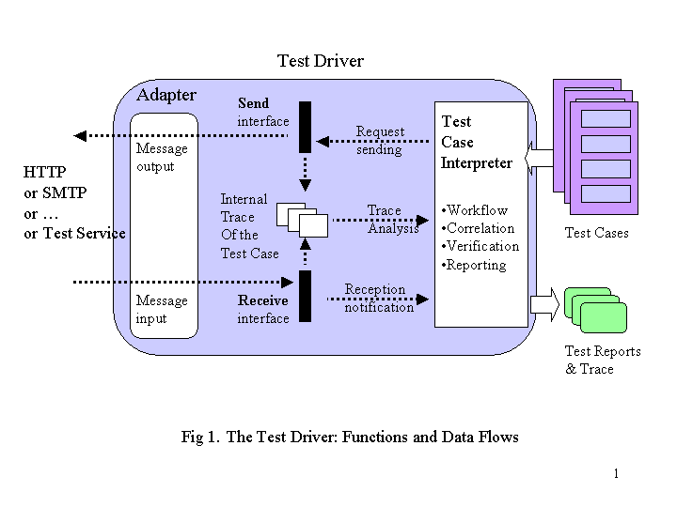

Using the Test Driver in Connection Mode

The Test Driver MUST be able to control the inputs and outputs of an MSH at transport level. This can be achieved by using an embedded transport adapter. This adapter has transport knowledge, and can format message material into the right transport envelope. It can also handle a connection with the candidate MSH.
When used in connection mode, the Test Driver is acting as a transport end-point that can receive or send messages with an envelope consistent with this transport protocol (e.g. HTTP or SMTP). Figure 2 illustrates how the Test Driver operates in connection mode.
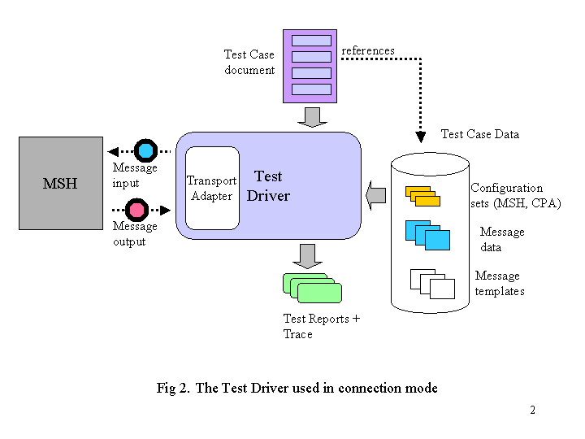

Using the Test Driver in Service Mode

In this configuration, the Test Driver directly interacts with the Service/Actions of the Test Service component (see later section), typically without involving the transport layer, e.g. by invoking these action via a software interface. This allows for controlling the test cases execution from the application layer (as opposed to the transport layer). Such a configuration is appropriate when doing interoperability testing - for example between two MSH implementations – and in particular, in situations where the transport layer should not be tampered with. The interactions with the Test Service will consist of:

- Sending: One action of the Test Service, the “Initiator”, serves as a channel to send requests to the MSH it has been interfaced with. This action – normally triggered by received messages – also provides an interface at application level. When invoked by a call that contains message data, the action generates a sending request to the MSH API for this message.

- Receiving: As all actions of the Test Service can participate in the execution of a Test Case (i.e. of its Test Steps), the Test Driver needs to be aware of their invocation by incoming messages. Each of these actions will notify the Test Driver through its “Receive” interface, passing received message data, as well as response data. This way, the Test Driver will build an internal trace (or state) for the Test Case execution, and will be able to verify the test based on this data.

The Test Driver MUST support the above communication operations with the Test Service. This may be achieved by using an embedded Service Adapter to bridge the sending and receiving functions of the Test Driver, with the Service/Action calls of the Test Service. Figure 3 illustrates how the Test Driver operates with a Service Adapter.
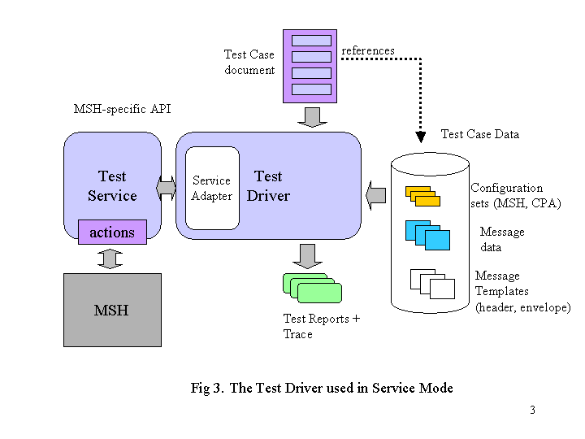

This design allows for a minimal exposure of the MSH-specific API, to the components of the Test Framework. The integration code that needs to be written for connecting the MSH implementation is then restricted to an interface with the Service/Actions defined by the framework. Neither the Test Driver, nor the Service Adapter, need to be aware of the MSH-specific interface.

The Test Service

Functions and Interactions

The Test Service defines a set of Actions that are useful for executing Test Cases. The Test Service receives message content and error notifications from the MSH, and also generates requests to the MSH, which normally translate into messages being sent out. The Test Actions are predefined, and part of the Test Framework (i.e. not user-written). Test Service and Actions will map to the Service and Action header attributes of ebXML messages generated during the testing. Figure 4 shows the details of the Test Service and its interfaces.

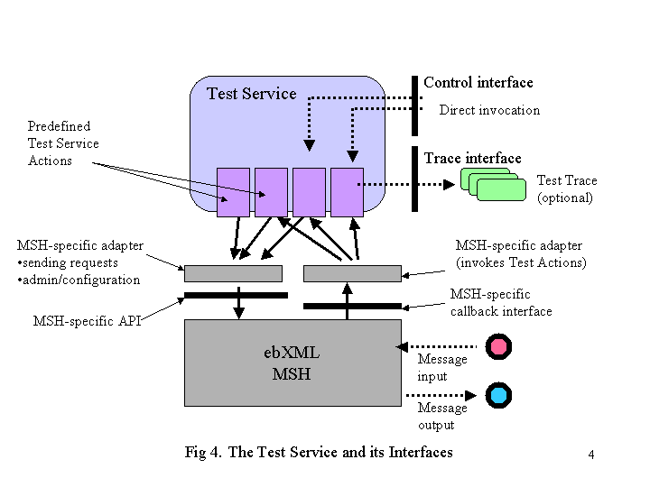

The functions of the Test Service are:

- Process received messages in the Action code they are intended to. These specialized Test Actions may perform diverse functions, which are enumerated below:
- Notify the Test Driver of incoming messages, in case it is interfaced with a Test Driver. In such case, the Test Service is said to be deployed in driver mode.
- Perform some test operations, e.g. compare a received message payload with a reference payload.
- Send back a response to the MSH, which will either simply acknowledge, or report on any test condition that may have been checked by the Action.
- Optionally, generate a trace of its operations, in order to help trouble shooting, or for reporting.

Although the Test Service simulates an application, it is part of the Test Framework, and does not vary from one candidate MSH to the other. However, in order to connect to the Test Service, a candidate MSH developer team will have to write wrapper code to the Test Service/Actions. This proprietary code is expected to require a minor effort, but is necessary as the API and callback interfaces of each MSH is not specified in the standard, and is implementation-dependent.

The Test Service name is: urn:ebXML:iic:test.

Requestor and Responder Roles

With respect to a particular instance of Test Service, two roles are identified:

- Requestor: The requestor party is the party that generates calls to the Test Service. The requestor usually involves a Test Driver in order to generate message material.

- Responder: The responder party is the party represented by the Test Service – including the associated MSH. Typically, the actions of the Test Service will respond in some way to the requestor.

There are two ways for a Test Driver to invoke a Test Service as illustrated in Figure 5, and they correspond to two different set-ups of the Requestor party.

In the upper part of the figure, a Test Driver directly generates message material at transport level. This is appropriate for conformance tests, where the message envelope itself may require some manipulation for some test cases.

In the lower part, the Test Driver uses another local instance of the (same) Test Service in order to invoke the remote Test Service. This is appropriate when message material can be controlled at a more abstract level (transport-independent), as in interoperability tests, using MSH implementations on each side. In that case, this additional Test Service instance will be part of the Requestor party, as it supports the generation of messages to the remote (Responder) instance.

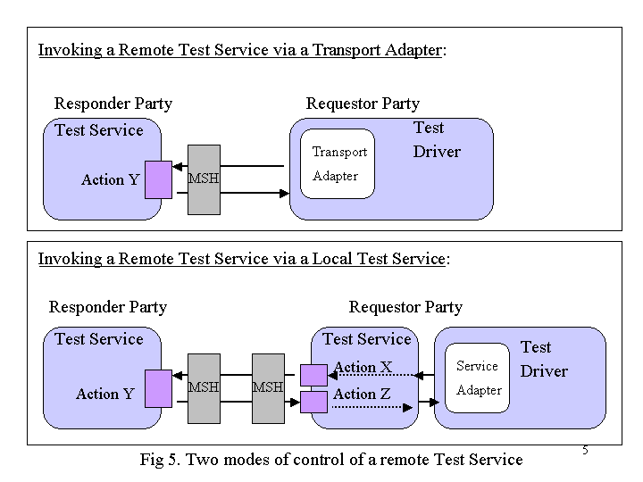

Modes of Operation of the Test Service

The Test Service can operate in two modes:

- Driver mode: in that mode, the actions of the Test Service instance, when invoked, will send a notification to the Receive interface. The Test Driver, which implements this interface, can then be notified of the invocation. This is the appropriate mode of operation when this Test Service instance is associated with the Test Driver (e.g. in Requestor party of second alternative in Figure 5) in order to drive the test cases.

- Non-driver mode: in that mode, the actions of the Test Service instance, when invoked, will NOT send a notification to the Receive interface. Instead, the action will send a response message to the “response URL”. The response URL is usually set to be the requestor URL. This is the appropriate mode of operation when this Test Service instance is remote to the Test Driver controlling the Test Case execution (e.g. in Responder party of Figure 5). Note: response message sending will require an adapter to the local MSH.

The Test Service is stateless, except for its mode of operation, which can be set by a special action call. By default, the mode is non-driver.

States of the Test Service

The Test Service has only two parameters that can be modified by action invocation (and therefore represent its state):

- Operation mode (driver or non-driver)
- Response URL (for response messages)

In addition, a Test Service instance is identified by an ID that will be reported in some response messages.
Except for these parameters, the Test Service is stateless.

Test Service Actions

The actions described here are standard to the Test Service, and should suffice in supporting most Test Cases.

Common Functions

Some functions are common to several actions, in addition to the specific functions they fulfill. These common functions are:

- Generate a response message. This function is usually enabled when operating the Test Service in non-driver mode. Response messages also specify a Service/Action, as they are usually intended to another Test Service instance associated with the requestor party. In case the test harness does not include a Test Service on requestor side, the Action field is irrelevant. The message will then be captured and analyzed in other ways (e.g. directly by a Test Driver, via an adapter to the transport protocol, as in MS conformance testing).

- Notify the Test Driver. This can only be done when the Test Service is coupled locally with a Test Driver, (see second part of Figure 5 in previous section). In that configuration, the Test Service is in driver mode. In such a case, the Receive interface of the Test Driver is invoked, which will add an item to the internal trace of the Test Case being executed (see Figure 1.)

Test Service Actions

The standard test actions are:

Mute action

Description: This is a “dummy” action, which does not generate any response message back. This action will report invocations and their content to the local Test Driver (if the Test Service is coupled with a Test Driver).
In driver mode: will notify the associated Test Driver, with received header and payload(s) material. The notification will report the action name (“mute”) and the instance ID of the Test Service.

Dummy action

Description: This is a “dummy” action, used by messages that do not need any specific response, and the sending of which only needs to cause some side-effect in the MSH, like generating an error. On invocation, this action will however generate a pre-canned response message back (no payload, simplest header with no extra-features), referring to the previous MessageID (for correlation) in the RefToMessageId header attribute.
Destination: the Mute action of the requestor’s Test Service. This notice serves as proof that the message has reached the responder’s Test Service, although no assumption can be made on the integrity of its content.
In driver mode: will notify the associated Test Driver, with received header and payload(s) material. The notification will report the action name (“dummy”) and the instance ID of the Test Service.

Reflector (or Responder) action

Description: On invocation, this action generates a response to a received message, by using the same message material, with minimal changes in the header:
- Swapping of the to/from parties so that the “to” is now the initial requestor.
- Setting RefToMessageId to the ID of the received message.
- Removing AckRequested or syncReply elts if any.
- All other header elements (except for time stamps) are unchanged. The conversation ID remains unchanged, as well as the CPAId. The payload is the same as in the received message, i.e. same attachment(s).
Destination: the Mute action of the requestor’s Test Service. This action acts somehow as a reflector for the requesting party.
In driver mode: notifies the associated Test Driver, with received header and payload(s) material. The notification will report the action name (“reflector”) and the instance ID of the Test Service.

Initiator action

Description: On invocation, this action generates a new message, totally unrelated to the received message. The new message material (payload and header) is provided in a pre-convened way in the payload of the received message. The header of the new message can be anything that is specified. For example, this action would be used to generate a "first" message of a new conversation, different from the conversation ID specified in the invoking message. Note: unlike in the Reflector action, MSH-controlled header attributes will not be determined by the invoking message header (messageID, RefToMessageId, timestamps...). So if the response needs to refer to the previous MessageID (for correlation), the RefToMessageId must be explicitly pre-set in the message material.
Destination: any service/action of the sender, specified with message material (by default: the Mute action of the requestor’s Test Service.)
In driver mode: in addition to generating the message, notifies the associated Test Driver, with header and payload(s) material. The notification will report the action name (“initiator”) and the instance ID of the Test Service.

PayloadVerify action

Description: On invocation, this action will compare the payload(s) of the received message, with reference payloads (files) pre-installed on the Test Service host. This action will test the service contract (application – MSH), as errors may originate either on the wire, or at every level of message processing in the MSH until message data is passed to the application. The action responds with a notification message to the requestor, about the outcome of the comparison. The previous MessageID is reported (for correlation) in the RefToMessageId header attribute of the response. The payload will contain an XML document of the form: <testservice><payload>…</ payload >< /testservice>. The payload element may have values: “validated” or “not-validated”. Destination: the Mute action of the requestor’s Test Service.
In driver mode: will notify the associated Test Driver, with received header and payload(s) material. The notification will report the action name (“payloadvalidate”) and the instance ID of the Test Service.

ErrorAppNotify action

Description: This action will capture specific error notifications from the MSH to its using application. It is not triggered by reception of an error message, but it is directly triggered by the internal error module of the MSH local to this Test Service. If the MSH implementation does not support such direct notification of the application (e.g. instead, it writes such notifications to a log), then an adapter needs to be written to read this log and invoke this action whenever such an error is notified. Such errors fall into two categories:
- MSH errors that need to be directly communicated to its application – and not to any remote party, e.g. failure to send a message (no Acks received after maximum retries).
- In case regular errors are generated by an MSH with a severity level set to “Error” – as opposed to “Warning” – the MSH is supposed to (SHOULD) also notify its application. The ErrorAppNotify action is intended to support both types of notifications. The action will make such notifications visible to the other party (typically the driver party), by generating a “report” message back to the requestor, which can check and report on the notified error.
Destination: the Mute action of the requestor’s Test Service.
In driver mode: will notify an error to the associated Test Driver.

ErrorURLNotify action

Description: This action will capture error messages, assuming that an adapter has been written for invoking this action. The adapter must have same URI as the ErrorURI specified in the CPA. The adapter will pass the entire message as is (in its ebXML envelope) to the action. The action extracts the ErrorCode and Severity elements, and sends then a notification message back to the originator. The action will make such notifications visible to the other party (typically the driver party), by generating a “report” message back to the requestor.
Destination: the Mute action of the requestor’s Test Service.
In driver mode: only notifies the associated Test Driver, with received header material (no report message generated). The notification will report the action name (“ErrorURLNotify”) and the instance ID of the Test Service.

Configurator action

Description: This action is called to either dynamically (re)configure the receiver party, or to verify that the receiver party has the right configuration set-up. Configuration may concern:
- MSH internals assumed by a test case (if applicable),
- CPA set-up assumed by a test case,
- Test Service parameters (e.g. ID, response-URL, mode of operation). In the case of CPA, the action can verify that the collaboration agreement for a conversation related to a test case or a set of test cases, is available. If the payload only contains a CPAId, this action will verify that the corresponding CPA is accessible. If the payload contains a CPA document, this CPA will be added to the available CPAs that the MSH can use. One way this can be done is by calling a configuration function of the MSH (via adapter code to its API). A response is generated back to the requestor. The previous MessageID is reported (for correlation) in the RefToMessageId header attribute of the response. When used to set some internal state of the Test Service, the message payload must contain an XML document of the form: <testservice><mode>…</mode><responseURL>…</responseURL>< /testservice>. The mode element can have values: “driver” or “non-driver”. The optional responseURL element specified the URL to which response messages must be sent. This action will be used in case the Test Service needs to be remotely and dynamically configured. For example, several remote Test Service instances may be started, and which one belongs to the driver party may be decided afterward. Or, the roles of two Test Service instances may need to be switched during an interoperability test, yet the switching be controlled from the same location.
Destination of response: the Mute action of the requestor’s Test Service.
In driver mode: notifies the associated Test Driver, e.g. with received CPAId. The notification will report the action name (“configurator”) and the instance ID of the Test Service.
Note: The above actions are specific to the Test Service, and are not supported by the Test Driver.

Integration with an Implementation

As mentioned before, the actions above are predefined and part of the test framework, and will require some integration code with the MSH implementation, in form of three adapters, to be provided by the MSH development (or user) team. These adapters are:

- Reception adapter, which is specific to the MSH call-back interface. This code allows for invocation of the actions of the Test Service, on reception of a message.

- MSH control adapter, which will be invoked by some Test Service actions, and will invoke in turn the MSH-specific Message Service Interface (or API). Examples of such invocations are for sending messages (e.g. by actions which send response messages), and MSH configuration changes (done by the Configurator action).

- Error URL adapter, which is actually independent from the candidate MSH. This adapter will catch error messages, and invoke the ErrorURLNotify action of the Test Service which should normally be associated with the Test Driver (driver mode).

Executing Test Cases

A more detailed description of the Test Case and Test Step representation is provided in section 7.
A Test Suite contains a sequence of Test Cases. Each Test Case is intended to verify that an implementation fulfills a requirement item (or a set of items) of the specification.

Test Case as a Sequence of Test Steps

A test case is a sequence of Test Steps. A Test Step is an atomic operation that is performed by one of the components of the Test Framework. A Test Case instance is an execution of a particular Test Case, identified by some specific message attribute values. For example, two instances of the same Test Case will be distinguished by distinct MessageID values in the generated messages. An example of a sequence of Test Steps associated with an MS Conformance Test Case is:

Step 1: Test driver sends a sample message to the Reflector action of the Test Service. Message header data is obtained from message header template XYZ, and message payload from ABC file.
Step 2: Test driver receives the response message and adds it to the stored sequence for this Test Case instance (correlation with Step 3 is done based on the RefToMessageID attribute, which should be identical to the MessageId of Step 3.)
Step 3: Test driver verifies the test condition on response message, for example that the SOAP envelope and extensions are well-formed.

Related Message Data and Message Templates

Some Test Steps will require message data. This message data will be identified by a message envelope template, which can be modified for this particular Test Case (e.g. change in references, change in element value). The message elements that can be referenced by a Test Case are:

- Message header data: it is represented in form of message header templates, that are XML documents analogous to a regular message header. The template is a list of template elements, each element being a pair < path (XMLPath) inside the header, value>. A message header template can be modified, i.e. either extended by adding new template elements, or modified by overriding elements of the template with new ones with different values, or yet modified by removing template elements. Message header templates can be converted into regular, conforming ebXML message header documents, or can be passed as arguments of a request to an MSH API adapter, which will convert it into a proprietary API call.

- Message payload data: it is represented in form of payload files, that can hold any kind of MIME content (XML or not). The content of a payload file will be inserted as a MIME part in a message.

- Message envelope template: it is represented as a MIME envelope template. Such a template specifies MIME envelope and headers. It also references one message header template, and zero or more payload files.

Related Configuration Data

Test Cases will be executed under a pre-defined agreement, as defined in CPA [ebXML CPPA]. This agreement will configure the ebXML implementations involved in the testing, or the collaborations that execute on these implementations. Each Test Case will therefore reference a Test Configuration document.

- Test Configuration document: it contains (1) a CPA (or CPA-like) document, (2) configuration data for the ebXML implementation(s) involved, expressed at an abstract level and expected to be general enough to most implementations, even if not specified.

Figure 6 illustrates how a Test Case references message data.

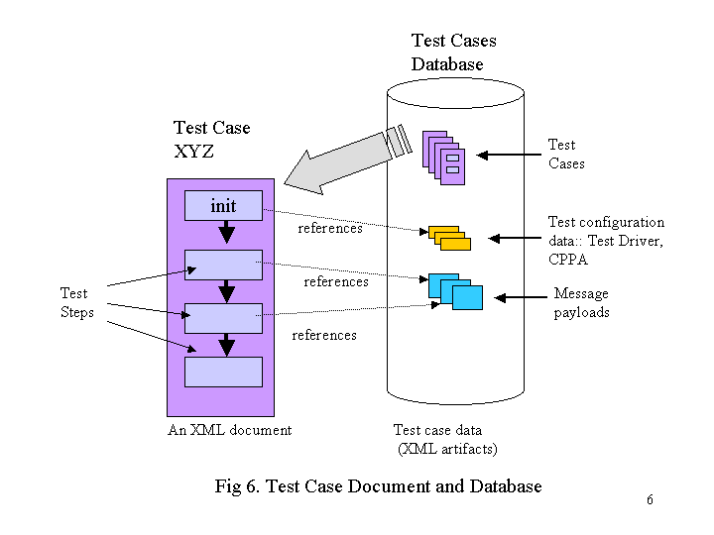

<JD2> I updated this figure.

Part II: Test Suite Representation

Test Suite

Conformance vs. Interoperability Test Suite

We distinguish two types of test suites, which share similar document schemas and architecture components, but serve different purposes:

- Conformance Test Suite. The objective is to verify the adherence or non-adherence of a candidate implementation to the target specification. The test harness and test cases will be typically designed around a single (candidate) implementation. The suite material emphasizes the target specification, by including a comprehensive set of Test Requirements, as well as a clear mapping of these to the original specification (e.g. in form of an annotated version of this specification).

- Interoperability Test Suite. The objective is to verify that two implementations (or more) of the same specification, or that an implementation and its operational environment, can interoperate according to an agreement or contract (which is compliant with the specification, but usually restricts further the requirements). These implementations are assumed to be conforming (i.e. have passed conformance tests), so the reference to the specification is not as important as in conformance. Such a test suite typically involves two or more implementations of the target specification. The test harness and test cases will be designed in order to drive and monitor these implementations.

A conformance test suite is composed of:

- One or more Test Profile documents (XML). Such documents represent the level or profile of conformance to the specification, as verified by this Test Suite.
- Design of a Test Harness for the target implementation, that is based on components of the ebXML Test Framework.
- A Test Requirements document. This document contains a list of conformance test assertions that are associated with the specification to be tested.
- An annotation of the target specification, that indicates the degree of coverage for each specification feature or section, that this set of Test Requirements provides.
- A Test Cases document. This document implements the Test Requirements, described using the Test Framework material (XML mark-up, etc.)

An Interoperability Test Suite is composed of:

- One or more Test Profile documents (XML). Such documents represent the level or profile of interoperability, as verified by this Test Suite.
- Design of a Test Harness for two or more interoperating implementations of the specification, that is based on components of the ebXML Test Framework.
- A Test Requirements document. This document contains a list of test assertions associated with this profile (or level) of interoperability.
- A Test Cases document. This document implements the Test Requirements, described using the Test Framework material (XML mark-up, etc.)

The Test Suite Document

The Test Suite XML document is a collection of configuration data, documentation and executable Test Cases.
- Configuration data provide basic Test Driver parameters used to modify the configuration of the Test Driver to accurately perform and evaluate test results. It also contains configuration data for the candidate ebXML implementation(s). Typically, such configuration data is provided as a subset of CPA document.
- Metadata provides author information, functional description and versioning and other general information about the Test Suite.
- Test Cases are a collection of discreet Test Steps. Each Test Step can execute any number of test Operations ( including sending, receiving, and examining returned messages ). An ebXML MS Test Suite document MUST validate against the ebXMLTestSuite.xsd file found in Appendix C.

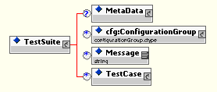
Figure 4 – Graphic representation of basic view of ebXMLTestSuite.xsd schema

Definition of Content

Name | Description
TestSuite | Container for all configuration, documentation and tests
Metadata | Container for general documentation of the entire Test Suite
cfg:ConfigurationGroup | Container for “bootstrap” configuration of the Test Driver
Message | Payload messages for inclusion in a Test Case
TestCase | Container for an individual Test Case

3.3.2 Test Suite Documentation

Documentation for the ebXML MS Test Suite is done through the Metadata element. It is a container element for general documentation.

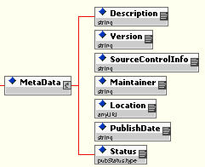
Figure 5 – Graphic representation of expanded view of the Metadata element

Definition of Content

Name | Description
Description | General description of the Test Suite
SourceControlInfo | Self descriptive
Maintainer | Name of person(s) maintaining the Test Suite
Location | URL or filename of this test suite
PublishDate | Date of publication
Status | Status of this test suite

The ConfigurationGroup

The ConfigurationGroup typically contains configuration data for:
- The candidate implementation. For example, a Message Service Handler. Such configuration information is provided in form of a set of CPA documents – or of partial CPA – associated with CPAId values that can be referred to in test cases material.
- the Test Driver. This includes necessary information it needs to modify its “base configuration” before executing a Test Case. Because the Test Driver is not a true MSH, ConfigurationItem names and values are defined for test execution purposes only, not to emulate the behavior of an MSH.

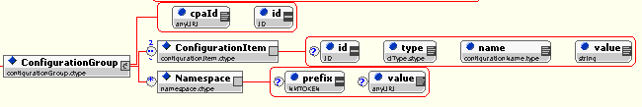
Figure 6 – Graphic representation of expanded view of the ConfigurationGroup element

Definition of Content

Name | Description
ConfigurationGroup | Container for any number of ConfigurationItems
cpaId | Unique identifier matching one of the testing CPA’s in this specification
id | Unique identifier for the ConfigurationGroup
ConfigurationItem | Individual name/value pair used by the Test Driver for configuration
id | Unique identifier for the ConfigurationItem
type | Short descriptor of the type of item
name | Short name for the ConfigurationItem
value | Value of the ConfigurationItem
Namespace | Container for namespace information for the ConfigurationGroup
prefix | Namespace prefix for all ConfigurationItems
value | Namespace value for all ConfigurationItems

Test Driver Configuration for ebXML MS Conformance Testing

Initial configuration of the Test Driver is done through a “base” Configuration Group of name/value pairs. By default, the Test Suite document MUST have a Configuration Group with an id of “base”, and containing one Configuration Item with a name of “cpa” and a value of “base” and a type of “constant”.

Multiple Configuration Declarations within the Test Suite

It is possible to dynamically modify the configuration of the Test Driver through the course of execution of the Test Suite. Configuration can be modified at the Test Suite, Test Case and Test Step levels through the introduction of a new Configuration Group or the addition/modification of an individual Configuration Item for the current Configuration Group.

Configuration Groups are hierarchically defined, with the “base” Configuration Group defined at the highest level in the testing tree. Modifications/additions at the Test Case or Test Level are possible through the introduction of Configuration Item(s). Wholesale replacement of the current Configuration Group is possible by the declaration of a new Configuration Group. The scope of the configuration change is hierarchical, and exists only for the definition of the current Test Suite, Case or Step. Upon completion, of that test component, configuration reverts to that previously defined at the higher level.

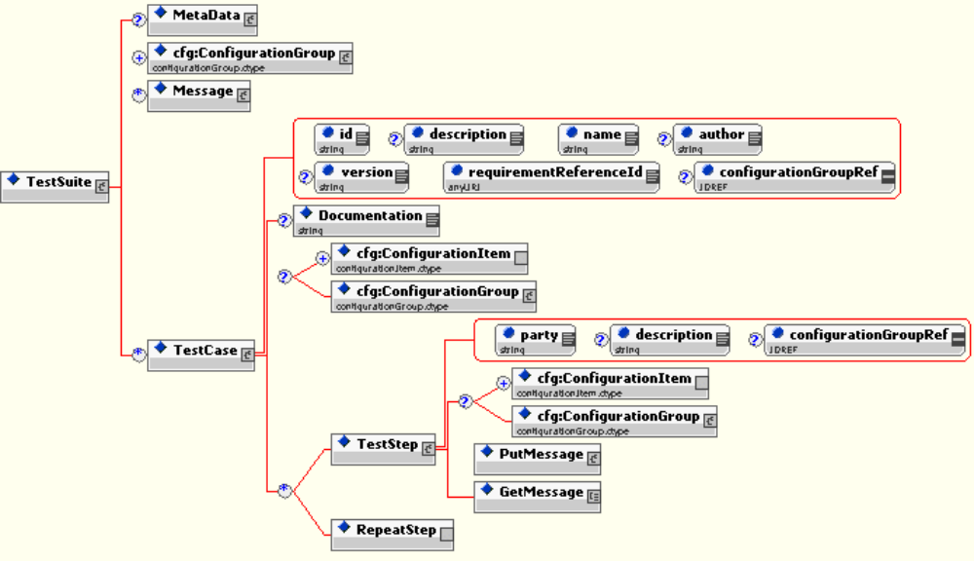
Figure 7 – Graphic representation of configuration at Test Suite, Test Case or Test Step level

Test Requirements

Purpose and Structure

The next step in designing a test suite, is to define Test Requirements. This material, when used in a conformance testing context, is also called Test Assertions in NIST and OASIS terminology (see definition in glossary in Appendix).
When used for conformance testing, each Test Requirement defines a test item to be performed, that covers a particular requirement of the target specification. It rewords the specification element in a “testable form”, closer to the final corresponding Test Case, but unlike the latter, independently from the test harness specifics. In the ebXML Test Framework, a Test Requirement will be made of three parts:

- Pre-condition. The pre-condition defines the context or situation under which this test item applies. It should help a reader understand in which case the corresponding specification requirement applies. In order to verify this Test Requirement, the test harness will attempt to create such a situation, or at the very least to identify when it occurs. If for some reason the pre-condition is not satisfied when doing testing, then it does not mean that the outcome of this test is negative – only that the situation in which it applies did not occur. In that case, the corresponding specification requirement could simply not be validated.

- Assertion. The assertion actually defines the specification requirement, as usually qualified by a MUST or SHALL keyword. In the test harness, the verification of an assertion will be attempted only if the pre-condition is itself satisfied. When doing testing, if the assertion cannot be verified while the pre-condition was, then the outcome of this test item is negative.

- Degree. Qualifies the degree of requirement in the specification, as indicated by such keywords as RECOMMENDED, SHOULD, MUST, MAY. Typically, we identify three degrees: (1) “required” (MUST, SHALL), (2) “recommended” ([HIGHLY ] RECOMMENDED, SHOULD), (3) “optional” (MAY, OPTIONAL). Any degree lower than “required” qualifies a Test Requirement that is not mandatory for Conformance testing. Yet, lower requirement degrees may be critical to interoperability tests.

The Test Requirements Document

The Test Requirements XML document provides metadata describing the Testing Requirements, their location in the specification, and their requirement type ( REQUIRED, HIGHLY RECOMMENDED, RECOMMENDED, or OPTIONAL ) . A Test Profile driver file MUST validate against the ebXMLTestRequirements.xsd file found in Appendix XX The ebXML MS Conformance Test Requirements file can be found in Appendix XX

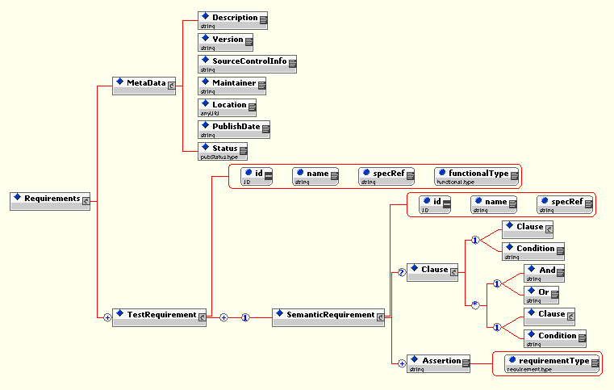
Figure 3 – Graphic representation of ebXMLTestRequirements.xsd schema

Definition of Content

Name | Description
Requirements | Container for all test requirements
MetaData | Container for requirements metadata, including Description, Version, Maintainer, Location, Publish Date and Status
Test Requirement | Container for all info for a single test requirement
description | Description of profile
id | Unique identifier for each Test Requirement
name | Name of test requirement
specRef | Pointer to location in specification where requirement is found
functionalType | Generic classification of function to be tested
SemanticRequirement | Sub-requirement for the main Test Requirement
id | Unique ID for the sub-requirement
name | Short descriptor of Semantic Requirement
specRef | Pointer to location in specification where sub-requirement is found
Clause | Grouping element for Condition expression(s)
Condition | Textual description of test precondition
And/Or | Union/Intersection operators
Assertion | Axiom expressing expected behavior of an MSH implementation under conditions specified by any Clause
requirementType | Enumerated Assertion descriptor ( REQUIRED, OPTIONAL…etc. )

Specification Coverage

A Test Requirement is a different way to express a requirement of the target specification. The reference to the specification is included in each Test Requirement, and is typically one or more section numbers. There is no one-to-one mapping between sections of a specification document and the Test Requirement items listed in the test material for this specification:

- A specification section may map to several Test Requirements.
- A Test Requirement item may also cover (partially or not) more than one section or sub-section.

A Test Requirement item may then cover a subset of the requirements that are specified in a section.
For these reasons, it is important to determine to which degree the requirements of each section of a specification, are fully satisfied by the set of Test Requirements listed in the test suite document. This is done by establishing the specification coverage by the Test Requirements.

The specification coverage is simply a list of all sections and subsections of a specification document, each annotated with:

- A coverage qualifier.
- A list of Test Requirements that map to this section.

The coverage qualifier may have values:

- Full: The requirements included in the specification document section are fully covered by the associated set of Test Requirements. This means that if each one of these Test Requirements is satisfied by an implementation, then the requirements of the corresponding document section are fulfilled. When the tests requirements are about conformance: The associated set of test requirement(s) are a clear indicator of conformance to the specification item, i.e. if a candidate implementation passes a test case that implements this test requirement(s) in a verifiable manner, there is a strong indication that it will behave similarly in all situations identified by the spec item.

- None: This section of the specification is not covered at all. Either there is no associated set of Test Requirements, or it is known that the test requirements cannot be tested even partially, at least with the Test Framework on which the test suite is to be implemented, and under the test conditions that are defined.

- Partial: The requirements included in this document section are only partially covered by the associated (set of) Test Requirement(s). This means that if each one of these Test Requirements is satisfied by an implementation, then it cannot be asserted that all the requirements of the corresponding document section are fulfilled: only a subset of all situations identified by the specification item are addressed. Reasons may be:

  - (1) the pre-condition(s) of the test requirement(s) ignores on purpose a subset of situations, that cannot be reasonably tested under the Test Framework.
  - (2) the occurrence of situations that match the pre-condition of a Test Requirementt is known to be under control of the implementation (e.g. implementation-dependent) or of external factors, and out of the control of the testbed. (see contingent run-time coverage definition, Section 7).
When the tests requirements are about conformance: The associated set of test requirement(s) are a weak indicator of conformance to the specification item. A negative test result will indicate non-conformance of the implementation.

Test Profiles

The Test Profile Document

The Test Profile document points to a subset of test requirements (in the Test Requirements document), that are relevant to the profile - either conformance, or interoperability profile - to be tested.
The document will drives the Test Harness by providing the Test Driver with a list of unique reference IDs of Test Requirements for a particular Test Profile. The Test Driver reads this document, and executes all Test Cases ( located in another document ) that contain a reference to each of the test requirements. A Test Profile driver file MUST validate against the ebXMLTestProfile.xsd file found in Appendix A. A list of Test Profile example files can be found in Appendix D.

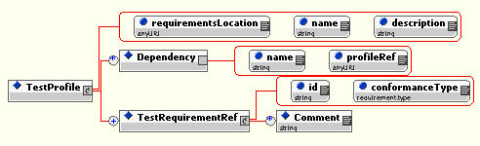
Figure 2 – Graphic representation of ebXMLTestProfile.xsd schema

Definition of Content

Name | Description
TestProfile | Container for all references to test requirements
requirementsLocation | Filename or URL of test requirements XML file
name | Name of profile
description | Description of profile
Dependency | Prerequisite profile reference container
name | Name of the required prerequisite profile
profileRef | Identifier of prerequisite profile to be loaded by Test Driver
TestRequirementRef | Test Requirement reference container
id | Identifier of Test Requirement
requirementType | Enumerated Requirement descriptor (REQUIRED, OPTIONAL…etc.)
Comment | Profile author’s comment for a particular requirement

Relationships between Profiles, Requirements and Test Cases

Creation of a testing profile requires selection of a group of Test Requirement references that fulfill a particular testing profile. For example, to create a testing profile for a Core Profile would require the creation of an XML document referencing Test Requirements 1,2,3,4,5 and 8.

The Test Driver would read this list, and select (from the Test Requirements Document) the corresponding Test Requirements (and their “sub” Semantic Requirements). The Test Driver then searches the Test Suite document to find all Test Cases that “point to” the selected Semantic Requirements. If more than one Test Case is necessary to satisfactorily test a single Semantic Requirement ( as is the case for Semantic Requirement #1)there may be more than one Test Case pointing to it. The Test Driver would then execute Test Cases #1, #2 and #3 in order to fully test an ebXML application against Semantic Requirement #1.

The only test material outside of the three documents below that MAY require an external file reference from within a Test Case are large, or non-XML message Payloads

Test Profile XML Document

TestRequirementRef #1 (Validation)
TestRequirementRef #2 (Packaging)
TestRequirementRef #3 (Core Extension Elements)
TestRequirementRef #4 (Error Handling)
TestRequirementRef #5 (SyncReply)
TesetRequirementRef #8 (Security)

Test Requirements XML Document

Test Requirement #1 (Validation)
Semantic Requirement #1 ( Valid MessageHeader content )
Semantic Requirement #2 ( Valid Acknowledgment content )
Semantic Requirement #3 ( Valid Signature content )

Test Requirement #2 (Packaging)
Semantic Requirement #4 ( SOAP message in root of MME doc )
Semantic Requirement #5 ( MIME message type is “text/xml” )
Semantic Requirement #6 ( MIME ‘start’ header is present )
…
Test Requirement #3 (Core Extension Elements)
…

RequirementRef #4 (Error Handling)
…

RequirementRef #5 (SyncReply)
…

RequirementRef #6 (Reliable Messaging)
RequirementRef #7 (Message Ordering)
RequirementRef #8 (Security)
…
RequirementRef #9 (Message Status)
RequirementRef #10 (Ping)
RequirementRef #11 (Multi-Hop)

Test Suite XML Document

Test Driver Configuration Data

XML Payloads

Test Cases
Test Case #1 (Test Valid “To content)
Test Case #2 (Test Valid “From content)
Test Case #3 (Teset Valid ‘MessageData” content)
…

Message Payloads

Test Cases

Structure of a Test Case

A Test Case is the translation of a Test Requirement, in an executable form, for a particular Test Harness. A test case includes the following information:

- Test Requirement reference.
- A Sequence of Test Steps.
- Condition(s) of success or of failure.

NOTE: The same Test Case may consolidate several Test Requirement items, i.e. a successful outcome of its execution will verify the associated set of Test Requirement items. This is usually the case when each of these Test Requirement items can make use of the same sequence of operations, varying only in the final test condition. When several Test Requirement items are covered by the same Test Case, the processing of the latter SHOULD produce separate verification reports (i.e. not all fail or not all pass).

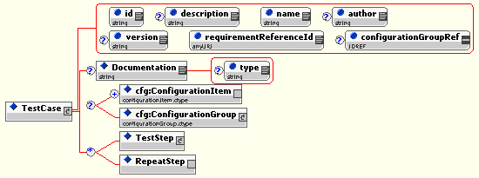
Figure 8 – Graphic representation of expanded view of the TestCase element

Definition of Content

Name | Description
id | Unique identifier for this test case
description | Short description of TestCase
name | Short name for Test Case
author | Name of person(s) creating the Test Case
version | Version number of Test Case
requirementReferenceId | Pointer to the unique ID of the Semantic Test Requirement ( in Appendix E )
configurationGroupRef | IDREF to reconfigure Test Driver using selected ConfigurationGroup
Documentation | Additional documentation text
type | Identifier of the type of documentation
ConfigurationItem | Discreet addition or change to current ConfigurationGroup
ConfigurationGroup | New definition of a ConfigurationGroup for this Test Case only
TestStep | Container for send, receive and message verification operations
RepeatStep | Container for pointer to previously executed Test Step

Test Steps

Test Steps are operations that MUST evaluate to a Boolean value of “true/false” or (semantically) a “pass/fail”. The aggregated result of all Test Steps in a Test Case MUST be ‘true’ for a Test Case result to be “pass”.

Prior to executing a Test Step, any configuration data necessary to modify the “default” configuration of the Test Driver MUST be included as ConfigurationItem or ConfigurationGroup content in the Test Step.

Test Step Operations

Within a Test Step, one of two main operations may be performed by the Test Driver. Message construction and transmission or message retrieval from the Message Store.

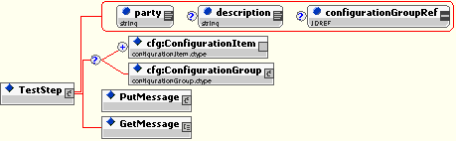
Figure 9 – Graphic representation of expanded view of the TestStep element

Definition of Content

Name | Description
party | Name of party that runs this Test Step (Test Driver or Candidate)
description | Short description of Test Step
configurationGroupRef | Reference to existing ConfigurationGroup to change current configuration
cfg:ConfigurationItem | Discreet change to current Test Driver configuration
cfg:ConfigurationGroup | Definition of new ConfigurationGroup for this Test Step
PutMessage | Construct and send an ebXML Message in its entirety (MIME,SOAP,ebXML)
GetMessage | Retrieve messages from Message Store in their entirety

The PutMessage Operation

The PutMessage Operation builds an ebXML message, along with its SOAP and MIME containers, using an XML syntax described in the ebXMLTestSuite.xsd schema in Appendix C. A minimal declaration is required to create a message, with “default” values for MIME headers and ebXML message content provided by the Test Driver. A message described in a PutMessage Operation MUST validate against the ebXMLTestSuite.xsd schema in Appendix C.

The message components that can be referenced and modified by PutMessage include:
<JD> Mike: can you tell if the 4 bullet points below are still valid? (I imported them from older MS conf suite doc)

[MIKE] – Yes, all below is still valid, with the exception of some wording modifications I include below.

- MIME header data: MIME headers MUST be created or modified using the declarative syntax described in the ebXMLTestSuite.xsd schema in Appendix XX. Default message MIME header data is illustrated in the message envelope template in section 7.1.6. How the MIME headers are actually constructed in the Test Driver component is implementation dependent. MIME message content MUST be created or modified using the declarative syntax described in the ebXMLTestSuite.xsd schema in Appendix C.

- SOAP header and body data: SOAP message content MUST be created or modified using the declarative syntax described in the ebXMLTestSuite.xsd schema described in Appendix C. Default message SOAP content is illustrated in the message envelope template in section 7.1.6. How the actual SOAP message is constructed in the Test Driver is implementation dependent.

- ebXML Message data: ebXML message content MUST be created or modified using the declarative syntax described in the ebXMLTestSuite.xsd schema described in Appendix C. Default message ebXML content is illustrated in the message envelope template in Appendix XX. How the actual ebXML message is constructed in the Test Driver is implementation dependent.

- ebXML payload data: ebXML message payload content – when there is a payload - MUST be created or modified using the syntax described in the ebXMLTestSuite.xsd schema described in Appendix C. ebXML payloads are created through file or XML template inclusion into a message, and MAY be modified through any implementation-specific XML syntax.

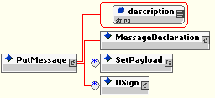
Figure 10 – Graphic representation of expanded view of the PutMessage element

Definition of Content

Name | Description
description | Metadata describing the nature of the PutMessage operation
MessageDeclaration | XML content to construct the message
SetPayload | Container element for metadata for appending a payload to message
DSign | Container element for pointer to message content to be digitally signed

<JD> It could be that the PutMessage op also logs sent messages in the message store. That will serve a purpose : e.g. be able to resend, or for GetMessage to know where to stop when doing a look-up of the m-store for received messages… opinion?

[MIKE] – I think that this should be implementation specific in my opinion. We should not dictate that sent messages be part of the message store, and putting them there just to provide a delimiter for the knowing when to stop a lookup also is an implementation feature that I believe this specification should not dictate. I believe that unless a particular implementation feature is specifically needed to run a test using our declarative syntax, we should not specify the underlying methodology of how it is implemented.
<JD2> agree the present material does not formally require such persistence.

The SetPayload Operation

The SetPayload Operation is a sub-operation for the PutMessage Operation. It provides the Test Driver with the necessary information to append a message payload. Payloads can be provided to the driver through a file name reference, an in-memory message document reference, or can be constructed “on-the-fly” through any declarative syntax specific to an ebXML application.

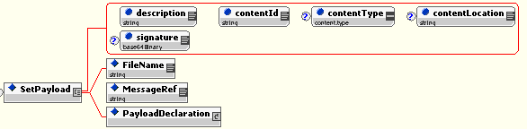
Figure 11 – Graphic representation of expanded view of the SetPayload element

Definition of Content

Name | Description
description | Metadata describing the nature of the SetPayload operation
contentId | Set the Content-Id MIME header of the payload
contentType | Set the the Content-Type MIME header of the payload
contentLocation | Set the the Content-Location MIME header of the payload
signature | sha-1 signature computed for payload for use in PayloadVerify Action
FileName | Name of the file to be loaded as a payload
MessageRef | Unique ID of the in memory XML document to be loaded as the payload
PayloadDeclaration | “Wildcard” XML declaration content for payload message construction ( implementation specific )

The Dsign Operation

The DSign Operation instructs the Test Driver to digitally sign the portion of the message defined in its child Reference element content. Configuration information for digitally signing a message is contained in the CPPA referenced in the current ConfigurationGroup as well as in ConfigurationItems in that ConfigurationGroup.


Figure 11 – Graphic representation of expanded view of the DSign element

Definition of Content

Name | Description
DSign | Container for content pointing to location(s) in message to sign
Reference | Element containing actual URI

The Message Declaration

The Declaration element is a container element for XML content describing the construction of MIME, SOAP and ebXML portions of a message. The XML content necessary to describe a basic message is minimal, with “default” parameter values supplied by the Test Driver for most message content. If the test developer wishes to “override” the default element and attribute values defined in the ebXMLTestSuite.xsd schema in Appendix C, they may do so by explicitly declaring those values in the XML markup.

For illustrative purposes, a “default” message can be represented by the message envelope template The Test Driver, after parsing the a simple Message Declaration, would generate the following MIME message with enclosed SOAP/ebXML content.
<JD2> I believe this notion of message envelope template is now obsolete. Is the MessageDeclaration below OK?

[MIKE2] – I agree that the word “template” causes confusion. It’s not a “Declaration” either, since our actual Declaration is the XML syntax used to create this “thing”. Perhaps we should change the wording above to:

The message below will be created by the Test Driver after parsing a simple Message Declaration:

Content-Type: multipart/related; type="text/xml"; boundary="boundaryText";
start=messagepackage@oasis.org

--boundaryText

Content-ID: <messagepackage@oasis.org>
Content-Type: text/xml; charset="UTF-8"

<SOAP:Envelope xmlns:xlink="http://www.w3.org/1999/xlink"
xmlns:xsi="http://www.w3.org/2001/XMLSchema-instance"
xmlns:SOAP="http://schemas.xmlsoap.org/soap/envelope/"
xmlns:eb="http://www.oasis-open.org/committees/ebxml-msg/schema/msg-header-2_0.xsd" xsi:schemaLocation="http://schemas.xmlsoap.org/soap/envelope/
http://www.oasis-open.org/committees/ebxml-msg/schema/envelope.xsd
http://www.oasis-open.org/committees/ebxml-msg/schema/msg-header-2_0.xsd http://www.oasis-open.org/committees/ebxml-msg/schema/msg-header-2_0.xsd">
<SOAP:Header>
<eb:MessageHeader SOAP:mustUnderstand="1" eb:version="2.0">
<eb:From>
<eb:PartyId>urn:oasis:iic:testdriver</eb:PartyId>
</eb:From>
<eb:To>
<eb:PartyId>urn:oasis:iic:testservice</eb:PartyId>
</eb:To>
<eb:CPAId>base_cpa</eb:CPAId>
<eb:ConversationId>$ConversationId</eb:ConversationId> <!—Test Driver supplies value at run time →
<eb:Service>urn:ebXML:iic:test</eb:Service>
<eb:Action>Dummy</eb:Action>
<eb:MessageData>
<eb:MessageId>$MessageId</eb:MessageId> <!—Test Driver supplies value at run time →
<eb:Timestamp>$Timetamp</eb:Timestamp> <!—Test Driver supplies value at run time →
</eb:MessageData>
</eb:MessageHeader>
</SOAP:Header>
</SOAP:Envelope>

--boundaryText

A Test Driver would “create” the above message by parsing and interpreting the minimal MessageDeclaration content below:
<JD2> just a check: is this in line with the current material? I notice references to conformance test in the elements below – should be only examples.

[MIKE2] – It is inline, but perhaps the word “conformance” should be taken out of all namespaces in all schemas. I think that it would be good to keep the namespaces identical to the actual namespaces used in our schemas

<ebTest:MessageDeclaration xmlns:ebTest="http://www.oasis-open.org/tc/ebxml-iic/conformance/tests">
<MIME:Message xmlns:MIME="http://www.oasis-open.org/tc/ebxml-iic/conformance/tests/MIME">
<MIME:MessageContainer>
<SOAP:Envelope xmlns:SOAP="http://www.oasis-open.org/tc/ebxml-iic/conformance/tests/SOAP">
<SOAP:Header>
<eb:MessageHeader xmlns:eb=http://www.oasis-open.org/tc/ebxml-iic/conformance/tests/eb>
<eb:Action="Dummy"/>
<eb:CPAId>cpa_basic</eb:CPAId>
</eb:MessageHeader>
</SOAP:Header>
</SOAP:Envelope>
</MIME:MessageContainer>
</MIME:Message>
</ebTest:MessageDeclaration>

To achieve the simplicity of a simple declarative syntax to describe message construction, “default” values for MIME headers are integrated into the ebXMLTestSuite.xsd schema in Appendix C. This allows default creation of MIME, SOAP and ebXML portions of the message through a validating parse of the MessageDeclaration XML content, with substitution of default values where they are not explicitly defined in the declaration. The following sections description of how to interpret the MessageDeclaration XML content MUST be implemented by a Test Driver in order for it to be conformant to this specification.

Interpreting the MIME portion of the Message Declaration

The XML syntax used by the Test Driver to construct the MIME message content consists of the declaration of a main MIME container for the entire message, followed by a MIME container for the SOAP message envelope. Default values for MIME headers MAY be “overridden” by explicit declaration of their values in the MessageDeclaration content, otherwise, default values defined in the ebXMLTestSuite.xsd schema are used by the Test Driver to construct the MIME headers.

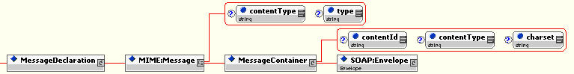
Figure 12 – Graphic representation of expanded view of the MessageDeclaration element

Definition of Content

Name | Declaration Description | Default Value | Default Value From
MIME:Message | Generate container for MIME, SOAP and ebXML message content
contentType | Generate MIME message ‘Content-Type’ header | multipart/related | Schema
type | Generate MIME message ‘type’ header | text/xml | Schema
MessageContainer | Generate MIME container in message
contentId | MIME Generate container ‘Content-ID’ header | messagepackage@oasis.org | Schema
contentType | Generate MIME message package ‘Content-Type’ header | Text/xml | Schema
charset | Generate MIME message package character set | UTF-8 | Schema
SOAP:Envelope | Generates container for SOAP message

An Example of Minimal MIME Declaration Content

The following XML represents all the information necessary to permit a Test Driver to construct a MIME message containing a SOAP envelope in its first MIME container. All MIME headers and their values would be generated by a validating parse of the document using the ebXMLTestSuite.xsd schema in Appendix C.

<MIME:Message xmlns:MIME="http://www.oasis-open.org/tc/ebxml-iic/conformance/tests/MIME">
<MIME:MessageContainer>
</MIME:MessageContainer>
</MIME:Message>

Interpreting the SOAP portion of the Message Declaration

The XML syntax used by the Test Driver to construct the SOAP message content consists of the declaration of a SOAP Envelope element, which in turn is a container for the SOAP Header, Body and non-SOAP XML content. Construction of the SOAP Header and Body content is simple for the Test Driver, requiring only the creating of the two container elements with their namespace properly defined, and valid according to the [SOAP] schema. The SOAP Body element, or any “wildcard” XML content is only constructed by the Test Driver if it is explicitly declared in the MessageDeclaration content.

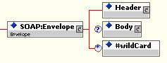
Figure 13 – Graphic representation of expanded view of the SOAP:Envelope element declaration

Definition of Content

Name | Declaration Description | Default Value | Default Value From
SOAP:Envelope | Generate container for SOAP Header and Body elements and their content
SOAP:Header | Generate container for ebXML Header extension elements and their content
SOAP:Body | Generate container for ebXML Body extension elements and their content
#wildCard | Generate “inline” wildcard content inside SOAP Envelope

An Example of Minimal SOAP Declaration Content

The following XML represents all the information necessary to permit a Test Driver to construct a SOAP message. . All required content not visible in the example would be generated by a validating parse of the document using the ebXMLTestSuite.xsd schema in Appendix C.

<SOAP:Envelope xmlns:SOAP=http://www.oasis-open.org/tc/ebxml-iic/conformance/tests/SOAP">
<SOAP:Header/>
</SOAP:Envelope>

Interpreting the SOAP Header Extension Element Declaration

The XML syntax used by the Test Driver to construct the ebXML Header extension message content consists of the declaration of a SOAP Header element, which in turn is a container for the ebXML Header extension elements and their content. The only element that is required in the container is the eb:MessageHeader element, which directs the Test Driver to construct an ebXML MessageHeader element, along with proper namespace declaration. The Test Driver does not construct any other Header extension elements unless they are explicitly declared as content in the SOAP Header Declaration.

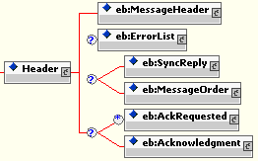
Figure 14 – Graphic representation of expanded view of the SOAP:Header element declaration

Definition of Content

Name | Declaration Description | Default Value | Default Value From
Header | SOAP Header declaration and container for ebXML ebXML Header Extension Element declarations

Interpreting the ebXML MessageHeader Element Declaration

The XML syntax used by the Test Driver to construct the ebXML MessageHeader extension content consists of the declaration of a MessageHeader element, and a required declaration of CPAId and Action elements within it. This is the ”minimum” declaration a test writer can create. All other required content, as defined in the schema in the ebXML MS v2.0 Specification, is provided through either default parameters defined in the ebXMLTestSuite.xsd schema in Appendix C, by the Test Driver (e.g. to supply required container elements ) or by explicit declaration of content in the declaration.

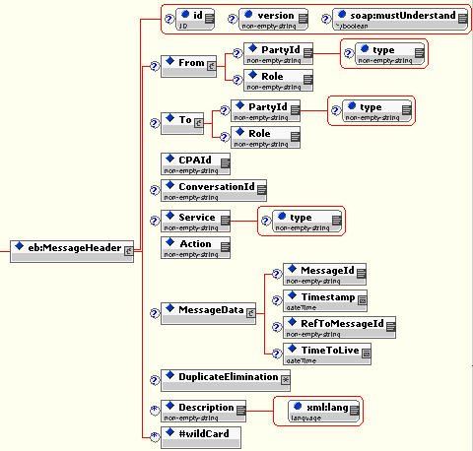
Figure 15 – Graphic representation of expanded view of the ebXML MessageHeader element declaration

<JD2> I am a little uneasy having this material (message header) being “normative”, as the TestFramework may be more general. Do we really need this schema above? It could change with future versions of MS. Could we consider message header data as part of the “configuration” of the framework, e.g. , the “interpretation of message headers could be driven by some Xpath expr that would know where to find values in a header, as well as how to build a header.

[MIKE2] – The above schema represents the required and optional elements and attributes that someone would use to construct any kind of ebXML MessageHeader.
I proposed this option because one can create a MessageHeader easily, with minimal XML. And it would not require the use of any cumbersome “template technology”, only an XML parser.
Regardless of how you do it, you are going to be dealing with some “normative” MessageHeader that needs to be modified in some declarative fashion. If the MS spec changes, then the normative part of this spec would have to be modified, in my opinion.
This schema is integral information for a test writer to write a MessageHeader. If we move it to “configuration” data, it still needs to be normatively defined so that someone can write a test, so I am not sure what would be gained by moving it there. Comments?

Definition of Content

Name | Declaration Description | Default Value | Default Value From
eb:MessageHeader | Generate container and all “default” content
id | Generate attribute and value | none
version | Modify default attribute value | 2.0 | Schema
soap:mustUnderstand | Modify default attribute value | true | Schema
From | Replace default container |  | Test Driver
PartyId | Generate element with its value | urn:ebXML:IIC:TestDriver | Schema
type | Generate type attribute with value | none
Role | Generates a Role element with its value | none
To | Replace default container |  | Test Driver
PartyId | Generate element with its value | urn:ebXML:IIC:TestService | Schema
type | Generate type attribute with value | none
Role | Generates a Role element with its value | none
CPAId | Modify default value | cpa_basic | Schema
ConversationId | Modify default value | Defined at run time | Test Driver
Service | Modify default value | urn:ebXML:iic:test | Schema
Action | Generate required element with value | none
MessageData | Modify default container
MessageId | Modify default value | Defined at run time | Test Driver
Timestamp | Modify default value | Defined at run time | Test Driver
RefToMessageId | Generate element with value | Defined at run time | Test Driver
TimeToLive | Generate element with value | none
DuplicateElimination | Generate element with value | none
Description | Generate element with value | none
#wildcard | Generate content inline | none

An Example of a Minimal ebXML MessageHeader Content Declaration

The following XML represents all the information necessary to permit a Test Driver to construct an ebXML MessageHeader element with all necessary content to validate against the ebXML MS v2.0 schema. All required content not visible in the example would be generated by a validating parse of the document using the ebXMLTestSuite.xsd schema in Appendix C or would be generated by the Test Driver itself.

<eb:MessageHeader>
<eb:Action="Dummy"/>
<eb:CPAId>cpa_basic</eb:CPAId>
</eb:MessageHeader>

Interpreting the ebXML ErrorList Element Declaration

The XML syntax used by the Test Driver to construct the ebXML ErrorList extension content consists of the declaration of an ErrorList element, and a required declaration of one or more Error elements within it. All required content, as defined in the schema in the ebXML MS v2.0 Specification, is provided through either default parameters defined in the ebXMLTestSuite.xsd schema in Appendix C, or by explicit declaration .

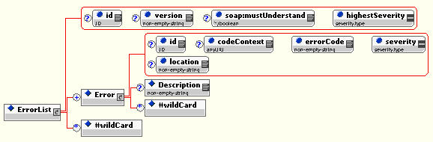
Figure 16 – Graphic representation of expanded view of the ebXML ErrorList element declaration

Definition of Content

Name | Declaration Description | Default Value | Default Value From
eb:ErrorList | Generate container element and all default content
id | Generate attribute and its value | none
version | Modify default value | 2.0 | Schema
soap:mustUnderstand | Modify default value | true | Schema
highestSeverity | Generate required attribute and value | none
Error | Generate required container
id | Generate attribute and value | none
codeContext | Generate element and value | none
errorCode | Generate required attribute and value | none
severity | Generate required attribute and value | none
location | Generate attribute and value | none
Description | Generate element and value | none
#wildCard | Generate content “inline” | none

An Example of a Minimal ebXML ErrorList Content Declaration

The following XML represents all the information necessary to permit a Test Driver to construct an ebXML ErrorList element with all necessary content to validate against the ebXML MS v2.0 schema. All required content not visible in the example would be generated by a validating parse of the document using the ebXMLTestSuite.xsd schema in Appendix C or would be generated by the Test Driver itself.

<eb:ErrorList eb:highestSeverity=Error">
<eb:Error eb:errorCode=”Inconsistent” eb:severity=”Error”/>
</eb:ErrorList>

Interpreting the ebXML SyncReply Element Declaration

The XML syntax used by the Test Driver to construct the ebXML SyncReply extension content consists of the declaration of an SyncReply element. All required content, as defined in the schema in the ebXML MS v2.0 Specification, is provided through either default parameters defined in the ebXMLTestSuite.xsd schema in Appendix C, or by explicit declaration.

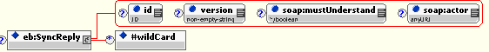
Figure 17 – Graphic representation of expanded view of the ebXML SyncReply element declaration

Definition of Content

Name | Declaration Description | Default Value | Default Value From
eb:SyncReply | Generate container element and all default content
id | Generate attribute and its value | none
version | Modify default value | 2.0 | Schema
soap:mustUnderstand | Modify default value | true | Schema
soap:actor | Modify attribute value | http://schemas.xmlsoap.org/soap/actor/next | Schema
#wildCard | Generate content “inline” | none

An Example of a Minimal ebXML SyncReply Content Declaration

The following XML represents all the information necessary to permit a Test Driver to construct an ebXML AckRequested element with all necessary content to validate against the ebXML MS v2.0 schema. All required content not visible in the example would be generated by a validating parse of the document using the ebXMLTestSuite.xsd schema in Appendix C or would be generated by the Test Driver itself.

<eb:SyncReply/>

Interpreting the ebXML AckRequested Element Declaration

The XML syntax used by the Test Driver to construct the ebXML AckRequested extension content consists of the declaration of an AckRequested element. All required content, as defined in the schema in the ebXML MS v2.0 Specification, is provided through either default parameters defined in the ebXMLTestSuite.xsd schema in Appendix C, or by explicit declaration.

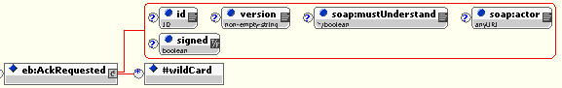
Figure 18 – Graphic representation of expanded view of the ebXML AckRequested element declaration

Definition of Content

Name | Declaration Description | Default Value | Default Value From
eb:AckRequested | Generate container element and all default content
id | Generate attribute and its value | none
version | Modify default value | 2.0 | Schema
soap:mustUnderstand | Modify default value | true | Schema
soap:actor | Generate attribute and value | none
signed | Modify attribute and value | false | Schema
#wildCard | Generate content “inline” | none

An Example of a Minimal ebXML AckRequested Content Declaration

The following XML represents all the information necessary to permit a Test Driver to construct an ebXML AckRequested element with all necessary content to validate against the ebXML MS v2.0 schema. All required content not visible in the example would be generated by a validating parse of the document using the ebXMLTestSuite.xsd schema in Appendix C or would be generated by the Test Driver itself.

<eb:AckRequested/>

Interpreting the ebXML Acknowledgment Element Declaration

The XML syntax used by the Test Driver to construct the ebXML Acknowledgment extension content consists of the declaration of an Acknowledgment element. All required content, as defined in the schema in the ebXML MS v2.0 Specification, is provided through either default parameters defined in the ebXMLTestSuite.xsd schema in Appendix C, or by explicit declaration.

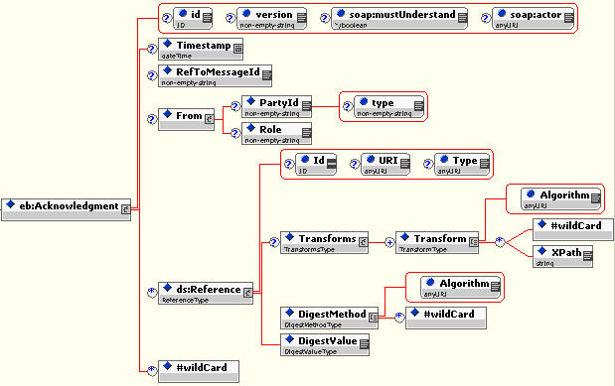
Figure 19 – Graphic representation of expanded view of the ebXML Acknowledgment element declaration

Definition of Content

Name | Declaration Description | Default Value | Default Value From
eb:Acknowledgment | Generate container element and all default content
id | Generate attribute and its value | none
version | Modify default value | 2.0 | Schema
soap:mustUnderstand | Modify default value | true | Schema
soap:actor | Generate attribute and value | none
Timestamp | Modify default value | Defined at run time | Test Driver
RefToMessageId | Modify default value | Defined at run time | Test Driver
From | Replace default container |  | Test Driver
PartyId | Generate element with its value | urn:ebXML:IIC:TestDriver | Schema
type | Generate type attribute with value | none
Role | Generates a Role element with its value | none
ds:Reference | Generate container element and all default content
Id | Generate attribute and its value | none
URI | Generate attribute and its value | none
type | Generate attribute and its value | none
Transforms | Generate container relement
Transform | Generate element with its value | none
Algorithm | Generate attribute with its value | none
#wildCard | Generate content “inline” | none
XPath | Generate element with its value | none
DigestMethod | Generate element with its value | none
Algorithm | Generate attribute with its value | none
#wildCard | Generate content “inline” | none
DigestValue | Generate element with its value | none
#wildCard | Generate content “inline” | none

An Example of a Minimal ebXML Acknowledgment Content Declaration

The following XML represents all the information necessary to permit a Test Driver to construct an ebXML Acknowledgment element with all necessary content to validate against the ebXML MS v2.0 schema. All required content not visible in the example would be generated by a validating parse of the document using the ebXMLTestSuite.xsd schema in Appendix C or would be generated by the Test Driver itself.

<eb:Acknowledgment/>

Interpreting the ebXML MessageOrder Element Declaration

The XML syntax used by the Test Driver to construct the ebXML MessageOrder extension content consists of the declaration of an MessageOrder element. All required content, as defined in the schema in the ebXML MS v2.0 Specification, is provided through either default parameters defined in the ebXMLTestSuite.xsd schema in Appendix C, or by explicit declaration.

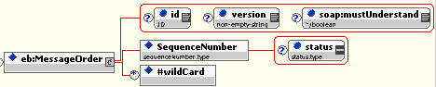
Figure 20 – Graphic representation of expanded view of the ebXML MessageOrder element declaration

Definition of Content

Name | Declaration Description | Default Value | Default Value From
eb:MessageOrder | Generate container element and all default content
id | Generate attribute and its value | none
version | Modify default value | 2.0 | Schema
soap:mustUnderstand | Modify default value | true | Schema
SequenceNumber | Generate element and value | none
status | Generate attribute and value | none
#wildCard | Generate content “inline” | none

An Example of a Minimal ebXML MessageOrder Content Declaration

The following XML represents all the information necessary to permit a Test Driver to construct an ebXML MessageOrder element with all necessary content to validate against the ebXML MS v2.0 schema. All required content not visible in the example would be generated by a validating parse of the document using the ebXMLTestSuite.xsd schema in Appendix C or would be generated by the Test Driver itself.

<eb:MessageOrder>
<eb:SequenceNumber>1</eb:SequenceNumber>
</eb:MessageOrder>

Interpreting the SOAP Body Extension Element Declaration

The XML syntax used by the Test Driver to construct the ebXML Body extension message content consists of the declaration of a SOAP Body element, which in turn is a container for the ebXML Manifest, StatusRequest and StatusResponse elements.
The Test Driver does not construct any of these SOAP Body extension elements unless they are explicitly declared as content in the SOAP Body Declaration.

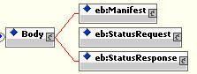
Figure 21 – Graphic representation of expanded view of the SOAP:Body element declaration

Interpreting the ebXML Manifest Element Declaration

The XML syntax used by the Test Driver to construct the ebXML Manifest extension content consists of the declaration of an Manifest element. All required content, as defined in the schema in the ebXML MS v2.0 Specification, is provided through either default parameters defined in the ebXMLTestSuite.xsd schema in Appendix C, or by explicit declaration.

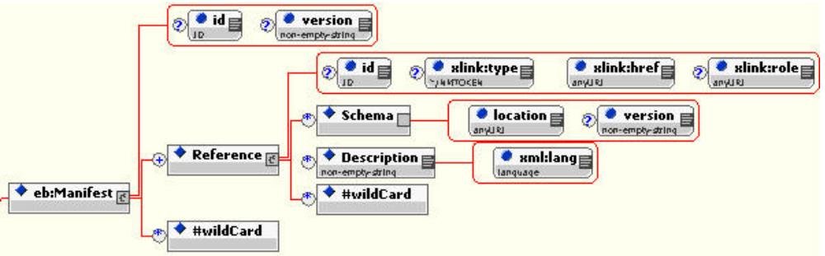
Figure 22 – Graphic representation of expanded view of the ebXML Manifest element declaration

Definition of Content

Name | Declaration Description | Default Value | Default Value From
eb:Manifest | Generate container element and all default content
id | Generate attribute and its value | none
version | Modify default value | 2.0 | Schema
id | Modify default value | true | Schema
xlink:type | Generate element and value | none
xlink:href | Generate attribute and value | none
Xlink:role | Generate attribute and value | none
Schema | Generate container element | none
location | Generate attribute and value | none
version | Generate attribute and value | none
Description | Generate element and value | none
xml:lang | Generate attribute and value | none
#wildCard | Generate content “inline” | none

An Example of a Minimal ebXML Manifest Content Declaration

The following XML represents all the information necessary to permit a Test Driver to construct an ebXML Manifest element with all necessary content to validate against the ebXML MS v2.0 schema. All required content not visible in the example would be generated by a validating parse of the document using the ebXMLTestSuite.xsd schema in Appendix C or would be generated by the Test Driver itself.

<eb:Manifest>
<eb:Reference xlink:href=”cid:mpld_1”/>
</eb:Manifest>

Interpreting the ebXML StatusRequest Element Declaration

The XML syntax used by the Test Driver to construct the ebXML StatusRequest extension content consists of the declaration of an StatusRequest element. All required content, as defined in the schema in the ebXML MS v2.0 Specification, is provided through either default parameters defined in the ebXMLTestSuite.xsd schema in Appendix C, or by explicit declaration.

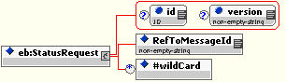
Figure 23 – Graphic representation of expanded view of the ebXML StatusRequest element declaration

Definition of Content

Name | Declaration Description | Default Value | Default Value From
eb:StatusRequest | Generate container element and all default content
id | Generate attribute and its value | none
version | Modify default value | 2.0 | Schema
RefToMessageId | Modify default value | Defined at run time | Test Driver
#wildCard | Generate content “inline” | none

An Example of a Minimal ebXML StatusRequest Content Declaration

The following XML represents all the information necessary to permit a Test Driver to construct an ebXML StatusRequest element with all necessary content to validate against the ebXML MS v2.0 schema. All required content not visible in the example would be generated by a validating parse of the document using the ebXMLTestSuite.xsd schema in Appendix C or would be generated by the Test Driver itself.

<eb:StatusRequest/>

Interpreting the ebXML StatusRequest Element Declaration

The XML syntax used by the Test Driver to construct the ebXML StatusResponse extension content consists of the declaration of an StatusResponse element. All required content, as defined in the schema in the ebXML MS v2.0 Specification, is provided through either default parameters defined in the ebXMLTestSuite.xsd schema in Appendix C, or by explicit declaration.

Figure 24 – Graphic representation of expanded view of the ebXML StatusResponse element declaration

Definition of Content

Name | Declaration Description | Default Value | Default Value From
eb:StatusResponse | Generate container element and all default content
id | Generate attribute and its value | none
version | Modify default value | 2.0 | Schema
messageStatus | Generate attribute and its value | none
RefToMessageId | Modify default value | Defined at run time | Test Driver
Timestamp | Modify default value | Defined at run time | Test Driver
#wildCard | Generate content “inline” | none

An Example of a Minimal ebXML StatusResponse Content Declaration

The following XML represents all the information necessary to permit a Test Driver to construct an ebXML StatusResponse element with all necessary content to validate against the ebXML MS v2.0 schema. All required content not visible in the example would be generated by a validating parse of the document using the ebXMLTestSuite.xsd schema in Appendix C or would be generated by the Test Driver itself.

<eb:StatusResponse messageStatus=”Processed”/>

The GetMessage Operation

The GetMessage Operation retrieves a Node List from the Message Store of the Test Driver. The contents of the NodeList is dependent upon the filter provided in the GetMessage element’s text content. The NodeList MAY be queried for Precondition or Test Condition tests, and any Payload associated with a message MAY be queried through the GetPayload operation.

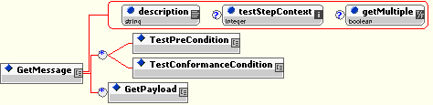
Figure 25 – Graphic representation of expanded view of the GetMessage element

Definition of Content

Name | Description
GetMessage | Text node containing XPath query for correlating messages in the Message Store. Also acts as a container for further operations.
description | Metadata describing the nature of the GetMessage operation
testStepContext | Keep the CPAId, MessageId and ConversationId from the specified step
getMultiple | By default, getMultiple is “false”, indicating that only one message should be present in the NodeList, even if multiple messages are in the Message Store
TestPreCondition | XPath query used to test message(s) in NodeList for a Precondition
TestConformanceCondition | XPath query used to test message(s) in NodeList for a Test Condition
GetPayload | Container for content describing retrieval and query of a payload for a particular message

<JD> we need to illustrate how we use GetPaylod to (1) select an expected response message using some filter, (2) select a set of messages (getMultiple). In particular, there are these two cases:
  - we expect to receive exactly 3 messages (of type XYZ) within 2 next minutes. In that case, the op will wait for selecting 3 good messages, or until timeout expires.

[MIKE] - (1) is a simple correlation of received messages, (2)… I would suggest waiting until timeout( not a failure.. just wait until max time an MSH has to respond, as defined by the CPA ) .. then count the correlated messages.. more/less than 3? .. Test fails.
<JD2> OK. BTW, I thought the timeout would be explicit in the test case definition, e.g. for a test step (we cannot always derive it from CPPA) but I do not see where in our schema we make room for it.

[MIKE2] – This can be added in our schema as a name/value pair in the <ConfigurationGroup><ConfigurationItem name=timeout value=2/></ConfigurationGroup>
I have not explicitly added it normatively, but I can see the advantage of being able to “override” CPPA defined values. Please let me know of other parameters that you think we should be able to override, and I will include them in the default <ConfigurationGroup id=”basic”>

  - We just want to count how many messages we got until timeout. So here reaching timeout is NOT a failure. But getting the wrong number of messages might be. (would the test be part of a ConformanceCondition?)

[MIKE] – Again, I think that having the Test Driver wait until the Timeout before evaluating content will satisfy this test case.
<JD2> But how do we tell when a timeout is a failure, vs. a normal termination of a test step?

[MIKE2] – In this case, “timeout “ is simply being used as a time delimiter for the TestDriver to gather up all received messages and correlate them. Timeout only has a meaning for test success/failure if… say…
0 messages are received before timeout is reached, when at least 1 message was expected.

<JD> Also, we need to explain more precisely how GetMessage is supposed to work on the m-store (see previous note on PutMessage). Note this is not implementation issue, but semantics issue (about the exact meaning of the op). Assuming the message store is simply a queue, that gets messages in order they are logged (and cleand-up at end of test case):
    - how the GetMessage works on the m-store in general (it looks up messages, but starting from which previous one in the m-store? In case the PutMessage op messages are also stored, could look up from the last posted message. In case there was another GetMessage op before, would search from the latest previously message selected by this op ?).

[MIKE] – Currently, received messages in the Message Store are retrieved based upon “context” ( context being CPAId, ConversationId and RefToMessageId ) I do not believe that “sent” messages MUST be stored in the MessageStore. <JD2> OK. This is an implementation issue. If someone wishes to “Repeat Step 3”, I do not feel that we should require them to store the message from Step 3. They may not wish to do that. Maybe they will just store the “context” from Step 3, and re-run the step. Comments?

    - Does GetMessage look up from the oldest message up or latest message down?.(I guess from oldest?)

[MIKE] – GetMessage doesn’t’ care about “oldest/youngest” message. It simply sees an XML tree of messages, hanging off of a <MessageStore> root element, and filters them according to the GetMessage XPath filter. We could require Test Drivers to select the “latest” message ( by Timestamp ) by default when “getMultiple” is set to “false”. Currently that is undefinedin the specification.

    - Even given this, we may consider the need to clean-up the m-store during the test case execution: some garbage messages may have been received for step N, that we don’t want to see for step N+1. Should we have a “clean-slate” option at beginning of some steps, such as PutMessage, that would erase prior m-store content?

[MIKE] – This sounds OK by me. This is clearly the place in the specification to describe all of the above items regarding GetMessage. I will update this portion of the spec.
<JD2> cleaning up the store between steps is just a way to make sure the next search (done by the “filter” of a GetMessage) will not look at the wrong message. More generally, when we execute GetMessage, we need to specify clearly what are the messages looked at in the store: we can’t say that GetMessage will “wait” for any incoming message and ignore past ones already in the store, as GetMessage execution may be delayed or too slow, and the incoming message being already in store. We can’t say that it will look at all messages in the store and select the right one, as we might select old, irrelevant messages.

[MIKE2] – I will describe the above here.

The TestPreCondition Operation

The TestPreCondition Operation examines a message or messages in a GetMessage NodeList by testing the content of the NodeList against the VerifyContent ( content value comparison) or ValidateContent ( content integrity evaluation ) operation.

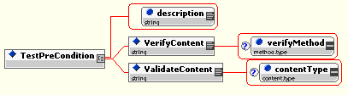
Figure 26 – Graphic representation of expanded view of the TestPreCondition element

Definition of Content

Name | Description
description | Metadata describing the nature of the TestPreCondition operation
VerifyContent | Use XPath expression to evaluate content of message(s)
verifyMethod | Either XPath or mda-5 ( for message or payload integrity test )
ValidateContent | Empty if type is XML or XPath expression to “point to” content to be validated for correct format if type is URI, Time or Signature
contentType | An enumerated list of XML, URI, time, or signature validation descriptors

<JD> ValidateCOntent is quite a good idea (can we give a more specific core list about some contetnType values? E.g. time (XML1.0, URI, XML-date format for time?) In case of XML, Could we add some secondary parameter, like a schema URL?

[MIKE] – Will be more explicit here regarding formats

The TestConformanceCondition Operation

The TestConformanceCondition Operation examines a message or messages in a NodeList by testing the content against an XPath expression in the TestPreCondition text. If the XPath expression returns a NodeList with one or more nodes, the ConformanceCondition is “true”, else it is “false”. Within a TestPreCondition Operation, content of the NodeList can be further examined through the VerifyContent ( content evaluation ) or ValidateContent ( content format evaluation ).

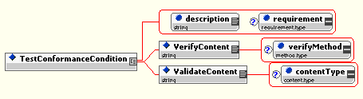
Figure 27 – Graphic representation of expanded view of the TestConformanceCondition element
<JD> does this handle conditions that require comparing to fields inside the message, regardless of their value? (That is necessary later for comparing elements in two different messages).

[MIKE] – If we want to compare the content of different returned messages, from different Test Steps ( say content from an Acknowledgment of a message sent in Step 1 with content from Acknowledgment to a message from Step 5 ), then we need to “label” ( in the Message Store ) each message in the Message Store with a corresponding StepId as part of its content.. so that our XPath expressions would be something like ( to compare the PartyIds of 2 different messages from 2 different Test Steps ):

/MessageStore/[MIME:Message[stepId=1]/MIME:Container[1]/SOAP:Envelope/SOAP:Header/eb:Acknowledgment/From/PartyId=MIME:Message[stepId=5]/MIME:Container[1]/SOAP:Envelope/SOAP:Header/eb:Acknowledgment/From/PartyId]

“Labeling” of incoming messages would be based upon their CPAId, ConversationId and RefToMessageId.. which should correspond to a message sent for a particular Test Step. That would be one way to solve the “comparison across test steps” problem. We can specify this in order to permit these kinds of comparisons across Test Steps ( i.e. different messages ).
<JD2> that looks powerful… that answers it. Would be good to say a few words on it and keep this as an example.

Definition of Content

Name | Description
description | Metadata describing the nature of the TestPreCondition operation
requirement | Metadata describing whether this Conformance Condition MUST or MAY exist ( for use in test reporting )
VerifyContent | Use XPath expression to evaluate content of message(s)
verifyMethod | Either XPath or mda-5 ( for message or payload integrity test )
ValidateContent | Empty if type is XML or XPath expression to “point to” content to be validated for correct format if type is URI, Time or Signature
contentType | An enumerated list of XML, URI, time, or signature validation descriptors

<JD> Overall: we should give a couple of well commented examples of test case (e.g. from MS conformance suite: one easy, one more difficult e.g. that involves counting the number of retries we capture.)

[MIKE] – I agree, that such Test Cases should be illustrated.. either in this document, or in the Conformance/Interop specs…. Or perhaps in this one?
<JD2> does not hurt to have a test case example here, as that helps test case developers who use the base framework as a reference.

Run-Time Coverage of Test Requirements

In a same way as Test Requirements may not be fully equivalent to the specification items they represent (see Specification Coverage, Section 5), the Test Cases that implement these Test Requirements may not fully verify these, for practical reasons.

Some Test Requirements may be difficult or impossible to verify in a satisfactory manner. The reason for this generally resides in an inability to satisfy the pre-condition. When processing a Test Case, the Test Harness will attempt to generate an operational context or situation that intends to satisfy the pre-condition, and that is supposed to be representative enough of real operational situations. The set of such real-world situations that is generally covered by the pre-condition of the Test Requirement is called the run-time coverage of this test Requirement. This happens in the following cases:

- Partial run-time coverage: It is in general impossible to generate all the situations that should verify a test. It is however expected that the small subset of run-time situations generated by the Test Harness, is representative enough of all real-world situations that are relevant to the pre-condition. However, it is in some cases obvious that the Test Case definition (and its processing) will not generate a representative-enough (set of) situation(s). It could be that a significant subset of situations identified by the pre-condition of a Test Requirement cannot be practically set-up and verified. For example, this is the case when some combinations of events or of configurations of the implementation will not be tested due to the impracticality to address the combinatorial nature of their aggregation. Or, some time-related situations cannot be tested under expected time constraints.

- Contingent run-time coverage: It may happen that the test harness has no complete control in producing the situation that satisfies the pre-condition of a Test Requirement. This is the case for Test Requirements that only concern optional features that an implementation may or may not decide to exhibit, depending on factors under its own control and that are not understood or not easy to control by the test developers. An example is: “ IF the implementation chooses to bundle together messages [e.g. under some stressed operation conditions left to the appreciation of this implementation] THEN the bundling must satisfy condition XYZ”.

When a set of Test Cases is written for a particular set of Test Requirements, the degree of coverage of these Test Requirements by these Test Cases SHOULD be assessed. The Test Requirements coverage – not to be confused with the Specification Coverage - is represented by a list of the Test Requirements Ids, which associates with each Test Requirement :

- The Test Case (or set of Test Cases) that cover it,
- The coverage qualifier, which indicates the degree to which the Test Requirement is covered.

The coverage qualifier may have values:

- Full: the Test Requirement item is fully verified by the set of Test Cases.
- Contingent: The run-time coverage is contingent (see definition).
- Partial: the Test Requirement item is only partially verified by the associated set of Test Cases. The run-time coverage is partial (see definition).
None: the Test Requirement item is not verified at all: there is no relevant Test Case.

Other Test Material

Test Material necessary to support the ebXML Testing Framework includes:

- Schemas necessary to construct Test Profile, Test Requirement and Test Suite XML documents
- CPPA documents necessary to describe the configuration of the Test Driver and Test Service components of the Test Framework.
- Schemas necessary to construct or validate XML message payload content
- Base, Reliable Messaging, Additional Features and MultiHop Conformance Test Profile XML Document
- Conformance Test Requirements
- Executable Test Suite

Schemas for Test Suite Material Construction

The OASIS ebXML Implementation and Interoperability Committee has provided a version of the ebXML Test Profile, Test Requirements and Test Suite schema that conforms to the W3C XML Schema Recommendation specification [XMLSchema]. Implementations of the ebXML Test Framework MUST use documents that validate against these three schemas. The normative versions of these schemas are located in Appendix A, B and C respectively.

Test Framework Collaboration Protocol Profile Agreements (CPPA)

Just as in a business transaction, a “testing transaction” between an ebXML Test Driver and Test Service requires a mutually agreed upon messaging configuration for the transmission of test messages. A set of CPPAs is required to establish the agreement between the two parties for particular conformance tests. Implementations of the ebXML Test Framework MUST configure their Test Driver and Test Service according to the semantics defined in the CPPAs listed below.

The normative “base” CPPA, located in Appendix D, validates against the ebXML CPPA schema [CPPA]. The ebXML Conformance Test Framework CPPA list includes:

CPAId | CPPA Description | Party Affected
cpa_basic | Minimal configuration for “bootstrap” configuration | All Test Driver and  Test Service Party Actions
cpa_no_errorURI | No ErrorURI defined | All Test Service Party Actions
cpa_sync_reply_mode_none | syncReplyMode = “none” | All Test Service Party Actions
cpa_no_dsig | No Signature configuration | All Test Service Party Actions
cpa_dup_elimination_true | DuplicateElimination = “true” | All Test Service Party Actions
cpa_dup_elimination_per_message | DuplicateElimination =“per message” | All Test Service Party Actions
cpa_dup_elimination_always | DuplicateElimination = “always” | All Test Service Party Actions
cpa_dup_elimination_never | DuplicateElimination = “never” | All Test Service Party Actions
cpa_persist_duration_0 | PersistDuration = 0 seconds | All Test Service Party Actions
cpa_message_order_guaranteed | MessageOrder = “Guaranteed” | All Test Service Party Actions

Both the Test Driver and the Test Service MUST resolve the above CPAId references in the Executable Test Suite to the semantically equivalent CPPA configuration described in the table above and in the CPPA instances described in Appendix D.

As the Conformance Test Suite continues to grow, new CPPAs will be required to properly execute those tests. Both the Test Driver and Test Service MUST resolve any new CPAIds to the same semantically equivalent CPPA configuration.

Schema for Test Message Payloads

Some Test Service Actions must receive or return messages containing specific XML message payloads that are verified by the Test Driver for determination of success or failure of a particular Test Step. Implementations of the ebXML Test Framework MUST use message payloads that validate against the ebXMLMessagePayload.xsd schema in Appendix E.

Conformance Test Profile Documents

The normative profile testing documents for conformance testing an MSH against specific profiles are represented as normative XML instance documents in Appendix F. Any ebXML Profile XML document MUST validate against the ebXMLTestProfile.xsd schema defined in Appendix F.

The profile instance documents in Appendix F include:

Document Name | Description
ebXMLMSv2.0CoreFeaturesProfile.xml | Selects “core” conformance testing requirements for ebXML  MS v2.0, including Packacing, ebXML SOAP Envelope Extensions, Error Handling, Security and SyncReply
ebXMLMSv2.0ReliableMessaging.xml | Core Features plus Reliable Messaging features
ebXMLMSv2.0MessageStatus_Order.xml | Core, Reliable Messaging plus Message Status, Message Order, Ping and Pong Actions
ebXMLMSv2.0MultiHop.xml | Core plus Multi-Hop features.

Appendices
Appendix A (Normative) The ebXML Test Profile Schema
The OASIS ebXML Implementation and Interoperability Committee has provided a version of the ebXML Test Profile schema using the schema vocabulary that conforms to the W3C XML Schema Recommendation specification [XMLSchema].
<?xml version = "1.0" encoding = "UTF-8"?>
<schema xmlns = "http://www.w3.org/2001/XMLSchema"
targetNamespace = "http://www.oasis-open.org/tc/ebxml-iic/test-profile"
xmlns:tns = "http://www.oasis-open.org/tc/ebxml-iic/test-profile"
>
<!-- $Id: TestProfile.xsd,v 1.2 2002/07/02 15:28:27 matt Exp $ -->

<element name = "TestProfile">
<complexType>
<sequence>
<element ref = "tns:Dependency" minOccurs = "0" maxOccurs = "unbounded"/>
<element ref = "tns:TestRequirementRef" maxOccurs = "unbounded"/>
</sequence>
<attribute name = "requirementsLocation" use = "required" type = "anyURI"/>
<attribute name = "name" use = "required" type = "string"/>
<attribute name = "description" use = "required" type = "string"/>
</complexType>
</element>
<element name = "Dependency">
<complexType>
<attribute name = "name" use = "required" type = "string"/>
<attribute name = "profileRef" use = "required" type = "anyURI"/>
</complexType>
</element>
<element name = "TestRequirementRef">
<!-- To overide the conformance type of the underlying requirement ... -->
<complexType>
<sequence>
<element name = "Comment" type = "string" minOccurs = "0" maxOccurs = "unbounded"/>
</sequence>
<attribute name = "id" use = "required" type = "string"/>
<attribute name = "conformanceType" use = "required" type = "tns:requirement.type"/>
</complexType>
</element>
<simpleType name = "requirement.type">
<restriction base = "string">
<enumeration value = "required"/>
<enumeration value = "strongly recommended"/>
<enumeration value = "recommended"/>
<enumeration value = "optional"/>
</restriction>
</simpleType>
</schema>

Appendix B (Normative) The ebXML Test Requirements Schema
The OASIS ebXML Implementation and Interoperability Committee has provided a version of the ebXML Test Requirements schema using the schema vocabulary that conforms to the W3C XML Schema Recommendation specification [XMLSchema].

<?xml version = "1.0" encoding = "UTF-8"?>
<!--Generated by XML Authority. Conforms to w3c http://www.w3.org/2001/XMLSchema-->
<schema xmlns = "http://www.w3.org/2001/XMLSchema"
targetNamespace = "http://www.oasis-open.org/tc/ebxml-iic/conformance/reqs"
xmlns:tns = "http://www.oasis-open.org/tc/ebxml-iic/conformance/reqs"
>
<group name = "SemanticRequirementGroup">
<sequence>
<element ref = "tns:SemanticRequirement"/>
</sequence>
</group>

<!--Generated by XML Authority. Conforms to w3c http://www.w3.org/2000/10/XMLSchema-->

<!-- OASIS/ebXML Test Suite Framework
Description: Schema used to define ebXML Test Requirements instance document

Author: Michael Kass
Organization: NIST

Author: Matthew MacKenzie
Organization: XML Global

Date: 03/31/2002
Version 1.0
-->

<!-- CHANGES:
Version 1.0 (Matt):
- added attributes requirementType and name to Level.
- added other to functional.type enumeration.
-->

<element name = "TestRequirement">
<complexType>
<sequence maxOccurs = "unbounded">
<group ref = "tns:SemanticRequirementGroup"/>
</sequence>
<attribute name = "id" use = "required" type = "ID"/>
<attribute name = "name" use = "required" type = "string"/>
<attribute name = "specRef" use = "required" type = "string"/>
<attribute name = "functionalType" use = "required" type = "tns:functional.type"/>
</complexType>
</element>
<element name = "SemanticRequirement">
<complexType>
<sequence>
<element ref = "tns:Clause" minOccurs = "0"/>
<element ref = "tns:Assertion" maxOccurs = "unbounded"/>
</sequence>
<attribute name = "id" use = "required" type = "ID"/>
<attribute name = "name" use = "required" type = "string"/>
<attribute name = "specRef" use = "required" type = "string"/>
</complexType>
</element>
<element name = "Clause">
<complexType>
<sequence>
<choice>
<element ref = "tns:Clause"/>
<element ref = "tns:Condition"/>
</choice>
<sequence minOccurs = "0" maxOccurs = "unbounded">
<choice>
<element ref = "tns:And"/>
<element ref = "tns:Or"/>
</choice>
<choice>
<element ref = "tns:Clause"/>
<element ref = "tns:Condition"/>
</choice>
</sequence>
</sequence>
</complexType>
</element>
<element name = "CONNECTIVEPREDICATE" type = "string"/>
<element name = "Condition" type = "string"/>
<element name = "ConditionRef">
<complexType>
<attribute name = "id" use = "required" type = "IDREF"/>
</complexType>
</element>
<element name = "And" type = "string"/>
<element name = "Or" type = "string"/>
<element name = "Assertion">
<complexType>
<simpleContent>
<extension base = "string">
<attribute name = "requirementType" use = "required" type = "tns:requirement.type"/>
</extension>
</simpleContent>
</complexType>
</element>
<element name = "MetaData">
<complexType>
<sequence>
<element ref = "tns:Description"/>
<element ref = "tns:Version"/>
<element ref = "tns:SourceControlInfo"/>
<element ref = "tns:Maintainer"/>
<element ref = "tns:Location"/>
<element ref = "tns:PublishDate"/>
<element ref = "tns:Status"/>
</sequence>
</complexType>
</element>
<element name = "Description" type = "string"/>
<element name = "Version" type = "string"/>
<element name = "SourceControlInfo" type = "string"/>
<element name = "Maintainer" type = "string"/>
<element name = "Location" type = "anyURI"/>
<element name = "PublishDate" type = "string"/>
<element name = "Status" type = "tns:pubStatus.type"/>
<simpleType name = "pubStatus.type">
<restriction base = "string">
<enumeration value = "DRAFT"/>
<enumeration value = "FINAL"/>
<enumeration value = "RETIRED"/>
</restriction>
</simpleType>
<simpleType name = "requirement.type">
<restriction base = "string">
<enumeration value = "required"/>
<enumeration value = "strongly recommended"/>
<enumeration value = "recommended"/>
<enumeration value = "optional"/>
</restriction>
</simpleType>
<simpleType name = "testLevel.type">
<restriction base = "string">
<enumeration value = "full"/>
<enumeration value = "most"/>
<enumeration value = "partial"/>
<enumeration value = "none"/>
</restriction>
</simpleType>
<simpleType name = "functional.type">
<restriction base = "string">
<enumeration value = "security"/>
<enumeration value = "reliable messaging"/>
<enumeration value = "packaging"/>
<enumeration value = "other"/>
</restriction>
</simpleType>
<simpleType name = "layerList">
<list itemType = "string"/>
</simpleType>
<element name = "Requirements">
<complexType>
<sequence>
<element ref = "tns:MetaData"/>
<element ref = "tns:TestRequirement" maxOccurs = "unbounded"/>
</sequence>
</complexType>
</element>
</schema>
Appendix C (Normative) The ebXML Test Suite Schema
( and supporting sub-schemas )

The OASIS ebXML Implementation and Interoperability Committee has provided a version of the ebXML Test Requirements schema using the schema vocabulary that conforms to the W3C XML Schema Recommendation specification [XMLSchema].

<?xml version = "1.0" encoding = "UTF-8"?>
<!--Generated by XML Authority. Conforms to w3c http://www.w3.org/2001/XMLSchema-->
<schema xmlns = "http://www.w3.org/2001/XMLSchema"
targetNamespace = "http://www.oasis-open.org/tc/ebxml-iic/conformance/tests"
xmlns:ebTest = "http://www.oasis-open.org/tc/ebxml-iic/conformance/tests"
xmlns:eb = "http://www.oasis-open.org/tc/ebxml-iic/conformance/tests/eb"
xmlns:MIME = "http://www.oasis-open.org/tc/ebxml-iic/conformance/tests/MIME"
xmlns:SOAP = "http://www.oasis-open.org/tc/ebxml-iic/conformance/tests/SOAP"
xmlns:cppa = "http://www.oasis-open.org/tc/ebxml-iic/conformance/tests/cppa"
xmlns:cfg = "http://www.oasis-open.org/tc/ebxml-iic/conformance/tests/config"
version = "1.0"
elementFormDefault = "unqualified"
attributeFormDefault = "unqualified">
<import namespace = "http://www.oasis-open.org/tc/ebxml-iic/conformance/tests/eb" schemaLocation = "eb.xsd"/>
<import namespace = "http://www.oasis-open.org/tc/ebxml-iic/conformance/tests/MIME" schemaLocation = "mime.xsd"/>
<import namespace = "http://www.oasis-open.org/tc/ebxml-iic/conformance/tests/SOAP" schemaLocation = "soap.xsd"/>
<import namespace = "http://www.oasis-open.org/tc/ebxml-iic/conformance/tests/cppa" schemaLocation = "cppa.xsd"/>
<import namespace = "http://www.oasis-open.org/tc/ebxml-iic/conformance/tests/config" schemaLocation = "ebXMLTestConfig.xsd"/>
<!--
EbXML Conformance Test SuiteSample Schema File
Michael Kass <michael.kass@nist.gov>.
Date: 10/11/02
This file was provided by the National Institute of Standards and Technology.
This software can be redistributed and/or modified freely provided that any derivative works bear some notice that they are derived from it, and any modified versions bear some notice that they have been modified.
-->

<element name = "TestSuite">
<complexType>
<sequence>
<element ref = "ebTest:MetaData" minOccurs = "0"/>
<element ref = "cfg:ConfigurationGroup" maxOccurs = "unbounded"/>
<element ref = "ebTest:Message" minOccurs = "0" maxOccurs = "unbounded"/>
<element ref = "ebTest:TestCase" minOccurs = "0" maxOccurs = "unbounded"/>
</sequence>
</complexType>
</element>
<element name = "MetaData">
<complexType>
<sequence>
<element ref = "ebTest:Description"/>
<element ref = "ebTest:Version"/>
<element ref = "ebTest:SourceControlInfo"/>
<element ref = "ebTest:Maintainer"/>
<element ref = "ebTest:Location"/>
<element ref = "ebTest:PublishDate"/>
<element ref = "ebTest:Status"/>
</sequence>
</complexType>
</element>
<element name = "Description" type = "string"/>
<element name = "Version" type = "string"/>
<element name = "SourceControlInfo" type = "string"/>
<element name = "Maintainer" type = "string"/>
<element name = "Location" type = "anyURI"/>
<element name = "PublishDate" type = "string"/>
<element name = "Status" type = "string"/>
<element name = "TestCase">
<complexType>
<sequence>
<element ref = "ebTest:Documentation" minOccurs = "0"/>
<element ref = "cfg:Configuration" minOccurs = "0"/>
<choice minOccurs = "0" maxOccurs = "unbounded">
<element ref = "ebTest:TestStep"/>
<element ref = "ebTest:RepeatStep"/>
</choice>
</sequence>
<attribute name = "id" use = "required" type = "string"/>
<attribute name = "description" use = "optional" type = "string"/>
<attribute name = "name" use = "required" type = "string"/>
<attribute name = "author" use = "optional" type = "string"/>
<attribute name = "version" use = "optional" type = "string"/>
<attribute name = "requirementReferenceId" use = "required" type = "anyURI"/>
<attribute name = "configurationGroupRef" use = "optional" type = "IDREF"/>
</complexType>
</element>
<element name = "TestStep">
<complexType>
<sequence>
<element ref = "cfg:Configuration" minOccurs = "0"/>
<element ref = "ebTest:PutMessage"/>
<element ref = "ebTest:GetMessage"/>
</sequence>
<attribute name = "party" use = "required" type = "string"/>
<attribute name = "description" use = "optional" type = "string"/>
<attribute name = "configurationGroupRef" use = "optional" type = "IDREF"/>
</complexType>
</element>
<element name = "MessageExpression">
<complexType>
<sequence>
<element ref = "ebTest:ErrorMessage"/>
</sequence>
</complexType>
</element>
<element name = "ErrorMessage" type = "string"/>
<element name = "PutMessage">
<complexType>
<sequence>
<element ref = "ebTest:MessageDeclaration"/>
<element ref = "ebTest:SetPayload" minOccurs = "0" maxOccurs = "unbounded"/>
<element ref = "ebTest:DSign" minOccurs = "0" maxOccurs = "unbounded"/>
</sequence>
<attribute name = "description" use = "required" type = "string"/>
</complexType>
</element>
<element name = "GetPayload">
<complexType mixed = "true">
<sequence>
<choice>
<element ref = "ebTest:Content-ID"/>
<element ref = "ebTest:Content-Location"/>
<element ref = "ebTest:Index"/>
</choice>
<choice minOccurs = "0" maxOccurs = "unbounded">
<element ref = "ebTest:TestPreCondition"/>
<element ref = "ebTest:TestConformanceCondition"/>
</choice>
</sequence>
<attribute name = "description" use = "required" type = "string"/>
</complexType>
</element>
<element name = "GetMessage">
<complexType mixed = "true">
<sequence>
<choice minOccurs = "0" maxOccurs = "unbounded">
<element ref = "ebTest:TestPreCondition"/>
<element ref = "ebTest:TestConformanceCondition"/>
</choice>
<element ref = "ebTest:GetPayload" minOccurs = "0" maxOccurs = "unbounded"/>
</sequence>
<attribute name = "description" use = "required" type = "string"/>
<attribute name = "testStepContext" use = "optional" type = "integer"/>
<attribute name = "getMultiple" default = "false" type = "boolean"/>
</complexType>
</element>
<element name = "SetPayload">
<complexType mixed = "true">
<choice>
<element ref = "ebTest:FileName"/>
<element ref = "ebTest:MessageRef"/>
<element ref = "ebTest:PayloadDeclaration"/>
</choice>
<attribute name = "description" use = "required" type = "string"/>
<attribute name = "contentId" use = "required" type = "string"/>
<attribute name = "contentType" use = "optional" type = "ebTest:content.type"/>
<attribute name = "contentLocation" use = "optional" type = "string"/>
<attribute name = "signature" use = "optional" type = "base64Binary"/>
</complexType>
</element>
<element name = "TestPreCondition">
<complexType mixed = "true">
<choice>
<element ref = "ebTest:VerifyContent"/>
<element ref = "ebTest:ValidateContent"/>
</choice>
<attribute name = "description" use = "required" type = "string"/>
</complexType>
</element>
<element name = "TestConformanceCondition">
<complexType mixed = "true">
<choice>
<element ref = "ebTest:VerifyContent"/>
<element ref = "ebTest:ValidateContent"/>
</choice>
<attribute name = "description" use = "required" type = "string"/>
<attribute name = "requirement" default = "required" type = "ebTest:requirement.type"/>
</complexType>
</element>
<simpleType name = "mimeHeader.type">
<restriction base = "NMTOKEN">
<enumeration value = "MIMEMessageContent-Type"/>
<enumeration value = "MIMEMessageStart"/>
<enumeration value = "Content-Type"/>
<enumeration value = "start"/>
<enumeration value = "charset"/>
<enumeration value = "type"/>
<enumeration value = "wildcard"/>
</restriction>
</simpleType>
<simpleType name = "content.type">
<restriction base = "NMTOKEN">
<enumeration value = "XML"/>
<enumeration value = "date"/>
<enumeration value = "URI"/>
<enumeration value = "signature"/>
</restriction>
</simpleType>
<simpleType name = "method.type">
<restriction base = "NMTOKEN">
<enumeration value = "xpath"/>
<enumeration value = "sha-1"/>
</restriction>
</simpleType>
<simpleType name = "messageContext.type">
<restriction base = "NMTOKEN">
<enumeration value = "true"/>
<enumeration value = "false"/>
</restriction>
</simpleType>
<simpleType name = "requirement.type">
<restriction base = "NMTOKEN">
<enumeration value = "required"/>
<enumeration value = "stronglyrecommended"/>
<enumeration value = "recommended"/>
<enumeration value = "optional"/>
</restriction>
</simpleType>
<element name = "MimeHeader" type = "ebTest:mimeHeader.type"/>
<element name = "MimeHeaderValue" type = "string"/>
<element name = "Content-Location" type = "string"/>
<element name = "Index" type = "string"/>
<element name = "FileName" type = "string"/>
<element name = "MessageRef" type = "string"/>
<element name = "Signature" type = "string"/>
<element name = "Content-ID" type = "string"/>
<element name = "MessageDeclaration">
<complexType>
<sequence>
<element ref = "MIME:Message"/>
</sequence>
</complexType>
</element>
<element name = "Query"/>
<element name = "ValidateContent">
<complexType>
<simpleContent>
<extension base = "string">
<attribute name = "contentType" default = "XML" type = "ebTest:content.type"/>
</extension>
</simpleContent>
</complexType>
</element>
<element name = "Container">
<complexType>
<simpleContent>
<extension base = "string">
<attribute name = "content-id" use = "optional" type = "string"/>
<attribute name = "content-location" use = "optional" type = "string"/>
</extension>
</simpleContent>
</complexType>
</element>
<element name = "VerifyContent">
<complexType>
<simpleContent>
<extension base = "string">
<attribute name = "verifyMethod" default = "xpath" type = "ebTest:method.type"/>
</extension>
</simpleContent>
</complexType>
</element>
<element name = "RepeatStep">
<complexType>
<attribute name = "stepNumber" use = "required" type = "integer"/>
<attribute name = "repeatTimes" default = "1" type = "integer"/>
</complexType>
</element>
<element name = "PayloadDeclaration">
<complexType>
<sequence>
<any namespace = "##other" processContents = "lax" minOccurs = "0" maxOccurs = "unbounded"/>
</sequence>
</complexType>
</element>
<element name = "Documentation">
<complexType>
<simpleContent>
<extension base = "string">
<attribute name = "type" use = "optional" type = "string"/>
</extension>
</simpleContent>
</complexType>
</element>
<element name = "Message">
<complexType>
<sequence>
<any namespace = "##other" processContents = "lax" minOccurs = "0" maxOccurs = "unbounded"/>
</sequence>
<attribute name = "id" use = "required" type = "ID"/>
</complexType>
</element>
<element name = "DSign">
<complexType>
<sequence>
<element ref = "ebTest:Reference" maxOccurs = "unbounded"/>
</sequence>
</complexType>
</element>
<element name = "Reference" type = "anyURI"/>
</schema>

MIME Message Declaration Schema

<?xml version = "1.0" encoding = "UTF-8"?>
<!--Generated by XML Authority. Conforms to w3c http://www.w3.org/2001/XMLSchema-->
<schema xmlns = "http://www.w3.org/2001/XMLSchema"
targetNamespace = "http://www.oasis-open.org/tc/ebxml-iic/conformance/tests/MIME"
xmlns:tns = "http://www.oasis-open.org/tc/ebxml-iic/conformance/tests/MIME"
xmlns:xs = "http://www.w3.org/2001/XMLSchema"
xmlns:SOAP = "http://www.oasis-open.org/tc/ebxml-iic/conformance/tests/SOAP">
<import namespace = "http://www.oasis-open.org/tc/ebxml-iic/conformance/tests/SOAP" schemaLocation = "soap.xsd"/>
<!-- Schema for the MIME envelope
-->

<!-- Envelope, header and body -->

<element name = "Message">
<complexType mixed = "true">
<choice>
<element ref = "tns:MessageContainer"/>
</choice>
<attribute name = "contentType" default = "multipart/related" type = "string"/>
<attribute name = "type" use = "optional" type = "string"/>
</complexType>
</element>
<element name = "MessageContainer">
<complexType>
<sequence>
<element ref = "SOAP:Envelope"/>
</sequence>
<attribute name = "contentId" use = "optional" type = "string"/>
<attribute name = "contentType" use = "optional" type = "string"/>
<attribute name = "charset" use = "optional" type = "string"/>
</complexType>
</element>
<element name = "PayloadContainer">
<complexType>
<sequence>
<any namespace = "##other" processContents = "lax" minOccurs = "0" maxOccurs = "unbounded"/>
</sequence>
<attribute name = "contentId" use = "optional" type = "string"/>
<attribute name = "contentType" use = "optional" type = "string"/>
<attribute name = "charset" use = "optional" type = "string"/>
</complexType>
</element>
</schema>

SOAP Message Declaration Schema

<?xml version = "1.0" encoding = "UTF-8"?>
<!--Generated by XML Authority. Conforms to w3c http://www.w3.org/2001/XMLSchema-->
<schema xmlns = "http://www.w3.org/2001/XMLSchema"
targetNamespace = "http://www.oasis-open.org/tc/ebxml-iic/conformance/tests/SOAP"
xmlns:tns = "http://www.oasis-open.org/tc/ebxml-iic/conformance/tests/SOAP"
xmlns:xs = "http://www.w3.org/2001/XMLSchema"
xmlns:eb = "http://www.oasis-open.org/tc/ebxml-iic/conformance/tests/eb">
<import namespace = "http://www.oasis-open.org/tc/ebxml-iic/conformance/tests/eb" schemaLocation = "eb.xsd"/>
<attributeGroup name = "encodingStyle">
<attribute name = "encodingStyle" type = "tns:encodingStyle"/>
</attributeGroup>

<!-- Schema for the SOAP/1.1 envelope

This schema has been produced using W3C's SOAP Version 1.2 schema
found at:

http://www.w3.org/2001/06/soap-envelope

Copyright 2001 Martin Gudgin, Developmentor.

Changes made are the following:
- reverted namespace to http://schemas.xmlsoap.org/soap/envelope/
- reverted mustUnderstand to only allow 0 and 1 as lexical values

Original copyright:

Copyright 2001 W3C (Massachusetts Institute of Technology,
Institut National de Recherche en Informatique et en Automatique,
Keio University). All Rights Reserved.
http://www.w3.org/Consortium/Legal/

This document is governed by the W3C Software License [1] as
described in the FAQ [2].

[1] http://www.w3.org/Consortium/Legal/copyright-software-19980720
[2] http://www.w3.org/Consortium/Legal/IPR-FAQ-20000620.html#DTD
-->

<!-- Envelope, header and body -->

<element name = "Envelope" type = "tns:Envelope"/>
<complexType name = "Envelope">
<sequence>
<element ref = "tns:Header"/>
<element ref = "tns:Body" minOccurs = "0"/>
<any namespace = "##other" processContents = "lax" minOccurs = "0" maxOccurs = "unbounded"/>
</sequence>
<anyAttribute namespace = "##other" processContents = "lax"/>
</complexType>
<element name = "Header">
<complexType>
<sequence>
<sequence>
<element ref = "eb:MessageHeader"/>
<element ref = "eb:ErrorList" minOccurs = "0"/>
<choice minOccurs = "0">
<element ref = "eb:SyncReply"/>
<element ref = "eb:MessageOrder"/>
</choice>
<choice minOccurs = "0">
<element ref = "eb:AckRequested" minOccurs = "0" maxOccurs = "unbounded"/>
<element ref = "eb:Acknowledgment"/>
</choice>
</sequence>
</sequence>
</complexType>
</element>
<complexType name = "Header">
<sequence>
<any namespace = "##other" processContents = "lax" minOccurs = "0" maxOccurs = "unbounded"/>
</sequence>
<anyAttribute namespace = "##other" processContents = "lax"/>
</complexType>
<element name = "Body">
<complexType>
<choice>
<element ref = "eb:Manifest"/>
<element ref = "eb:StatusRequest"/>
<element ref = "eb:StatusResponse"/>
</choice>
</complexType>
</element>
<complexType name = "Body">
<annotation>
<documentation>
Prose in the spec does not specify that attributes are allowed on the Body element
</documentation>
</annotation>
<sequence>
<any namespace = "##any" processContents = "lax" minOccurs = "0" maxOccurs = "unbounded"/>
</sequence>
<anyAttribute namespace = "##any" processContents = "lax"/>
</complexType>

<!-- Global Attributes. The following attributes are intended to be usable via qualified attribute names on any complex type referencing them. -->

<attribute name = "mustUnderstand" default = "0">
<simpleType>
<restriction base = "boolean">
<pattern value = "0|1"/>
</restriction>
</simpleType>
</attribute>
<attribute name = "actor" type = "anyURI"/>
<simpleType name = "encodingStyle">
<annotation>
<documentation>
'encodingStyle' indicates any canonicalization conventions followed in the contents of the containing element. For example, the value 'http://schemas.xmlsoap.org/soap/encoding/' indicates the pattern described in SOAP specification
</documentation>
</annotation>
<list itemType = "anyURI"/>
</simpleType>
<complexType name = "Fault"
final = "extension">
<annotation>
<documentation>
Fault reporting structure
</documentation>
</annotation>
<sequence>
<element name = "faultcode" type = "QName"/>
<element name = "faultstring" type = "string"/>
<element name = "faultactor" type = "anyURI" minOccurs = "0"/>
<element name = "detail" type = "tns:detail" minOccurs = "0"/>
</sequence>
</complexType>
<complexType name = "detail">
<sequence>
<any namespace = "##any" processContents = "lax" minOccurs = "0" maxOccurs = "unbounded"/>
</sequence>
<anyAttribute namespace = "##any" processContents = "lax"/>
</complexType>
</schema>

Test Driver Configuration Schema

<?xml version = "1.0" encoding = "UTF-8"?>
<!--Generated by XML Authority. Conforms to w3c http://www.w3.org/2001/XMLSchema-->
<schema xmlns = "http://www.w3.org/2001/XMLSchema"
targetNamespace = "http://www.oasis-open.org/tc/ebxml-iic/conformance/tests/config"
xmlns:tns = "http://www.oasis-open.org/tc/ebxml-iic/conformance/tests/config"
xmlns:cppa = "http://www.oasis-open.org/tc/ebxml-iic/conformance/tests/cppa"
version = "1.0"
elementFormDefault = "unqualified"
attributeFormDefault = "unqualified">
<import namespace = "http://www.oasis-open.org/tc/ebxml-iic/conformance/tests/cppa" schemaLocation = "cppa.xsd"/>
<!--

OASIS/ebXML Test Suite Framework
Description: Schema used to define ebXML Test Suite Configuration instance document

Authors:
Michael Kass, NIST
Matthew MacKenzie, XML Global

EbXML Messaging v2 Conformance Test Suite Configuration Schema.

This software can be redistributed and/or modified freely provided
that any derivative works bear some notice that they are derived from
it, and any modified versions bear some notice that they have been
modified.

$Revision: 1.1 $
$Author: matt $
$Date: 2002/05/28 17:21:59 $

-->

<element name = "Configuration" type = "tns:configuration.ctype"/>
<element name = "ConfigurationItem" type = "tns:configurationItem.ctype"/>
<element name = "ConfigurationGroup" type = "tns:configurationGroup.ctype"/>
<element name = "Namespace" type = "tns:namespace.ctype"/>

<!-- complex types -->

<complexType name = "configuration.ctype">
<choice>
<element ref = "tns:ConfigurationItem" maxOccurs = "unbounded"/>
<element ref = "tns:ConfigurationGroup"/>
</choice>
</complexType>
<complexType name = "configurationItem.ctype">
<attribute name = "id" use = "optional" type = "ID"/>
<attribute name = "type" use = "required" type = "tns:ciType.stype"/>
<attribute name = "name" use = "required" type = "tns:configurationName.type"/>
<attribute name = "value" use = "required" type = "string"/>
</complexType>
<complexType name = "configurationGroup.ctype">
<sequence>
<element ref = "tns:ConfigurationItem" minOccurs = "2" maxOccurs = "unbounded"/>
<element ref = "tns:Namespace" minOccurs = "0" maxOccurs = "unbounded"/>
</sequence>
<attribute name = "cpaId" use = "required" type = "anyURI"/>
<attribute name = "id" use = "required" type = "ID"/>
</complexType>
<complexType name = "namespace.ctype">
<attribute name = "prefix" type = "NMTOKEN"/>
<attribute name = "value" type = "anyURI"/>
</complexType>

<!-- simple types -->

<simpleType name = "ciType.stype">
<restriction base = "string">
<enumeration value = "xpath"/>
<enumeration value = "constant"/>
</restriction>
</simpleType>
<simpleType name = "configurationName.type">
<restriction base = "string">
<enumeration value = "cpa"/>
</restriction>
</simpleType>
</schema>
Appendix D The ebXML Message Store Schema

Appendix E The ebXML Test Report Schema

Appendix F The “Basic” Testing CPPA

The CPPA below is an [MIKE]- change to “semantic example”? example of “basic” Collaboration Profile Protocol Agreement that contains the default CPA values used in the majority of Conformance test cases in the ebXML MS v2.0 Conformance Test Suite. It describes the Test Driver and Test Service service names and actions, their communication protocols, their Action relationships and their message packages. This CPPA corresponds to the CPAId of “cpa_basic”, and must be referenced as such from within any test message that requires this CPPA configuration.

<JD> We should specify the content of assumed CPA in a more abstract (and explicit) way, example:

[MIKE] –I agree. However, we still need to define a real CPPA that unambiguously describes all of the semantics of our Test Framework. The text below does not do that, nor will any “mini-cpa” format. I agree that the 15 page CPPA is bloated and not necessary in this document, but we need to explicitly define the agreement between the Test Driver and the Test Service components of the Test Harness… perhaps as an external reference to a URL of the actual CPPA?
<JD2> Mike: our Test Framework does not need to understand CPPAs at all… These are just mentioned as configuration material (to be preinstall by developers when deploying test harness and preparing MSHs). Our test cases reference these CPPAs instances using CPAId. The MSH (or BPSS) impl will resolve this, and that is enough. Any other content we want to show-up in messages, we explicitly describe in Test Cases. Any expected behavior (e.g. timing) is also explicitly described in Test Cases (e.g. timeout, content of received messages). So we don’t need to assume a CPA format: out of scope here. If we add one, it is for convenience. But Test Driver normally does not have to process a CPPA.

[MIKE2] – OK.. I see that I was not interpreting what you were saying correctly. I can see using some kind of abstract XPath-like syntax to describe “deltas” to a “base CPPA”. Would you agree though, that we need to define a normative “base CPPA” from which all these other CPPAs will be derived? I agree that putting it in this specification is too much ( 15 pages ), but believe that we must reference this “base CPPA” in this spec as a URL, and as a normative reference. Using some “abstract representation” of changes makes sense ( either XPath-like or other XML syntax ). That’s all I’ll say here. Please let me know if I’m still not interpreting correctly. ( I also agree that “mini-cpa” is not necessary here.. only a real “basic cppa” plus “deltas” represented in some abstract form. )

I would not advocate the use of any particular “mini-cpa” format as an implementation requirement, or as a “Normative Reference” for this and other ebXML Test Framework documents. I would only recommend use a “mini-cpa” as a non-normative, semantic reference to describe those Services and Actions used by the Test Harness.

Basic CPA: (id: cpa_basic)
Transport:
Protocol HTTP 1.1
SyncReplyMode: None
Reliability:
Retry/Timeout
Receipt Acknowledgement: Not required
Response: Not required
Response Acknowledgement: Not required
Duplicate Check : None
Order: No
Security:
Encryption: No
Signature: No
Non-Repudiation
Origin Not required
Receipt Not required
Multi Hop: No
Error:
ErrrorURI: <URI of driver party>

<JD> if we want to be more specific, we can give the Xpath of each field of interest in the list of name-value pairs above. We don’t have to give the CPA schema below (15 pages in this document!). In fact, our test suite material should accept a more abstract description of CPA content, like just a list of Xpath-based name-value pairs above (elements left unspecified – out of the list - means that their content does not matter for the test cases).

[MIKE]- I think that a “mini-cpa” format would be great.

I see that you also would like to see the Test Harness accept a CPA format for testing.
<JD2> No, I was just saying that we could describe abstract CPA content, using Xpath to avoid ambiguous naming of elements. I believe no CPPA format at all need be assumed or even referenced by Test Driver (see my remark above)

Why does our Test Harness have to accept any specified CPPA format at all? Why not just provide a reference, and leave the definition of the CPPA material up to the implementer,and not make it part of our harness implementation?

As long as we provide concrete specified CPPAs (according to ebXML CPPA Specification ) for “basic_cppa”, “SyncReply_cppa” or any other variation.. as a reference in our specification, why do we need to define a new CPPA format that must be implemented? In the long run, such a format will be “self-defeating” for any testing beyond simple tests we are doing now. What do we do when we want to actually do a full conformance test against CPPA capability for an MSH implementation? Use “mini-cpa”? (I’m looking down the road at testing beyond what we are doing now.) Mini-cpa.. or any other “name/value” scheme does not fully represent the complexities of a true CPPA, and will not do the job in the future. If we advocate a new CPPA format for implementation in the Test Harness, we lock ourselves into something that will not adequately describe configuration for future testing.

That being said, I am not against using some kind of a semantic equivalent for expression of the fundamental characteristics of the CPPA in this specification. I personally like the “mini-cpa” format used by Hatem. I just do not advocate requiring any particular CPPA format in our Test Harness implementation.
<JD2> mini-CPA may be useful, but keep in mind that it only serves MSH testing. Normally, our Test Framework should suppoirt testing of all ebXML components. A full blown CPPA will be used by other implementations (BPSS). But it would be clumsy to use a full CPA for MSH testing… Fortunately, we don’t have to decide of a specific format here: As I said, CPPA data is supposed to be understood / processed / resolved and interpreted by ebXML implementations that we test, not by Test Driver or Test Service. That is why I suggest a very abstract definition of the CPA content: we only specify the CPA values needed for each test suite (MS, registry, BPSS), and that may vary from one suite to the other.

If we are moving toward specifying a CPPA format for implementation into our harness, I vote for the ebXML CPPA defined in the ebXML CPPA Specification. Anything else will eventually fail because it will not represent everything that can be expressed in a true CPPA. Comments?

<JD> We should also be able to define a CPA content as “derived” from another CPA.
E.g. define cpa_basic_syncsig as:
Cpa_basic with (SyncReplyMode=”mshSignalsOnly)

[MIKE] – Agreed, for expression of a CPPA in this specification.

So if we define an XML doc to represent the abstract name-value pairs CPA content above, we could add a CPA reference in case the CPA we define derives from another one (overrides or extend to its name-value pairs):

For basic CPA:

<cpaData ID=”cpa_basic”>
<cpaDerivedFrom/>
<cpaValues>
<valexpr path=”Protocol”> HTTP1.1</valexpr>
<valexpr path=”syncReplyMode”> None</valexpr>
… rest of list of Xpath exprs…
</cpaValues>
</cpaData>

[MIKE] – For expressive purposes in this specification, we could do something like this. I would recommend using Hatem’s “mini-cpa” format below as the “base”: We will also have to document the semantic mapping of “mini-cpa” values to their corresponding values in an actual ebXML CPPA document.

<JD2> we may, but again Test Framework should not need to interpret this: this is only for documentsation purpose. And is specific to MSH testing.

Hatem’s “mini-cpa” format:

- <CPA cpaid="abc-xyx">
- <Party>
<PartyId type="urn:oasis:names:tc:ebxml-cppa:partyid-type:duns">011234567890</PartyId>
<PartyId type="zz">abc</PartyId>
- <Service type="string" name="Purchasing">
<ReceiveAction>PurchaseOrder</ReceiveAction>
<SendAction>Invoice</SendAction>
- <MessagingInfo isNonRepudiationRequired="false" isNonRepudiationReceiptRequired="false" isConfidential="none" isAuthenticated="none" isTamperProof="none" isAuthorizationRequired="false" isIntelligibleCheckRequired="false" timeToAcknowledgeReceipt="PT2H" timeToAcknowledgeAcceptance="PT2H" timeToPerform="P1D" messageOrderSemantics="NotGuaranteed" syncReplyMode="signalsOnly" ackRequested="true" ackSignatureRequested="false" duplicateElimination="perMessage" actor="urn:oasis:names:tc:ebxml-msg:actor:toPartyMSH">
<Retries>3</Retries>
<RetryInterval>PT1M</RetryInterval>
<EndPoint protocol="HTTP" version="1.1" name="http://www.abc.com/ebXML" />
<AccessAuthentication>basic</AccessAuthentication>
<AccessAuthentication>digest</AccessAuthentication> <TransportEncryptionAlgorithm>http://www.w3.org/2001/04/xmlenc#3des-cbc</TransportEncryptionAlgorithm> <TransportEncryptionAlgorithm>http://www.w3.org/2001/04/xmlenc#aes256-cbc</TransportEncryptionAlgorithm> <SSLClientCertificateName>ABC_CLIENT_CERT</SSLClientCertificateName> <SSLServerCertificateName>ABC_SERVER_CERT</SSLServerCertificateName> <NonRepudiationProtocol>http://www.w3.org/2000/09/xmldsig#</NonRepudiationProtocol> <HashFunction>http://www.w3.org/2000/09/xmldsig#sha1</HashFunction> <SignatureAlgorithm>http://www.w3.org/2000/09/xmldsig#dsa-sha1</SignatureAlgorithm> <SigningCertificateName>ABC_SIGNING</SigningCertificateName>
+ <DigitalEnvelope>

</MessagingInfo>
</Service>
</Party>
- <Party>
<PartyId type="urn:oasis:names:tc:ebxml-cppa:partyid-type:duns">012125551234</PartyId>
<PartyId type="zz">xyz</PartyId>
- <Service type="string" name="Purchasing">
<ReceiveAction>Invoice</ReceiveAction>
<SendAction>InvoiceAck</SendAction>
- <MessagingInfo isNonRepudiationRequired="false" isNonRepudiationReceiptRequired="false" isConfidential="transient" isAuthenticated="none" isTamperProof="transient" isAuthorizationRequired="false" isIntelligibleCheckRequired="false" timeToAcknowledgeReceipt="PT1H" timeToAcknowledgeAcceptance="PT1H" timeToPerform="P1D" messageOrderSemantics="NotGuaranteed" syncReplyMode="none" ackRequested="false" ackSignatureRequested="false" duplicateElimination="none" actor="urn:oasis:names:tc:ebxml-msg:actor:toPartyMSH">
<Retries>4</Retries>
<RetryInterval>PT1M</RetryInterval>
<EndPoint protocol="HTTPS" version="1.1" name="https://www.xyz.com/ebXML" />
<AccessAuthentication>basic</AccessAuthentication>
<TransportEncryptionAlgorithm>http://www.w3.org/2001/04/xmlenc#3des-cbc</TransportEncryptionAlgorithm> <SSLClientCertificateName>XYZ_CLIENT_CERT</SSLClientCertificateName> <SSLServerCertificateName>XYZ_SERVER_CERT</SSLServerCertificateName> <NonRepudiationProtocol>http://www.w3.org/2000/09/xmldsig#</NonRepudiationProtocol> <HashFunction>http://www.w3.org/2000/09/xmldsig#sha1</HashFunction> <SignatureAlgorithm>http://www.w3.org/2000/09/xmldsig#dsa-sha1</SignatureAlgorithm> <SigningCertificateName>XYZ_SIGNING</SigningCertificateName>
- <DigitalEnvelope>
<Protocol version="2.0">S/MIME</Protocol>
<EncryptionAlgorithm>DES-CBC</EncryptionAlgorithm> <CertificateName>XYZ_ENCRYPTION_CERT</CertificateName>
</DigitalEnvelope>
</MessagingInfo>
</Service>
</Party>
</CPA>

For basic CPA with syncReply for signals: (we refer to CPA basic, and just add the Xpath expr that

<cpaData ID=”cpa_basic_syncsig”>
<cpaDerivedFrom>cpa_basic</cpaDerivedFrom>
<cpaValues>
<valexpr path=”syncReplyMode”> mshSignalsOnly</valexpr>
</cpaValues>
</cpaData>

[MIKE] – For representing “changes”/”deltas” a syntax like that above could be used.

The Xpath expressions used in CPA data document, are valid for documents that validates to the ebXML CPPA v1.11 schema for [CPPA].

Appendix F Terminology
MSH: Message Service Handler, an implementation of ebXML Messaging Services.

- Candidate Implementation (or Implementation Under test): The implementation (realization of a specification) used as a target of the testing (e.g. conformance testing).

- Certificate of Validation (or Brand, or Claim of Conformance): document assessing the degree to which a candidate implementation satisfies the requirements of a specification, as resulting from a validation process. Is based on the testing results and established criteria for issuing the certificates. The criteria indicates the set of tests (or number, or percentage) that an implementation must pass in order to receive a certificate. A certificate might only state that an implementation was tested to completion and provide a list of the errors found. A successful validation does not warrant that the product is free of non-conformities, even if all tests passed.

- Certification: The acknowledgement that a validation has been completed and the criteria established by the certifying organization for issuing a certificate, has been met. Certification cannot exist without validation, but validation can exist without certification.

- Certification Authority (or Certificate Issuer): Organization responsible for issuing certificates for validated products. The Certification Authority may be a trade association, consortium, standard group, government agency or private sector company.

- Conformance: Fulfillment of an implementation of all requirements specified; adherence of an implementation to the requirements of one or more specific standards or specifications.

- Conformance Clause: Is a part or collection of parts of a specification that defines the requirements, criteria or conditions that must be satisfied by an implementation in order to claim conformance. The conformance clause identifies what must conform and how conformance can be met. Typically the conformance clause is a high-level description of what is required of implementers and applications. It may refer to other parts of the standard. It may specify sets of properties, which may take the form of profiles or levels. It may specify minimal requirements for certain functions and for implementation-dependent values. A conformance clause (1) promotes a common understanding of conformance and what is required to claim conformance to a specification, (2) facilitates consistent application of conformance within a specification, (3) promotes uniformity in the development of conformance test suites.

- Conformance Profiles and Levels: Often implementations do not use all the features within a specification. In order to accommodate these implementations it may be desirable to divide a specification into sets of functions. Implementers would still be conforming if they implemented one or more of these sets rather than the entire standard. These sets are commonly implemented as profiles or levels. Profiles are used as a method for defining subsets of a specification by identifying the functionality, parameters, options, and /or implementation requirements necessary to satisfy the requirements of a particular community of users. Levels are used to indicate nested subsets of functionality, ranging from minimal or core functionality to full or complete functionality. Typically, Level 1 is the core of the specification that must be implemented by all products.

- Conformance Testing: Process of verifying the adherence or non-adherence of an implementation to a specification. Assumes black box testing. This means that the internal structure of the source code of a candidate implementation is not available to the tester.

- Falsification: Test method that attempts to find errors in an implementation to determine if it correctly implements the requirements in a given specification. Falsification testing can only demonstrate non-conformance. If errors are found, the implementation does not conform. The absence of errors does not necessarily imply the converse.

- Interoperability Testing: Process of verifying that two implementations of the same specification, or that an implementation and its operational environment, can interoperate according to the requirements of an assumed agreement or contract. This contract does not belong necessarily to the specification, but its terms and elements should be defined in it with enough detail, so that such a contract, combined with the specification, will be sufficient to determine precisely the expected behavior of an implementation, and to test it.

- Test Assertions: A specification may include Test Assertions as part of the specification. A Test Assertion is a statement of behavior, action or condition that can be measured or tested. It is derived from the specification’s requirements and bridges the gap between the narrative of the specification and the test cases. Each test assertion is an independent, complete, testable statement for requirements in the specification. Each test assertion results in one or more test Cases. Examples of specifications that included test assertions as part of their specification include several IEEE (e.g. POSIX) and ISO standards (e.g. STEP).

- Test Case: Consists of a set of a test tool(s), software or files (data, programs, scripts, or instructions for manual operations) that checks a particular requirement in the specification to determine whether the results produced by the implementation match the expected results, as defined by the specification. Each Test Case includes: (1) a description of the test purpose (what is being tested - the conditions / requirements / capabilities which are to be addressed by a particular test, (2) the pass/fail criteria, (3) a reference to the requirement or section in the standard from which the test case is derived (traceability back to the specification).

- Testing Laboratory: Organization and its environment that tests an implementation, using the official conformance test suite. May be recognized by the consumer, implementer, and Certification Authority as qualified to perform testing for a given validation program. The Testing Laboratory produces a Test Report.

- Test Material: Includes Test Suites, Test Cases (including test tools), Test Procedures.

- Test Method or Methodology: Specified technical procedure to design a Test Suite for a given specification.

- Test Procedures: Procedures to be followed when applying a Test Suite to a product for the purpose of Conformance Testing.

- Test Report: Document that presents the results of the testing effort, along with additional information required by the Certification Authority, if certification exists. The test report should provide enough information that if necessary, the testing effort could be duplicated. The test report should contain at least the following information: (1) a complete description of the implementation under test, (2) the date of testing, (3)name and version number of the test suite, (4) the results of executing the test suite, including any errors that may have been detected.

- Test Suite (or Conformance Test Suite): A combination of Test Cases and Test documentation. Is used to check whether an implementation satisfies the requirements in the standard. The test documentation describes how the testing is to be done and the directions to follow (Test Procedures). A test suite does not assess the performance of an implementation, unless performance requirements are specified in the specification.

- Validation: Validation is the process of testing software for compliance with applicable specifications or standards. As indicated from Carnegie Mellon Software Engineering Institute (SEI), validation determines if the requirements and final system or software fulfills its specified use. “The Validation process determines whether the requirements and the final, as built system or software fulfills [sic] its specific intended use. This involves developing, documenting and implementing a validation plan for the project, preparing selected test requirements, test cases and test specifications for analyzing test results and testing the software as appropriate in selected areas of the target environment.”

- Validation of a Test Case: The process of determining if the Test Case correctly indicates conformance to the corresponding specification material.

- Validation of an Implementation: Process of testing for conformance. The validation process consists of the steps necessary to perform testing by using an official test suite in a prescribed manner.

- Verification: 1. In information assurance, comparing an activity, a process, or a product with the corresponding requirements or specifications. Note: Examples of verification are comparing a specification with a security policy model or comparing object code with source code. [2382-pt.8] 2. [The] process of comparing two levels of an information system (IS) specification for proper correspondence (e.g., security policy model with top-level specification, top-level specification with source code, or source code with object code). [INFOSEC-99]. As indicated from Carnegie Mellon SEI, the verification process determines whether the requirements for a system or software are complete and correct. Of a Test Case: determining if an implementation satisfies the requirement expressed by the Test Case assertion, i.e. an execution of the test case on the implementation will produce a positive outcome.

References

Non-Normative References

[ebTESTREQ] ebXML Collaboration Protocol Profile and Agreement specification, Version 1.0, published 10 May, 2001, http://www.ebxml.org/specs/ebCCP.doc
[ebTESTSUITE] ebXML Business Process Specification Schema, version 1.0, published 27 April 2001, http://www.ebxml.org/specs/ebBPSS.pdf.
[ebRS] ebXML Registry Services Specification, version 2.0, published 6 December 2001
http://www.oasis-open.org/committees/regrep/documents/2.0/specs/ebrs.pdf,
published, 5 December 2001.
http://www.oasis-open.org/committees/regrep/documents/2.0/specs/ebrim.pdf
[XMLSchema] W3C XML Schema Recommendation,
http://www.w3.org/TR/2001/REC-xmlschema-0-20010502/
http://www.w3.org/TR/2001/REC-xmlschema-1-20010502/
http://www.w3.org/TR/2001/REC-xmlschema-2-20010502/
[ebCPP] ebXML Collaboration Protocol Profile and Agreement specification, Version 1.0, published 10 May, 2001, http://www.ebxml.org/specs/ebCCP.doc
[ebBPSS] ebXML Business Process Specification Schema, version 1.0, published 27 April 2001, http://www.ebxml.org/specs/ebBPSS.pdf.
[ebMS] ebXML Messaging Service Specification, Version 2.0 http://ebxml.org/project_teams/transport/private/ebXML_Messaging_Service_Specification_v0-21.pdf

Contact Information
Team Leader
Name | Jacques Durand
Vice Team Leader
Name
Team Editor
Name | Michael Kass

Acknowledgments

The OASIS ebXML-MS Technical Committee would like to thank …

Disclaimer
The views and specification expressed in this document are those of the authors and are not necessarily those of their employers. The authors and their employers specifically disclaim responsibility for any problems arising from correct or incorrect implementation or use of this design.
This document and the information contained herein is provided on an "AS IS" basis and OASIS DISCLAIMS ALL WARRANTIES, EXPRESS OR IMPLIED, INCLUDING BUT NOT LIMITED TO ANY WARRANTY THAT THE USE OF THE INFORMATION HEREIN WILL NOT INFRINGE ANY RIGHTS OR ANY IMPLIED WARRANTIES OF MERCHANTABILITY OR FITNESS FOR A PARTICULAR PURPOSE."

Copyright Statement
Copyright (C) The Organization for the Advancement of Structured Information Standards [OASIS]
January 2002. All Rights Reserved.
This document and translations of it may be copied and furnished to others, and derivative works that comment on or otherwise explain it or assist in its implementation may be prepared, copied, published and distributed, in whole or in part, without restriction of any kind, provided that the above copyright notice and this paragraph are included on all such copies and derivative works. However, this document itself may not be modified in any way, such as by removing the copyright notice or references to OASIS, except as needed for the purpose of developing OASIS specifications, in which case the procedures for copyrights defined in the OASIS Intellectual Property Rights document MUST be followed, or as required to translate it into languages other than English.
The limited permissions granted above are perpetual and will not be revoked by OASIS or its successors or assigns.

Intellectual Property Rights Statement
"OASIS takes no position regarding the validity or scope of any intellectual property or other rights that might be claimed to pertain to the implementation or use of the technology described in this document or the extent to which any license under such rights might or might not be available; neither does it represent that it has made any effort to identify any such rights. Information on OASIS's procedures with respect to rights in OASIS specifications can be found at the OASIS website. Copies of claims of rights made available for publication and any assurances of licenses to be made available, or the result of an attempt made to obtain a general license or permission for the use of such proprietary rights by implementors or users of this specification, can be obtained from the OASIS Executive Director."
"OASIS invites any interested party to bring to its attention any copyrights, patents or patent applications, or other proprietary rights which may cover technology that may be required to implement this specification. Please address the information to the OASIS Executive Director."
"OASIS has been notified of intellectual property rights claimed in regard to some or all of the contents of this specification. For more information consult the online list of claimed rights."

Eric V.L. Comments
-------------------------------------------------
Service Adaptor - need to pull in "hub" Appendix c line 1304 piece from
interop 0.6 document as the alternate implementation option for Service
Adaptor implementations.
<JD> need to check this, isn't that specific to interop harness?

484 Service=ebXML_IIC_Testing
1403
I noticed in table default we have a Service="urn:ebXML:iic:test"
and examples use this
2720,3118
<JD> fixed.

urn:ebxml:iic:testservice
I think we have to either have a service type for the first one or we
need a URI in general.
<JD> these are default vals for PartyID: its OK

Line 598 - do we need to add striping of AckRequested Acknowledgement...
(Reliable Messaging elements ???)
<JD> OK

699-708 is repeated in 713-729
I suspect a bad copy-paste - the 713-729 fits better in the document
outline has 3.3.5.3 Integration with an implementation
heading above so remove 699-708 section.
<JD> OK

705 Error URL Adaptor - Does this mean the the TestService needs to
have it's own listener ?
It implies that the Error URL is independant of the MSH that is
adapting the TestService ?

General comment on XSchema sections
For Table of Element and Attribute descriptions - we should somehow
differentiate elements from their attributes

879 what is SourceControlInfo ?

899
How is "Namespace" element supposed to be used (aren't namespaces part
of the element to begin with using xmlns?)

1454 change an=> a
"declaration of a SyncReply"

1475 AckRequested=>SyncReply

1713,1731 description = MetaData make it Text - there really isn't any meta data here

1739 TestPreCondition => TestConformanceCondition

1731, 1749 wouldn't VerifyContent also be the md-5 value if verifyMethod=mda-5
Something like
Description:
XPath expression to evalute content of message or md5 hash value of message content depending on verifyMethod value.

Assumptions on Interop and Conformance docs:
I expect all the test framework will be pulled out and a reference or requirement added in it's place ?

I would then think we want a section in each that states what components or pieces of the Test Framework are needed
e.g.
Conformance TOC:
Definitions/Summary on conformance
Audience
Requirements
Wire/Transport Adaptor with support for HTTP, SMTP ... protocol
Actions from TestService component:
Mute,Dummy,....
Profiles
TestSuite writeup using TestFramework TestSuite schema
Payload Schemas

Interop TOC:
Definitions/Summary on interoperability
Audience
Requirements
Pass conformance test for interop profile being tested
Service Adaptor for TestDriver & TestService components
Actions from TestService component:
Mute,Dummy,...
TestSuite writeup using TestFramework TestSuite schema
Payload Schemas

Carnegie Mellon SEI, http://www.sei.cmu.edu/iso-15504/resources/part2100.pdf (Software Process Assessment – Part 2: A model for process management, Version 1.00)

