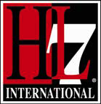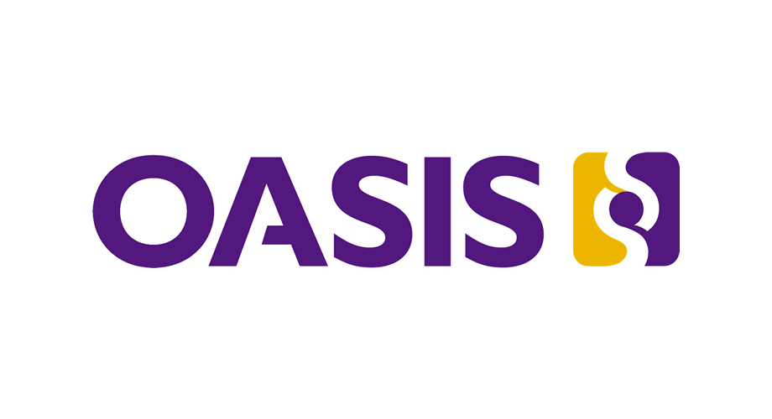
For Immediate Release

HL7 and OASIS Announce Joint Publication of Data Transformation to Advance Emergency and Disaster Response
Advances ER readiness
and improves transition of care between first responders and hospitals

ANN ARBOR, MI, USA and Burlington, MA, USA – September 20, 2016 – Health Level Seven® International (HL7®) and OASIS, as a result of their cooperation agreement, today announced that they have published a joint implementation guide to advance emergency and disaster response by bridging the electronic gap between emergency response and hospital communities, by eliminating the need to reenter or duplicate patient information. The guide, known as “HL7 Version 2.7.1 Implementation Guide: Message Transformations with OASIS Tracking of Emergency Patients (TEP), Release 1” is expected to improve accuracy and timeliness of data exchange between the emergency response community and hospitals, and between hospitals in a disaster situation. It will also improve coordination and ER readiness for incoming emergency patients.
Quote from TN Commissioner of Health (per John Roberts) on how such a standard can improve/affect disaster preparedness – such as from a hurricane or flooding. Perhaps using a real-world example from what TN experienced from Katrina or other disasters in which the state experienced a huge influx of patients.
The implementation guide will facilitate data exchange by providing a mapping between the OASIS Emergency Data eXchange Language (EDXL) TEP 1.1 message, which facilitates the coordination of patient movement across the continuum of emergency medical care, and HL7’s Version 2 Admit Discharge Transfer (ADT) messaging standard used in the healthcare setting. It will allow hospitals and emergency departments to track incoming patients from emergency services in the field via existing HL7 conformant systems. When a patient must be transported from a healthcare facility by emergency services to another healthcare facility, such as day-to-day transfers or hospital evacuation, the bidirectional data exchange facilitated by the guide enhances continuity of care.
Quote from someone on OASIS side regarding the EMS perspective – maybe more detail about the Common Operating Picture (COP).

For more information about the implementation guide or to download it free of charge, please visit the HL7 website at: http://www.hl7.org/implement/standards/product_brief.cfm?product_id=439.

The guide is also available via the OASIS website at: https://www.oasis-open.org/committees/document.php?document_id=57505&wg_abbrev=emergency.

About Health Level Seven International (HL7)
Founded in 1987, Health Level Seven International (www.HL7.org) is the global authority for healthcare information interoperability and standards with affiliates established in more than 30 countries. HL7 is a nonprofit, ANSI-accredited standards development organization dedicated to providing a comprehensive framework and related standards for the exchange, integration, sharing, and retrieval of electronic health information that supports clinical practice and the management, delivery and evaluation of health services. HL7’s more than 1,600 members represent approximately 500 corporate members, which include more than 90 percent of the information systems vendors serving healthcare. HL7 collaborates with other standards developers and provider, payer, philanthropic and government agencies at the highest levels to ensure the development of comprehensive and reliable standards and successful interoperability efforts.

About OASIS
OASIS (http://www.ihe.net) is a not-for-profit, international consortium that drives the development, convergence and adoption of open standards for the global information society. OASIS promotes industry consensus and produces worldwide standards for cloud computing, security, business transactions, electronic publishing, Smart Grid, and other applications. OASIS open standards offer the potential to lower cost, stimulate innovation, grow global markets, and protect the right of free choice of technology. OASIS members broadly represent the marketplace of public and private sector technology leaders, users and influencers. The consortium has more than 5,000 participants representing over 600 organizations and individual members in 65 countries.

HL7 Media Contact: Andrea Ribick, HL7, +1 (734) 677-7777 or andrea@HL7.org
OASIS Media Contact: Carol Geyer, phone number or carol.geyer@oasis-open.org

# # #

