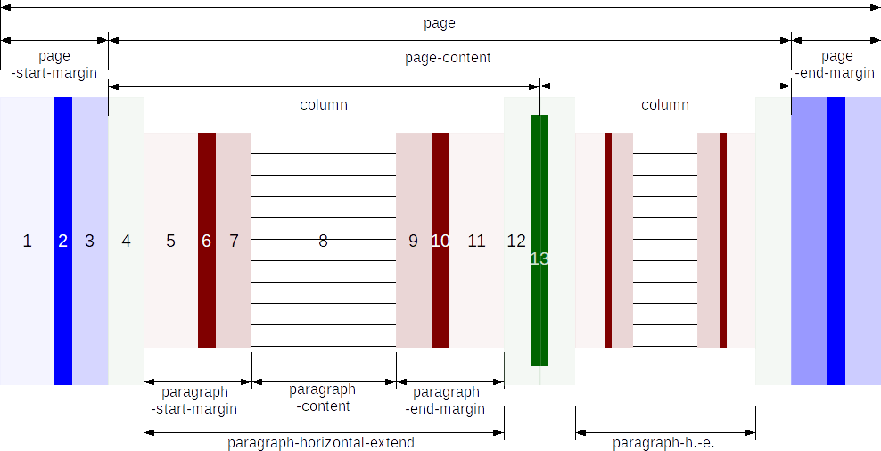
Area | Related Attributes
page | fo:page-width in <style:page-layout-properties> in <style:page-layout>
1 | fo:margin in <style:page-layout-properties>
2 | fo:border in <style:page-layout-properties>
3 | fo:padding in <style:page-layout-properties>
page-start-margin | Width is calculated:  sum of left page margin (1), border (2) and padding (3).  Instead of "left" see special rules for inside/outside page layout.
page-end-margin | Width is calculated:  sum of right page margin, border and padding.  Instead of "right" see special rules for inside/outside page layout.
page-content | Width is calculated:  width of page − width of page-start-margin − width of page-end-margin.
4 | fo:start-indent in <style:column> in <style:columns> in <style:page-layout-properties>
12 | fo:end-indent in <style:column> in <style:columns> in <style:page-layout-properties>
13 | style:width in <style:column-sep>. The separator line is drawn on top of the indents and does not impact other widths.
column | Width is calculated:  The width of the page-content is divided with respect to style:rel-width in <style:column> in <style:columns> in <style:page-layout-properties>  "column" does not belong to the areas available for positioning. Instead of indents of individual columns the attribute fo:column-gap can be used with similar calculations.
paragraph | Width is calculated:  paragraph-horizontal-extend = width of column − width of column start-indent (4) − width of column end-indent (12)
5, 11 | called "indent" in typography  fo:margin in <style:paragraph-properties> in <style:style> in file format
6, 10 | fo:border in <style:paragraph-properties>
7, 9 | fo:padding in <style:paragraph-properties>
paragraph-start-margin | Width is calculated:  sum of paragraph left margin, border and padding.  Instead of "left" see special rules for inside/outside page layout.
paragraph-end-margin | Width is calculated:  sum of paragraph right margin, border and padding.  Instead of "right" see special rules for inside/outside page layout.
8  paragraph-content | Width is calculated:  paragraph-horizontal-extend − width of paragraph-start-margin − width of paragraph-end-margin
A section acts similar to a page in regard to horizontal division, except that left and right border and padding are not available for sections, but only left and right margin. The paragraph-horizontal-extend of the section environment corresponds to the page width.
Anchor positions cannot refer to sections directly.

