
Symptoms Autonomic Framework (SAF) Version 1.0
Working Draft
12 November 2009
Specification URIs:
This Version:
http://docs.oasis-open.org/saf/symptoms/1.0/wd01/saf-symptoms-1.0-spec-wd-01.html
http://docs.oasis-open.org/saf/symptoms/1.0/wd01/saf-symptoms-1.0-spec-wd-01.doc
(Authoritative Format)
http://docs.oasis-open.org/saf/symptoms/1.0/wd-01/saf-symptoms-1.0-spec-wd-01.pdf
Previous Version:
[NA]
Latest Version:
http://docs.oasis-open.org/saf/symptoms/1.0/saf-symptoms-1.0-spec-wd-01.html
http://docs.oasis-open.org/saf/symptoms/1.0/saf-symptoms-1.0-spec-wd-01.doc
http://docs.oasis-open.org/saf/symptoms/1.0/saf-symptoms-1.0-spec-wd-01.pdf
Technical Committee:
OASIS Symptoms Autonomic Framework (SAF) TC
Chair(s):
Jeffrey Vaught, CA Inc
Stavros Isaiadis, Fujitsu Limited
Editor(s):
Vivian Lee, Fujitsu Limited

Declared XML Namespace(s):
http://docs.oasis-open.org/saf/ns/symptoms/2009/10

Abstract:
This document normatively defines a reference architecture for the Symptoms Autonomic Framework, a tool in the automatic detection, optimization, and remediation of operational aspects of complex systems, notably data centers. It also provides a non-normative XML data model, based on pseudo schema, and a normative set of schema and WSDL documents.
Status:
This document was last revised or approved by the SAF TC on the above date. The level of approval is also listed above. Check the “Latest Version” or “Latest Approved Version” location noted above for possible later revisions of this document.
Technical Committee members should send comments on this specification to the Technical Committee’s email list. Others should send comments to the Technical Committee by using the “Send A Comment” button on the Technical Committee’s web page at http://www.oasis-open.org/committees/saf/.
For information on whether any patents have been disclosed that may be essential to implementing this specification, and any offers of patent licensing terms, please refer to the Intellectual Property Rights section of the Technical Committee web page (http://www.oasis-open.org/committees/saf/ipr.php.
The non-normative errata page for this specification is located at http://www.oasis-open.org/committees/saf/.
Notices
Copyright © OASIS® 2008. All Rights Reserved.
All capitalized terms in the following text have the meanings assigned to them in the OASIS Intellectual Property Rights Policy (the "OASIS IPR Policy"). The full Policy may be found at the OASIS website.
This document and translations of it may be copied and furnished to others, and derivative works that comment on or otherwise explain it or assist in its implementation may be prepared, copied, published, and distributed, in whole or in part, without restriction of any kind, provided that the above copyright notice and this section are included on all such copies and derivative works. However, this document itself may not be modified in any way, including by removing the copyright notice or references to OASIS, except as needed for the purpose of developing any document or deliverable produced by an OASIS Technical Committee (in which case the rules applicable to copyrights, as set forth in the OASIS IPR Policy, must be followed) or as required to translate it into languages other than English.
The limited permissions granted above are perpetual and will not be revoked by OASIS or its successors or assigns.
This document and the information contained herein is provided on an "AS IS" basis and OASIS DISCLAIMS ALL WARRANTIES, EXPRESS OR IMPLIED, INCLUDING BUT NOT LIMITED TO ANY WARRANTY THAT THE USE OF THE INFORMATION HEREIN WILL NOT INFRINGE ANY OWNERSHIP RIGHTS OR ANY IMPLIED WARRANTIES OF MERCHANTABILITY OR FITNESS FOR A PARTICULAR PURPOSE.
OASIS requests that any OASIS Party or any other party that believes it has patent claims that would necessarily be infringed by implementations of this OASIS Committee Specification or OASIS Standard, to notify OASIS TC Administrator and provide an indication of its willingness to grant patent licenses to such patent claims in a manner consistent with the IPR Mode of the OASIS Technical Committee that produced this specification.
OASIS invites any party to contact the OASIS TC Administrator if it is aware of a claim of ownership of any patent claims that would necessarily be infringed by implementations of this specification by a patent holder that is not willing to provide a license to such patent claims in a manner consistent with the IPR Mode of the OASIS Technical Committee that produced this specification. OASIS may include such claims on its website, but disclaims any obligation to do so.
OASIS takes no position regarding the validity or scope of any intellectual property or other rights that might be claimed to pertain to the implementation or use of the technology described in this document or the extent to which any license under such rights might or might not be available; neither does it represent that it has made any effort to identify any such rights. Information on OASIS' procedures with respect to rights in any document or deliverable produced by an OASIS Technical Committee can be found on the OASIS website. Copies of claims of rights made available for publication and any assurances of licenses to be made available, or the result of an attempt made to obtain a general license or permission for the use of such proprietary rights by implementers or users of this OASIS Committee Specification or OASIS Standard, can be obtained from the OASIS TC Administrator. OASIS makes no representation that any information or list of intellectual property rights will at any time be complete, or that any claims in such list are, in fact, Essential Claims.
The names "OASIS", [insert specific trademarked names and abbreviations here] are trademarks of OASIS, the owner and developer of this specification, and should be used only to refer to the organization and its official outputs. OASIS welcomes reference to, and implementation and use of, specifications, while reserving the right to enforce its marks against misleading uses. Please see http://www.oasis-open.org/who/trademark.php for above guidance.

Table of Contents
1 Introduction 5
1.1 Terminology 5
1.1.1 Notational Conventions 5
1.2 XML Namespaces 5
1.3 Normative References 6
1.4 Non-Normative References 6
2 Information Model 7
2.1 Syndrome 7
2.1.1 Non Normative Pseudo Schema 8
2.2 Protocol 9
2.2.1 Non Normative Pseudo Schema 10
2.3 Prescription 10
2.3.1 Non Normative Pseudo Schema 11
2.4 Symptom 12
2.4.1 Non Normative Pseudo Schema 13
3 Architectural Roles 14
3.1 Information Sources 14
3.1.1 Syndrome and Protocol Catalogue 14
3.1.2 Symptom Store 14
3.2 Active Roles 14
3.2.1 Catalogue Source 14
3.2.2 Symptom Source 14
3.2.3 Case Manager 15
3.2.4 Diagnostician 15
3.2.5 Practitioner 15
4 Interfaces 16
5 Notes on Future Specification Development 18
6 Appendix A 19
6.1 Medical Sequence Diagram 19
7 Conformance 21
A. Acknowledgements 22
B. Non-Normative Text 23
C. Revision History 24

Introduction
The Symptoms Autonomic Framework is an architecture for enabling interoperable diagnosis and treatment of complex systems. The architecture is implementation agnostic yet it supports both stateful or real-time processing and postmortem diagnostics. The key constituent of the architecture is the Symptom, an instance indicating an observed negative or positive condition. Symptoms can be characterized by a Syndrome, which is a published pattern of conditions and other Symptoms. Once identified, a Syndrome can be treated (either to remedy a problem or enhance positive characteristics of the system) by application of one or more Protocols, which describe how to carry out a process to treat, optimize, or further diagnose the Syndrome. The Protocol is rendered to a specific situation and Subject in the form of a Prescription. The framework also provides for diagnostics, a type of Protocol, to provide further information to refine the diagnosis of a given Syndrome. These four elements comprise the Symptoms information model, presented in the next section. This document also defines the key actors that participate in the Symptoms cycle of identify, diagnose, and treat, namely the Syndrome Catalog, Case Manager, Symptom Source, Diagnostician, and Practitioner. Lastly, a collection of interfaces, which may be supported by these actors, is described.

Terminology
The key words “MUST”, “MUST NOT”, “REQUIRED”, “SHALL”, “SHALL NOT”, “SHOULD”, “SHOULD NOT”, “RECOMMENDED”, “MAY”, and “OPTIONAL” in this document are to be interpreted as described in [RFC2119].

Notational Conventions
This specification uses a notational convention, referred to as “Pseudo-schemas” in a fashion similar to the WSDL 2.0 Part 1 specification. A Pseudo-schema uses a BNF-style convention to describe attributes and elements:
- `?' denotes optionality (i.e. zero or one occurrences),
- `*' denotes zero or more occurrences,
- `+' one or more occurrences,
- `[' and `]' are used to form groups,
- `|' represents choice.
- Attributes are conventionally assigned a value corresponding to their type.
<!-- sample pseudo-schema -->
<element
required_attribute_of_type_QName="xs:QName"
optional_attribute_of_type_string="xs:string"? >
<required_element />
<optional_element />?
<one_or_more_of_these_elements />+
<zero_or_more_of_these_elements />*
[ <choice_1 /> | <choice_2 /> ]
</element>

XML Namespaces
The following namespaces are used in this document:
Prefix | Namespace
xsd | http://www.w3.org/2001/XMLSchema
sym | http://docs.oasis-open.org/saf/ns/symptoms/2009/10

Normative References
[RFC2119] S. Bradner, Key words for use in RFCs to Indicate Requirement Levels, http://www.ietf.org/rfc/rfc2119.txt, IETF RFC 2119, March 1997.

[XPATH20] A. Berglund et al, XML Path Language, version 2.0, http://www.w3.org/TR/xpath20/, January 2007.

[XML10] T. Brey et al, Extensible Markup Language (XML) 1.0, November 2008.

Non-Normative References
[Reference] [Full reference citation]

NOTE: The proper format for a citation to an OASIS Technical Committee’s work (whether Normative or Non-Normative) is:
OASIS
Stage (Committee Draft 01, Committee Draft 02, Committee Specification 01, etc. or Standard)
Title (italicized or in quotation marks)
Approval Date (Month YYYY)
URI of the actual Authoritative Specification (namespace is not acceptable as the content changes over time)

For example:

EDXL-HAVE OASIS Standard, “Emergency Data Exchange Language (EDXL) Hospital AVailability Exchange (HAVE) Version 1.0”, November 2008.
http://docs.oasis-open.org/emergency/edxl-have/os/emergency_edxl_have-1.0-spec-os.doc

Information Model

Syndrome
A Syndrome is an identifiable collection of zero or more related Symptoms (as identified by a signature). Since a Syndrome describes a Symptom (see below) a Syndrome can be thought of as describing a class of Symptom Instances.
Field | Type | Properties | Description
Syndrome Type | anyURI | Required, Immutable | The SyndromeType uniquely defines the semantics of the Syndrome.
Syndrome Name | string | Required, Mutable | A descriptive name for the Syndrome.
Description | string | Required, Mutable | A verbose explanation of the Syndrome for human consumption.
Likelihood | {Common,  Uncommon,  Rare,  NotAvailable} | Required, Mutable | An indication as to the typicality of this Syndrome.
Impact | {HighImpact, ModerateImpact, LowImpact, UnknownImpact} | Required, Mutable | The effect of this Syndrome with respect to the consequences of not detecting, diagnosing, or treating it.
Urgency | {HighUrgency,ModerateUrgency,LowUrgency,UnknownUrgency} | Required, Mutable | The speed and tenacity with which this Syndrome should receive attention.
Signature | string | Required, Mutable | An XPath 2.0 expression [XPATH20] that detects an interesting pattern of Symptoms and how to recognize a Syndrome. If the result is empty the Syndrome is not present in the system. A non-empty result contains an XML document [XML10]. This document MAY contain matched Symptom instances or other information pertaining to the Syndrome. This document MUST be available for Processing Protocols.
Associated Protocols | anyURI[0..n] | Optional, Mutable | A collection of diagnostic tests and actions, which may be prescribed by the Diagnostician.

Non Normative Pseudo Schema
The following is one possible non-normative pseudo schema for the Syndrome.
<Syndrome>
<SyndromeType>xsd:anyURI</SyndromeType>
<SyndromeName>xsd:string</SyndromeName>
<Description>xsd:string</Description>?
<Likelihood>
[Common|Uncommon|Rare|NotAvailable]
</Likelihood>
<Impact>
[HighImpact|ModerateImpact|LowImpact|UnknownImpact]
</Impact>
<Urgency>
[HighUrgency|ModerateUrgency|LowUrgency|UnknownUrgency]
</Urgency>
<Signature>xsd:string</Signature>
<AssociatedProtocols>xsd:anyURI</AssociatedProtocols>*
</Syndrome>

Protocol
A Protocol is a process for confirming a potential Syndrome diagnosis via the creation of validating Symptoms, for remediating a Syndrome, optimizing the system, and/or preventing a Syndrome from occurring. It provides the template necessary to create a Prescription.
Field | Type | Properties | Description
Protocol  Type | anyURI | Required, Immutable | ProtocolType uniquely defines the semantics of the Protocol.
Prescription Type | anyURI | Required, Immutable | PrescriptionType uniquely defines the semantics of all Prescription instances, baring this type, created as a result of applying this Protocol and MUST be included in any generated Prescriptions.
Protocol  Name | string | Required, Mutable | A descriptive name for the Protocol.
Description | string | Required, Mutable | A verbose explanation of the Protocol for human consumption.
Effectiveness | {Effective,  PartiallyEffective,  BestEffort,  Ineffective,  Inconclusive} | Required, Mutable | The expected success of the Protocol.
Risk | {HighRisk,  ModerateRisk,  LowRisk,  UnknownRisk} | Required, Mutable | The expected side effects or undesired consequences of running the Protocol.
Duration | {LongDuration,  ModerateDuration,  ShortDuration,UnknownDuration} | Required, Mutable | The expected amount of time necessary to complete the Protocol.
Function | {Diagnostic,  Preventative,  Remedial,  Diagnostic_Preventative,  Diagnostic_Remedial,  Preventative_Remedial,  Diagnostic_  Preventative_Remedial,  Other} | Required, Mutable | The type of Protocol, either a remedial treatment, a preventative treatment, a confirming diagnostic, or a combination.
Directive | string | Required, Mutable | An XPath 2.0 expression that generates an XML document containing information needed to create the Arguments of a Prescription instance. This document MAY contain Symptom elements or other information pertaining to the Syndrome or the system environment.
Potential  Syndromes | anyURI[0..n] | Optional, Mutable | A list of Syndromes that can be indirectly matched as a result of the Protocol process.
Process | string | Optional, Mutable | Implementation specific diagnostic and treatment workflow instructions.

Non Normative Pseudo Schema
The following is one possible non-normative pseudo schema for the Protocolclass.
<Protocol>
<ProtocolType>xsd:anyURI</ProtocolType>
<PrescriptionType>xsd:anyURI</PrescriptionType>
<ProtocolName>xsd:string</ProtocolName>
<Description>xsd:string</Description>?
<Effectiveness>
[Effective|PartiallyEffective|
BestEffort|Ineffective|Inconclusive]
</Effectiveness>
<Risk>
[HighRisk|ModerateRisk|LowRisk|UnknownRisk]
</Risk>
<Duration>
[LongDuration|ModerateDuration|ShortDuration|UnknownDuration]
</Duration>
<Function>
[Diagnostic|Preventative|Remedial|
Diagnostic_Preventative|Diagnostic_Remedial|
Preventative_Remedial|Diagnostic_Preventative_Remedial|Other]
</Function>
<Directive>xsd:string</Directive>
<PotentialSyndromes>xsd:anyURI</PotentialSyndromes>*
<Process>xsd:string</Process>?
</Protocol>

Prescription
A Prescription is an instance of a process, which MAY correspond to a Protocol. It is used to provide remediation, diagnostics, preventative measures, or optimization to be performed. Prescriptions MAY represent automated or Manual steps. A Prescription includes arguments specific to the subject or component that is the target of the prescription.
Field | Type | Properties | Description
PrescriptionId | anyURI | Required, Unique, Immutable | The identifier for the Prescription. This element MUST be globally unique and MAY be used as the primary key for the Prescription.
Prescription Type | anyURI | Required, Immutable | The PrescriptionType defines the semantics of this Prescription. All Prescriptions baring the same PrescriptionType MUST have the same semantics.
ExpirationDate | dateTime | Optional, Mutable | An optional date recommendation beyond which the Prescription MAY no longer be useful.
Arguments | anyType[0..n] | Optional, Mutable | The XML rendered arguments needed by the recipient of the Prescription to apply this Prescription to a specific target.
Process | string | Optional, Mutable | Optional process, such as a script to be executed by the recipient of the Prescription.

Non Normative Pseudo Schema
The following is one possible non-normative pseudo schema for the Prescription class.
<Prescription>
<PrescriptionId>xsd:anyURI</PrescriptionId>
<PrescriptionType>xsd:anyURI</PrescriptionType>
<ExpirationDate>
xsd:dateTime
</ExpirationDate>
<Arguments>
<xsd:any/>+
</Arguments>?
<Process>xsd:string</Process>?
</Prescription>

Symptom
A Symptom is the instance, possibly corresponding to a Syndrome and described by a Signature, indicating that the condition or situation is present in the system. There SHOULD be a Syndrome corresponding to each type of Symptom or a combination of Symptoms as identified by the Syndrome signature. Unlike Syndromes and Protocols, which may be relatively static and represent the knowledge within the framework, Symptoms represent the dynamic state of the system and are therefore expected to change frequently.
Field | Type | Properties | Description
SymptomId | anyURI | Required, Unique, Immutable | The identifier for the Symptom. This element MUST be globally unique and MAY be used as the primary key for the Symptom.
SymptomType | anyURI | Required, Immutable | This URI defines the semantics of this Symptom. All Symptoms baring the same SymptomType MUST have the same semantics.
CreationDate | dateTime | Required, Immutable | The date-time (in UTC) when the Symptom was created. The value of this element SHOULD provide as much granularity as possible.
Confidence | {HighConfidence,ModerateConfidence,LowConfidence,UnknownConfidence} | Require, Mutable | The level of confidence in the accuracy and quality of this symptom, as determined by the Symptom Source.
Reporter | anyURI | Required, Immutable | Identification of the entity that emitted the Symptom.
Subject | anyURI | Required, Immutable | Identification of the entity exhibiting the Symptom.
ExpirationDate | dateTime | Optional, Mutable | An optional date-time (in UTC) recommendation beyond which the Symptom may no longer be useful.
Issued Prescription | anyURI [0..n] | Optional, Mutable | Prescriptions issued as a result of this Symptom.
ProbableCause | anyURI[0..n] | Optional, Mutable | Reference to the Symptom instances giving rise to this Symptom.
Content | anyType[0..n] | Optional, Mutable | An implementation dependent element that could contain such data as the raw events/messages that triggered the creation of the Symptom.

Non Normative Pseudo Schema
The following is one possible non-normative pseudo schema for the Symptom class.
<Symptom>
<SymptomId>xsd:anyURI</SymptomId>
<SymptomType>xsd:anyURI</SymptomType>
<CreationDate>xsd:dateTime</CreationDate>
<Confidence>
[HighConfidence|ModerateConfidence|
LowConfidence|UnknownConfidence]
</Confidence>
<Reporter>xsd:anyURI</Reporter>
<Subject>xsd:anyURI</Subject>
<ExpirationDate>
xsd:DateTime
</ExpirationDate>
<IssuedPrescription>xsd:anyURI<\IssuedPrescription>*
<ProbableCause>xsd:anyURI<\ProbableCause>*
<Content>xsd:any</Content>*
</Symptom>

Architectural Roles
An implementation of the Symptoms Autonomic Framework MAY implement any of the roles detailed below. If an implementation provides a capability described by any of the roles, it MUST implement that capability as specified below. An implementation MAY incorporate all the roles into a single entity or MAY define separate entities for collections of roles. More than one instance of any role MAY be present in an implementation of the Symptoms Autonomic Framework.

Information Sources
This specification defines two information sources, the Syndrome and Protocol Catalogue (Catalogue for short) and the Symptom Store. This specification does not prescribe the method for persisting the information sources (e.g. data base, files store, memory image, etc.). This specification prescribes the contents of the data exchange and recommends a set of schemas by which this data is communicated to and from other roles and components of the Symptoms Autonomic Framework.

Syndrome and Protocol Catalogue
The Catalogue contains Syndromes and Protocols associated with the system for which that Catalogue was designed. In any Symptoms Autonomic Framework there MAY be several Catalogues, each possibly associated with a specialized aspect of the system. While the Catalogue is generally static during operation of the Symptoms Autonomic Framework, it MAY evolve over time as new Syndromes and Protocols are identified. The data exchange to and from the Catalogue MUST comply with the Syndromes and Protocols as defined in this specification.

Symptom Store
The Symptoms Store is an optional repository when Symptom persistence is desired and contains Symptoms that have been created by Symptom sources. In any Symptoms Autonomic Framework there MAY be several Symptom Stores. The Symptom Store is dynamic and its contents are expected to change continuously during the operation of the Symptoms Framework. The currency of the Symptom Store is dependent on many factors such as Symptom Source emission rate, network latency, store frequency, etc. The data flows to and from the Symptoms Store MUST carry Symptoms as defined in this specification.

Active Roles
The Active Roles in the Symptoms Autonomic Framework include Catalogue Sources, Symptoms Sources, a Case Manager, a Diagnostician, and a Practitioner described in the following sections. Each role MAY be instantiated in the Symptoms Autonomic Framework as a distinct component. The roles MAY also be combined in arbitrary ways to create more complex components performing the functions of several or all roles. There MAY be any number (including zero) of components in Symptoms Autonomic Framework exhibiting each role.

Catalogue Source
The Catalogue Source role represents a source of Syndromes and Protocols. A Catalogue MAY have initial content or be empty when Symptoms Autonomic Framework is setup. A Catalogue Source MAY provide additional contents to or updates the Catalogues as the Symptoms Autonomic Framework evolves during operation.

Symptom Source
The Symptoms Source role represents an emitter of Symptoms. A Symptom Source MAY provide Symptoms at any time. The symptom source MAY be a component that experiences the symptom (the subject or affected component) or the reporter of a symptom that receives, filter, enrich, and forwards, symptoms from other Symptom Sources.

Case Manager
The Case Manager acts as the orchestrator within the Symptoms Autonomic Framework. The Case Manager gathers Symptoms, keeps track of what Symptoms are currently of importance within the system, and directs the actions of the other roles. The Case Manager maintains the state of the Symptoms Autonomic Framework and keeps track of the diagnose-prescribe cycle. A Case Manager may have broader knowledge about the entire system disposition and consult with one or more Diagnosticians to leverage specialties prior to prescribing a Prescription. The Case Manager role selects which Prescriptions to administer based on Diagnoses provided by the Diagnosticians. These Prescriptions MAY provide additional diagnostic information (that is a new Symptom) to narrow the scope of possible Syndromes or perform treatments on the system.

Diagnostician
The Diagnostician compares Symptoms with the signatures of various Syndromes to determine if any Syndromes, matching those Symptoms, exist within the system. While the rules governing the processes are expressed in XPath 2.0, the processes used to analyze and/or match against the syndromes are implementation specific.

Practitioner
The Practitioner administers Prescriptions as requested by the Case Manager.
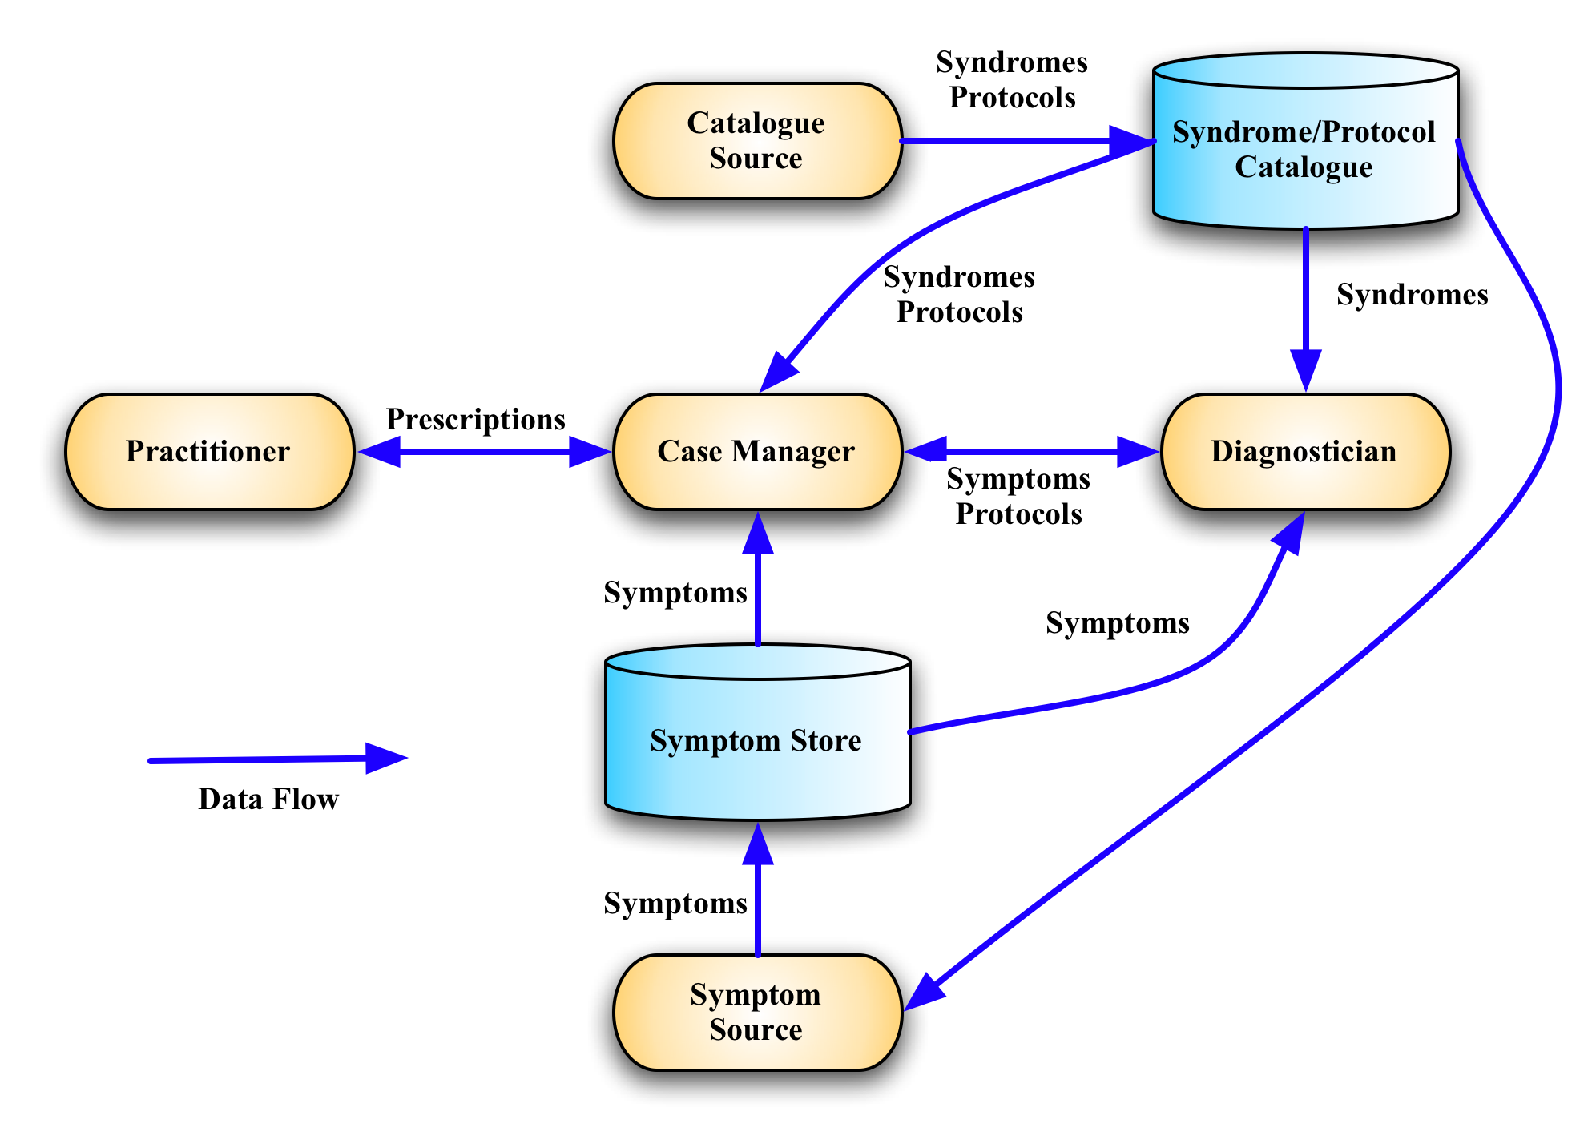
Figure 1: Roles and Information Stores in the Symptoms Autonomic Framework.

Interfaces
Problem determination includes problem detection, isolation, and resolution. Effective problem diagnosis is dependent upon basic reliability, availability, and serviceability (RAS) capabilities present in any system. Problems include situations that degrade the overall performance of installed components, situations that make some of the components unavailable, and situations that make all components unavailable. Often components implement special behavior that is available when they are in a failure mode. This behavior captures the internal and or external state of the component to aid in later problem determination.
The components can either play a role as the component that experiences the situation (the subject or affected component) or the reporter of a situation. In some cases, the reporter and the subject components can be the same. The subject and reporter roles are outside the Symptoms Autonomic Framework architecture, but are discussed here for clarity.
The Subject is the component that was affected by or was impacted by the event or the situation. The reporters are those components that submit symptoms on behalf of the Subjects. The reporter produces symptoms according to the symptoms model and uses an emission mechanism to submit the symptoms.
In this specification we have introduced concepts of the Symptom, Syndrome, Protocol, and Prescription each describing parts of the Symptoms Autonomic Framework information model. These elements of the information model are exchanged using the following interfaces.
Interface | Description | Operations | Candidate Role
Symptom Emitter | This is for the symptom sources or reporters emitting symptoms |  | Symptom Source
Symptom Handler | This is for the entity that receives symptoms for further processing | receiveSymptom  listSupportedTypes | Diagnostician  Symptom Source  Case Manager  Others
Prescription Emitter | The source for emitting a prescription |  | Case Manager
Prescription Handler | This is for component that receives and acts on the prescription | receivePrescription listSupportedTypes | Practitioner  Case Manager  Others
Catalog Emitter | The source (files, tools, etc) for syndromes and protocols. | returnCatalog | Catalog Source  Authoring Tools
Catalog Handler | This for the component that is capable of handling specific syndromes and protocols. | receiveCatalog | Catalog Source  Case Manager  Others

Notes on Future Specification Development
This section highlights a number of issues that the authors believe should addressed by the Technical Committee once it is formed. The reasons for not addressing these issues in this version of the specification vary from, a feeling that a wider community is needed to address them, to a need to complete this version in a timely manner.
While the Signature in a Syndrome is specified as a single XPath expression, it is acknowledged by the authors that processing of this expression may be performed incrementally to reflect the dynamic nature of Symptom creation. It may be necessary to decompose, explicitly in the specification, this XPath expression into a conjunction of multiple, simpler expressions.
The Associated Protocols in a Syndrome may have dependencies between them, such as "all must be applied", "any one may be applied", "must be applied in order", or possibly organized into sub-groups.
Some data types in the specification may benefit from version numbering, other than that implicit in the element type URI.
With the exception of open content in several places, this specification has omitted extensibility. Extensibility can help with the development of future versions of the specification and possible extensions.
In the pre standards phase of this work, it was suggested that some form of "Group Id" or "Linking Tag" be included at the top level of the Symptom to indicate that this Symptom was in someway related to other Symptoms and that this relationship was identifiable by the creator of the Symptom.

Appendix A

Medical Sequence Diagram
The diagram below provides non-normative example of how the Symptoms Autonomic Framework might apply in the motivational use case used to design the Symptoms concept. This example is drawn from the simple case of someone not feeling well and a health care provider provides diagnosis and treatment.
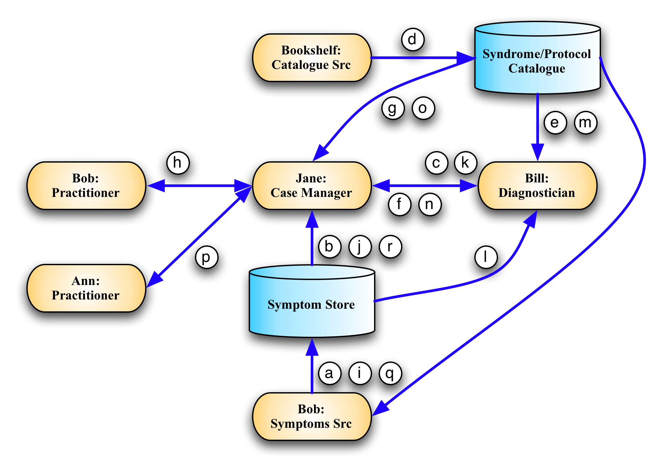
Figure 2: Medical Diagnosis Sequence
Symptoms Process:
- Bob (Symptoms Source) says, "I don't feel so good." (Symptom).
- Jane (Case Manager) hears of Bob's Symptom, and
- asks Bill (Diagnostician), "What do you think it is? "
- Bill collects a first aid book (Catalogue) from the bookshelf (Catalogue Source).
- Bill consults the Catalogue and learns that the top entry listing the "I don't feel so good" Symptom is a "Fever" (Syndrome), and
- he passes this to Jane.
- Jane looks up "Fever" in the Catalogue where it recommends, "take temperature" (Protocol) to verify the Syndrome, using a mercury thermometer (Prescription).
- She then instructs Bob (this time a Practitioner) to take his own temperature.
- Bob reports his temperature (a new Symptom).
- Jane reads it and
- again consults Bill.
- Bill reads the value of the temperature and
- again finds that "Fever" is the most likely Syndrome based on the high value of the newly reported Symptom.
- Bill tells Jane it's a "Fever."
- Jane, again consulting the Catalogue, decides that a medication (Protocol) is needed and selects two Aspirin (Prescription) and
- asks Ann to give Bob two Aspirin.
- Bob later reports, "I feel much better" (another new Symptom) and
Jane stops worrying.

Conformance
The last numbered section in the specification must be the Conformance section. Conformance Statements/Clauses go here. [need more wording here!]
An implementation is not conformant with this specification if it fails to satisfy one or more of the MUST or REQUIRED level requirements defined herein for the roles and modes it implements.
Normative text within this specification takes precedence over normative outlines, which in turn take precedence over the XML Schema [XML Schema Part 1, Part 2] and WSDL [WSDL 1.1] descriptions, which in turn take precedence over examples.

- Acknowledgements
The following individuals have participated in the creation of this specification and are gratefully acknowledged:
Participants:
Mike Baskey, IBM
Alvin Black, CA
Stavros Isaiadis, Fujitsu Limited
Vivian Lee, Fujitsu Limited
Paul Lipton, CA
Yasuhide Matsumoto, Fujitsu Limited
Marcelo Perazolo, IBM
David Snelling, Fujitsu Limited
Jeffrey Vaught, CA
Co-Developers of the initial contributions:
This document is based on initial contributions to the OASIS SAF Technical Committee by the following co-developers.
Mike Baskey, IBM
Alvin Black, CA
Vivian Lee, Fujitsu Limited
Paul Lipton, CA
Yasuhide Matsumoto, Fujitsu Limited
Marcelo Perazolo, IBM
Abdi Salahshour, IBM
David Snelling, Fujitsu Limited
Jeffrey Vaught, CA
Acknowledgements of the initial contributions:
The following individuals have provided invaluable input to the original contributions and were acknowledged in the initial contributions.
Mike Baskey, IBM
Alvin Black, CA
Michel Drescher, Fujitsu Limited
Vivian Lee, Fujitsu Limited
Paul Lipton, CA
Yasuhide Matsumoto, Fujitsu Limited
Marcelo Perazolo, IBM
Abdi Salahshour, IBM
David Snelling, Fujitsu Limited
Jeffrey Vaught, CA
- Non-Normative Text
- Revision History

Revision | Date | Editor | Changes Made
Wd-01 | 2009/11/12 | Vivian Lee | Created the initial working draft by converting the input specification to OASIS template.

