    - Visibility to Business
The relationship of visibility to the SOA ecosystem encompasses both human social structures and automated IT mechanisms. Figure 24 depicts a business setting that is a basis for visibility as related to the Social Structure Model (Figure 3) in the Participation in a SOA Ecosystem view (see Section 3.1). Participants acting in the roles of service consumers and service providers may have awareness of each other directly or gain such awareness through some third party acting in the role of mediator, what we refer to as mediated awareness. A consumer’s willingness to use a service is reflected by the consumer’s presumption of satisfying goals and needs as these compare with information provided in the service description. Service providers offer capabilities that have real world effects that result in a change in state. Reachability of the service by the consumer may lead to interactions that change the state of the SOA ecosystem. The consumer can measure the change of state to determine if the claims made by description and the real world effects of consuming the service meet the consumer’s needs.
Those acting in the roles of consumers, providers, or mediators may reside within a single ownership boundary or interactions between them may cross ownership boundaries.
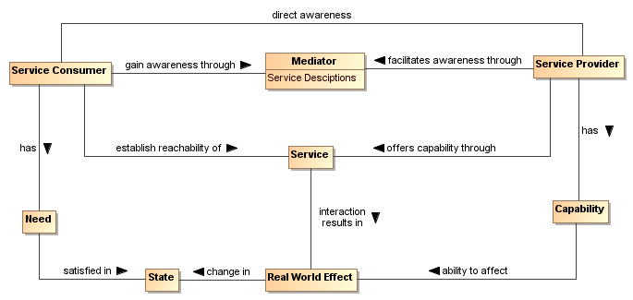
Figure 24 - Visibility to Business
Visibility and interoperability in a SOA ecosystem requires more than location and interface information. A meta-model for this broader view of visibility is depicted in Section 4.1. In addition to providing improved awareness of service capabilities through description of information such as reachability, behavior models, information models, functionality, and metrics, the service description may identify policies valuable for determination of willingness to interact.
A mediator using service descriptions may provide event notifications to both consumers and providers about information relating to the descriptions. One example of this is a publish/subscribe model where the mediator allows consumers to subscribe to service description version changes made by the provider. Likewise, the mediator may provide notifications to the provider of consumers that have subscribed to service description updates.
Another important characteristic of a SOA ecosystem is the ability to narrow visibility to trusted members within a social structure. Mediators for awareness may provide policy based access to service descriptions allowing for the dynamic formation of awareness between trusted members.
    - Visibility
Attaining visibility is described in terms of steps that lead to visibility. Different participant communities can bring different contexts for visibility within a single social structure, and the same general steps can be applied to each of the contexts to accomplish visibility.
Attaining SOA visibility requires
- service description creation and maintenance,
- processes and mechanisms for achieving awareness of and accessing descriptions,
- processes and mechanisms for establishing willingness of participants,
- processes and mechanisms to determine reachability.
Visibility may occur in stages, i.e. a participant can become aware enough to look or ask for further description, and with this description, the participant can decide on willingness, possibly requiring additional description. For example, if a potential consumer has a need for a tree cutting (business) service, the consumer can use a web search engine to find web sites of providers. The web search engine (a mediator) gives the consumer links to relevant web pages and the consumer can access those descriptions. For those prospective providers that satisfy the consumer's criteria, the consumer's willingness to interact increases. The consumer may contact several tree services to get detailed cost information (or arrange for an estimate) and may ask for references (further description). The consumer is likely to establish full visibility and proceed with interaction with the tree service that mutually establishes visibility.
      - Awareness
An important means for one participant to be aware of another is to have access to a description of that participant and for the description to be sufficiently complete to support the other requirements of visibility.
Awareness can be established without any action on the part of the target participant other than the target providing appropriate descriptions. Awareness is often discussed in terms of consumer awareness of providers but the concepts are equally valid for provider awareness of consumers.
Awareness can be decomposed into: creating the descriptions, making them available, and discovering the descriptions. Discovery can be initiated or it can be by notification.
Achieving awareness in a SOA ecosystem can range from word of mouth to formal service descriptions in a standards-based registry/repository. Some other examples of achieving awareness in a SOA ecosystem are the use of a web page containing description information, email notifications of descriptions, and document based descriptions.
Direct awareness is awareness between a consumer and provider without the use of a third party. Mediated awareness, on the other hand, is provided by a third party participant to one or more providers or consumers of one or more services. A registry/repository can provide such awareness as can a Web page displaying similar information.
Direct awareness may be the result of having previously established an execution context, or direct awareness may include determining the presence of services and then querying the service directly for description. As an example, a priori visibility of some sensor device may provide the means for interaction or a query for standardized sensor device metadata may be broadcast to multiple locations. If acknowledged, the service interface for the device may directly provide description to a consumer so the consumer can determine willingness to interact.
The same medium for awareness may be direct in one context and may be mediated in another context. For example, a service provider may maintain a web site with links to the provider’s descriptions of services giving the consumers direct awareness to the provider’s services. Alternatively, a community may maintain a web site with a search interface that makes use of an index of these (and possibly other) descriptions of services, and the web site could be used by any number of consumers. More than one approach to mediation may be involved, as different sources of description may specialize in different functions whose use provides mediation.
Descriptions may be formal or informal.
        - Mediated Awareness

Mediated awareness typically promotes simplification of the overall services infrastructure. As an example, the telephone book is a mediating registry where individuals perform manual searches to locate services (i.e. the yellow pages). The telephone book is also a mediated registry for solicitors to find and notify potential customers (i.e. the white pages).
The benefits, for large and dynamic numbers of service consumers and service providers, of utilizing the awareness mediator typically far outweigh the management issues associated with it. Some of the benefits of mediated service awareness are:
- Potential service consumers have a known location for searching thereby eliminating needless and random searches
- Typically a consortium of interested parties (or a sufficiently large corporation) serves as the host of the mediation facility
- Standardized tools and methods can be developed and promulgated to promote interoperability and ease of use.
However, mediated awareness can have some risks associated with it:
- A single point of failure. If the awareness mediator fails then a large number of service providers and consumers are potentially adversely affected.
- A single point of control. If the awareness mediator is owned by, or controlled by, someone other than the service consumers and/or providers then the latter may be put at a competitive disadvantage based on policies of the discovery provider.

        - Awareness in Complex Social Structures

