the oasis transformational government framework

Executive Summary
All around the world, governments at national, state, regional and local level face huge pressure to do more with less. Responding effectively to these challenges means governments need to be capable of delivering change which is transformational, not incremental.
During much of the last two decades, many thought that new technology would provide the key to deliver these transformations. But at a time when virtually every government is now an ‘eGovernment’ it is now clear that ICT is no magic bullet. Duplicated expenditure, wasted resources, no critical mass of users for online services, and limited impact on core public policy objectives - this has been the reality of many countries' experience of eGovernment.
An increasing number of governments are now starting to get to grips with the much broader and more complex set of cultural and organisational changes which are needed if ICT is to deliver significant benefits in the public sector. Countries such as the United Kingdom, Canada and Australia have all recently published strategies which shift decisively away from ‘eGovernment’ towards a much more radical focus on transforming the whole relationship between the public sector and users of public services.
This paper outlines the work of the OASIS Technical Committee established to address this new approach by developing a new framework and set of enabling standards that can jump-start this transformation and optimise the benefits of technology-enabled change at all levels of government. The various components of the Transformational Government Framework (TGF) described in this paper represent the initial outputs of the committee which are intended to become an OASIS standard – the TGF Primer and the TGF Core Pattern Language - but their work is still on-going, and as such should not be taken as the complete product set. These initial products are available at www.oasis-open.org/committees/tgf/.

Keywords: Transformational Government, eGovernment, citizen-centric services

Key Sentence: In the increasingly common situation of governments being expected to deliver better and more services for less cost whilst maintaining high-level oversight and governance, the Transformational Government Framework (TGF) provides a framework for designing and delivering an effective programme of technology-enabled change at all levels of government.

The transformational government framework

Defining Transformational Government

The definition of Transformational Government used within the OASIS Framework is the following:
‘A managed process of ICT-enabled change in the public sector, which puts the needs of citizens and businesses at the heart of that process and achieves significant and transformational impacts on the efficiency and effectiveness of government.’
This definition deliberately does not seek to describe some ‘perfect end-state’ for government. That is not the intent of the Transformational Government Framework (TGF). All governments are different: the historical, cultural, political, economic, social and demographic context under which each government operates is different, as is the legacy of business processes and technology implementation from which it starts. So the TGF is not a one-size-fits-all prescription for what a government should look like in future.

Thus, the focus is rather on the process of transformation: how a government can build a new way of working, which enables it rapidly and efficiently to adapt to changing citizen needs and emerging political and market priorities. In the words of one of the earliest governments to commit to a transformational approach: “….the vision is not just about transforming government through technology. It is also about making government transformational through the use of technology” (UK Government’s white paper, 2005).

A full understanding of this definition of Transformational Government can also be assisted by focusing on the four major ways in which Transformational Government programmes differ from traditional eGovernment programmes:
- they take a whole-of-government view of the relationship between the public sector and the citizen or business user;
- they include initiatives to eEnable the frontline of public services: that is, staff involved in direct personal delivery of services such as education and healthcare - rather than just looking at transactional services which can be eEnabled on an end-to-end basis;
- they take a whole-of-government view of the most efficient way of managing the cost base of government;
- they focus on the ‘citizen’ not the ‘customer’. That is, they seek to engage with citizens as owners of and participants in the creation of public services, not as passive recipients of services.

Transforming services around the citizen and business user

Most governments are structured around a set of vertically-integrated silos or stovepipes - agencies, departments, ministries. By and large, it is these silos that the governments of developed countries have spent billions of dollars on ‘eEnabling’ since the 1990s. Yet, the needs of citizens, businesses and others engaging with government typically cut across the organisational structures and hierarchies of government - an ICT investment strategy, which is fundamentally not a citizen-focused one, and which has inevitably resulted in low levels of take-up for eServices. Governments in developed countries are now grappling with the legacy of thousands of fragmented, silo-focused websites, 270,000+ in the United States of America public sector, over 9,000 gov.de sites in Germany, and over 3,000 gov.uk sites in the United Kingdom (CS Transform’s white paper, 2010). An increasing number are now seeking to make a fundamental strategic shift, towards a holistic, citizen-Centered approach, driven at the whole-of-government level. This shift includes, in leading countries, a move to a one-stop citizen-centric service delivered over multiple channels.

eEnabling the frontline

Traditional eGovernment programmes focused on eEnabling transactional services and providing online content. Yet, the great majority of public sector staff and expenditure is not involved in such services, but is rather on the ‘front line’: teachers, healthcare workers, police, court officials, emergency response teams and so on. Leading governments are now increasingly beginning to understand how the work of such front line staff can be transformed through the use of real-time knowledge management and mobile workflow applications.

Empowering the citizen

Citizens' experience of new technology is shaped by the best of the global private sector and - increasingly - through an ability to co-create content and services as individuals or in peer-to-peer networks. As a result, citizens will increasingly demand this level of interactivity and ownership in their relationship with public services. Transformational Government programmes embrace this. Where traditional eGovernment programmes focused on the user as ‘the customer’, Transformational Government looks to enhance the relationship between government and the citizen on a much richer, more reciprocal, and more empowering basis.

Cross-government efficiency

The silo-based approach to ICT investment, typical of eGovernment, has not only resulted in ‘un-citizen-centric’ services (as discussed above), but also in duplication and inefficiency. Governments have ‘reinvented the wheel’ in ICT terms - over and over again - with different agencies each:

- maintaining their own databases, even for universal data sets such as citizen identity, addresses and so on;
- building bespoke applications for eService functions which are common to all or many agencies (such as payments in and out, eligibility, notification, and authentication), as well as for common business processes such as HR and Financial Management, and doing so in ways which not only duplicate expenditure, but which also will not inter-operate with other agencies - making it more difficult and expensive to move towards inter-agency collaboration in future.

A key focus of Transformational Government is therefore to move towards an integrated ICT and back-office service architecture across all parts of government - reaping efficiency gains while at the same time enabling better, more citizen-focused service delivery. As ‘cloud computing’ gains traction and momentum, this approach to government ICT opens up even greater scope to achieve large-scale efficiency savings while simultaneously improving organisational agility.

Purpose of the Transformational Government Framework

Delivering this degree of change is not straight-forward for governments. Indeed, government faces unique challenges in delivering transformational change, notably:

- the unparalleled breadth and depth of its service offering;
- the fact that it provides a universal service, engaging with the whole population rather than picking and choosing its customers;
- structures, governance, funding and culture which, are all organised around specific business functions, not around meeting citizen needs in a holistic way.

The governments and industry leaders involved in the OASIS Technical Committee therefore believe that the time is now right to set out a clear best practice framework, within which governments can overcome these challenges to deliver genuinely transformational ICT-enabled change in the public sector.

Against this background, the purpose of the TGF is as follows:

“In the increasingly common situation of governments being expected to deliver better and more services for less cost whilst maintaining high-level oversight and governance, the TGF provides a framework for designing and delivering an effective programme of technology-enabled change at all levels of government.”

Target audience for the Transformational Government Framework

The TGF is primarily intended to meet the needs of:

- Ministers and senior officials responsible for shaping public sector reform and eGovernment strategies and policies (at national, state/regional and city/local levels);
- senior executives in industry who wish to partner with and assist governments in the transformation of public services and to ensure that the technologies and services which the private sector provides can have optimum impact in terms of meeting public policy objectives.

Secondary audiences for the TGF are:

- leaders of international organisations working to improve public sector delivery, whether at a global level (e.g. World Bank, United Nations) or a regional one (e.g. European Commission, ERIS@, ASEAN, IADB);
- professional bodies that support industry sectors by the development and maintenance of common practices, protocols, processes and standards to facilitate the production and operation of services and systems within the sector, where the sector needs to interact with government processes and systems;
- academic and other researchers working in the field of public sector reform;
- civil society institutions engaged in the debate on how technology can better enable service transformation.

OASIS Technical Committee’s work

The OASIS Technical Committee was established in October 2010 and its current membership includes representatives from national governments, major industry organisations, academia and other internationally recognised experts on eGovernment. Full details of its work are available at www.oasis-open.org/committees/tc_home.php?wg_abbrev=tgf .

A TGF Primer that gives an overview of the Framework and a TGF Core Pattern Language that sets out the formal TGF Specification have been approved by the Technical Committee and both are available on the TC’s website as referenced above. These products are being taken through the entire OASIS approvals’ process to become an OASIS Standard.

The Transformational Government Framework
The TGF can be seen schematically below.
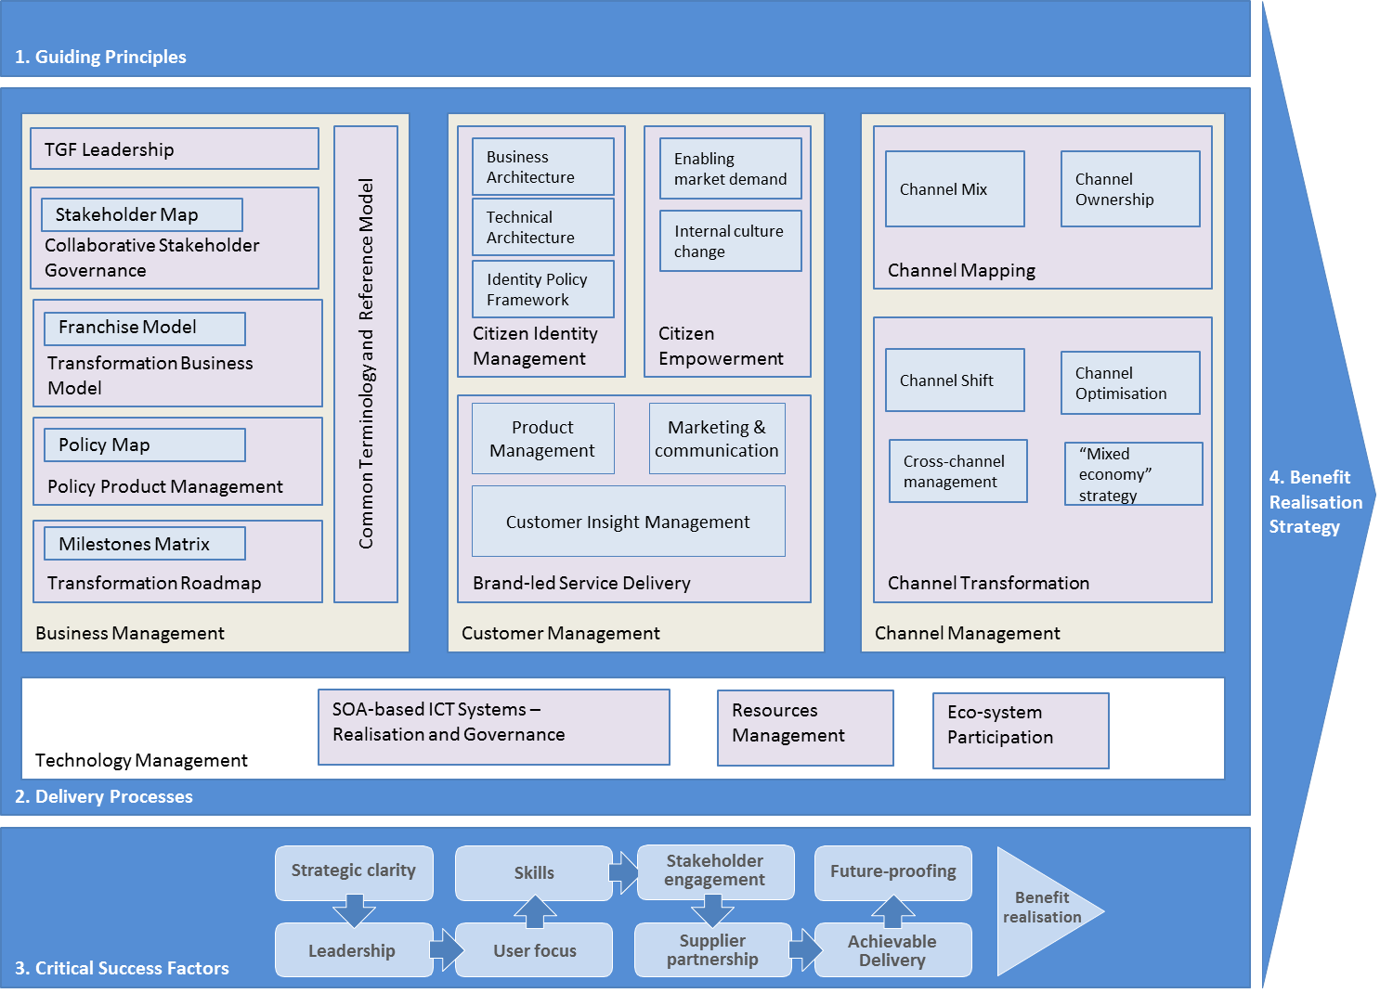
Figure 1. The Transformational Government Framework schematic.
There are four main components to the Framework:

- A set of guiding principles for transformation: that is, the core values which underpin successful citizen-centric reform around the world.
- The major delivery processes within government, all of which need refocusing in a citizen-centric way in order to deliver genuinely transformational impact: business management, customer management, channel management, and service-oriented technology management.
- A checklist of the critical success factors that every government needs to manage if it is to develop and deliver an effective Transformational Government programme.
- The Benefit Realisation Framework that is needed to ensure that the Transformation Government programme ultimately delivers all of its intended benefits and impacts in practice.

Each of these components is described in more detail below.

Component 1 of the TGF: Guiding Principles

As discussed above in Part 1.1 of this document, a one-size-fits all approach to public sector reform will not work. Nevertheless, there are some guiding principles, which 10-15 years of experience with eEnabled government around the world suggests are universal. They are based on the experience of many OASIS member organisations working with governments of all kinds, all around the world, and they form the heart of the Framework.
In the TGF, the term “principle” is used to mean an enduring statement of values which can be used on a consistent basis to steer business decision making over the long term. The TGF Guiding Principles are set out below, and must be used by any Transformational Government programme conforming to the TGF. The guidance for programme managers is therefore:

Develop a detailed and segmented understanding of your citizen and business customers
  - Own the customer at the whole-of-government level
  - Don't assume the organisation knows what users of the services think - research, research, research
  - Invest in developing a real-time, event-level understanding of citizen interactions with government

Build services around customer needs, not organisational structure
  - Provide people with one place to access government, built round their needs
  - Don't try to restructure government to do this - build ‘customer franchises’ which sit within the existing structure of government and act as change agents
  - Deliver services across multiple channels - but use Service-Oriented Architecture (SOA) principles to join it all up, reduce infrastructure duplication, and to encourage customers into lower cost channels
  - Don't spend money on technology before addressing organisational and business change
  - Don't reinvent wheels - build a cross-government strategy for common citizen data sets (e.g. name, address) and common citizen applications (e.g. authentication, payments, notifications)

Citizen service transformation is done with citizens, not to them
  - Engage citizens directly in service design and delivery
  - Give citizens the technology tools that enable them to create public value themselves
  - Give citizens ownership and control of their personal data - and make all non-personal government data freely open for reuse and innovation by citizens and third parties.

Grow the market
  - Ensure that the service transformation plans are integrated with an effective digital inclusion strategy to build access to and demand for e-services across society
  - Recognise that other market players (in the private, voluntary and community sectors) will have a significant influence on citizen attitudes and behaviour - so build partnerships which enable the market to deliver your objectives.

Manage and measure the nine critical success factors - see Figure 1

Component 2 of the TGF: Delivery processes

Delivering the principles outlined above, in line with the Critical Success Factors detailed in Component 3 of the TGF, involves re-inventing every stage of the service delivery process. The TGF identifies four main delivery processes, each of which needs to be managed in a government-wide and citizen-centric way in order to deliver effective transformation:
- business management
- customer management
- channel management
- technology management

The following sections look in more detail at each of the four delivery processes, setting out the best practices which should be followed in order to ensure conformance with the TGF.

Business Management

For largely historical reasons, governments are generally organised around individually accountable vertical silos (for example, tax, health, transport), with clear demarcations between central, regional, and local government. Yet, citizen and business needs cut across these demarcations. In moving to a citizen-centric approach, it is vital to redress this fragmented approach to business management, and to put in place business management processes which operate at the whole-of-government level.

The TGF identifies six key aspects of business management which need to be tackled in this way:

- a Transformational Government leadership: the key people and governance structures needed to develop and implement a Transformational Government programme;
- a collaborative Stakeholder Governance Model: the process by which all key stakeholders are identified, engaged and buy-in to the transformation programme;
- a common terminology and Reference Model: ensuring that all stakeholders have a clear, consistent and common understanding of the key concepts involved in Transformational Government; how these concepts relate to each other; how they can be formally modelled; and how such models can be leveraged and integrated into new and existing information architectures;
- a Transformation Business Model: a new virtual business layer within government, focused round the needs of citizens and businesses, which enables the existing silo-based structure of government to collaborate effectively in understanding and meeting user needs;
- the development and management of Policy Products: Policy products that constitute the documented commitment to the transformational process of any conformant agency;
- a Transformation Delivery Roadmap: giving a four to five year view of how the programme will be delivered, with explicit recognition of priorities and trade-offs between different elements of the programme.

A high level view of the logical relationships between these components is illustrated below:

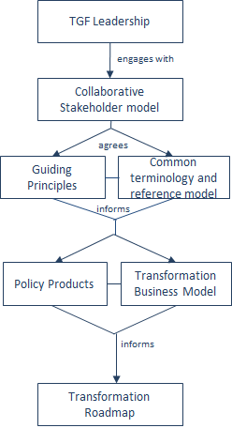
Figure 3: Business Management components
Collaborative Stakeholder Model
A central task of the TGF leadership and collaborative stakeholder model is to develop a new and effective business model that enables the machinery of government to deliver citizen-centric services in practice. It’s the failure to address this requirement for a new business model which, arguably, has been the greatest weakness of most traditional eGovernment programmes. For the most part, the transition to eGovernment has involved overlaying technology onto the existing business model of government: a business model based around unconnected silos - in which policy-making, budgets, accountability, decision-making and service delivery are all embedded within a vertically-integrated delivery chain based around specific government functions. The experience of governments around the world over the last two decades is that this simply does not work.

So what is the new business model that is required to deliver citizen service transformation? Many attempts have been made by governments to introduce greater cross-government coordination, but largely these have been ‘bolted on’ to the underlying business model, and hence experience only limited success.

The TGF recommends implementation of a business model which permits the joining-up of services from all parts of government in a way that makes sense to citizens, yet without attempting to restructure those parts of government. Conceptually, this leads to a model where the existing structure of government continues to act as a supplier of services, but intermediated by a ‘virtual’ business infrastructure based around customer needs. A top-level view of such a virtual, market-based approach to citizen service transformation is set out in the figure below:
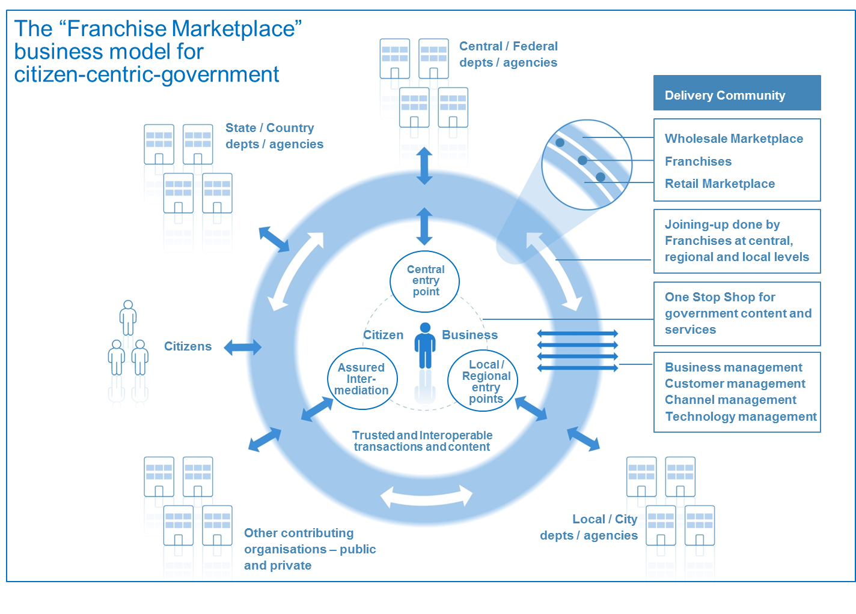

Figure 4: The Franchise Model
Key features of this business model are:
- The model puts into place a number of agile cross-government virtual ‘franchise businesses’ based around customer segments (such as, for example, parents, motorists, disabled people). These franchises are responsible for gaining full understanding of their customers' needs so that they can deliver quickly and adapt to changing requirements over time in order to deliver more customer centric services - which in turn, is proven to drive higher service take-up and greater customer satisfaction.
- Franchises provide a risk-averse operational structure that enables functionally-organised government agencies at national, regional and local level to work together in a customer-focused ‘Delivery Community’. They do this by:
- enabling government to create a ‘virtual’ delivery structure focused on customer needs;
- operating inside the existing structure government (because they are owned and resourced by one of the existing ‘silos’ which has a close link to the relevant customer segment);
- dividing the task into manageable chunks;
- removing a single point of failure;
- working to a new and precisely-defined operating model so as to ensure consistency;
- working across government (and beyond) to manage the key risks to citizen-centric service delivery;
- acting as change agents inside government departments / agencies.
- The model enables a ‘mixed economy’ of service provision: first, by providing a clear market framework within which private and voluntary sector service providers can repackage public sector content and services, and second by disseminating Web 2.0 approaches across government to make this simpler and cheaper at a technical level.
- The whole model is capable of being delivered using Cloud Computing.

This Franchise model represents an important breakthrough in the shift from a traditional eGovernment approach towards citizen service transformation. Certainly, the model as a whole, or key elements of it, has been adopted successfully in governments as diverse as the United Kingdom, Hong Kong, Croatia, Abu Dhabi and Australia (where it has been adopted by both the South Australia and Queensland governments).

It is clearly possible that alternate models may develop in future. Regardless of how the Transformational Government agenda develops, every government will need to find some sort of new business model along these lines, rather than continue simply to overlay technology onto an old silo-based business model built for an un-networked world.

Enabling the Franchise Model

A number of relationships need to be managed by a franchise to enable it to develop, maintain and deliver transformational citizen-centric services. These represent different viewpoints that can be broadly classified as:

- Customers: Those citizens and businesses to whom the franchise delivers content and services, plus those internal stakeholders to whom the franchise provides a service within the government.
- Partners: Those who are actors in the normal operation and delivery of the service, both internally and externally to the government.
- Influencers: those who have a political, business or altruistic interest in the service and the part that it plays in broader government, business and social scenarios.
- Internal Customers: Those who work with the franchise to develop and maintain the service.
Policy Product Management

A ‘Policy Product’ within the context of the TGF is any document which has been formally adopted on a government-wide basis in order to help achieve the goals of citizen service transformation. These documents vary in nature (from statutory documents with legal force, through mandated policies, to informal guidance and best practice) and in length (some may be very lengthy documents; others just a few paragraphs of text). Policy Products are important drivers of change within government: first because the process of producing them, if managed effectively, can help ensure strategic clarity and stakeholder buy-in; and second because they then become vital communication and management tools.

Over recent years, several governments have published a wide range of Policy Products as part of their work on Interoperability Frameworks and Enterprise Architectures, and other governments are therefore able to draw on these as reference models when developing their own Policy Products. However, we believe that the set of Policy Products required to ensure that a holistic, government -wide vision for transformation can be delivered is much broader than is currently being addressed in most Interoperability Frameworks and Enterprise Architectures.

A TGF-conformant transformation programme will use the Policy Product Map shown below as an assessment framework for determining what Policy Products are needed to deliver the programme effectively. This maps the four delivery processes described in Component 2 of the TGF (Business Management, Customer Management, Channel Management and service-oriented Technology Management) against the five interoperability domains identified in what is currently the broadest of Interoperability Frameworks - the European Interoperability Framework (EIF): technical, semantic, organisational, legal and policy interoperability – (see http://ec.europa.eu/isa/strategy/doc/110113__iop_communication_annex_eif.pdf ). While the EIF framework is conceptually complete, by mapping it against these core delivery processes, a much clearer sense can be gained of the actions which are needed.

The full analysis of the Policy Products which are typically needed to deliver an effective and holistic transformation programme is still to be completed; however the diagram below illustrates the types of products that might be needed. Whilst every policy product indicated may not be needed, we recommend that any conformant transformation programme should use the overall framework of the Policy Product Map to conduct a gap analysis aimed at identifying all key Policy Products needed for that government.
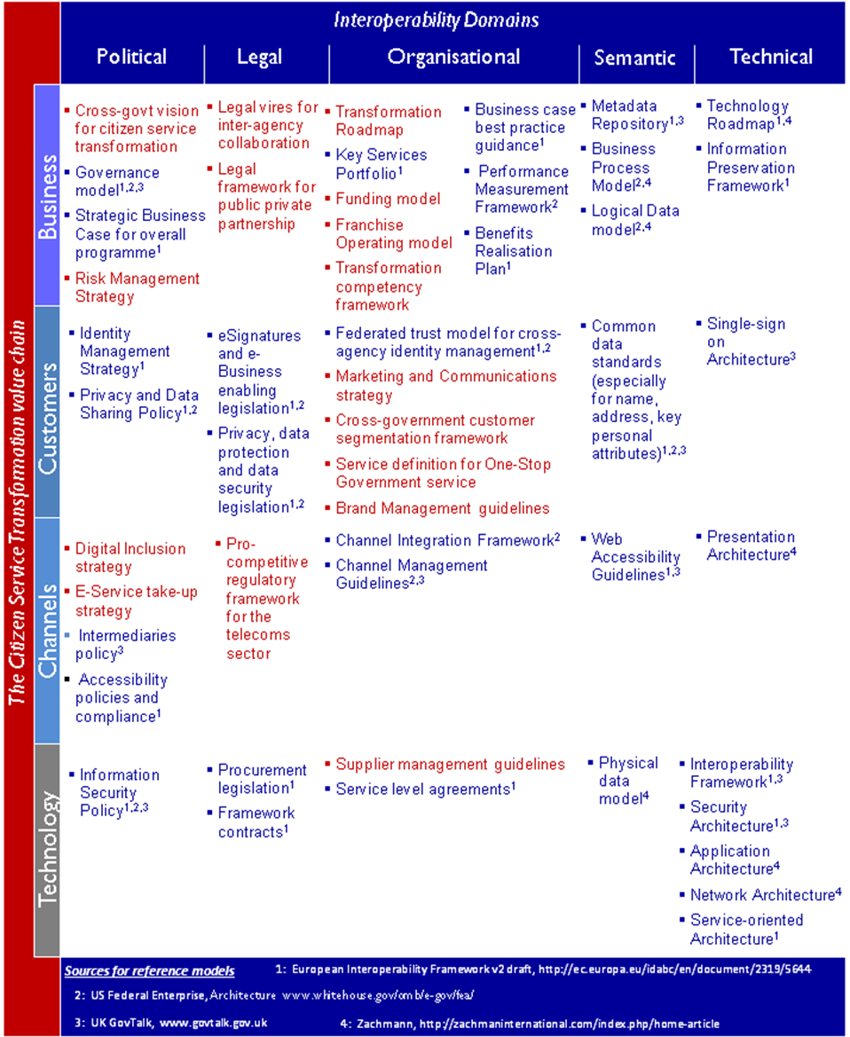
Figure 5: The Policy Product Map

Transformation Roadmap

Finally, it is essential that the vision, strategy, business model and policies for citizen service transformation are translated into an effective Transformation Roadmap.

Since everything can clearly not be done at once, it is vital to map out which elements of the transformation programme need to be started immediately, which can be done later, and in what order. There is no one-size-fits all strategy that governments can use, since strategy needs to be tailored to the unique circumstances of each government's situation.

However, all governments face the same strategic trade-offs: needing to ensure clear line-of-sight between all aspects of programme activity and the end outcomes which the government is seeking to achieve, and to balances quick wins with the key steps needed to drive longer term transformation.

In the early days of the Transformational Government programme, it is recommended that the major strategic focus should be on: safe delivery - that is, prioritising high benefit actions which help to accelerate belief and confidence across the government and the wider stakeholder community that ICT-enabled change is possible and beneficial - but which can be delivered with very low levels of risk. As the programme develops, and an increasing number of services become available, the strategic focus can move towards building take-up, that is building demand for online services and creating a critical mass of users. Once that critical mass starts to appear, the strategic focus can start to shift towards fuller transformation in other words, to start driving out some of the more significant transformational benefits that high levels of service take-up enables, for example in terms of reducing the cost of government service delivery.

As the diagram below makes clear, these strategic foci are not mutually exclusive, but overlap. Crucially, in the Safe Delivery phase there will also be some vital steps needed in order to pave the way for longer term transformation, particularly in respect of establishing the business case for transformation, and embedding the strategy in effective governance processes. But the diagram shows how the strategic weight between each consideration should shift over time.

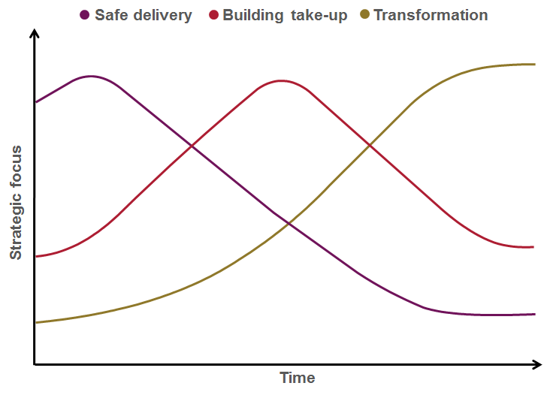
Figure 6: The Transformation Roadmap
Guided by the strategic trade-off framework described above, experience shows that a phased approach is the most successful. Typically, an effective Delivery Roadmap will cover five main phases.

1. Plan: the preparation and planning needed to develop a tailored Delivery Roadmap for the government, to ensure that the business case for transformation is fully articulated, and that all key stakeholders are on-board. Key outputs from this phase should include:
- Transformation vision: a high level document setting out the agreed future model for transformation of the organisation and its re-engineered business processes;
- Strategic business case: the key costs and benefits associated with the transformation programme;
- Delivery roadmap: a multi-year transformation plan, covering, among other things:
- a change management plan (including communication and training plans);
- central capability building and governance processes;
- a sourcing strategy;
- a strategy for moving towards a service oriented ICT architecture;
- a risk management strategy;
- a high level benefit realisation plan, setting out the actions needed to ensure full downstream delivery of the intended benefits from the transformation programme.
2. Initiate: in this first phase of delivery, the focus is on building the maximum of momentum behind the Roadmap for the minimum of delivery risk. This means focusing in particular on three things:
- some early quick wins to demonstrate progress and early benefits, for a minimum of delivery risk and using little or no technology expenditure;
- embedding the Roadmap in governance structures and processes which will be needed to inform all future investments, notably the frameworks of enterprise architecture, customer service standards and issue/risk management that will be required;
- selecting effective delivery partners.
3. Deliver: in this phase, some of the more significant investments start coming on stream - for example, the first version of the major ‘one-stop’ citizen-facing delivery platforms, and the first wave of transformation projects from ‘champion’ or ‘early adopter’ agencies within the government.
4. Consolidate: in this phase, the focus shifts towards driving take-up of the initial services, expanding the initial one-stop service over more channels, learning from user feedback, and using that feedback to specify changes to the business and technology architectures being developed as longer term, strategic solutions.
5. Transform: finally, the programme looks to build out the broader range of e-transformation projects, drive forward the migration of all major citizen-facing services towards the new one-stop channels, and complete the transition to the full strategic ICT platform needed to guarantee future agility as business and customer priorities change.

Customer Management

Citizen-centric customer management involves taking a holistic, market-driven approach to every step of the service design and delivery process. Three areas in particular are of vital importance:

- Brand-led service delivery
- Identity management
- Citizen empowerment

A high level view of the logical relationships between these components is illustrated below.

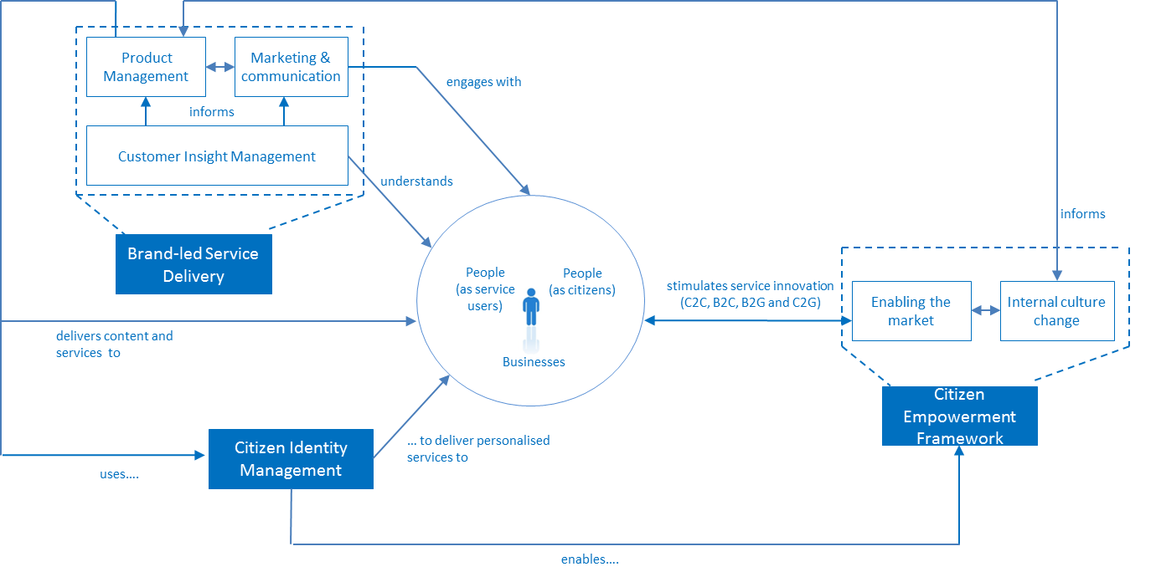

Figure 7: Customer Management components

Brand and Marketing Management

Marketing is critical to effective citizen service transformation, yet, it is something at which government traditionally does not excel. Often, marketing is fundamentally misunderstood within government - as being equivalent to advertising or perhaps, more broadly, as being equivalent to communication.

Properly understood, however, marketing is the process of:

- understanding the target market for government services in all its breadth and complexity;
- learning what is needed in order to meet citizen needs;
- developing an offer for citizens and businesses that they will engage with;
- establishing a clear set of brand values for that offer - a set of underpinning statements that adequately describe what the product or service will deliver and how;
- delivering that offer though appropriate channels, in a way which fully delivers on the brand values;
- generating awareness about the offer;
- creating desire/demand for the offer;
- reminding people;
- changing the offer in the light of experience;

This is the process that a brand-led consumer product company such as Procter and Gamble or Virgin would go through when developing a new product. However, it is not typically how governments manage their own service development, and governments generally lack the skills to do it. Moreover, the challenge faced by governments is significantly more complex than any private sector company, given the greater range and complexity of services and government’s need to provide a universal service rather than pick and choose its customers. Yet if governments are to succeed in the ambition of shifting service delivery decisively away from traditional channels to lower-cost digital channels, then these marketing challenges have to be met.

Given the fact that a) citizen needs cut across organisational boundaries in government and b) the skills for delivering an effective brand-led marketing approach to service transformation will inevitably be in short supply, it is important that these challenges are addressed at a government-wide level.

Channel Management

Channel management is often a weak spot in government service delivery, with widespread duplication, inefficiency and lack of user-focus. Experience shows common pitfalls include:

- managing new, digital channels as ‘bolt-ons’, with business and technical architectures that are entirely separate from traditional face-to-face or paper-based channels;
- no common view of citizen service across multiple channels;
- operational practices, unit costs and service standards for many channels which fall well below standards set for those channels in the private sector;
- a reliance on government-owned channels, with insufficient understanding of how to partner with private and voluntary sector organisations who have existing trusted channels to government customers;
- unproductive and costly competition among service delivery channels.

Transformational Government programmes seek to avoid these pitfalls, by building a channel management approach centered on the needs and behaviour of the citizen. The two key elements of the approach recommended in the TGF are:

- Channel Mapping: a clear audit of what existing channels are currently used to deliver government services. The TGF Channel Mapping approach includes an analysis of the current usage and costs of these channels across two key dimensions: which delivery channels are being used (‘channel mix’) and who owns them (‘channel ownership’).
- Channel Management Strategy: the TGF helps build a new channel management approach centred on the needs and behaviour of citizens and businesses. The key components of such an approach include:
  - Channel Shift
  - Channel Optimisation
  - Cross-Channel Management
  - Development of a wholesale intermediary market.

A high level view of the logical relationships between these components is illustrated below:

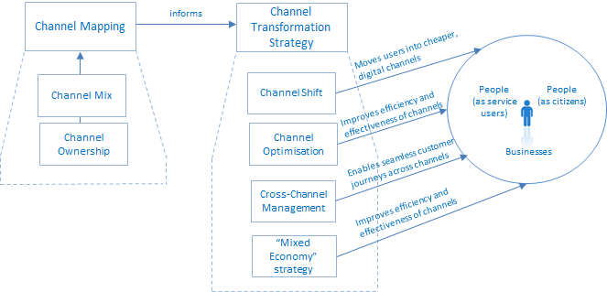

Figure 8: Channel Management components

Technology management

The transformations to business, customer and channel management described above require a new approach to technology and in particular a commitment to the paradigm and principles of SOA and SOA-based infrastructure, as defined in the OASIS Reference Model for Service-Oriented Architecture.

Transformational Government demands a single view of the citizen or business, delivered inside an integrated business and channels architecture. In terms of ICT, all of this requires governments to learn from private-sector best practice. Industry is moving towards a model of company-wide, service-orientated enterprise architecture, where common building blocks using open standards can be re-used to enable flexible and adaptive use of technology to react quickly to changing customer needs and demands. Increasingly, companies are gaining even greater efficiency benefits by managing these building blocks as a service, provided not within their own ICT architecture but from within ‘the Cloud’ - the dynamically-scalable set of computing resources now being offered as a service over the Internet.

Governments are increasingly taking this 'building block' approach to technology development. Key building blocks such as ICT infrastructure, common data sets, and identity verification need to be coordinated effectively. While much can be learned from the private sector, simply importing industry practices will not solve this coordination problem within government.

Governments are taking different approaches to the coordination function: some build central infrastructure for use by all departments and agencies; others identify lead departments to build and implement common solutions; others have a more decentralised approach, allowing departments to develop their own solutions according to a common architecture and standard set. However, finding an effective approach which works within a specific government approach is vital, since without this sort of technology flexibility, then Transformational Government becomes impossible - or possible only at great expense and with significant wasteful and duplicated IT expenditure.

The Technology Management Framework is modeled as one of the four TGF delivery processes, but it is concerned with more than ‘just’ the delivery of services using ICT. Its focus on the SOA paradigm is key to an approach that puts citizens and businesses as customers at the centre of a service ecosystem with many stakeholders, roles and systems involved.

The three key elements of the approach recommended in the TGF are:

- Resources Management which underpins ecosystem governance
- Ecosystem Participation
- Realisation and governance of SOA-based ICT systems

A high level view of the logical relationships between these components is illustrated below.

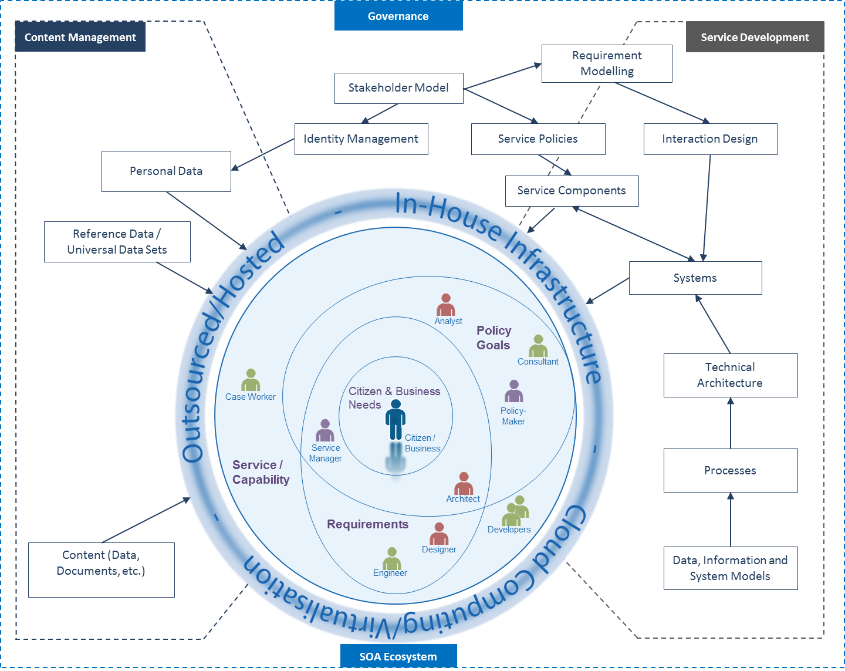
Figure 9: Overview of Technology Management Framework

Component 3 of the TGF: Critical Success Factors

Programmes and projects, which seek to deliver Transformational Government, face a significant range of risks to successful delivery. Typically, the risks are not related to the technology involved - which is largely now mature and proven bur, rather to the business and cultural changes which are needed within the government to deliver the business management, customer management and channel management transformations described above.

However, there is now an increasing body of research which seeks to understand why some ICT-enabled transformation programmes succeed and why others fail. The TGF has drawn together the findings from such research, validating these with OASIS members from around the world, to identify nine Critical Success Factors that must be taken into account. Successful transformation programmes manage and measure Critical Success Factors throughout the life of the programme. The guidance for programme managers is therefore:

Strategic Clarity

- All-of-Government view: Transformational government cannot be pursued on a project-by-project or agency-specific basis but requires a whole-of-government view, connecting up relevant activities in different agencies at different levels of government within and between countries.
- Clear vision: have a common and comprehensive view across all programme stakeholders of what the programme seeks to achieve. In particular, no money will be spent on technology before identifying the key organisational and business changes needed to deliver the organisation’s vision.
- Strong business case: the outcomes of what is to be achieved are known, there is a base line of the current situation, and it is known know how success will be measured.
- Focus on results: although there is a vision of where the organisation wants to go, and a set of principles by which it will move forwards, it will not over-plan. Instead, the strategy focuses on taking concrete, practical steps in the short to medium term, rather than continually describing the long-term vision.

Leadership

- Sustained support: the political leaders and top management are committed to the project for the long term.
- Leadership skills: programme leaders have the skills needed to drive IT-enabled business transformation, and have access to external support.
- Collaborative governance: leaders from all parts of this and other organisations involved in the programme are motivated for it to succeed, and are engaged in clear and collaborative governance mechanisms to manage any risks and issues.

User focus

- A holistic view of the customer: understand who the customers for the services are – not just for individual services, but across the government as a whole. Know your customers, both internal and external, are different, and understand their needs on a segmented basis.
- Citizen-centric delivery: citizens can access all of the services through a ‘one-stop’ shop. This is available over multiple channels but make use of web services to join it all up and reduce infrastructure duplication – as well as actively encourage customers into lower cost channels.
- Citizen empowerment: engage citizens directly in service design and delivery, and provide them with technology tools that allow them to create public value themselves.

Stakeholder Engagement

- Stakeholder communication: all stakeholders – users, suppliers, delivery partners elsewhere in the public, private and voluntary sector, politicians, the media etc – have a clear understanding of the programme and how they can engage with it.
- Cross-sector partnership: other market players (in the private, voluntary and community sectors) often have much greater influence on citizen attitudes and behaviour than government – so the strategy aims to build partnerships which enable the market to deliver our objectives.

Skills

- Skills mapping: recognise that the mix of business change, product and marketing management, programme management, and technology skills needed to deliver transformational change does not yet exist in the organisation. Therefore map out the skills needed, and have a clear strategy for acquiring them.
- Skills integration: have effective mechanisms in place to maximise the value from the skills available in all parts of the delivery team, bringing together internal and external skills into an integrated team.

Supplier Partnership

- Smart supplier selection: select suppliers based on long-term value for money rather than price, and in particular based on a degree of confidence that the chosen supplier will secure delivery of the expected business benefits.
- Supplier integration: manage the relationship with strategic suppliers at top management level, and ensure effective client/supplier integration into an effective programme delivery team with shared management information systems.

Future-proofing

- Interoperability: use interoperable, open standards which are well supported in the market-place.
- Web-centric delivery: use SOA principles in order to support all of the customer interactions, from face-to-face interactions by front line staff to online self-service interactions.
- Agility: deploy technology using common building blocks which can be re-used to enable flexible and adaptive use of technology to react quickly to changing customer needs and demands.
- Shared services: manage key building blocks as government-wide resources – in particular common data sets (e.g. name, address); common citizen applications (e.g. authentication, payments, notifications), and; core ICT infrastructure.

Achievable Delivery

- Phased implementation: avoid a ‘big bang’ approach to implementation, reliant on significant levels of simultaneous technological and organisational change. Instead, develop a phased delivery roadmap which:
  - works with citizens and businesses to identify a set of services which will bring quick user value, in order to start building a user base;
  - prioritises those services which can be delivered quickly, at low cost and low risk, using standard (rather than bespoke) solutions;
  - works first with early adopters within the government organisation to create exemplars and internal champions for change;
  - learns from experience and then drives forward longer term transformations.
- Continuous improvement: do not expect to get everything right first time, but have systems which enable the programme to move quickly and learn from experience.
- Risk management: have clarity and insight into the consequences of transformation and mechanisms to assess risk and handle monitoring, recovery and roll-back

Benefit Realisation

- Benefit Realisation Strategy: have a clear strategy to ensure that all intended benefits from the Transformation Programme are delivered in practice, built around the three pillars of benefit mapping, benefit tracking and benefit delivery.

Component 4 of the TGF: Benefit Realisation Strategy

Logically, the design and delivery of a Benefit Realisation Strategy is a part of the Business Management task, and is a core responsibility for the Transformational Government Leadership and the collaborative stakeholder governance model described in the TGF Business Management component. It is of such vital importance though, that we have highlighted it as a distinct component of the overall TGF.

Put simply, ICT projects in government (and indeed in the private sector) do not automatically deliver benefits. Governments historically have fallen into two pitfalls which have hindered full benefit realisation:

- Failure to pro-actively manage the downstream benefits after an individual ICT project has been completed. Often, ICT projects are seen as ‘completed’ once the initial technical implementation has been achieved. But to get the full projected benefits (efficiency savings, customer service improvements etc), ongoing management is essential, often involving significant organisational and cultural changes. A study for the European Commission (eGovernment Economics Project, 2006) calculated that, as a rule of thumb, organisational change accounts for 55 % of the full costs of eGovernment projects in Europe, with only 45 % of the costs going on ICT. Yet, these change costs are often not fully factored in or delivered, resulting in a failure to maximise the potential benefits of the ICT investments.
- Failure at a whole-of-Government level to undertake the restructuring of the public labour market to take advantage of new efficiencies. Effective delivery of eGovernment services – both in external service delivery to citizens and businesses, and in modernising the internal operations of government – opens up the potential to reduce significantly the cost of government. As the cost of delivering government services reduces, governments need to plan and implement the necessary restructuring of the public sector labour market to realise efficiency benefits in the traditional paper-based channels. These efficiency savings can then either be returned to the tax payer in the form of lower takes, or recycled into priority front-line public services such as health and education. A study by the OECD (IT Outlook, OECD 2006) showed that this ‘whole-of-government’ approach to efficiency savings had until that point been a feature of only a few countries, notably Canada, the United Kingdom and Finland. Increasingly though, financial pressures are forcing governments to focus on this issue.

The TGF does not seek to specify in detail what benefits and impacts a Transformational Government programme should seek to achieve – this is a matter for each individual government. However it does identify three key parts of a Benefit Realisation Strategy as follows:

- Benefit Mapping: which sets out all the intended outcomes from the transformation programme and gives visibility of how the outputs from specific activities and investments in the programme flow through to deliver those outcomes;
- Benefit Tracking: which takes this a step further by base lining current performance against the target output and outcomes, defining ‘smart’ success criteria for future performance, and tracking progress against planned delivery trajectories aimed at achieving these success criteria, and;
- Benefit Delivery: which ensures that governance arrangements are in place to ensure continued benefits after the initial transformation programme is implemented.
The relationship between these parts and conformance criteria for this element of the TGF are shown below:
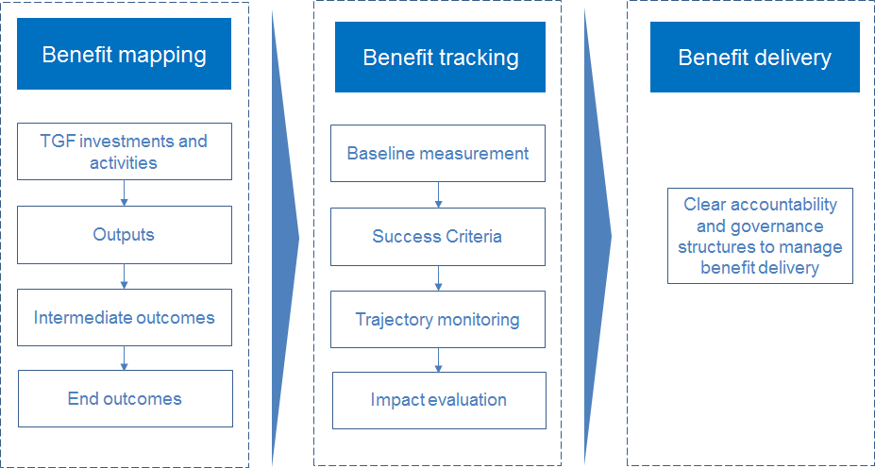

Figure 10: Overview of the Benefit Realisation Strategy

THE TGF CORE PATTERN LANGUAGE
The TGF Core Pattern Language is a formalisation of the Framework that is intended to be readable end-to-end as a piece of prose but is structured also in a way that lends itself to being quoted and is used pattern by pattern and to being encapsulated in more formal, tractable, and machine-processable forms including concept maps, Topic Maps, RDF or OWL.
It provides a concise, structured and formal set of ’patterns’ using the so-called “Alexandrian form” (Alexander C, 1964 and 1979), where each pattern describes a core problem, a context in which the problem arises and an archetypal solution to the stated problem.
The exact configuration will vary from one pattern language to another but each pattern in the TGF Core Pattern Language is structured as follows:
- The name of the pattern and a reference number;
- The conformance level intended to be applied in any use of the pattern;
- An introduction that sets the context and, optionally, indicates how the pattern contributes to a larger pattern;
- A headline statement that captures the essence of the problem being addressed;
- The body of the problem being addressed as well as constraints and evidence for the pattern’s validity;
- The solution stated as an instruction – what needs to be done;
- Optionally, some completion notes that links the pattern to related and more detailed patterns that further implement or extend the current pattern. This may also include references to external resources that are not part of the standard.
Version 1 of the TGF Core Pattern Language contains 20 Core Patterns but as a Pattern Language is inherently extensible, it is expected that extensions and specializations are likely to be developed by individual Governments to suit their implementation needs. Further explanation of the applicability of the Pattern Language approach to the TGF is available at www.PeterFBrown.com/Pages/PatternLanguages.aspx

Included in the TGF Core Pattern Language is a set of Conformance criteria that need to be adhered to for any Transformational Government program to be compliant with the OASIS standard.

Conclusions
There is a clear need to learn the lessons of the work by public sector administrations on eGovernment programmes over the last decade and to move to a more citizen-centric service delivery model called Transformational Government. The outcomes of these programmes have generally failed to meet expectations, deliver policy objectives and achieve citizen engagement.

The new model emphasises the need for much more focus on the business, operational and cultural aspects rather than solely on the technology issues, which has been the approach to date. Just bolting technology onto the current working methods of government does not achieve the desired outcomes. These other factors need to be addressed first before technical solutions are thought about.

There is also the need to break the usual public sector model of silo-based services and require, amongst other factors, a new approach to cross-organisation funding and customer management. A very important factor in this new approach is the implementation of a ’franchise’ business model, whereby services are brigaded under a customer segment champion and delivered by that individual, on behalf of the whole of government.

The TGF addresses all these needs and provides a practical, tried and tested way forward utilizing the best parts of existing eGovernment programs and avoiding large new investments. Its formalization as a Pattern Language enables it to be encapsulated in more formal, tractable, and machine-processable forms, thus making it easy to integrate into desk-top tools and management software aiding testing and assurance of compliance and conformance.

References
Alexander, C. (1964). Notes on the Synthesis of Form, Harvard University Press
Alexander, C. (1979). The Timeless Way of Building, Oxford University Press
Cabinet Office (2005). UK Government’s white paper: Transformational Government – enabled by technology
CS Transform (2010). Citizen Service Transformation: A manifeston for change in the delivery of public services
eGovernment Economics Project (2006). European Commission’s eGovernment Economics
Project (eGEP) – Economic Model
OECD (2006). OECD Information Technology Outlook 2006

Appendix A - Copyright © OASIS® 2011. All Rights Reserved.

The complete OASIS Intellectual Property Rights Policy may be found at the OASIS website.
This document and translations of it may be copied and furnished to others, and derivative works that comment on or otherwise explain it or assist in its implementation may be prepared, copied, published, and distributed, in whole or in part, without restriction of any kind, provided that the above copyright notice and this section are included on all such copies and derivative works. However, this document itself may not be modified in any way, including by removing the copyright notice or references to OASIS, except as needed for the purpose of developing any document or deliverable produced by an OASIS Technical Committee (in which case the rules applicable to copyrights, as set forth in the OASIS IPR Policy, must be followed) or as required to translate it into languages other than English.
The limited permissions granted above are perpetual and will not be revoked by OASIS or its successors or assigns.

