SC40/WG1 Individual Expert Contribution

Contribution to a possible TR – Mapping of OASIS TGF to ISO 38500
Introduction
This contribution is in response to ISO/IEC JTC 1/SC40/WG 1 N35, Call for Contributions to a TR mapping OASIS "Transformational Government Framework" (TGF) to ISO/IEC 38500.
It is hoped that this contribution can be considered during the meeting in Brazil, May 2015 where a more detailed discussion and progress towards a TR can be reached.
The liaison contribution document, ISO/IEC JTC 1/SC40/WG 1 N33, should also be considered in this discussion.

The SC40/WG1 Business Plan
As the SC40 business plan to the JTC1 Plenary (SC40 N107) highlights, the work initially covers “the development of the ISO/IEC 38500 series standards”. In addition, “The Working Group 1 - Governance of Information Technology’s role is to lead the development of standards, tools, frameworks, best practices and related documents on the governance of information technology. This includes providing guidance on the inter-relationships between the organisation, stakeholders, and information technology.
The application of this work includes assisting governing bodies to meet their obligations, informing management, and guiding other standardization efforts.”
Within this scope, we have seen WG1 publish a new version of the cornerstone standard ISO/IEC 38500:2015, Governance of IT for the organization and other work in this series:
- ISO/IEC TS 38501:2015 Governance of IT – Implementation guide
- ISO/IEC TR 38502:2014 Governance of IT - Framework and Model.
Additional work is underway on the topics of audit and the structure of principles based standards.
Up to this point, most of the work of WG1 has been concerned with building on the principles and model outlined in 38500. That is, how to clarify the distinction between governance and management, how to implement it and how to audit the result.
The mapping exercise proposed in N35 shows how the OASIS TGF can leverage the work of the 38500 series and, from the WG1 perspective, how the 38500 series can assist governing bodies within government to transform their services to better serve their constituents.
The proposal of a Technical Report to map OASIS TGF to ISO/IEC 38500 fits very well into the business plan of Working Group 1 because it assists “governing bodies to meet their obligations, informing management and guiding other standardization efforts”.
The proposed work is important because transforming government services to better meet the needs of citizens is an ongoing challenge and very topical. As an example, the Australian Government has recently announced the creation of a Digital Transformation Office, “so that government services can be delivered digitally from start to finish and better serve the needs of citizens and businesses”.
Understanding the general patterns and principles of how to achieve that transformation in government as described in the OASIS TGF, mapped to the principles and models in the 38500 series to give overall governance of IT guidance in this space could be a very useful combination.

Structure of the OASIS TGF
The “Transformational Government Framework” is a set of deliverables approved by the OASIS TGF Technical Committee and, in the case of the TGF OASIS Standard, by the OASIS membership via ballot.
The TGF is structured as a collection of “Patterns”, each developed according to the approach taken by Christopher Alexander in his original work on the subject, in which he established a model for developing “timeless” patterns encapsulating general architectural and urban planning concepts. His work has also been used in many other fields, such as organizational change and software design patterns.
The TGF patterns are grouped into four main areas: Guiding principles; Critical Success Factors; Benefits Realization; and the three main Delivery processes, Business Management, Service Management and Technology/Digital Asset Management.
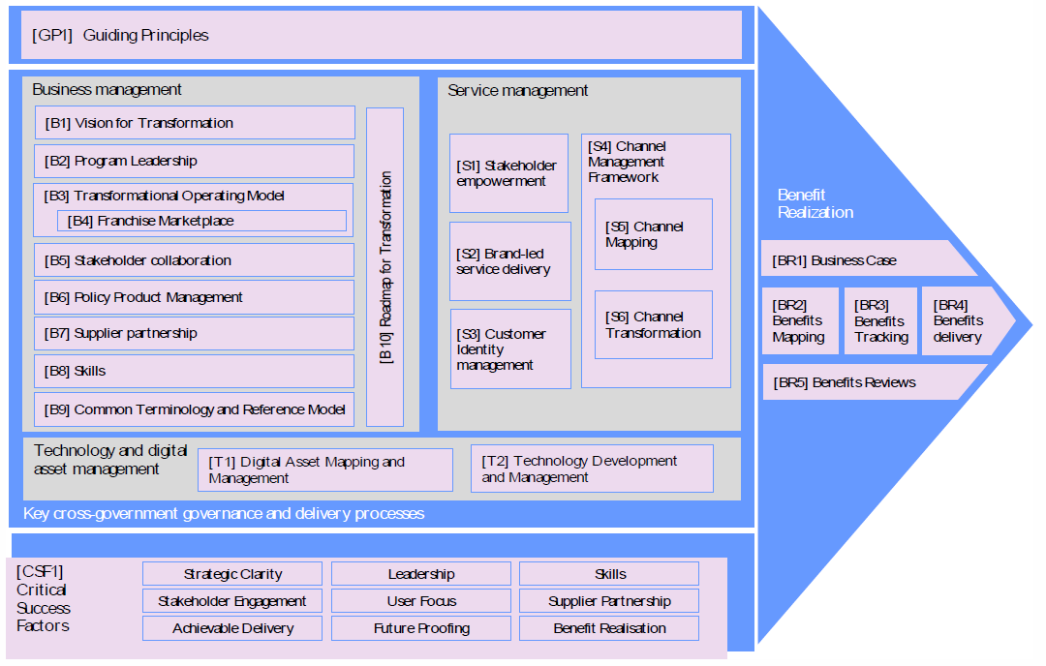
Figure 1 - Overview of the Structure of the TGF (Source: OASIS)

High-Level Comparison of OASIS TGF and ISO 38500
The table below gives a very high level comparison of the two standards and serves as a starting point for the work.
ISO 38500 | OASIS TGF
Overall
High-Level Principles-based advisory standard | High-Level Principles-based advisory standard
“Promote effective, efficient and acceptable use of Information Technologies in all organizations” | A managed process of ICT-enabled change in the public sector
Board guidance on the role of a governing body | Emphasis on collaborative governance with stakeholders
Encourages use of appropriate standards to underpin IT governance | Encourages use of open standards for IT
“Framework of principles for Directors” | “Working reference manual for use of the managed process
Emphasizes whole business context of IT use | Implies whole business use of IT
Governance of managed processes, controlled by IT or business units
May assist directors in assuring conformance and compliance
Governance of IT | Governance of change and the role of ICT enabling that change  Managing IT as a strategic asset
Principles | [GP1] Guiding Principles
Responsibility | [B2] Program Leadership
Strategy | [B10] Roadmap for Transformation  [CSF1] Critical Success Factors
Acquisition | [T2] Technology Development and Management
Performance | [CSF1] Critical Success Factors
Conformance
Human Behaviour | [B5] Stakeholder Collaboration  [CSF] Skills

Observations
Some observations relating to preliminary work on this topic (and for further discussion):
- The OASIS TGF highlights the relevance of “Government IT” as a potential specialized area of interest for SC40. (There may be potential opportunities to examine further specialization of the application of the 38500 series such as to the Governance of IT within Smart Cities as well as within other sectors.)
- OASIS, in their own contribution on this issue indicates that,
  - The result of such mapping could lead to the OASIS TGF TC recommending the existing (or a future) version of the TGF Standard to JTC 1 as a “PAS” submission or identifying requirements for a new work item, within the OASIS TGF TC or within JTC 1/SC 40, the specific sub-committee within JTC 1 that is responsible for the domain of IT Service Management and IT Governance.
- The TGF currently exists as an OASIS Standard, as a version 1; and as an OASIS Committee Specification, for version 2 (it has not yet been approved as an OASIS Standard as a version 2).
- A question, raised by the mapping, is whether the TGF in its entirely, is fully within the scope of JTC 1/SC40. However, it is likely that the mapping exercise will be of benefit even if it doesn’t cover all of the TGF.

Conclusions
- The creation of a within SC40 that serves as a guide to TGF for users of the ISO 38500 series (and vice versa) is a worthwhile activity.
- This work appears to fall comfortably within the scope of SC40 and Working Group 1 in particular.

Not a direct correspondence, although TGF does cover
https://www.dto.gov.au/
http://www.pm.gov.au/media/2015-01-23/establishment-digital-transformation-office
See https://www.oasis-open.org/committees/tgf
OASIS, “Transformational Government Framework, Pattern Language – Core Patterns v1”, see http://docs.oasis-open.org/tgf/TGF-PL-Core/v1.0/os/TGF-PL-Core-v1.0-os.pdf
Christopher Alexander, ‘The Timeless Way of Building’, OUP, 1979
OASIS, “Transformational Government Framework, v2”, see http://docs.oasis-open.org/tgf/TGF/v2.0/cs01/TGF-v2.0-cs01.pdf
OASIS, “Mapping OASIS TGF to ISO 38500: An Introduction Version 1.0”, see http://docs.oasis-open.org/tgf/TGF-ISO38500-Mapping-Intro/v1.0/cn01/TGF-ISO38500-Mapping-Intro-v1.0-cn01.pdf

