BEAst proposals for changes in UBL version 2.4 Despatch Advice.

- Add ProjectReference between OrderReference and AdditionalDocumentReference.
<cac:ProjectReference>
<cbc:ID>PN123</ID>
</cac:ProjectReference>

- Add AccountingCost between ProjectReference and AdditionalDocumentReference. (Already sent to Peter.)
<cbc:AccountingCost>KN_321:321:456</cbc:AccountingCost>

- cbc:ValueID or cac:StandardPropertyIdentificationValue in cac:AdditionalItemProperty. (Already sent to Peter.)
The purpose of this is to be able to have values that are machine readable and the values are taken from a standardized list of properties such as ETIM or Data Template properties. See the table below for an example.

Example of a standard property Concrete Exposure class XC from the EN206 standard. In this example the actual property has an GUID as an ID 77e416eb-a363-4258-a04e-171d843a6460 and the values has GUID:s for each value. The proposed new element in red below. The new proposed element should be of type= IDType.

cbc:Value | cac:ValueID
XC1 | BD64890F-E73E-4834-BA5F-1EC2E0B795D0
XC2 | D1E9B8F7-8E50-4230-BA2F-0D6920FB32A4
XC3 | 8BC280E2-D279-4209-ADFF-28BE9F5C28A5

<cac:AdditionalItemProperty>
<cbc:ID schemeID="EN206" schemeVersionID="2017">77e416eb-a363-4258-a04e-171d843a6460</cbc:ID>
<cbc:Name>Concrete Exposure class XC</cbc:Name>
<cbc:Value>XC1</cbc:Value>
<cbc:ValueID schemeID="EN206" schemeVersionID="2017">BD64890F-E73E-4834-BA5F-1EC2E0B795D0</cbc:ValueID>
</cac:AdditionalItemProperty>

- Add new party – TransportPayerParty in Shipment/Consignment.
A full group with all normal elements in a Party. The purpose of the new party is for the receiving party to know if there will be an invoice related to the transport for the buyer.

- Add AccountingCost at line level between OrderLineReference and DocumentReference.
<cbc:AccountingCost>KN_321:321:456</cbc:AccountingCost>

- Add TreatmentCode somewhere in Item group. This may be needed when the item is waste, and the supplier must report what they have done with the waste.
There may be a need for some more related elements so that a whole group should be added instead of just this single element, but that needs to be checked with people that are experts on waste.
<cbc:TreatmentCode>Z01</cbc:TreatmentCode>

- Add RentalIndicator at line level in Item group after CatalogueIndicator. Value true/false. Used to indicate that the item is rented, not purchased.
<cbc:RentalIndicator>true</cbc:RentalIndicator>

- We have also discussed suggesting that a group for Price should be added. We have not yet decided if we would like to do that but would like to give a heads-up for this already now.

Fuel and Environmental Emission.
- Remove the EnvironmentalEmission group from FuelConsumption. Let the EnvironmentalEmission group be on the same level as FuelConsumption on ShipmentStage level, more on that in 2.a below. FuelConsumption and EnvironmentalEmissions needs to be independent since large carriers as DHL and Schenker can provide environmental emissions but will not provide the fuel consumption.

- Proposed changes to the FuelConsumption group:

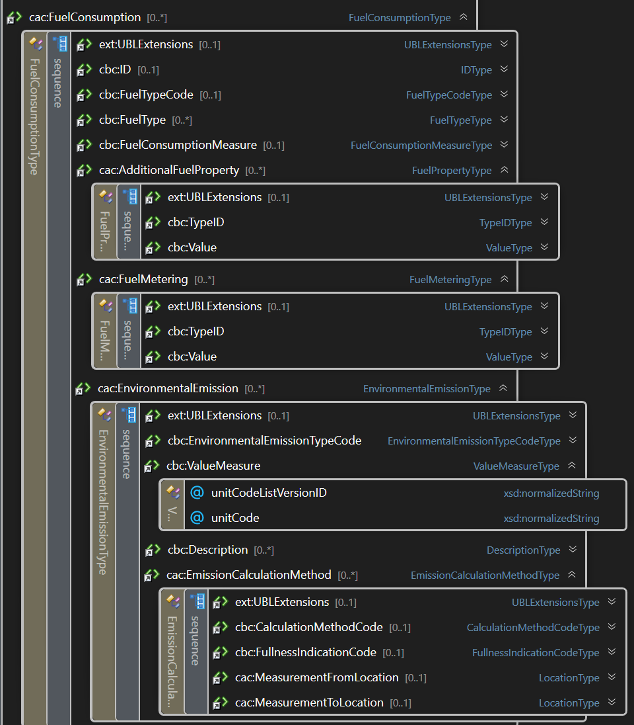
Figure 1 Current structure in 2.4

  - Move the FuelConsumption group to ShipmentStage group on both header and item level. The reason is that a TransportMeans is needed for carbon accounting reasons and that in some cases multiple stages might be needed to fulfill reporting requirements.
  - Add element FuelMeasurementMethod after FuelConsumptionMeasure to inform about how the consumption was measured.
<cbc:FuelMeasurementMethod>StandardEstimate</cbc:FuelMeasurementMethod>

  - Since the calculation of the emission is depending on what type of engine is used, we also suggest to add EngineType in the FuelConsumption (or Fuel) group.
<cbc:EngineType>EURO6</cbc:EngineType>

  - We propose to add some additional information about the fuel and the fuel supplier. We propose to add the group Item in the FuelConsumption (or Fuel) group.
<cac:Item>
<cac:SellersItemIdentification>
<cbc:ID>123</cbc:ID>
</cac:SellersItemIdentification>
<cac:StandardItemIdentification>
<cbc:ID schemeID="0160">1234567891234</cbc:ID>
</cac:StandardItemIdentification>
<cac:ManufacturerParty>
<cac:PartyIdentification>
<cbc:ID schemeID="0088">7300010000001</cbc:ID>
</cac:PartyIdentification>
<cac:PartyName>
<cbc:Name>Preem</cbc:Name>
</cac:PartyName>
</cac:ManufacturerParty>
</cac:Item>
We are not sure if ManufacturerParty is the best choice since it is really the Provider of the fuel, but since ManufacturerParty is already a part of the Item group maybe we can accept that.

