

Standards for Distributed Network Supply Chains

**Computing Ecosystem Supply Chain Technical Committee (CESTC)**

# Abstract

In an era where the computing industry plays a pivotal role in enhancing global productivity, well-being, and creativity, collaborative efforts are essential to construct ecosystems that adapt seamlessly to evolving customer needs.

The global surge in technology demand is exposing significant challenges concerning capital, capacity, and resilience within the technology supply chain. Within the Computing Ecosystem Supply Chain TC (CESTC), we are pioneering a business model centered on data sharing facilitated by distributed ledger technologies integrated with Generative AI capabilities. This innovative approach aims to establish industry standards and solutions that equip our members to address the pressing challenges ahead.

This whitepaper articulates our proposed business model, elucidates the inherent efficiencies, and provides a comprehensive exploration of use cases. Specifically, it underscores the imperative to enhance forecasting accuracy for Demand, Supply, and Inventory throughout the value chain, spanning from N-tier suppliers to end customers. By doing so, we seek to propel advancements in Transparency, Traceability, Sustainability, and Resiliency.

Whether your respective company is a supplier or provider to the semiconductor industry, to original equipment & design manufacturers, system integrators, or a customer in digital value chains; we all face the challenge to improve our working capital through better supply planning, provide shareholder value through timely & accurate forecasts and meet new customer services for trust, security & sustainability.

Value Added Services for End Customers

Call the Quarter and Forecast the Next

Improve Working Capital and Cash Flow

Standards for Data, Entitlement, and Access

*Figure 1. Standards for data and information sharing as a foundation for ecosystem agility*

## Introduction / Opportunity Statement

|  |
| --- |
| This white paper has been crafted by the Computing Ecosystem Supply Chain Technical Committee (CESTC), a collaborative initiative operating within the OASIS Open community. Our committee is committed to influencing the trajectory of standards in our industry. Together, we undertake the pivotal responsibility of prioritizing use cases for standards development. Post-prioritization, we form sub-teams to intricately structure deliverables and establish timelines for our endeavors. Periodically, the outcomes of our collective efforts are presented to the entire group for ratification. |
| *Figure 2. Computing Ecosystem Supply Chain Technical Committee (CESTC)* |
| Our primary focus is the establishment of technical standards for common data representation (including ontologies, taxonomies and schemas), smart contracts, and APIs for seamless interworking on a shared ledger and facilitating generative AI integration.  Beyond the standards, the consortium's ambition is to go further by fostering the creation of compatible business models. These models are designed to empower enterprises, facilitating the exchange of data for mutual benefit. This paper delves into the intricate patterns of data sharing that result in a net-positive value for all participants, ensuring that the investment of human and capital resources yields returns that surpass the contributions made by each individual participant. |

# Case for Ecosystem Collaboration

The complex nature of supply chains in the computing industry highlights the crucial need for enhanced ecosystem collaboration. While interconnected, data systems often operate in isolation, creating communication silos. Shifting to a collaborative ecosystem with connected systems improves visibility, agility, and geo-resilience in supply networks, enhancing efficiency and establishing secure, ethical upstream supply chains. This transition from viewing connected data visibility as optional to a necessity is driven by industry growth, evolving laws and compliance regulations and increasingly sophisticated customer needs.

Comprehensive visibility across the end-to-end supply chain is now an integral prerequisite for seamless business operation, mandated by regulatory frameworks to trace and monitor every aspect, including ethical considerations. This paradigm shift emphasizes the indispensable role of connected data visibility in ensuring business growth, compliance, risk management, and fostering a robust supply chain aligned with responsible and transparent business practices.

The computing ecosystem's ability to optimize collaboration and through interconnected data relies on establishing a scalable, standards-based foundation. Standards are crucial for ensuring operational excellence, serving as the foundation for enterprises to consistently share and access data a shared network. Creating such an open network that allows participants to draw from reliable sources and innovate based on that data, requires a collaborative effort to transparently define common data representation, smart contracts, and APIs. This ensures that all members can seamlessly utilize these specifications, regardless of the specific network solution in their ecosystems. This standardized approach promotes interoperability, efficiency, and collaboration, setting the stage for scalable and sustainable advancements.

The Computing Ecosystem Supply Chain Technical Committee (CESTC) has identified several impactful use cases that could leverage ecosystem collaboration, addressing critical aspects of the supply chain. Each of these included use cases represents opportunities for organizations to contribute learnings in how the broader ecosystem can collaborate to solve common challenges:

* Supply Demand Optimization
  + Enhancing forecasting of supply, demand, and inventory to mitigate material scarcity and reduce the Bullwhip Effect.
  + Improve working capital & resiliency against variability.
  + Network visibility as an industry service.
* Traceability for Materials and Labor:
  + Enhancing visibility into the origin and journey of materials and labor throughout the supply chain.
* Chain of Custody for Authenticity of Components:
  + Ensuring the verifiable authenticity and integrity of components through a secure chain of custody.
* Security Services to Mitigate Vulnerabilities:
  + Implementing services to identify and mitigate vulnerabilities within the supply chain, enhancing overall security.
* Sustainability Services for Carbon Verification:
  + Providing services to verify and assess the carbon footprint of materials and processes, aligning with sustainability goals.
* Geo-balanced Sourcing Profiles:
  + Developing profiles that optimize sourcing strategies based on geographic considerations, promoting a balanced approach.
* End-to-end Traceability from Raw Materials to Finished Goods:
  + Establishing comprehensive traceability from the raw materials stage to the production of finished goods, ensuring transparency.

*Figure 6. Ecosystem supply chain business applications*

# Getting Technical

The Computing Ecosystem Supply Chain Technical Committee (CESTC) will focus on mitigating the impediments to enhance the ease of onboarding trusted data, chaining it together, and delivering it to trusted partners. By mitigating impediments associated with data quality, partner onboarding, and intelligible data parsing, the committee aims to streamline the process of data sharing, ensuring a scalable and efficient ecosystem for all participants. The uses cases that improve ecosystem operations and aid in provisioning new services for customers require a distributed data collaboration tool.

## Distributed Ledger Solution Strengths:

A distributed ledger solution offers three distinctive characteristics that uniquely position it to chain data and foster a network effect of interconnected data across a lifecycle and among ecosystem partners. However, the benefits of these characteristics come with impediments to scaling data sharing services.

1. Immutability:  
   Benefit: Verifiable record of data.  
   Challenge: Requires meticulous attention to data quality to maintain the integrity of the verifiable record.
2. Unlimited Peer Relationships for Sharing Data:  
   Benefit: Facilitates many-to-many secured company relationships.  
   Challenge: Necessitates a standardized model to seamlessly onboard and grant access to the right partners at scale.
3. Data Ontologies by Default as a Chained, Lifecycle View of Data:  
   Benefit: Enables chaining and branching of data.  
   Challenge: Demands attention to simplify linking and parsing data to entitled partners from authoritative sources.

## Standards for Quality and Automation

The three standardization tools we must work with are A) Data Representation B) Smart Contracts, and C) APIs. With these basic building blocks the ecosystem can standardize approaches to on-boarding data, intercompany relationships, and business logic to facilitate automation.

**Addressing Data Quality Issues**

By standardizing data representation, encompassing data attributes, metadata, and controlled lists of values, smart contracts can systematically detect and flag data quality issues. For instance, parameters such as date fields outside the current +/- 1 week, volume quantities exceeding 1.5 times the last period, or unregistered geo-locations can be scrutinized. This ensures that data entering the ledgers adhere to specified standards, promoting accuracy and reliability.

**Chaining Data *Smartly***

A company ideally sends similar transactions to a shared ledger, allowing these transactions to intelligently append to other data, constructing a comprehensive lifecycle view across the value chain. The objective of 'write once, associate many times' requires precise data attributes defined by standards. Smart contracts then utilize these attributes to construct a routing table. For instance, from supplier components in a device to a device in a box, boxes on a pallet, and further decomposed to a device in a rack or a user's hands. The smart contract dynamically builds branches, granting access based on these dynamic branches.

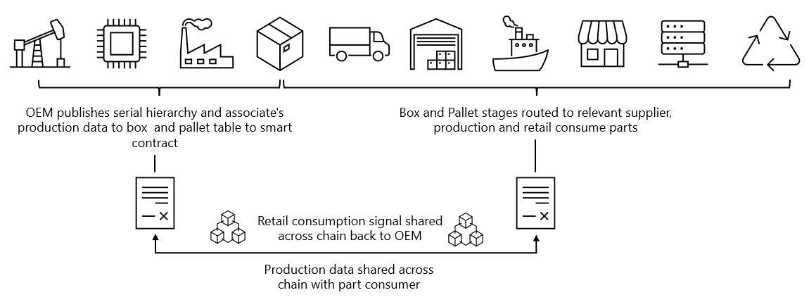

*Figure 4. Selective data sharing mechanism in a distributed network solution*

**Enabling Frictionless Partner Relationships**

Leveraging the product association table, an entitlement smart contract may facilitate the activation of new partners. The CESTC will investigate processes that facilitate creating supplier associations with finished goods information across the value chain. Ultimately, generative AI will play a role in automating partner relationships inherent in the data, but the CESTC focus on security and privacy standards will be important to ensure confidentiality for partner versus ecosystem data.

*Figure 5. Product genealogy structure using smart contract logic*

# Conclusion

A transformative shift is underway in the computing supply chain, marked by the adoption of multi-party data sharing and the integration of chained data across the ecosystem. This evolution introduces new and advanced capabilities that empower ecosystem partners and collectively enhance the computing supply chain.

Ecosystem partners stand to gain substantial benefits from insights derived through aggregated data within the supply chain network. This opens avenues for agility and margin improvement through strategic collaboration. Entitled supply chain partners will have visibility into the movement of products across the entire supply chain, surpassing the traditional 1-up and 1-down exchange of data with direct suppliers and customers. The establishment of a connected ecosystem will result in an improved demand signal and a reduction in the bullwhip effect, ultimately streamlining end-to-end business operations for optimized value chain performance.

To realize efficient, secure, and scalable data sharing and chaining capabilities, the standardization of data representations, APIs, and smart contracts is crucial. The CESTC, through use case proof of concepts, aims to develop technical standards on data integration, data represenations, and data processing elements applicable to any distributed ledger-based technology solution and in future generative AI solutions. The outlined roadmap of deliverables represents the future applications of chained data, highlighting its pivotal role in advancing the computing ecosystem.

# References

LEV, B. (2011, November). *How to Win Investors Over*. Harvard Business Review. Retrieved June 2, 2023, from https://hbr.org/2011/11/how-to-win-investors-over

WAYMAN, R. (2022, March 31). *Earnings Guidance: Can It Predict the Future?* Investopedia. Retrieved June 2, 2023, from <https://www.investopedia.com/articles/analyst/03/012903.asp>

<https://www.truecommerce.com/blog/bullwhip-effect-supply-chain/>

[When Smart Contracts become smarter: The power of AI in Smart Contract (linkedin.com)](https://www.linkedin.com/pulse/when-smart-contracts-become-smarter-power-ai-contract-rockship/)