HARP Overview for Technical Committee
HARP = Hosted Assembly Review Portal
It is not intended to be a CM tool with full functionality. The content is uploaded into a database to be reviewed and commented.
Cloud based software, accessible through a browser.

Main View:
- The project map in the left pane, including individual any content (PowerPoints, word docs, css files, DITA files and DITAmaps).
- Preview of the content appears in the right pane. It will preview any content file it can, excluding Ppt files.
  - Clicking on a DITA map opens it as a table of content with clickable links into the individual topics.
- Functional buttons are in the right pane, above the preview of the current content.
- Project level search is available in the upper right

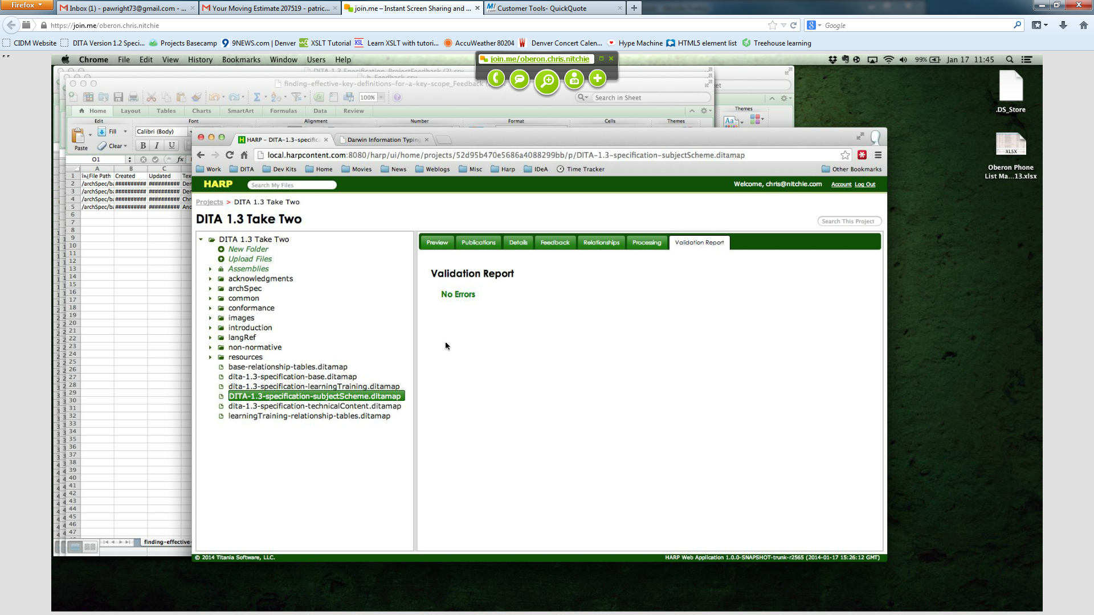

Feedback Mechanisms:
- Comments can be entered with a comment bubble on an individual file. They appear in yellow.
- The user who enters a comment can delete their own. The owner of the project can delete any project.
- Other users can only view a comment.
- Additional comments can be added to the same piece of text or content. But it is not easy to track all of the comments. They will appear in the same comment pop-up, however.
- Comments (at a project level or file level) can be exported to an excel file (csv). It includes date, time, person, file, and other metadata about comments.
- Higher level comments can be left on a DITAmap and they will appear in the preview pane on that map in yellow.
- An HTML view of the comments summary that can be sorted is not available but Chris indicated that it could be quickly built if it is critical. A quick summary is available at the moment (screenshot).
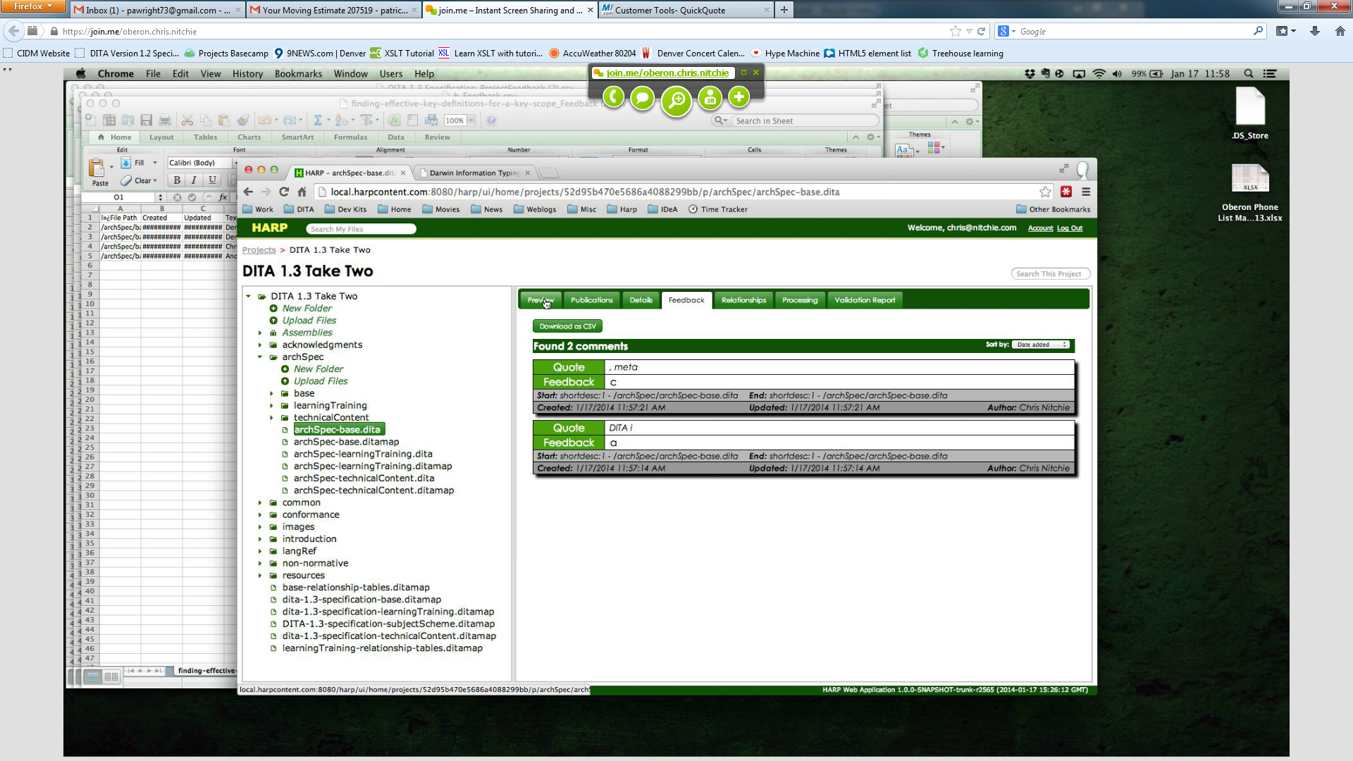
- Uploading a new version of the DITA file will overwrite and comments made to the old version of the file. It was suggested that a new project be created to maintain the old comments (and old file versions).

User Management: Users can be set to owner, reviewer, editor or view only. View only is useful if the project owner wants to prevent any further changes to a project.

