Voting Process

Author C. J. AOUN
Email caoun@election.com
Tel +44 20 8998 4321
Version 3.1
Status Draft
Date 18 December, 2001
Project Election Services Committee - OASIS

When this committee was established it had the following mission statement “develop a standard for the structured interchange of data among hardware, software, and service providers who engage in any aspect of providing election or voter services to public or private organizations. The services performed for such elections include but are not limited to voter role/membership maintenance (new voter registration, membership and dues collection, change of address tracking, etc.), citizen/membership credentialing, redistricting, requests for absentee/expatriate ballots, election calendaring, logistics management (polling place management), election notification, ballot delivery and tabulation, election results reporting and demographics.”

It is necessary to re-examine the list of services to ensure that we have identified the correct ones for the e-voting process.

The core of the deliverable we are working on is the facilitation of data exchange between client and supplier and between suppliers. This data exchange will be the content of any transaction relating to an election. We found it essential to start from the beginning by defining what is an election, in terms of a process, then from there identify what and where data is to be communicated.

From the outset we questioned how general we should remain versus how deep we should drill down, and we decided to start at a very global level. That would be our starting point to share with the committee and from there we can move as far as the majority will agree on and as detailed as possible.

As shown below, the core of our work is the process. From this we should derive our final outputs in terms of XML schemas and standards. The challenge is to put on paper a common process accepted by various governments and democracies.

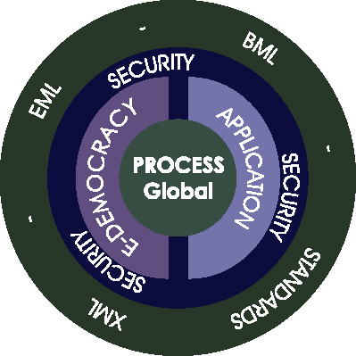

XML is a simple, standard way to delimit exchanged data. Any one can use his/her favorite programming language to create an arbitrary data structure, and then share it with anyone else using any other language on any other computing platform. From this we worked to create where our committee should seek to create those standards of communication. We deduced that at this level we should simply define those standards to exchange data related to election services and not interfere with the engine responsible for generating it.

Now let us move into examining the process and identify where a schema might be needed.

High-Level Process Model
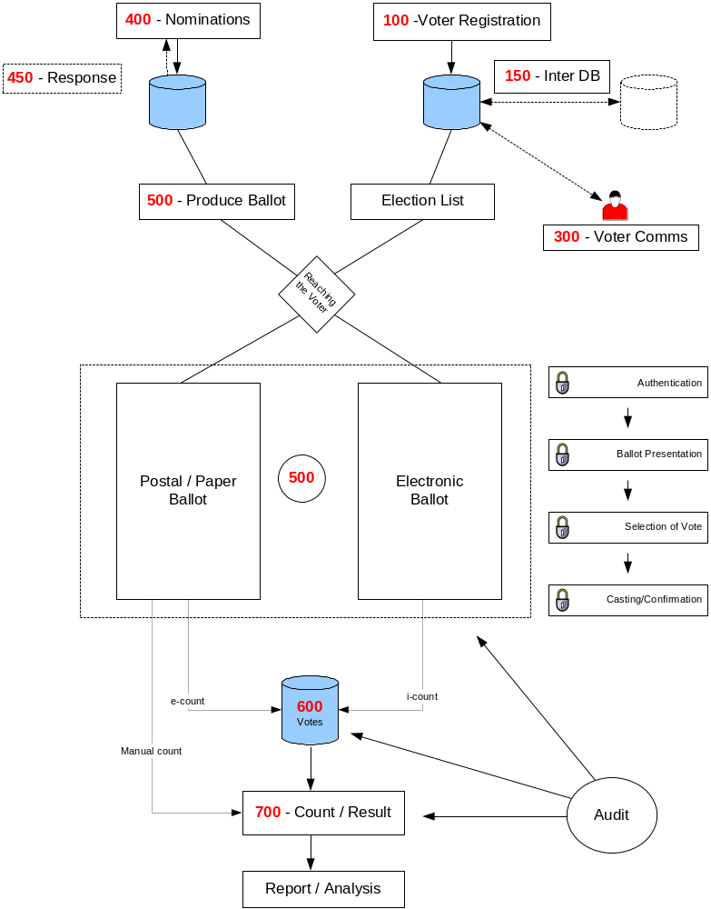
This high-level process model is derived from real life experience designed to accommodate all the feedback and input from this committee members.
Moving forward, this model will be detailed as much as possible to encompass all arenas of election services we are committed to cover.
For clarity and in conform to reality the whole process can be divided into 3 sections:
- Pre election
- Election
- Post election

X i.e.: Received initial committee discussion and approval.
X i.e.: XML Schema available.

X i.e.: Need clarification.

 | Status | Unclear | Schema
- Pre election
  - Voters (see figure A)
- Voter registration ⁽¹⁰⁰⁾ | X |  | X
- Inter database communication ⁽¹⁵⁰⁾ | X |  | X
- Voter Communication ⁽³⁰⁰⁾ |  | X
- Notification ⁽³¹⁰⁾ | X
- Polling card |  | X
- Reminder to vote |  | X
  - Candidates (see figure B)
- Nomination ⁽⁴⁰⁰⁾ | X
- Response to nomination ⁽⁴⁵⁰⁾ | X
- Produce Ballot ⁽⁵⁰⁰⁾ |  |  | X
- Reaching the voter (see figure C) |  | X
- Election (see figure D)
  - Voting
    - Authentication
    - Ballot Presentation ⁽⁵⁰⁰⁾
- Selection /Vote ⁽⁶⁰⁰⁾ |  |  | X
    - Casting
    - Confirmation
- Post election (see figure D)
- Counting and results ⁽⁷⁰⁰⁾ |  | X
- Audit |  | X
- Help Desk |  | X

Figure A:
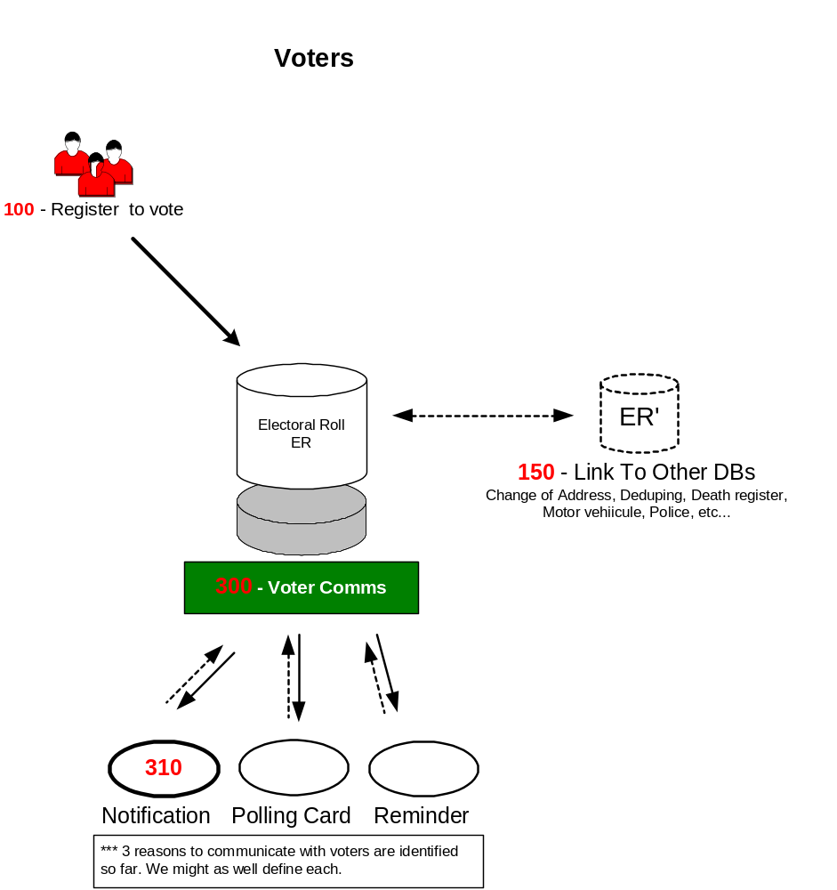
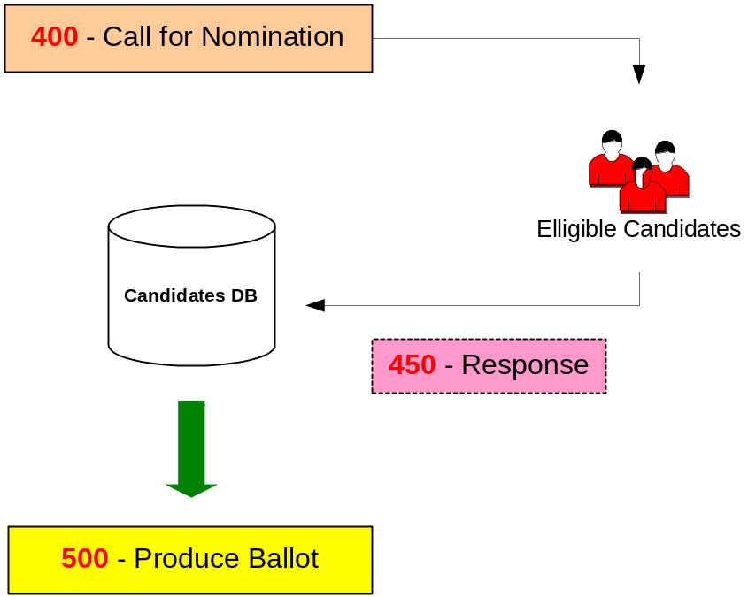Figure B:

Figure C:
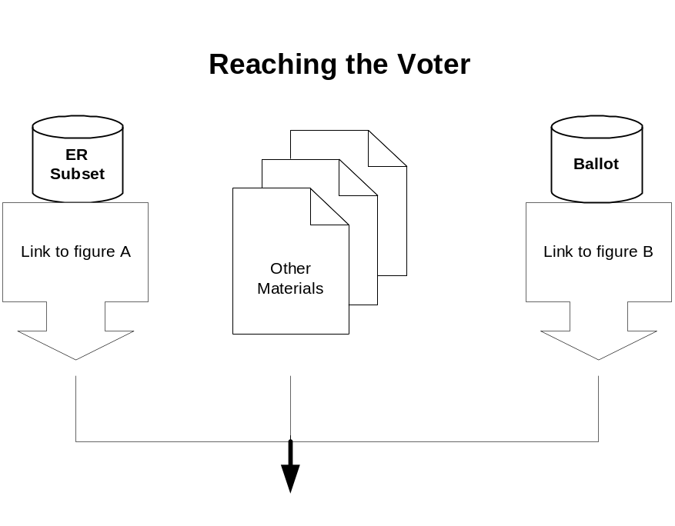

Figure D:
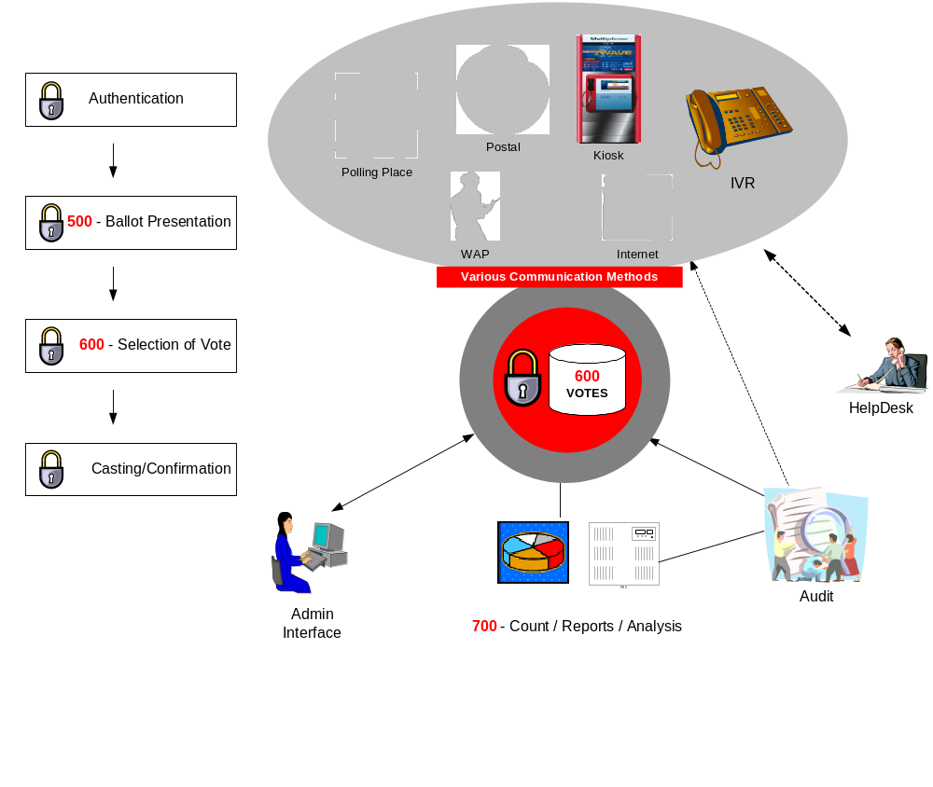
The architecture above is what we propose to symbolize as this global process and interfaces 100 to N00 mark where we thought we should concentrate our efforts. This would be where a schema is probably needed to define what data and how to be interchanged.
However while doing so we came across exceptions related to cultural divide, language, bylaws, different type of service possible etc… From this way of thinking we came to the solution of identifying a common set of data not related or affected by any differences and all governments will agree on needing. The mandatory will be the minimum common set of data likely accepted by all governments and everything else will fall under the optional data. Note here that some of the optional data will be partly considered as required in one system and either optional or even forbidden in others.

I will ignore at this level the language consideration and assume all the work is to be developed in a one language. Of course second phase will be to run thru the schemas and update it accordingly taking into consideration the multi-lingual aspect.

- Voter Registration

Mandatory:

National/Local ID
Name
NameStructure
Electoral Address
AddressStructure
Electoral Contact Info

*** Objective is to link to other committee for names and addresses.

NameStructure
Title
First Name
Last Name
Middle Name

AddressStructure
Address Line 1
Address Line 2
Street Name
City Name
Postcode
Country

ContactStructure
Email
Home Telephone
Work Telephone
Personal Mobile
Business Mobile
Fax

Optional:

Mailing Address
AddressStructure
Mailing Contact Info
ContactStructure
Date of Birth
Effective Date (added and activated to the ER)
Preferred language
Preferred method
Special requests (visually impaired, disabled, need translator, etc…)
Choice of voting method

- Outgoing Voter Communications

Assuming this will cover all type of communications between the election officer(s) and the voter(s).
I still find this section misleading and suggest reworking terminologies or concept for the following reasons:
  - I was able to identify only three scenarios of communication related to a specific election. (1-voter notification, 2- Voter Card, and 3-Reminder to vote)
  - All transactions within an election are considered voter communication incoming and/or outgoing. The ballot is a communication outgoing to the voter and his/her vote is an incoming communication. Etc…

Till we decide on these issues and how to approach I will concentrate on the Voter notification.

Voter notification

Mandatory

Name
NameStructure

Mailing Address
AddressStructure

Voter Number
Election Name
Voting Place
Voting Choices
In person
Postal
Electronically
Return Address
AddressStructure

2a- Incoming Voter Communications

Voter notification

Mandatory

Name
NameStructure

Mailing Address
AddressStructure

Election Name
Voter Number
Voting Choice

- Candidate Nomination

Describes the process where a candidate sends in his nomination.

Mandatory

Candidate Name
NameStructure
Candidate Address
AddressStructure
Contact Info
ContactStructure
Party Name
Election Name
Seat Name
Endorsers (1 to n) n=number of maximum of endorsers required.
Endorser Name
NameStructure
Endorser Address
AddressStructure
Contact Info
ContactStructure
Job Status or Title

Optional
Personal Profile or Biography
Election Statement

- Response to Nomination

Mandatory
Candidate Name
NameStructure
Candidate Address
AddressStructure
Contact Info
ContactStructure
Election Name
Party Name
Seat Name
Nomination accepted Yes/No
Remark

- Ballot

Mandatory
Election Name
Ballot
Ballot Name/Position
Region
Rotation
Voting Instructions

Position Name
Position Description
Max Votes This section repeats / position
Min Votes
Method of voting
Candidate Name
Candidate Party

Optional
Text to Display
Header
Message
Action
Footer
Style sheet

Issues
This outline can cover a wide range of ballots whether FPP or STV, also surveys, referendums etc. But still does not cover all possibilities. For example the proportional list system widely used in Switzerland and Germany. A complicated system including vote by list, crossing out, combined lists, etc… Our view is to deal with each special case separately and generate various standards, one / category. We will restrict our work for the time being on this ballot type which covers basically the majority of voting types.

- Vote

Mandatory
Voter information (NB: Need to clarify what to do in case of anonymous vote.)
Election Name
Ballot
Ballot Name/Position
Region

Position Name
Method
Selection
Name
Weight/Value
Preference

Audit Information
Channel Type (P, I, W, etc)
Operating System information
Type
Version
Location
Counting System information
Type
Version
Location
Batch
Sequence

- Results
*** Not complete yet ***

Mandatory
Election Name
Seat name (1 to n)
Position (1 to n)
Candidate This section repeats n times.
Choice

Issues
At this level are we supposed to deliver only a bulk of data, which is in reality a ready set of data of the actual vote? If we have 10k votes should our output be another set of 10k records with a standard described in this point? Or shall we simply produce a result and define a standard of communicating this result. If so which result format/layout or conditions we should pick, and how do we incorporate the e-vote outcome with any postal and person votes to produce an overall result? By doing so, aren’t we limiting the output? EML is supposed to be exchange of data without limitation of format or layout, we should simply make data available in a uniform and standard data.
Exp:
DB content Vote, date, time, election, seat, Region, sub region, sub-sub-region
We have for example 1000 votes with this format distributed in at least 2 or more tables.
Result standard 1
1000 XML elements of the content combined in one file
Result standard 2
1 XML element summarizing the content (result/candidate for example)

- Post election
*** Not complete yet ***

Issues and Questions still to cover:
- 300 Voter communications: Should we go ahead and identify in what cases an official communication is taking place between the election officials and the voters? Defining a very general voter COMM will not serve the purpose of this committee. As I was able to identify so far only scenarios of communication shall we treat each scenario as 1 set and define a schema / scenario? The term voter communication could be extended to cover ballot and the vote since each single step of the election cycle is in a way or another a voter COMM.
- 700 Count/Result: What is the outcome expected? Are we defining the actual result as a final page? Based on what criteria? Or we simply need to define a schema of data involved in result compilation?
- Audit: We need to define the actual mechanism of audit. Once we do that some data has to be added or included in our schema to make this possible. Audit is a very delicate issue in our committee and will highly affect the over all voting schemas. We need to reach a point of agreement between keeping the vote secret, the voter identity anonymous and at the same time being able to link all under a court order.
- Security/Authentication: outside scope, how would it affect the vote?
I would argue that security is not outside scope of this committee; rather I would argue it is a major element that would affect the acceptance of our product.
Security and Privacy represents the two side of a balance. The more the security is the less privacy and vice versa. A major challenge for our committee is to define the level at which we should stop in a way we offered the maximum security possible without affecting the privacy. (Privacy in this paragraph includes anonymous vote, identity of the voter, how a voter voted.)

- Voter Registration: Annually/Rolling, per election.
- Armed Forces: How are they identified, how do they get enrolled.
- Reporting: include all data, e-vote result, or whole result.
- Re-districting
- Postal vote
- Databases: O/S scope.
- Proportional Voting
- Payment of candidates fees: O/S scope
- Anonymous/Non-Anonymous voting

