NBAC Face-to-Face (F2F) Meeting Minutes
29 October – 1 November 2018

NIEM Management Transition

Mr. Mr. Rory Kinney announced the DOD CIO has accepted NIEM management responsibilities from DHS.

The DOD CIO will chair the NIEM Executive Steering Committee and is looking to extend ESC membership to senior leaders from all NIEM domains.

The Joint Staff J6 will perform NIEM Management Office (MO) duties, formerly called Program Management Office (PMO). Management Office (MO) is now used since the word “program” implies “program of record” within the DOD.

Ms. Christina Bapst-Stump was awarded an Outstanding Achievement Award for her performance as the NIEM PMO Managing Director.

Best of NIEM 2018 Awards

Mr. Rory Kinney, Ms. Christina Bapst-Stump, and Ms. Heather Grace announced and presented the Best of NIEM 2018 award winners to:

Mr. Luvisia Molenje received the “Best Overall” award for the U.S. Citizenship and Immigration Services (USCIS) work with the American Association of Motor Vehicle Administrators (AAMVA) to exchange driver’s license information to support both motor vehicle and immigration law enforcement requirements.

Dr. Christopher Carrino received the “Measurable Impact and Results” award for the U.S. Census Bureau work to exchange census data between more than 50 federal, state, and local census data collection systems.

Mr. Rodney Rourk, Ms. Sandy Freiter, and Mr. Paul Denning received the “Cross-Boundary Collaboration” award for the DOD’s Security Equipment Integration Working Group (SEIWG) work to standardize Force Protection Systems Physical Security Equipment Information Exchanges.

Mr. Thomas Krul received the “Supporting an Efficient and Effective Government” award for Canada’s demonstration of the Trusted Information Exchange Services (TIES) to exchange maritime security information between North Atlantic Treaty Organization (NATO) mission partners.

NIEM Business Architecture Committee (NBAC) Update

Mr. Kamran Atri and Mr. Ryan Schultz summarized the highlights of the NBAC F2F collaborative work from the previous two days and Ms. Heather Grace presented the NBAC 2019 work activities that included:

Defining and delivering NIEM schema requirements to the NTAC.

Updating the NIEM strategy and vision.

Better supporting NIEM Domain Stewards through:

Process Improvement – requirements and capability harmonization

Business Procedures – NIEM configuration change management

Demonstration – improved capabilities and reuse opportunities

GitHub – synchronized collaboration for resolving NIEM business architecture and technical specification issues

Technical Support – continually improve training resources and end-to-end NIEM lifecycle support

NIEM Technical Architecture Committee (NTAC) Update

Dr. Scott Renner and Mr. Mike Hulme presented the NTAC 2018 achievements and 2019 work activities that included:

Completing the NIEM Naming and Design Rules 4.0, NIEM Code List Specification 4.0, and support for JSON

Working toward a simplified way to specify information exchanges (IEPDs) as an alternative to the existing Model Package Description (MPD) Specification

A NIEM JSON technical specification that supports NIEM conformance using JSON instead of XML

A concept for a long term NIEM tool architecture

Technical challenges related to the internationalization of NIEM

NIEM 5.0 technical topics

NIEM Version Release Update

Ms. Christina Medlin provided the following NIEM 4.1 release metrics and schedule for NIEM 4.2 and NIEM 5.0.

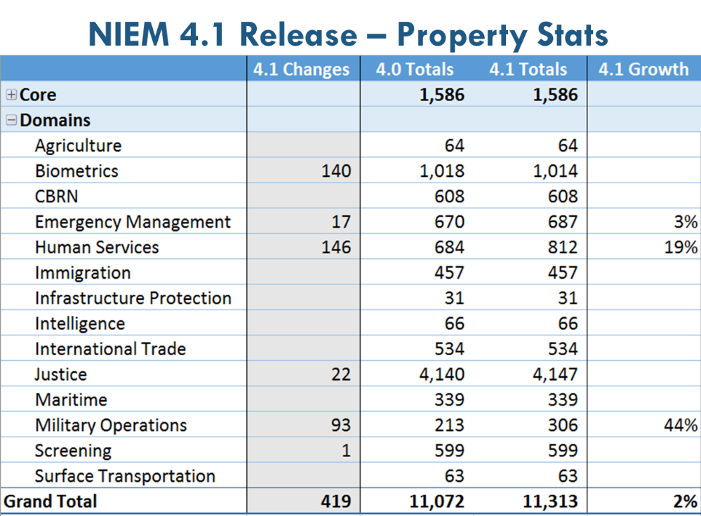

NIEM 4.2 minor release projected schedule:

Alpha 1 - January 2019

Beta 1 0 - March 2019

RC 1 - May 2019

Release - Summer 2019

NIEM 5.0 major release plan:

Alpha 1 - January 2020

Beta 1 - March 2020

RC 1 - May 2020

Release - Summer 2020

NIEM Training Curriculum Overview

Mr. Webb Roberts demonstrated the NIEM training resources located at http://niem.github.io/training/

NIEM training tracks designed to support specific user roles including:

Domain Modeler

IEPD Developer

IEPD Implementer

Domain and Community Updates:

Health – Ms. Sherilyn Pruitt HHS OS/ONC, Ms. Cait Ryan

The U.S. Department of Health and Human Services (HHS) is working to identify a new office for leading NIEM Health community collaboration as the Federal Health Architecture (FHA) organization is being disestablished.

They are working to define public health use cases to improve enterprise information sharing.

One challenge is to share health information while complying with the Health Insurance Portability and Accountability Act (HIPA).

Human Services – Mr. Chris Traver HHS ACF

The Administration for Children and Families (ACF) has initiated the Human Services Data Integration Solutions Community (HSDISC) to coordinate across ACF programs.

Some key objectives are to work trafficking in person and state-based child welfare benefits.

Privacy and confidentiality is a significant challenge to information sharing solutions.

Mr. Traver is concerned that NIEM momentum is slowing at the national level and recommends a NIEM community-based approach to share information between domains with senior leader champions.

Justice – Ms. Kate Silhol Nlets

International Justice and Public Safety Network (Nlets) has about 140 NIEM conformant IEPDs that are being used to support National Crime Information Center (NCIC) state warrant and the Bureau of Justice Statistics (BJS) rap sheet queries.

Emergency Management (EM) – Mr. Kamran Atri DHS

EM is working to support Federal Emergency Management Agency (FEMA) IEPD development that is advancing a JSON infrastructure that has 11 micro services that are NIEM conformant.

The NIEM community has the opportunity to help connect FEMA first responder sensors and recommends synchronizing NBAC/NTAC activities to facilitate implementing solutions to real world problems using available technology.

Statistics – Dr. Chris Carrino U.S. Census Bureau

In preparation for the 2020 census, they used the NIEM Naming and Design rules to standardize data element terms to share information between 62 systems.

Would like to incorporate these census terms into NIEM 4.2 and progress towards onboarding a Statistics domain.

Housing – Dr. Russell Varnado HUD

HUD is like a giant insurance company managing more than 25,000 foreclosed houses, which is down from 250,000.

HUD collaborates with states, banks, mortgage companies, DoT, Grants, and FEMA.

OMB issued policy for Federal departments and agencies to use NIEM, yet many people to not understand NIEM.

Grants – Mr. Kamran Atri DHS

There are 23 agencies managing more than $40B.

Grants has produced several NIEM conformant IEPDs and grant data has been incorporated into NIEM; however there is no steward.

Recommend NIEM MO work to obtain a Grant Domain Steward.

Immigration – Mr. Luvisia Molenje USCIS

USCIS is using NIEM as a canonical data model in more than 200 application program interfaces (APIs) to exchange information between 32 systems in a service oriented architecture (SOA) enterprise service bus (ESB) environment.

USCIS is migrating to microservices with data store.

NIEM opportunities include serialization message streaming, block chain data integrity, evolving a multi-domain model architecture, and aggregate data with micro services.

NIEM selling point is data integrity.

Maritime – Dr. Benjamin Apple, ONI

The Navy has included NIEM in both their Navy and Intelligence data strategies; even though, the Intelligence Community (IC) has rejected NIEM.

Approximately 80% of the Director of National Intelligence (DNI) budget is to support DOD.

Biometrics – Mr. Thomas Freed, DHS OBIM

The Office of Biometric Identity Management (OBIM) is working a rapid DNA prototype with DHS Science and Technology (S&T) and using AWS and Gov Cloud as a conceptual prototyping environment (CPE).

OBIM is building their reference data model to be NIEM conformant.

The cloud is problematic for fingerprint matching in searching over 300 TB of data to identify a match from over 230 M identities.

The DHS Homeland Advanced Recognition Technology (HART) will replace their IDENT legacy system with a SOA, microservices, and an ESB.

Mr. Freed showed a video highlighting their progress and benefit that uses NIEM as a data sharing enabler.

International Tiger Team – Mr. Kamran Atri, Mr. Thomas Krul

Over 250 international attributes have been added to NIEM core.

The Centers for Disease Control and Prevention (CDC) has developed an international information sharing approach that is evolving to NIEM.

Canada is working to solve the language translation information sharing challenge.

Emerging Technologies Tiger Team (ET3) - Mr. Lain McNeill

Highlighting the Columbus, OH Smart City progress using aggregate data for analytics, Mr. McNeill recommend building out NIEM to demonstrate the benefits of using NIEM with technology to real world problems.

Need to identify requirements for open and unstructured data for the NTAC to work NIEM approaches.

IEPD Registry Survey – Ms. Heather Grace, Mr. Chuck Chipman

Demonstrated a conceptual prototype of an IEPD registry using GitHub.

Mr. Traver stated discoverability is key and a repository would help with reuse.

Mr. Freed would like a place to post biometrics IEPDs

The NBAC Co-Chairs agreed to field an initial IEPD registry in 2019.

NIEM Strategic Planning

The NIEM community will work to define a unifying NIEM Vision statement and will discuss during NBAC monthly teleconferences.

The NIEM strategy should align with the Federal Data Strategy.

Some NIEM strategic priorities discussed included:

Advance NIEM adoption

Mature domains

Improve domain support

Solve real world data sharing problems.

Action Items

There are 29 action items and 15 reminders identified during the F2F meeting that will be integrated into the NIEM FY19 work plan and discussed during monthly teleconferences, Excel file attached.

All NIEM F2F briefing materials are posted at: https://niem.github.io/2018-fall/
46 NIEM F2F Participants:
First Name | Last Name | Community / Domain | Organization
Kim | Amster | Biometrics | Integral Consulting
Benjamin | Apple, PhD | Maritime | ONI, Office of the CIO
Kamran | Atri | Emergency Mgmt | DHS NPPD OCIO
Christina | Bapst-Stump | NIEM PMO | NIEM PMO
Bill | Barlow | Military Operations | DoD CIO
Aubrey | Beach III | NIEM MO | JS J6 (BAH)
Jim | Cabral | NTAC
Chris | Carrino, PhD | Statistics | U.S. Census Bureau
Chris | Chamberlin | Biometrics | DHS NPPD OBIM
Chuck | Chipman | Military Operations | GTRI JS J6
Gerard | Christman | NIEM MO | DOD CIO
Paul | Denning | SEIWG | MITRE
Mark | Dotson | Military Operations | DOD JS J6
Thomas | Freed | Biometrics | DHS NPPD OBIM
Sandra | Freiter | Military Operations | SEIWG
Joel | Galloway | Biometrics | SNA International
Heather | Grace | NBAC | Joint Staff J6
William | Graves | Biometrics | DOD PM Biometrics
Dilip | Guha, Ph.D. | NIEM Management | JS J6 DDC5I
Brian | Handspicker | Health | Iris Health Solutions
Dave | Hardy | Military Operations | JS J6
Elie | Hayeck, Ph.D. | NIEM Management | DOD CIO (MITRE)
Mike | Hulme | NTAC | Unisys
Rory | Kinney (SES) | NIEM Management | DOD CIO
Vamsi | Kondannagari | Biometrics | Integral Consulting
Thomas | Krul | Canada | Canada, Public Safety
CJ | Lee, Ph.D. | Biometrics | SNA International
Peter | Mance | Biometrics | Integral Consulting
Andy | Mapes | NIEM Management | DOD CIO
Lain | McNeill | Emergency Mgmt | CSE-Corp
Christina | Medlin | NIEM | GTRI
Luvisia | Molenje | Immigration | DHS USCIS
Ralph | O'Connell | Military Operations | DOD JS J6
Sherilyn | Pruitt | Health | HHS (OS/ONC)
Jafer | Raza | Biometrics | Integral Consulting
Scott | Renner, Ph.D. | NTAC | MITRE
Webb | Roberts | NIEM | GTRI
Curtis | Ross | Immigration | DHS Immigration
Rodney | Rourk | Military Operations | Chair, SEIWG
Cait | Ryan | Health | Iris Health Solutions
Ryan | Schultz | Military Operations | JS J6
Kate | Silhol | Justice | Nlets
Diane | Stephens | Biometrics | NIST
Chris | Traver | Human Services | HHS ACF
Russell | Varnado, Ph.D. | Housing | HUD
Shunda | Woodhouse | Military Operations | JS J6

