Common Transactive Services 1.0
The Energy Mashup Lab Specification
30 November 2020
Editor:
William T. Cox (cto@theenergymashuplab.org wtcox@coxsoftwarearchitects.com)
Toby Considine (director@theenergymashuplab.org toby.considine@gmail.com)
Additional artifacts:
This prose specification is one component of a Work Product that also includes:
- UML models
- JSON schemas
- Simple Binary Encoding binding (FIX)
- XML schemas
Related work:
This specification is related to:
- OASIS Energy Interoperation v1.0 (OASIS Standard) and its TeMIX Profile
- OASIS WS-Calendar Platform-Independent Model v1.0
- OASIS WS-Calendar Streams v1.0
Abstract:
TBD
Status:
This document is produced by The Energy Mashup Lab
Copyright © The Energy Mashup Lab 2020. All Rights Reserved.
Portions taken from Energy Interoperation Version 1.0. Edited by Toby Considine. 11 June 2014. OASIS Standard Copyright © OASIS Open 2014
See full copyright notices below.

Notices
Copyright © The Energy Mashup Lab 2020. All Rights Reserved.
Portions Copyright © OASIS Open 2014. All Rights Reserved.
All capitalized terms in the following text have the meanings assigned to them in the OASIS Intellectual Property Rights Policy (the "OASIS IPR Policy"). The full Policy may be found at the OASIS website.
This document and translations of it may be copied and furnished to others, and derivative works that comment on or otherwise explain it or assist in its implementation may be prepared, copied, published, and distributed, in whole or in part, without restriction of any kind, provided that the above copyright notice and this section are included on all such copies and derivative works. However, this document itself may not be modified in any way, including by removing the copyright notice or references to OASIS, except as needed for the purpose of developing any document or deliverable produced by an OASIS Technical Committee (in which case the rules applicable to copyrights, as set forth in the OASIS IPR Policy, must be followed) or as required to translate it into languages other than English.
The limited permissions granted above are perpetual and will not be revoked by The Energy Mashup Lab or its successors or assigns.
This document and the information contained herein is provided on an "AS IS" basis and OASIS DISCLAIMS ALL WARRANTIES, EXPRESS OR IMPLIED, INCLUDING BUT NOT LIMITED TO ANY WARRANTY THAT THE USE OF THE INFORMATION HEREIN WILL NOT INFRINGE ANY OWNERSHIP RIGHTS OR ANY IMPLIED WARRANTIES OF MERCHANTABILITY OR FITNESS FOR A PARTICULAR PURPOSE.
The Energy Mashup Lab requests that any party that believes it has patent claims that would necessarily be infringed by implementations of this Specification or OASIS Standard, to notify The Energy Mashup Lab Director and provide an indication of its willingness to grant patent licenses to such patent.
The Energy Mashup Lab invites any party to contact The Energy Mashup Lab Director if it is aware of a claim of ownership of any patent claims that would necessarily be infringed by implementations of this specification by a patent holder that is not willing to provide a license to such patent. The Energy Mashup Lab may include such claims on its website, but disclaims any obligation to do so.
The Energy Mashup Lab takes no position regarding the validity or scope of any intellectual property or other rights that might be claimed to pertain to the implementation or use of the technology described in this document or the extent to which any license under such rights might or might not be available; neither does it represent that it has made any effort to identify any such rights.
Table of Contents
1 Introduction 7
1.1 Generality of the Common Transactive Services 8
1.2 Application of the Common Transactive Services 8
1.3 The EML-CTS System 9
1.4 Terminology 9
1.5 Normative References 9
1.6 Non-Normative References 10
1.7 Naming Conventions 11
1.8 Editing Conventions 11
1.9 Architecture 12
1.9.1 Security Considerations 12
1.9.2 CTS Extended Example 12
2 Overview of Common Transactive Services 13
2.1 Scope of Common Transactive Services 13
2.2 Specific scope statements 13
2.3 Assumptions 13
2.3.1 Conformance with Energy Interoperation 13
2.3.2 Conformance with EMIX 14
2.3.3 Conformance with WS-Calendar Streams 14
2.3.4 Compatibility with Facilities Smart Grid Information Model 14
2.4 Common Transactive Services Architecture 15
2.4.1 Sides in Tenders and Transactions 16
2.4.2 Semantic Composition 16
2.5 Products and Instruments 17
3 Services and Operations 19
3.1 Structure of Common Transactive Services and Operations 19
3.2 Naming of Services and Operations 19
3.3 Payloads and Messages 20
3.4 Description of the Services and Operations 20
3.5 Responses 20
4 Transactive Services 23
4.1 Pre-Transaction Services 23
4.1.1 Interaction Pattern for the EiTender Service 23
4.1.2 Information Model for the EiTender Services 24
4.1.3 Operation Payloads for the EiTender Service 26
4.2 Transaction Management Services 27
4.2.1 Interaction Pattern for the EiTransaction Service 27
4.2.2 Information Model for the EiTransaction Service 27
4.2.3 Operation Payloads for the EiTransaction Service 28
4.3 Comparison of Transactive Payloads 29
5 Market Information 31
5.1 The Market Context 31
5.2 Interaction Pattern for the Market Context Service 31
5.3 Information Model for the EiMarketContext Service 32
5.4 Operation Payloads for the EiMarketContext Service 32
6 Bindings 33
6.1 JSON 33
6.2 XML Schema 33
6.2.1 XML Namespaces 33
6.3 Simple Binary Encoding 33
7 Conformance of Common Transactive Services 35
8 Claiming Conformance to Common Transactive Services 37
Appendix A. Acknowledgments 39
Appendix B. Background and Development history 40
Appendix C. Glossary 41
Appendix D. Revision History 42

Index to Figures
Figure 3-1: Example of generic error response for a service operation 21
Figure 4-1: UML Sequence Diagram for the EiTender Service 24
Figure 4-2: Class EiTenderType 24
Figure 3-3 Enumeration TransactiveStateType 25
Figure 4-4: UML Class Diagram for the Operation Payloads for the EiTender Service 26
Figure 4-5: UML Sequence Diagram for the EiTransaction Service 27
Figure 4-6: UML Class Diagram of EiTransaction 28
Figure 4-7: UML Class Diagram of EiTransaction Service Operation Payloads 28
Figure 4-8: UML Diagram comparing all Transactive Payloads 29
Figure 5-1: UML Sequence diagram for Market Context service 31

Index to Tables
Table 3-1: EiResponse Attributes 21
Table 4-1: Pre-Transaction Tender Services 23
Table 4-2: EiResponse Attributes 25
Table 4-3: Transaction Management Service 27
Table 4-4: EiTransaction Attributes 28

Introduction
Common Transactive Services (CTS) allows actor interaction with any market. Technically, CTS is a streamlined and simplified profile of the OASIS Energy Interoperation (EI) specification, which describes an information and communication model to coordinate energy between any two parties, such as energy suppliers and customers, markets and service providers.
Transactive Resource Management (TRM) has been used for many non-energy resources, such as water delivery, network bandwidth, and even internet advertising. The initial research in TRM used a market to allocate heat within a commercial building [TRM]. In TRM, a resource is defined as a tradable commodity whose value depends on price, location, and time of delivery [EMIX]. TRM balances supply and demand over time using automated voluntary transactions between market participants.
TRM applied to energy is commonly referred to as Transactive Energy (TE). Neither EI nor CTS specifies which technologies participants will use; rather they define a technology-agnostic interface to enable accelerated market development of such technologies.
TRM is a means to allocate transactable energy resources including the delivery of commodities such as electrical energy, electrical power, natural gas, and thermal energy such as steam, hot water, or chilled water. Transactable energy resources also include the capability to deliver resources, such as transmission line capacity and flow-rate capacity.
The Common Transactive Services are a lightweight profile of the OASIS Energy Interoperation specification. All CTS messages are simple and make no assumptions about the systems behind the messages.
The target actors for CTS include but are not limited to
- Smart Buildings/Homes/Industrial Facility
- Building systems/devices
- Business Enterprises
- Vehicles
- Microgrids
- IoT (Internet of Things) devices
Transactive Energy has the potential to make our electrical system more efficient, by better matching supply and demand in real time. TE enable actors to use energy when it is less expensive and produce energy when it’s more valuable, thus reducing reliance on distant suppliers while maximizing use of local power sources. TE relies on markets and consumer choice to make better decisions about power supply and use.
TE demonstrations and deployments to date have been unique systems—each uses its own message model and its own market dynamics. Many early implementations required the use of central or cloud-based markets. Central markets discount local decision making while introducing new barriers to resilience. Others rely on a single price-setting supplier. None are interoperable either at the system level or for the actors involved.
Turning back to the more general Transactive Resource Management, nothing in CTS restricts its use to electricity-based markets. Natural gas markets share many characteristics with electricity markets. Local thermal energy distribution systems can balance electricity markets while having their own surpluses and shortages.
Progress toward TE can be accelerated if a common interaction model is used across systems. Looked at from another perspective, a client written for a participant in one such system should be able to interoperate with another TE system. The Common Transactive Services from The Energy Mashup Lab fulfil that promise.

Generality of the Common Transactive Services
CTS can be used to trade (Tender, Transact on) any [Transactive Resource]. While our focus is generally on electrical energy or power, in the rest of this document we use [power] to mean electrical energy or power or any other Transactive Resource.
The actual product in EML-CTS (next section) is implicit in the market with which one communicates. This limits complexity of product definition to a useful level, so market and product definition may be considered configuration rather than data.

Application of the Common Transactive Services
The purpose of this specification is to codify the common interactions and messages required for simple markets, hence for simple transactive energy markets. Any system able to use CTS should be able to interoperate with any CTS-conforming market with minimal or no change.
CTS defines communications between market actors and does not define the market or the device controls. Autonomous market actors must be able to recognize patterns and make choices to best support their own needs. Actors need not share details of their internal operations with others.
CTS is valuable for creating micromarkets to manage power within microgrids. Micromarkets support the capability for dynamic restructuring of grids for fault resilience and efficiency [GridFaultResilience]. Micromarkets contain complexity by abstracting interactions to the few common messages of CTS.
CTS does not presume a market with a single seller (e.g., a utility). CTS recognizes two parties to a transaction, and the role of any party can switch from buyer to seller from one transaction to the next. Each Resource Offer (Tender) has a Buy or Sell side attribute. We assume that when each transaction is committed (once power has been purchased) it is owned by the purchaser, and it can be re-sold as desired or needed.
A CTS-operated micromarket may balance power over time in a traditional distribution system attached to a larger power grid or it may bind to and operate a stand-alone autonomous microgrid [BusinessCase].

The EML-CTS System
In 2015, the US National Institute for Standards and Technology (NIST) began the Transactive Energy Modeling and Simulation Challenge (TE Challenge). A report delivered to TE Challenge in 2016 [CTS2016] defined a small subset of Energy Interoperation, known as the Common Transactive Services.
In 2019, The Energy Mashup Lab, under contract to NIST, began developing an open source software system (Apache 2.0 license) that uses a robust financial or “order book” market for peer-to-peer transactions. The system architecture separates market interactions from the actors buying and selling power. The architecture also permits changing the market engine itself. This implementation is called EML-CTS and is available today.
In creating EML-CTS members of The Energy Mashup Lab further simplified CTS as a smaller subset profile of the Energy Interoperation TeMIX profile [TEMIX].
TE demonstrations have used different market engines, including double auction markets. EML-CTS was designed to be able to use any (e.g. either, both, or some other market engine) while keeping interactions between systems and the market unchanged.
The EML-CTS 1.0 implementation uses Java class definitions similar to those in the UML in this specification. Messages are sent using REST POST operations, and JSON serialization uses the Java classes.

Terminology
The key words “MUST”, “MUST NOT”, “REQUIRED”, “SHALL”, “SHALL NOT”, “SHOULD”, “SHOULD NOT”, “RECOMMENDED”, “MAY”, and “OPTIONAL” in this document are to be interpreted as described in [RFC2119]

Normative References
[EMIX] Energy Market Information Exchange (EMIX) Version 1.0, January 2012, OASIS Committee Specification 02, Latest version: http://docs.oasis-open.org/emix/emix/v1.0/emix-v1.0.html.
[EnergyInterop] Energy Interoperation Version 1.0. Edited by Toby Considine. 11 June 2014. OASIS Standard. http://docs.oasis-open.org/energyinterop/ei/v1.0/energyinterop-v1.0.html.
[JSON] JavaScript Object Notation and JSON Schema. https://cswr.github.io/JsonSchema/
[RFC2119] S. Bradner, Key words for use in RFCs to Indicate Requirement Levels, http://www.ietf.org/rfc/rfc2119.txt, IETF RFC 2119, March 1997.
[RFC2246] T. Dierks, C. Allen Transport Layer Security (TLS) Protocol Version 1.0, http://www.ietf.org/rfc/rfc2246.txt, IETF RFC 2246, January 1999.
[SBE] Simple Binary Encoding Technical Specification 1.0. FIX Trading Community, June 16, 2016. https://www.fixtrading.org/standards/sbe/
[WS-Calendar-PIM] WS-Calendar Platform Independent Model (PIM) Version 1.0. Edited by William Cox and Toby Considine. 21 August 2015. OASIS Committee Specification. http://docs.oasis-open.org/ws-calendar/ws-calendar-pim/v1.0/ws-calendar-pim-v1.0.html.
[MIN] WS-Calendar Minimal PIM-Conformant Schema Version 1.0. Edited by William Cox and Toby Considine. 26 August 2016. OASIS Committee Specification. http://docs.oasis-open.org/ws-calendar/ws-calendar-min/v1.0/ws-calendar-min-v1.0.html .
[Streams] Schedule Signals and Streams Version 1.0. Edited by Toby Considine and William T. Cox. 18 September 2016. OASIS Committee Specification. http://docs.oasis-open.org/ws-calendar/streams/v1.0/streams-v1.0.html.
[XSD] W3C XML Schema Definition Language (XSD) 1.1. Part 1: Structures, S Gao, C. M. Sperberg-McQueen, H Thompson, N Mendelsohn, D Beech, M Maloney http://www.w3.org/TR/xmlschema11-1/, April 2012, Part 2: Datatypes, D Peterson, S Gao, A Malhotra, C. M. Sperberg-McQueen, H Thompson, P Biron, http://www.w3.org/TR/xmlschema11-2/ April 2012

Non-Normative References
[Actors] C. Hewitt, "Actor Model of Computation: Scalable Robust Information Systems," arxiv.org, 2010.
[Framework] National Institute of Standards and Technology, NIST Framework and Roadmap for Smart Grid Interoperability Standards, Release 1.0, January 2010, http://nist.gov/public_affairs/releases/upload/smartgrid_interoperability_final.pdf
[CTS2016] Cox, W. T., Cazalet, E., Krstulovic, A., Miller, W., & Wijbrandi, W. Common Transactive Services. TESC 2016. Available at http://coxsoftwarearchitects.com/Resources/TransactiveSystemsConf2016/Common%20Transactive%20Services%20Paper%2020160516.pdf
[EML-CTS] Energy Mashup Lab Common Transactive Services (open source software) https://github.com/EnergyMashupLab/eml-cts)
[FSGIM] Facility smart grid information model. ISO 17800. https://www.iso.org/standard/71547.html 2017
[iCalendar] Internet Calendaring and Scheduling Core Object Specification (iCalendar), https://tools.ietf.org/html/rfc5545. 2009, B. Desruisseaux, See also Calendar Availability, https://tools.ietf.org/html/rfc7953, C. Daboo, M. Douglas. 2016
[SmartGridBusiness] Toby Considine and William Cox, Smart Loads and Smart Grids—Creating the Smart Grid Business Case. Grid-Interop 2009. Available at http://coxsoftwarearchitects.com/Resources/Grid-Interop2009/Smart%20Loads%20and%20Smart%20Grids.pdf
[StructuredEnergy] Structured Energy: Microgrids and Autonomous Transactive Operation, http://coxsoftwarearchitects.com/Resources/ISGT_2013/ISGT-Cox_StructuredEnergyPaper518.pdf . Innovative Smart Grid Technologies 2013 (IEEE).
[GridFaultResilience] William Cox and Toby Considine, Grid Fault Recovery and Resilience: Applying Structured Energy and Microgrids. IEEE Innovative Smart Grid Technologies 2014. Available at http://coxsoftwarearchitects.com/Resources/ISGT_2014/ISGT2014_GridFaultRecoveryResilienceStructuredMicrogrids_Paper.pdf
[TRM] B. Huberman and S. H. Clearwater, Thermal markets for controlling building environments, Energy Engineering, vol. 91, no. 3, pp. 26- 56, January 1994.
[UML] Object Management Group, Unified Modeling Language (UML), V2.4.1, August 2011. http://www.omg.org/spec/UML/2.4.1/

Naming Conventions
This specification follows some naming conventions for artifacts defined by the specification, as follows:
For the names of elements and the names of attributes within XSD files and UML models, the names follow the lowerCamelCase convention, with all names starting with a lower-case letter. For example,
<element name="componentType" type="ei:ComponentType"/>
For the names of types within XSD files, the names follow the UpperCamelCase convention with all names starting with a lower-case letter prefixed by “type-“. For example,
<complexType name="ComponentServiceType">
For clarity in UML models the suffix “type” is not always used.
For the names of intents, the names follow the lowerCamelCase convention, with all names starting with a lower-case letter, EXCEPT for cases where the intent represents an established acronym, in which case the entire name is in upper case.
JSON and where possible SBE names follow the same conventions.

Editing Conventions
For readability, element names in tables appear as separate words. The actual names are lowerCamelCase, as specified above, and as they appear in the UML models, and in the XML and JSON schemas.
All elements in the tables not marked as “optional” are mandatory.
Information in the Meaning column of the tables is normative. Information appearing in the Notes column is explanatory and non-normative.
Examples and Appendices are non-normative.

Architecture
Services requests and responses are public actions of each interoperating system. Service actions are independent from private actions behind the interface (i.e., device control actions). A service is used without needing to know all the details of its implementation. Services are generally paid for results, not effort.

Security Considerations
Loose integration using the SOA style assumes careful definition of security requirements between partners. Size of transactions, costs of failure to perform, confidentiality agreements, information stewardship, and even changing regulatory requirements can require similar transactions be expressed within quite different security contexts. It is a feature of the SOA approach that security is composed in to meet the specific and evolving needs of different markets and transactions. Security implementation is free to evolve over time and to support different needs. The Common Transactive Services allow for this composition, without prescribing any particular security implementation.

CTS Extended Example
As an extended example, using the Common Transactive Services, a microgrid is comprised of a number of interacting nodes (parties). Those parties interact in a micromarket co-extensive in scope with the microgrid. No actor reveals any internal mechanisms, but only its interest in buying and selling power.
CTS can also be used for the fractal integration of microgrids. Any micromarket can be bound to or co-extensive with a node in a larger microgrid. A micromarket participating in this way exposes only its aggregate market position. Any participant in CTS effectively aggregates resources it logically contains.
In a similar way, in considering a topology of microgrids, any participant in the original micromarket MAY itself represent a contained autonomous microgrid or, in fact, any autonomous entity whether or not it is managed in turn by a market. [StructuredEnergy][SmartGridBusiness]

Overview of Common Transactive Services

Scope of Common Transactive Services
CTS engages Transactive Resources, e.g. Distributed Energy Resources (DER) and any provider or consumer of energy, while making no assumptions as to their processes or technology.
This specification supports agreements and transactional obligations, while offering flexibility of implementation to support specific approaches and goals of the various participants.
No particular agreements are endorsed, proposed or required in order to implement this specification. Energy market operations are beyond the scope of this specification although interactions that enable management of the actual delivery and acceptance are within scope but not included in CTS 1.0.
As shown in [CTS2016] the Common Transactive Services with suitable product definitions can be used to communicate with essentially any market.

Specific scope statements
Interaction patterns and service definitions to support the following are in scope for Common Transactive Services:
- Interaction patterns to support transactive energy.
- Information models for price and product communication.
- Payload definitions for Common Transactive Services
The following are out of scope for Common Transactive Services:
- Requirements specifying the type of agreement, contract, product definition, or tariff used by a particular market.
- Computations or agreements that describe how power is sold into or sold out of a market.
Section 0 describes standard bindings, which may be extended by The Energy Mashup Lab or others in the future.

Assumptions

Conformance with Energy Interoperation
OASIS Energy Interoperation [EnergyInterop] Transactive Services is the basis for CTS, which draws definitions of actors, parties, and transactive interactions from the Energy Interoperation TEMIX profile.
Energy Interop assumes an Energy Services Interface (ESI) as the external face of the energy-consuming or supplying node. Energy Interop defines an end-to-end interaction model; this characteristic is shared by CTS.

Conformance with EMIX
This specification uses models and artifacts simplified from and in the style of OASIS Energy Market Information Exchange [EMIX] to communicate product definitions, quantities, and prices. EMIX provides a succinct way to indicate how prices, quantities, or both vary over time.
The EMIX product definition, as included in the Transactive Resource, is implied in CTS 1.0. Future CTS specifications may include market context from EMIX and Energy Interop, as well as other information on products and markets including market terms.

Conformance with WS-Calendar Streams
The WS-Calendar specifications express sequences and enable negotiation of schedules in a manner that is semantically compatible with human schedules, i.e., [iCalendar]. The WS-Calendar Platform Independent Model (PIM) [WsCalendar-PIM] defines common semantics for the specifications. WS-Calendar is the standard under the NIST Smart Grid Roadmap for all such communication.
WS-Calendar is used to describe products whose value changes with time of delivery, and again into Energy Interoperation, which uses Transactive Resources.
This specification bases its representation of single intervals on Schedule Signals and Streams [Streams], a WS-Calendar-PIM conforming specification for expressing consecutive occurrences of schedules or products.
A current implementation, EML-CTS, transacts a single interval at a time expressed as a single-interval Stream. Energy systems supported by CTS-based markets may express their requirements and capabilities over time using multi-interval Streams or in separate single-interval Streams.

Compatibility with Facilities Smart Grid Information Model
The Facilities Smart Grid Information Model [FSGIM] was developed to define the power capabilities and requirements of building systems over time. FSGIM addresses the so-called built environment and uses the semantics of WS-Calendar and EMIX to construct its information models for [power] use over time. These sequences of [power] requirements are referred to as load curves. Load curves can potentially be relocated in time, perhaps delaying or accelerating the start time to get a more advantageous price for [power]. These load curves are the basis upon which a TE Agent would base its market decisions.
The Architecture of EML-CTS is premised on distinct physical systems being able to interoperate by coordinating their production and consumption of [power] irrespective of their ownership, motivations, or internal mechanisms. This specification defines messages and interactions of that interoperation.
CTS tenders and transactions can be used to express FSGIM load requests. CTS 1.0 uses single-interval Streams to express single-interval tenders in anticipation of the possible use of Streams in FSGIM-conformant communications.

Common Transactive Services Architecture
The implied CTS architecture is drawn from and is a subset and simplification of the architecture presented in [EnergyInterop]. Specifically, the Energy Interoperation architecture uses the Service-Oriented Architecture (SOA) model which has become the consensus view for energy-related interoperation.
The Energy Mashup Lab uses the Actor Model, which can be implemented in SOA with a few lightweight Service Operations. The Lab adapted the SOA model of Energy Interoperation into an Actor-to-Actor model that requires fewer and lighter weight messages.
The Actor Model names a style of system integration used for high scalability and resilience. The Actor Model uses a small number of simple messages to coordinate behavior among simple agents termed Actors. Note that Actors need not be actually simple; any complexity in the Actors are reduced to simple messages.
Simple messages are an essential aspect of actor architectures. The Common Transactive Services are a lightweight profile of the OASIS Energy Interoperation specification, and in fact of the TEMIX profile of Energy Interoperation. All CTS messages are simple and make no assumptions about the systems behind the messages.
Just as the market participants present simple messages, so too, does the market. The internals of a market contain a market engine to match tenders and to declare contracts. The rules used to match tenders could be nearly instant order book, or periodic double auction, or some other model. This complexity is hidden. The market receives tenders and announces contracts. Only the simple messages of CTS are used.
All interactions described in CTS are as defined in [EnergyInterop]. That specification describes interactions between pairs of actors, and, in a deployment, relationships are established among actors. Actors may perform in pairwise chains of actors.
All interactions and actors below are described as if for Actors in electrical energy markets. For use in other transactive energy markets, or even transactive resource markets, only the product or resources would be changed.
An actor takes on a role, for example a business role as a Party. In the UML model, PartyId and CounterPartyId inherit from ActorId which in turn inherits from class UidType.

Sides in Tenders and Transactions
At any moment, a Party has a position which represents the cumulative amount of power (or other product) that an actor has previously transacted for that time interval.
A Party can take one of two Sides in a given Transaction:
- Buy, or
- Sell
A Party selling [power] relative to its current position takes the Sell Side of the Transaction. A Party buying [power] relative to its current position takes the Buy Side of the Transaction.
From the perspective of the market, there is no distinction between a party selling additional power and party selling from its previously acquired position. An Actor representing a generator generally takes the Sell side of a transaction. An Actor representing a consumer generally takes the Buy side of a transaction. A generator may take the Buy Side of a Transaction in order to reduce its own generation, in response either to changes in physical or market conditions or to reflect other commitments made by the actor. A consumer may choose to sell from its current position if its plans change, or if it receives an attractive price. A power storage system actor may choose to buy or sell from interval to interval, consistent with its operating and financial goals.
We do not specify how the [power] is delivered. For example, a long-distance transfer might be implemented with the seller selling power to its local grid and the buyer buying power from its local grid, with financial reconciliation producing the same result as a direct sale and deliver.

Semantic Composition
The semantics and interactions of CTS are selected from and derived from [EnergyInterop].
Energy Interoperation incorporates two other standards, [EMIX] and [WS-Calendar], and uses an early Streams definition.
- EMIX describes price and product for electricity markets.
- WS-Calendar communicates schedules and sequences of operations. This specification uses the [Streams] optimization which is a standalone specification, rather than part of Energy Interoperation 1.0.
- Energy Interoperation uses the vocabulary and information models defined by those specifications to describe the services that it provides. The payload for each Energy Interoperation service references a product defined using [EMIX]. EMIX schedules and sequences are defined using [WS-Calendar]. Any additional schedule-related information required by [EnergyInterop] is expressed using [WS-Calendar].
- Since [EnergyInterop] was published, a semantically equivalent but simpler [Streams] specification was developed in the OASIS WS-Calendar Technical Committee. CTS uses that simpler [Streams] specification.
In effect, CTS is a profile of Energy Interoperation but with simplified information models and defines only payloads, not the messaging.
CTS 1.0 supports a market for a single product (say energy) in multiple time intervals.
Product definition in CTS 1.0 are implicit but characteristics can be discerned using the market context requests and responses.
Future development of CTS is planned to include discoverable market and product description information through the EMIX and Energy Interoperation Market Context. The EMIX Market Context associates market rules and catalogs the products tradeable.
Future versions of CTS will support multiple markets and multiple products.
All terms used in this specification are as defined in their respective specifications.

Products and Instruments
An EMIX product is a specific resource. To transact that product, it is packaged in a tender with a specific quantity for a specific duration.
CTS transacts power products at specific times. The thing traded (often called an instrument in financial markets) includes the product together with quantity and the time interval. Tenders become contracts when a tender to buy some quantity of a product are matched with a tender to sell the same quantity of that product.

Services and Operations
This section re-iterates terms and simpler models from [EnergyInterop]. That specification is normative.
This terminology is used through all payload definitions presented in this specification.
The column labeled Response lists the name of the service operation payload (in Energy Interoperation and its TEMIX profile, this includes the service operation as well) invoked in response. Most operations have a response. The roles of Service Consumer and Service Provider are reversed for the Response.
For transactive services any party may receive tenders (priced offers) of service and possibly make tenders (priced offers) of service.
Any party using transactive energy services may own generation or distributed generation or reduce or increase energy from previously transacted energy amounts. The dispatch of these resources and the use of energy by a party are influenced by tenders between Parties that may result in new Transactions and changes in operations.

Structure of Common Transactive Services and Operations
The Common Transactive Services presented in this specification are only
- Transactive Services—for implementing transactions and tenders
We include UML definitions for the standard payloads for service requests, rather than the service, communication, or other characteristics. In Section 6 we describe standard serialization for the CTS standard payloads; additional bindings may be used by conforming implementations.

Naming of Services and Operations
The naming of services and operations follows a pattern defined in . Services are named starting with the letters Ei following the Upper Camel Case convention. Operations in each service use one or more of the following patterns. The first listed is a fragment of the name of the initial service operation; the second is a fragment of the name of the response message which acknowledges receipt, describes errors, and may pass information back to the invoker of the first operation.
Create—Created An object is created and sent to the other Party
Cancel—Canceled A previously created request is canceled
For example, to construct an operation name for the EiTender service, "Ei" is concatenated with the name fragment (verb) as listed. An operation to cancel an outstanding Tender is called EiCancelTender.

Payloads and Messages
We define only the payloads; the particular networking technique and message structure is determined by the applications sending and receiving CTS payloads.

Description of the Services and Operations
The sections below provide the following for each service:
- Service description
- Table of operations
- Interaction patterns for the service operations in graphic form, using Energy Interoperation normative interactions
- Normative information model using [UML] for key artifacts used by the service
- Normative operation payloads using [UML] for each operation

Responses
In a service interaction, responses may need to be tracked to determine if the transaction is successful or not. This may be complicated by the fact that any given transaction may involve the transmission of one or more information objects.
An EiResponse returns the success or failure of the entire operation, with possible detail included in responseTermsViolated (not in this release)..
It is MANDATORY to return as appropriate both errors and success in responses.
The class diagram in Figure 3-1 reflects the generic response in CTS 1.0.
The description of EiResponseType is from Energy Interoperation, changing only the cardinality of responseDescription (to zero, that is, not passed).
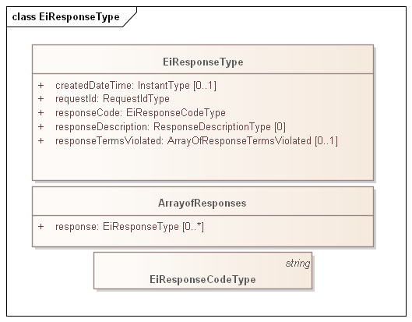
Figure 3-1: Example of generic error response for a service operation
The attributes of EiResponseType are in the following table.
Table 3-1: EiResponse Attributes
Attribute | Meaning | Notes
Created DateTime | Optional timestamp indicating the date and time when this EiResponse was created
Request ID | A reference ID which identifies the artifact or message element to which this is a response. The Request ID uniquely identifies this request, and can serve as a messaging correlation ID. | Provided by the payload generation and/or messaging system.
Response Code | The Response Code indicates success or failure of the operation requested. The Response Description is unconstrained text, perhaps for use in a user interface.  The code ranges are those used for HTTP response codes, specifically  1xx: Informational - Request received, continuing process  2xx: Success - The action was successfully received, understood, and accepted  3xx: Pending - Further action must be taken in order to complete the request  4xx: Requester Error - The request contains bad syntax or cannot be fulfilled  5xx: Responder Error - The responder failed to fulfill an apparently valid request | EML-CTS uses response code 200 for success
Response Description | The Response Description is in the model but profiled to be cardinality 0..0. | Not present in CTS 1.0 payloads
Response Terms Violated | The Terms Violated by the request to which this is a response. Conforming CTS 1.0 implementations SHALL omit this attribute. | Market Terms and Market Context may be implemented in a future release. Work is in progress to profile and simplify the terms.

There is no exhaustive list of all possible Response Codes. The Response Codes are intended to enable even the smallest device to interpret Response. This specification uses a pattern consisting of a 3-digit code, with the most significant digit sufficient to interpret success or failure. This pattern is intended to support that smallest device, while still supporting more nuanced messages that may be developed.
While the only value after the leading digit the Response Code defined in Energy Interoperation is 00, conforming specifications may extend these codes to define more fine-grained response codes. These should extend the pattern above; for example, a response code of 403 should always be within the realm of Requester Error.
EML-CTS uses response code 200 for success.

Transactive Services
Transactive Services define and support the lifecycle of transactions from initial Tender to final settlement. The phases described in [EnergyInterop] are
- Registration—to enable further phases. (Not part of CTS)
- Pre-Transaction —binding tenders for transactions. (Part of CTS)
- Transaction Services—execution and management of transactions. (Part of CTS)
- Post-Transaction—settlement, energy used or demanded, payment, position. (Not part of CTS)
For transactive services, the roles are Parties and Counterparties.
The terminology of this section is that of business agreements: tenders and transaction. The Service descriptions and payloads are simplified and updated from those defined in Energy Interoperation.

Pre-Transaction Services
Pre-transaction services are those between parties that may prepare for a transaction. The pre-transaction services in CTS is EiTender with payloads shown in Table 4-1.
Tenders and transactions are artifacts based on [EMIX] artifacts suitably flattened and simplified, and which contain schedules and prices in varying degrees of specificity or concreteness.
Table 4-1: Pre-Transaction Tender Services
Service | Request Payload | Response Payload | Notes
EiTender | EiCreateTenderType | EiCreatedTenderType | Create and send Tender
EiTender | EiCancelTenderType | EiCanceledTenderType | Cancel one or more Tenders
EiTender | EiDistributeTenderType | None | Distribute a list of Tenders to a transport or messaging system defined list of parties

Interaction Pattern for the EiTender Service
Figure 4-1 presents the [UML] sequence diagram for the EiTender Service. Note that EiDistributeTender is not part of CTS 1.0, but is being considered for a future release.
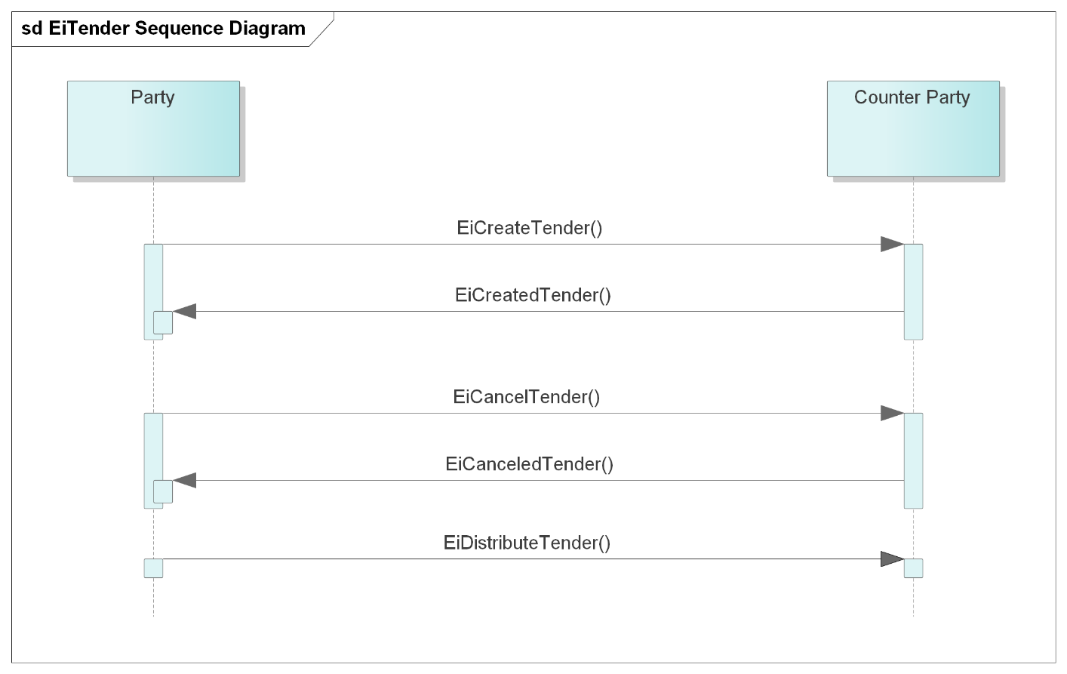
Figure 4-1: UML Sequence Diagram for the EiTender Service

Information Model for the EiTender Services
The information model for the EiTender Service artifacts follows that of [EMIX], but flattened and with product definition implied by the implementation.
Time interval, price, and quantity are key elements for a product; the other aspects of product definition (e.g. energy and units) are implicit as described in Section 2.4.2.
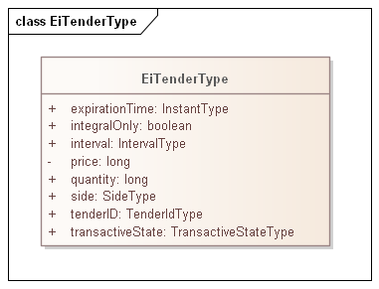
Figure 4-2: Class EiTenderType
The attributes of EiTender are shown in the following table.
Table 4-2: EiResponse Attributes
Attribute | Meaning | Notes
Expiration Time | The date and time after which this Tender is no longer valid.
Integral Only | All of the Tender must be bought or sold at once; no partial sale or purchase | In CTS set to False. Partial sale or purchase is always allowed. The attribute is present for possible future evolution.
Interval | The time interval for the product being offered
Price | The unit price for the product being offered | Total price is the product of price and quantity
Quantity | The quantity of the product being offered | Total price is the product of price and quantity
Side | Whether the tender is to buy or to sell the product
Tender ID | An ID for this tender
Transactive State | The transactive state of this payload (tender) | See below

Transactive State is a concept from EMIX; it describes the state of an object. For CTS 1.0, only states tender and transaction are used.
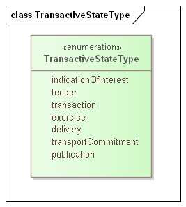
Figure 3-3 Enumeration TransactiveStateType

Operation Payloads for the EiTender Service
The [UML] class diagram describes the payloads for the EiTender service operations.
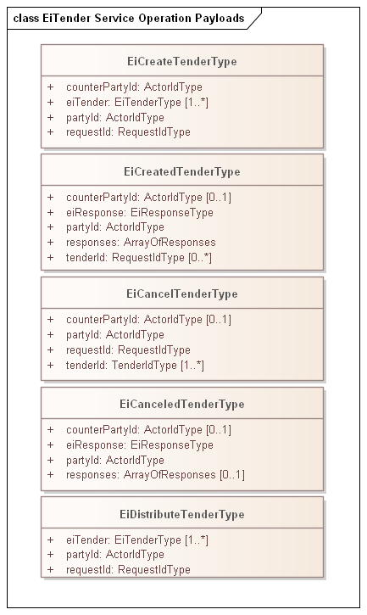
Figure 4-4: UML Class Diagram for the Operation Payloads for the EiTender Service

Transaction Management Services
This section presents the Transaction Service payloads.
market context and product are implied and may in the future be made explicit with a Market Context reference (see Section 2.4.2). Canceling or modifying transactions is not permitted in either CTS or Energy Interoperation. Following the approach in distributed agreement protocols, compensating tenders and transactions SHOULD be created as needed to compensate for any effects.
Table 4-3: Transaction Management Service
Service | Request | Response | Notes
EiTransaction | EiCreateTransactionType | EiCreatedTransactionType | Create and send Transaction

Interaction Pattern for the EiTransaction Service
This is the [UML] sequence diagram for the EiTransaction Service:
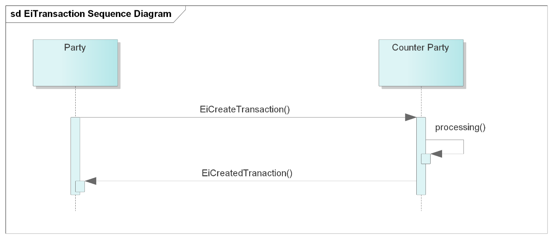
Figure 4-5: UML Sequence Diagram for the EiTransaction Service

Information Model for the EiTransaction Service
Transactions are derived from [EMIX] artifacts including a Stream with time, quantity, and price. Flattening similar to that in EiTender is used.
Although an EiTransaction object includes the original EiTender, the EiTransaction carries its own Transactive State.
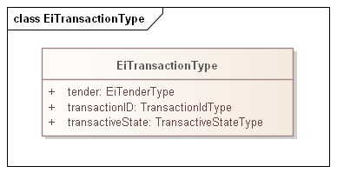
Figure 4-6: UML Class Diagram of EiTransaction
The attributes of EiTransaction are shown in the following table.
Table 4-4: EiTransaction Attributes
Attribute | Meaning | Notes
Tender | The tender (Fig. 4-2) that led to this Transaction. | The ID, quantity and price may differ from that originally tendered due to market actions.
Transaction ID | An ID for this Transaction | The contained Tender has its own TenderID
Transactive State | The transactive state of this payload is transaction | See Figure 3-3 Enumeration TransactiveStateType

Operation Payloads for the EiTransaction Service
The [UML] class diagram describes the payloads for the EiTransaction service operations.
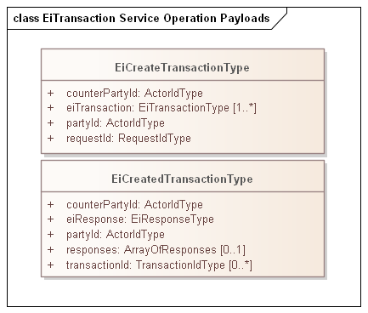
Figure 4-7: UML Class Diagram of EiTransaction Service Operation Payloads

Comparison of Transactive Payloads

Figure 4-8: UML Diagram comparing all Transactive Payloads
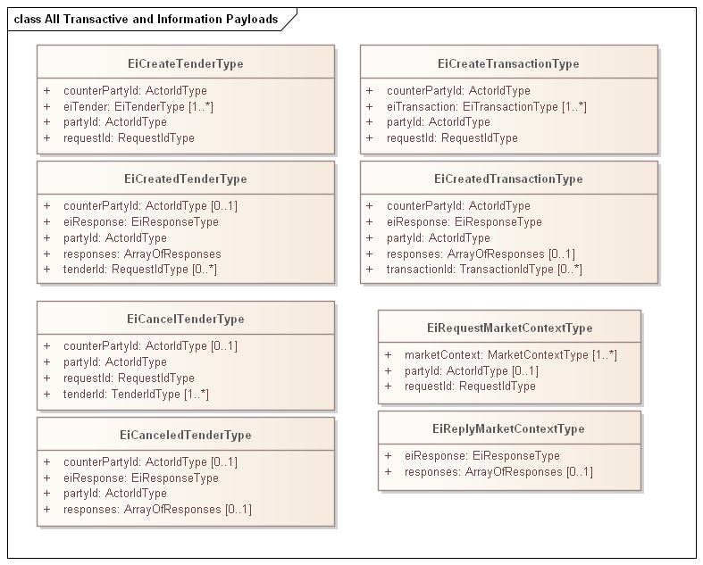

Market Information
Each Event and Service in Energy Interoperation takes place within a Market Context. This Context defines the behaviors that that each Party can expect from the other.
This concept with some simplification is part of the Common Transactive Services.
This is work in progress.

The Market Context
Market Contexts are resolvable URIs and are used to express market information that rarely changes, so it is not necessary to communicate it with each message.
In any market context, there are standing terms and expectations about product offerings. If these standing terms and expectations are not known, many exchanges may need to occur before finding products that meet those expectations. If these expectations are only known through local knowledge, then national and international products need to be re-configured for each local market that they enter. If all market information were to be transmitted in every information exchange, messages based on EMIX would be overly repetitive.
The Market Context for CTS is simplified from that in Energy Interoperation.

Interaction Pattern for the Market Context Service
The Market Context Service enables a Party to request the details of a Market Context. Parties MAY be able to request and compare Market Contexts to select which markets to participate in. Such Interactions are out of scope for this specification.
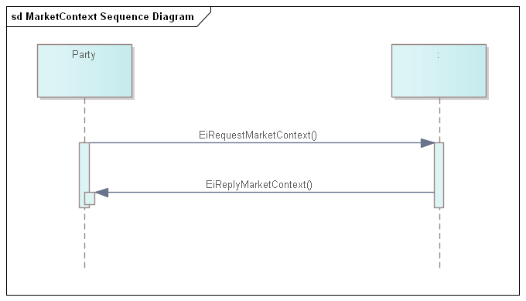
Figure 5-1: UML Sequence diagram for Market Context service
The Market Context service can retrieve the full information associated with an EiMarketContext. There is one operation and a responding operation.
Profiled and simplified market context information is planned for a future release.

Information Model for the EiMarketContext Service
Simplified profile pending.

Operation Payloads for the EiMarketContext Service
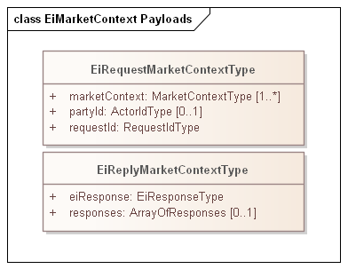
Figure 5-2: UML of Market Context Service payloads

Bindings
Payloads and interaction patterns are described in [UML] in Section 1 above. This section contains bindings for the payloads in three encoding schemes:
- JSON [JSON]
- XML Schema [XSD]
- FIX Simple Binary Encoding [SBE]

JSON
TODO—JSON Schema available

XML Schema
TODO—XML Schema available

XML Namespaces

Simple Binary Encoding
TODO—Work in progress

Conformance of Common Transactive Services
By design, CTS is a simplified and restricted subset profile of TeMIX. CTS simplifies aspects of OASIS Energy Interoperation, and omits other aspects. This section informally describes how CTS relates to the TeMIX profile. CTS is a profile of the TeMIX Profile of Energy Interoperation 1.0, described in Section 14.2 of [EnergyInterop] with the following changes:
- Only the Payloads for Service Operation and the interaction patterns are defined.
- The following Services from the TeMIX profile are omitted:
  - EiRegisterParty
  - EiQuote
  - EiEnroll
  - EiDelivery
- The following Services from the TeMIX profile are included and simplified as follows.
  - Attribute names have been made consistent with lowerCamelCase conventions.
  - The inheritance hierarchy for UIDs and identifier types have been simplified
    - Only selected identifier types are included
    - The identifier types in this draft specification are opaque types rather than strings
  - The enumeration TransactiveStateType is identical to that in Energy Interoperation, but only the following Transactive States are used:
    - Tender
    - Transaction
    - Indication of Interest (pending work in progress)
  - Market Context and the EMIX Market Context are flattened and simplified as follows:
    - MarketContextType is a URI.
    - Standard Terms are not profiled in this draft, but are planned to be a flattened and simplified subset of the EMIX Standard Terms.
Portions of CTS conform to and use updated and simplified versions of the specifications consumed by Energy Interoperation, specifically
- OASIS WS-Calendar [MIN]
- OASIS WS-Calendar Schedule Streams and signals [Streams]
This draft specification uses the WS-Calendar [MIN] interval directly (as IntervalType). An update in progress will instead use WS-Calendar Schedule Streams and Signals [Streams] with single interval streams. This will permit future implementations to use streams of values where appropriate.

Claiming Conformance to Common Transactive Services
This section will describe conformance clauses for implementations claiming conformance to Common Transactive Services.

- Acknowledgments
This specification began with William Cox leading the Common Transactive Services team in the 2015-2016 NIST Transactive Energy Challenge to define the initial structure of the CTS [CTS2016].
Others picked up and used that work, culminating in a contract from NIST with TC9, Inc and Cox Software Architects LLC to develop agents to support co-simulation of bilateral markets with GridLAB-D™ input models in the NIST Cyberphysical systems modelling platform. That contract required all work to be open source from day one, and all work to be done in the open. TC9 opted to perform the work in the open repositories of The Energy Mashup Lab. NIST has incorporated that code into their TE Market simulation model.
The initial draft of CTS 1.0 (this specification) was based on clarifications and simplifications discovered building the internal services and APIs of that project. The Lab has continued to refine that work through and with the NJIT Capstone Projects.
All work continues in the open GitHub repositories, and all code is licensed under an Apache 2.0 license.
The following individuals have participated in the creation, refining, and implementation of this specification and are gratefully acknowledged:
- NIST, the National Institute of Standards and Technology, including
  - David Holmberg
  - Thomas Roth
- Members of the WS-Calendar, Energy Market Information Exchange, and Energy Interoperation TCs (see acknowledgement in the respective specifications)
- Members of the NIST Transactive Energy Challenge Common Transactive Services work group (see acknowledgement in the respective specification and paper)
- New Jersey Institute of Technology and the NJIT Capstone program where The Energy Mashup Lab worked with faculty, staff, and teams of Seniors and Masters students, specifically
  - Professor Osama Eljabiri
  - Capstone Executive Team members for each term listed below
  - Team Members Fall 2020: Omair Abdul, Omar Janouk, Matthew Molinari
  - Team members Summer 2020: Indira A. Akkiraju, Josiah Nieves, Alex Shepherd
  - Team members Spring 2020: Matt Amato, Dhruvinkumar Desai, Anupam Saini, Justin Schuster
  - Team members Fall 2019: Rajeev Chanchlan, Jasper Sam David, Mounica Gona, Dhrumil Shah, Karan Shah
- The Energy Mashup Lab, its officers and associates
  - Toby Considine
  - William Cox
  - David A Cohen
- Background and Development history
The Common Transactive Services (CTS) are a lightweight profile of the OASIS Energy Interoperation Standard [EnergyInterop].
The Energy Interoperation Technical Committee was formed to define the necessary interactions between Smart Grids and their end nodes, including Smart Buildings, Enterprises, Industry, Homes, and Vehicles. The specification defines data and communication models that enable standard exchange of signals for dynamic pricing, reliability, and emergencies. Energy Interoperation supports market-based balancing of energy supply and demand while increasing fluidity of contracts.
In 2015, the US National Institute for Standards and Technology (NIST) began the Transactive Energy Modeling and Simulation Challenge (TE Challenge). A report delivered to the TE Challenge and a paper delivered to the Transactive Energy Systems Conference [TESC2016] defined a minimal subset of Energy Interoperation, which became known as the common transactive services. The report further showed commonality between the messages of existing TE systems, including several not based on Energy Interoperation.
The Energy Mashup Lab has created an open source implementation using the Common Transactive Services called EML-CTS, which has in turn helped us to further simplify the original description of CTS and led to this evolved specification.
The EML-CTS v1.0 system uses CTS message payloads expressed in JSON for all market communications. The Lab plans to contribute this specification to the OASIS Energy Interoperation Technical Committee as the basis for work on a standard lightweight specification for The Common Transactive Services.
- Glossary
No definition in this glossary supplants normative definitions in this or referenced specifications. They are here merely to provide a guidepost for readers at to terms and their special uses. Implementers will want to be familiar with all referenced standards.
Actor is an architectural component that interacts with other actors. Actors may take on roles, e.g. as a Party in a transaction.
Agreement is broad context that incorporates market context. Agreement definitions are out of scope in the Common Transactive Services.
EMIX: As used in this document, EMIX objects are descriptions applied to a WS-Calendar Sequence. EMIX defines Resource capabilities, used in tenders to match capabilities to need, and in Products, used in tenders and in specific performance and execution calls. Please note that CTS uses more recent WS-Calendar specifications than that used in EMIX, and that the product definition in CTS 1.0 is implicit.
Party or Transactive Party is a role that an actor may take. In the EML-CTS implementation, the Local Market Agent (LMA) is not a party, but the Transactive Energy User Agent (TEUA) is a party and represents its Energy Manager.
Resource (as defined in EMIX): A Resource is something that can describe its capabilities in a Tender into a market. How those Capabilities vary over time is defined by application of the Capability Description to a WS-Calendar Sequence. See [EMIX].
Stream: A set of contiguous intervals of the same size. See [Streams]
Tender: A tender is an offering for a Transaction. See Transaction.
Transaction: A binding commitment between parties entered into under an agreement.
- Revision History

Revision | Date | Editor | Changes Made
CTS 1.0 Draft of 2020-10-28 | 2020-10-28 | William Cox | First published document.  Evolved from OASIS Energy Interoperation Standard, CTS reports and papers, and the EML-CTS project
CTS 1.0 Contribution Version | 2020-11-30 | William Cox | Updated text and references for planned contribution to OASIS Energy Interoperation Technical Committee

See http://docs.oasis-open.org/emix/emix/v1.0/cs02/emix-v1.0-cs02.html#_Toc319594576
In North American wholesale electricity markets, transmission rights are bought and sold.
https://github.com/EnergyMashupLab/eml-cts
In ISO and IEC terminology, portions that are not normative are informative. OASIS uses the term non-normative instead.
See e.g. Energy Interoperation EiDelivery Service https://docs.oasis-open.org/energyinterop/ei/v1.0/os/energyinterop-v1.0-os.html#_Toc388604056
See Section 1.5 Normative References
See Section 1.1.
Conformance with the Energy Interoperation TEMIX Profile may require single intervals.
See C. Hewitt, "Actor Model of Computation: Scalable Robust Information Systems," arxiv.org, 2010, or C. Hewitt, "A Universal Modular Actor Formalism for Artificial Intelligence," ICJA, 1973, or many other references
https://www.oasis-open.org/committees/tc_home.php?wg_abbrev=ws-calendar
Most underlying matching engines and markets trade instruments, which are associated with a product definition —which may not be fully expressed in an EMIX product definition—plus quantity and time.
This pattern was developed and is used by current work in the IEC Technical Committee 57 (Power Systems).
This contrasts with Energy Interoperation, where it is not mandatory to return any responses if the entire EiCancelTender service operation was completed successfully. The pattern in Energy Interoperation is to return those that have failed (required) and those that succeeded (optional).
As an example of the Correlation Pattern for messages
See e.g. https://en.wikipedia.org/wiki/List_of_HTTP_status_codes
See, e.g., WS-Transaction and WS-BusinessActivity.
This is consistent with the way that distributed agreement protocols such as [WS-BusinessActivity] manage compensation rather than cancelation.
https://github.com/EnergyMashupLab/eml-cts
See http://docs.oasis-open.org/emix/emix/v1.0/cs02/emix-v1.0-cs02.html#_Toc319594576

