Introduction

All countries are based on the rule of law and all of them have extensive internet sites, Official Journals, for editing and communicating legislation to the general public and businesses. The process of cooperation at the international level has increased the need to identify and exchange legal information.
This need is partially met by the digitalization of legal information and the widespread use of the internet. However, the use of legal information is greatly limited by the differences that exist in the various legal systems and in the way in which relevant information is organized and classified or stored in technical systems. It is even further hampered by the amount of legal data available.
Citation and exchange of legal information across borders and across different systems, and in particular data relating to international, European or national legislation would be very useful to all. In order to facilitate the further development of interlinked legal data and to serve legal professionals and citizens, we are missing some of the most basic building blocks for interoperability in order to share, cite and link legal data. Benefiting from the emerging architecture of the semantic web and Linked Open Data, this solution would allow a greater and faster exchange of data by enabling an automatic and efficient exchange of information. It would also allow humans and machines to have an improved access to Governments’ legislation, allowing easy referencing, understanding the meaning of the information processed, downloading, analyzing, re-using and interconnecting different information and sources across domains.
Parsing or resolving the documents could be a nice side effect, but it should not be the final goal.
Constructing a universal pattern, given the differences in national legal systems, would be unnecessary complex and would not cover special cases, therefore almost impossible. But constructing common building blocks for naming and citing legislation documents, with additional structured metadata, that are sufficiently standardized and flexible and that respect each countries unique legislative and legal tradition, would be feasible. It should also take in consideration that this should be a cost-effective implementation on top of existing IT solutions or databases, and it should be designed to work seamlessly on top of existing systems.

Building common blocks

In line with the principle of proportionality and the principle of decentralization, each country and company should continue to operate its own national Official Journals and Legal Gazettes or legal databases in the way they prefer. We should therefore construct carefully a system to cite and identify legislation in order to respect the legal and constitutional differences between countries. The trade-off for this flexibility is that implementing such a solution requires a degree of judgment, thought and experience and that we agree and accept that there will be some differences in the solutions found by different countries or entities.

Identification and citation of legal documents

Depending on the legal environment, users identify or cite legislation differently, some use the type (Law, constitution etc.), others include date references (date of signature, date of publication, date of consolidated act etc.), other use common names for a given act of legislation.

For the identification and citation of legislation, simple general blocks should be used.

Out of these blocks a simple unique identifier could be constructed which is recognizable, readable and understandable by both humans and computers, and which is compatible with existing technological standards. In addition, a common set of standardized metadata elements to describe legislation in compliance with a recommended ontology could be presented in order to guarantee interoperability.

In summary, three elements would compose the solution, and could be implemented step by step:
- HTTP Uniform Resource Identifiers (URIs) build out of simple common building blocks
- Set of metadata
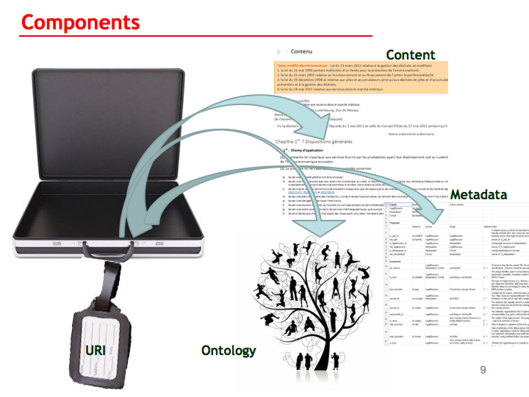
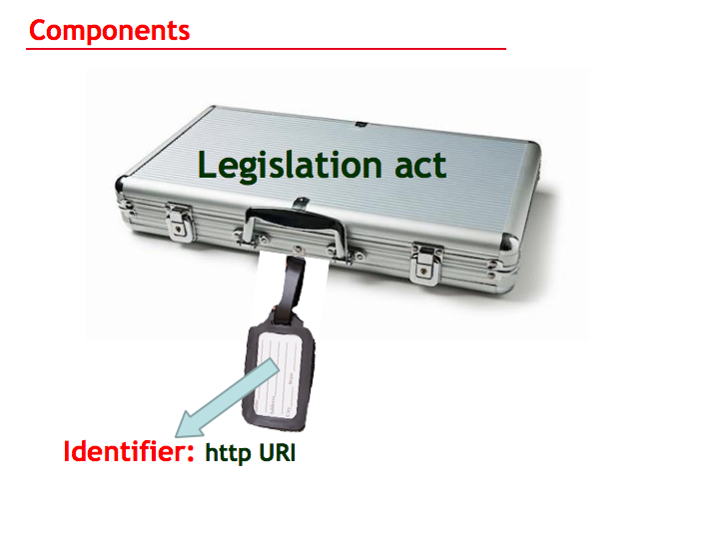
- Exchange format - Ontology

URI

Building your identifiers you should keep in mind different considerations:
  - Build for humans and computers http URIs
- start designing with data and not with pages
- ask yourself if bringing the structure FBER model into the URI does bring any real benefit
- document your URI schema
  - Identify your first order objects and make them addressable
  - Use user-friendly, readable, reliable and hackable URIs
- ask yourself how the users cite your legislation
- have tasteful user-friendly URIs
- put forward the social considerations and not the technical function of the URI
      - uniquely identify legislation in a unique manner, depending on what is unique - to identify your legislative acts
  - Add additional information
      - you may want to add in the metadata
      - correlate with external identifier schemes
      - create parallel data services using other standards

The goal of achieving something that could work consistently in all countries and legal data publishers is unattainable in that sense. It is important to have good schema for each country and institutions that share some common principles. The publishers should have complete freedom to create their own identifiers with a set of building blocks out of a common toolbox.

URI should not only have a technical consideration, but also a social consideration. Identifiers for our legislation should be user-friendly and popular in its terms of use.

Any additional information you may want to add could be added to the metadata which you will receive when you dereference the identifier. For this, one essential requirement is that you have an HTTP URI.

In essence, it is important that the URI is flexible and user-friendly with well-defined consistent metadata. Finding the minimum level of agreement on the basis of common building blocks, will enhance interoperability, and therefore would feasible and could be implemented by many.

Use Cases:

Luxembourg

Publisher: Government - Official Journal
Mark-up is done manually and the URI links are added to the XML structured data.

References or citations to other acts are mainly mentioned by “Type” and “Date”.
http://eli.legilux.public.lu/eli/etat/leg/loi/2014/04/02/n3/jo/references
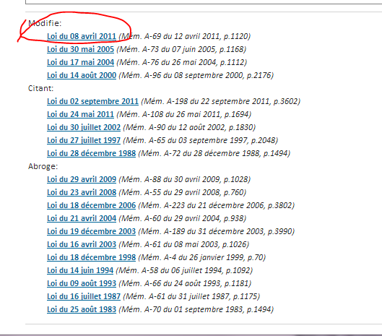

Sometimes the short title is also added in citations.
Example: « Loi du 29 mars 2013 relative à l'organisation du casier judiciaire et aux échanges d'informations extraites du casier judiciaire entre les états membres de l'union européenne et modifiant »
Law of 29 March 2013 concerning (in French: “relative”) the organization of …
URI structure would be http://eli.legilux.public.lu/eli/etat/leg/loi/2013/03/29/n10

http://eli.legilux.public.lu/eli/etat/leg/loi/2011/04/08/n2
Details for building the URI out of the information
Loi | http://eli.legilux.public.lu/eli/etat/leg/loi/
2011 | http://eli.legilux.public.lu/eli/etat/leg/loi/2011/
Avril | http://eli.legilux.public.lu/eli/etat/leg/loi/2011/04/
8 | http://eli.legilux.public.lu/eli/etat/leg/loi/2011/04/08/
n2 | To have the uniqueness I need to add something:  By building the final Uri I had the possibility to choose a unique number from the database eg 123456 or something else, but none of this the final users could have found or known it.  So I kept it simple Number 1 number 2 = n1 n2 … easier to remember !  And for the moment it is the order of publication in the PDF.

Original Text from the introduction text in the law:
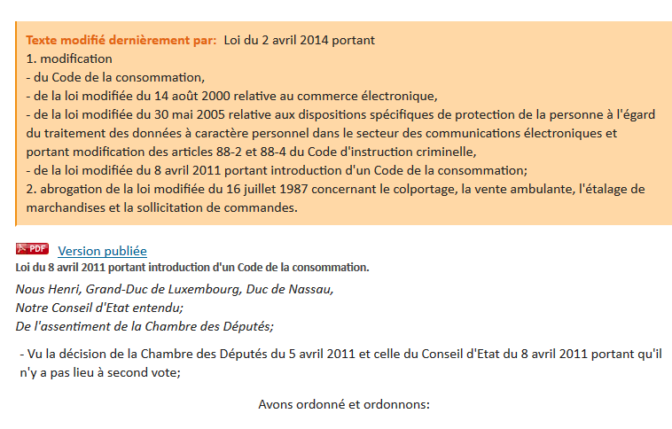

Details of the above introduction below:
Modification  • du Code de la consommation,  • de la loi modifiée du 14 août 2000 relative au commerce électronique,  • de la loi modifiée du 30 mai 2005 relative aux dispositions spécifiques de protection la personne à l'égard du traitement des données à caractère personnel dans le secteur des communications électroniques et portant modification des articles 88-2 et 88-4 du Code d'213instruction criminelle,  • de la loi modifiée du 8 avril 2011 portant introduction d'un Code de la consommation; | This law modifies :  Different Codes  The law of August 14 2000 regarding electronic commerce  Etc.  Remarks:  Does not mention what exactly is modified
abrogation de la loi modifiée du 16 juillet 1987 concernant le colportage, la vente ambulante, l'étalage de marchandises et la sollicitation de commandes. | Repeals law and all the modifiers of 16 July 1987 act
Nous Henri, Grand-Duc de Luxembourg, Duc de Nassau | Signed by Grand Duc Henri
De l'assentiment de la Chambre des Députés | With the assent of the Parliament: no exact reference
Vu la décision de la Chambre des Députés du 11 mars 2014 et celle du Conseil d'Etat du 25 mars 2014 portant qu'il n'y a pas lieu à second vote | Reference to consent of Parliament and “Conseil d’Etat” – only date no exact reference
«Art. L. 211-7. (1) Lorsque du fait du choix des parties le droit d’un pays tiers est applicable au contrat, le …… suivantes:  – la directive 1999/44/CE du Parlement européen et du Conseil du 25 mai 1999 sur certains aspects de la vente  et des garanties des biens de consommation;  Lorsque le droit applicable au contrat est celui d’un pays tiers, le règlement (CE) n° 593/2008 s’applique afin de déterminer si le consommateur continue de bénéficier de la protection garantie par la directive 2011/83/UE du Parlement européen et du Conseil du 25 octobre 2011 relative aux droits des consommateurs, modifiant la  directive 93/13/CEE du Conseil et la directive 1999/44/CE du Parlement européen et du Conseil et abrogeant la  directive 85/577/CEE du Conseil et la directive 97/7/CE du Parlement européen et du Conseil.» | Cites EU Directives and Regulations  Remarks :  Which version in time ?

URI Structures are based on how users cite legislation

URI structure: http://eli.legilux.public.lu/eli/etat/leg/{type}/{year}/{month}/{day}/{id}
Legilux.public.lu | Luxembourg official Journal website
public | in Luxembourg we have for all official Government internet sites in the URL the Word “public”
lu | for Luxembourg
eli | to show that it is a European Legislation Identifier
leg or adm | “LEG” for Legislation  “ADM” for administrate circulars for example
Type | Nature of the act (law, decree, draft bill, etc.)
Year / Month / day | Date of signature of the act (not date of Publication)
Id | Unique identifier

http://eli.legilux.public.lu/eli/etat/leg/{type}/{year}/{month}/{day}/{id}
http://eli.legilux.public.lu/eli/etat/leg/{type}/{year} | For example :  http://eli.legilux.public.lu/eli/etat/leg/loi/2013 | Result would give all the laws of 2013
http://eli.legilux.public.lu/eli/etat/leg/{type}/{year}/{month} | For example :  http://eli.legilux.public.lu/eli/etat/leg/loi/2013/03 | Result would give all the laws of March 2013
http://eli.legilux.public.lu/eli/etat/leg/{type}/{year}/{month}/{day} | For example :  http://eli.legilux.public.lu/eli/etat/leg/loi/2013/03/29 | Result would give all the laws of 29 March 2013
http://eli.legilux.public.lu/eli/etat/leg/{year} | For example :  http://eli.legilux.public.lu/eli/etat/leg/2013 | Result would give all kind of acts for 2013

Use case for Constitutional Court
http://eli.legilux.public.lu/eli/etat/leg/acc/2013/07/12/n1
There is a reference to an article of a law  “ L'article 29 point 2 de la loi modifiée du 30 juin 1976 portant 1 | Reference to an article, but points to the initial law.  Remarks:  Which point in time for the article is to be used?

Future draft URI structure with more detailed information

Reference to point in time and consolidated version
In Luxembourg it not possible, for the moment, to refer, technical wise, to a point in time of a given act. The below draft URI structure is ready but not implemented.
http://eli.legilux.public.lu/eli/etat/leg/{type}/{year}/{month}/{day}/{Sub-Level}/{id}/{version}{Point in Time}/{Language}
Version | To distinguish between original act or consolidated version
Point in Time | YYYYMMDD  Version of the act as valid at a given date
Sub Level e.g. Art section etc. | Reference to a subdivision of an act, e.g. Article 15
Language | To differ different official expressions of the same act  Use of DCTERMS.ISO3166: 3 alpha

Example: http://eli.legilux.public.lu/eli/etat/leg/rgd/2009/12/10/n1/consolide/20130102

United Kingdom

Sources:
http://www.legislation.gov.uk/help#referLegislation
http://www.legislation.gov.uk/developer/uris
http://www.legislation.gov.uk/pdfs/GuideToRevisedLegislation_Oct_2013.pdf
http://en.wikipedia.org/wiki/Citation_of_United_Kingdom_legislation

UK – Reference to legislation in academic work or publication

The way in which legislation should be referred to in academic work and publications depends on the referencing style adopted by the academic institution or publishing house in question. For example, many universities use style guides based on the Harvard Referencing Style. The particular style requirements of each institution or publisher may differ, however, and you should always check with your faculty or publisher how they expect you to refer to legislation in your work. Bearing this in mind, you may find the following information useful: Title, year and number

The formats described here reflect generally accepted practice among legislators and legal practitioners.

Public General Acts of the UK Parliament
These may be cited by the short title (which includes the year) and chapter number (bracketed), e.g. Constitutional Reform Act 2005 (c. 4).
Citations of pre-1963 Acts may also contain a reference to the 'regnal year' (that is, the year of the sovereign's reign) of the session of parliament in which the Act was passed, e.g. Statute of Westminster 1931 (22 and 23 Geo. 5 c. 4). This means that the Act was passed in 1931 during the session of Parliament spanning the 22nd and 23rd years of the reign of King George the Fifth.

Local Acts of the UK Parliament
These may be cited by the short title (which includes the year) and chapter number in Roman numerals (bracketed), e.g. London Local Authorities Act 1996 (c. ix)

Acts of Earlier Parliaments
These may be cited in exactly the same way as UK Public General Acts except that, in the case of Acts of the old Scottish or Irish parliaments, there might also be a letter 'S' or 'I' as appropriate in square brackets at the end of the citation, e.g. Writs Act 1672 (c. 16 [S])

Acts of the Scottish Parliament
These may be cited by the short title (which includes the year) and 'asp' number (bracketed), e.g. Human Tissue (Scotland) Act 2006 (asp 4).

Acts of the Northern Ireland Assembly (and other primary legislation for Northern Ireland)
These may be cited by the short title (which includes the year) and chapter number (bracketed), e.g. Social Security Act (Northern Ireland) 2002 (c. 10).

Acts of the Parliament of Northern Ireland (1921 to 1972) and Measures of the Northern Ireland Assembly (1974 only) are cited in exactly the same way as Acts of the Northern Ireland Assembly.
For the citation of Northern Ireland Orders in Council, see under 'Statutory Instruments' below.

Church Measures
These may be cited by the short title (which includes the year) and Measure number (bracketed), e.g. Clergy Discipline Measure 2003 (No. 3).

Statutory Instruments
These may be cited by the title (which includes the year) and Statutory Instrument (S.I.) number (bracketed), e.g. The Detergents Regulations 2005 (S.I. 2005/2469).
Northern Ireland Orders in Council (which are in the form of Statutory Instruments), will be cited similarly, but with the addition of the 'N.I'series number, e.g. The Budget (Northern Ireland) Order 2005 (S.I. 2005/860) (N.I. 3.).

Scottish Statutory Instruments
These may be cited by the title (which includes the year) and Scottish Statutory Instrument (S.S.I.) number (bracketed), e.g. The Tuberculosis (Scotland) Order 2005 (S.S.I. 2005/434).

Statutory Rules of Northern Ireland
These may be cited by the title (which includes the year) and Statutory Rules (S.R.) number (bracketed), e.g. The Quarries Regulations (Northern Ireland) 2006 (S.R. 2006/205).

Church Instruments
These instruments do not have any series numbers, perhaps because there are so few of them. They are generally cited by date in the style: Instrument dated 14.12.2000 made by the Archbishops of Canterbury and York or, occasionally: Archbishops' Instrument dated 14.12.2000.

Author
There is no readily identifiable 'author'of an Act or Statutory Instrument in the same way as there is an author of a book or article. If there could be said to be an 'author'it would be the Crown. Check with your faculty or publisher whether this information is really needed in the reference and, if so, how they want it to be expressed.

Publisher
This information can be found on the printed Act or instrument, or in the bound volume. Except for very old legislation (before 1889), the publisher will either be His or Her Majesty's Stationery Office ('HMSO') or. since 1996 (1997 for Acts).'The Stationery Office Limited' (a private company which publishes legislation under the authority and superintendence of HMSO under contract).

Place of Publication
The 'place of publication' is only ever given as 'UK' on printed copies of legislation. If a more particular location is really required, the place of publication can generally be taken to depend on the legislature from which the legislation originated: London (for Acts of the UK parliament and Statutory Instruments made under them); Edinburgh (for Acts of the Scottish Parliament and Scottish Statutory Instruments); Belfast (for Acts of the Northern Ireland Assembly and Statutory Rules of Northern Ireland made under them); or Cardiff (for Measures of the National Assembly for Wales or Statutory Instruments made by the Assembly).

How to cite the revised version of an Act
You would cite a revised version of an Act in exactly the same way as you would cite the Act as originally enacted (i.e., in this case, the XXX Act YYYY (c. NN)) but, by convention, you might then add "(as amended)" to indicate that you are referring to the revised version.

Other UK Citation Styles
The citation styles listed above are those generally followed however there are some variations which are also often used.
- It’s common for citations to legislative documents to exclude either the title or the series number, e.g. “Superannuation Act 1972” or “1972 c. 11” rather than “Superannuation Act 1972 (c. 11)”. Sometimes the missing part of the reference is provided in an accompanying footnote (you can see an example in http://www.legislation.gov.uk/uksi/2014/1229/article/2/made ).
- It’s also common for documents to include definitions of abbreviated citations that have a limited reference scope, e.g. “In this Act, “ALDA 1979” means the Alcoholic Liquor Duties Act 1979” and “the 1986 Act” means the Insolvency Act 1986” (see http://www.legislation.gov.uk/ukpga/2013/29/section/235 for some examples).
- It should also be noted that most UK legislation contains a provision that specifies how it should be cited (i.e. it defines the document’s short title) e.g. see http://www.legislation.gov.uk/uksi/2014/1229/article/1/made and http://www.legislation.gov.uk/ukpga/2010/1/section/2 for examples.

URI structure reflecting UK legislation:
http://www.legislation.gov.uk/developer/uris

3 levels of URIs are defined

identifier URIs; for example, "The Transport Act 1985", http://www.legislation.gov.uk/id/ukpga/1985/67

document URIs; for example, "The current version of The Transport Act 1985" (as opposed to a previous version), http://www.legislation.gov.uk/ukpga/1985/67

representation URIs; for example, "The current version of The Transport Act 1985 in XML" (as opposed to an HTML document), http://www.legislation.gov.uk/ukpga/1985/67/data.xml

We recommend that you link to identifier URIs.

When you request an identifier URI, the response will usually be a 303 See Other redirection to a document URI. When you request a document URI, you will usually get a 200 OK response and a Content-Location header that will point to an appropriate representation URI based on the Accept headers that you use in the request.

Identifier URIs generally follow the template:
http://www.legislation.gov.uk/id/{type}/{year}/{number}[/{section}]

However, legislation is often quoted without a chapter number, which can make it hard to automatically construct these URIs. If you don’t know the chapter number for a piece of legislation, you can use a search URI of the form: http://www.legislation.gov.uk/id?title={title}

If the title is recognized, this will result in a 301 Moved Permanently redirection to the canonical URI for the legislation.

For example, requesting:
http://www.legislation.gov.uk/id?title=The%20Transport%20Act%201985
will result in a 301 Moved Permanently redirection to
http://www.legislation.gov.uk/id/ukpga/1985/67

On occasion, items of legislation have very similar titles, and the title search will result in multiple possibilities. In this case, the response will be a 303 Multiple Choices containing a simple XHTML document.

For example, requesting
http://www.legislation.gov.uk/id?title=Disability%20Rights%20Commission%20Act
will result in a document containing multiple results
- The Disability Rights Commission Act 1999 (Commencement No.3) Order 2006
- The Disability Rights Commission Act 1999 (Commencement No. 2 and Transitional Provision) Order 2000
- The Disability Rights Commission Act 1999 (Commencement No. 1 and Transitional Provision) Order 1999
- Disability Rights Commission Act 1999(repealed)

Interesting approach: User testing has shown that users want an updated in force version of an act.
http://www.legislation.gov.uk/ukpga/2002/30/schedule/7 redirects to the latest in force version
http://www.legislation.gov.uk/ukpga/2002/30/schedule/7?timeline=true shows a timeline with different point in time versions
http://www.legislation.gov.uk/ukpga/2002/30/schedule/7/2007-04-01 Same act with a point in time as 1 April 2007
UK example:

http://www.legislation.gov.uk/ukpga/2002/30/schedule/7

http://www.legislation.gov.uk | Official site for UK legislation
ukpga | Document type: in this case United Kingdom Public GeneralAct
2002 | Year:
30 | Chapter 30
Schedule | Subdivision … like a paragraph
7 | Schedule number 7
http://www.legislation.gov.uk/ukpga/2002/30/schedule/7/2007-04-01 | As in force on 1 April 2007

Office of Publication of the European Union

METADATA

It should be stated that consistent metadata is very important.

Even s simple URI Identifier, without a complicated FBER structure, with structured common Metadata would be a big way forward.

Other Identifiers can be easily build out other the metadata an added as additional services on top of existing solutions.

List of Metadata

Properties | Definitions
is_part_of | A related resource in which the described resource is physically or logically included (definition from Dublin Core). Cover the case of legal resources included in an Official Journal and the case of legal resources grouping other legal resources across time.
has_part | Inverse of "is_part_of"
is_realized_by | Relates a legal resource to a legal expression of this resource in the form of a "sequence of signs" (typically alpha-numeric characters in a legal context). (definition adapted from RDA). Inverse of "realizes".
realizes | Relates a legal expression to the legal resource realised through that expression. (definition adapted from RDA). Inverse of "is_realized_by".
is_embodied_by | Relates a legal expression to a physical format of that expression (definition adapted from RDA). Inverse of "embodies".
embodies | Relates a physical format to the legal expression embodied in that format (definition adapted from RDA). Inverse of "is_embodied_by".
uri_schema | Schema describing the URI of an ELI instance. ELI uses URI template specifications (IETF RFC 6570). Schemes should be associated with member states and will be published in a registry.
id_local | The unique identifier used in a local reference system to maintain backwards compatibility. Examples include CELEX at EU level, or the NOR in France
type_document | The type of a legal resource (e.g. "Directive", "Règlement grand ducal", "law", "règlement ministeriel", "draft proposition", "Parliamentary act", etc.).  Member states are encouraged to make their own list of values in the corresponding concept scheme. EU Publications Office provides a list of values for EU resource types at http://publications.europa.eu/mdr/authority/resource-type
relevant_for | Refers to a place or an area associated with the resource. This covers the notions of jurisdiction, sovereignty, applicability or administrative area. The place identifier should be based on ISO3166-2. See: https://www.iso.org/obp/ui/#search.  Member states are encouraged to make their own list of values in the corresponding concept scheme. EU Publications Office provides a list of places at http://publications.europa.eu/mdr/authority/place  The group notes the limitations of what can be said with a single property; member states can refine this notion by declaring specific sub properties.
passed_by | The authority that originally passed or made the law. The relationship between current and any former law making body should be represented in the concept scheme.  Member states are encouraged to make their own list of Agents. EU Publications Office provides a list of corporate bodies at http://publications.europa.eu/mdr/authority/corporate-body.
responsibility_of | The individual, organisational unit or organisation, that has some kind of responsibility for the legislation.
is_about | A subject for this legal resource. The use of Eurovoc (http://eurovoc.europa.eu) is encouraged to select values for this property. Member states are encouraged to align local values to Eurovoc.
date_document | Date of adoption or signature (of the form yyyy-mm-dd)
date_publication | Date of publication of the official version of the legislation, in hard copy or online, depending on what the official publication is, and when it was published. Publication dates at the level on legal expressions can be separately asserted, using standard Dublin Core properties.
in_force | A value indicating whether a legal resource or a legal expression is currently in force, not in force, partially in force, etc.  Member states are encouraged to make their own list of values in the corresponding concept scheme.
first_date_entry_in_force | The first date any part of the legal resource or legal expression came into force (can be seen as the start date of a dc:valid range for this resource)
date_no_longer_in_force | If the date is known, it is when the legal resource or legal expression is no longer in force (can be seen as the end date of a dc:valid range for this resource)
related_to | Indicates a somehow related other document, not necessarily a legal resource. Note that citation links should use the cites property.
changes | Legal resource changing (amending or replacing) another legal resource This may be a direct change (textual or non-textual amendment) or a consequential or indirect change. Note, the property is to be used to express the existence of a change relationship between two acts rather than the existence of a consolidated version of the text that shows the result of the change. For consolidation relationships, use the "consolidates" and "consolidated_by" properties.
changed_by | Inverse of "changes"
basis_for | Legal resource (typically constitution, treaty or enabling act) that empowers the creation of another legal resource (secondary legislation)
based_on | inverse of "basis_for"
cites | Citation in the text of the legislation. This may be at the legal resource or legal expression level, as required by the implementation context. This includes verbatim citation and citations in referrals.
cited_by | Inverse of "cites"
consolidates | Link between a consolidated version, which is the product of an editorial process that revises the legislation to include changes made by other acts, and the original or previous consolidated version and the legislation making the change.
consolidated_by | Inverse of "consolidates"
transposes | To be used for precise statements of transposition, at act or article level, from the original version of a national implementing measure to the legal resource Directive as published in the EU Official Journal. Can be used for transposition tables, once OPEU has introduced ELI support down to the article level.  Note that this should point to the legal resource of the Directive itself, not to one of its language-specific legal expression.
transposed_by | Inverse of "transposes".  Note that this property is expressed on a legal resource, not on one of its language-specific legal expression.
implements | To be used for more general statements about the relationship between domestic and EU legislation, e.g. between consolidated versions of national implementing measures and consolidated versions of Directives.  Note that this should point to the legal resource of the Directive itself, not to one of its language-specific legal expression.
implemented_by | Inverse of "implements".  Note that this property is expressed on a legal resource, not on one of its language-specific legal expression.
language | The language of an expression.  EU Publications Office provides a list of languages at http://publications.europa.eu/mdr/authority/language. This list is large enough so that member states should not have to declare local values.  Note that, if needed, a language can also be stated on a legal resource using the Dublin Core "language" property.
title | The title, or name, of an expression.  Note that, if needed, a title can also be stated on a legal resource using the Dublin Core "title" property.
title_short | Established short title of the expression (if any)
title_alternative | An alternative title of the expression (if any).  Note that, if needed, an alternative title can also be stated on a legal resource using the Dublin Core "alternative" property.
published_in | Reference to the Official Journal or other publication in which the legal resource is published, identified by a suitable mechanism. Preferably to be expressed as a URI to a given resource, in the absence of such a URI as a descriptive string.
publishes | Inverse of "published_in". Note this property does not link a publisher with a resource, but rather a specific Format of a resource with a specific Format of another resource, indicating that the subject Format publishes the object Format.
description | An account of the resource (definition from Dublin Core), e.g. a summary.
is_exemplified_by | Link to a concrete file URL.  Relates a format to a single exemplar or instance of that format (definition adapted from RDA).
publisher | An entity responsible for making the resource available (definition from Dublin Core)
format | The file format, physical medium, or dimensions of the resource (definition from Dublin Core).  Possible URIs values should be taken from http://www.iana.org/assignments/media-types (e.g. http://www.iana.org/assignments/media-types/application/xml), and can serve as a basis for content negotiation for the server to return the appropriate file based on the client preference.
version | A version status for the resource. Member states are encouraged to make their own list of values in the Version concept scheme. Example of such values can be "Official Journal", "made", "consolidated", "proposed", "prospective", etc.
version_date | A date associated with the version.
rights | Information about rights held in and over the resource (definition from Dublin Core)
rightsholder | A person or organization owning or managing rights over the resource (definition from Dublin Core)
licence | A legal document giving official permission to do something with the resource (Definition from Dublin Core)
legal_value | The legal value associated with a specific format of a resource. A set of values is defined by ELI in the corresponding concept scheme. These values are :  - unofficial : no particular or special standing;  - official : published by an organisation with the public task of making the information available (e.g. a consolidated version of a EU directive) ;  - authoritative : the publisher gives some special status to the publication (e.g. "the Queens Printer" version of an Act of Parliament, or the OJ version of a EU Directive);  - definitive : the text is conclusively what the law says, (e.g. the digitally signed version of an OJ).  Member states can extend this list with local values if needed.

Ontology

Even though, not all will implement an ontology or a FBER based model, it would be important to keep in mind a structure while building URI for your data. The Excel Sheet attached, and below the diagrams could give some examples for thought.

