Naming convention proposal
Draft to be discussed

Fragment / portion
Legal citations usually point to a specific part of the abstract document as shown in this text:
“Article 3 of Directive 2003/87/EC”
Reference to this part can be done by
- Request a Fragment : This syntax permits the server to return the whole document, while the fragment information is used only by the client.
- Query a Portion : the information is sent to the server and the server returns the corresponding part of document. This syntax permits the server to manage the fragment information and so to detect the best manifestation (or all the manifestations) available AND to extract the portion requested
So, every fragment request has his equivalent as portion query. The syntax is identical, the only difference is that the fragment request starts with a # while the portion query starts with a ~.
- [http://www.authority.org]/akn/sl/act/2004-02-13/2/#art_3
- [http://www.authority.org]/akn/sl/act/2004-02-13/2/~art_3

Container
Akoma Ntoso documents are divided into containers : <preface>, <preamble>, the main content of the document, <conclusions> and <attachments>.
The <attachments> will be examined in a further section.
The <preface>, <preamble> and <conclusions> elements are available in all types of documents.
But for the main content of a document, there are different elements available, in Akoma ntoso, depending on the type of the documents (because the content are differently structured).
If we take into account only the document types that represents a single document (so, not a document collection), we have, as element for the main content : <body>, <mainBody>, <amendmentBody>, <debateBody>, <judgmentBody>.
For all these elements, Akoma ntoso naming convention can provide a common prefix (for example, « main » or « body »). No numbering is needed as only one element of this type is allowed in a document. So it will be possible to request / query the complete main part of the document, like we can request/query the preface or the preamble or the conclusions
- [http://www.authority.org]/akn/sl/act/2004-02-13/2~preamble
Query for the main content of a document. As it is an act, it queries the whole <body> element
- [http://www.authority.org]/akn/sl/act/2004-02-13/2~main
Query for the main content of a document. As it is an act, it queries the whole <body> element
- [http://www.authority.org]/akn/sl/act/2004-02-13/2#main
request for the main content of a document. The server transmits the whole document and the extraction of the body is at the client level.
- So [http://www.authority.org]/akn/eu/act/2003-11-13/87~main__art_3 is equivalent to [http://www.authority.org]/akn/eu/act/2003-11-13/87~art_3, if the human convention for referencing this type of document specifies that the reference to an article is enough in the context of this type of document.

Component
I call “component” a text that is represented in Akoma Ntoso as a specific abstract document but is included inside another document.
The parent document is called the "master document"
We have 3 types of imbrication of such components :
- Attachments
- Component of a document collection
- Document included in one element of the main content of a document

Attachment
This document is specified in a specific container (<attachments>) of the master document (recursively)
The skeleton of the master document in Akoma Ntoso is the following :
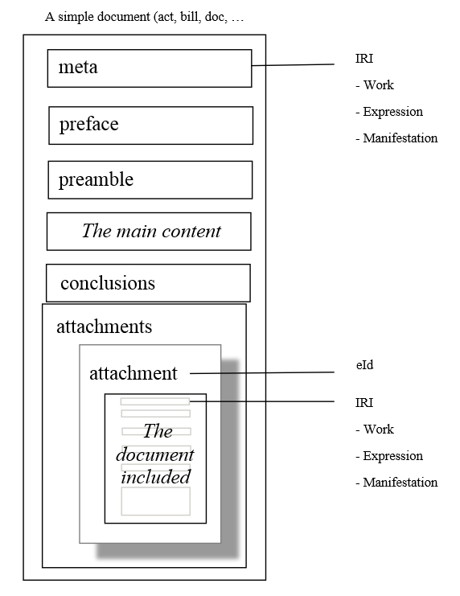

Reference an attachment
We have two possible methods to refer an attachment (annex, schedule, …)
- As a fragment / portion of the master document
In this case, we use the "eId" value of the <attachment> element as the context to find the correspondent document.
  - [http://www.authority.org]/akn/sl/act/2004-02-13/2/~attachment_1 queries for the whole attachment 1 of the act
  - [http://www.authority.org]/akn/sl/act/2004-02-13/2/~attachment_1__list_1__point_6 queries for the point 6 of the first list of the document that is in the attachment 1 of the act.
- Using only the IRI of the document included in the <attachment> element. In this case, the IRI of the master document is not used, except eventually, as a basis to build the IRI of the attachment.

The IRI of the attachment document that is annexed
An annex of a document is usually a part of the main content that is put at the end of the document because it is too large or too technical or both. When the attachment contains this type of content, it means that the corresponding abstract document has no life of its own but is really a inseparable component of the master document.
For this type of document, the IRI of the annex is built on the IRI of the master document. The convention can be the following:
IRI of the work :
- <IRI of the work master document>
- "!"
- Type of the inclusion of the document in the attachment (annex, schedule, …). It can be the "name" attribute of the document or the <FRBRsubtype> element
- /
- Number of the attachment in the list of attachments
IRI of the Expression
- <IRI of the work>
- All the information of the expression, as already described in the main specification .
This information is related to the document attached and not to the master document. It means, for example, that you can have a master document that is multilingual and contains an annex (an attachment) that is in English. So the IRI of the expression will be
<IRI of the work master document>!annex/1/eng@...
Exemple
[http://www.authority.org]/akn/sl/act/2004-02-13/2!annex/1/eng@... The english version of the Annex 1 of the act n° 2 of the 13-02-2004

The IRI of the attachment that is an independent document attached to the current document
This is the case, for example, when an agreement is attached to the act that adopts it.
In this case, the IRI of the document that is attached is not build on the IRI of the master document. It will be built exactly as if the document is not attached to the master document.
The reference to that document can be done using the IRI of the document or using the "eId" of the <attachment> element. Suppose that
The agreement 2015/111 is attached to the European decision (of the council)
IRI of the European decision work : /akn/eu/act/decision/cnl/2015/111
IRI of the agreement work : /akn/eu/act/agreement/2015/111
You can reference the agreement as
- /akn/eu/act/decision/cnl/2015/111~attachment_1
or
- /akn/eu/act/agreement/2015/111

Documents collection
The document collection is a document that group multiples independent documents. It can be a list of similar documents (list of amendments) that is needed during one stage of the procedure. It can also be something similar to a folder with one important document and other additional documents allowing the user to take an informed decision-making.
This is, for example, the case of the Proposal of the European Commission, that contains a bill, and additional documents like explanatory memorandum or financial statement,
This is also the case of the Parliament report that can contain minority report or opinion from other committees, … All these documents are independent and none can be attached to another.
The skeleton of the document collection is the following (recursively)
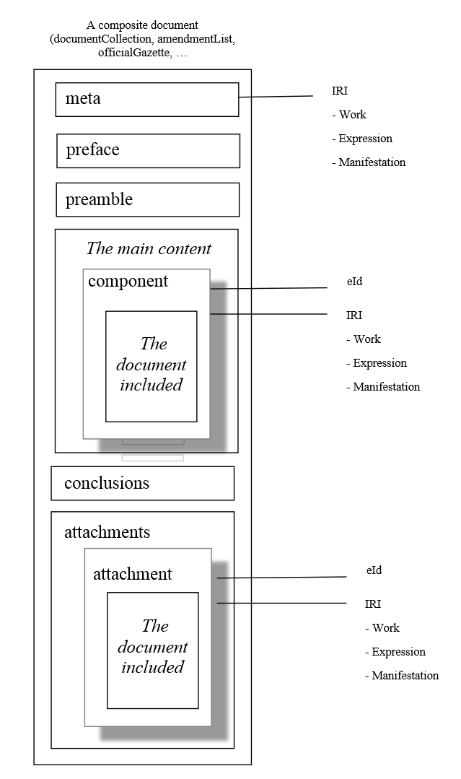

Reference a component
Similarly to the attachment, we have two possible methods to reference component
- As a fragment / portion of the document collection
In this case, we refer to the "eId" value of the <component> element as the context to find the correspondent document.
  - [http://www.authority.org]/akn/eu/documentCollection/proposal/com/2004/2~component_1 queries for the whole component 1 of the Commission proposal
  - http://www.authority.org]/akn/eu/documentCollection/proposal/com/2004/2~component_1__list_1__point_6 queries for the point 6 of the first list of the document that is in the component 1 of the Commission proposal.
- using his IRI of the document included in the <component> element. .

The IRI of the document in a component
Some component documents have no specific identifiers and are referenced using some information of the documentCollection. This is for example the case for the bill inside the proposal from the Commission.
For this type of situation, the IRI of the component can use some information coming from the documentCollection. But other information is from the component:
IRI of the work :
- country of the component
- type of document (from the component)
- document subtype (from the component)
- emanating actors : information can come from the document collection and from the component
- date of creation : can be the same date as the one of the document Collection
- number : can be the same one as the one of the document Collection
IRI of the Expression
- <IRI of the work>
- All the information of the expression, as described in the specification .
Of course, this information is related to the component and not to the document collection. It means, for example, that you can have an amendment list that is multilingual and contains an amendment that is completely in English.
Exemple
http://www.authority.org]/akn/eu/bill/directive/com,ep,cnl/2004/2

The IRI of the component that has already an IRI as independent document (to be validated)
This is the case, the IRI of the work can be the same work IRI as the work that is independent, or it can be a new IRI built as for the previous case. This will be always the case if multiple component has the same types, like amendments in an amendment list.

Document included in an element of the main content of a document
(to be completed)

