ECF5 Spec Feedback and Considerations – 11
This document contains additional questions and commentary resulting from a review at the Electronic Court Filing Version 5.0 Working Draft 15.

- FilingAttorneyID

It was noted that ecf:FilingAttorneyID has been added to CaseOfficialAugmentation in working draft 15 (wd15).

This was presumably done so that an Attorney ID can be provided for an attorney (e.g. j:CaseDefenseAttorney, j:ProsecutionAttorney, j:CaseRespondentAttorney, and j:CaseInitiatingAttorney).

This was also presumably done to address the question raised in item 7 in the ‘ECF5 Spec Considerations – 6’ document, i.e. “So if I have an ecf:FilingAttorneyID with a value of ‘10’, how do I locate the entity to which this refers?”. Doing this was not possible to do prior to the addition of ecf:FilingAttorneyID to CaseOfficialAugmentation. Take note that this is still not possible if CaseOfficialAugmentation/ecf:FilingAttorneyID is not used. Should this element be mandatory and not optional?

However, in the context of CaseOffiicalAugmentation, the identifier for an attorney is just that, an Attorney ID and not necessarily a Filing Attorney ID. In other words, there may be many attorneys listed and only one of these may be the filing attorney. Shouldn’t this element, in this context, just be named ecf:AttorneyID?

In WD16, ecf:FilingAttorneyID is renamed to ecf:AttorneyID and made mandatory.

- Reviewed Lead and Connected Documents Attorney ID

The definition for ecf:FilingAttorneyID in ecf:ReviewedLeadDocument/DocumentAugmentation is “Identifier recognized by the court as being unique within this case, and used to identify the attorney who is filing this document. Not present for pro se litigants.”

The ending portion of the definition (i.e. “Not present for pro se litigants”) should be stricken (see ECF Specification 6.2.8 Filer and Party Identifiers (i.e. “Self-represented litigants that are also an attorney MAY be presented using both attorney and party elements”.

“Not present for pro se litigants.” was removed from the definition.

- Filing Lead and Connected Documents Attorney ID

The definition for ecf:FilingAttorneyID in ecf:FilingLeadDocument/DocumentAugmentation is “an identifier for an attorney.”

Shouldn’t the definition for ecf:FilingAttorneyID in this context be the same as the definition in the reviewed document context?

Each element has a single definition. We cannot provide different definitions for the same element in different contexts.

- Attorney to Party Association

In the ‘ECF Spec Feedback and Considerations – 7’ document, item 1, I suggest that specification document provide guidance on associating attorneys to the parties they represent.

In the wd15 version of the Specification document, section 6.2.11.1 Element Content References, a non-normative example is provided that shows one way to associate an attorney to the party or parties he/she represents.

The purpose of this non-normative example is to illustrate ‘Content References’ and is not to illustrate the correct or even a preferred way to associate attorneys to the parties they represent.

In the civil.xml example, the j:CaseInitiatingParty (i.e. Defendant John W. Doe) appears to be associated with the attorney Jane Doe (Prosecutor). This assumed relationship is only derived by noting that the defendant is a j:CaseInitiatingParty and the attorney is a j:CaseInitiatingAttorney. Perhaps an assumption such as this would be typically correct in a simple case, however this is not reliable, especially for more complex cases.

In the interest of interoperability, a normative approach should be defined.

WD16 includes a comment to discuss this with the TC.

- Cancel Filing Message

In the ‘ECF Spec Feedback and Considerations – 10’ document, item 1, the answer to the question below was provided:

Is cancellation automatically granted if requested prior to the RecordFiling request?

No – it is up to the clerk or court to decide.

So how does the Cancel Filing requestor get the clerk’s answer? There is not any Cancel Filing Response message.

Note: in Tyler’s original proposal (Cancel Filing.docx), the following was provided:

In addition to the standard ecf:Error construct, the response message identifies the filing in question as well as the status of the filing after the operation, thereby declaring the current filing status regardless of whether the operation failed or succeeded.

Reference Materials
Operation |  | Material |  | Purpose
CancelFiling | XSD\CancelFiling.xsd |  | Definition of the request message
 | XSD\CancelFilingResponse.xml |  | Definition of the response message
 | XML\CancelFiling.xml |  | Sample request message
 | XML\CancelFilingResponse.xml |  | Sample response message

Note: Tyler appears to have subsequently proposed a synchronous response. The following is from ‘Tyler ECF5 Proposals – Responses to 092415 Meeting Notes.pdf:

This operation is proposed as a query operation – to facilitate a synchronous response that indicates whether the cancellation was successful or not, thereby allowing a court/system to set business conditions defining when a cancellation is allowed (e.g. cancel cannot be performed after the clerk has already begin reviewing the filing).

I do not think that a synchronous response is possible. The clerk needs time to consider the cancellation request, and a clerk may not even be available when the request arrives. Therefore a callback message appears to be the only reasonable alternative.

As a minimum, the filer will receive the result in a NotifyFilingReviewComplete message. WD16 clarifies Section 6.1.10 NotifyFlingReviewComplete to include “if the clerk cancels” as a trigger. Let’s discuss with the TC whether we need a separate CancelFilingResponse message.

- Cancel Message Filing Identifier

Section 6.2.6 Filing Identifiers requires that filing identifiers are “generated by the court in response to a ReviewFiling operation.”

One would expect Filing Identifier to be a required element on a Cancellation Request message so as to ensure there is no misunderstanding as to which submittal cancellation is being requested. Since DocumentIdentification is used for the Filing Identifier, the element for the filing identifier is present on the cancellation request message, but its usage is optional. It seems it should be mandatory in this context.

The cardinality of cancel:CancelFilingMessage/nc:DocumentIdentification is 1,unbounded.

Also, the Cancellation Request Message (i.e. cancel:CancelFilingMessage) should be added to the list of messages that employ the Filing Identifier in section 6.2.6 Filing Identifiers.

WD16 includes cancel:CancelFilingMessage in the list in 6.2.6.

- Associating Reviewed Documents to Filing Documents

In the ‘ECF Spec Feedback and Considerations – 10’ document, item 2, Three possible methods for associating the reviewed document to its filing document were suggested.

In response, Jim Cabral provided:

Added the following to 6.2.4

ecf:ReviewedLeadDocument MUST reference filing:FilingLeadDocument and ecf:ReviewedConnectedDocument MUST reference filing:FilingConnectedDocument using nc:DocumentIdentification/nc:IdentificationID.

Changed docket.xml to use nc:DocumentIdentification/nc:IdentificationID rather than structures:ref to reference the lead and connected documents.

In summary, J.C. selected the first of the three options (i.e. option A. nc:DocumentIdentiifcation/nc:IdentiifcationID) and identified it as normative.

The docket.xml example (originally provided as CorrectedFiling-1.xml) includes both the A. and C. options for each reviewed document. The normative requirement to use nc:DocumentIdentiifcation/nc:IdentificationID does not preclude the simultaneous use of nc:DocumentAssociation (Option C.). However, a new ecf:DocumentRelatedCode (e.g. ‘reviewed’) may need to be added to the gc file list.

However, since both Lead and Reviewed Documents can have more than one nc:DocumentIdentification/nc:IdentificationID, the specification must go further and detail how the appropriate nc:DocumentIdentification/nc:IdentificationID is known (such as with a specific nc:IdentificationCategory element value, e.g. ‘ECFDocumentID’).
The changes to 6.2.4 already state that DocumentIdentification must be used. It isn’t clear to me how common the problem you identified would occur or that adding a nc:IdentificationCategory of “ECFDocumentID” solves the problem you identified.

- DocumentStatus missing for Lead Documents

In ECF 4.01, nc:DocumentStatus was available for FilingLeadDocument and FilingConnectedDocument (e.g. for all elements derived from ecf:DocumentType), including ecf:ElectronicFilingMessageType).

However, in ECF5, nc:DocumentStatus is not available for filing:FilingLeadDocument or filing:FilingConnectedDocument (or in anything derived from filing:FilingMessageType).

As noted, nc:DocumentStatus is included in reviewed documents (i.e. ReviewedLeadDocument and ReviewedConnectedDocument). Why is DocumentStatus not included in lead documents?

At present, Arizona does not use nc:DocumentStatus in lead documents or messages. However I do not recall any conversations in the TC regarding the removal of DocumentStatus. Before contracting the specification in this way, I think we should verify this with the TC.

WD16 adds nc:DocumentStatus to all documents.

- Element Order (e.g. DocumentPostDate

This issue was first raised in the ‘ECF Spec Feedback and Considerations – 9’ document, item 4. The issue is that some elements, e.g. nc:DocumentPostDate, appear to be in the wrong sequence.

Jim’s response is: The order of elements is defined by the inheritance of NIEM and ECF types.

However, I find this confusing. If I use NIEM Wayfarer and view the list of elements that ncDocument (nc:DocumentType) can contain in schema order, as shown below:…
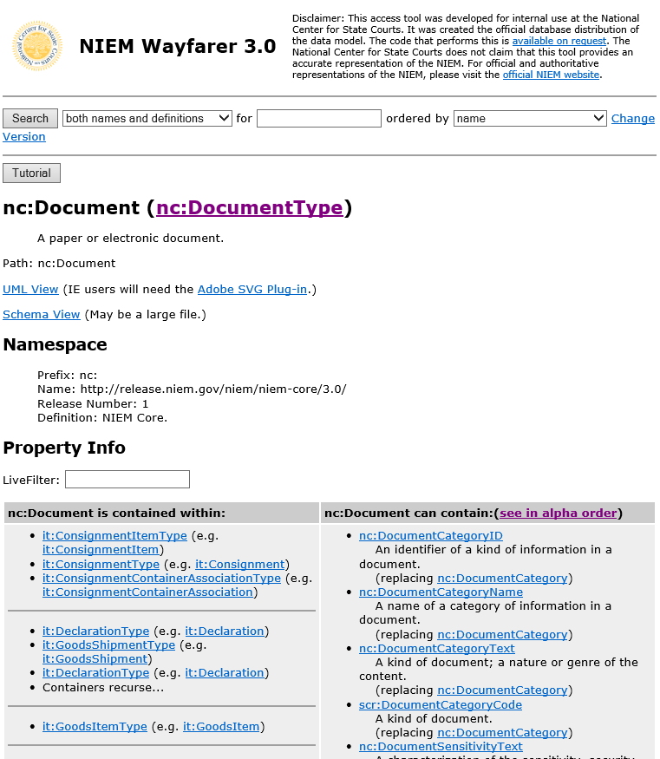

Then I will observe the following sequence for ECF employed document elements:

nc:DocumentCatgoryText
nc:DocumentSoftwareName
nc:DocumentDescripitionText
nc:DocumentEffectiveDate
nc:DocumentFileControlID
nc:DocumentFiledDate
nc:DocumentIdentification
(missing nc:DocumentPostDate)
nc:DocumentReceivedDate
nc:DocumentSequenceID
nc:DocumentTitleText
nc:DocumentLanguageCode
nc:DocumentSubmitter
nc:DocumentAugmentationPoint

All of the NIEM DocumentType elements used by ECF 5 are in the schema order that NIEM Wayfarer says they should be in, except for nc:DocumentPostDate!

In ECF 5.0, nc:DocumentPostDate is included in ecf:CaseFilingType, not nc:DocumentType. Therefore, it appears in the order next to other elements in ecf:CaseFilingType.

- Document Stamping MDE

A new ‘Document Stamp Major Design Element (see section 2.1 Relationship to Prior Specifications), has been added in ECF5.

In section 3.2.1 The Filing and Service Process, it states “if the document stamp information is requested, the information will be returned through the following operation: NotifyDocumentStampInformation”.

The table in section 4.1 Messages, shows that the NotifyDocumentStampInformation operation is provided by the FilingReview MDE, and not the Document Stamp MDE.

Other than the mention in section 2.1 (i.e. “New Document Stamp Major Design Element (MDE) and operations support retrieval of case information required for stamping”) there is no other mention of a Document Stamp MDE.

Good point. The table in Section 4.1 is updated in WD16.

- Payment Message in RFR

In section 4.1 Message, in the table for Filing Review, the ReviewFiling operation is listed as consuming a filing:FilingMessage, and optionally, a payment:PaymentMessage. The association of the two messages can be found in MessageWrappers.xsd as shown below

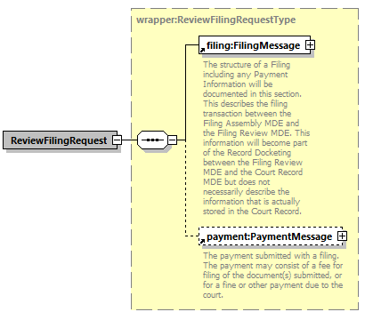
There are no example messages for ReviewFilingRequest.

I have created a ReviewFilingRequest xml example by combining the existing civivl.xml and payment.xml examples together wrapped instead of wrapper:ReviewFilingRequest. Additional manual edits were also made. This example is ‘civil-ReviewFilingRequest-01.xml’

The example was included in the examples folder.

- Service Recipient Identifiers

In section 6.2.9 Service Recipient Identifiers, it states:

Identifiers for filers and parties to a case, including person, organizations and property, labeled as ecf:ServiceRecipientID/nc:IdentificationID, MUST correspond to the above filer and party identifiers. The following is a non-normative example of an identifier for filer number 100:
<ecf:ServiceRecipientID>
<nc:IdentificationID>100<nc:IdentificationID>
</ecf:ServiceRecipientID>

The service information response message example (i.e. ServiceInformationResponse.xml) includes:

<serviceinformationresponse:ServiceRecipient>
<nc:EntityPerson>
<nc:PersonName>
<nc:PersonGivenName>John</nc:PersonGivenName>
<nc:PersonSurName>Smith</nc:PersonSurName>
</nc:PersonName>
<ecf:PersonAugmentation>
<ecf:CaseParticipantRoleCode>defendant</ecf:CaseParticipantRoleCode>
<ecf:ElectronicServiceInformation>
<ecf:ReceivingMDELocationID>
<nc:IdentificationID>https://eserviceprovider.com:8000</nc:IdentificationID>
</ecf:ReceivingMDELocationID>
<ecf:ReceivingMDEProfileCode>urn:oasis:names:tc:legalxml-courtfiling:schema:xsd:WebServicesMessaging-2.0</ecf:ReceivingMDEProfileCode>
<ecf:ServiceRecipientID>
<nc:IdentificationID>1031</nc:IdentificationID>
</ecf:ServiceRecipientID>
</ecf:ElectronicServiceInformation>
<ecf:FilingPartyID>
<nc:IdentificationID>10</nc:IdentificationID>
</ecf:FilingPartyID>

This does not seem consistent with 6.2.9. I would expect that in the service information response example, the value for ecf:ServiceRecipientID/nc:IdentificationID would be the same as the element value for ecf:FilingPartyID/nc:IdentificationID.

Furthermore, the service information response message does not contain ecf:FilingAttorneyID.

The example was updated to make ecf:ServiceRecipientID and ecf:EFilingPartyID match. There is no attorney in the example.

- xxx

