ECF5 Spec Feedback and Considerations – 31

This document provides additional ECF-5 feedback, questions, and commentary. This feedback is based on review of the Electronic Court Filing Version 5.0 Working Draft 39 (WD39), unless otherwise noted. This document does not represent a comprehensive review of WD39 but instead only raises issues uncovered during a limited review time interval.

- Telephone Number Type

Whereas ECF5 provides for contact telephone numbers with nc:ContactTelephoneNumber, e.g.:

<nc:ContactTelephoneNumber>
<nc:FullTelephoneNumber>
<nc:TelephoneNumberFullID>6021234567</nc:TelephoneNumberFullID>
</nc:FullTelephoneNumber>
</nc:ContactTelephoneNumber>

unfortunately, there is no means by which to specify the type of phone, such as cell phone, home phone, business phone, etc.

NIEM does provide nc:TelephoneNumberCategoryCode with code table definition provided by xCard:TelephoneNumberCategoryCodeSimpleType with values:

cell A cellular or mobile telephone
fax A facsimile-capable telephone
home A home telephone
pager A paging device
textphone A telecommunication device for people with hearing or speech difficulties
video A video conferencing-capable telephone
voice A voice-capable telephone
work A work telephone

Alternatively, NIEM also provides j:TelephoneNumberCategoryCode with code table definition provided by ndex:TelephoneNumberCategoryCodeSimpleType with values:

Facsimile Fax telephone number
Landline Landline telephone number
Mobile Mobile telephone number
Other Other telephone number
Pager Pager telephone number
VoIP VoIP telephone number (such as Skype, Vonage)

nc:TelephoneNumberCategoryCode and j:TelephoneNumberCategoryCode should be contained within nc:TelephoneNumberType, but unfortunately are not in ECF5 as shown below:

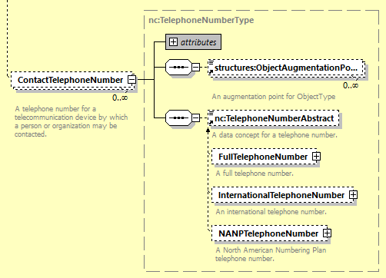

Is there a way to address this without holding up the adoption of ECF5?

