19.496 style:list-style-name
The style:list-style-name attribute specifies a list style for style families with paragraph formatting properties. This applies to automatic and common styles.
The list style specified by this attribute is applied to headings and paragraphs that are contained in a list, where the list does not specify a list style itself, and the list has no list style specification for any of its parents.
The list style specified by this attribute is applied to headings that are not contained in a list.
In case a heading is contained in a list, the level-style to be used is determined by the list level. The text:outline-level attribute of a heading is not evaluated for the level-style. Producers should keep the value of the text:outline-level attribute in sync with the list level, because in several elements (e.g. 7.3.8 <text:chapter>, 8.3.2 <text:table-of-content-source>) not the list level but the outline level is evaluated.
In case a heading is not contained in a list, the level style to be used is determined by the value of the text:outline-level attribute.
The text:outline-level attribute is mandatory for a <text:h> element, see schema line 840 and line 852. That is not explicitly mentioned in 19.844.4 <text:h>. There is the sentence “Headings without a level attribute are assumed to be at level 1.” instead. But there cannot be any heading without a level attribute. Or do I misunderstand the schema?
The style:list-style-name attribute value can be empty. If empty, this attribute does not inherit a list style value from a parent style.
For the sentence above likely additions are needed. Problems and example see next page.
Section 19.498.2 contains the sentence
“outline style - The outline style as a list style can be referenced by the style:list-style-name attribute.”
Should this text be copied here? For example,
“The style:list-style-name attribute may reference the <text:outline-style> element.”

16.34 <text:outline-style>
The <text:outline-style> element contains the elements that specify a style for each outline level.
An outline style is a list style that is applied to all headings within a text document where the heading's paragraph style does not define a list style to use itself, and—in case the heading is contained in a list—, neither the list itself nor any of its parent lists specify a list style.
This addition makes clear, that in case a list specifies a style, it has preference over the outline-style.

There exists further problems:

Problem A
Take a simple paragraph inside a list. Consider the case, that no style is specified on the list elements themselves and the paragraph style has a style:list-style-name attribute with empty value. Applying section “5.3.2 Default List Style” I get the conclusion:
First bullet item there does not apply, because no list in the parent lists has specified a list style, otherwise the style:list-style-name would not be used, see second sentence in 19.496.
Second bullet item does not apply, because the style:list-style-name attribute exists but has an empty value. Therefore no list-style is specified, that can be used.
So third bullet item is used, which means, that an implementation-dependent default is used.
But is that the intention for allowing an empty value for the style:list-style-name attribute?

Problem B
Take a heading inside a list. Consider the case, that no style is specified on the list elements themselves and the headings paragraph style has a style:list-style-name attribute with empty value. Section 16.34<text:outline-style> has the sentence,
“An outline style is a list style that is applied to all headings within a text document where the heading's paragraph style does not define a list style to use itself.”
Does the wording “does not define a list style to use itself” includes the case that the style:list-style-name attribute exists, but has an empty value? If not, then problem A applies. Here too, it is not clear, what the intention was, to allow an empty value for the style:list-style-name attribute.

Problem C
If a list does not specify a list style at all and the paragraphs inside the list, do not have a style:list-style-name attribute in their paragraph styles, then from section 5.3.2 an implementation-dependent default list style is used. On the other hand from section 16.34 we get, that if the headings paragraph style does not define a list style, then the outline style is used. So what style is used for a heading inside a list, in case the style:list-style-name attribute does not exist in the paragraph style of the heading? Is it the default list style or the outline style?

Problem D
How do indents definied in the paragraph style interact with indents definied in the list style?

Example
Application handle this very different. Therefore I think, that the specification needs to be very exact about what should happen in these cases.
Look at file ListWithEmptyListStyleName.odt, for example. Here are some screenshots:
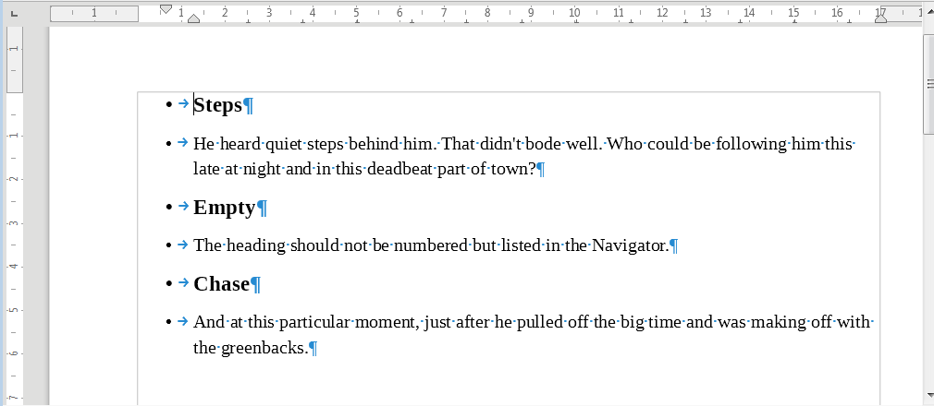
LibreOffice 5.4

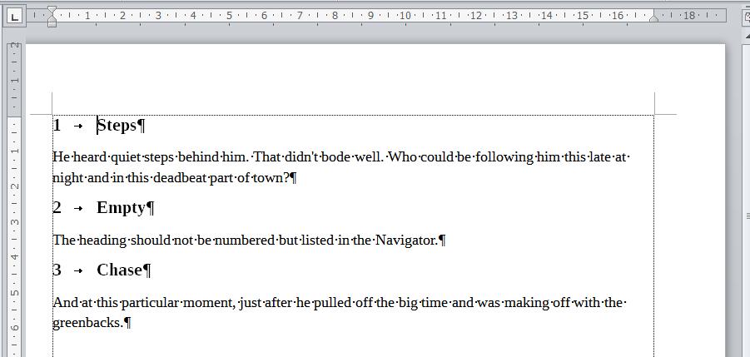
Microsoft Word 2010, after it “repairs” the file, because it expects an ODF1.1 file

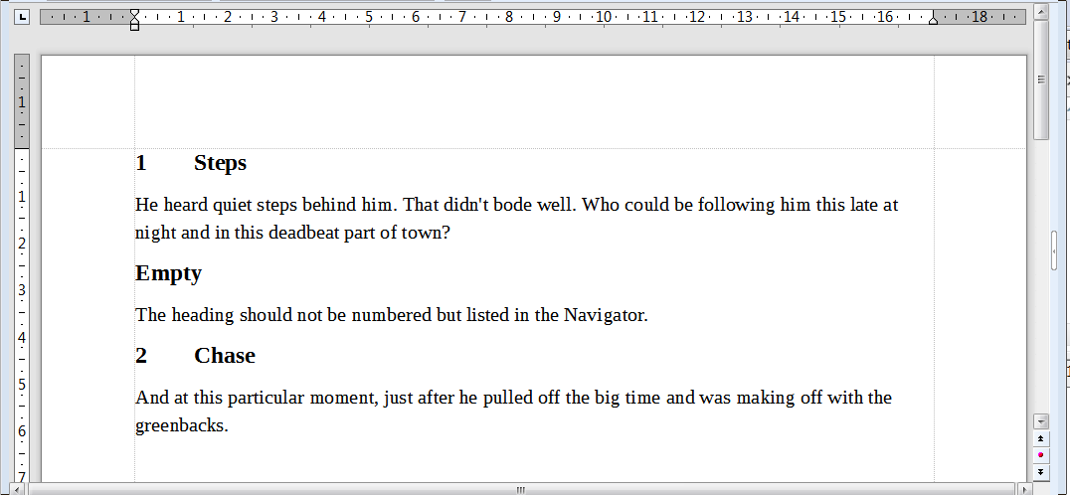
TextMaker Professional 2016

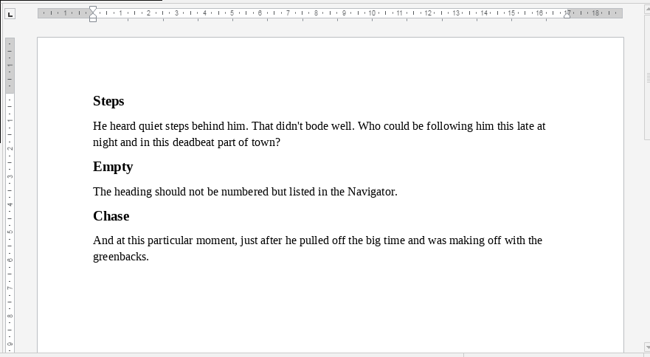
ONLYOFFICE Desktop Editors version 4.3.2.320
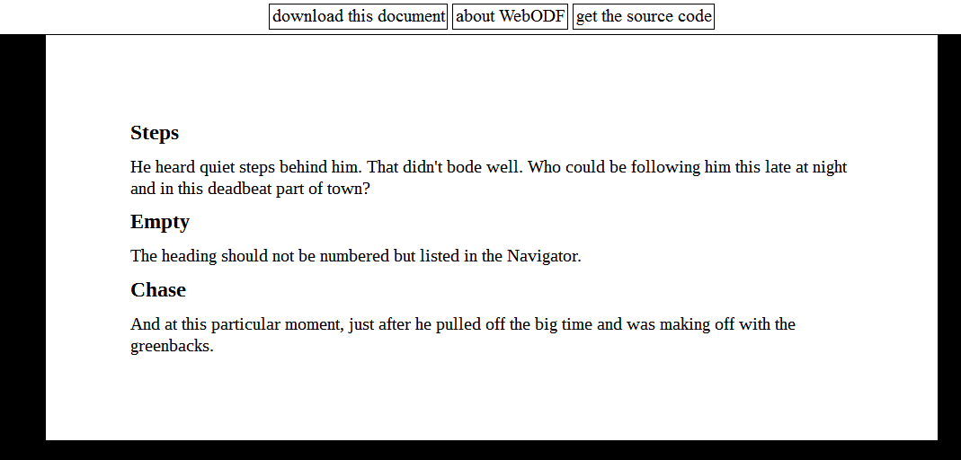
WebODF plugin for Seamonkey

The file EmptyStyleNoHeading.odt is a similar file but now without headings. Here again some screenshots. (You will notice problems with borders in addition, but that is not the topic here.)
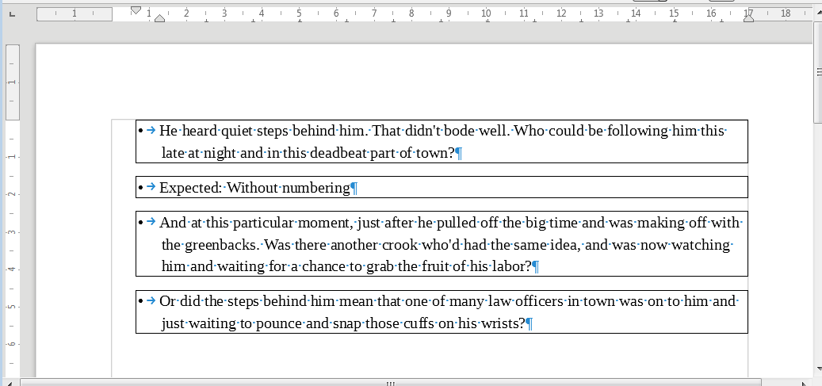
LibreOffice 5.4

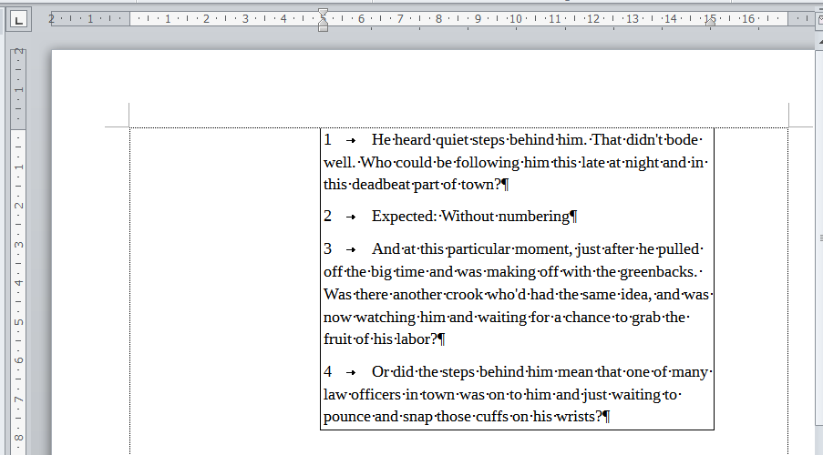
Microsoft Word 2010, after it “repairs” the file, because it expects an ODF1.1 file

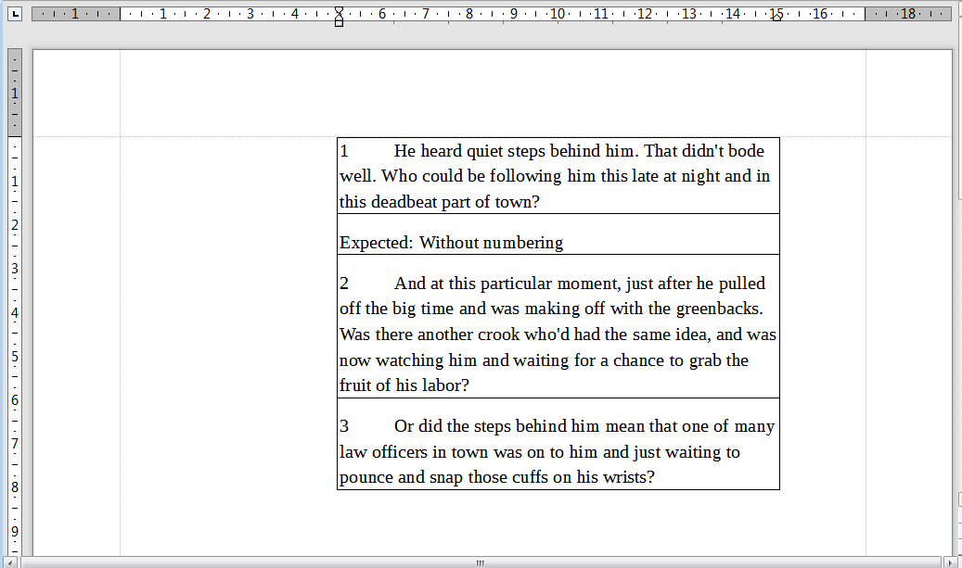
TextMaker Professional 2016

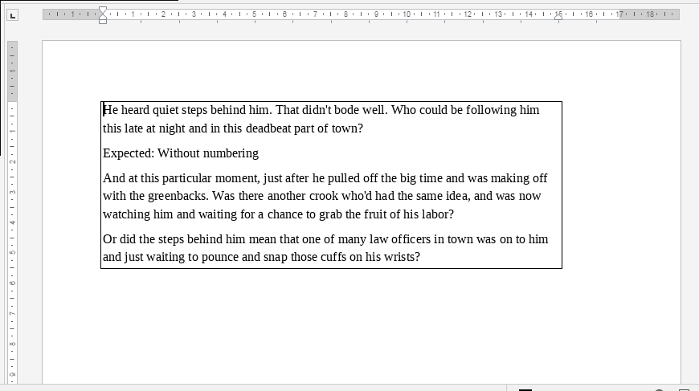
ONLYOFFICE Desktop Editors version 4.3.2.320

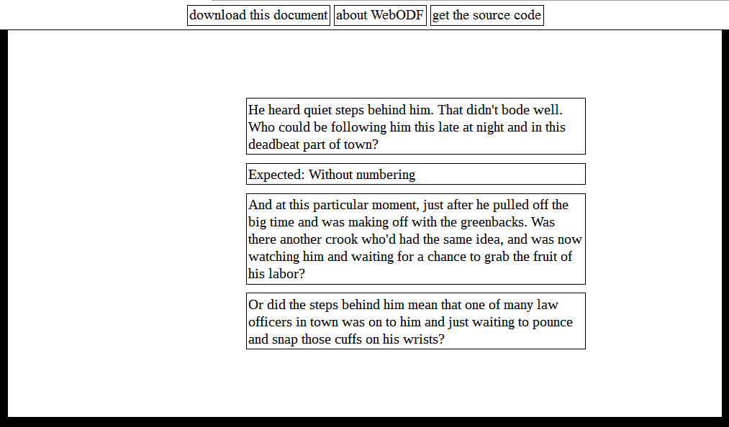
WebODF plugin for Seamonkey

