Terms for Layout of Text Documents

General
If the description mentions the shorthand properties fo:margin, fo:border or fo:padding for a specific direction left, right, top or bottom, then the applicable single property, e.g fo:margin-left, is implicitly meant too.
The descriptions assume a left-to-right, top-to-bottom writing mode.

Table Cell
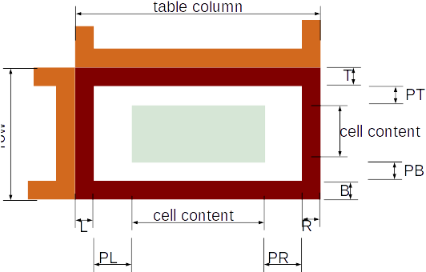
Area | Relevant Attributes
table column | A table column has a fixed width by style:column-width or width is calculated from the width of the entire table and the attribute style:rel-column-width. Column width depends on column content, if attribute style:use-optimal-column-width is set. All attributes are from <style:table-column-properties>.
row | A row has a fixed height by style:min-row-height and style:row-height. Row height depends on row content, if attribute style:use-optimal-row-height is set. All attributes are from <style:table-row-properties>.
Border widths  L, R, T, B | Borders belong to cells, not to columns or rows. Borders are not between columns or rows but inside the cells. Border width is set by fo:border attributes and for the special case of border style double by style:border-line-width attributes, all in <style:table-cell-properties>.  In case table:border-model="collapsing" is set for the table, each of two adjacent cells gets half of the calculated border width.
Padding  PL, PR, PT, PB | Padding area is given by fo:padding attributes from <style:table-cell-properties>.
cell content | Width of the cell content area  is won  Height of the cell content area  = row height or the sum of the row heights in case of merged cells − calculated top and bottom border widths − top and border padding widths.

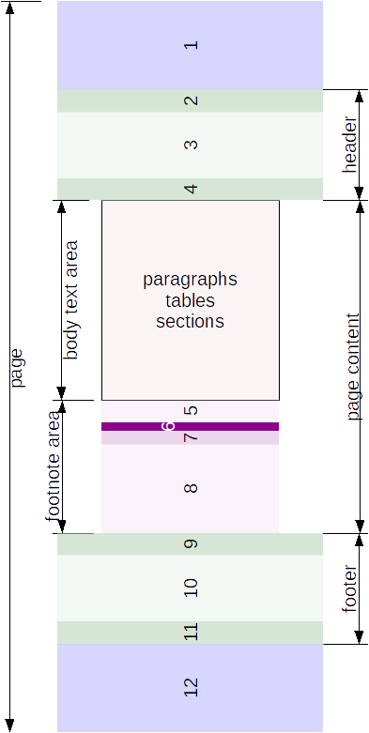
Page Vertical
Area | Relevant Attributes
page | fo:page-height in <style:page-layout-properties>
1 | height of area 1 = sum of height from fo:margin, fo:border and fo:padding, all in <style:page-layout-properties>  In case a shadow is defined by a style:shadow attribute, the width of the shadow is added to the width of the border.
2, 4 | height of area 2 or area 4 respectively = sum of height values from fo:margin, fo:border and fo:padding attributes in <style:header-footer-properties> in <style:header-style>.  In case a shadow is defined by a style:shadow attribute, the width of the shadow is added to the width of the border.  The fo:margin-bottom value may shrink dynamically when the header content grows, if style:dynamic-spacing="true" is set.
3 header content | Height is calculated.
header | height of header = height of areas 2 and 4 + height of header content  Height of header can be fixed using svg:height.
9, 11 | height of area 9 or area 11 respectively = sum of height values from fo:margin, fo:border and fo:padding attributs in <style:header-footer-properties> in <style:footer-style>.  In case a shadow is defined by a style:shadow attribute, the width of the shadow is added to the width of the border.  The fo:margin-top value may shrink dynamically when the footer content grows, if style:dynamic-spacing="true" is set.
10 footer-content | Height is calculated.
footer | height of footer = height of areas 9 and 11 + height of footer-content  Height of footer can be fixed using svg:height.
12 | height of area 12 = sum of height from fo:margin, fo:border and fo:padding, all in <style:page-layout-properties>.  In case a shadow is defined by a style:shadow attribute, the width of the shadow is added to the width of the border.
page-content | height of page-content = page height − height of area 1 − height of header − height of footer −height of area 12.
5, 6, 7  footnote separator line | height is sum of style:width, style:distance-before-sep and style:distance-after-sep from <style:footnote-sep> from <style:page-layout-properties>.
8 footnotes | Height is calculated from content.
footnote area | height of footnote area = height of footnote separator line (5)(6)(7) + height of footnotes. Height can be limited to style:footnote-max-height from <style:page-layout-properties>.
body text area | height of body text area = height of page content − height of footnote area
Endnotes are handled similar to footnotes in regard to vertical division.

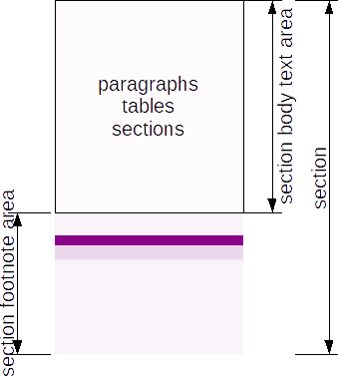
Section vertical
Sections do not have top or bottom margins, borders, shadows or paddings. Sections act similar to a page content area in regard to vertical division. A section has its own section body text area, its own section footnote area, and its own section endnote area. Section height depends on content, there exists no attribute for a fixed height.
Sections are not directly available for anchor positions.

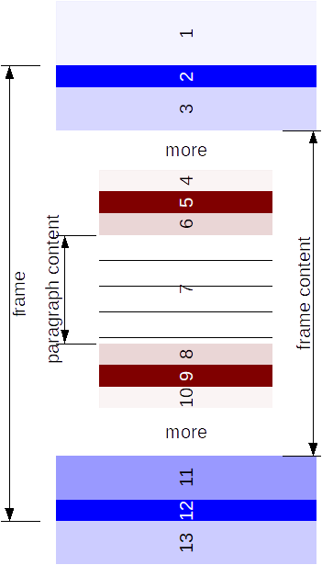
Frames and Paragraphs Vertical
Area | Relevant Attributes
1, 13 | These areas are specified by fo:margin attributes of <style:graphic-properties>. These areas do not count for the frame height, in contrast to the page height, where areas defined by the fo:margin attributes are included.
frame | The frame height is specified by svg:height in <draw:frame> element or calculated as relative height by the style:rel-height attribute.
2, 3 and 11, 12 | Areas 2 and 12 are specified by fo:border attributes, area 3 and 11 by fo:padding attributes, all in <style:graphic-properties>.  In case a shadow is defined by a style:shadow attribute, the width of the shadow is added to the width of the border.
frame content | height of frame content = frame height − height of areas 2 and 3 − height of areas 11 and 12.
4, 10 | These areas are defined by fo:margin attributes in <style:paragraph-properties>. Collapse margin is applied in vertical direction.
5, 6, 8, 9 | Areas 5 and 9 are specified by fo:border attributes, areas 6 and 8 by fo:padding attributes, all in <style:paragraph-properties>.  In case a shadow is defined by a style:shadow attribute, the width of the shadow is added to the width of the border.
7 paragraph content | Height is calculated from content.
The values page, page-content, frame, frame-content and paragraph-content of the attribute style:vertical-rel correspond to the areas described here. The value paragraph of the attribute style:vertical-rel has a special handling because of margin collapsing.

Problems with position top, center and bottom in combination with value paragraph:
Word has not implemented values paragraph or paragraph-content at all, but has only "line" as reference in the UI.
LibreOffice, Calligra and TextMaker first calculate an ersatz for area 4. They calculate its height =
height of area 4 − height of area 10 of the previous paragraph, at least 0. But the positioning is different then. LibreOffice builds an area of areas 5 to 9 including shadows and the ersatz for area 4. Then it positions the object according value top, center or bottom into this area. In result the bottom margin (10) of a paragraph is always ignored as area for vertical positioning of type paragraph by LibreOffice. Calligra takes the ersatz for area 4 and positions the object into this area. In result the objects are always above the top of border (5). TextMaker takes the top edge line of the ersatz for area 4 and then aligns the objects to this line and not to an area.

Page, Frame and Section Content Horizontal

Pages
Area | Related Attributes | 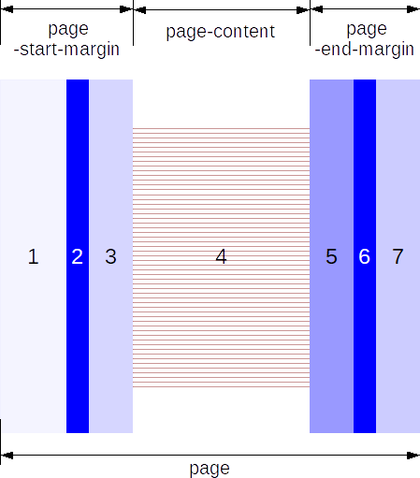
page | fo:page-width  in <style:page-layout-properties>  in <style:page-layout>
1, 7 | fo:margin  in <style:page-layout-properties>
2, 6 | fo:border  in <style:page-layout-properties>  In case a shadow is defined by a style:shadow attribute, the width of the shadow is added to the width of the border.
3, 5 | fo:padding  in <style:page-layout-properties>
page-start-margin | Width of page-start-margin area =  sum of left page margin (1), border (2) and padding (3).  Instead of "left" see special rules in section style:horizontal-rel (20.291) for inside/outside positions.
page-end-margin | Width of page-end-margin area =  sum of right page margin (7), border (6) and padding (5).  Instead of "right" see special rules in style:horizontal-rel (20.291) for inside/outside positions.
4  page-content | Width of page-content area =  width of page − width of page-start-margin − width of page-end-margin.

Frames
Area | Related Attributes
frame | svg:width in <draw:frame>  or calculated from style:rel-width | 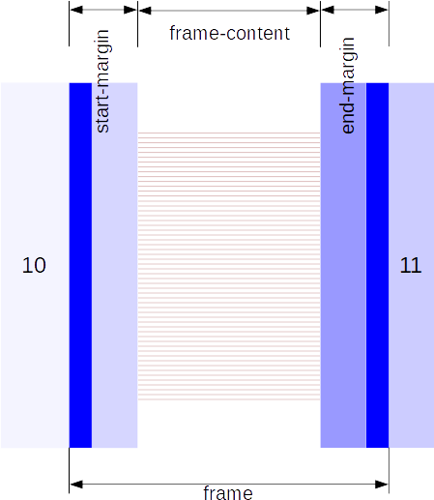
10, 11 | These areas are given by the fo:margin attributes in <style:graphic-properties> of the <draw:frame> element.  In contrast to the similar horizontal division for pages, they do not count for the frame width.
frame-start-margin  frame-end-margin | Width of frame margin area = sum of frame border and padding.  Values are in fo:border and fo:padding, all in <style:graphic-properties>.  In case a shadow is defined by a style:shadow attribute, the width of the shadow is added to the width of the border.  In regard to "left" and "right" see special rules in section style:horizontal-rel (20.291) for inside/outside positions.
frame-content | Width of frame-content = width of frame − width of frame-start-margin − width of frame-end-margin.

Sections
Area | Related Attributes
 | The width of a section is given by the content area of the parent element of the <text:section> element. | 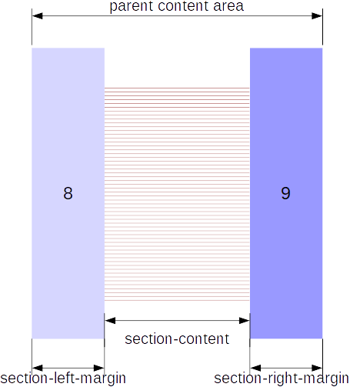
8, 9 | Left (8) and right (9) margin of a section are given by the fo:margin-left and fo:margin-right attributes in the <style:section-properties> element.  Border, shadow and padding are not available for sections.  Sections are not directly available for positions.
section-content-area | Width of section content area = width of parent content area − section left margin − section right margin

Text Columns
The content area of pages, sections and frames can be divided into columns. Having one columns is allowed.
The relevant attributes and elements are
in <style:page-layout-properties> element, in case of dividing a page content area,
in <style:section-properties> element, in case of dividing a section content area,
in <style:graphic-properties> element, in case of dividing a frame content area.
Columns are not directly available for positioning.
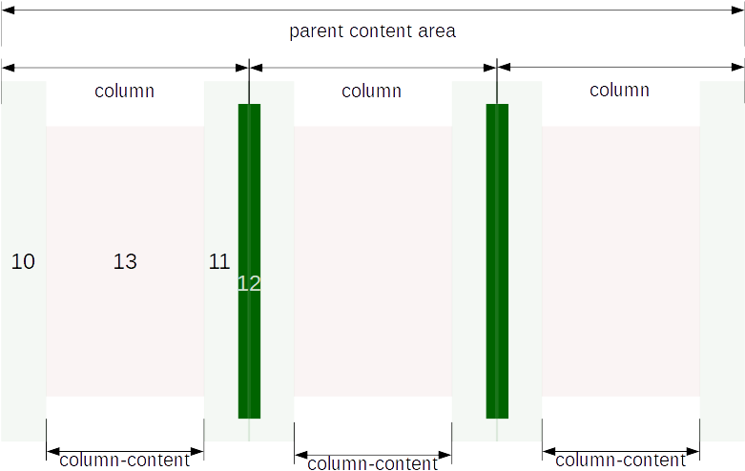
Area | Related Attributes
10 | Attribute fo:start-indent in element <style:column> in element <style:columns>.
11 | Attribute fo:end-indent in element <style:column> in element <style:columns>
12 | Attribute style:width in <style:column-sep>.
column | The width of the parent-content area is divided with respect to attribute style:rel-width in the <style:column> elements. Instead of widths for individual columns the attributes fo:column-gap and fo:column-count of element <style:columns> can be used in case of equally wide columns.
13 column-content area | Width of column content area =  width of column − width of column start-indent (10) − width of column end-indent (11) The separator line (12) is drawn on top of the indent areas and does not impact other widths.

Paragraphs Horizontal
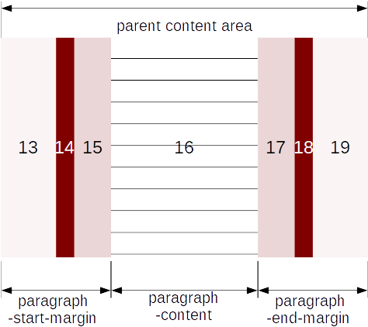
Parent content area of a paragraph can be a content area of a page, header, footer, section, frame, text column, or table cell. Always the innermost parent is taken.

Area | Related Attributes
13, 19 | Attribute fo:margin in <style:paragraph-properties> in <style:style>.
14, 18 | Attribute fo:border in <style:paragraph-properties>  In case a shadow is defined by a style:shadow attribute, the width of the shadow is added to the width of the border.
15, 17 | Attribute fo:padding in <style:paragraph-properties>
paragraph-start-margin | Width of paragraph start-margin =  sum of paragraph left margin, border and padding.  Instead of "left" see special rules in section style:horizontal-rel (20.291) for inside/outside positions.  If the paragraph is in a list and the fo:margin-left and fo:text-indent attributes of a <style:list-level-label-alignment> element are used, then the sum of the attribute values is used as width of the paragraph-start-margin.  If the paragraph is in a list and the text:space-before attribute of its <style:list-level-properties> element is used, then that value is used for the width of the paragraph start margin.
paragraph-end-margin | Width of paragraph end-margin =  sum of paragraph right margin, border and padding.  Instead of "right" see special rules in section style:horizontal-rel (20.291) for inside/outside positions.
16  paragraph-content | Width of paragraph content area =  Width of innermost parent content area − width of paragraph-start-margin − width of paragraph-end-margin
The values page, page-content, page-start-margin, page-end-margin, frame, frame-content, frame-start-margin, frame-end-margin, paragraph-content, paragraph-start-margin, and paragraph-end-margin of the style:horizontal-rel attribute correspond to the areas described here.
The value paragraph of the style:horizontal-rel attribute has no individual definition, but refers to the innermost parent content area of the paragraph.

Characters

