Background

In my perspective, there are at least four way of representing a Parts List contextual information (≈ header information in a document describing a parts list). The solution we choose will also have implications on any other type of documented result, where there is header information describing the context of the information beeing exchanged, such as a FMECA analysis report, a maintenance plan etc etc.

In my discussion below, on the four approaches I’ve identified for representing a Parts List, I do not andress the issue on whether a Parts List should be based on PROMISSORY_USAGE, NEXT_ASSEMBLY_ USAGE or even the superclass entity VIEW_DEFINITION_USAGE in order to represent the parent – child relationship.

My question is; which of these four (or more?) approaches below would be best to use? And as I said, it does have implications on many other things such as Mainenance plan, FMECA report etc. The answer is quite urgent, since we’re beginning to to deliver results from the different pilot implementations, and we don’t want to take off going in the wrong direction, or even worse, take off in different directions. This could be hard to change as we get further down the road.

And my four nominees are:

- Assigning DOCUMENT to the MESSAGE entity, where the DOCUMENT entity represents a reference to the corresponding documented result (Parts List), i.e. no further contextual information is included within the exchange file

- Using a PRODUCT_AS_REALIZED to represesent the Parts List and its contextual information.

- Identifying the PROMISSORY_USAGE entity (or whatever entity is being used) according to the identification of the documented result (Parts List)

- Classifing the VIEW_DEFINITION_CONTEXTs for the parent and child PARTs according to the documented result (Parts List) and assigning an identifier (IDENTIFICATION_ASSIGNMENT) that corresponds to the identifer of the documented result.

Nominee #1 – Assigning DOCUMENT to MESSAGE

The first candidate is assigning a DOCUMENT to the MESSAGE entity, where the DOCUMENT entity represents a reference to the corresponding documented result (e.g. Parts List). An example is given in the instance diagram below.

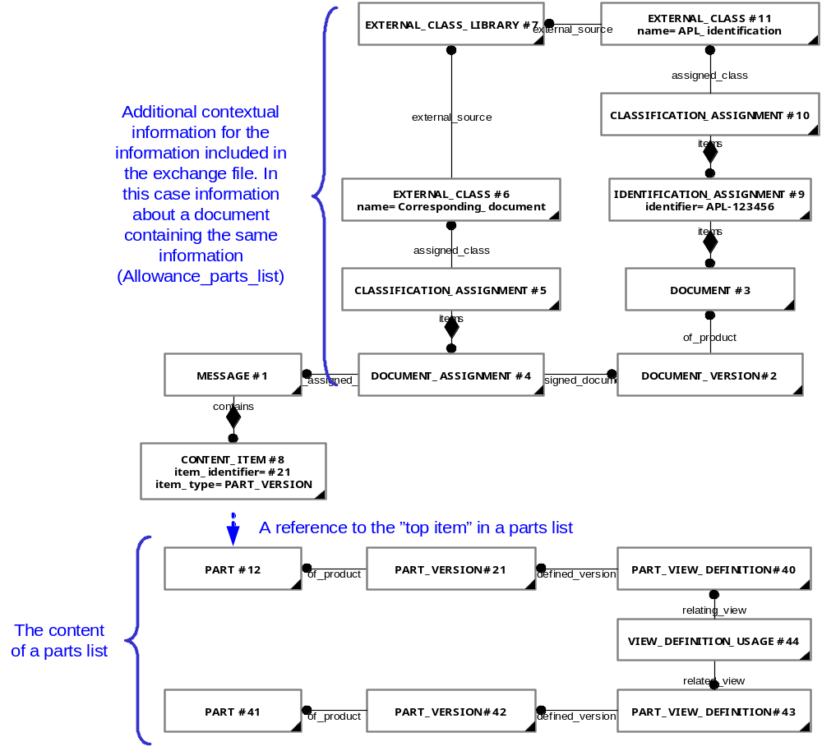

Pros (+)
- The exhange is based on an “information perspective” rather than on a “document centric perspective”

Cons (-)
- It’s hard to recreate the document, if needed

NOTE: This approach is being used by the Swedish pilot implementation on ‘Maintenance plan’ and ‘Product configuration’ for the Gripen aircraft.

Nominee #2 – Using PRODUCT_AS_REALIZED

The second approach is to define an explicit entity instance which represents the documented result (e.g. Parts List). This approch is desribed in the existing capability C011 – ‘Representing_analysis_result’ and is currently used by DEX002 – ‘Fault State’ and DEX005 – ‘Maintenance Plan’.

NOTE: Even though this is the approach used by the current version of DEX005, the Swedish pilot used the approch of assigning a DOCUMENT to MESSAGE instead (as described above)

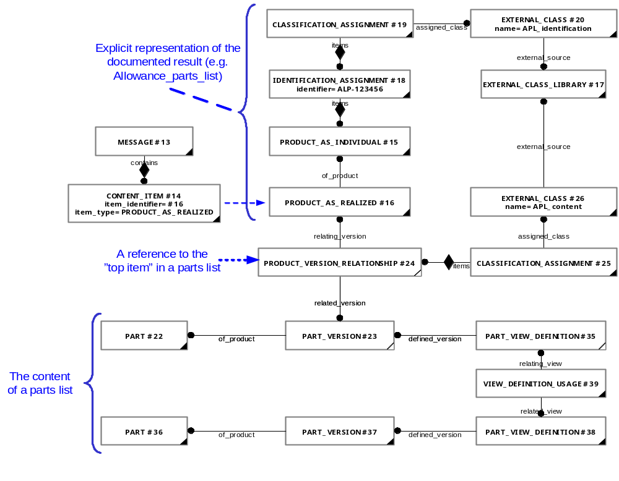
Pros (+)
- The document can be recreated by the recieving application

Cons (-)
- Could be hard for “outsiders” to understand that the “document” is represented as a PRODUCT_AS_REALIZED.

Nominee #3 – Identification of PROMISSORY_USAGE entity (or whatever entity is being used)

The third approch could be to identify the PROMISSORY_USAGE entity (or whatever entity is being used) according to the identification of the documented result (Parts List).

NOTE: This is not one of my favorite solutions. It may even be in conflict with how one should use the model, but I’ve seen odd things before.
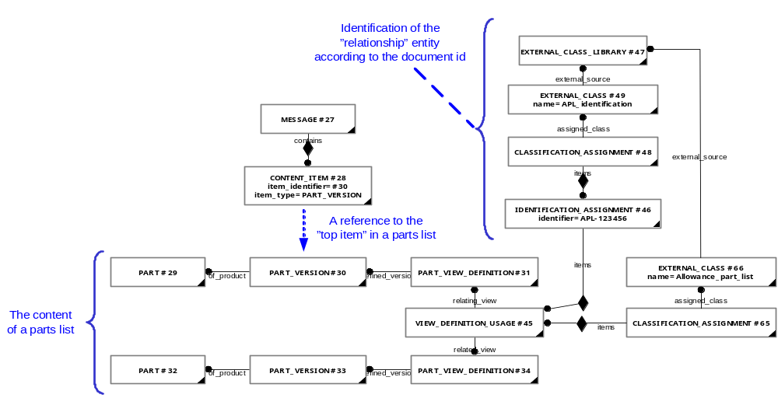

Pros (+)
- ??

Cons (-)
- Might be in conflict with the PLCS data model

Nominee #4 – Classifing and identification of VIEW_DEFINITION_CONTEXTs

The fourth approch is be to classify and identify the respective VIEW_DEFINITION_CONTEXT that are used to represent the structure of a Parts List.

This is the PDMSchema approach ??

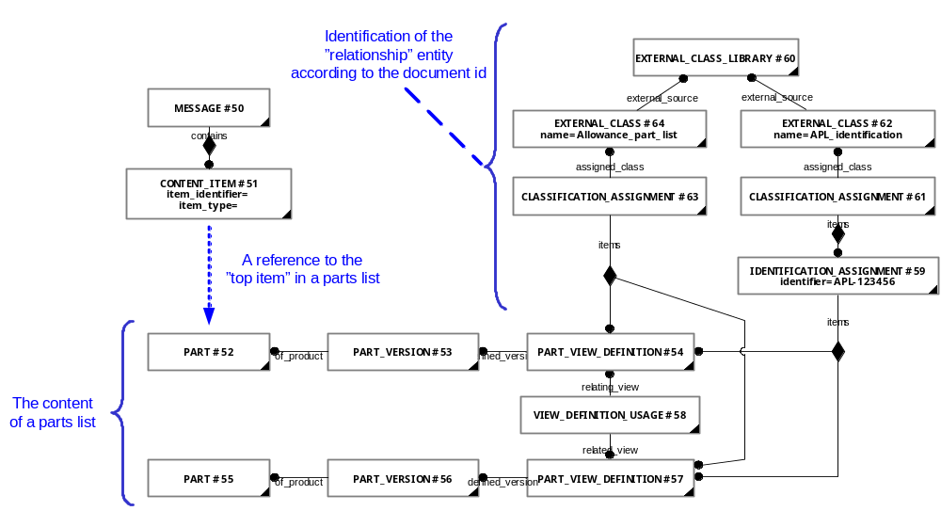

Pros (+)
- Might be in line with the PDMSchema approach (as I understand it)

Cons (-)
- ??

