
OASIS/ebXML Registry Information Model v2.3
–Committee Working Draft
OASIS/ebXML Registry Technical Committee
October 2002
This page intentionally left blank.

Status of this Document

This document is an OASIS Registry Technical Committee Working Draft - October 2002.
Distribution of this document is unlimited.
The document formatting is based on the Internet Society’s Standard RFC format.
This version:
http://www.oasis-open.org/committees/regrep/documents/2.3/specs/ebrim.pdf

Latest Technical Committee Approved version:
http://www.oasis-open.org/committees/regrep/documents/2.2/specs/ebRIM.pdf

Latest OASIS Approved Standard:
http://www.oasis-open.org/committees/regrep/documents/2.0/specs/ebRIM.pdf

OASIS/ebXML Registry Technical Committee
This is an OASIS/ebXML Registry Technical Committee draft document. The following persons are members of the OASIS/ebXML Registry Technical Committee:
Zachary Alexander, Individual Member
John Bekisz, Software AG, Inc.
Kathryn Breininger, Boeing
Lisa Carnahan, NIST
Joseph M. Chiusano, LMI
Suresh Damodaran, Sterling Commerce
Fred Federlein, Sun Microsystems
Sally Fuger, Individual Member
Michael Kass, NIST
Kyu-Chul Lee, Individual Member
Matthew MacKenzie, XML Global
Komal Mangtani, BEA Systems
Monica Martin, Drake Certivo, Inc.
Farrukh Najmi, Sun Microsystems
Sanjay Patil, IONA
Nikola Stojanovic, Individual Member
Scott Zimmerman, Storagepoint
Contributors
The following persons contributed to the content of this document, but were not a voting member of the OASIS/ebXML Registry Technical Committee.
Anne Fischer, Individual
Len Gallagher, NIST
Sekhar Vajjhala, Sun Microsystems

Table of Contents

1 Status of this Document 2
2 OASIS/ebXML Registry Technical Committee 3
3 Introduction 10
3.1 Summary of Contents of Document 10
3.2 General Conventions 10
3.2.1 Naming Conventions 10
3.3 Audience 11
3.4 Related Documents 11
4 Design Objectives 12
4.1 Goals 12
5 System Overview 13
5.1 Role of ebXML Registry 13
5.2 Registry Services 13
5.3 What the Registry Information Model Does 13
5.4 How the Registry Information Model Works 13
5.5 Where the Registry Information Model May Be Implemented 13
5.6 Conformance to an ebXML Registry 14
6 Registry Information Model: High Level Public View 15
6.1 RegistryObject 15
6.2 RepositoryItem 16
6.3 Slot 16
6.4 Association 16
6.5 ExternalIdentifier 16
6.6 ExternalLink 16
6.7 ClassificationScheme 17
6.8 ClassificationNode 17
6.9 Classification 17
6.10 RegistryPackage 17
6.11 AuditableEvent 17
6.12 User 17
6.13 PostalAddress 17
6.14 EmailAddress 18
6.15 Organization 18
6.16 Service 18
6.17 ServiceBinding 18
6.18 SpecificationLink 18
7 Registry Information Model: Detail View 19
7.1 Attribute and Methods of Information Model Classes 20
7.2 Data Types 21
7.3 Object Reference Support 21
7.3.1 Class ObjectRef 21
7.4 Internationalization (I18N) Support 22
7.4.1 Class InternationalString 22
7.4.2 Class LocalizedString 23
7.5 Class RegistryObject 24
7.5.1 Attribute Summary 24
7.5.2 Attribute accessControlPolicy 25
7.5.3 Attribute description 25
7.5.4 Attribute id 25
7.5.5 Attribute name 25
7.5.6 Attribute objectType 25
7.5.7 Method Summary 26
7.6 Class RegistryEntry 26
7.6.1 Attribute Summary 27
7.6.2 Attribute expiration 27
7.6.3 Attribute majorVersion 27
7.6.4 Attribute minorVersion 27
7.6.5 Attribute stability 28
7.6.6 Attribute status 28
7.6.7 Attribute userVersion 29
7.7 Class Slot 29
7.7.1 Attribute Summary 29
7.7.2 Attribute name 29
7.7.3 Attribute slotType 29
7.7.4 Attribute values 29
7.8 Class ExtrinsicObject 29
7.8.1 Attribute Summary 30
7.8.2 Attribute isOpaque 30
7.8.3 Attribute mimeType 30
7.9 Class RegistryPackage 30
7.9.1 Attribute Summary 31
7.9.2 Method Summary 31
7.10 Class ExternalIdentifier 31
7.10.1 Attribute Summary 31
7.10.2 Attribute identificationScheme 31
7.10.3 Attribute registryObject 32
7.10.4 Attribute value 32
7.11 Class ExternalLink 32
7.11.1 Attribute Summary 32
7.11.2 Attribute externalURI 32
7.11.3 Method Summary 32
7.12 Class User 33
7.12.1 Attribute Summary 33
7.12.2 Attribute address 33
7.12.3 Attribute emailAddresses 33
7.12.4 Attribute organization 33
7.12.5 Attribute personName 33
7.12.6 Attribute telephoneNumbers 34
7.12.7 Attribute url 34
7.13 Class Organization 34
7.13.1 Attribute Summary 34
7.13.2 Attribute address 34
7.13.3 Attribute emailAddresses 34
7.13.4 Attribute parent 35
7.13.5 Attribute primaryContact 35
7.13.6 Attribute telephoneNumbers 35
7.14 Class PostalAddress 35
7.14.1 Attribute Summary 35
7.14.2 Attribute city 35
7.14.3 Attribute country 35
7.14.4 Attribute postalCode 35
7.14.5 Attribute state 36
7.14.6 Attribute street 36
7.14.7 Attribute streetNumber 36
7.14.8 Method Summary 36
7.15 Class TelephoneNumber 36
7.15.1 Attribute Summary 36
7.15.2 Attribute areaCode 37
7.15.3 Attribute countryCode 37
7.15.4 Attribute extension 37
7.15.5 Attribute number 37
7.15.6 Attribute phoneType 37
7.16 Class EmailAddress 37
7.16.1 Attribute Summary 37
7.16.2 Attribute address 37
7.16.3 Attribute type 37
7.17 Class PersonName 37
7.17.1 Attribute Summary 38
7.17.2 Attribute firstName 38
7.17.3 Attribute lastName 38
7.17.4 Attribute middleName 38
8 Association Information Model 39
8.1 Example of an Association 39
8.2 Source and Target Objects 39
8.3 Association Types 39
8.4 Intramural Association 40
8.5 Extramural Association 40
8.6 Confirmation of an Association 41
8.6.1 Confirmation of Intramural Associations 41
8.6.2 Confirmation of Extramural Associations 42
8.6.3 Deleting an Extramural Associations 42
8.7 Visibility of Unconfirmed Associations 42
8.8 Possible Confirmation States 42
8.9 Class Association 43
8.9.1 Attribute Summary 43
8.9.2 Attribute associationType 43
8.9.3 Attribute sourceObject 45
8.9.4 Attribute targetObject 45
8.9.5 Attribute isConfirmedBySourceOwner 45
8.9.6 Attribute isConfirmedByTargetOwner 45
9 Classification Information Model 46
9.1 Class ClassificationScheme 49
9.1.1 Attribute Summary 49
9.1.2 Attribute isInternal 49
9.1.3 Attribute nodeType 49
9.2 Class ClassificationNode 50
9.2.1 Attribute Summary 50
9.2.2 Attribute parent 50
9.2.3 Attribute code 50
9.2.4 Attribute path 50
9.2.5 Method Summary 51
9.2.6 Canonical Path Syntax 51
9.3 Class Classification 52
9.3.1 Attribute Summary 52
9.3.2 Attribute classificationScheme 53
9.3.3 Attribute classificationNode 53
9.3.4 Attribute classifiedObject 53
9.3.5 Attribute nodeRepresentation 53
9.3.6 Context Sensitive Classification 53
9.3.7 Method Summary 55
9.4 Example of Classification Schemes 55
10 Service Information Model 57
10.1 Class Service 57
10.1.1 Attribute Summary 57
10.1.2 Method Summary 57
10.2 Class ServiceBinding 57
10.2.1 Attribute Summary 57
10.2.2 Attribute accessURI 58
10.2.3 Attribute targetBinding 58
10.2.4 Method Summary 58
10.3 Class SpecificationLink 58
10.3.1 Attribute Summary 58
10.3.2 Attribute specificationObject 59
10.3.3 Attribute usageDescription 59
10.3.4 Attribute usageParameters 59
11 Event Information Model 60
11.1 Class AuditableEvent 60
11.1.1 Attribute Summary 60
11.1.2 Attribute eventType 60
11.1.3 Attribute affectedObjects 61
11.1.4 Attribute requestId 61
11.1.5 Attribute timestamp 61
11.1.6 Attribute user 61
11.2 Class Subscription 61
11.2.1 Attribute Summary 61
11.2.2 Attribute action 62
11.2.3 Attribute endDate 62
11.2.4 Attribute notificationInterval 62
11.2.5 Attribute selector 62
11.2.6 Attribute startDate 62
11.3 Class Selector 62
11.4 Class QuerySelector 63
11.4.1 Attribute Summary 63
11.4.2 Attribute query 63
11.5 Class Action 63
11.5.1 Attribute Summary 63
11.5.2 Attribute notificationOption 63
11.6 Class ListenerNotifyAction 64
11.6.1 Attribute Summary 64
11.6.2 Attribute service 64
11.7 Class EmailNotifyAction 64
11.7.1 Attribute Summary 64
11.7.2 Attribute emailAddress 65
11.8 Class Notification 65
11.8.1 Attribute Summary 65
11.8.2 Attribute subscription 65
11.9 Class EventRefsNotification 65
11.9.1 Attribute Summary 65
11.9.2 Attribute eventRefs 66
11.10 Class EventsNotification 66
11.10.1 Attribute Summary 66
11.10.2 Attribute events 66
11.11 Class EventsAndObjectsNotification 66
11.11.1 Attribute Summary 66
11.11.2 Attribute eventScopes 67
11.12 Class EventScope 67
11.12.1 Attribute Summary 67
11.12.2 Attribute event 67
11.12.3 Attribute affectedObjects 67
12 Cooperating Registries Information Model 68
12.1.1 Class Registry 68
12.1.2 Class Federation 68
12.1.3 Federation Configuration 69
13 Security Information Model 70
13.1 Class AccessControlPolicy 71
13.2 Class Permission 71
13.3 Class Privilege 71
13.4 Class PrivilegeAttribute 72
13.5 Class Role 72
13.6 Class Group 72
13.7 Class Identity 73
13.8 Class Principal 73
14 References 74
15 Disclaimer 75
16 Contact Information 76
Copyright Statement 77

Table of Figures
  Figure 1: Information Model High Level Public View 15
  Figure 2: Information Model Inheritance View 19
  Figure 3: Example of RegistryObject Association 39
  Figure 4: Example of Intramural Association 40
  Figure 5: Example of Extramural Association 41
  Figure 6: Example showing a Classification Tree 47
  Figure 7: Information Model Classification View 48
  Figure 8: Classification Instance Diagram 48
  Figure 9: Context Sensitive Classification 54
Figure 10: Federation Information Model 69
  Figure 11: Information Model: Security View 70

Table of Tables
  Table 1: Sample Classification Schemes 56

Introduction

Summary of Contents of Document
This document specifies the information model for the ebXML Registry.

A separate document, ebXML Registry Services Specification [ebRS], describes how to build Registry Services that provide access to the information content in the ebXML Registry.

General Conventions
The following conventions are used throughout this document:

UML diagrams are used as a way to concisely describe concepts. They are not intended to convey any specific Implementation or methodology requirements.

The term “repository item” is used to refer to an object (e.g., an XML document or a DTD) that resides in a repository for storage and safekeeping. Each repository item is described by a RegistryObject instance. The RegistryObject catalogs the RepositoryItem with metadata.

The term "RegistryEntry" is used to refer to an object that provides metadata about a repository item.

The keywords MUST, MUST NOT, REQUIRED, SHALL, SHALL NOT, SHOULD, SHOULD NOT, RECOMMENDED, MAY, and OPTIONAL, when they appear in this document, are to be interpreted as described in RFC 2119 [Bra97].

Software practitioners MAY use this document in combination with other ebXML specification documents when creating ebXML compliant software.

Naming Conventions

In order to enforce a consistent capitalization and naming convention in this document, "Upper Camel Case" (UCC) and "Lower Camel Case" (LCC) Capitalization styles are used in the following conventions:
- Element name is in UCC convention
(example: <UpperCamelCaseElement/>)
- Attribute name is in LCC convention
(example: <UpperCamelCaseElement lowerCamelCaseAttribute="whatEver"/>)
- Class, Interface names use UCC convention
(examples: ClassificationNode, Versionable)
- Method name uses LCC convention
(example: getName(), setName()).

Audience
The target audience for this specification is the community of software developers who are:
- Implementers of ebXML Registry Services
- Implementers of ebXML Registry Clients

Related Documents
The following specifications provide some background and related information to the reader:

- ebXML Registry Services Specification [ebRS] - defines the actual Registry Services based on this information model

Design Objectives

Goals
The goals of this version of the specification are to:
- Communicate what information is in the Registry and how that information is organized

- Align with relevant works within other ebXML working groups
- Be able to evolve to support future ebXML Registry requirements
- Be compatible with other ebXML specifications

System Overview

Role of ebXML Registry

The registry provides a stable store where information submitted by a Submitting Organization is made persistent. Such information is used to facilitate ebXML-based Business to Business (B2B) partnerships and transactions. Submitted content may be XML schema and documents, process descriptions, ebXML Core Components, context descriptions, UML models, information about parties and even software components.

Registry Services
A set of Registry Services that provide access to registry content to clients of the registry is defined in the ebXML Registry Services Specification [ebRS]. This document does not provide details on these services but may occasionally refer to them.

What the Registry Information Model Does
The Registry Information Model provides a blueprint or high-level schema for the ebXML Registry. Its primary value is for implementers of ebXML Registries. It provides these implementers with information on the type of metadata that is stored in the registry as well as the relationships among metadata classes.
- The Registry information model:
- Defines what types of objects are stored in the Registry
- Defines how stored objects are organized in the Registry

How the Registry Information Model Works
Implementers of the ebXML Registry MAY use the information model to determine which classes to include in their registry implementation and what attributes and methods these classes may have. They MAY also use it to determine what sort of database schema their registry implementation may need.
The information model is meant to be illustrative and does not prescribe any specific Implementation choices.

Where the Registry Information Model May Be Implemented
The Registry Information Model MAY be implemented within an ebXML Registry in the form of a relational database schema, object database schema or some other physical schema. It MAY also be implemented as interfaces and classes within a registry implementation.

Conformance to an ebXML Registry
If an implementation claims conformance to this specification then it supports all required information model classes and interfaces, their attributes and their semantic definitions that are visible through the ebXML Registry Services.

Registry Information Model: High Level Public View
This section provides a high level public view of the objects in the Registry.

Figure 1 shows the high level public view of the objects in the Registry and their relationships as a UML Class Diagram. It does not show Inheritance, Class attributes or Class methods.
The reader is again reminded that the information model is not modeling actual repository items.
Update picture for Registry??

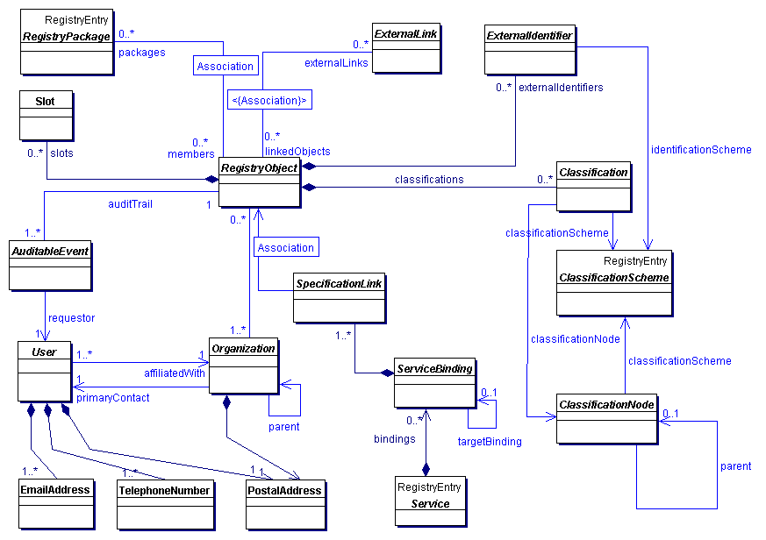
- Figure 1: Information Model High Level Public View

RegistryObject
The RegistryObject class is an abstract base class used by most classes in the model. It provides minimal metadata for registry objects. It also provides methods for accessing related objects that provide additional dynamic metadata for the registry object.

RepositoryItem
The RepositoryItem class represents an object (e.g., an XML document or a DTD) that resides in a repository for storage and safekeeping. Each RepositoryItem instance is associated with a RegistryObject instance. The RegistryObject catalogs the RepositoryItem with metadata. The RepositoryItem class is not represented in the XML schema for the registry because a repository item is a mime attachment within registry requests as explained in [ebRS].

Slot
Slot instances provide a dynamic way to add arbitrary attributes to RegistryObject instances. This ability to add attributes dynamically to RegistryObject instances enables extensibility within the Registry Information Model. For example, if a company wants to add a “copyright” attribute to each RegistryObject instance that it submits, it can do so by adding a slot with name “copyright” and value containing the copyrights statement.

Association
Association instances are RegistryObject instances that are used to define many-to-many associations between objects in the information model. Associations are described in detail in section 8.

ExternalIdentifier
ExternalIdentifier instances provide additional identifier information to a RegistryObject instance, such as DUNS number, Social Security Number, or an alias name of the organization.

ExternalLink
ExternalLink instances are RegistryObject instances that contain a named URI to content external to the Registry. Unlike managed content, such external content may change or be deleted at any time without the knowledge of the Registry. A RegistryObject instance may be associated with any number of ExternalLinks.
Consider the case where a Submitting Organization submits a repository item (e.g., a DTD) and wants to associate some external content to that object (e.g., the Submitting Organization's home page). The ExternalLink enables this capability. A potential use of the ExternalLink capability may be in a GUI tool that displays the ExternalLinks to a RegistryObject. The user may click on such links and navigate to an external web page referenced by the link.

ClassificationScheme
ClassificationScheme instances are RegistryEntry instances that describe a structured way to classify or categorize RegistryObject instances. The structure of the classification scheme may be defined internal or external to the registry, resulting in a distinction between internal and external classification schemes. A very common example of a classification scheme in science is the “Classification of living things” where living things are categorized in a tree like structure. Another example is the Dewey Decimal system used in libraries to categorize books and other publications. ClassificationScheme is described in detail in section 9.

ClassificationNode
ClassificationNode instances are RegistryObject instances that are used to define tree structures under a ClassificationScheme, where each node in the tree is a ClassificationNode and the root is the ClassificationScheme. Classification trees constructed with ClassificationNodes are used to define the structure of Classification schemes or ontologies. ClassificationNode is described in detail in section 9.

Classification
Classification instances are RegistryObject instances that are used to classify other RegistryObject instances. A Classification instance identifies a ClassificationScheme instance and taxonomy value defined within the classification scheme. Classifications can be internal or external depending on whether the referenced classification scheme is internal or external. Classification is described in detail in section 9.

RegistryPackage
RegistryPackage instances are RegistryEntry instances that group logically related RegistryObject instances together.

AuditableEvent
AuditableEvent instances are RegistryObject instances that are used to provide an audit trail for RegistryObject instances. AuditableEvent is described in detail in section 11.1.

User
User instances are RegistryObject instances that are used to provide information about registered users within the Registry. User objects are used in audit trail for RegistryObject instances. User is described in detail in section 7.12.

PostalAddress
PostalAddress is a simple reusable Entity Class that defines attributes of a postal address.

EmailAddress
EmailAddress is a simple reusable Entity Class that defines attributes of an email address.

Organization
Organization instances are RegistryObject instances that provide information on organizations such as a Submitting Organization. Each Organization instance may have a reference to a parent Organization.

Service
Service instances are RegistryEntry instances that provide information on services (e.g., web services).

ServiceBinding
ServiceBinding instances are RegistryObject instances that represent technical information on a specific way to access a specific interface offered by a Service instance. A Service has a collection of ServiceBindings.

SpecificationLink
A SpecificationLink provides the linkage between a ServiceBinding and one of its technical specifications that describes how to use the service with that ServiceBinding. For example, a ServiceBinding may have a SpecificationLink instance that describes how to access the service using a technical specification in the form of a WSDL or a CORBA IDL document.

Registry Information Model: Detail View
Follow same sequence of classes as public view for consistency??
This section covers the information model classes in more detail than the Public View. The detail view introduces some additional classes within the model that were not described in the public view of the information model.

Figure 2 shows theIinheritance or “is a” relationships between the Classes in the information model. Note that it does not show the other types of relationships, such as “has a” relationships, since they have already been shown in a previous figure. Class attributes and class methods are also not shown. Detailed description of methods and attributes of most interfaces and Classes will be displayed in tabular form following the description of each Class in the model.

The class Association will be covered in detail separately in section 8. The classes ClassificationScheme, Classification, and ClassificationNode will be covered in detail separately in section 9.

The reader is again reminded that the information model is not modeling actual repository items.
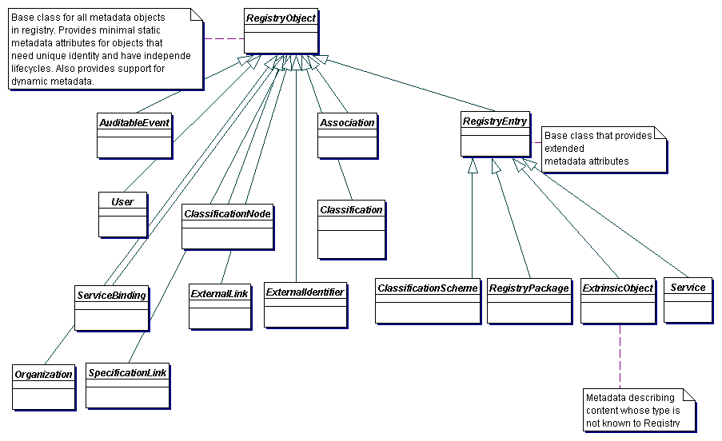
- Figure 2: Information Model Inheritance View
Update figure 2??

Attribute and Methods of Information Model Classes
Information model classes are defined primarily in terms of the attributes they carry. These attributes provide information on the state of the instances of these classes. Implementations of a registry often map class attributes to attributes in an XML store or columns in a relational store.

Information model classes may also have methods defined for them. These methods provide additional behavior for the class they are defined within. Methods are currently used in mapping to Filter Query and the SQL Query capabilities defined in [ebRS].

Since the model supports inheritance between classes, it is usually the case that a class in the model inherits attributes and methods from its base classes, in addition to defining its own specialized attributes and methods.

Data Types
The following table lists the various data types used by the attributes within information model classes:

Data Type | XML Schema  Data Type | Description | Length
Boolean | boolean | Used for a true or false value
String4 | string | Used for 4 character long strings | 4 characters
String8 | string | Used for 8 character long strings | 8 characters
String16 | string | Used for 16 character long strings | 16 characters
String32 | string | Used for 32 character long strings | 32 characters
String | string | Used for unbounded Strings | unbounded
ShortName | string | A short text string | 64 characters
LongName | string | A long text string | 128 characters
FreeFormText | string | A very long text string for free-form text | 256 characters
UUID | string | DCE 128 Bit Universally unique Ids used for referencing another object | 64 characters
URI | string | Used for URL and URN values | 256 characters
Integer | integer | Used for integer values | 4 bytes
DateTime | dateTime | Used for a timestamp value such as Date

Move ObjectRef and I18N after RegistryObject which should be first??

Object Reference Support
The information model supports the ability for an attribute in an instance of an information model class to reference a RegistryObject instance using an object reference. An object reference is modeled in this specification with the ObjectRef class.

Class ObjectRef
An instance of the ObjectRef class is used to reference a RegistryObject. A RegistryObject may be referenced via an ObjectRef instance regardless of its location or that of the object referring to it.

Attribute Summary

Attribute | Data Type | Required | Default Value | Specified By | Mutable
id | UUID | Yes |  | Client | Yes
home | URI | No |  | Client | Yes
Should we change datatype from id/idref to String??

Attribute id
Every ObjectRef instance must have an id attribute. The id attribute must contain the value of the id attribute of the RegistryObject being referenced.

Attribute home
Every ObjectRef instance may optionally have a home attribute specified. The home attribute if present must contain the base URI to the home registry for the referenced RegistryObject. The base URI to a registry is described by the REST interface as defined in [ebRS].

Local Vs. Remote ObjectRefs
When the home attribute is specified, and matches the base URI of a remote registry, then ObjectRef is referred to as a remote ObjectRef.
If the home attribute is null then its default value is the base URI to the current registry. When the home attribute is null or matches the base URI of the current registry, then the ObjectRef is referred to as a local ObjectRef.

Internationalization (I18N) Support
Some information model classes have String attributes that are I18N capable and may be localized into multiple native languages. Examples include the name and description attributes of the RegistryObject class in 7.5.

The information model defines the InternationalString and the LocalizedString interfaces to support I18N capable attributes within the information model classes. These classes are defined below.

Class InternationalString
This class is used as a replacement for the String type whenever a String attribute needs to be I18N capable. An instance of the InternationalString class composes within it Collection of LocalizedString instances, where each String is specific to a particular locale. The InternationalString class provides set/get methods for adding or getting locale specific String values for the InternationalString instance.
Places that may need to use I18N String: Slot.name, SpecificationLink.useageDescription??

Attribute Summary

Attribute | Data Type | Required | Default Value | Specified By | Mutable
localized-Strings | Collection of Localized-String | No |  | Client | Yes

Attribute localizedStrings
Each InternationalString instance may have localizedStrings attribute that is a Collection of zero or more LocalizedString instances.

Class LocalizedString
This class is used as a simple wrapper class that associates a String with its locale. The class is needed in the InternationalString class where a Collection of LocalizedString instances are kept. Each LocalizedString instance has a charset and lang attribute as well as a value attribute of type String.

Attribute Summary

Attribute | Data Type | Required | Default Value | Specified By | Mutable
lang | language | No | en-us | Client | Yes
charset | String | No | UTF-8 | Client | Yes
value | string | Yes |  | CLient | Yes

Attribute lang
Each LocalizedString instance may have a lang attribute that specifies the language used by that LocalizedString.

Attribute charset
Each LocalizedString instance may have a charset attribute that specifies the name of the character set used by that LocalizedString.

Attribute value
Each LocalizedString instance must have a value attribute that specifies the string value used by that LocalizedString.

Class RegistryObject
Direct Known Subclasses:
Association, AuditableEvent, Classification, ClassificationNode, ExternalIdentifier, ExternalLink, Organization, RegistryEntry, User, Service, ServiceBinding, SpecificationLink

RegistryObject provides a common base class for almost all objects in the information model. Information model Classes whose instances have a unique identity are descendants of the RegistryObject Class.

Note that Slot, PostalAddress, and a few other classes are not descendants of the RegistryObject Class because their instances do not have an independent existence and unique identity. They are always a part of some other Class's Instance (e.g., Organization has a PostalAddress).

Attribute Summary
The following is the first of many tables that summarize the attributes of a class. The columns in the table are described as follows:

Column | Description
Attribute | The name of the attribute
Data Type | The data type for the attribute
Required | Specifies whether the attribute is required to be specified
Default | Specifies the default value in case the attribute is omitted
Specified By | Indicates whether the attribute is specified by the client or specified by the registry. In some cases it may be both
Mutable | Specifies whether an attribute may be changed once it has been set to a certain value

Attribute | Data Type | Required | Default Value | Specified By | Mutable
accessControlPolicy | UUID | No |  | Registry | No
description | International-String | No |  | Client | Yes
id | UUID | Yes |  | Client or registry | No
home | URI | No |  | Client | Yes
name | International-String | No |  | Client | Yes
objectType | LongName | Yes |  | Registry | No
Fix sorting on all tables??

Attribute accessControlPolicy
Each RegistryObject instance may have an accessControlPolicy instance associated with it. An accessControlPolicy instance defines the Security Model associated with the RegistryObject in terms of “who is permitted to do what” with that RegistryObject.

Attribute description
Each RegistryObject instance may have textual description in a human readable and user-friendly manner. This attribute is I18N capable and therefore of type InternationalString.

Attribute id
Each RegistryObject instance must have a universally unique ID. Registry objects use the id of other RegistryObject instances for the purpose of referencing those objects.

Note that some classes in the information model do not have a need for a unique id. Such classes do not inherit from RegistryObject class. Examples include Entity classes such as TelephoneNumber, PostalAddress, EmailAddress and PersonName.

All classes derived from RegistryObject have an id that is a Universally Unique ID as defined by [UUID]. Such UUID based id attributes may be specified by the client. If the UUID based id is not specified, then it must be generated by the registry when a new RegistryObject instance is first submitted to the registry.

Attribute name
Each RegistryObject instance may have a human readable name. The name does not need to be unique with respect to other RegistryObject instances. This attribute is I18N capable and therefore of type InternationalString.

Attribute objectType
Each RegistryObject instance has an objectType. The objectType for almost all objects in the information model is the name of their class. For example the objectType for a Classification is “Classification”. The only exception to this rule is that the objectType for an ExtrinsicObject instance is user defined and indicates the type of repository item associated with the ExtrinsicObject.
Fix to say that it is a ref to a ClassificationNode in ObjectTypes scheme??

Pre-defined Object Types
The following table lists pre-defined object types. Note that for an ExtrinsicObject there are many types defined based on the type of repository item the ExtrinsicObject catalogs. In addition there are object types defined for all leaf sub-classes of RegistryObject.

These pre-defined object types are defined as a canonical ClassificationScheme called ObjectTypes. While the ObjectTypes scheme may easily be extended, a Registry MUST support the object types as defined by the ObjectTypes scheme at:
Need to publish this scheme??
http://www.oasis-open.org/committees/regrep/documents/3.0/content/ObjectTypes.xml

Method Summary
In addition to its attributes, the RegistryObject class also defines the following methods. These methods are used to navigate relationship links from a RegistryObject instance to other objects.

Method Summary for RegistryObject
Collection | getAuditTrail()  Gets the complete audit trail of all requests that effected a state change in this object as an ordered Collection of AuditableEvent objects.
Collection | getClassifications()  Gets the Classification that classify this object.
Collection | getExternalIdentifiers()  Gets the collection of ExternalIdentifiers associated with this object.
Collection | getExternalLinks()  Gets the ExternalLinks associated with this object.
Collection | getRegistryPackages()  Gets the RegistryPackages that this object is a member of.
Collection | getSlots()  Gets the Slots associated with this object.

Class RegistryEntry
Super Classes:
RegistryObject

Direct Known Subclasses:
ClassificationScheme, ExtrinsicObject, RegistryPackage, Service

RegistryEntry is a common base class for classes in the information model that require additional metadata beyond the minimal metadata provided by RegistryObject class. RegistryEntry is used as a base class for high-level coarse-grained objects in the registry. Their life cycle typically requires more management (e.g. may require approval, deprecation). They typically have relatively fewer instances but serve as a root of a composition hierarchy consisting of numerous objects that are sub-classes of RegistryObject but not RegistryEntry.

The additional metadata is described by the attributes of the RegistryEntry class below.

Attribute Summary

Attribute | Data Type | Required | Default Value | Specified By | Mutable
expiration | DateTime | No |  | Client | Yes
majorVersion | Integer | Yes | 1 | Registry | Yes
minorVersion | Integer | Yes | 0 | Registry | Yes
stability | LongName | No |  | Client | Yes
status | LongName | Yes |  | Registry | Yes
userVersion | ShortName | No |  | Client | Yes

Note that attributes inherited by RegistryEntry class from the RegistryObject class are not shown in the table above.

Attribute expiration
Each RegistryEntry instance may have an expirationDate. This attribute defines a time limit upon the stability indication provided by the stability attribute. Once the expirationDate has been reached the stability attribute in effect becomes STABILITY_DYNAMIC implying that the repository item can change at any time and in any manner. A null value implies that there is no expiration on stability attribute.

Attribute majorVersion
Each RegistryEntry instance must have a major revision number for the current version of the RegistryEntry instance. This number is assigned by the registry when the object is created and it may be changed by the registry when an object is updated.

Attribute minorVersion
Each RegistryEntry instance must have a minor revision number for the current version of the RegistryEntry instance. This number is assigned by the registry when the object is created and it may be changed by the registry when an object is updated.

Attribute stability
Each RegistryEntry instance may have a stability indicator. The stability indicator is provided by the submitter as an indication of the level of stability for the repository item.

Pre-defined RegistryEntry Stability Enumerations
The following table lists pre-defined choices for RegistryEntry stability attribute.
These pre-defined stability types are defined as a ClassificationScheme. While the scheme may easily be extended, a registry MAY support the stability types listed below.
Following fonts need to be fixed so consistent with RS??

Name | Description
Dynamic | Stability of a RegistryEntry that indicates that the content is dynamic and may be changed arbitrarily by submitter at any time.
DynamicCompatible | Stability of a RegistryEntry that indicates that the content is dynamic and may be changed in a backward compatible way by submitter at any time.
Static | Stability of a RegistryEntry that indicates that the content is static and will not be changed by submitter.

Attribute status
Each RegistryEntry instance must have a life cycle status indicator. The status is assigned by the registry.

Pre-defined RegistryObject Status Types
The following table lists pre-defined choices for RegistryObject status attribute.
These pre-defined status types are defined as a ClassificationScheme.

Name | Description
Submitted | Status of a RegistryObject that catalogues content that has been submitted to the registry.
Approved | Status of a RegistryObject that catalogues content that has been submitted to the registry and has been subsequently approved.
Deprecated | Status of a RegistryObject that catalogues content that has been submitted to the registry and has been subsequently deprecated.
Withdrawn | Status of a RegistryObject that catalogues content that has been withdrawn from the registry. A repository item has been removed but its ExtrinsicObject still exists.

Attribute userVersion
Each RegistryEntry instance may have a userVersion. The userVersion is similar to the majorVersion-minorVersion tuple. They both provide an indication of the version of the object. The majorVersion-minorVersion tuple is provided by the registry while userVersion provides a user specified version for the object.

Class Slot
Slot instances provide a dynamic way to add arbitrary attributes to RegistryObject instances. This ability to add attributes dynamically to RegistryObject instances enables extensibility within the information model.

A RegistryObject may have 0 or more Slots. A slot is composed of a name, a slotType and a collection of values.

Attribute Summary

Attribute | Data Type | Required | Default Value | Specified By | Mutable
name | LongName | Yes |  | Client | No
slotType | LongName | No |  | Client | No
values | Collection of LongName | Yes |  | Client | No

Attribute name
Each Slot instance must have a name. The name is the primary means for identifying a Slot instance within a RegistryObject. Consequently, the name of a Slot instance must be locally unique within the RegistryObject instance.

Attribute slotType
Each Slot instance may have a slotType that allows different slots to be grouped together.

Attribute values
A Slot instance must have a Collection of values. The collection of values may be empty. Since a Slot represent an extensible attribute whose value may be a collection, therefore a Slot is allowed to have a collection of values rather than a single value.
Need to discuss whether to add a scheme to a Slot??

Class ExtrinsicObject
Super Classes:
RegistryEntry, RegistryObject

ExtrinsicObjects provide metadata that describes submitted content whose type is not intrinsically known to the registry and therefore MUST be described by means of additional attributes (e.g., mime type).

Examples of content described by ExtrinsicObject include Collaboration Protocol Profiles [ebCPP], Business Process descriptions, and schemas.

Attribute Summary

Attribute | Data Type | Required | Default Value | Specified By | Mutable
isOpaque | Boolean | No |  | Client | No
mimeType | LongName | No |  | Client | No

Note that attributes inherited from RegistryEntry and RegistryObject are not shown in the table above.

Attribute isOpaque
Each ExtrinsicObject instance may have an isOpaque attribute defined. This attribute determines whether the content catalogued by this ExtrinsicObject is opaque to (not readable by) the registry. In some situations, a Submitting Organization may submit content that is encrypted and not even readable by the registry.

Attribute mimeType
Each ExtrinsicObject instance may have a mimeType attribute defined. The mimeType provides information on the type of repository item catalogued by the ExtrinsicObject instance.

Class RegistryPackage
Super Classes:
RegistryEntry, RegistryObject

RegistryPackage instances allow for grouping of logically related RegistryObject instances even if individual member objects belong to different Submitting Organizations.

Attribute Summary

The RegistryPackage class defines no new attributes other than those that are inherited from RegistryEntry and RegistryObject base classes. The inherited attributes are not shown here.

Method Summary
In addition to its attributes, the RegistryPackage class also defines the following methods.

Method Summary of RegistryPackage
Collection | getMemberObjects()  Get the collection of RegistryObject instances that are members of this RegistryPackage.

Class ExternalIdentifier
Super Classes:
RegistryObject

ExternalIdentifier instances provide the additional identifier information to RegistryObject such as DUNS number, Social Security Number, or an alias name of the organization. The attribute identificationScheme is used to reference the identification scheme (e.g., “DUNS”, “Social Security #”), and the attribute value contains the actual information (e.g., the DUNS number, the social security number). Each RegistryObject may contain 0 or more ExternalIdentifier instances.

Attribute Summary

Attribute | Data Type | Required | Default Value | Specified By | Mutable
identificationScheme | UUID | Yes |  | Client | Yes
registryObject | UUID | Yes |  | Client | No
value | LongName | Yes |  | Client | Yes
Note that attributes inherited from the base classes of this class are not shown.

Attribute identificationScheme
Each ExternalIdentifier instance must have an identificationScheme attribute that references a ClassificationScheme. This ClassificationScheme defines the namespace within which an identifier is defined using the value attribute for the RegistryObject referenced by the RegistryObject attribute.

Attribute registryObject
Each ExternalIdentifier instance must have a registryObject attribute that references the parent RegistryObject for which this is an ExternalIdentifier.

Attribute value
Each ExternalIdentifier instance must have a value attribute that provides the identifier value for this ExternalIdentifier (e.g., the actual social security number).

Class ExternalLink
Super Classes:
RegistryObject

ExternalLinks use URIs to associate content in the registry with content that may reside outside the registry. For example, an organization submitting a DTD could use an ExternalLink to associate the DTD with the organization's home page.

Attribute Summary

Attribute | Data Type | Required | Default Value | Specified By | Mutable
externalURI | URI | Yes |  | Client | Yes

Attribute externalURI
Each ExternalLink instance must have an externalURI attribute defined. The externalURI attribute provides a URI to the external resource pointed to by this ExternalLink instance. If the URI is a URL then a registry must validate the URL to be resolvable at the time of submission before accepting an ExternalLink submission to the registry.

Method Summary
In addition to its attributes, the ExternalLink class also defines the following methods.

Method Summary of ExternalLink
Collection | getLinkedObjects()  Gets the collection of RegistryObjects that are linked by this  ExternalLink to content outside the registry.

Class User
Super Classes:
RegistryObject

User instances represent users that have registered with a registry. User instances are also used in an AuditableEvent to keep track of the identity of the requestor that sent the request that generated the AuditableEvent.

Attribute Summary

Attribute | Data Type | Required | Default Value | Specified By | Mutable
address | PostalAddress | No |  | Client | Yes
emailAddresses | Collection of EmailAddress | Yes |  | Client | Yes
organization | UUID | No |  | Client | No
personName | PersonName | Yes |  | Client | No
telephoneNumbers | Collection of TelephoneNumber | Yes |  | Client | Yes
url | URI | No |  | Client | Yes

Attribute address
Each User instance may have an address attribute that provides the postal address for that user.

Attribute emailAddresses
Each User instance has an attribute emailAddresses that is a Collection of EmailAddress instances. Each EmailAddress provides an email address for that user. A User must have at least one email address.

Attribute organization
Each User instance may have an organization attribute that references the Organization instance with which the user is affiliated.

Attribute personName
Each User instance must have a personName attribute that provides the name for that user.

Attribute telephoneNumbers
Each User instance must have a telephoneNumbers attribute that contains the Collection of TelephoneNumber instances defined for that user. A User must have at least one TelephoneNumber.

Attribute url
Italicise all attributes in headings and para as done in url above??
Each User instance may have a url attribute that provides the URL address for the web page associated with that user.

Class Organization
Super Classes:
RegistryObject

Organization instances provide information on organizations such as a Submitting Organization. Each Organization instance may have a reference to a parent Organization.

Attribute Summary

Attribute | Data Type | Required | Default Value | Specified By | Mutable
Address | PostalAddress | Yes |  | Client | Yes
emailAddresses | Collection of EmailAddress | No |  | Client | Yes
Parent | UUID | No |  | Client | Yes
primaryContact | UUID | Yes |  | Client | No
telephoneNumbers | Collection of TelephoneNumber | Yes |  | Client | Yes

Attribute address
Each Organization instance must have an address attribute that provides the postal address for that organization.

Attribute emailAddresses
Each Organization instance may have an attribute emailAddresses that is a Collection of EmailAddress instances. Each EmailAddress provides an email address for that Organization.

Attribute parent
Each Organization instance may have a parent attribute that references the parent Organization instance, if any, for that organization.

Attribute primaryContact
Each Organization instance must have a primaryContact attribute that references the User instance for the user that is the primary contact for that organization.

Attribute telephoneNumbers
Each Organization instance must have a telephoneNumbers attribute that contains the Collection of TelephoneNumber instances defined for that organization. An Organization must have at least one telephone number.

Class PostalAddress

PostalAddress is a simple reusable Entity Class that defines attributes of a postal address.

Attribute Summary

Attribute | Data Type | Required | Default Value | Specified By | Mutable
city | ShortName | No |  | Client | Yes
country | ShortName | No |  | Client | Yes
postalCode | ShortName | No |  | Client | Yes
state | ShortName | No |  | Client | Yes
street | ShortName | No |  | Client | Yes
streetNumber | String32 | No |  | Client | Yes

Attribute city
Each PostalAddress may have a city attribute identifying the city for that address.

Attribute country
Each PostalAddress may have a country attribute identifying the country for that address.

Attribute postalCode
Each PostalAddress may have a postalCode attribute identifying the postal code (e.g., zip code) for that address.

Attribute state
Each PostalAddress may have a state attribute identifying the state, province or region for that address.

Attribute street
Each PostalAddress may have a street attribute identifying the street name for that address.

Attribute streetNumber
Each PostalAddress may have a streetNumber attribute identifying the street number (e.g., 65) for the street address.

Method Summary
In addition to its attributes, the PostalAddress class also defines the following methods.

Method Summary of ExternalLink
Collection | getSlots()  Gets the collection of Slots for this object. Each PostalAddress may have multiple Slot instances where a Slot is a dynamically defined attribute. The use of Slots allows the client to extend PostalAddress class by defining additional dynamic attributes using slots to handle locale specific needs.

Class TelephoneNumber
A simple reusable Entity Class that defines attributes of a telephone number.

Attribute Summary

Attribute | Data Type | Required | Default Value | Specified By | Mutable
areaCode | String8 | No |  | Client | Yes
countryCode | String8 | No |  | Client | Yes
extension | String8 | No |  | Client | Yes
number | String16 | No |  | Client | Yes
phoneType | String32 | No |  | Client | Yes
url | URI | No |  | Client | Yes

Attribute areaCode
Each TelephoneNumber instance may have an areaCode attribute that provides the area code for that telephone number.

Attribute countryCode
Each TelephoneNumber instance may have a countryCode attribute that provides the country code for that telephone number.

Attribute extension
Each TelephoneNumber instance may have an extension attribute that provides the extension number, if any, for that telephone number.

Attribute number
Each TelephoneNumber instance may have a number attribute that provides the local number (without area code, country code and extension) for that telephone number.

Attribute phoneType
Each TelephoneNumber instance may have phoneType attribute that provides the type for the TelephoneNumber. Some examples of phoneType are “home”, “office”.

Class EmailAddress
A simple reusable Entity Class that defines attributes of an email address.

Attribute Summary
Attribute | Data Type | Required | Default Value | Specified By | Mutable
address | ShortName | Yes |  | Client | Yes
type | String32 | No |  | Client | Yes

Attribute address
Each EmailAddress instance must have an address attribute that provides the actual email address.

Attribute type
Each EmailAddress instance may have a type attribute that provides the type for that email address. This is an arbitrary value. Examples include “home”, “work” etc.

Class PersonName
A simple Entity Class for a person’s name.

Attribute Summary

Attribute | Data Type | Required | Default Value | Specified By | Mutable
firstName | ShortName | No |  | Client | Yes
lastName | ShortName | No |  | Client | Yes
middleName | ShortName | No |  | Client | Yes

Attribute firstName
Each PersonName may have a firstName attribute that is the first name of the person.

Attribute lastName
Each PersonName may have a lastName attribute that is the last name of the person.

Attribute middleName
Each PersonName may have a middleName attribute that is the middle name of the person.

Association Information Model
A RegistryObject instance may be associated with zero or more RegistryObject instances. The information model defines an Association class, an instance of which may be used to associate any two RegistryObject instances.

Example of an Association
One example of such an association is between two ClassificationScheme instances, where one ClassificationScheme supersedes the other ClassificationScheme as shown in Figure 3. This may be the case when a new version of a ClassificationScheme is submitted.
In Figure 3, we see how an Association is defined between a new version of the NAICS ClassificationScheme and an older version of the NAICS ClassificationScheme.

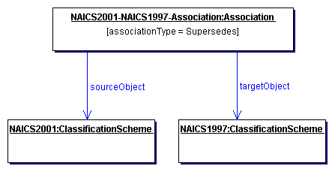
- Figure 3: Example of RegistryObject Association

Source and Target Objects
An Association instance represents an association between a source RegistryObject and a target RegistryObject. These are referred to as sourceObject and targetObject for the Association instance. It is important which object is the sourceObject and which is the targetObject as it determines the directional semantics of an Association.
In the example in Figure 3, it is important to make the newer version of NAICS ClassificationScheme be the sourceObject and the older version of NAICS be the targetObject because the associationType implies that the sourceObject supersedes the targetObject (and not the other way around).

Association Types
Each Association must have an associationType attribute that identifies the type of that association.

Intramural Association
A common use case for the Association class is when a User “u” creates an Association “a” between two RegistryObjects “o1” and “o2” where Association “a” and RegistryObjects “o1” and “o2” are objects that were created by the same User “u.” This is the simplest use case, where the Association is between two objects that are owned by the same User that is defining the Association. Such Associations are referred to as intramural Associations.
Figure 4 below, extends the previous example in Figure 3 for the intramuralAassociation case.

- 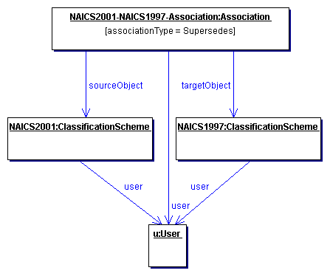
- Figure 4: Example of Intramural Association

Extramural Association
The information model also allows more sophisticated use cases. For example, a User “u1” creates an Association “a” between two RegistryObjects “o1” and “o2” where association “a” is owned by User “u1”, but RegistryObjects “o1” and “o2” are owned by User “u2” and User “u3” respectively.
In this use case an Association is defined where either or both objects that are being associated are owned by a User different from the User defining the Association. Such Associations are referred to as extramural Associations. The Association class provides a convenience method called isExtramural that returns "true" if the Association instance is an extramural Association.
Figure 5 below, extends the previous example in Figure 3 for the extramura Aassociation case. Note that it is possible for an extramura Aassociation to have two distinct Users rather than three distinct Users as shown in Figure 5. In such case, one of the two users owns two of the three objects involved (Association, sourceObject and targetObject).

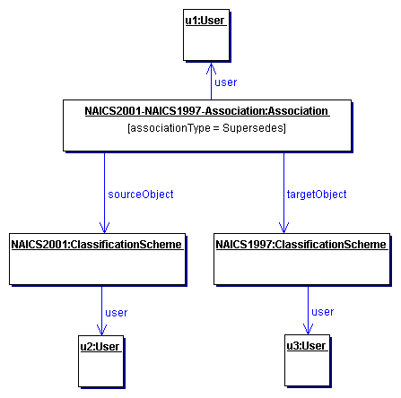
- Figure 5: Example of Extramural Association

Confirmation of an Association
An Association may need to be confirmed by the parties whose objects are involved in that Association as the sourceObject or targetObject. This section describes the semantics of confirmation of an association by the parties involved.

Confirmation of Intramural Associations
Intramural associations may be viewed as declarations of truth and do not require any explicit steps to confirm that Association as being true. In other words, intramural associations are implicitly considered confirmed.

Confirmation of Extramural Associations
An extramural association may be thought of as a unilateral assertion that may not be viewed as truth until it has been confirmed by the other (extramural) parties involved (Users “u2” and “u3” in the example in section 8.5).
To confirm an extramural association, each of the extramural parties (parties that own the source or target object but do not own the Association) must submit an identical Association (clone Association) as the Association they are intending to confirm using a SubmitObjectsRequest. The clone Association must use the same id as the original Association.

Deleting an Extramural Associations
An Extramural Association is deleted like any other type of RegistryObject, using the RemoveObjectsRequest as defined in [ebRS]. However, in some cases deleting an extramural Association may not actually delete it but instead only revert a confirmed association to unconfirmed state.

When deleted by its owner, an extramural Association must always be deleted irrespective of its confirmation state.
When deleted by the owner of its source/target object who is not the owner of the Association itself, an extramural Association must become unconfirmed.

Visibility of Unconfirmed Associations
Unconfirmed extramural Associations are visible to third party registry clients. Third party registry clients can determine the confirmation state of an extramural Association and decide whether to trust that Association or not.

Possible Confirmation States
Assume the most general case where there are three distinct User instances as shown in Figure 5 for an extramural Association. The extramural Association needs to be confirmed by both(extramura) parties (Users “u2” and “u3” in example) in order to be fully confirmed. The methods isConfirmedBySourceOwner and isConfirmedByTargetOwner in the Association class provide access to the confirmation state for both the sourceObject and targetObject. A third convenience method called isConfirmed provides a way to determine whether the Association is fully confirmed or not. So there are the following four possibilities related to the confirmation state of an extramural Association:
- The Association is confirmed neither by the owner of the sourceObject nor by the owner of the targetObject.
- The Association is confirmed by the owner of the sourceObject but it is not confirmed by the owner of the targetObject.
- The Association is not confirmed by the owner of the sourceObject but it is confirmed by the owner of the targetObject.
- The Association is confirmed by both the owner of the sourceObject and the owner of the targetObject. This is the only state where the Association is fully confirmed.

Class Association
Super Classes:
RegistryObject

Association instances are used to define many-to-many associations among RegistryObjects in the information model.

An instance of the Association class represents an association between two RegistryObjects.

Attribute Summary

Attribute | Data Type | Required | Default Value | Specified By | Mutable
associationType | LongName | Yes |  | Client | No
sourceObject | UUID | Yes |  | Client | No
targetObject | UUID | Yes |  | Client | No
isConfirmedBy-SourceOwner | boolean | No | false | Registry | No
isConfirmedBy-TargetOwner | boolean | No | false | Registry | No

Attribute associationType
Each Association must have an associationType attribute that identifies the type of that association.

Pre-defined Association Types
The following table lists pre-defined association types. These pre-defined association types are defined as a ClassificationScheme. While the scheme may easily be extended a registry MUST support the association types listed below.
Need yo update for new associationTypes in V3 features (CatalogingServiceFor…)??

Name | description
RelatedTo | Defines that source RegistryObject is related to target RegistryObject.
HasFederationMember | Defines that the source Federation object has the target Registry object as a member. Reserved for use in Registry Federation feature.
HasMember | Defines that the source RegistryPackage object has the target RegistryObject object as a member. Reserved for use in Packaging of RegistryObjects.
ExternallyLinks | Defines that the source ExternalLink object externally links the target RegistryObject object. Reserved for use in associating ExternalLinks with RegistryObjects.
Contains | Defines that source RegistryObject contains the target RegistryObject. The details of the containment relationship are specific to the usage. For example a parts catalog may define an Engine object to have a contains relationship with a Transmission object.
EquivalentTo | Defines that source RegistryObject is equivalent to the target RegistryObject.
Extends | Defines that source RegistryObject inherits from or specializes the target RegistryObject.
Implements | Defines that source RegistryObject implements the functionality defined by the target RegistryObject.
InstanceOf | Defines that source RegistryObject is an instance of target RegistryObject.
Supersedes | Defines that the source RegistryObject supersedes the target RegistryObject.
Uses | Defines that the source RegistryObject uses the target RegistryObject in some manner.
Replaces | Defines that the source RegistryObject replaces the target RegistryObject in some manner.
SubmitterOf | Defines that the source Organization is the submitter of the target RegistryObject.
ResponsibleFor | Defines that the source Organization is responsible for the ongoing maintainence of the target RegistryObject.
OffersService | Defines that the source Organization object offers the target Service object as a service.

Attribute sourceObject
Each Association must have a sourceObject attribute that references the RegistryObject instance that is the source of that Association.

Attribute targetObject
Each Association must have a targetObject attribute that references the RegistryObject instance that is the target of that Association.

Attribute isConfirmedBySourceOwner
Each Association may have an isConfirmedBySourceOwner attribute that is set by the registry to be true if the Association has been confirmed by the owner of the sourceObject. For intramural Associations this attribute is always true. This attribute must be present when the object is retrieved from the registry. This attribute must be ignored if specified by the client when the object is submitted to the registry.

Attribute isConfirmedByTargetOwner
Each Association may have an isConfirmedByTargetOwner attribute that is set by the registry to be true if the association has been confirmed by the owner of the targetObject. For intramural Associations this attribute is always true. This attribute must be present when the object is retrieved from the registry. This attribute must be ignored if specified by the client when the object is submitted to the registry.

Method Summary of Association
Boolean | isConfirmed()  Returns true if isConfirmedBySourceOwner and isConfirmedByTargetOwner attributes are both true. For intramural Associations always returns true.
Boolean | isExtramural()  Returns true if the sourceObject and/or the targetObject are owned by a User that is different from the User that created the Association.

Classification Information Model
This section describes how the information model supports Classification of RegistryObject.

A RegistryObject may be classified in many ways. For example the RegistryObject for the same Collaboration Protocol Profile (CPP) may be classified by its industry, by the products it sells and by its geographical location.

A general ClassificationScheme can be viewed as a Classification tree. In the example shown in Figure 6, RegistryObject instances representing Collaboration Protocol Profiles are shown as shaded boxes. Each Collaboration Protocol Profile represents an automobile manufacturer. Each Collaboration Protocol Profile is classified by the ClassificationNode named “Automotive” under the ClassificationScheme instance with name “Industry.” Furthermore, the US Automobile manufacturers are classified by the “US” ClassificationNode under the ClassificationScheme with name “Geography." Similarly, a European automobile manufacturer is classified by the “Europe” ClassificationNode under the ClassificationScheme with name “Geography.”

The example shows how a RegistryObject may be classified by multiple ClassificationNode instances under multiple ClassificationScheme instances (e.g., Industry, Geography).

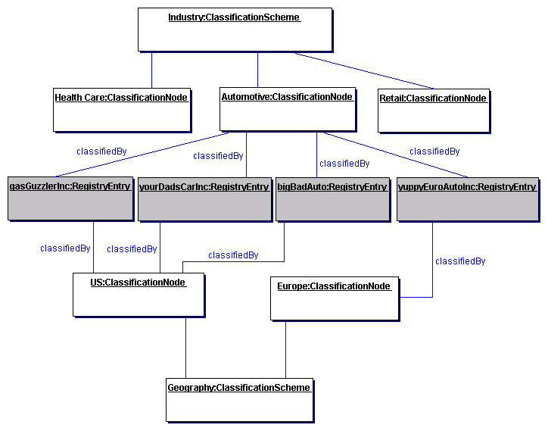
- Figure 6: Example showing a Classification Tree
It is important to point out that the shaded nodes (gasGuzzlerInc, yourDadsCarInc etc.) are not part of the Classification tree. The leaf nodes of the Classification tree are Health Care, Automotive, Retail, US and Europe. The shaded nodes are associated with the Classification tree via a Classification Instance that is not shown in the picture.

In order to support a general ClassificationScheme that can support single level as well as multi-level Classifications, the information model defines the classes and relationships shown in Figure 7.
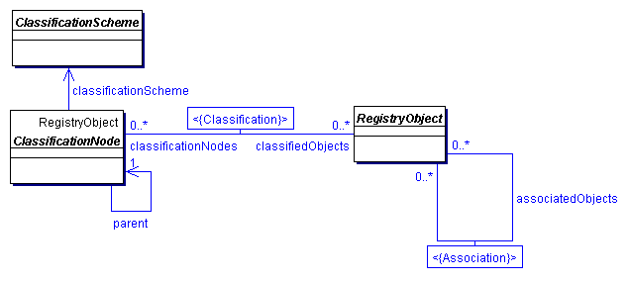
- Figure 7: Information Model Classification View

A Classification is somewhat like a specialized form of an Association. Figure 8 shows an example of an ExtrinsicObject Instance for a Collaboration Protocol Profile (CPP) object that is classified by a ClassificationNode representing the Industry that it belongs to.

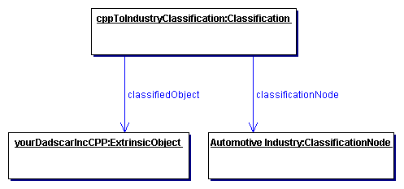
- Figure 8: Classification Instance Diagram

Class ClassificationScheme
Base classes:
RegistryEntry, RegistryObject

A ClassificationScheme instance describes a registered taxonomy. The taxonomy hierarchy may be defined internally to the registry by instances of ClassificationNode or it may be defined externally to the Registry, in which case the structure and values of the taxonomy elements are not known to the Registry.
In the first case the classification scheme is defined to be internal and in the second case the classification scheme is defined to be external.
The ClassificationScheme class inherits attributes and methods from the RegistryObject and RegistryEntry classes.

Attribute Summary

Attribute | Data Type | Required | Default Value | Specified By | Mutable
isInternal | Boolean | Yes |  | Client | No
nodeType | String32 | Yes |  | Client | No
Note that attributes inherited by ClassificationScheme class from the RegistryEntry class are not shown.

Attribute isInternal
When submitting a ClassificationScheme instance the Submitting Organization must declare whether the ClassificationScheme instance represents an internal or an external taxonomy. This allows the registry to validate the subsequent submissions of ClassificationNode and Classification instances in order to maintain the type of ClassificationScheme consistent throughout its lifecycle.

Attribute nodeType
When submitting a ClassificationScheme instance the Submitting Organization must declare the structure of taxonomy nodes within the ClassificationScheme. This attribute is an enumeration with the following values:
- UniqueCode. This value indicates that each node of the taxonomy has a unique code assigned to it.
- EmbeddedPath. This value indicates that the unique code assigned to each node of the taxonomy also encodes its path. This is the case in the NAICS taxonomy.
- NonUniqueCode. In some cases nodes are not unique, and it is necessary to use the full path (from ClassificationScheme to the node of interest) in order to identify the node. For example, in a geography taxonomy Moscow could be under both Russia and the USA, where there are five cities of that name in different states.

Class ClassificationNode
Base classes:
RegistryObject

ClassificationNode instances are used to define tree structures where each node in the tree is a ClassificationNode. Such Classification trees are constructed with ClassificationNode instances under a ClassificationScheme instance, and are used to define Classification schemes or ontologies.

Attribute Summary

Attribute | Data Type | Required | Default Value | Specified By | Mutable
parent | UUID | No |  | Client | No
code | LongName | No |  | Client | No
path | String | No |  | Registry | No

Attribute parent
Each ClassificationNode may have a parent attribute. The parent attribute either references a parent ClassificationNode or a ClassificationScheme instance in case of first level ClassificationNode instances.

Attribute code
Each ClassificationNode may have a code attribute. The code attribute contains a code within a standard coding scheme.

Attribute path
Each ClassificationNode may have a path attribute. The path attribute must be present when a ClassificationNode is retrieved from the registry. The path attribute must be ignored when the path is specified by the client when the object is submitted to the registry. The path attribute contains the canonical path from the ClassificationScheme of this ClassificationNode. The path syntax is defined in 9.2.6.

Method Summary
In addition to its attributes, the ClassificationNode class also defines the following methods.

Method Summary of ClassificationNode
ClassificationScheme | getClassificationScheme()  Get the ClassificationScheme that this ClassificationNode belongs to.
Collection | getClassifiedObjects()  Get the collection of RegistryObjects classified by this ClassificationNode.
Integer | getLevelNumber()  Gets the level number of this ClassificationNode in the  classification scheme hierarchy. This method returns a  positive integer and is defined for every node instance.

In Figure 6, several instances of ClassificationNode are defined (all unshaded boxes). A ClassificationNode has zero or one parent and zero or more ClassificationNodes for its immediate children. The parent of a ClassificationNode may be another ClassificationNode or a ClassificationScheme in case of first level ClassificationNodes.

Canonical Path Syntax
The path attribute of the ClassificationNode class contains an absolute path in a canonical representation that uniquely identifies the path leading from the ClassificationScheme to that ClassificationNode.
The canonical path representation is defined by the following BNF grammar:

canonicalPath ::= '/' schemeId nodePath
nodePath ::= '/' nodeCode
| '/' nodeCode ( nodePath )?

In the above grammar, schemeId is the id attribute of the ClassificationScheme instance, and nodeCode is defined by NCName production as defined by http://www.w3.org/TR/REC-xml-names/#NT-NCName.

Example of Canonical Path Representation
The following canonical path represents what the path attribute would contain for the ClassificationNode with code “United States” in the sample Geography scheme in section 9.2.6.2.

/Geography-id/NorthAmerica/UnitedStates

Sample Geography Scheme
Note that in the following examples, the id attributes have been chosen for ease of readability and are therefore not valid URN or UUID values.

<ClassificationScheme id='Geography-id' name="Geography”/>

<ClassificationNode id="NorthAmerica-id" parent="Geography-id" code=NorthAmerica" />
<ClassificationNode id="UnitedStates-id" parent="NorthAmerica-id" code="UnitedStates" />

<ClassificationNode id="Asia-id" parent="Geography-id" code="Asia" />
<ClassificationNode id="Japan-id" parent="Asia-id" code="Japan" />
<ClassificationNode id="Tokyo-id" parent="Japan-id" code="Tokyo" />

Class Classification
Base Classes:
RegistryObject

A Classification instance classifies a RegistryObject instance by referencing a node defined within a particular ClassificationScheme. An internal Classification will always reference the node directly, by its id, while an external Classification will reference the node indirectly by specifying a representation of its value that is unique within the external classification scheme.

The attributes and methods for the Classification class are intended to allow for representation of both internal and external classifications in order to minimize the need for a submission or a query to distinguish between internal and external classifications.

In Figure 6, Classification instances are not explicitly shown but are implied as associations between the RegistryObject instances (shaded leaf node) and the associated ClassificationNode.

Attribute Summary

Attribute | Data Type | Required | Default Value | Specified By | Mutable
classificationScheme | UUID | for external classifications | null | Client | No
classificationNode | UUID | for internal classifications | null | Client | No
classifiedObject | UUID | Yes |  | Client | No
nodeRepresentation | LongName | for external classifications | null | Client | No
Note that attributes inherited from the base classes of this class are not shown.

Attribute classificationScheme
If the Classification instance represents an external classification, then the classificationScheme attribute is required. The classificationScheme value must reference a ClassificationScheme instance.

Attribute classificationNode
If the Classification instance represents an internal classification, then the classificationNode attribute is required. The classificationNode value must reference a ClassificationNode instance.

Attribute classifiedObject
For both internal and external classifications, the classifiedObject attribute is required and it references the RegistryObject instance that is classified by this Classification.

Attribute nodeRepresentation
If the Classification instance represents an external classification, then the nodeRepresentation attribute is required. It is a representation of a taxonomy element from a classification scheme. It is the responsibility of the registry to distinguish between different types of nodeRepresentation, like between the classification scheme node code and the classification scheme node canonical path. This allows the client to transparently use different syntaxes for nodeRepresentation.
Check Len’s proposal on nodeRepresentation??

Context Sensitive Classification
Consider the case depicted in Figure 9 where a Collaboration Protocol Profile for ACME Inc. is classified by the “Japan” ClassificationNode under the “Geography” Classification scheme. In the absence of the context for this Classification its meaning is ambiguous. Does it mean that ACME is located in Japan, or does it mean that ACME ships products to Japan, or does it have some other meaning? To address this ambiguity a Classification may optionally be associated with another ClassificationNode (in this example named isLocatedIn) that provides the missing context for the Classification. Another Collaboration Protocol Profile for MyParcelService may be classified by the “Japan” ClassificationNode where this Classification is associated with a different ClassificationNode (e.g., named shipsTo) to indicate a different context than the one used by ACME Inc.
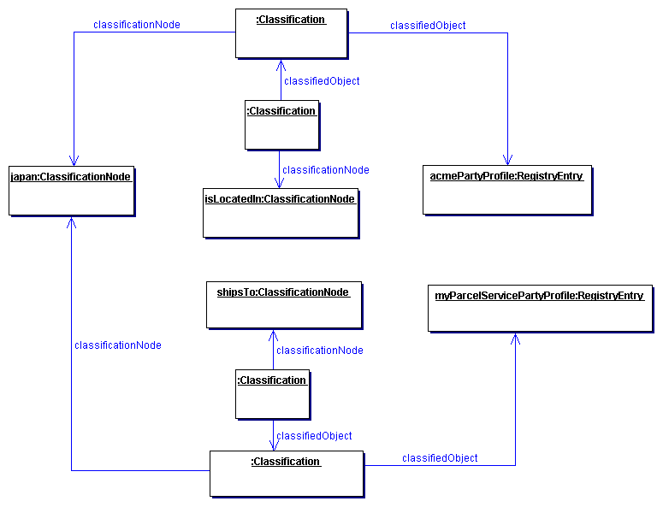
- Figure 9: Context Sensitive Classification

Thus, in order to support the possibility of Classification within multiple contexts, a Classification is itself classified by any number of Classifications that bind the first Classification to ClassificationNodes that provide the missing contexts.

In summary, the generalized support for Classification schemes in the information model allows:
- A RegistryObject to be classified by defining an internal Classification that associates it with a ClassificationNode in a ClassificationScheme.
- A RegistryObject to be classified by defining an external Classification that associates it with a value in an external ClassificationScheme.
- A RegistryObject to be classified along multiple facets by having multiple Classifications that associate it with multiple ClassificationNodes or value within a ClassificationScheme.
- A Classification defined for a RegistryObject to be qualified by the contexts in which it is being classified.

Method Summary
In addition to its attributes, the Classification class also defines the following methods:
Fix indentation in first para of method descriptions inside tables of methods??
Return Type Method
UUID | getClassificationScheme()  For an external classification, returns the scheme identified by the classificationScheme attribute.  For an internal classification, returns the scheme identified by the same method applied to the ClassificationNode instance
String | getPath()  For an external classification returns a string that conforms to the canonical path syntax as specified in 9.2.6.  For an internal classification, returns the value contained in the path attribute of the ClassificationNode instance identified by the classificationNode attribute.
LongName | getCode()  For an external classification, returns a string that represents the declared value of the taxonomy element. It will not necessarily uniquely identify that node.  For an internal classification, returns the value of the code attribute of the ClassificationNode instance identified by the classificationNode attribute.

Example of Classification Schemes
The following table lists some examples of possible ClassificationSchemes enabled by the information model. These schemes are based on a subset of contextual concepts identified by the ebXML Business Process and Core Components Project Teams. This list is meant to be illustrative not prescriptive.

Classification Scheme | Usage Example | Standard Classification Schemes
Industry | Find all Parties in Automotive industry | NAICS
Process | Find a ServiceInterface that implements a Process
Product / Services | Find a Business that sells a product or offers a service | UNSPSC
Locale | Find a Supplier located in Japan | ISO 3166
Temporal | Find Supplier that can ship with 24 hours
Role | Find All Suppliers that have a Role of “Seller”
- Table 1: Sample Classification Schemes

Service Information Model
This chapter describes the classes in the information model that support the registration of services. The service registration information model is flexible and supports the registration of web services as well as other types of services.

Class Service
Super Classes:
RegistryEntry, RegistryObject

Service instances provide information on services, such as web services.

Attribute Summary
The Service class does not define any specialized attributes other than its inherited attributes.

Method Summary
In addition to its attributes, the Service class also defines the following methods.

Method Summary of Service
Collection | getServiceBindings()  Gets the collection of ServiceBinding instances defined for this Service.

Class ServiceBinding
Super Classes:
RegistryObject

ServiceBinding instances are RegistryObjects that represent technical information on a specific way to access a specific interface offered by a Service instance. A Service has a Collection of ServiceBindings.
The description attribute of ServiceBinding provides details about the relationship between several specification links comprising the Service Binding.

Attribute Summary

Attribute | Data Type | Required | Default Value | Specified By | Mutable
accessURI | URI | No |  | Client | Yes
targetBinding | UUID | No |  | Client | Yes

Attribute accessURI
A ServiceBinding may have an accessURI attribute that defines the URI to access that ServiceBinding. This attribute is ignored if a targetBinding attribute is specified for the ServiceBinding. If the URI is a URL then a registry must validate the URL to be resolvable at the time of submission before accepting a ServiceBinding submission to the registry.

Attribute targetBinding
A ServiceBinding may have a targetBinding attribute defined that references another ServiceBinding. A targetBinding may be specified when a service is being redirected to another service. This allows the rehosting of a service by another service provider.

Method Summary
In addition to its attributes, the ServiceBinding class also defines the following methods.

Method Summary of ServiceBinding
Collection | getSpecificationLinks()  Get the collection of SpecificationLink instances defined for this ServiceBinding.

Class SpecificationLink
Super Classes:
RegistryObject

A SpecificationLink provides the linkage between a ServiceBinding and one of its technical specifications that describes how to use the service using the ServiceBinding. For example, a ServiceBinding may have SpecificationLink instances that describe how to access the service using a technical specification such as a WSDL document or a CORBA IDL document.

Attribute Summary

Attribute | Data Type | Required | Default Value | Specified By | Mutable
specificationObject | UUID | Yes |  | Client | Yes
usageDescription | InternationalString | No |  | Client | Yes
usageParameters | Collection of FreeFormText | No |  | Client | Yes

Attribute specificationObject
A SpecificationLink instance must have a specificationObject attribute that provides a reference to a RegistryObject instance that provides a technical specification for the parent ServiceBinding. Typically, this is an ExtrinsicObject instance representing the technical specification (e.g., a WSDL document).

Attribute usageDescription
A SpecificationLink instance may have a usageDescription attribute that provides a textual description of how to use the optional usageParameters attribute described next. The usageDescription is of type InternationalString, thus allowing the description to be in multiple languages.

Attribute usageParameters
A SpecificationLink instance may have a usageParameters attribute that provides a collection of Strings representing the instance specific parameters needed to use the technical specification (e.g., a WSDL document) specified by this SpecificationLink object.

Event Information Model
This chapter defines the information model classes that support the registry Event Notification feature. These classes include AuditableEvent, Subscription, Selector, Action and Notification. They constitute the foundation of the Event Notification information model.
Consider revising event type hierarchy (e.g. abstract base class Event)??

Class AuditableEvent
Super Classes:
RegistryObject

AuditableEvent instances provide a long-term record of events that effected a change in a RegistryObject. A RegistryObject is associated with an ordered Collection of AuditableEvent instances that provide a complete audit trail for that RegistryObject.
AuditableEvents are usually a result of a client-initiated request. AuditableEvent instances are generated by the Registry Service to log such Events.
Often such events effect a change in the life cycle of a RegistryObject. For example a client request could Create, Update, Deprecate or Delete a RegistryObject. An AuditableEvent is created if and only if a request creates or alters the content or ownership of a RegistryObject. Read-only requests do not generate an AuditableEvent.

Attribute Summary

Attribute | Data Type | Required | Default Value | Specified By | Mutable
eventType | LongName | Yes |  | Registry | No
affectedObjects | Collection of ObjectRef | Yes |  | Registry | No
requestId | ObjectRef | Yes |  | Registry | No
timestamp | dateTime | Yes |  | Registry | No
user | ObjectRef | Yes |  | Registry | No

Attribute eventType
Each AuditableEvent must have an eventType attribute which identifies the type of event recorded by the AuditableEvent.

Pre-defined Auditable Event Types
The following table lists pre-defined auditable event types. These pre-defined event types are defined as a pre-defined ClassificationScheme with name “EventType”. A Registry MUST support the event types listed below. Remove Relocated if we don’t do ObjectRelocation??

Name | Description
Created | An Event that marks the creation of a RegistryObject.
Deleted | An Event that marks the deletion of a RegistryObject.
Deprecated | An Event that marks the deprecation of a RegistryObject.
Downloaded | An Event that marks the downloading of a RegistryObject.
Relocated | An Event that marks the relocation of a RegistryObject.
Updated | An Event that that marks the updating of a RegistryObject.
Versioned | An Event that marks the versioning of a RegistryObject.

Attribute affectedObjects
Each AuditableEvent must have an affectedObjects attribute that identifies the collection of RegistryObjects instances that were affected by this event.

Attribute requestId
Each AuditableEvent must have a requestId attribute that identifies the client request instance that affected this event.

Attribute timestamp
Each AuditableEvent must have a timestamp attribute that records the date and time that this event occurred.

Attribute user
Each AuditableEvent must have a user attribute that identifies the User that sent the request that generated this event affecting the RegistryObject instance.

Class Subscription
Subscription instances are RegistryObjects that define a User’s interest in certain types of AuditableEvents. A User may create a subscription with a registry if she wishes to receive notification for a specific type of event.

Attribute Summary

Attribute | Data Type | Required | Default Value | Specified By | Mutable
actions | Collection of Action | Yes, may be empty |  | Client | Yes
endDate | dateTime | No |  | Client | Yes
notificationInterval | duration | No |  | Client | No
selector | Selector | Yes |  | Client | No
startDate | dateTime | No | Current time | Client | Yes

Attribute action
A Subscription instance must have an actions attribute that is a Collection of zero or more Action instances. An Action instance describes what action the registry must take when an event matching the Subscription transpires. The Action class is decsribed in section 11.5.

Attribute endDate
This attribute denotes the time after which the subscription expires and is no longer active. If this attribute is missing the subscription never expires.

Attribute notificationInterval
This attribute denotes the duration that a registry must wait between delivering successive notifications to the client. The client specifies this attribute in order to control the frequency of notification communication between registry and client. If this attribute is missing, sending of notifications should happen as soon as relevant events occur.

Attribute selector
This attribute defines the selection criterea that determines which events match this Subscription and are of interest to the User. The Selector class is described in section 11.3.

Attribute startDate
This attribute denotes the time at which the subscription becomes active. If this attribute is missing subscription starts immediately.

Class Selector
An instance of the Selector class specifies or “selects” events of interest that a subscriber is interested in. It is a base type from which more specialized Selector types are extended. Currently it defines no attributes or elements of its own.

Class QuerySelector
This class extends the Selector class and specifies or “selects” events of interest in terms of an SQL or Filter query. The query typically is on the AuditableEvent and related registry objects.

Attribute Summary

Attribute | Data Type | Required | Default Value | Specified By | Mutable
query | Adhoc Query | Yes |  | Client | Yes

Attribute query
The query attribute specifies an SQL or Filter query as decsribed by [ebRS]. The query determines whether an event qualifies for that Subscription or not.

Class Action
The Action class is an abstract base class that specifies what the registry must do when an event matching the action’s Subscription transpires. A registry uses Actions within a Subscription to asynchronously deliver event Notifications to the subscriber.
If no Actions are defined within the Subscription that implies that the user does not wish to be notified asynchronously by the registry and instead intends to periodically poll the registry and pull the pending Notifications.

Attribute Summary

Attribute | Data Type | Required | Default Value | Specified By | Mutable
notificationOption | Enumeration | No | “Events And Objects” | Client | Yes

Attribute notificationOption
Fix this section basd on input from Paul Teasdale and make only 2 option Objects and ObjectRefs??
This attribute controls the specific type of event notification content desired by the subscriber. It is used by the subscriber to control the granularity of event notification content communicated by the registry to the subscriber.

Pre-defined notificationOption Values
The following table lists pre-defined notificationOption values.

Name | Description
EventRefs | Indicates that the subscriber wants to receive only references to AuditableEvents within a notification.
Events | Indicates that the subscriber wants to receive actual AuditableEvents within a notification.
EventsAndObjects | Indicates that the subscriber wants to receive actual AuditableEvents within a notification as well as the actual RegistryObjects that were impacted by the AuditableEvents.

Class ListenerNotifyAction
This is a specialized Action where a web service registered by the Subscription’s owner is invoked to deliver the notification of the Subscription events. This Action is suitable for delivery of events to software agents.

Attribute Summary

Attribute | Data Type | Required | Default Value | Specified By | Mutable
service | Service | Yes |  | Client | Yes

Attribute service
This attribute is an ObjectRef to a Service instance where the Service instance is a registered service that implements the Event Notification protocol described in [ebRS].
A registry must invoke this service to programmatically deliver event notification to the registered Service.

Class EmailNotifyAction
This is a specialized Action where the notification is delivered to an email adress. This Action is suitable for delivery of events to humans.

Attribute Summary

Attribute | Data Type | Required | Default Value | Specified By | Mutable
emailAddress | Email Address | Yes |  | Client | Yes

Attribute emailAddress
This attribute defines the EmailAddress where event notification must be delivered via normal email. This is usually used to deliver event notifications to a human.

Class Notification
A Notification instance is used to convey event information from the registry to the subscriber during event notification. As such, it serves as a wrapper or envelope for event related content.
While an Action for a Subscription describes how events matching the subscription are delivered to the client, A Notification actually describes what is delivered to the client.
The Notification class is an abstract base class for more specialized Notification classes.

Attribute Summary

Attribute | Data Type | Required | Default Value | Specified By | Mutable
subscription | ObjectRef | Yes |  | Registry | No

Attribute subscription
This attribute is an ObjectRef to the Subscription that resulted in this Notification.

Class EventRefsNotification
This is a specialized Notification where only references to AuditableEvents are delivered. The receiver must explicitly pull the actual events from the registry at a later time. This type of Notification is suitable when the most light-weight event notification is desired.

Attribute Summary

Attribute | Data Type | Required | Default Value | Specified By | Mutable
eventRefs | Collection of ObjectRef | Yes, may be empty |  | Registry | No

Attribute eventRefs
This attribute is a Collection of ObjectRefs where each ObjectRef is a reference to an AuditableEvent matching the Subscription.

Class EventsNotification
This is a specialized Notification where the actual AuditableEvents are delivered. The RegistryObjects affected by the AuditableEvents are not delieverd. The receiver must explicitly pull the actual RegistryObjects affected by the AuditableEvents from the registry at a later time. This type of Notification is suitable when the more information about the event is desired.

Attribute Summary

Attribute | Data Type | Required | Default Value | Specified By | Mutable
events | Collectionof AuditableEvent | Yes, may be empty |  | Registry | No

Attribute events
This attribute is a Collection of AuditableEvents matching the Subscription.

Class EventsAndObjectsNotification
This is a specialized Notification where the actual AuditableEvents as well as the RegistryObjects affected by the events are delivered. This type of Notification is the most heavy-weight and suitable when the most complete information about the event is desired.

Attribute Summary

Attribute | Data Type | Required | Default Value | Specified By | Mutable
eventScopes | Collection of EventScope | Yes, may be empty |  | Registry | No

Attribute eventScopes
This attribute is a Collection of EventScope instances. Class EventScope is described next.

Class EventScope
This is a simple entity class that wraps an AuditableEvent and the RegistryObjects affected by that event.

Attribute Summary

Attribute | Data Type | Required | Default Value | Specified By | Mutable
event | Auditable Event | Yes |  | Registry | No
affectedObjects | Collection of Registry Objects | Yes, may be empty |  | Registry | No

Attribute event
This attribute is an AuditableEvent matching the Subscription.

Attribute affectedObjects
This attribute is a Collection of those RegistryObjects that were impacted by the AuditableEvent identified by the event attribute.

Cooperating Registries Information Model
This chapter describes the classes in the information model that support the cooperating registries capability.

Class Registry
Super Classes:
RegistryEntry

Registry instances are used to represent a single physical OASIS ebXML registry.
Need to adding missing attributes such as eventRetentionPeriod, notificationRetentionPeriod from Events proposal??.

Attribute Summary

Attribute | Data Type | Required | Default Value | Specified By | Mutable
operator | ObjectRef | Yes |  | Client | Yes

Attribute operator
Each Registry instance must have an attribute named operator that is a reference to the Organization instance representing the organization for the registry’s operator. Since the same Organization may operate multiple registries, it is possible that the home registry for the Organization referenced by operator may not be the local registry.

Class Federation
Super Classes:
RegistryEntry

Federation instances are used to represent a registry federation.

Attribute Summary

Attribute | Data Type | Required | Default Value | Specified By | Mutable
replicationSyncLatency | duration | No | 24 hours | Client | Yes

Must change all of RIM to replace UUID with ObjectRef to allow remote references??

Attribute replicationSyncLatency
Each Federation instance may specify a replicationSyncLatency attribute that describes the time duration that is the amount of time within which a member of this Federation must synchronize itself with the current state of the Federation. Members of the Federation may use this parameter to periodically synchronize the federation metadata they must cache locally about the state of the Federation and its members. Such synchronization may be based upon the registry event notification capability.

Federation Configuration
A federation is created by the creation of a Federation instance. Membership of a registry within a federation is established by creating an Association between the Registry instances for the registry seeking membership with the Federation instance. The Association must have its associationType be “HasFederationMember”, the federation instance as its sourceObject and the Registry instance as its targetObject as shown in Figure 10.
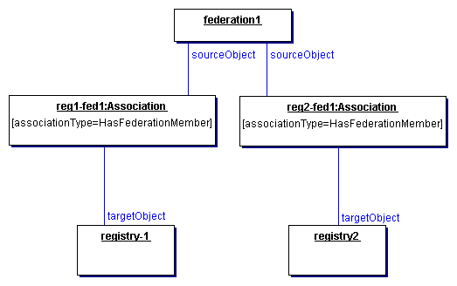
Figure 10: Federation Information Model

Security Information Model
This section describes the aspects of the information model that relate to the security features of the registry.

Figure 11 shows the view of the objects in the Registry from a security perspective. It shows object relationships as a UML Class diagram. It does not show Class attributes or Class methods that will be described in subsequent sections. It is meant to be illustrative not prescriptive.

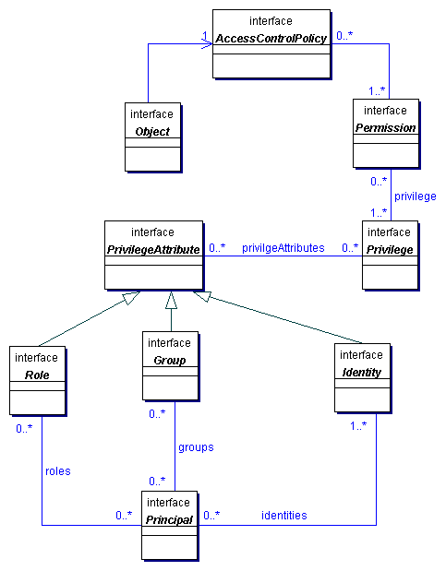
- Figure 11: Information Model: Security View

Class AccessControlPolicy
Every RegistryObject may be associated with exactly one AccessControlPolicy, which defines the policy rules that govern access to operations or methods performed on that RegistryObject. Such policy rules are defined as a collection of Permissions.

Method Summary of AccessControlPolicy
Collection | getPermissions()  Gets the Permissions defined for this AccessControlPolicy. Maps to attribute named permissions.

Class Permission

The Permission object is used for authorization and access control to RegistryObjects in the registry. The Permissions for a RegistryObject are defined in an AccessControlPolicy object.

A Permission object authorizes access to a method in a RegistryObject if the requesting Principal has any of the Privileges defined in the Permission.
See Also:
Privilege, AccessControlPolicy

Method Summary of Permission
String | getMethodName()  Gets the method name that is accessible to a Principal with Privileges specified by this Permission. Maps to attribute named methodName.
Collection | getPrivileges()  Gets the Privileges associated with this Permission. Maps to attribute named privileges.

Class Privilege

A Privilege object contains zero or more PrivilegeAttributes. A PrivilegeAttribute can be a Group, a Role, or an Identity.

A requesting Principal MUST have all of the PrivilegeAttributes specified in a Privilege in order to gain access to a method in a protected RegistryObject. Permissions defined in the RegistryObject's AccessControlPolicy define the Privileges that can authorize access to specific methods.

This mechanism enables the flexibility to have object access control policies that are based on any combination of Roles, Identities or Groups.
See Also:
PrivilegeAttribute, Permission

Method Summary of Privilege
Collection | getPrivilegeAttributes()  Gets the PrivilegeAttributes associated with this Privilege. Maps to attribute named privilegeAttributes.

Class PrivilegeAttribute
All Known Subclasses:
Group, Identity, Role

PrivilegeAttribute is a common base class for all types of security attributes that are used to grant specific access control privileges to a Principal. A Principal may have several different types of PrivilegeAttributes. Specific combination of PrivilegeAttributes may be defined as a Privilege object.
See Also:
Principal, Privilege

Class Role
All Superclasses:
PrivilegeAttribute

For example a hospital may have Roles such as Nurse, Doctor, Administrator etc. Roles are used to grant Privileges to Principals. For example a Doctor Role may be allowed to write a prescription but a Nurse Role may not.

Class Group
All Superclasses:
PrivilegeAttribute

A Group is an aggregation of users that may have different Roles. For example a hospital may have a Group defined for Nurses and Doctors that are participating in a specific clinical trial (e.g., AspirinTrial group). Groups are used to grant Privileges to Principals. For example the members of the AspirinTrial group may be allowed to write a prescription for Aspirin (even though Nurse Role as a rule may not be allowed to write prescriptions).

Class Identity
All Superclasses:
PrivilegeAttribute

This is typically used to identify a person, an organization, or software service. Identity attribute may be in the form of a digital certificate.

Class Principal

Principal is a generic term used by the security community to include both people and software systems. The Principal object is an entity that has a set of PrivilegeAttributes. These PrivilegeAttributes include at least one identity, and optionally a set of role memberships, group memberships or security clearances. A principal is used to authenticate a requestor and to authorize the requested action based on the PrivilegeAttributes associated with the Principal.
See Also:
PrivilegeAttributes, Privilege, Permission

Method Summary of Principal
Collection | getGroups()  Gets the Groups associated with this Principal. Maps to attribute named groups.
Collection | getIdentities()  Gets the Identities associated with this Principal. Maps to attribute named identities.
Collection | getRoles()  Gets the Roles associated with this Principal. Maps to attribute named roles.

References
[ebGLOSS] ebXML Glossary,
http://www.ebxml.org/documents/199909/terms_of_reference.htm
[OAS] OASIS Information Model
http://xsun.sdct.itl.nist.gov/regrep/OasisRegrepSpec.pdf
[ISO] ISO 11179 Information Model
http://208.226.167.205/SC32/jtc1sc32.nsf/576871ad2f11bba785256621005419d7/b83fc7816a6064c68525690e0065f913?OpenDocument
[BRA97] IETF (Internet Engineering Task Force). RFC 2119: Key words for use in RFCs to Indicate Requirement Levels
http://www.cis.ohio-state.edu/cgi-bin/rfc/rfc2119.html
[ebRS] ebXML Registry Services Specification
http://www.oasisopen.org/committees/regrep/documents/3.0/specs/ebRS.pdf
[ebCPP] ebXML Collaboration-Protocol Profile and Agreement Specification
http://www.ebxml.org/specfrafts/

[UUID] DCE 128 bit Universal Unique Identifier
http://www.opengroup.org/onlinepubs/009629399/apdxa.htm#tagcjh_20
http://www.opengroup.org/publications/catalog/c706.htmttp://www.w3.org/TR/REC-xml

[XPATH] XML Path Language (XPath) Version 1.0
http://www.w3.org/TR/xpath

[NCName] Namespaces in XML 19990114
http://www.w3.org/TR/REC-xml-names/#NT-NCName.

Disclaimer
The views and specification expressed in this document are those of the authors and are not necessarily those of their employers. The authors and their employers specifically disclaim responsibility for any problems arising from correct or incorrect implementation or use of this design.

Contact Information

Team Leader
Name: Kathryn R. Breininger
Company: The Boeing Company
Street: P.O. Box 3707 MC 62-LC
City, State, Postal Code: Seattle, WA 98124-2207
Country: USA
Phone: 425-965-0182
Email: kathryn.r.breininger@boeing.com

Editor
Name: Sally Fuger
Company: Automotive Industry Action Group
Street: 26200 Lahser Road, Suite 200
City, State, Postal Code: Southfield, MI 48034
Country: USA
Phone: (248) 358-9744
Email: sfuger@aiag.org

Technical Editor
Name: Farrukh S. Najmi
Company: Sun Microsystems
Street: 1 Network Dr., MS BUR02-302
City, State, Postal Code: Burlington, MA, 01803-0902
Country: USA
Phone: (781) 442-0703
Email: farrukh.najmi@sun.com

Copyright Statement
OASIS takes no position regarding the validity or scope of any intellectual property or other rights that might be claimed to pertain to the implementation or use of the technology described in this document or the extent to which any license under such rights might or might not be available; neither does it represent that it has made any effort to identify any such rights. Information on OASIS's procedures with respect to rights in OASIS specifications can be found at the OASIS website. Copies of claims of rights made available for publication and any assurances of licenses to be made available, or the result of an attempt made to obtain a general license or permission for the use of such proprietary rights by implementors or users of this specification, can be obtained from the OASIS Executive Director.
OASIS invites any interested party to bring to its attention any copyrights, patents or patent applications, or other proprietary rights which may cover technology that may be required to implement this specification. Please address the information to the OASIS Executive Director.
Copyright ©The Organization for the Advancement of Structured Information Standards [OASIS] 2002. All Rights Reserved.
This document and translations of it may be copied and furnished to others, and derivative works that comment on or otherwise explain it or assist in its implementation may be prepared, copied, published and distributed, in whole or in part, without restriction of any kind, provided that the above copyright notice and this paragraph are included on all such copies and derivative works. However, this document itself may not be modified in any way, such as by removing the copyright notice or references to OASIS, except as needed for the purpose of developing OASIS specifications, in which case the procedures for copyrights defined in the OASIS Intellectual Property Rights document must be followed, or as required to translate it into languages other than English.
The limited permissions granted above are perpetual and will not be revoked by OASIS or its successors or assigns.
This document and the information contained herein is provided on an "AS IS" basis and OASIS DISCLAIMS ALL WARRANTIES, EXPRESS OR IMPLIED, INCLUDING BUT NOT LIMITED TO ANY WARRANTY THAT THE USE OF THE INFORMATION HEREIN WILL NOT INFRINGE ANY RIGHTS OR ANY IMPLIED WARRANTIES OF MERCHANTABILITY OR FITNESS FOR A PARTICULAR PURPOSE."

