SOA-Tel Meetings Information
13-15 September 2009
Ottawa Canada

1. Meeting Location
The meeting will be held at Nortel Campus at the following address
3500 Carling Avenue
Ottawa, Ontario K2H 8E9
Participants are to use the main entrance of the campus located at the main tower in Lab 5.
Please note that Nortel location is located at the West end of town, which is about 20 minutes by car from the Ottawa downtown area.

2. Transportation Airport to Downtown
- To get from the Airport to the Hotels in downtown the following options are available:
      - Shuttle service to Ottawa Downtown fee: 18-20 Canadian (30-35 Canadian roundtrip)
      - Estimated taxi fare: 25-35 CAD (one way)
      - Car Rental (fees vary…)

3. Hotel Information
- Note: The Crowne Plaza and Delta hotels are about 1 block away from the Marriott.

The Map below can be used to give an idea of where the hotels are located.

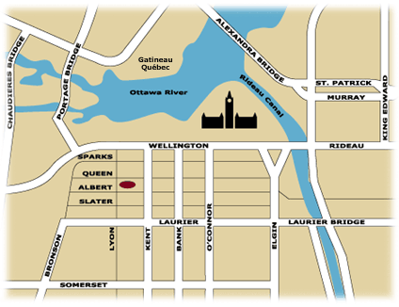

Suggested Hotels:
1. Marriott OTTAWA, 100 Kent Street, Ottawa, Ontario K1P 5R7 Canada
Phone: +1 613 238 1122, Fax: +1 613 783 4229
http://marriott.com/property/propertypage/YOWMC
Driving Directions from Ottawa Airport to the Marriott

From: Ottawa Airport To: Ottawa Marriott, 100 Kent Street, Ottawa, Ontario Canada K1P 5R7
Driving Directions: Airport Parkway North for 5 miles. The Airport Parkway becomes Bronson Avenue (Northbound).Continue North on Bronson Avenue for 5 kilometers. Turn right on Queen Street (Eastbound). Hotel is located 3 blocks down Queen Street at the corner of Queen and Kent Streets.

2. Crowne Plaza, 101 LYON ST., OTTAWA, ON K1R 5T9,
For Hotel Reservations: +1 613 237 3600 (In North America call: 1 800 2CROWNE)
http://www.crowneottawa.ca/index.asp

Driving Directions from Ottawa Airport to Crowne Plaza
From the airport off the 417 hwy, take Bronson ave north. Turn right on Queen street, Hotel is on the corner of Queen and Lyon.

3. Delta Hotels, 361 Queen Street, Ottawa, Ontario K1R 7S9
Tel: +1 613 238 6000, Fax: +1 613 238 2290, (In North America Toll-Free: 1 877-814-7706)
http://www.deltahotels.com/hotels/hotels.php?hotelId=14

Driving Directions from Ottawa Airport
Take Airport Parkway, the Airport Parkway turns into Bronson Avenue.
Take Bronson all the way to Queen Street.
Turn right onto Queen Street, Hotel is 1 Block on the left.

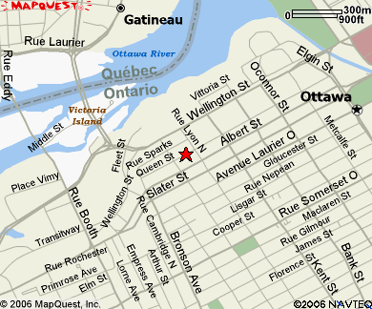

4. The Westin Ottawa, 11 Colonel By Drive Ottawa, Ontario K1N 9H4 Canada
Phone: +1 613 560 7000, Fax: +1 613 234 5396
http://www.starwoodhotels.com/westin/search/hotel_detail.html?propertyID=1083

5. Novotel Ottawa
33 Nicholas Street Ottawa, Ontario K1N 9M7
Ph: +1 613 230 3033 Fax: +1 613 760 4765
(In North America 1-800-NOVOTEL (668-6835))
http://www.novotelottawa.com/home/novotelottawahotels.html

4. Airport Information
Ottawa has an International airport (http://www.ottawa-airport.ca/index-e.php).
The airport is about 25 minutes by Taxi from Downtown (about 25-30 Canadian Dollars by Taxi).
There are Car Rental facilities that include the major North American companies.
There are public shuttles from the airport to the downtown area. Information is available at
http://www.ottawa-airport.ca/AirportServices/otherTransportation-e.php

5. Ottawa Tourist Information
Ottawa is the Capital of Canada. It is a nice city with a lot of attractions. Information about the city can be found at
http://city.ottawa.on.ca/index_en.html

6. Weather
September in Ottawa can be cold. Be prepared to bring with you an Umbrella and a good jacket. Weather information can be found at
http://www.weather.ca/weather/cities/can/pages/CAON0512.htm

7. Other Information

7.1 Currency & Exchange
Currency is the Canadian dollar. There are currency exchange counters at the Airport.
7.2 Emergency Number
In case of emergency please Dial 911
7.3 Business Hours
Shopping hours vary per shopping center and location. Most centres are open from 9 AM to 9 PM M-F. Saturday shopping hours are usually 9 AM to 5 PM. Sunday shopping hours are usually 11 AM to 5 PM. Banking Hours depends on the bank and are generally 9:30 AM to 4:00 PM Monday to Friday. Some banks do open on Saturday. Government hours are M-F from 9:00 AM to 5:00 PM.
7.4 Electricity
Canada uses the same electric outlets like the U.S, basically 120 V, 60 Hz. See Figure below for outlet types.
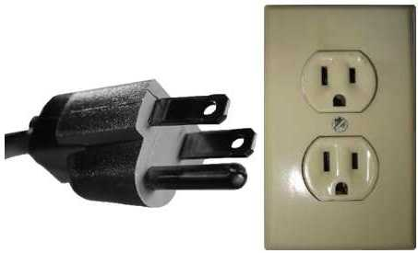

7.5 Automated Teller Machines (ATM) for Foreign Travellers
Travellers who carry internationally recognized ATM/Credit cards can get a cash advance in Canadian dollar at Automated Teller Machines (ATMs) installed at airports, major hotels, department stores and tourist attractions.

7.6. Tipping
Tipping is expected at restaurants typically at 15-20% of the amount of the bill.

7.7 Tax
Tax is added on good and services including food. Tax rate (including Federal and Provincial) is 14% in Ontario.

7.8 Medical Emergencies
In case of a Medical Emergency your best bet is to go the Nearest Hospital to the Emergency room. List of Hospitals can be found at http://www.answers.com/topic/list-of-hospitals-in-ottawa

7.9 Computer Networking
Meeting room will be equipped with wireless access (Wireless LAN, supporting IEEE802.11b, 2.4GHz band) to the Internet. Those who wish to use the wireless access must be equipped with the necessary hardware and correctly configured PC.

8. Contacts
Abbie Barbir is the Nortel contact for this event.
You can reach Abbie Barbir at the following numbers:
- Cell: +1 613 697 0865
- Office: +1 613 763 5229

9. Information about Nortel Site

The Nortel Carling Campus (3500 Carling Avenue) is divided into 10 different labs.
The major one is Lab 5 - it connects all the labs together ( see map below).
Meeting will be held in Lab 5. You need to report to Lab 5 main entrance at the Tower. If you are using your own car, you can park at any parking L. M, N, S, R, J, K, B or C.
The Carling campus is equipped with a bus station located at the Lab 5 east wing, where you can take buses to all parts of the city. For more information on bus routes and times check the OC Transpo site, which you can visit here.
To get in and out or roam within any building you need to always have your visitor badge and MUST be accompanied by a Nortel Full Time employee.

Note: Meeting Location is in Lab 5 (@5 on the Map, Near the Canadian Flag)



