Transformational Government Framework Version 2.0
Working Draft 01
22 October 2013
Technical Committee:
OASIS Transformational Government Framework TC
Chair:
John Borras (johnaborras@yahoo.co.uk), Individual
Editors:
John Borras (johnaborras@yahoo.co.uk), Individual
Peter F Brown (peter@peterfbrown.com), Individual
Chris Parker (chris.parker@cstransform.com), CS Transform Limited
Related work:
This specification replaces and supersedes:
- Transformational Government Framework (TGF) Pattern Language Core Patterns Version 1.0. 25 April 2013. OASIS Standard. http://docs.oasis-open.org/tgf/TGF-PL-Core/v1.0/os/TGF-PL-Core-v1.0-os.html.
- Transformational Government Framework Primer Version 1.0. 11 January 2012. OASIS Committee Note 01. http://docs.oasis-open.org/tgf/TGF-Primer/v1.0/cn01/TGF-Primer-v1.0-cn01.html.
See also:
- Transformational Government Framework: Tools and Models for the Business Management Framework - Volume 1 Using the Policy Product Matrix Version 1.0. 07 June 2012. OASIS Committee Note. http://docs.oasis-open.org/tgf/TGF-BMF-Tools/v1.0/cn01/TGF-BMF-Tools-v1.0-cn01.html

This document is intended to become a Non-Standards Track Work Product. The patent provisions of the OASIS IPR Policy do not apply.
Abstract:
The Transformational Government Framework (TGF) is a practical “how to” standard for the design and implementation of an effective program of technology-enabled change at national, state or local government level. It describes a managed process of ICT-enabled change within the public sector and in its relationships with the private and voluntary sectors, which puts the needs of citizens and businesses at the heart of that process and which achieves significant and transformational impacts on the efficiency and effectiveness of government.
The TGF provides a tried and tested way forward utilizing the best parts of existing e-Government programs and avoiding large new investments. Its formalization as a Pattern Language enables it to be encapsulated in more formal, tractable, and machine-processable forms, thus making it easy to integrate into desk-top tools and management software aiding testing and assurance of compliance and conformance.
This Work Product constitutes the initial core set of patterns that form the TGF Standard. This set may be revised and/or extended from time to time as appropriate.
Status:
This Working Draft (WD) has been produced by one or more TC Members; it has not yet been voted on by the TC or approved as a Committee Draft (Committee Specification Draft or a Committee Note Draft). The OASIS document Approval Process begins officially with a TC vote to approve a WD as a Committee Draft. A TC may approve a Working Draft, revise it, and re-approve it any number of times as a Committee Draft.
Initial URI pattern:
http://docs.oasis-open.org/tgf/TGF/v2.0/csd01/TGF-v2.0-csd01.doc
(Managed by OASIS TC Administration; please don’t modify.)

Copyright © OASIS Open 2013. All Rights Reserved.
All capitalized terms in the following text have the meanings assigned to them in the OASIS Intellectual Property Rights Policy (the "OASIS IPR Policy"). The full Policy may be found at the OASIS website.
This document and translations of it may be copied and furnished to others, and derivative works that comment on or otherwise explain it or assist in its implementation may be prepared, copied, published, and distributed, in whole or in part, without restriction of any kind, provided that the above copyright notice and this section are included on all such copies and derivative works. However, this document itself may not be modified in any way, including by removing the copyright notice or references to OASIS, except as needed for the purpose of developing any document or deliverable produced by an OASIS Technical Committee (in which case the rules applicable to copyrights, as set forth in the OASIS IPR Policy, must be followed) or as required to translate it into languages other than English.
The limited permissions granted above are perpetual and will not be revoked by OASIS or its successors or assigns.
This document and the information contained herein is provided on an "AS IS" basis and OASIS DISCLAIMS ALL WARRANTIES, EXPRESS OR IMPLIED, INCLUDING BUT NOT LIMITED TO ANY WARRANTY THAT THE USE OF THE INFORMATION HEREIN WILL NOT INFRINGE ANY OWNERSHIP RIGHTS OR ANY IMPLIED WARRANTIES OF MERCHANTABILITY OR FITNESS FOR A PARTICULAR PURPOSE.

Table of Contents
1 Introduction 4
1.1 Terminology 4
1.2 Normative References 4
1.3 Non-Normative References 4
2 Overview 5
3 Guiding Principles 9
[GP1] Guiding Principles 9
4 Business Management 12
[B1] Vision for Transformation 13
[B2] Program Leadership 15
[B3] Transformational Operating Model 17
[B4] Franchise Marketplace 21
[B5] Stakeholder Collaboration 24
[B6] Policy Product Management 29
[B7] Supplier Partnership 31
[B8] Skills 34
[B9] Common Terminology and Reference Model 35
[B10] Roadmap for Transformation 39
5. Service Management 42
[S1] Stakeholder Empowerment 43
[S2] Brand-Led Service Delivery 47
[S3] Identity and Privacy Management 50
[S4] Channel Management Framework 53
[S5] Channel Mapping 55
[S6] Channel Transformation 57
6 Technology and Digital Asset Management 60
[T1] Resources Mapping and Management 61
[T2] Technology Development and Management 63
7 Benefits Realization 65
[BR1] Business Case 67
[BR2] Benefits Mapping 69
[BR3] Benefits Tracking 71
[BR4] Benefits Delivery 73
[BR5] Benefits Reviews 74
8 Critical Success Factors 75
[CSF1] Critical Success Factors 75
9 Conformance 76
Appendix A. Acknowledgments 80
Appendix B. Enabling the Franchise Marketplace Model 81
Appendix C Checklist of Critical Success Factors 83
Appendix D. The Purpose of the TGF 87
Appendix E. Revision History 93

Introduction

Terminology
The key words “MUST”, “MUST NOT”, “REQUIRED”, “SHALL”, “SHALL NOT”, “SHOULD”, “SHOULD NOT”, “RECOMMENDED”, “MAY”, and “OPTIONAL” in this document are to be interpreted as described in [RFC2119].

Normative References
- [RFC2119] Bradner, S., “Key words for use in RFCs to Indicate Requirement Levels”, BCP 14, RFC 2119, March 1997. http://www.ietf.org/rfc/rfc2119.txt.

Non-Normative References
- [Alexander 1964] C. Alexander, Notes on the Synthesis of Form, Harvard University Press, 1964
- [Alexander 1979] C. Alexander, The Timeless Way of Building, Oxford University Press, 1979
- [Brown 2011] P. Brown, Introducing Pattern Languages, March 2011 http://www.peterfbrown.com/Documents/Introducing%20Pattern%20Languages.pdf
- [Coplien 1996] J. O. Coplien, Software Patterns, Bell Laboratories, The Hillside Group 1996
- [EIF] The European Interoperability Framework, version 2, European Commission 2010, Annex 2 of http://eur-lex.europa.eu/LexUriServ/LexUriServ.do?uri=COM:2010:0744:FIN:EN:PDF
- [OIX] Open Identity Exchange, http://openidentityexchange.org/
- [SFIA] The Skills Framework for the Information Age, SFIA Foundation, http://www.sfia.org.uk/cgi-bin/wms.pl/932
- [SOA-RAF] The SOA Reference Architecture Framework, OASIS, http://www.oasis-open.org/committees/tc_home.php?wg_abbrev=soa-rm
- [SOA-RM] The Reference Model for Service-Oriented Architecture, OASIS, http://docs.oasis-open.org/soa-rm/v1.0/
- [PMRM] The Privacy Management Reference Model, OASIS, http://www.oasis-open.org/committees/tc_home.php?wg_abbrev=pmrm

Overview

Summary
The Transformational Government Framework (TGF) is a practical “how to” standard for the design and implementation of an effective program of technology-enabled change at national, state or local government level. It describes a managed, customer-centred process of ICT-enabled change within the public sector and in its relationships with the private and voluntary sectors, which puts the needs of citizens and businesses at the heart of that process and which achieves significant and transformational impacts on the efficiency and effectiveness of government.

Context
All around the world, governments at national, state, and local levels face huge pressure to do “more with less”. Whether their desire is: to raise educational standards to meet the needs of a global knowledge economy; to help our economies adjust to financial upheaval; to lift the world out of poverty when more than a billion people still live on less than a dollar a day; to facilitate the transition to a sustainable, inclusive, low-carbon society; to reduce taxation; or to cut back on public administration; every government faces the challenge of achieving their policy goals in a climate of increasing public expenditure restrictions.
Responding effectively to these challenges will mean that governments need to deliver change which is transformational rather than incremental.
During much of the last two decades, technology was heralded as providing the key to deliver these transformations. Now that virtually every government is an "e-Government" - with websites, e-services and e-Government strategies proliferating around the world, even in the least economically developed countries - it is now clear that Information and Communication Technologies (ICT) are no “silver bullet”. The reality of many countries' experience of e-Government has instead been duplication of ICT expenditure, wasted resources, no critical mass of users for online services, and limited impact on core public policy objectives.
An increasing number of governments and institutions are now starting to address the much broader and more complex set of cultural and organizational changes which are needed if ICT is to deliver significant benefits in the public sector. We call this process: Transformational Government.

Definition of Transformational Government
The definition of Transformational Government used in the Framework is:
Transformational Government
A managed, customer-centred, process of ICT-enabled change within the public sector and in its relationships with the private and voluntary sectors
, which puts the needs of citizens and businesses at the heart of that process and which achieves significant and transformational impacts on the efficiency and effectiveness of government.
This definition deliberately avoids describing some perfect “end-state” for government. That is not the intent of the Transformational Government Framework. All governments are different: the historical, cultural, political, economic, social and demographic context within which each government operates is different, as is the legacy of business processes and technology implementation from which it starts. So the Transformational Government Framework is not a “one-size-fits-all” prescription for what a government should look like in future.
Rather, the focus is on the process of transformation: how a government can build a new way of working which enables it rapidly and efficiently to adapt to changing citizen needs and emerging political and market priorities. In the words of one of the earliest governments to commit to a transformational approach: “…. the vision is not just about transforming government through technology. It is also about making government transformational through the use of technology”,

Target audience for the Transformational Government Framework
The Transformational Government Framework (TGF) is intended primarily to meet the needs of:
- Political and administrative leaders responsible for shaping public sector reform and e-Government strategies and policies (at national, state/regional and city/local levels).
- Senior executives in industry who wish to partner with and assist governments in the transformation of public services and to ensure that the technologies and services which the private sector provides can have optimum impact in terms of meeting public policy objectives.
- Service and technology solution providers to the public sector.
Secondary audiences for the Transformational Government Framework include:
- Leaders of international organizations working to improve public sector delivery, whether at a global level (e.g. World Bank, United Nations) or a regional one (e.g. European Commission, ASEAN, IADB).
- Professional bodies that support industry sectors by the development and maintenance of common practices, protocols, processes and standards to facilitate the production and operation of services and systems within the sector, where the sector needs to interact with government processes and systems.
- Academic and other researchers working in the field of public sector reform.
- Civil society institutions engaged in debate on how technology can better enable service transformation.

Structure of the Transformational Government Framework
The TGF can be seen schematically in Figure 1. At the top-level, it is made up of the following components:
- guiding principles: a statement of values which leaders can use to steer business decision-making as they seek to implement a TGF program;
- guidance on the three major governance and delivery processes which need to be refocused in a customer-centric way, and at whole-of-government level, in order to deliver genuinely transformational impact:
- business management,
- service management, and
- technology management based on the principles of service-oriented architecture.
- benefit realization: guidance on how to ensure that the intended benefits of a TGF program are clearly articulated, measured, managed, delivered and evaluated in practice;
- critical success factors: a checklist of issues which TGF programs should regularly monitor to ensure that they are on track for successful delivery and that they are managing the major strategic risks effectively.
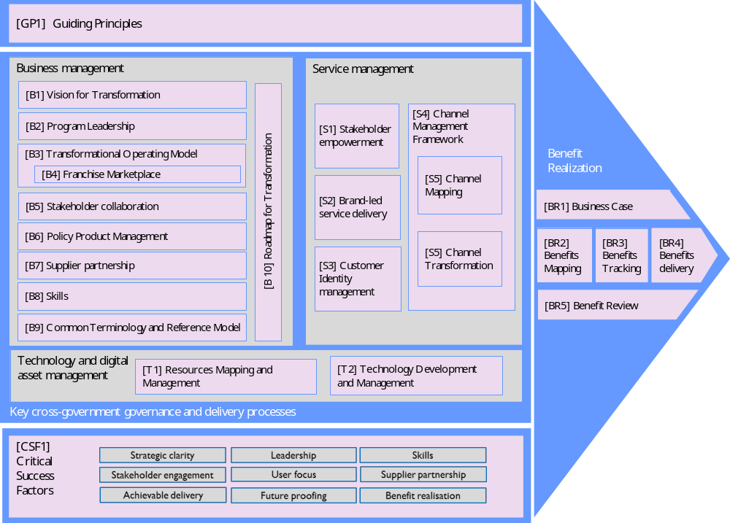
Figure 1: The overall TGF framework
Each of these six components is described in detail in the following sections, which set out the activities which a TGF programme should undertake in each area in order to be successful. These activities (highlighted in pink in Figure 1) are expressed in a formal structure as a set of “patterns languages”. This set of patterns is intended to be readable end-to-end as a piece of prose but is structured also in a way that lends itself to being quoted and used pattern by pattern and to being encapsulated in more formal, tractable, and machine-processable forms including concept maps, Topic Maps, RDF or OWL.

Pattern Languages
The idea of Pattern Languages, as a process for analyzing recurrent problems and a mechanism for capturing those problems and archetypal solutions, was first outlined by architect Christopher Alexander [Alexander 1964] and [Alexander 1979]: “The value of a Pattern Language is that remains readable and engaging whilst providing basic hooks for further machine processing… [it] is not an ‘out-of-the-box’ solution but rather some ‘familiar’ patterns with which a team can work” [Brown 2011].
The exact configuration varies from one pattern language to another, and the pattern adopted in the TGF is structured as follows:
- the name of the pattern and a reference number;
- an introduction that sets the context and, optionally, indicates how the pattern contributes to a larger pattern;
- a headline statement that captures the essence of the need being addressed;
- the body of the need being addressed;
- the recommended solution – what needs to be done;
- some notes on linkages, showing how each pattern links to related and more detailed patterns that further implement or extend the current pattern. In some cases this also includes references to external resources that are not part of the TGF.
These patterns together make up an initial set of “Core Patterns” of what is expected to be an evolving set of TGF patterns. These form the core of the TGF standard, and it is against these that conformance criteria are set out in Section 9. Where closely related patterns have been grouped together in one section of this document – for example, on Business Management, Service Management and Technology Management – the relevant section also includes some additional introductory text to help readers understand linkages more easily. This text, however, does not form part of the TGF Core Pattern Language.
- Guiding Principles
There is one TGF Core Pattern on Guiding Principles. This is set out below.

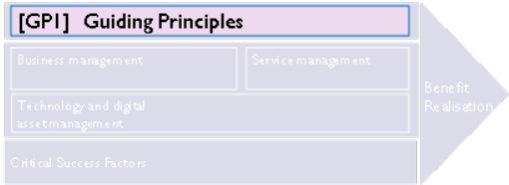
[GP1] Guiding Principles

Context
Development and delivery of a successful TGF program requires collaboration and change across a wide range of individuals, communities and organizations over a sustained period of time. An approach that is rooted in a set of clearly stated principles can help ensure that business decisions across those organizations align.
In the TGF, we use the term “principle” to mean an enduring statement of values which can used on a consistent basis to steer business decision by multiple stakeholders making over the long term , and which are:
- used to inform and underpin strategy;
- understood, agreed and owned by stakeholders.
❖  
The Problem
A management hand on the tiller is not enough to deliver effective transformation. Effective transformational government strategies need to be principle-based.
“Transformational Government” is a managed process of ICT-enabled change in the public sector, which puts the needs of citizens and businesses at the heart of that process and which achieves significant and transformational impacts on the efficiency and effectiveness of government. Leaders of TGF programs face significant challenges. These include:
- the scope of the program, which touches on a very wide range – potentially all – social and economic activity in a jurisdiction;
- the scale of ambition for the program, which is aiming to achieve change that is transformational not incremental;
- the wide range of stakeholders and delivery partners involved in the program.
Taken together, these challenges mean that top-down change management approaches cannot work. Success cannot be delivered by planning in detail all elements of the change at the outset. Rather, it can be delivered by setting out a clear and agreed vision, and then underpinning this with a roadmap that does not over-plan but that provides a framework for an organic, inclusive process of change to deliver the vision over time across multiple stakeholders. Key elements of this are explored in the other Patterns of the TGF. But the starting point should be clarity about the guiding principles that stakeholders will seek to work towards throughout this process.
A “one-size-fits-all” approach to public sector reform does not work. Nevertheless, there are some guiding principles which 10-15 years of experience with e-enabled government around the world suggests are universal. They are based on the experience of many OASIS member organizations working with governments of all kinds, all around the world, and they form the heart of the TGF.

❖  
The Solution
TGF leaders should collaborate with stakeholders to develop and agree a set of guiding principles for that specific TGF program that cover, as a minimum, the core TGF Guiding Principles.
The TGF Guiding Principles are set out below, and must be used by any Transformational Government program conforming to the Framework. These principles together represent an enduring statement of values which the Leadership for a Transformational Government program should adopt and use consistently as a basis to steer business decision-making throughout the conception, development, implementation and follow-up of that program. These are explicitly declaratory statements of principle (“We believe…”) that reflect the desired commitment of the program Leadership as well as indicating the expectations from all Stakeholders.
We believe in establishing a vision of the future which our TGF program will create which is clear, compelling and jointly owned by all stakeholders
Clarity about the social, economic and environmental outcomes we want to achieve, and the challenges involved in doing so.
A shared vision of how we will invest in and transform our physical, spatial, digital and human assets to deliver those outcomes, and what doing so will look and feel like.
All stakeholders involved in developing and delivering the vision.
We believe in detailed and segmented understanding of our citizen and business customers
These customers should be owned at the whole-of-government level.
Decisions should be based upon the results of research and evidence rather than assumptions being made about what customers think.
Real-time, event-level understanding of citizen and business interactions with government should be developed.
We believe in services built around customer needs, not organizational structure
Customers should be provided with a “one-stop service” experience in their dealings with government, built around their needs (such as accessibility).
Government should not be continually restructured in order to achieve this. Instead "customer franchises" should be created – small customer-focused teams that sit within the existing structures of government and act as change agents for their customer segments.
Services should be delivered across multiple channels using Service-Oriented Architecture (SOA) principles to join it all up, reduce infrastructure duplication, and encouraging customers into lower cost channels where appropriate.
Organizational and business change must be addressed before money is spent on technology.
A cross-government strategy should be built for common citizen and business data sets (e.g. name, address) and common customer applications (e.g. authentication, payments, notifications).
We believe that transformation is done with citizens and businesses, not to them
All stakeholders should be engaged directly in service design and delivery.
Customers should be given the technology tools that enable them to create public value themselves.
People should be given ownership and control of their personal data - and all non-personally identifiable data held by government should be freely open for reuse and innovation by third parties.
We believe in growing the market for transformed services
Service transformation plans should be integrated with an effective digital inclusion strategy to build access to and demand for e-services across society.
We will use the benefits from future universality of digital access to help fund the costs of ensuring digital inclusion now.
Partnerships should be built with other market players (in the private, voluntary and community sectors) in recognition of their significant influence on customer attitudes and behaviour and enable the market and others to work with government to deliver jointly-owned objectives.
We believe in managing and measuring key critical success factors:
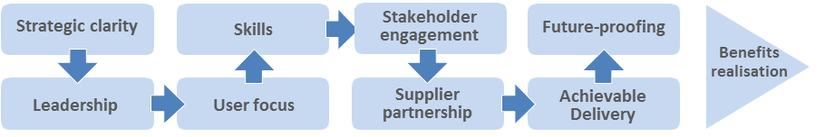
Figure 2: The nine Critical Success Factors
❖  
Linkages
Delivering these principles, in line with the [CSF1] Critical Success Factors, requires government to re-visit – and potentially to transform – every stage of the service delivery process. Developing, agreeing and acting as guardians of the guiding principles is a core task for people involved in [B2] Program Leadership, and should be addressed at an early stage in development of the [B1] Vision for Transformation and [B10] Roadmap for Transformation.

- Business Management
This section of the TGF focuses on business management: that is, the key aspects of governance, planning and decision making that need to be managed at a whole-of-government level. This does not mean a top-down, centrally planned and managed approach; it does mean taking a government-wide approach to:
- establishing an integrated vision and strategy;
- underpinning this with an operating model which balances the need for government-wide cohesion on the one hand and local innovation on the other;
- taking a “viral” approach to implementation: establishing the business processes, capacity and structures that can drive transformation and create sustained improvements over time, even if all the steps of that transformational journey cannot be planned in detail at the outset.
The core patterns within the business management component of the TGF are:
- [B1] Vision for Transformation
- [B2] Program Leadership
- [B3] Transformation Operating Model
- [B4] Franchise Marketplace
- [B5] Stakeholder Collaboration
- [B6] Policy Product Management
- [B7] Supplier Partnership
- [B8] Skills
- [B9] Common Terminology and Reference Model
- [B10] Roadmap for Transformation

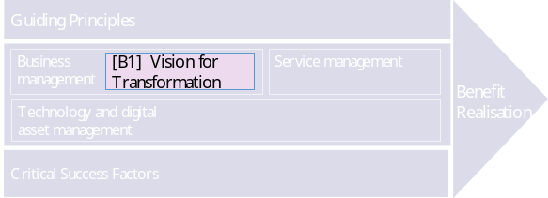
[B1] Vision for Transformation

Context
First among the [GP1] Guiding Principles is the need for [B2] Program Leadership to develop a clear, compelling and shared vision for the transformation program.
❖  
The Problem
An agreed vision of what the future will look like as a result of a transformation program is essential for success.
It is not the intent of the Transformational Government Framework to describe some perfect “end-state” for government. All governments are different: the historical, cultural, political, economic, social and demographic context within which each government operates is different, as is the legacy of business processes and technology implementation from which it starts. So the Transformational Government Framework is not a “one-size-fits-all” prescription for what a government should look like in future.
Rather, each TGF program needs to set its own clear vision. This will require agreement and clarity amongst stakeholders on:
- the social, economic and/or environmental impacts that the TGF program seeks to achieve;
- the challenges that a TGF program needs to overcome in order to deliver these impacts and the vision should address – such as, for example:
- Public sector budget pressures
- Changing service needs
- Infrastructure stress
- Resource scarcity
- Skills and market access
- Growing population
- Aging population
- Mobile population
- Economic inequality
- Digital divide
- how the future will “feel” different for key stakeholders – so that the vision is articulated not in technical terms, but also in human and emotional ones.
❖  
The Solution
Program Leadership must create a vision for the TGF program that:
a) is developed in an iterative and collaborative manner (that is, inclusive of all stakeholder groups and informed by user research and engagement, with social media and other technologies used to enable wide public participation in the process);
b) embraces the opportunities opened up by new technologies and delivery channels, open data and effective collaboration;
c) does so in a way which integrates these with the core socio-economic, political and environmental vision for the future, rather than seeing them as somehow separate from the government’s core strategic objectives;
d) is measurable.
❖  
Linkages
The vision should be informed by the TGF program’s [GP1] Guiding Principles, and developed through intensive Engagement with [B5] Stakeholder Collaboration. It is vital to ensure that the vision can be expressed in terms of measurable outcomes and that clear “line of sight” is established between all activities in the roadmap and delivery of these outcomes for the program vision. Guidance on how to do this effectively is set out at Benefit Realization.

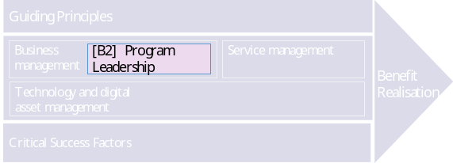
[B2] Program Leadership

Context
Development of a shared and compelling [B1] Vision for Transformation requires significant leadership and strategic clarity; delivery of the vision then requires that leadership to be sustained over a period of years.

❖  
The Problem
Transformational government cannot be pursued on a project-by-project or agency-specific basis but requires a whole-of-government view. At the same time, transformation cannot be delivered successfully through traditional top-down program structures – so TGF programs need to find effective ways to empower and enable leadership on a distributed, cross-government basis.
There is no “ideal” leadership structure for a transformation program. However, global experience suggests the following factors are vital to address in whichever way is most appropriate for the specific government context:
- A clear focus of accountability for the TGF program as a whole.
At both the political and administrative levels there should be an explicit functional responsibility for the TGF program. These functions should be occupied by individuals with sufficient authority to shape resource allocation and organizational priorities.
- Building a broad-based leadership team across the government.
It is not essential that all Ministers and senior management are committed to the TGF program from the very outset. Indeed, a key requirement of building and managing a [B10] Roadmap for Transformation is to work in ways that nurture and grow support for the strategy through the implementation process. However, it is important the TGF program is not seen as a centralized or top-down. Sharing leadership roles for the design and delivery of a program with senior colleagues across the government and with external partner organizations is therefore important.
- Bringing leaders together in effective governance arrangements.
Government-wide governance systems need to be established at two levels:
  - the strategic governance level, focused on defining required outcomes of the TGF program and ensuring effective Benefit Realization;
  - the delivery governance level, focused on implementation of the [B10] Roadmap for Transformation.
- Deployment of formal program management disciplines.
To deliver effective government-wide transformation, it is vital to use a formalised program management approach, such as PRINCE 2, and to. develop and manage a portfolio of programs and projects that together are intended to deliver the [B1] Vision for Transformation. While these projects can be managed by many different stakeholders, they should be brought together into an overall strategic program of work with:
  - an overall [BR1] Business Case, supported by measurement of clear success indicators;
  - prioritization of activities and program changes, based on performance and feedback criteria linked to the programs [GP1] Guiding Principles;
  - common frameworks for managing strategic risks, issues and constraints, bought into by all delivery partners.

- Ensuring the right skills mix in the leadership team.
Effective leadership of a transformation program requires the senior accountable leaders to have access to a mix of key skills in the leadership team which they build around them, including: strategy development skills, stakeholder engagement skills, marketing skills, commercial skills and technology management skills. Deployment of a formal competency framework, such as Skills Framework for the Information Age [SFIA] can be helpful in identifying and building the right skill sets.
- Allowing for organizations’ evolution over time.
Contributions by private and voluntary stakeholders are likely to be subject to “engagement lifecycles”. Organizations are created, evolve and eventually merge or decline. The continuity of assets and services needs to be actively managed throughout this evolutionary process.
- Ensuring an open and transparent governance process
Finally, transparency is important in order to build trust, strengthen accountability for delivery of the TGF program, and to facilitate openness and collaboration with all stakeholders. This means that the leadership of a TGF program should aim to publish all key vision and strategy documents, make names and contact details of program leaders publically available, and publish regular updates of performance and delivery against the [B10] Roadmap for Transformation.
❖  
The Solution
A TGF program should therefore establish leadership and governance arrangements that ensure:
- a clear focus of accountability within the government for the program;
- a broad-based leadership team across the government;
- government leaders are brought together into effective governance arrangements, at both the strategic and delivery levels;
- deployment of formal program management disciplines and prioritization of activities and program changes, based on performance and feedback criteria;
- the right skills mix in the leadership team;
- an ability to manage organizational evolution among partner organizations, and to deliver continuity through political changes;
- openness and transparency in the governance process, including through digitally-enabled models of wider civil participation.

❖  
Linkages
Key tasks for the leadership of a TGF programme include:
- articulating and acting as guardians of the [GP1] Guiding Principles for the TGF program;
- ensuring that the program is aligned to deliver a clear, compelling and agreed [B1] Vision for Transformation;
- acting as champions and ambassadors for the TGF approach as part of [B5] Stakeholder Collaboration;
- developing and overseeing a [B10] Roadmap for Transformation;
- ensuring line-of-sight from all within that roadmap and the strategic outcomes being targeted by the programme through its Benefit Realization framework;
- ensuring that the program is effectively managing all of the [CSF1] Critical Success Factors.

[B3] Transformational Operating Model
Context
A central task of the [B2] Program Leadership and [B5] Stakeholder Collaboration is to enable the machinery of government to deliver customer-centric services “one stop services”. They need to cooperate with stakeholders in developing a new operating model that delivers those services in practice, when and where they are needed.
❖  
The Problem
The failure to create an appropriate new operating model has arguably been the greatest weakness of most traditional e-Government programs. The transition to e-Government has involved overlaying technology onto the existing operating model of government: an operating model based around existing functionally-oriented government departments and agencies. These behave like unconnected silos in which policy-making, budgets, accountability, decision-making and service delivery are all embedded within a vertically-integrated delivery chain based around delivery functions rather than recipient needs.
The experience of governments around the world over the last two decades has been that silo-based delivery of services simply does not provide an effective and efficient approach to e-government. Many attempts have been made by governments to introduce greater cross-government coordination, but largely these have been "bolted on" to the underlying business model, and hence experience only limited success. Without examination of, or fundamental change to, the underlying business model level, the design and delivery of services remains fragmented and driven by the structures of government, rather than the needs of the government’s customers.
Figure 3 below illustrates the traditional operating model which is still typical of most governments:
- the individual citizen or business has to engage separately with each silo: making connections for themselves, rather than receiving seamless and connected service that meets their needs;
- data and information has typically been locked within these silos, limiting the potential for collaboration and innovation across the government, and limiting the potential to drive change at speed.

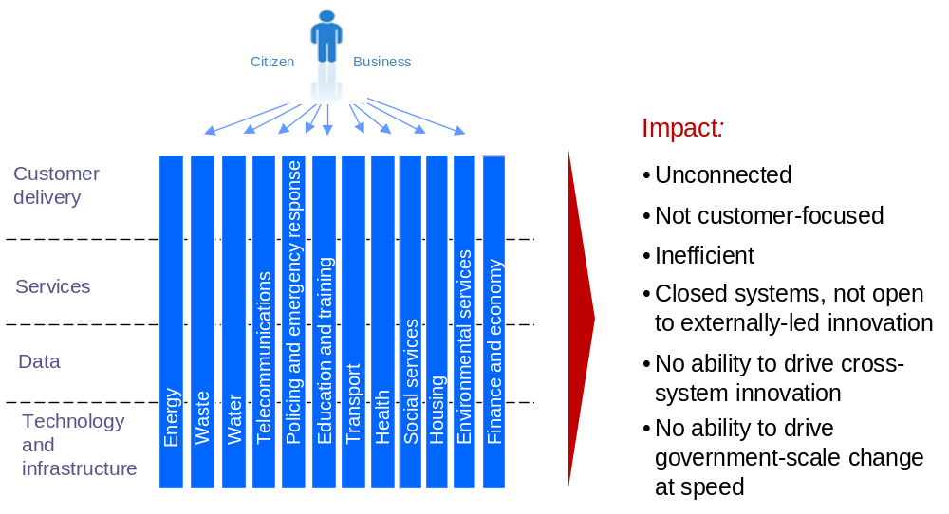
Figure 3 – Traditional operating model: where governments have come from
Government transformation programs involve a shift in emphasis, away from silo-based delivery and towards an integrated, multi-channel, service delivery approach: an approach which enables a whole-of-government view of the customer and an ability to deliver services to citizens and businesses where and when they need it most, including through one-stop services and through private and voluntary sector intermediaries.
Key features of this shift to a transformational operating model include:
- investing in smart data, i.e. ensuring that data on the performance and use of the government’s physical, spatial and digital assets is available in real time and on an open and interoperable basis, in order to enable real-time integration and optimization of resources;
- managing public sector data as an asset in its own right, both within the government and in collaboration with other significant data owners engaged in the TGF program;
- enabling externally-driven, stakeholder-led innovation by citizens, communities, and the private and voluntary sectors, by opening up government data and services for the common good:
  - both at a technical level, through development of open data platforms;
  - and at a business level, through steps to enable a thriving market in reuse of public data together with release of data from commercial entities in a commercially appropriate way;
- enabling internally-driven, government-led innovation to deliver more sustainable and citizen-centric services, by:
  - providing citizens and businesses with public services, which are accessible in one stop, over multiple channels, that engage citizens, businesses and communities directly in the creation of services, and that are built around user needs not the government’s organizational structures;
  - establishing an integrated business and information architecture which enables a whole-of-government view of specific customer groups for government services (e.g. elderly people, drivers, parents, disabled people);
- setting holistic and flexible budgets, with a focus on value for money beyond standard departmental boundaries;
- establishing government-wide governance and stakeholder management processes to support and evaluate these changes.
Figure 4 summarizes these changes to the traditional way of operating which transformational government programs are seeking to implement.
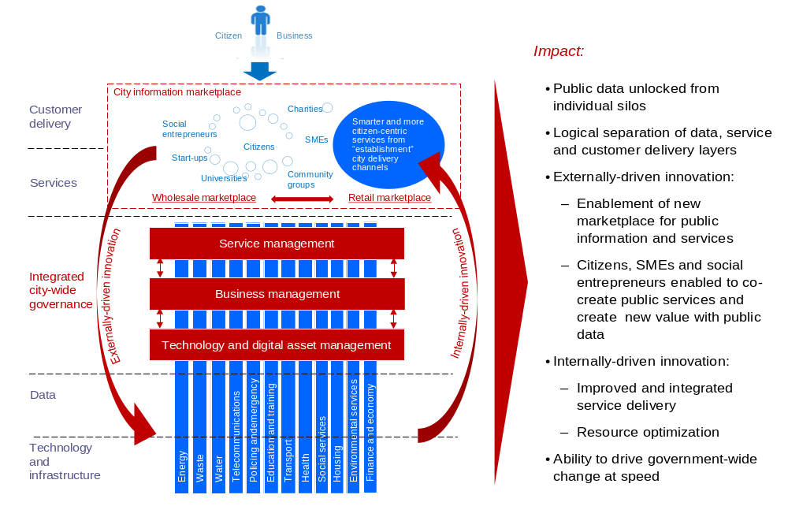

Figure 4 – New integrated operating model: where governments are moving to
❖  
The Solution
TGF programs should therefore ensure that their [B1] Vision for Transformation includes the need to establish a Transformational Operating Model to help build services around citizen and business needs, not just government’s organizational structure. This will include:
- providing citizens and businesses with services which are accessible in one stop and ideally offered over multiple channels;
- enabling those services also to be delivered by private and voluntary sector intermediaries.
The Transformational Operating Model must go beyond simple coordination between the existing silos and should include:
- An integrated business and information architecture which enables a whole-of-government view of the customer, thus making possible both the integration of services and “cross-selling” between services;
- Incentives and business processes that encourage the internal cultural change and cross-silo collaboration needed to drive the integration and joining-up of services;
- A cross-government strategy for shared development, management and re-use of common customer data sets, applications, and applications interfaces (e.g. authentication, payments, and notifications);
- Opening up public data for re-use and innovation by the private and voluntary sectors, and directly by citizens and businesses.

❖  
Linkages
Rather than attempting to restructure Government to deliver such a Transformational Business Model, the [B4] Error: Reference source not found SHOULD be considered as the recommended approach to implement this model. Multi-channel delivery of services can be provided through optimized [S6] Channel Transformatio. and public data can be opened up to create new sorts of value through [S1] Stakeholder Empowerment. Common customer data sets can be built as shared services with customer data under customer control and managed using [T2] Technology Development and Management. This pattern is facilitated by placing citizen, business, and organizational data under their control as set out in [S3] Identity and Privacy Management.

[B4] Franchise Marketplace
Context
The [B3] Transformational Operating Model underpins the requirement of Transformational Government programs to build services around citizen and business needs rather than government’s organizational structure. This includes having a whole-of-government view of the customer; as well as providing those customers with services that are accessible when and where they are most needed and ideally offered over multiple channels. This can be achieved using a “Franchise Marketplace”
❖  
The Problem
There is a seeming paradox - given the huge range of government service delivery - between keeping “global” oversight of all aspects of a customer’s needs at the same time as delivering well-targeted services in an agile way.
Too many government departments and agencies have overlapping but partial information about their citizens and business customers, but nobody takes a lead responsibility for owning and managing that information across government, let alone using it to design better services.
One way of addressing this problem has been to restructure government: to put responsibility for customer insight and service delivery into a single, central organization which then acts as the “retail arm” for government as a whole to interact with all its customers.
Under this model, one organization becomes responsible for the service delivery function across all channels - face-to-face, contact centre, web - with relevant staff and budgets being transferred from other agencies.
This is one way of implementing the [B3] Transformational Operating Model as required but with one obvious difficulty: making structural changes to government can be extremely hard. The sheer scale of the “government business” means that any changes need to be implemented carefully over a long period of time and take account of the inherent risks in organizational restructuring. The resulting large-scale delivery organization needs extremely careful management if it is to maintain the agility that smaller-scale, more focused delivery organizations can achieve.
An alternative approach is called the “Franchise Marketplace”: a model that permits the joining-up of services from all parts of government and external stakeholders in a way that makes sense to citizens and businesses, yet without attempting to restructure the participating parts of government. Conceptually, this leads to a model where the existing structure of government continues to act as a supplier of services, but intermediated by a "virtual" business infrastructure based around customer needs. A top-level view of such a virtual, market-based approach to transformational government is set out in the figure below:
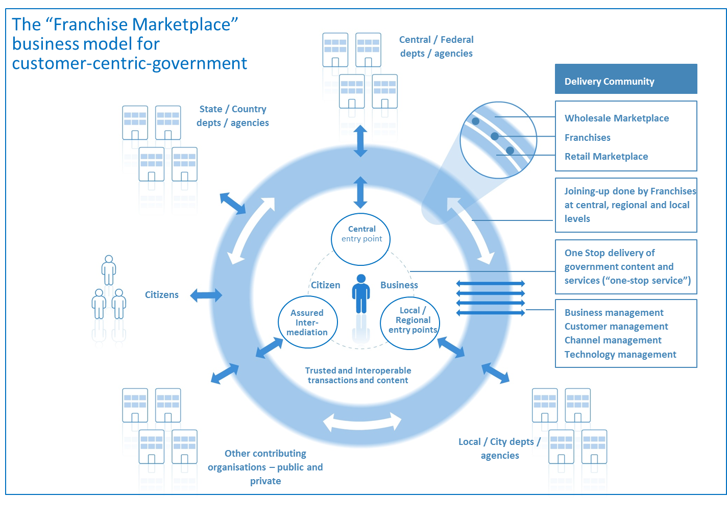
Figure 5: Overview of the Franchise Marketplace
Key features of this business model are:
The model puts into place a number of agile cross-government virtual "franchise businesses" based around customer segments (such as, for example, parents, motorists, disabled people). These franchises are responsible for gaining full understanding of their customers' needs so that they can deliver quickly and adapt to changing requirements over time in order to deliver more customer centric services - which in turn, is proven to drive higher service take-up and greater customer satisfaction.
Franchises provide a risk-averse operational structure that enables functionally-organized government agencies at national, regional and local to work together in a customer-focused "Delivery Community". They do this by:
- Enabling government to create a "virtual" delivery structure focused on customer needs;
- Operating across the existing structure of Government (because they are led by one of the existing "silos") and resourced by organizations that have close links with the relevant customer segment including, possibly, some outside of government;
- Dividing the task into manageable chunks;
- Removing a single point of failure;
- Working to a new and precisely-defined operating model so as to ensure consistency;
- Working across and beyond government to manage the key risks to customer-centric service delivery;
- Acting as change agents inside-Government departments / agencies.
The model enables a "mixed economy" of service provision:
firstly, by providing a clear market framework within which private and voluntary sector service providers can repackage public sector content and services; and
secondly by deploying ‘Web 2.0’ type approaches across government that promote re-use and ‘mash-ups’ of existing content and services, to make this simpler and cheaper at a technical level.
The whole model is capable of being delivered using Cloud Computing.
This Franchise model represents an important break-through in the shift from a traditional e-Government approach towards transformational government. Certainly, the model as a whole or key elements of it has been adopted successfully in governments as diverse as the UK, Hong Kong, Croatia, Abu Dhabi and Australia (where it has been adopted by both the South Australia and Queensland governments).
It is clearly possible that alternate models may develop in future. But however the Transformational Government agenda develops, every government will need to find some sort of new business model along these lines, rather than continue simply to overlay technology onto an old silo-based business model built for an un-networked world.
❖  
The Solution
Establish a number of agile, cross-government, virtual "franchise businesses" that:
- are based around customer segments (such as, for example, parents, motorists, disabled people) and that sit inside the existing structure of government;
- deliver customer-centric, trusted and interoperable content and transactions to citizens, businesses and other organizations; and
- act as champions of and drivers for customer-centric public service improvement.
❖  
Linkages
The Franchise Marketplace is a specific example of a [B3] Transformational Operating Model and is considered as the most effective and lowest risk way of delivering the element of the [GP1] Guiding Principles which requires Transformation Programs to “Build services around customer needs, not organizational structure”. Further details on the key stakeholders who need to be involved in enabling the Franchise Marketplace model are contained at Appendix B.

[B5] Stakeholder Collaboration
Context
Effective stakeholder collaboration is critical. Establishing a process of sustainable change requires a critical mass of actors inside and outside of the government to be both engaged and supportive. Delivering a [B1] Vision for Transformation cannot be done without meaningful stakeholder collaboration.
The private, voluntary and community sectors have considerable influence on citizen attitudes and behavior. These influences must be transformed into partnerships which enable the market to deliver program objectives. This requires a “map” of all stakeholders as part of overall business management.
❖  
The Problem
It is not enough to map and understand stakeholder relationships and concerns. Classic models of ‘actor’ and ‘stakeholder’ also need to be re-assessed
Leaders from all parts of the government organization, as well as other organizations involved in the program, need to be motivated for the program to succeed and need to be engaged in clear and collaborative governance mechanisms to manage any risks and issues. The development and delivery of an effective Transformational Government program requires engagement with a very wide range of stakeholders, not only across the whole of government but also, in most cases, with one or more of the private, voluntary and community sectors as well as with public service customers. A significant effort is needed to include all stakeholders in the governance of the Transformational Government program at an appropriate and effective level.
Key elements are set out below that a conformant TGF program will need to address in developing its Collaborative Stakeholder Governance Model, if it is to engage successfully with stakeholders and align them effectively behind shared objectives.
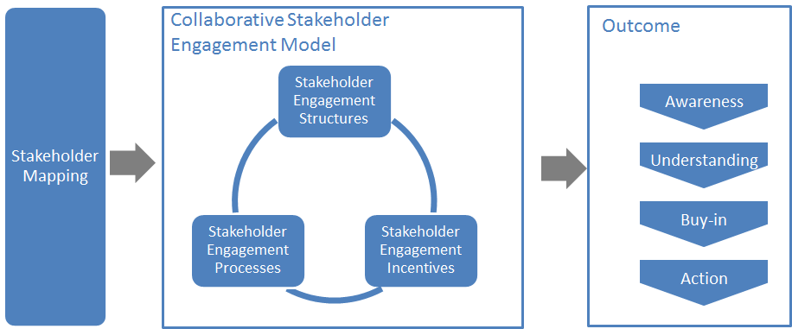
Figure 6: Overview of Collaborative Stakeholder Governance
It is vital to describe and map the complete landscape of relevant stakeholders. The Transformational Government Framework puts the individual – whether acting on their own behalf as a citizen or on behalf of another citizen or of a business– at the centre:
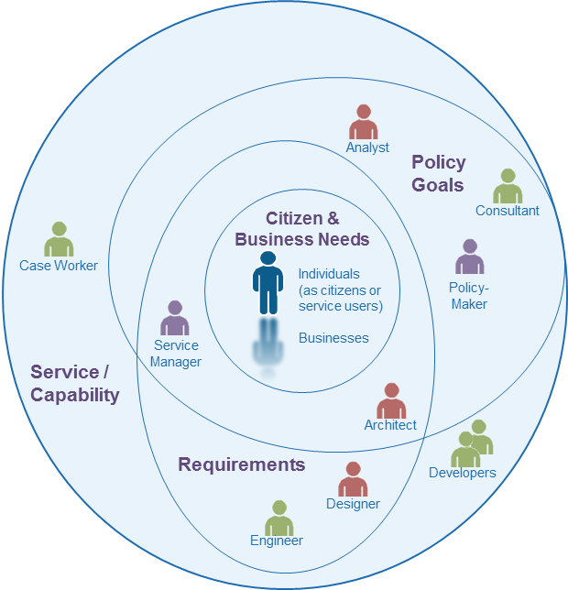
Figure 7: Landscape of some key stakeholders
This view deliberately and completely avoids the rather generic concept of ‘User’ that is dominant in traditional IT stakeholder engagement models, preferring rather to identify the different interests and concerns that are at stake (the mauve labels) and the key groups of stakeholders (the different people icons) in the development of any service.
The figure is by no means complete nor the only ‘valid’ view. It seeks instead to illustrate that the process of transformation requires reappraisal of the current set-up and assessment of what needs to change.
By clearly separating out key stakeholder groups and starting to understand and articulate their specific concerns as stakeholders (any individual’s role may vary according to context: in one situation, a person is a parent; in another, a policy-maker; or another, a service provider), we can start to understand how stakeholders relate (in different roles): to each other; to various administrations and services involved; to policy drivers and constraints; and how these all come together in a coherent ecosystem supported by a Transformational Government Framework. In this view:
A service (or ICT capability made available as a service) is understood as responding to a set of requirements and policy goals (some of which overlap) – stakeholders concerned at this level include, for example, case workers in a public administration or developers who have worked with them in delivering a specific service;
Requirements encapsulate and formalize vaguely stated goals and needs of citizens and businesses and take on board the policy goals of the political sponsor or champion – stakeholders at this level include, for example, managers of public service who can articulate the needs of their respective services, the information and systems architects who capture those needs as formal requirements that engineers can work with to develop services;
Policy Goals capture the high-level concerns and priorities of the political authorities and continually assess how these goals reflect key citizen and business concerns – stakeholders include policy makers and senior management as well as consultants and analysts involved in helping identify technology and administrative trends that can be used to leverage those goals; and finally;
Citizen and Business Needs that, ultimately, can only be fully understood by the people concerned themselves – nonetheless stakeholders at this level can also include citizen or business associations, consumer and other interest groups who engage with policy makers to advance the interests of certain groups with distinct needs and are able to articulate those needs in ways that can be used by analysts and consultants.
The various ellipses in the diagram above are deliberately not concentric circles. This is to underline that the process of establishing a service or capability is not a linear one going from needs, goals and requirements. In reality stages are often inter-related.
The mapping of stakeholders and their principal concerns at a generic level is used as a key input to the TGF [B9] Reference Model and that needs to be validated within any TGF program. It is valuable as a tool for encouraging collaborative governance as it renders explicit many of the relationships and concerns that are often left implicit but nonetheless impact on an organization’s ability to reflect stakeholders’ concerns.
However, it is not enough simply to map and understand stakeholder relationships and concerns. An effective TGF program will also address the three other dimensions of the model illustrated above:
Stakeholder Engagement Structures: the organizational arrangements put in place to lead the transformation program, e.g.:
- central unit(s)
- governance boards
- industry partnership board.
Stakeholder Engagement Processes: the processes and work flows through which the TGF Leadership and the different TGF Stakeholders interact, e.g.:
- reporting and accountability processes
- risk management processes
- issue escalation processes
- consultation processes
- collaborative product development processes.
Stakeholder Incentives: the set of levers available to drive change through these governance structures and processes. These will vary by government, but typical levers being deployed include:
- central mandates
- political leadership
- administrative championship
- personal performance incentives for government officials
- alignment between public policy objectives and the commercial objectives of private sector partners.
There is no one right model for doing this successfully, but any conformant TGF program needs to make sure that it has used the framework above to define its own Collaborative Stakeholder Engagement Model which explicitly articulates all of these elements: a comprehensive stakeholder map, coupled with the structures, processes and incentives needed to deliver full understanding and buy-in to the program, plus effective stakeholder action in support of it.
Collaboration between TGF Programs
The model clearly focuses attention within any specific TGF program. However (and increasingly) collaboration is required also between governments and, by implication, between TGF programs. In the figure below, we see that collaboration between TGF programs is favoured at the political, legal and organizational levels and only later, if and when necessary, at the more ‘tightly-coupled’ semantic and technical levels.
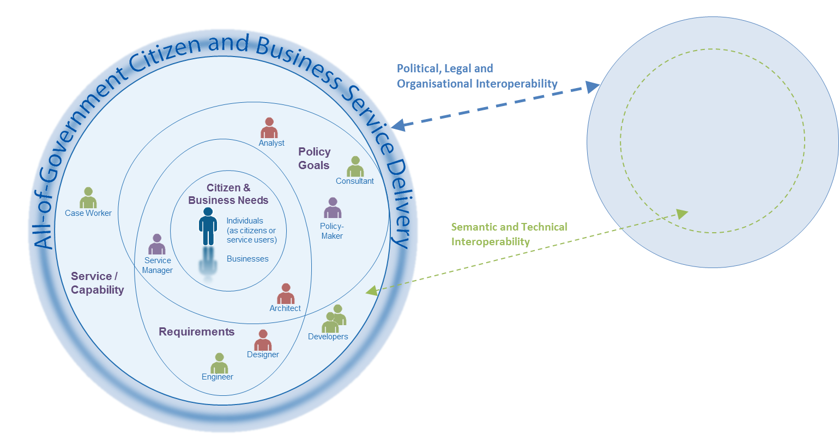
Figure 8: Collaboration between TGF programs through different levels of Interoperability
This approach is also consistent with the SOA paradigm for service development – not only are requirements defined and services offered independently of any underlying technology or infrastructure but also one TGF program can be seen (and may need to be seen) as a ‘service provider’ to another TGF program’s ‘service request’. For example, a business wishing to establish itself in a second country may need to provide authenticated information and credentials managed by government or business in the first country.
A further advantage of this approach is that it becomes easier to identify and manage high level government requirements for services: whether in the choice of ICT standards that may need to be used to address a particular technology issue or determining the criteria for awarding public procurement contracts, this approach allows a ‘loose-coupling’ at the level of clearly defined high-level policy needs rather than the more tightly-coupled and often brittle approach of specifying particular technologies, software or systems.
❖  
The Solution
TGF programs should establish, and give high priority and adequate resources to, a formal managed stakeholder engagement program. This should be led by a senior executive and integrated into the roles of all involved in delivering the TGF program, and should cover:

- Stakeholder modelling: identifiying and mapping the relationships between all key stakeholders in the program (users, suppliers, delivery partners elsewhere in the public, private and voluntary sector, politicians, the media, etc.); maintaining and updating the stakeholder model on a regular basis;

- A collaborative stakeholder governance model: establishing a clear set of structures, processes and incentives through which the [B2] Program Leadership and the different stakeholders will interact, brought together as a formal, managed stakeholder engagement programme. This should be led at senior level within the Program Leadership and be integrated into the roles of all those involved in delivering the TGF program, and shouldand covering:

‒ stakeholder communicationparticipation: ensuring that all stakeholders have a clear understanding of the TGF program, how they can engage with it, and how they will benefit from it, and have effective and inclusive routes (including through use of digital media) to engage with and participate in the program;

‒ cross-sectoral partnership: engaging effectively with stakeholders from the private, public and voluntary sectors to deliver the program in a way that benefits all sectors;
‒ engagement with other transformation programs to learn lessons and exchange experience.
❖  
Linkages
Stakeholder Collaboration should be established as a formal workstream within the [B10] Roadmap for Transformation, with measurable performance metrics built into the Benefits Realization framework. Stakeholder engagement underpins all other parts of the TGF, because anyone in involved in the realization of the [B1] Vision for Transformation (or receiving benefits as a result) is considered a stakeholder. However, intensive multi-stakeholder engagement is particularly important for [B1] Vision for Transformation, [B2] Program Leadership, [B7] Supplier Partnership, [S2] Brand-led Service Delivery, [S1] Stakeholder Empowerment and [S3] Identity and Privacy Management. The development of successful customer franchises within the [B4] Franchise Marketplace will depend on the effectiveness of collaborative governance – while at the same time helping improve stakeholder collaboration significantly..

[B6] Policy Product Management
Context
In any government, “Policy Products” - the written policies, frameworks and standards which inform government activity - are important drivers of change. In the context of Transformational Government, the [B2] Program Leadership will use a wide set of Policy Products to help deliver the program – and, in particular, to ensure interoperability between the different organizations and systems involved in the TGF program.
❖  
The Problem
Traditional policy approaches for e-government have often been too narrowly focused. An effective Transformational Government program requires a more holistic approach to policy development.
We define a "Policy Product" as: any document that has been formally adopted on a government-wide basis in order to help achieve the goals of transformational government. These documents vary in nature (from statutory documents with legal force, through mandated policies, to informal guidance and best practice) and in length (some may be very lengthy documents; others just a few paragraphs of text). Policy Products are important drivers of change within government: first because the process of producing them, if managed effectively, can help ensure strategic clarity and stakeholder buy-in; and second because they then become vital communication and management tools.
Over recent years, several governments have published a wide range of Policy Products as part of their work on e-Government, including e-Government Visions, e-Government Strategies, e-Government Interoperability Frameworks, and Enterprise Architectures. Other governments are therefore able to draw on these as reference models when developing their own Policy Products. However, we believe that the set of Policy Products required to ensure that a holistic, government -wide vision for transformation can be delivered is much broader than is currently being addressed in most Interoperability Frameworks and Enterprise Architectures.
The European Commission identifies five broad interoperability domains via the European Interoperability Framework (EIF): technical, semantic, organizational, legal, and policy interoperability. While this framework is conceptually complete, TGF programs will find it helpful to map the five EIF dimensions against the three government-wide delivery and governance processes identified in the TGF: business management, service management, and technology and data asset management.
The resulting matrix represents the landscape within which a government needs to map the barriers to interoperability which it faces, and relevant constraints placed by national or international policy commitments. In each cell of the matrix, some action is likely to be needed.
This Policy Product Matrix MUST be used to create a map of all the Policy Products needed to deliver a particular TGF program effectively. This matrix maps the three delivery processes of the TGF (Business Management, Service Management and Technology Management) against the five interoperability domains identified in the [EIF].
❖  
The Solution
TGF Programs should therefore use the Policy Product Matrix below as a tool to:
- help identify key barriers to interoperability in their TGF program;
Delivery Processes | Interoperability Levels
Delivery Processes | Political | Legal | Organizational | Semantic | Technical
Business Management
Service Management
Technology Management
- identify, for each and every cell in the matrix, the policy product(s) that are needed to deliver the Transformational Program effectively. Nil, one, or multiple policy product(s) may be required per cell. Consideration MUST be given to every cell as to which policy products might be included.
- establish policies and actions to address these, drawing on international, European or national standards where possible; and
- promote commonality of approaches and easier linkages with other TGF programs.
❖  
Linkages
The [B2] Program Leadership should undertake this policy gap analysis through [B5] Stakeholder Collaboration, and then ensure that the accountability and process for developing any missing Policy Products is embedded within the [B10] Roadmap for Transformation.
A full analysis of the Policy Products which we recommend are typically needed to deliver an effective and holistic transformation program are described in a separate TGF Committee Note “Tools and Models for the Business Management Framework”. Although the detailed Policy Products in that note are advisory and not all of them may be needed, any conformant transformation program MUST use the overall framework and matrix of the Policy Product Map in order to conduct at minimum a gap analysis aimed at identifying the key Policy Products needed for that government, taking the Committee Note into account as guidance.

[B7] Supplier Partnership
Context
Governments rely heavily on suppliers to deliver large parts of their services. These suppliers are usually external organizations but they can also be other internal parts of government. The management of supplier relationships needs to sit above the management of individual contracts and it is important that distinction is fully understood by all parties. Legacy supplier relationships and procurement policies have often raised significant barriers to transformation programs.
❖  
The Problem
Transformational Government programs require effective, partnership-based relationships with suppliers, that act as enablers rather than blockers of their vision for more citizen-centric and integrated service delivery.
Supplier partnerships should set out a formalized and robust way of managing, monitoring and developing supplier and commissioning party performance whilst at the same time minimizing risks to the business. ‘Partnerships’ focus on the overall relationship over time rather than the specific relationship around an individual, time-limited, contract.
Yet traditional public sector procurement and supplier management practices can represent a significant obstacle to transformational government. From both the public and private sector sides of the market, there is strong evidence that such practices can stifle innovation and inhibit the ability of governments and industry jointly to undertake real life R&D and to pool intellectual property for mutual benefit.
Equally, there is increasing consensus on new, “smarter” approaches to supplier partnership, which are already starting to develop and should be more widely adopted. Figure 9 summarizes some of the key elements of this shift.
Traditional public procurement and supplier management |  | Transformational Supplier Partnership
Silo-based procurement, with requirements set by individual agencies within the government… |  | An integrated strategic approach to the commissioning of services, across the government and in partnership with other public service delivery organizations
…and with little ability to fund solutions that benefit multiple organizations |  | Budget alignment mechanisms enable effective provision of common good platforms and services
The government defines the technology and other inputs it wants to buy, and the immediate outputs it wants these to deliver |  | The government defines the outcomes and service levels it wants to achieve
Requirements are developed internally by the government |  | Requirements are developed iteratively, in partnership between customer, commissioner and supplier
The government brings its requirements to the market in a piecemeal manner |  | Published pipelines of future requirements help to stimulate the market and enable suppliers to propose new cross-cutting solutions to deliver multiple requirements
Government agencies define their requirements in isolation from each other |  | Joint procurement initiatives, facilitated by shared pipelines, enable shared services across more than one agency and also stimulate the market for standardized and replicable public sector solutions (including via Cloud Computing)
Procurement and contracting is based around purchaser–provider, client–agent relationships |  | A range of more innovative delivery models are deployed, including joint ventures and partnerships between government, industry and academia that promote collaborative solutions while safeguarding the intellectual property of each
Procurement decisions focus primarily on price |  | Procurement decisions focus primarily on long-term value for money, including:  - total cost of ownership (including costs of exit);  - the suppliers’ ability to innovate;  - confidence in delivering the expected business benefits.
IT as a capital investment |  | IT as a service
Long-term, inflexible contracts |  | Short-term, on-demand purchasing
Bespoke, vertically-integrated solutions for each line of business |  | Sharing and re-using standardized components, drawing on best-of-breed building blocks and commercial-off-the-shelf products
Government systems are unable to interoperate, due to over-reliance on proprietary systems |  | Interoperability based on open standards is designed into all procurements from the outset
Important public data-sets cannot be opened up because they are owned by suppliers |  | Standard contractual arrangements ensure that all government suppliers make public data available via open standards and either for free or, where appropriate, on fair, reasonable and non-discriminatory terms
No incentives on suppliers to share, collaborate and innovate with other stakeholders |  | Contractual arrangements encourage collaboration with others to create new value, and the sharing of common assets, with benefits being shared between the government and its suppliers
The government buys from a limited pool of large suppliers |  | The government buys from a large pool of small suppliers, plus strategic relations with a smaller number of platform suppliers who themselves integrate with many SMEs
Government leaders focus on managing relationships with a few large vendors |  | Government leaders focus on nurturing and managing an innovation ecosystem
Figure 9 – Towards transformational supplier partnerships
❖  
The Solution
TGF programs should therefore:
- take an integrated view of the program’s procurement requirements, establishing governance arrangements that enable a government-wide overview of major procurements;
- review procurement policies to ensure they align with smart contracting principles:
  - focus on procuring business outcomes: specify what the supplier should achieve, not how it should achieve it (in general, this includes procuring services not assets);
  - build open data into all procurements: be clear that all data is to be owned by the government not the supplier, or establish clear requirements for the supplier to make data available via open standards and fair, reasonable and non-discriminatory terms;
  - incentivize innovation and collaboration: ensure that contractual arrangements encourage collaboration with others to create new value, and the sharing of common government assets;
  - avoid supplier lock-in, by integrating interoperability requirements into all ICT procurement, using commercial-off-the-shelf products and open standards wherever possible, and factoring in the costs of exit from the outset;
- work to nurture an innovation ecosystem across the government and its suppliers, including by:
  - publishing the government’s procurement policies, ensuring that all changes following the review are widely known;
  - publishing and updating a pipeline of major procurement opportunities;
  - early and iterative engagement with potential suppliers, including local and other SMEs, to benefit from innovation and stimulate the market;
  - stimulating SME-led innovation, including through use of competitions and placing SME-engagement requirements on large suppliers;
  - Driving forward the internal cultural and behavioural changes entailed by the above recommendations.

❖  
Linkages
Successful supplier partnerships require specific skills sets to effectively manage the relationship. Attention should be given to this as part of the wider focus on ensuring the requisite [B8] Skills are available to the program. The need to nurture an innovation ecosystem of suppliers should be a major theme of [B5] Stakeholder Collaboration, and will be facilitated by adoption of the [B4] Franchise Marketplace. In reviewing procurement and contracting policies, program leaders should seek to align contracting principles with the strategy for open, service-oriented, IT architecture set out in [T2] Technology Development and Management.

[B8] Skills
Context
Implementing a Transformational Government program and establishing [S2] [S2] Brand-Led Service Delivery involves taking a holistic, market-driven approach to service design and delivery, which in turn often requires new skills. Part of the responsibility of [B2] Business Management is to ensure that program leaders have the skills needed to drive all aspects of the program. This focus on skills has of course to be part of an effective HR Management discipline.
❖  
The Problem
Governments generally lack the key skills to manage service development. Where they do exist there is often reliability on a small number of individuals with no continuity plans in place for when those individuals are either absent for any reason or leave the team.
We know that the full range of business change, product and marketing management, program management, and technology skills needed to deliver transformational change does not already exist in our organization.
Many of the policy products required for the Transformational Government program will take us into new territory and it is unlikely that we will all the skills necessary to develop these in-house.
❖  
The Solution
Ensure the right skills mix is available to the program, particularly in the leadership team but also throughout the whole delivery team.
Map out the required skills together with a clear strategy for acquiring them and a continuity plan for maintaining them.
Be prepared to buy-in or borrow the necessary skills in the short term to fill any gaps.
Ensure that the program leaders, i.e. the senior accountable leaders, have the skills needed to drive ICT-enabled business transformation, and have access to external support.
Ensure there is skills integration and skills transfer by having effective mechanisms to maximize value from the skills available in all parts of the delivery team, bringing together internal and external skills into an integrated team.
❖  
Linkages
The development of a Transformation Competency Framework is a good way of producing a taxonomy of the competencies required to deliver ICT-enabled transformation, which should then be underpinned by tools enabling organizations to assess their competency gaps and individuals to build their own personal development plans. Deployment of a formal competency framework such as [SFIA] can be helpful in identifying and building the right skill sets. As an example see the UK’s eGovernment Competency Framework which is available at http://www.civilservice.gov.uk/about/improving/psg .
See also [B6] Policy Product Management, [B7] Supplier Partnership and [CSF1] Critical Success Factors.

[B9] Common Terminology and Reference Model
Context
In any change program of the breadth and complexity that the TGF supports, it is vital that all stakeholders have a common understanding of the key concepts involved and how they interrelate, and have a common language to describe these in.
❖  
The Problem
Leadership and communication both break down when stakeholders understand and use terms and concepts in very different ways, leading to ambiguity, misunderstanding and, potentially, loss of stakeholder engagement.
In everyday life, we use terms – ‘citizen’, ‘need’, ‘service’ – as common, often implicitly accepted labels for concepts. The concept is the abstract mental idea (which should be universal and language independent) to which the term gives a material expression in a specific language. Particularly in an international environment such as global standardization initiatives, the distinction is important as it is common concepts that we wish to work with, not common terms.
This distinction also helps avoid common modeling pitfalls. Terms that may seem similar or the same across two or more languages may actually refer to different concepts; or a single term in one language could be understood to refer to more than one concept which another language expresses with discrete terms: For example, the English term ‘service’ can refer to different concepts - an organizational unit (such as ‘Passport Service’) or something that is performed by one for another (such as ‘a dry cleaning service’), whereas discrete terms are used for the discrete concepts in German (‘Dienst’ or ‘Dienstleistung’). As the TGF is intended for use anywhere in the world, it is important to ensure that (ideally) global concepts can be transposed and translated and thus understood in other languages: we therefore need to associate an explicit definition with each concept as we do in a dictionary. The TGF uses the structure and methodology of an existing international standard to create its terminology
Concepts do not exist in isolation. In addition to clear definitions and agreed terms, It is the broader understanding of the relationships between concepts that give them fuller meaning and allow us to model our world, our business activities, our stakeholders, etc. in a way that increases the chance that our digital systems are an accurate reflection of our work. Any conformant agency should be able to use a common terminology without ambiguity and be sure that these terms are used consistently throughout all work.
The Solution
Ensure that all stakeholders have a clear, consistent and common understanding of the key concepts involved in Transformational Government; how these concepts relate to each other; how they can be formally modeled; and how such models can be leveraged and integrated into new and existing information architectures. To this end:
Seek agreement among stakeholders to establish and maintain an agreed and shared Common Terminology and Reference Model.
❖  
Linkages
A core terminology is proposed below and any program should consider this as a basis for its own terminology and reference model. The TGF does not include a formal ontology but is sufficiently clear in its concepts, definitions and relationships between concepts that subsequent ontology development is possible if so desired.

Core Terminology
Accessibility
A policy prescription that aims at ensuring that people with disabilities and the elderly can use public services with the same service levels as all other individuals.
Business Change
A change to processes, procedures, policies, organizational structures, etc., that is necessary to realize benefits made possible by Enablers.
Channel
A particular means and/or path of delivery of a service to a customer.
Customer
Any natural or legal person (a citizen or a business) who uses a public service. Standard SOA terminology refers to “consumer” but “customer” is to be preferred in order to highlight a more active role than is implied by (the more passive term) consumer.
Customer Franchise
A collaborative organization created by the government with the purpose of: understanding the needs of a specific customer segment for government services (such as, for example, parents, motorists, disabled people, land and property); championing the needs of that segment within government; aggregating content and transactions for that segment from across government and beyond; and delivering that content and services as part of the wider Franchise Marketplace.
Delegate
Some person or agent acting with authority on behalf of another person.
Delivery Roadmap
A detailed multi-year plan for the delivery of an overall cross-government vision for service transformation.
Ecosystem
A set of ICT systems and stakeholders together with the environment and context within which they all operate.
Enabler
Usually something built or acquired, such as an IT system, building, equipment or plant, and which creates the platform for benefits.
Franchise Marketplace
The virtual business infrastructure within which Customer Franchises collaborate with each other and other stakeholders to deliver user-centric, trusted and interoperable content and transactions to citizens and businesses. The Franchise Marketplace is the business model recommended by the TGF for best delivering the TGF Guiding Principle of “Build services around customer needs, not organizational structure”.
Function
A team or group of people and the tools or other resources they use to carry out one or more processes or activities.
Goal
A broadly stated, unmeasured but desired Outcome. Not to be confused with an Objective.
Governance
The method or system by which an organization's strategy, policies and processes are directed, monitored and evaluated.
Input
A resource to be processed to produce an Output. It can be any resource - document, artifact - anything.
Interoperability
The ability of disparate and diverse organizations to interact towards mutually beneficial and agreed common goals, involving the sharing of information and knowledge between the organizations, through the business processes they support, by means of the exchange of data between their respective ICT systems.
Leadership
Key people and governance structures needed to develop and implement a Transformational Government program
Measure
One or more Measures will be associated with an End or Intermediate Outcome. They are used to assess progress towards the targets of the program.
Metric
A measure that is used to help manage any service, plan, project or other activity. For example Key Performance Indicators (KPIs) are used to measure the achievement of critical success factors.
Need
A general statement expressed by a stakeholder of something that is desired. Not to be confused with a Requirement.
Objective
A specific, measurable and achievable Outcome that a participant seeks tohave realised.
One-stop Service
A service designed around the needs of citizens and businesses. Such a service brings content and transactions from a wide number of different government agencies, and from different layers of government, enabling them to be integrated as a “one stop” point of service delivery, according to common service standards and with common marketing and communication.
Outcome
The result of carrying out an activity, following a process, or delivering an IT service etc. The term is used to refer to intended results as well as to actual results.
or
The net result of an activity being carried out, following a process, or delivering an IT service etc. The term can be used to refer to intended outcomes as well as to actual outcomes.
or
An impact of the program to which one or more stakeholders attribute value. Outcomes can be “End” – directly contributing to Strategic Purpose, or “Intermediate” – a step towards an End Outcome. (NB in some Benefits Realization Management methods Outcomes are referred to as Benefits.)
Output
A specialist product (the tangible or intangible artifact) that is produced, constructed or created as a result of a planned activity and handed over to a user(s).
or
A product that is the result of a planned activity.
or
Something that is delivered as a result of investment and/or activity within the TGF program. TGF outputs will be either enablers or business changes.
Policy Product
A document that has been formally adopted on a government-wide basis and aimed at helping achieve one or other goal of transformational government.
Process
A structured proposed set of activities designed to accomplish a specific Objective. A process takes one or more defined inputs and turns them into defined outputs. It may include any of the roles, responsibilities, tools and management controls required to reliably deliver the outputs. A process may define policies, standards, guidelines, activities and work instructions if they are needed.
Requirement
A formal statement of a desired result that, if achieved, will satisfy a Need.
Security
The set of mechanisms for ensuring and enhancing trust and confidence in a system.
Service-Orientation
A paradigm for organizing and utilizing distributed capabilities that may be under the control of different ownership domains.
Stakeholder
Any person inside or outside an organization who has a vested interest in a given ecosystem.
Stakeholder Governance Model
Model and process in which key stakeholders are identified, and engaged and who in turn buy-in to the transformation program.
Strategic Purpose
The overall Goal and Objective which TGF Outcomes are designed to achieve; the core rationale for undertaking the TGF program.
System
A number of related things that work together to achieve an overall Objective.
Transformational Government
A managed, customer-centred, process of ICT-enabled change within the public sector and in its relationships with the private and voluntary sectors

[B10] Roadmap for Transformation
Context
It is essential that the vision of the [B2] Program Leadership, and the associated [B3] Transformation Operating Model and process of [B6] Policy Product Management are translated into an effective Roadmap for Transformation.
❖  
The Problem
TGF programs need to develop a roadmap that is practically deliverable: that is, not This should not be some all-encompassing master plan – which is likely to be brittle and prone to failure – but a pragmatic framework for delivering clearly identifiable results in achievable stages.

Since everything can clearly not be done at once, it is vital to map out which elements of the transformation program need to be started immediately, which can be done later, and in what order. The "big bang" approach to implementation has been shown not to work or be effective. By its nature it is heavily reliant on significant levels of simultaneous technological and organizational change. Instead, a transformational government program will develop a phased delivery roadmap which balances quick wins with the key steps needed to drive longer term transformation.
There is no one-size-fits all strategy which governments can use, since strategy needs to be tailored to the unique circumstances of each government's situation. However, all governments face the same strategic trade-offs: needing to ensure clear line-of-sight between all aspects of programme activity and the end outcomes which the Government is seeking to achieve. In the early days of the Transformational Government program, the major strategic focus should be on safe delivery - that is, prioritizing high benefit actions which help to accelerate belief and confidence across the Government and the wider stakeholder community that ICT-enabled change is possible and beneficial - but which can be delivered with very low levels of risk. As the programme develops, and an increasing number of services become available, the strategic focus can move towards building take-up: that is, building demand for online services and creating a critical mass of users. Once that critical mass starts to appear, the strategic focus can start to shift towards fuller transformation: in other words, to start driving out some of the more significant transformational benefits that high levels of service take-up enables, for example in terms of reducing the cost of government service delivery.
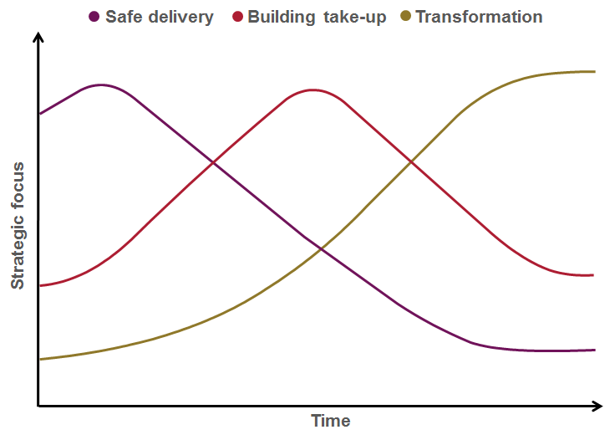
As the diagram below makes clear, these strategic foci are not mutually exclusive, but overlap. Crucially, in the Safe Delivery phase there will also be some vital steps needed in order to pave the way for longer term transformation, particularly in respect of establishing the business case for transformation, and embedding the strategy in effective governance processes. But the diagram shows how the strategic weight between each consideration should shift over time.
Figure 10: Roadmap priorities over time
Guided by the strategic trade-off framework described above, experience shows that a phased approach is the most successful. Typically, an effective Delivery Roadmap will cover five main phases.
Plan
The preparation and planning needed to develop a tailored Delivery Roadmap for the Government, to ensure that the business case for transformation is fully articulated, and that all key stakeholders are on-board. Key outputs from this phase should include:
- [GP1] Guiding Principles: the agreed set of principles that stakeholders and delivery partners seek to work towards in delivering the TGF program;
- [B1] Vision for Transformation: Transformation vision: a high level document setting out the agreed future vision for the program;
- Benefits Realization Framework, including:
- [BR1] Business Case: the key costs and benefits associated with the Transformation program;
- initial high level plans for [BR2] Benefits Mapping, [BR3] Benefits Tracking, [BR4] Benefits Delivery and [BR6] Benefits Reviews, setting out the actions needed to ensure full downstream delivery of the intended benefits from the transformation program.
- [B10] Roadmap for Transformation: a multi-year transformation plan, covering, among other things:
- establishing the [B2] Program Leadership people and governance processes;
- a [B5] Stakeholder Collaboration workstream;
- development and delivery of a [B7] Supplier Partnership strategy;
- plans for mapping IT and digital assets, and moving towards the open, service-oriented, IT architecture described in [T2] Technology Development and Management, and using this to enable the [B3] Transformational Operating Model;
- a risk management strategy, to ensure that the delivery process effectively addresses the [CSF1] Critical Success Factors.

Initiate
In this first phase of delivery, the focus is on building the maximum of momentum behind the Roadmap for the minimum of delivery risk. This means focusing in particular on three things:
- some early quick wins to demonstrate progress and early benefits, for a minimum of delivery risk and using little or no technology expenditure, in order to accelerate belief and confidence across key stakeholders;
- embedding the Roadmap in governance structures and processes which will be needed to inform all future investments, notably the frameworks of enterprise architecture, customer service standards and issue/risk management that will be required;
- selecting effective delivery partners.
Deliver
In this phase, some of the more significant investments start coming on stream - for example, , an open data platform to support SME and community-led innovation with public data, the first version of the major "one-stop" customer-facing delivery platforms, and the first wave of transformation projects from "champion" or "early adopter" agencies within the Government.
Consolidate
In this phase, the focus shifts towards driving take-up of the initial services, expanding the initial one-stop service over more channels, learning from smart data and user feedback, and using that feedback to specify changes to the business and technology architectures being developed as longer term, strategic solutions.
Transform
Finally, the program looks to build out the broader range of e-transformation projects, drive forward the migration of all major customer-facing services towards the new one-stop channels, and complete the transition to the full strategic IT platform needed to guarantee future agility as business and customer priorities change.
❖  
The Solution
TGF programs leaders should therefore:
Establish a phased Transformation Roadmap.
Work with citizens and businesses to identify a set of services that represents a ‘quick win’ for government and its customers alike.
Give priority to services that can be delivered quickly, at low cost, and low risk using ‘off the shelf’ (rather than bespoke) solutions.
Establish systems to learn from early customer experience, to improve services in the light of this, and then to drive higher levels of take-up.
Work with early adopters within the government organization in order to create exemplars and internal champions and thus learn from experience and drive longer-term transformation.
❖  
Linkages
The [B10] Roadmap for Transformation should be pursued with due attention to risk management, and should therefore include checkpoints at key stages to allow regular, independent review of performance against the [CSF1] Critical Success Factors.

Service Management
This section of the TGF focuses on service management: that is, the way in which services for citizens and businesses are planned and delivered. The focus is on the changes that are needed in cities to align service delivery more closely with the [GP1] Guiding Principles, and with the changes described in [B3] Transformational Operating Model.
At the heart of the TGF approach to service management is a belief that a twin track approach needs to be taken to the smart transformation of city services:
- first, the increasing digitization of government services and assets presents a huge opportunity to make the government more open to externally-driven innovation. So a TGF program should seek to accelerate this, by facilitating and incentivizing the development of a new marketplace for public sector information, within which public systems are opened up to SMEs, social entrepreneurs and individual citizens to design and deliver public services themselves, mash up public data with other data, and create new sorts of value. This is addressed below in [S1] Stakeholder Empowerment
- second, the government itself (together with other major public service deliverers) has a responsibility to drive improvements to its own services through the application of smart data and more citizen-centric ways of working. This is addressed below in [S2] Brand-led Service Delivery.
Both elements of this twin-track approach are supported by the other patterns in the TGF Service Management Framework:
- [S3] Identity and Privacy Management
- [S4] Channel Management Framework, and the further more detailed guidance on this provided by [S5] Channel Mapping and [S6] Channel Transformation.

[S1] Stakeholder Empowerment
Context
The [GP1] Guiding Principles highlight the importance of opening up the government’s data to drive innovation and create new value, and empowering citizens and businesses to create services and value themselves through public data.

❖  
The Problem
Many e-Government programs have failed because the citizen and business customers of public sector services are seen as simply passive recipients of those services rather than active stakeholders in their design and delivery. Successful service transformation is done with citizens, businesses and organizations, and not to them

Stakeholder empowerment involves a set of changes which are much more fundamental than the online consultations and "e-participation" initiatives which characterized the first wave of e-Government programmes. It is also more fundamental than the application of the latest generation of technologies to government - although such technologies do have a role to play.
The key shift is to think of service delivery not as something which is done by government to citizens and businesses but as something in which they are active co-creators of services - or even where public services are delivered directly citizen-to-citizen with no or minimal government involvement. Innovators in government who are making that shift are starting to develop a wide range of new ways to create public value and enhance services, as illustrated in the 2 figures below:
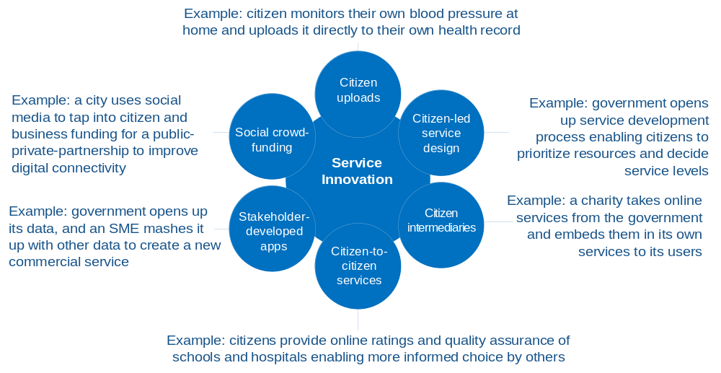
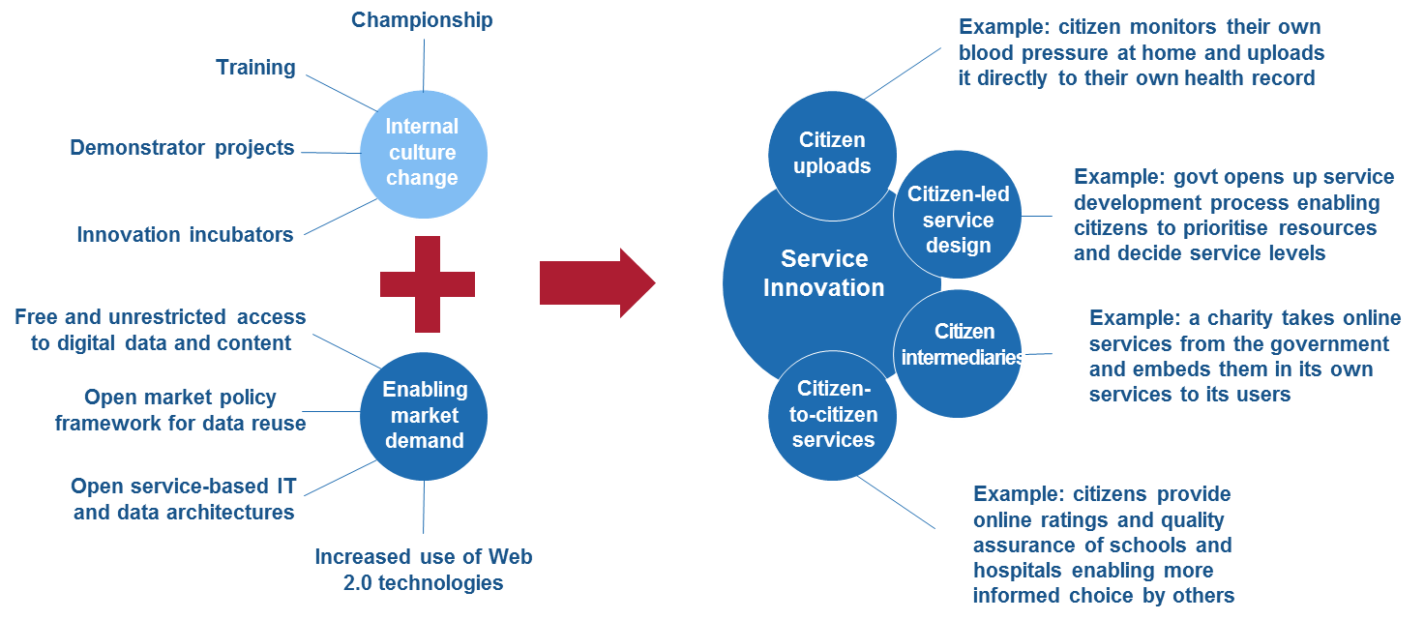
Figure 11: 2 Examples of Service Innovation
Such changes are beginning to happen whether governments plan for them or not, driven by the increasing adoption of social media and by rising expectations from citizens on the degree of interactivity they want from services (expectations that are constantly being raised by the best digital offerings from the private sector globally).
TGF programs can seek to embrace and accelerate those changes through measures such as those illustrated below.
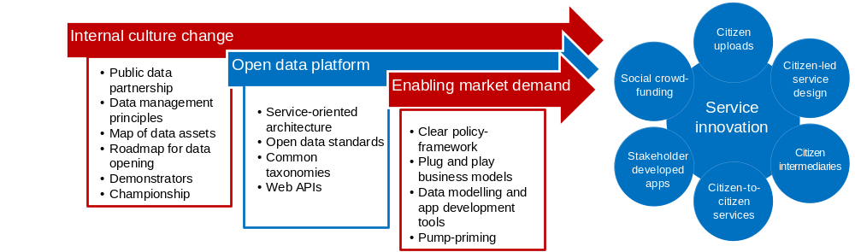

Figure 12: Accelerating Service Innovation
A key enabler is the establishment of an open data platform or platforms for the government: aimed at putting public data in the hands of citizens, entrepreneurs, social enterprises, public service providers, and businesses. Developing a sustainable business model and funding approach for the establishment, maintenance and development of such open data platforms is vital. There are a range of options, such as pooling resources from public sector bodies as a cost-effective, shared service route to complying with their open data obligations, generating revenue from the platform itself through subscription and value-add services, and leveraging investment on the basis of future efficiency savings in government and economic growth generated by the platform.
However, while open data platforms have the potential to unleash significant amounts of innovation, experience from governments around the world is that the technology alone will not do so. Business change is critical, and this needs to be addressed at two levels, as illustrated above:
- first, action on the supply side within government, to help create a culture of open innovation within the public sector. Such a culture change - which reflects an increasing trend in the private sector to see external ideas and Collaboration as being the key to successful innovation - is particularly challenging in the public sector given the strong tradition of internal control over decision-making and policy development. So pro-active change management is essential , working.e with data owners across the government to ensure a willingness and capability to provide data into the platform, and to tackle barriers to opening up data. These barriers are as much cultural ones as they are technical ones (given the strong tradition of internal “silo-based” control of public data) and require sustained leadership over several years. Illustrative actions, which may be built into a [B10] Roadmap for Transformation, include:
- building a shared vision and business case for the value that smarter, more open and more interoperable public data can create;
- agreeing a set of principles for the future management of data that data owners commit to working towards, including use of open data standards;
- developing a prioritized map of key data assets across the government, and a roadmap for converging these with the agreed principles and standards;
- promoting demonstrator projects and championing the benefits being achieved by early adopters.
- second, action to enable demand-side pull by customers and third party organizations outside of Government. Particularly important here is the principle that all non-personal data held by government should be open, public, easily reusable, and available at marginal cost - which for digital information means free. By opening up government data, content and services for reuse and repurposing by others, government can enable a level of service innovation and market reach that it could not hope to achieve on its own. Most governments also find that simply making data and content available in theory is not sufficient: in practice they also need to pro-actively facilitate market-based public service delivery. . Illustrative actions which might be built into a [B10] Roadmap for Transformation, include:
- establishing a clear and easily understandable policy framework of rights and responsibilities around open public data, which:
  - puts protection of personal privacy at its heart;
  - creates a level-playing field between public, private and voluntary sector organizations that develop services based on public data;
  - ensures compliance with relevant regulation and with government open data policy;
- establishing a service-oriented technology architecture based around open standards and technologies which makes it easier in practical terms for third parties to re-purpose and repackage Government content;
- developing and documenting a suite of sustainable business models for supply and use of public data (including publication of free public data, publication of public data with additional charges to cover the cost of value-add services, and publication of data on a commercial subscription basis);
- enhancing the open data platform so it provides tools to facilitate exploration and experimentation with public data by application developers;
- pump-priming the market with seed-corn funding and/or incubation facilities to stimulate innovative, service-related application development aimed at solving public sector challenges;
- supporting stakeholder and community-led Collaboration and programmes to enable individuals, communities and businesses to learn about, use and benefit from digital technologies;
- supporting Social Crowdfunding approaches that support and enable citizen-initiated ideas for change within their communities as opposed to government-initiated ideas

❖  
The Solution
TGF programs should empower stakeholders to create new sorts of services and value by opening up public data via open platforms, and by driving forward the internal culture changes and the external market enablers which are needed to create a flourishing marketplace in public sector information, in particular by:
Engaging service customers directly in identification, initiation, service design and delivery of services as active stakeholders.
Encouraging and enabling service innovation in the Citizen-to-Citizen, Business-to-Citizen, Citizen-to-Government, and Business-to-Government sectors.
Giving people access to the technology tools that enable them to create public value themselves. Giving them ownership and control of their personal data.
Making all non-personally identifiable data that is held by government, freely open for reuse and innovation by third parties.
❖  
Linkages
The approach to stakeholder empowerment described above is a key element of the broader shift towards establishing a [B3] Transformational Operating Model. Key enablers of the approach are Encourage internal cultural change with the Error: Reference source not found as well as through E [B5] Sngagement with Stakeholder Collaboration and s by use of a [B6] Policy Product Management. To succeed, the approach also needs to be closely linked with work on [S3] Identity and Privacy Management, and the more integrated approach to specifying, purchasing and managing government services recommended at [B7] Supplier Partnership. Further details on the technology and data asset management processes needed to support the approach are set out at [T1] Resource Mapping and Management and [T2] Technology Development and Management.

[S2] Brand-Led Service Delivery
Context
The [GP1] Guiding Principles highlight the importance of building services around customer needs, not organizational structure. The [B4] Franchise Marketplace sets out an effective operating model to enable this, but it needs to be supplemented by skills and tools that enable insight into citizen and business needs and a detailed and segmented understanding of citizens and businesses as customers of government services.

❖  
The Problem
A lack of focus on customers often leads to duplicated and inefficient government services delivered through inappropriate channels.
Understanding customer needs, and how to design and deliver services that users will engage with, requires a brand-led approach. A brand is something much deeper and more fundamental than logos, badging and corporate identity. It is the underlying promise made by an organization to its customers about the products and services it delivers, as reflected in the reality of how customers experience those products and services. Branding is a discipline in which governments lag behind the best of the private sector. Whereas brand development in the private sector is an explicit and vital driver of overall product and service strategy, the public sector has largely ignored a painful fact: that its services constitute a brand, whether they acknowledge this or not, and one that is all-too-often perceived negatively.
In a brand-led company, customer insight informs all aspects of the product development process, and involves a comprehensive program of qualitative and quantitative research to understand and segment the customer base. Lessons learned from this are fed into a brand-led product management process - not as a one-off input of initial research, but through a continuous process of iterative design and customer testing. A key output from this is a set of brand values for the product or service, which then need to drive all aspects of service delivery, support, and marketing. This is all managed as an iterative process of continuous improvement.
Marketing is critical to effective transformational government, yet is something at which government traditionally does not excel. Often, marketing is fundamentally misunderstood within government - as being equivalent to advertising or perhaps, more broadly, as being equivalent to communication.
Properly understood, however, marketing is the process of:
- Understanding the target market for government services in all its breadth and complexity;
- Learning what is needed in order to meet customer needs;
- Developing an offer for citizens and businesses that they will engage with;
- Establishing a clear set of brand values for that offer - a set of underpinning statements that adequately describe what the product or service will deliver and how;
- Delivering that offer though appropriate channels, in a way which fully delivers on the brand values;
- Generating awareness about the offer;
- Creating desire/demand for the offer;
- Reminding people;
- Changing the offer in the light of experience.
This is the process that a brand-led consumer product company such as Proctor and Gamble or Virgin would go through when developing a new product. However, it is not typically how governments manage their own service development, and governments generally lack the skills to do it. Moreover, the challenge faced by governments is significantly more complex than any private sector company, given the greater range and complexity of services and governments need to provide a universal service rather than pick and choose its customers. Yet if governments are to succeed in the ambition of shifting service delivery decisively away from traditional channels to lower-cost digital channels, then these marketing challenges have to be met.
And given the fact that a) customer needs cut across organizational boundaries in government and b) the skills for delivering an effective brand-led marketing approach to service transformation will inevitably be in short supply, it is important that these challenges are addressed at a government-wide level.
A TGF-conformant Transformation Program will establish government-wide processes for managing the three core elements of the TGF Brand-led Service Delivery Framework illustrated below:
- Customer insight
- Brand-led product management
- Marketing communications

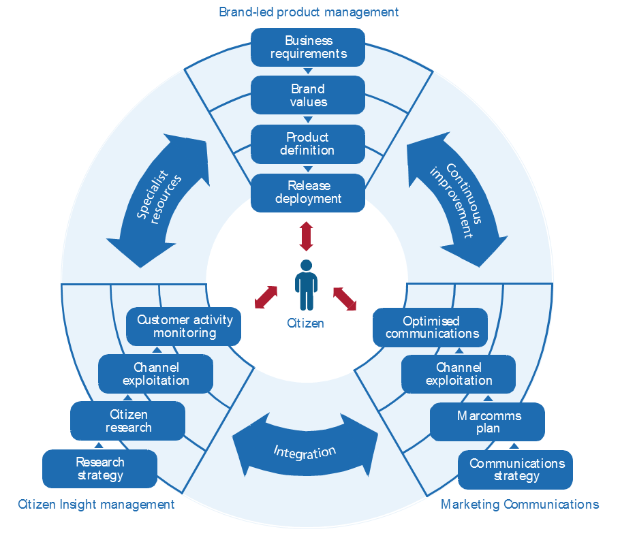
Figure 13: Brand-led Service Delivery Framework
Customer insight must inform all aspects of the process, and involves a comprehensive programme of qualitative and quantitative research to understand and segment the customer base for government services. The lessons learnt from this need to be fed into a brand-led product management process - not as a one-off input of initial research, but through a continuous process of iterative design and customer testing. A key output from this will be a set of brand values for the service, which then need to drive all aspects of service delivery, and marketing communications for the service.
This is an iterative process of continuous improvement, not a linear one. Continuous customer insight research is needed to ensure that both the service delivery experience and the marcoms activity remain aligned with the brand values, through successive phases of release deployment. As the service is implemented, across a range of channels, best practice management information systems can be deployed to ensure that the Government now has real-time, event-level management information about the experience of all customers - which in turn provides a powerful feedback loop into further innovation in the service design.
Often, this will require the Government to bring in specialist resources, because typically it may face significant gaps in terms of the people and skills needed to manage brand-led product development and marketing cycles of this nature.
❖  
The Solution
Establish a culture of Brand-led Service Delivery across government, based around three key pillars of (i) Customer Insight, (ii) Product Management, and (iii) Marketing and Communication:
- Customer Insight: Don’t assume to know what customers of a service think. Be obsessive about understanding the needs of customers – both internal and external – on a segmented basis. Invest in developing a real-time, event-level understanding of citizen and business interactions with government.
- Product management: Establish a brand-led product management process covering all stages of government service design and delivery, agreed and managed at a whole-of-government level, which gives citizens access to "one-stop services” available over multiple channels.
- Marketing and communication: Use the brand values for one-stop government to drive all aspects of marketing and communications for government services.
❖  
Linkages
Often, governments may face significant gaps in terms of the people and skills needed to manage brand-led product development and marketing cycles of this nature, so identifying and addressing these gaps as part of the [B8] Skills strategy is vital. It is also vitally important that the drive to brand-led service delivery is led at a whole-of-government level: the element of the [GP1] Guiding Principles which points to the need to “own the customer at the whole-of-government” level is therefore of particular significance for this pattern – and [B4] Franchise Marketplace provides the overall operating model to help drive this transformation. The cultural change required by brand-led service delivery will be facilitated and accelerated through [S1] Stakeholder Empowerment.

[S3] Identity and Privacy Management
Context
A key element of the [GP1] Guiding Principles is that “Service transformation is done with citizens, businesses, and organizations and not to them”. One of the consequences of this is that an effective identity management strategy needs to give people – whether acting on their own behalf as a citizen, or on behalf of another citizen or of a business – ownership and control of their personal data.
❖  
The Problem
Transformational government requires trust. Significant benefits can be achieved by making data more open, more interconnected and available in real-time. But it is essential that any moves in this direction retain the trust of citizens and businesses, by placing the security and privacy of their personal data at the heart of the government’s approach to Service Management.

Identity is a complex, and by definition deeply personal, concept. As the following figure illustrates, a single person may in fact have multiple, overlapping "identities" ", often referred to as personas.
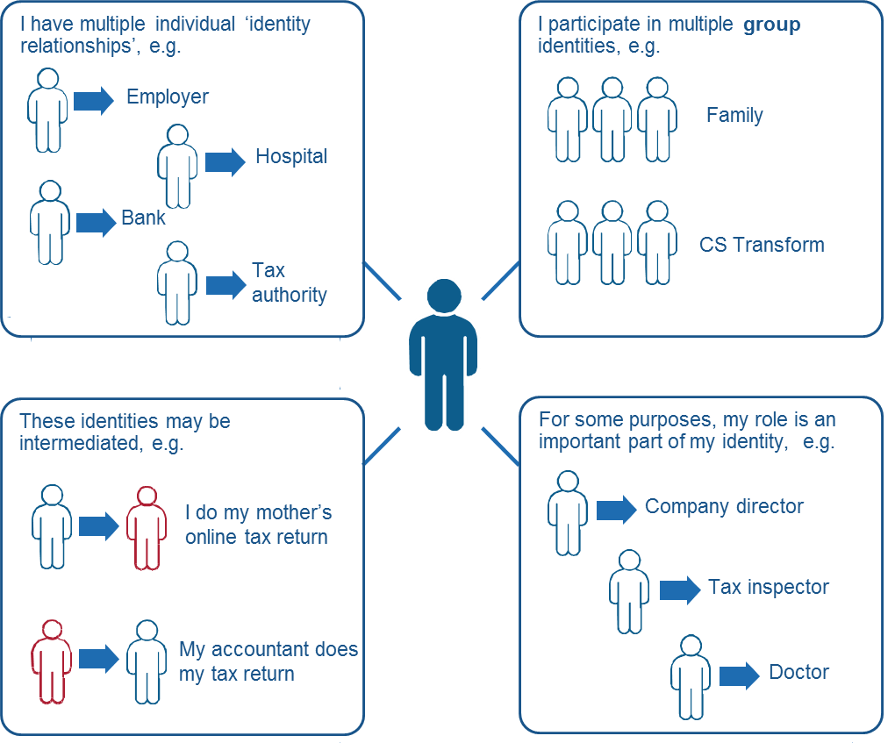
Figure 14: Complexity of identities
These identities often overlap, but in some cases the individual may want to keep them separate in order to protect privacy. At other times, the individual may want them to be joined up, and be frustrated at constantly having to furnish government with the same information over and over again. This reflects an increasing trend for customers to want to take back control of their personal data, and proactively choose when and where to release it.
Governments have often struggled to manage this complexity. Historically each silo-based government service agency defined the identities of its own customers. Even countries which have traditionally had the simplicity of a single citizen identifier (such as Finland, where there has been a single population register since 1634), have tended to build up separate and inconsistent business processes for identity verification. Although the advent of e-Government held out the promise of significant simplification of identity management - bringing service improvement gains for the customer and efficiency savings for the Government - significant barriers remain. Legislative barriers to some agencies releasing data, privacy law inhibiting the use of common identifiers in different domains and the nascent technical responses to surmount these issues, have slowed progress.
A wide range of agencies, standards bodies and advocacy groups are deeply involved in transforming many aspects of this work, from business, legal and social models to develop identity ecosystems to engender trust, security, privacy and a great customer experience (such as promoted by NSTIC ) and interoperable technical and privacy standards for authentication, authorization and privacy management (such as OASIS [SAML, XACML and PMRM]) through to the business, legal and social issues around online identity assurance (such as promoted by [OIX]). These are supported by emerging standards for identity proofing, binding identities to credentials, and pseudonmyising them for privacy protection.
Deployment of identity management at scale is not yet mature, and the approaches and standards that support them are still evolving to reflect changes in customers’ social habits, ubiquity of mobile devices and the move to cloud computing.
It is not the purpose of the Transformational Government Framework to address the details of identity management but rather to give high-level guidance on the main issues that a conformant program should seek to address. Increasingly a set of best practices is emerging around the world which we believe represents a way forward for transformational government, which is broadly applicable across a very wide range of governments. The following key aspects outline some identity-specific focus areas to enable the process of transformation:
Business Architecture
Firstly, a business architecture for identity management which is based on federation between a wide range of trusted organizations (the Government, banks, employers etc), and a clear model for cross-trust between these organizations.
Technical Architecture
Secondly, a technology architecture to support this which does not rely on monolithic and potentially vulnerable large databases, but which, in line with the SOA paradigm, uses Internet-based gateway services to act as a broker between the different databases and IT systems of participants in the federated trust model.
Customer-centric Identity Model
Thirdly - and perhaps most importantly - a customer service model for identity management which places individuals themselves directly in control of their own data, able to manage their own relationship with government – whether on their own behalf as citizens or in another identity relationship or intermediated role – and with clearly visible controls to reassure them that this is the case. This customer-centric approach to identity management is illustrated in the figure below.
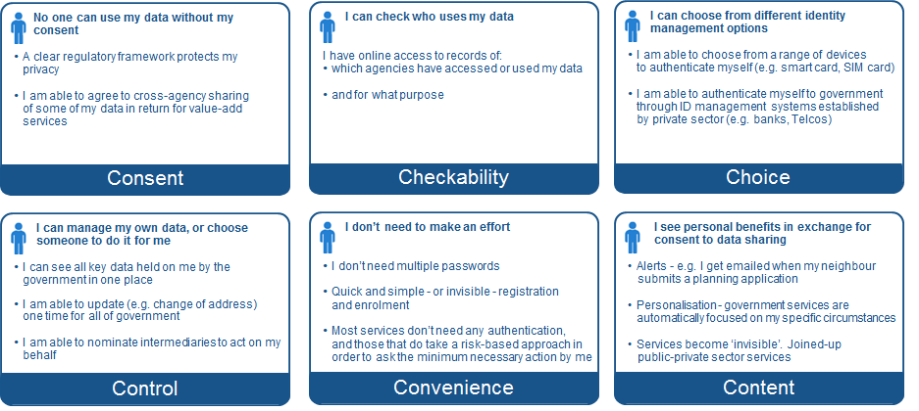
Figure 15: Overview of Customer-Centric Identity Model
No single Government has implemented all features of this approach, but all are being successfully deployed around the world, and together they represent our view of the approach to identity management which will best help deliver Transformational Government.
❖  
The Solution
Establish an Identity and Privacy Management Framework and within this:
- Develop a federated identity trust framework between a wide range of organizations that the customer has existing relationships with and who manage identities on their customers’ behalf (e.g Government, banks, employers, online businesses) with a clear business model for mutual trust amongst all parties for the customers’ benefit and improved online experience;
- Deploy a supporting technology architecture with designed-in security and privacy features (e.g. pseudonymisation and customer consent management) which does not rely on monolithic and potentially vulnerable large databases but which, in line with the SOA paradigm, uses Internet-based gateway services to act as a broker between the different databases and IT systems of participants in the federated trust model;
- Deploy supporting identity management lifecycle processes (e.g. creation, enrolment, verification, credential management, authentication, authorization, suspension, archiving and deletion);
- Put people directly in control of their own data, able to manage their own relationship with government – whether on their own behalf as individual citizens or in another identity relationship or intermediated role – and with clearly visible controls to reassure them that this is the case.
❖  
Linkages
This pattern is important in order to deliver integrated, citizen-centric services as part of a [B3] Error: Reference source not found and the [B4] Error: Reference source not found, as well as to enable the customer-led service innovation envisaged by [S1] Stakeholder Empowerment. At a technology level, the approach is underpinned by the SOA-based [T2] Technology Development and Management. Key actions to be taken to deliver the identity and privacy management framework should be built into the [B10] Roadmap for Transformation.

[S4] Channel Management Framework
Context
Government services are delivered through a wide range of channels. One of the core aims of a Transformational Government program is to ensure that these are managed in the most cost-effective way at a whole-of-government level, and meet the needs of citizen and business customers.
❖  
The Problem
Channel management is often a weak spot in government service delivery, with widespread duplication, inefficiency and lack of user-focus.
Experience has shown the common pitfalls in channel management by governments include:
- Managing new, digital channels as "bolt-ons", with business and technical architectures which are entirely separate from traditional face-to-face or paper-based channels;
- No common view of customer service across multiple channels;
- Operational practices, unit costs and service standards for many channels which fall well below standards set for those channels in the private sector;
- A reliance on government-owned channels, with insufficient understanding of how to partner with private and voluntary sector organizations who have existing trusted channels to government customers;
- Unproductive and costly competition among service delivery channels.
Transformational Government programs seek to avoid these pitfalls, by building a channel management approach centered on the needs and behavior of its citizen and business customers. This means that delivery of services needs to be customer-centric, with services accessible where and when citizens and businesses want to use them, including through both "one-stop" services and a wide range of private and voluntary sector intermediaries. Services should be offered over multiple channels, but with clear policies to shift service users into lower-cost digital channels (including a digital inclusion strategy to enable take-up of digital services by those segments of the customer population currently unable or unwilling to use them).
❖  
The Solution
Establish a Channel Management Framework, which includes:
- a clear audit of what existing channels are currently used to deliver government services, and the costs and service levels associated with these (‘Channel Mapping’); and
- the vision and roadmap for developing a new channel management approach centered on the needs and behavior of citizens and businesses (‘Channel Transformation’).
❖  
Linkages
This pattern helps deliver integrated, customer-centric services as part of a [B3] Transformation Operating Model and the [B4] Franchise Marketplace, as well as to enable the service innovation envisaged by [S1] Stakeholder Empowerment.
It is extended by two further patterns, [S5] Channel Mapping and [S6] Channel Transformation. A high level view of the logical relationships between these components is illustrated below.
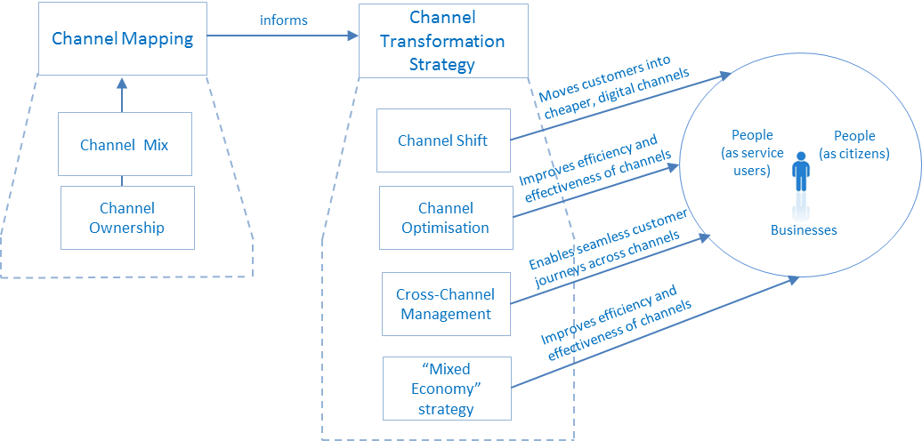
Figure 16: Overview of the Channel Management Framework

[S5] Channel Mapping
Context
A vital first step in developing a [S4] Channel Management Framework is to carry out a mapping of existing delivery channels across government, and to put a cost to each transaction delivered through these channels based on standard industry assumptions.
❖  
The Problem
Government service delivery organizations often do not have a clear and quantified understanding of which channels their customers use, what the average and marginal costs of delivery through these channels is, or how service levels and customer satisfaction vary by channel.
A vital first step in developing a customer-centric channel management strategy is to carry out a mapping of existing delivery channels across government, and to put a cost to each transaction delivered through these channels based on standard industry assumptions.
When government organizations carry out a full channel mapping for the first time, a common finding is that much customer contact between governments and citizens/businesses is:
- unnecessary - because the user is struggling to find the right place to get the service they need, resulting in multiple contacts before their need is finally resolved;
- hidden and un-costed - because only some of these customer contacts are caught by existing management information systems. The rest are just lost within the broader operational structure and budget of the organization.
And when channel mapping is undertaken at the whole-of-government level, it typically highlights significant duplication across government (for example: having multiple high-street locations in the same town serving different government departments or agencies; thousands of contact telephone numbers; hundreds or even thousands of web-sites). There is significant scope for delivering both cost savings and service improvements by joining government services together through channels managed on a shared basis, and through channels managed by private and voluntary sector intermediaries.
A clear map of customer interactions by channel, and the true costs of these, therefore provides essential data in building the business case for service transformation.
In undertaking this mapping it is advisable that a holistic approach is taken to understanding the range of channels through which government services are and could be delivered. Government services can be delivered through a wide range of different channels. It can be helpful to think of that range as varying across two key dimensions, as illustrated below:
- Channel mix: that is, the physical type of channel being used. Traditionally, channels for government service delivery have included the face-to-face channel (through high-street and other locations), traditional mail and the traditional telephone. More recently, interactive voice recognition (IVR) and the Internet have become important channels. A key distinction is the extent to which the channel is based around self-service by the customer, or requires some form of intermediation - either in person (e.g. the customer visiting a government office or an official visiting the citizens in the community) or remotely (e.g. by telephone or email).
- Channel ownership: it is important to understand, too, the variety of "channel ownership" options which are available. Traditionally, channels for government services have been branded as belonging to a specific government agency. Increasingly, governments looking to develop a customer-centric approach have also started to badge these on a government-wide basis: either covering a single channel (such as a national government portal), or multiple channels (such as Service Canada, which spans walk-in offices, contact centres, and the web).
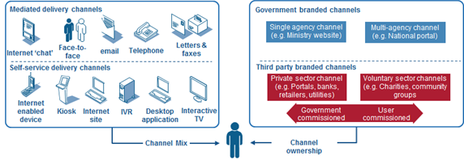
Figure 17: Overview of Channel Mapping
❖  
The Solution
Establish a clear map of customer interactions by channel, and the true costs of these, in order to provide essential data in both building the business case for service transformation, and in highlighting priority areas for reform.
Take a holistic approach to understanding the range of channels through which government services are and could be delivered, including both “Channel Mix” (that is, the physical type of channel being used, including face-to-face, mail, e-mail, Internet and telephone) and also the variety of "Channel Ownership" options that are available (including service delivery through private and voluntary sector channels).
❖  
Linkages
This pattern is needed to inform development of a [S4] Channel Transformation Framework.

[S6] Channel Transformation
Context
The [S4] Channel Management Framework requires a TGF program not only to undertake [S5] Channel Mapping of existing channel usage and channel costs, but also to develop a Channel Transformation strategy that sets out the vision and roadmap for developing a new channel management approach centered around the needs and behavior of citizens and businesses.
❖  
The Problem
Government can learn a lot from the best of private sector approaches to channel management, but also needs to recognize unique challenges and opportunities that apply to channel management in the public sector.
Once a full [S5] Channel Mapping exercise has captured the current channel mix and cost base, it is important to map out a strategy for the future desired channel mix, and the future customer experience over different channels. Successful private-sector businesses tend to be more effective at this than government. They understand that each channel opens up different ways to create value for customers, so they differentiate services across channels. They also take a hard-nosed approach to channel management, with customers being encouraged to use the channels that are most efficient from a business point of view. They also realize that channel shift is a complicated process, which needs planning over a multi-year period.
Transformational Government programs adopt a similar approach, setting out clear strategies for channel transformation. Typically though they recognize two distinct differences between the public and private sector:
- first, government has an obligation to provide services on a universal basis, so is not able to pick and choose which customers it will engage with through different channels. "Directed choice" towards cheaper channels is therefore the strategy selected for most citizen-facing services (although a number of governments are increasingly looking to make Internet-only services the norm for businesses).
- second, in terms of the online channel, government is in a unique position compared with any other online service provider. Whereas an online bank or retailer is limited by the size of the online population in the market, a government can take action significantly to increase that online population. "Digital inclusion" policies, aimed at increasing the proportion of potential customers who have access to and confidence in using online channels, are therefore an important part of government channel strategies which would not normally be seen in their private-sector counterparts.
As well as seeking to shift future service delivery to an optimal channel mix, Transformational Government programs seek to optimize the performance of each individual channel. In the UK for example, a government-wide review of customer contact found that contact centre performance lagged significantly behind private sector benchmarks, and that on average operational savings of 25% could be achieved in public centre contact centres over a 3 year period by adopting best practices. However, it is vital not to think about channel optimization solely on a channel-by-channel basis. There are two imperatives for taking a cross-channel approach to service delivery:
- first, to improve service to customers. Customers do not want simply want services to be available through a choice of channels. Rather they want services to be delivered in an integrated way across channels. Transformational Government programs therefore focus on achieving an integrated view of customer interactions across all channels.
- second, to reduce costs. A shared service approach to channel management can deliver significant efficiency savings. By building channel support services around a common, web-based infrastructure, governments can both reduce costs while also facilitating joined-up services.
Finally, it is essential to recognize that a customer-centric approach involves delivering services where customers want to receive them - and this may often mean that it is important to deliver services through private or voluntary sector intermediaries.
This is particularly important as services become digitized, potentially reducing the marginal costs of delivery to near zero and hence making it easier for third party organizations to bundle public sector services with their own service offerings. This can be challenging for governments, however, since for the first time it means that they are "competing" for customers with other organizations. Establishing clear ground rules for how this sort of mixed economy of service provision should work, on a basis that will encourage private and voluntary sector organizations to become actively involved, is therefore an important task for government in creating the policy framework for Transformational Government and SHOULD be addressed using the [B4] Franchise Marketplace Model.
In addressing these issues, it is important to recognize that government service delivery cannot be divorced from what is happening in the broader market: the expectations of citizens and businesses are shaped by their experiences of other services. Demand for e-services across society will continue to grow while other market players (in the private, voluntary and community sectors) will have a significant influence on the attitudes and behavior of public service customers.
❖  
The Solution
Develop a Channel Transformation Strategy which:
- is centred on the needs and behavior of citizens and businesses;
- identifies the opportunities for current services to be “engineered out” through the introduction of new smart connectivity directly between government assets and digital devices;
- shifts customers where appropriate to lower cost digital channels;
- encourages access and use of digital services by groups currently excluded from these for whatever reasons, by:
  - using the benefits from future universality to fund the costs of ensuring digital inclusion now;
  - ensuring adequate “assisted digital” provision for the digitally excluded;
- taking a proactive approach to the digitally excluded in terms of training, access and education, and the identification of channels to allow their views and voices to be heard and incorporated into decision-making.
- optimizes the cost and performance of each channel, using public and private sector benchmarks to drive improvement;
- improves cross-channel management, by building channel support services around a common, web-based infrastructure in order both to improve customer service and reduce costs;
- facilitates development of a thriving mixed economy delivery of services;
- builds partnerships which enable the market and others to work with the government to deliver jointly-owned objectives.
❖  
Linkages
The Channel Transformation Strategy must be informed by [S5] Channel Mapping, and must address how to shift customers into lower-cost channels while maintaining and reinforcing [S1] Stakeholder Empowerment. The mixed economy of delivery of government services is developed with private and voluntary sector intermediaries and SHOULD be addressed using the [B4] Franchise Marketplace pattern. A significant effort is needed to include all stakeholders in the governance of the Transformational Government program at an appropriate and effective level: see [B3] Stakeholder Collaboration. TFurther detail on the technical and semantic interoperability issues which need to be managed in supporting channel integration are given at [B6] Policy Product Management and [T2] Technology Development and Management. The key milestones and accountabilities for delivery of the Channel Transformation Strategy should be embedded within the [B10] Roadmap for Transformation.

- Technology and Digital Asset Management
This part of the TGF addresses how changes to the way in which technology and digital assets are managed can help to accelerate, de-risk and lower the cost of transformation programmes (and in particular to align service delivery more closely with the [GP1] Guiding Principles, and with the vision described for establishing a [B3] Transformational Operating Model.
There are two core patterns within the TGF Technology and Digital Asset Management Framework:
- [T1]: resources mapping and management;
- [T2]: technology development and management.

[T1] Resources Mapping and Management
Context
All too often, technology resources - and the digital data they incorporate - are seen simply as a means to a specific end; and so are procured and managed by a single organization for a single purpose. As systems become more complex and organizations mature, resource re-use becomes ever more important and prevalent. Establishing a [B3] Transformational Operating Model. involves a set of significant changes to this silo-based approach to managing technology and digital resources.
This need for governments to get a grip on the effective management of their digital assets is being increased dramatically by the growth of the “Internet of Things”. Buildings, roads, places and a huge range of things and devices are becoming smart and internet-connected, multiplying hugely the potential sources of government data (but also the potential for inefficiency, duplication and lack of “citizen-centricity” if that data is not effectively managed).

❖  
The Problem
TGF programs need to establish governance process which enable technology and digital assets to be managed as government-wide resources.
Transformational Government demands a single view of the citizen or business, delivered inside an integrated business and channels architecture. In terms of ICT, all of this requires governments to learn from private-sector best practice. Industry is moving towards a model of company-wide, service-orientated enterprise architecture, where common building blocks using open standards can be re-used to enable flexible and adaptive use of technology to react quickly to changing customer needs and demands. Increasingly, companies are gaining even greater efficiency benefits by managing these building blocks as a service, provided not only from within their own ICT architecture but also from within "the Cloud" - the dynamically-scalable set of private and public computing resources now being offered as a service over the Internet.
Governments are increasingly taking this 'building block' approach to technology development. A key starting point is to map out key assets and establish governance processes that enable them to be managed as an asset separately from their original intended use. In order to be reused effectively, resources need to be:
- identified and managed as distinct, valued assets by explicitly designated owners;
- identifiable across ownership domains;
- associated with clear policies and processes for reuse, particularly across ownership domains.
This entails the explicit identification and management of all resources as valued assets, whether information resources (data sets, documents, models, processes, etc.), or technology ‘soft products’ (systems, applications and services) or other aspects of the overall service ecosystem.

The ability to identify a resource is important in system interactions, in order to determine such things as rights and authorizations, as well as to understand what functions are being performed; what the results mean. Within large-scale, SOA ecosystems, interactions take place across ownership boundaries and the combination of interactions can be unpredictable. Identifiers provide the means for all resources important to a given SOA system to be unambiguously identifiable at any moment and in any interaction.
Establishing resource identity and subsequently managing those resources and their identities thus become an important part of technology management.

❖  
The Solution
TGF programs should therefore map out major information and ICT system resources across the government, prioritize those with the greatest potential for reuse, and establish governance processes and usage policies aimed at maximizing asset reuse. This should involve:
managing information and ICT system resources as distinct, valued assets.
- managing issues related to the Identification, ownership, stewardship and usage policies for each asset type.
- producing a clear model and understanding of the stakeholders, actors and systems that comprise the overall service ecosystem and their relationships to each other.
❖  
Linkages
Moving towards effective government-wide management of technology and digital assets will be an incremental process over time, not a one-off change. This process should be built in as a core element of the [B10] Roadmap for Transformation. Priority in that process should be given to assets that stakeholders identify as critical for:
- opening up high-priority government data assets to wider use as part of [S1] Stakeholder Empowerment;
- providing a government-wide “view of the customer” as part of the multi-channel, service delivery approach required by [B3] Transformational Operating Model and subject to the citizen-centric trust model within [S3] Identity and Privacy Management;
Further detail on the long-term architectural vision that this resource management process should aim to move the government towards is described in [T2] Technology Development and Management.
Section 3.1.3 of the [SOA-RAF] looks at the issue of resources and how they should be identified and managed.

[T2] Technology Development and Management
Context
In order for [T1] Resources Mapping and Management to be effective in aligning government technology and digital assets with the integrated, non-silo based approach set out in [B3] Transformational Operating Model, it is essential to have a top-level vision and architecture for future technology use across the government.

❖  
The Problem
Technological change is more rapid than organizational change and yet governments often find themselves locked-in to particular technology solutions.
Governments need to protect themselves against the downside of technology evolution by developing a strategic approach to IT that guarantees future agility as markets develop and government priorities change.
Transformational Government needs a strategic IT platform to guarantee future agility as business and customer priorities change. Such a platform cannot afford to be locked-in to specific technologies or solutions that prevent or limit such agility.

This means that a TGF program should establish a blueprint for open, government-wide, service-oriented, interoperable IT. Key features of such a blueprint include:
- a commitment to the paradigm and principles of Service Oriented Architecture (SOA) and SOA-based infrastructure, as defined in the OASIS ‘Reference Model for Service-Oriented Architecture [SOA-RM]. Service-Oriented Architecture must be understood in its broadest sense – as a paradigm for organising and using capabilities distributed and managed across different ownership domains. In this sense, SOA is technology and platform agnostic and thus provides an appropriate foundation for the technology management framework.
- modular design, including the realization of discrete services that can perform work on behalf of other parties, underpinned by clear service descriptions and contracts for any capability that is offered for reuse by another party;
- clear ownership and governance for all blueprint elements;
- shared services: managing key ICT building blocks as government-wide resources available as re-usable, shared services - in particular common customer data sets (e.g. name, address); applications and application interfaces (e.g. authentication, payments, notifications); and core ICT infrastructure.
- published standards to enable safe exchange of information between modules (all open, exportable, and based wherever possible on international standards) and which cover: services; data outcomes; rules; KPIs; interoperability.
- a commitment to enable both privacy and openness: all personal data held securely, and under the ownership and control of the individual citizen; all non-personally identifiable public data open for reuse and innovation by third parties;
- tools and resources: standards, metadata, tools, incentives and business models to facilitate transition towards the blueprint architecture by stakeholder organisations.
Such a blueprint is not something that would typically be implemented in a “big bang” or by a single IT supplier, but should:
- provide an agreed architecture on which government organisations and their suppliers can converge over time;
- establish a multi-level competitive landscape at the platform, services and application layers.

❖  
The Solution
TGF programs should therefore work with stakeholders (including government agencies, IT suppliers, SMEs and other delivery partners) to establish and maintain an open, service-oriented, government-wide IT architecture, and to develop a phased migration plan towards that architecture, which:
- concentrates technology resources and efforts around leveraging open standards and SOA Principles so as to ensure development and deployment agility, and support all customer interactions, from face-to-face interactions by frontline staff to online self-service interactions.
- uses the Reference Model for Service-Oriented Architecture [SOA-RM] as the primary source for core concepts and definitions of the SOA paradigm
- realizes discrete services that can perform work on behalf of other parties, with clear service descriptions and contracts for any capability that is offered for use by another party.
- manages key ICT building blocks as government-wide resources and make them available as re-usable, shared services - in particular common customer data sets (e.g. name, address); applications and application interfaces (e.g. authentication, payments, notifications); and core ICT infrastructure.
- wherever possible prefers interoperable, open standards, particularly when these are well supported in the market-place.
- pays due attention to the total cost of ownership and operation of technology and consider the possible value of open source when making technology choices.
❖  
Linkages
Shifting from the current set of legacy IT systems and contractual arrangements to a more integrated, SOA-based approach will be a multi-year process of change. That process should be built in as a core element of the [B10] Roadmap for Transformation and, in particular, to work on [B7] Supplier Partnership (which is essential in order to ensure that new procurements establish requirements and supplier relationships that help build towards the future vision). And the process will need proactive governance, as described in [T1] Resources Mapping and Management.

The [EIF] has a useful definition of “open” in 5.1.1 “Specifications, openness and reuse”.

Benefits Realization
This part of the TGF gives guidance on how to ensure that the intended benefits of a TGF program are clearly articulated, measured, managed, delivered and evaluated in practice. Benefits realization is an integral part of the [CSF1] Critical Success Factors.
Many organizations often fail to pro-actively manage the downstream benefits after an individual ICT project or program has been completed. Often, ICT programs are seen as “completed” once the technical implementation is initially operational. Yet in order to reap the full projected benefits (efficiency savings, customer service improvements etc.), on-going management is essential, often involving significant organizational and cultural changes. The Transformational Government Framework does not seek to specify in detail what benefits and impacts a Transformational Government program should seek to achieve – that is a matter for each individual government - however, the TGF does set out a best practice approach to benefit realization.
This approach is based around the five part framework illustrated below:
- First, the overall Business Case for the TGF program, which needs to be kept refreshed through the life of the program rather than seen simply as a tool to secure initial funding and agreement to proceed. This is supported by the three pillars of…….
- Benefit Mapping: which sets out all the intended outcomes from the transformation program and gives visibility of how the outputs from specific activities and investments in the program flow through to deliver those outcomes;
- Benefit Tracking: which takes this a step further by baselining current performance against the target output and outcomes, defining “smart” success criteria for future performance, and tracking progress against planned delivery trajectories aimed at achieving these success criteria; and
- Benefit Delivery: which ensures that governance arrangements are in place to ensure that benefits are delivered in practice, including after the initial transformation program is implemented.
- Finally, the whole framework is supported by a process of Benefits Reviews. Reviews will be required at various points, and consideration should be given to some of them being done independently of the TGF program team.
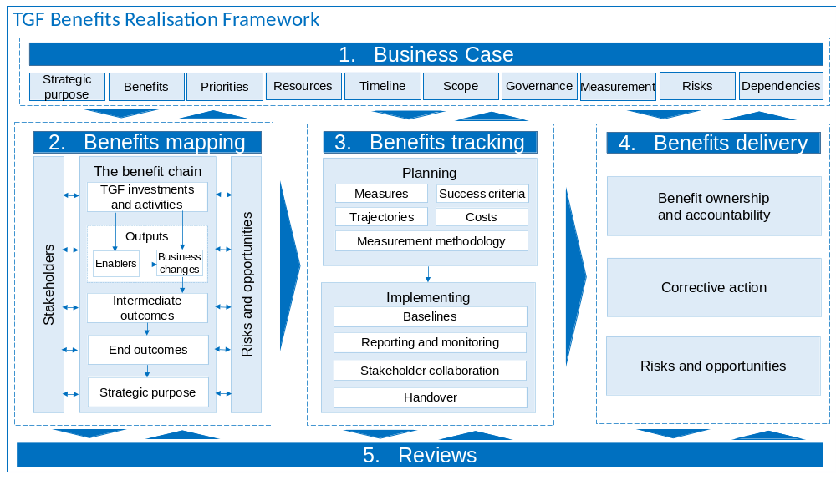
Figure 18: Overview of TGF Benefits Realization Framework
The TGF Core Patterns for each of these elements are set out below. In operation, there will be feedback between each of these elements, and for large programs, some or all of these steps may also be applied to individual sub-programs or projects.

[BR1] Business Case
Context
A vital first step in developing a Benefits Realization Framework is to produce the Business Case for the overall TGF Program.
❖  
The Problem
If a Business Case is seen simply as a tool to secure initial funding and agreement to proceed, then the program may not be designed to capture everything it needs to achieve the objectives, and may contain work that is not necessary. Furthermore, if it is not reviewed as the program progresses, then there is a chance either that the program will drift from the original intentions, or that the Business Case itself becomes out of date and loses relevance.
Early on in the development of a TGF program it is vital to document a business case which outlines the objectives of the program, gives the strategic context, sets out the benefits to be realized and how delivery of these benefits will be measured, along with the costs of achieving them and the risks associated with delivery.
The TGF Business Case must be captured in a single document, which provides both guidance and authority for subsequent Benefits Realization Management activity. It must be approved at the highest governance level of the program.
The content should address:
- Strategic purpose: the vision and strategic aims of the program, and how it will help deliver any broader strategic objectives of the government.
- Benefits to be realized: the benefits that the program will deliver, who will be responsible for them, when they will occur and how they will be measured. This should cover both tangible benefits (financial and non-financial) and intangible ones.
- Priorities: this is vital for any TGF program. As the program starts to be delivered, not all anticipated benefits may prove to be deliverable within time and budget. It is therefore essential to understand relative priorities from the outset in order to manage any trade-offs that may be needed.
- Resources required to deliver the benefits: the business case should articulate the resources needed to deliver the program, across all key organizations involved.
- Deliverables and timeline: normally, the business case will also include a high-level summary of the delivery plan set out in more detail in [BM8] Roadmap for Transformation.
- Scope: the areas to which the document applies, in particular if there are any relevant parts of government activity where it does not, or a different strategy applies.
- Governance: the business case should set out functions, roles and accountabilities – both for delivery of specific benefits as the program moves forward (example: Benefits Ownership) and also for measurement of benefits. Also, the role of any existing organizational units responsible for performance measurement should be clarified.
- Methods and processes for measurement: the approach to measurement has significant implications for resourcing and costs. The business case should set out the high-level approach to this, and specify where there are particular requirements. For example, if the views of end users are going to be one source of measurement, there are a range of methods and techniques to gather and analyse this; the business case should indicate the level of importance to be attached to this.
- Risks and Mitigation: the business case should set out the key risks and proposed mitigation strategies associated with the program. Where any significant assumptions have been made in developing other aspects of the business case, these should be highlighted as risks and managed as such through the program until the business case can be refreshed with definitive data.
- Dependencies and relationship to other initiatives: a TGF program is unlikely to proceed in isolation. It will interact with other programs across government and within partner organizations, at infrastructure, business and policy levels. Dependencies between these programs at the benefits level need to be captured here; most particularly, if the TGF program and another one are feeding into the same overall cost saving target, it must be clear what each program is contributing. As a TGF program may have an extended duration, other initiatives will come and go, so this area will need to be reviewed and updated as the program progresses.
- Terminology and method: if an organisation already has a standard for Benefits Realization Management, it may be sufficient to refer to that. If not, then the strategy must make clear the approach to be used and the meaning of any BRM-specific term. Bear in mind that as a TGF program will cross organisational boundaries, other partners may not be familiar with the selected standard; they may also have different levels of maturity with respect to Benefits Realization Management.
The business case should be maintained as a living document through the course of the program, which is refreshed with new data as assumptions are validated and which is used as a management tool to ensure all program activity remains firmly fixed on delivering the strategic purpose of the program. An initial business case will contain early estimates of the outputs from planning of the other benefits realization steps – benefits mapping, benefits tracking and benefits delivery – but should then be iteratively improved as delivery of each of these steps moves forward.
❖  
The Solution
Produce a Business Case that demonstrates clear links to approved strategic objectives, and clearly identifies and quantifies the impacts and outcomes that implementation of the TGF aims to achieve.
Capture the Business Case in a document approved at the top level of program governance.
Use the Business Case as a major input to the Program Design.
Review the Program against the Business Case at key points and update the Business Case if necessary.

In addition it is advisable to:
Ensure that the Business Case shows a clear line-of-sight between every investment and activity in the program, the immediate outputs these produce, and the final targeted outcomes.
Ensure that the business changes required are identified in the Business Case and given appropriate emphasis and resource.
❖  
Linkages
Work to develop the Business Case should form an integral part of the initial planning phase of the [B10] Roadmap for Transformation, and should be developed through [B5] Stakeholder Collaboration. Benefits realization is an integral part of the [CSF1] Critical Success Factors, and review of progress against the business case should therefore be part of the checkpoint process recommended in [CSF1] Critical Success Factors. From the outset, the Business Case should contain high level summaries of the approach envisaged to, [B2] Benefits Mapping, [B3] Benefits Tracking, and [B4] Benefits Delivery. As work on delivery of those patterns gets underway through the roadmap implementation process, any significant changes to initial analysis and assumptions should be fed back into a revised version of the Business Case.

[BR2] Benefits Mapping
Context
An important step in developing a Benefits Realization Framework is to produce a map of the benefits that need to be delivered as part of the overall TGF Program.
❖  
The Problem
In complex programs, it is important to understand the logic of how the outputs lead to Intermediate Outcomes and finally on to the achievement of the Final Outcomes and Objectives. In this way, it is clear whether all areas are covered and that all activities support the required Outcomes. If this is not done, it is difficult to verify the program design and also to make “solution engineering” decisions, if trade-offs are required.
It is not sufficient simply to list the intended benefits of a TGF program. Rather, it is vital to map out the different types of benefit in graphical form, to ensure clarification and convergence of perception of the aims of the program and the contributions of its components. Specifically, three key elements need to be mapped:
- The benefit chain: there are multiple approaches to developing benefit maps. However, they all have broadly similar approaches, and contain similar elements:
  - The TGF program will be undertaken to achieve a Strategic Purpose, as set out in the Business Case, and the aim of the benefit chain is to give clear line of sight between all program activities and investments and the ultimate delivery of that Strategic Purpose.
  - Feeding into delivery of the Strategic Purpose will be a set of End Outcomes for the program, which will usually be driven by Intermediate Outcomes. The Objectives and Outcomes represent the “results” end of the map – the benefits part of the business case.
  - The map should then be extended to capture those activities which contribute to the achievement of that purpose. In general these fall into two types, Enablers and Business Changes. Enablers tend to be artefacts or systems of some kind – buildings, IT systems, equipment, etc. Business Changes are such things as changes to processes, policies, organisational structure, and even behaviours and values. Enablers on their own – which are not then followed up by any Business Change – cannot deliver benefits, so it is vital that these changes are effectively understood and mapped. Many projects with significant IT content suffer from a focus on delivering enablers at the expense of outcomes, and so a key purpose of the TGF Benefits Realization Framework is to ensure that the required business changes are identified and given appropriate emphasis.
It is important that this benefit chain is underpinned by a clear and evidence-based theory of change, giving confidence that there is a genuine cause and effect flow from activities to outputs to outcomes. In some TGF programs, which are aiming to impact at a strategic socio-economic level, it will not always be possible or cost-effective to prove full causality at all points in the chain, but it is nevertheless important to demonstrate a credible case for impact.
- Stakeholders: mapping the relationship between stakeholders and Outcomes (End Outcomes in particular) is extremely important. It informs the understanding for all parties of the case for their involvement in the program, provides significant guidance in determining benefit ownership, and guides communication planning. Understanding the relationship between stakeholders and Enablers and Business Changes can be of considerable use in programme planning and communication.
- Risks and opportunities: it is important once you have identified the End Outcomes that the program starts to consider the risks and opportunities associated with them. Risk management often focuses on delivery risk; while this is an important area, what really matter are risks (or opportunities) as they relate to the benefits being sought.
The development of the maps must involve close collaboration with the appropriate stakeholders. The objectives and benefits should be developed with senior management and the enablers and changes with operational management, SMEs and those developing/providing the enablers. As well as contributing to the efficacy of the maps, this will also encourage contributors to buy in to the output.
❖  
The Solution
Produce a map of benefits which sets out all the intended outcomes from the transformation program and gives visibility of how the outputs from specific activities and investments in the program flow through to deliver those outcomes.
❖  
Linkages
This pattern is needed to ensure that the high level objectives for the TGF program as set out in the [BR1] Business Case are underpinned by clarity about how program activities will deliver outputs and outcomes that achieve those targeted objectives. It will set out the detailed measures and performance indicators needed to track progress against all stages of this benefit chain through the process of [BR3] Benefits Tracking.

[BR3] Benefits Tracking
Context
An important step in managing a Benefits Realization Framework is to track the realization of benefits that need to be delivered as part of the overall TGF Program.
❖  
The Problem
There is often a lack of adequate tracking of benefits within business transformation programs. Benefit Tracking should baseline current performance against the target output and outcomes, define “smart” success criteria for future performance, and track progress against planned delivery trajectories aimed at achieving these success criteria.
Benefits tracking involves planning and delivering the measurement systems needed to track progress against the business case.
Key elements to be addressed when planning for Benefits Tracking are:
- Measures: measures to underpin the End and Intermediate Outcomes must be identified. Generally, all End Outcomes should have at least one associated measure, and some Intermediate Outcomes may also be worth measuring, for example to provide leading indicators that indicate whether the benefits realization is developing as expected.
- Success criteria: the scale and pace of change which the program is expected to be deliver should be identified for each measure. That is, clarity is needed not just about what will be measured, but what sort of change in performance against that measure is positive and what level of change will be regarded as a successful outcome.
- Trajectories: for all of the measures put in place, it is essential that the timing and profile of the expected realization is defined, so that stakeholders know when to expect to see the benefits. Improvements will usually only start to happen after the implementation of relevant Enablers and Changes, and may experience an initial “dip” before recovering and heading in the intended direction. Some will experience steady progression, some will move in steps. All of this information needs to be available so that stakeholders know what to expect, and to support reporting and monitoring.
- Costs: it is important to note that measurement is never free; even if the source data is already being produced, the analysis and interpretation will still take someone’s time and effort. The following principles should be borne in mind:
  - The cost of measurement needs to be included in the costs of the program. If measurement is expected to continue as part of the new service, cost and resources should be included in the budget for the service.
  - Use existing data sources where available – do not re-invent the wheel.
  - Existing KPI’s may be appropriate, either as they are or with minor adjustments, again minimising cost.
  - If the organisation has a group responsible for monitoring organisational performance, their involvement needs to be defined and agreed; it is likely that this group will take over some or all of the responsibility for on-going measurement when the program closes.
  - Distinguish between those measures that need to continue after the program, and those that are specific to the program; stop measuring the latter as soon as the purpose has been achieved.
- Measurement methodology: in some instances, this may be relatively straightforward, but in other cases will require some thought. For example, cashable financial benefits should be relatively straightforward to track, but assessing changes in sentiment in a stakeholder or user group may require the use of proxy measures.
Key elements to be addressed when implementing Benefits Tracking are:
- Baselines: to be able to measure the progress, it is first essential to establish what the pre-change baseline is. If this is not currently known, it needs to be established as soon as possible.
- Reporting and monitoring: on the measures themselves, but also the impact of any schedule slips with respect to enablers and changes on the schedule for the benefits.
- Stakeholders: the interaction and communication with stakeholders with respect to benefits realization must be addressed. It must also be coordinated with other TGF program communication to avoid overloading stakeholders or risking confusion.
- Handover: monitoring and reporting on benefits may need to continue after the program organisation is closed down. In this case, it should be clear where this will be done, and at what point the handover will be made.
❖  
The Solution
Set measurable success criteria and track the progress towards these criteria.

In addition it is advisable to:
Track progress against planned delivery trajectories for each of the targeted outputs and outcomes.
❖  
Linkages
Benefits Tracking implements a pragmatic approach to measuring in practice delivery of the TGF benefits outlined at a strategic level in the [BR1] Business Case and at more detailed level in [BR2] Benefits Mapping. The information gathered through Benefits Tracking is essential to inform effective in [BR4] Benefits Delivery.

[BR4] Benefits Delivery
Context
An important step in managing a Benefits Realization Framework is to ensure the benefits that need to be delivered as part of the overall TGF Program are delivered.
❖  
The Problem
Change programs, especially long term ones, can suffer from a lack of focus on the intended outcomes once the implementation starts. There is also the risk that this focus will be lost once the program structure starts to be dismantled, which often occurs before full realization of the benefits is scheduled to be achieved.
While [BR4] Benefits Tracking activity may often be managed at a program level, perhaps through a program management office, Benefits Delivery needs to be a core responsibility of business leaders within the government organizations impacted by the TGF Program. Key elements include:
- Benefit ownership: for each intermediate and end outcome identified in the benefit maps, a senior and empowered manager should be accountable for championing the delivery of that outcome – even where that individual does not have personal responsibility for delivering all the elements of the [B10] Roadmap for Transformation.
- Corrective action: if a threat to an Outcome is identified, alternative responses and associated costs should be evaluated so that program governance can decide on the appropriate action.
- Risks and opportunities: although this information was initially captured during [BR2] Benefit Mapping, this information should be regularly reviewed and updated. New risks and opportunities may emerge along the way.
❖  
The Solution
Establish clear accountability and governance structures to manage benefit delivery during and after the life of the program.
❖  
Linkages
Ensuring that these Benefit Delivery accountabilities and processes are established and effectively managed is a core responsibility of [B2] Program Leadership.

[BR5] Benefits Reviews
Context
An important step in managing a Benefits Realization Framework is to undertake regular reviews at various points in the TGF program.
❖  
The Problem
The whole Benefits Realization Framework needs to be supported by a process of Review. Reviews are necessary to ensure that plans are well thought-through, to address issues as realization progresses, and to assess the final position.
Benefit realization is identified as one of the [CSF1] Critical Success Factors for the TGF, and therefore needs to be subject to regular review. In particular, the following review steps are important:
- Capture previous lessons: this can be from any relevant program – other TGF programs, or similar programs within the contributing organisations.
- Plan review: once the Benefits Realization Plan is available, this must be reviewed critically. This is the point to look for problems caused by optimism/overconfidence bias or the shared assumptions of “groupthink”. For example, are the targets really achievable? Are the Enablers and Changes sufficient to produce the Outcomes?
- Progress reviews: Outcomes should be reviewed at appropriate points during the program. The reviews should take place at meaningful points where substantial new information about progress is available – for example, the first measures on a leading indicator where a difference is expected. This should include a review of risks and opportunities - the status of those already identified, and whether any new ones have emerged. These points may or may not coincide with other general program review points, which should include a general review of benefits material along with other program information.
- Closure review: it is important that the closure review includes an assessment of the effectiveness of the benefits realization approach, as well as an assessment of performance against benefits targets. (Note: this review is likely to take place around the time of program closure; it is likely that some benefits realization is still in progress, so any assessment must account for this.)
- Independent reviews: a TGF program should consider whether it is appropriate to use independent reviews at all points. This has particular value at start-up.
❖  
The Solution
Hold reviews at appropriate points in the TGF program plan.

In addition it is advisable to:
Consider using reviewers independent of the program team.
❖  
Linkages
This pattern is needed as part of the overall management of the Benefits Realization Framework.

Critical Success Factors
There is one TGF Core Pattern on Critical Success Factors. This is set out below.

[CSF1] Critical Success Factors
Context
In delivering a [B10] Roadmap for Transformation, TGF programs should ensure that they are managing the major strategic risks effectively. Typically, these risks are not related to the technology itself – which is largely mature and proven – but rather to business and cultural changes. Such changes are integral to the the business management, service management and technology management transformations required as part of a Transformational Government program.

❖  
The Problem
Programs and projects which seek to deliver Transformational Government face significant risks to successful delivery. Clarity and insight into the consequences of transformation are needed.
It is unrealistic to expect to get everything right first time and moving forward will be a process of continuous improvement. Systems are needed which allow the government organization to understand the current position, to plan, to move quickly, and to learn from experience.
A conformant program needs to keep track of a core set of critical success factors throughout the lifetime of the program.
There is now an increasing body of research which seeks to understand why some ICT-enabled transformation programs succeed and why others fail. The TGF therefore recommends the following nine Critical Success Factors that reflect and respond to the findings of such research, validated with OASIS members around the world. More detail on each of these CSFs is contained in a checklist at Appendix C. These Critical Success Factors need to be taken on board by any government seeking to develop and deliver an effective Transformational Government program.
- Strategic Clarity

- Leadership

- User focus

- Stakeholder engagement

- Skills

- Supplier Partnership

- Future-proofing

- Achievable Delivery

- Benefits Realization

❖  
The Solution
Develop then manage and measure a clearly defined set of Critical Success Factors.
Seek regular, independent review of performance against those critical success factors.
Have mechanisms in place to assess risk and handle monitoring, recovery and roll-back.
❖  
Linkages
Monitoring of progress against the critical success factors is a core task for [B2] Program Leadership. Regular external healthchecks of the programme against the critical success factors should be built in to the [B10] Transformation Roadmap.

Conformance
The following statements indicate whether, and if so to what extent, each of the above patterns is to be used in a conformant transformational government program.

All conformant Transformational Government programs:
- MUST collaborate with stakeholders to develop and agree a set of Guiding Principles for that program that cover, as a minimum, the core TGF [GP1] Guiding Principles.
- MUST produce a Vision for the TGF program that:
- is developed in an iterative and collaborative manner;
- embraces the opportunities opened up by new technologies and delivery channels, open data and effective collaboration;
- does so in a way which integrates these with the core socio-economic, political and environmental vision for the future, rather than seeing them as somehow separate from the government’s core strategic objectives;
- is measurable.
- MUST have Program Leadership that ensures:
- clear accountability at both the political and administrative levels for the program as a whole;
- engagement of a broad-based leadership team across the wider government;
- effective governance arrangements at both the strategic and delivery levels;
- deployment of formal program management disciplines, and prioritization of activities and program changes, based on performance and feedback criteria;
- a clearly identified mix of leadership skills;
- an ability to manage organizational evolution among partner organizations, and to deliver continuity through political changes;
- openness and transparency in the governance process, including through digitally-enabled models of wider civic participation.
- MUST have a Transformational Operating Model which is built around citizen and business needs, not just government’s organizational structure. This MUST include:
- providing citizens and businesses with services which are accessible in one stop and ideally offered over multiple channels;
- enabling those services also to be delivered by private and voluntary sector intermediaries;
- an integrated business and information architecture which enables a whole-of-government view of the customer;
- incentives and business processes that encourage the internal cultural change and cross-silo collaboration needed to drive the integration and joining-up of services;
- a cross-government strategy for shared development, management and re-use of common customer data sets, applications, and applications interfaces (e.g. authentication, payments, and notifications).
- SHOULD consider the [B4] Franchise Marketplace as the recommended approach to implementing the Transformational Operating Model;
- MUST demonstrate Stakeholder Collaboration by establishing, and giving high priority and adequate resources to a formal managed stakeholder engagement program which is led by a senior executive and integrated into the roles of all involved in delivering the TGF program, and that SHOULD:
- identify and map the relationships between all key stakeholders in the program, then maintain and update this stakeholder model on a regular basis;
- establish a clear set of structures, processes and incentives through which the Program Leadership and the different stakeholders will interact;
- ensure that all stakeholders have a clear understanding of the TGF program, how they can engage with it, and how they will benefit from it;
- engage effectively with stakeholders from the private, public and voluntary sectors to deliver the program in a way that benefits all sectors;
- engage with other transformation programs to learn lessons and exchange experiences.
- MUST create a Policy Product Map (using the matrix as a tool to help identify the Policy Products required) within the relevant government as outlined in [B6] Policy Product Management, and MUST establish policies and actions to address gaps identified through this mapping, which SHOULD draw on international, European and national standards where possible.
- MUST establish a Supplier Partnership Framework which:
- takes an integrated view of the program’s procurement requirements;
- ensures that procurement policies are aligned with the TGF (focusing on procuring business outcomes, building open data into all procurements, incentivizing innovation and collaboration, avoiding supplier lock-in);
- works to nurture an innovation ecosystem across the government, including through:
    - publication of its procurement policies, and publication and updating a pipeline of major government procurement opportunities;
    - early and iterative engagement with potential suppliers, including SMEs;
    - stimulating SME-led innovation, including through use of competitions and placing SME-engagement requirements on large suppliers;
    - driving forward the internal cultural and behavioural changes entailed by these changes.

- MUST address Skills issues by: mapping out the required skills for the program; establishing a clear strategy for acquiring them and a continuity plan for maintaining them; ensuring skills integration and skills transfer across the internal and external elements of the delivery team; and SHOULD consider using a formal competency framework to inform this work.

- MUST agree and use a Common Terminology, and SHOULD consider using the TGF recommended terminology at [B9] Common Terminology and Reference Model to inform this.
- MUST have a Roadmap for Transformation.
- MUST have a Stakeholder Empowerment framework, which:
- encourages and enables service innovation in the Citizen-to-Citizen, Business-to-Citizen, Citizen-to-Government, and Business-to-Government sectors;
- opens up public data via open platforms;
- drives forward the internal culture changes and the external market enablers which are needed to create a flourishing marketplace in public sector information.
- MUST have a Brand-led Service Delivery Strategy, which is agreed and managed at a whole-of-government level and which addresses:
- Customer Insight
- Product Management
- Marketing and communication;

- MUST have an Identity and Privacy Management Framework, which:
- uses a federated identity trust framework comprising approved identity, credential and attribute service providers;
- uses a service-oriented architecture (as part of the wider SOA described in the TGF Technology Management Framework) which evidences features that support designed-in security and privacy with customer control over the management and release of personal data;
- evidences information management and graphical design features that deliver a seamless and uplifting online experience for customers.
- MUST have a Channel Management Framework which includes:
- a clear audit of what existing channels are currently used to deliver government services, and the costs and service levels associated with these (‘Channel Mapping’); and a Channel Transformation Strategy, which;
  - is centred on the needs and behavior of citizens and businesses;
  - identifies the opportunities for current services to be “engineered out” through the introduction of new smart connectivity directly between government assets and digital devices;
  - shifts customers where appropriate to lower cost digital channels;
  - encourages access and use of digital services by groups currently excluded from these;
  - optimizes the cost and performance of each channel, using public and private sector benchmarks to drive improvement;
  - improves cross-channel management, by building channel support services around a common, web-based infrastructure in order both to improve customer service and reduce costs
  - facilitates development of a thriving mixed economy delivery of services;
  - builds partnerships which enable the market and others to work with the government to deliver jointly-owned objectives.
16. MUST undertake Resources Mapping and Management, by mapping out major information and ICT system resources across the government, prioritizing those with the greatest potential for reuse, and establish governance processes and usage policies aimed at maximizing asset reuse.

- MUST address Technology Development and Management by working with stakeholders to establish and maintain an open, service-oriented, government-wide IT architecture, and to develop a phased migration plan towards that architecture, which:
- concentrates technology resources and efforts around leveraging open standards and SOA Principles so as to ensure development and deployment agility, and support all customer interactions, from face-to-face interactions by frontline staff to online self-service interactions;
- uses the Reference Model for Service-Oriented Architecture [SOA-RM] as the primary source for core concepts and definitions of the SOA paradigm;
- realizes discrete services that can perform work on behalf of other parties, with clear service descriptions and contracts for any capability that is offered for use by another party;
- wherever possible prefers interoperable, open standards, particularly when these are well supported in the market-place;
- pays due attention to the total cost of ownership and operation of technology and considers the possible value of open source when making technology choices.
- MUST have a Business Case that:
- is approved at the top level of program governance;
- clearly identifies and quantifies the impacts and outcomes that implementation of the TGF aims to achieve, and demonstrate clear links from these to appropriate strategic objectives;
- ensures clear line-of-sight between every investment and activity in the program, the immediate outputs these produce, and the final targeted outcomes;
- is kept under regular review and updated as necessary.
- MUST address Benefits Mapping by underpinning the initial business case with a more detailed map of benefits which sets out all the intended outcomes from the transformation program and gives visibility of how the outputs from specific activities and investments in the program flow through to deliver those outcomes.
- MUST undertake Benefits Tracking, including through:
  - establishment of clear and quantified baselines for current performance of target outputs and outcomes;
  - setting measurable success criteria;
  - tracking progress against planned delivery trajectories for each of the targeted outputs and outcomes.

- MUST manage Benefits Delivery, establishing clear accountability and governance structures to manage benefit delivery during and after the life of the program.

- MUST undertake regular Benefits Reviews.
- MUST measure and manage Critical Success Factors and SHOULD consider using as a minimum the [CSF1] Critical Success Factors.

- Acknowledgments
The following individuals have participated in the creation of this specification and are gratefully acknowledged:
Participants:
Oliver Bell, Microsoft Corporation
John Borras, Individual Member
Peter F Brown, Individual Member
Nig Greenaway, Fujitsu Ltd
Jenny Huang, iFOSS Foundation
Gershon Janssen, Individual Member
Arnaud Martens, Belgian SPF Finances
Chris Parker, CS Transform Ltd
John Ross, Individual Member
Colin Wallis, New Zealand Government
Joe Wheeler, MTG Management Consultants, LLC
Mark Woodward, Individual Member
- Enabling the Franchise Marketplace Model
A number of relationships need to be managed by a franchise to enable it to develop, maintain and deliver transformational customer-centric one-stop services. These represent different viewpoints that can be broadly classified as:
Customers: Those citizens and businesses to whom the franchise delivers content and services, plus those internal stakeholders to whom the franchise provides a service within the government.
Partners: Those who are actors in the normal operation and delivery of the service, both internally and externally to the government.
Influencers: those who have a political, business or altruistic interest in the service and the part that it plays in broader government, business and social scenarios.
Internal Customers: Those who work with the franchise to develop and maintain the service.
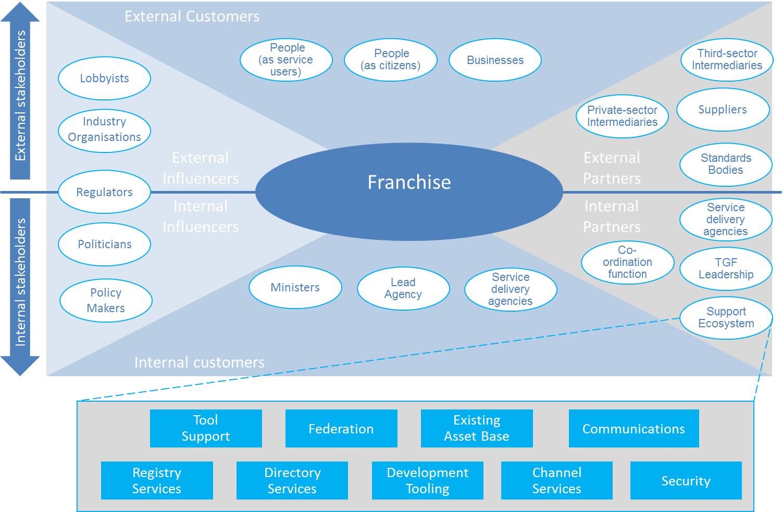
Figure 19: Relationships in the Franchise Marketplace
The Franchise
The franchise is based around a customer segment. It may contain bodies drawn from central, regional, and state government and others that contribute to serving that segment.
It MUST have a lead organization that ensures its interests are represented to other franchises and bodies. It MUST also have sponsoring organizations that with a responsibility for the full range of service perspectives across the segment.
The franchise is responsible for ensuring that all relationships with external bodies are managed and for the provision of supporting assets necessary to allow organizations within the franchise and working with it to discharge their responsibilities in an open, consultative and transparent manner.
Despite the importance of the franchise concept, it is not intended to add unnecessary bureaucracy – rather, it is intended to provide a lightweight framework within which participants can work naturally and cooperatively.
Customers
Customers are the most important actors in operational services as the services MUST address their needs and those of the people that they represent.
Thus, as well as being users, it is essential that they are consulted during the proposal stage for all services. Once operational, this group SHOULD to be involved in customer satisfaction exercises and the development of any service enhancements to ensure that their needs continue to be met.
It is vital that Franchises identify their internal government customers and apply similar customer research and customer satisfaction measurement to these internal customer relationships as well as to external ones.
Partners
Many partners will be involved in helping the Franchise effectively to deliver the requirements of its customer segment. The partnership may involve:
- working with the franchise to develop and maintain the service;
- providing the supporting assets which give a technical underpinning for this and other services.
The supporting assets provide the technical underpinning for project delivery. Where they are publically owned, it is intended that they will provide light-touch governance and facilities (primarily technical) to support franchises and inter-working between them and with standards bodies.
It is essential that they ensure the provision and availability of assets that are universal (i.e. fundamental items that are required by all public sector organizations) or common (i.e. assets used across multiple franchises).
Tooling SHOULD to be provided with the aim of supporting all stakeholders and facilitating their collaboration.
Influencers
The influencers are those who identify, and possibly mandate, the need for a service. Accordingly, it is vital that they are able to steer developments within and across franchises. They also have a responsibility to ensure that all stakeholders are aligned and are organizationally capable of discharging their responsibilities.

Appendix C Checklist of Critical Success Factors
This annex provides a checklist giving more detail on the nine critical success factors referred to in the [CSF1] Critical Success Factors.
1) Strategic clarity
- Clear vision  - Our vision has been developed collaboratively.  - All stakeholders have a clear and common understanding of what our programme is seeking to achieve.  - This vision is underpinned by guiding principles on how we work together to deliver the vision in practice. | ✓  ✓  ✓
- Strong business case  - We know what outcomes we want to achieve, and have established clear, evidence-based measures of success.  - There is a clear and quantified baseline of the costs and performance of current service delivery systems across the government, against which we can compare the impact of the programme. | ✓  ✓
- Focus on results  - We focus on taking concrete, practical steps in the short to medium term.  - The programme is delivering significant benefits to stakeholders (including citizens and businesses) now.  - We are not spending money on technology before having identified the key organizational and business changes needed for it to help deliver our vision. | ✓  ✓  ✓
2) Leadership
- Sustained support  - Political leaders and senior management are committed to the programme for the long term. | ✓
- Leadership skills  - Our leadership team has the skills needed to drive ICT-enabled business transformation.  - Our leadership team has access to external support, including engagement with leaders of other transformational government initiatives | ✓  ✓
- Collaborative governance  - Leaders from all parts of our and other organizations involved in the programme are motivated for it to succeed, and are engaged in clear and collaborative governance mechanisms to manage key risks and issues.  - There is unambiguous accountability as to which partner has the lead role on each aspect of roadmap delivery. | ✓  ✓
3) User focus
- A holistic view of the city’s citizen and business customers  - We have a whole-of-government view of the customers for our services, and understand their needs on a segmented basis.  - Customer insight is informed by both on research and analysis of customer data.  - Customer insight is pooled at a government-wide level, not managed within individual silos. | ✓  ✓  ✓
- Customer-centric delivery  - Citizens and businesses can access all our services through a one-stop-service.  - This is available over multiple channels, but we use common web-based services to join it all up, provide a single view of the customer and reduce infrastructure duplication.  - We are proactively working to encourage take up of services through digital channels, and to help those who are currently digitally excluded to benefit from these services. | ✓  ✓  ✓
- Stakeholder empowerment  - We engage customers directly in service design and delivery.  - We provide all stakeholders with access to public data and support to use it to create new commercial and public value. | ✓  ✓
4) Stakeholder engagement
- Stakeholder participation  - All our stakeholders (users, suppliers, delivery partners elsewhere in the public, private and voluntary sector, politicians, the media, etc.) have a clear understanding of our programme, how they can engage with it and how they will benefit from it. | ✓
- Cross-sectoral partnership  - The programme is engaging effectively with stakeholders in the public, private and voluntary sectors.  - The programme is delivering clear benefits for all stakeholder groups. | ✓  ✓
- Engagement with other transformation programs  - Our programme is engaging systematically with other transformation programs to learn lessons and exchange experience. | ✓
5) Skills
- Skills mapping  - We have mapped out the skills we need to deliver the programme, and have established clear plans for acquiring and maintaining them. | ✓
- Skills integration  - We have effective mechanisms in place to maximize value from all the skills available across the partners involved in delivery of the transformation roadmap. | ✓
6) Supplier partnership
- Smart supplier selection  - Our procurement and contracting policies are aligned with smart procurement principles (focus on outcomes, open data, incentives for innovation and collaboration, avoidance of lock-in).  - We select suppliers based on long-term value for money rather than price, and in particular based on our degree of confidence that the chosen suppliers will secure delivery of the expected business benefits. | ✓  ✓
- Supplier integration  - We manage the relationship with strategic suppliers at the level of top management on both sides of the partnership, aiming to develop win-win alignment behind our vision and roadmap for transformation. | ✓
7) Future-proofing
- Interoperability  - Wherever possible we use interoperable, open standards that are well supported in the market-place. | ✓
- Web-centric delivery  - We use SOA principles in order to support all of our customer interactions, from face-to-face interactions by frontline staff to online self-service interactions. | ✓
- Agility and resilience  - We deploy technology using common building blocks that can be reused to enable flexibility, resilience and adaptiveness. | ✓
- Shared services  - We manage key building blocks as government-wide resources - in particular common customer data sets (e.g. name, address); common applications and application interfaces (e.g. authentication, payments, notifications); and core ICT infrastructure. | ✓
- Support and maintenance  - We have support and maintenance arrangements in place that can take over responsibility for assets developed and/or managed by stakeholders who leave the smart city’s ecosystem for whatever reason.  - We have a process in place that can engage with replacement stakeholders when existing stakeholders deemed to provide value leave the smart city’s ecosystem or become disengaged. | ✓  ✓
8) Achievable delivery
- Phased implementation  - We avoid a "big bang" approach to implementation, reliant on significant levels of simultaneous technological and organizational change. | ✓
- Continuous improvement  - We expect not to get everything right first time, but have systems that enable us to understand the current position, plan, move quickly and learn from experience. | ✓
- Risk management  - We have clarity and insight into the consequences of transformation and mechanisms to assess risk and handle monitoring, recovery and roll-back.  - Our programme benefits from regular external healthchecks. | ✓  ✓

9) Benefits realization
- Benefit mapping  - Every aspect of our work and investment has clear line-of-sight through to the strategic outcomes being targeted by the program.  - Every major delivery partner involved in the programme has a clear and quantified view of the benefits that the programme will deliver specifically for that partner.  - The benefits that the programme is seeking to achieve are documented in a strategic business case that has been agreed at senior level with all partner organisations who are accountable for delivering benefits in the business case. | ✓  ✓  ✓
- Benefit tracking  - Clear baselines for all benefits have been established (that is, we know where we are starting from).  - Measurable success criteria have been agreed for each benefit in the business case (that is, we know where we want to get to).  - An effective measurement framework of key performance indicators is in place to track progress in delivering each benefit (that is, we know how well we are doing). | ✓  ✓  ✓
- Benefit delivery  - Governance arrangements are in place to ensure clear accountabilities for the delivery of every intended outcome. | ✓

- The Purpose of the TGF
A full understanding of the definition of Transformational Government can be assisted by focusing on the four major ways in which Transformational Government programs differ from traditional e-Government programs:
They take a whole-of-government view of the relationship between the public sector and the citizen or business user
They include initiatives to e-enable the frontline of public services: that is, staff involved in direct personal delivery of services such as education and healthcare - rather than just looking at transactional services which can be e-enabled on an end-to-end basis
They take a whole-of-government view of the most efficient way of managing the cost base of government
They focus less on service customers as passive recipients of services and more with citizens and businesses as owners of and participants in the creation of public services.
Each of these defining aspects of Transformational Government is explored in more detail below.

Transforming services around the citizen and business user
Most governments are structured around a set of vertically-integrated silos or stovepipes - agencies, departments, ministries. By and large, it is these silos which the Governments of developed countries have spent billions of dollars "e-enabling" since the 1990s. However, this is an ICT investment strategy which is fundamentally not customer-focused, because the needs of citizens, businesses and others cut across the organisational structures and hierarchies of government. It has inevitably resulted in low levels of take-up for e-services. Governments in developed countries are now grappling with the legacy of thousands of fragmented, silo-focused websites: more than 270,000 in the US public sector, 9,000 in Germany, and 3,000 in the UK. An increasing number of governments are now seeking to make a fundamental strategic shift, towards a holistic, customer-centred approach, driven at the whole-of-government level.
This shift includes, in leading countries, a move to a customer-centric “one-stop service” delivered over multiple channels.
“One-stop service” as used in the TGF does not imply that all government services need to be brought together in one physical place or website. Typically, a one-stop service brings together the majority of content and services used by the majority of people, leaving more specialist services to engage with their customers either through service-specific channels or through one-stop services focused on specific clusters or sectors of customer need

e-Enabling the frontline
Traditional e-Government has focused on e-enabling transactional services and providing online content. The great majority of public sector staff and expenditure is not however involved in such services, but rather in "front line" delivery: teachers, healthcare workers, police, court officials, emergency response teams, etc. Leading governments are beginning to understand how the work of such front line staff can be transformed through the use of real-time knowledge management and mobile workflow applications.

Empowering Stakeholders
People’s experience of new technologies is shaped by the best that the private sector has to offer globally and - increasingly - through the ability to co-create content and services as individuals or in peer-to-peer networks. They will demand ever greater interactivity and ownership in their relationship with public services. Transformational Government programs embrace this. Where traditional e-Government programs focused on the user as "the customer", Transformational Government enhances the relationship between government, citizen, and business on a richer, more reciprocated, and more empowering basis.

Cross-government efficiency
The silo-based approach to ICT investment typical of much e-Government has not only resulted in "un-customer-centric" services (as discussed above), but also in duplication and inefficiency. Governments have "reinvented the wheel" in ICT terms - over and over again - with different agencies each:
maintaining their own databases, even for universal data sets such as customer identity, addresses and so forth;
building bespoke applications for e-service functions common to all or many agencies (such as payments in and out, eligibility, notification, and authentication), as well as for common business processes such as HR and Financial Management; and
doing so in ways which not only duplicate expenditure, but which also will not inter-operate with other agencies - making it more difficult and expensive to move towards inter-agency collaboration in future.
A key focus of Transformational Government is therefore to move towards a service-oriented and building-block approach to ICT and back-office service architecture across all parts of government - reaping efficiency gains while at the same time enabling better, more customer-focused service delivery. As “cloud computing” gains traction and momentum, this approach opens up even greater scope to achieve large-scale efficiency savings while simultaneously improving organizational agility.
Clustering services in a way that reflects customers needs also opens up the opportunity for productivity and efficiency gains. Faster and more targeted delivery of services provides a better user experience which in turn drives up confidence to increasingly use the services. The overall positive effect is one which has the potential to grow the digital economy and provide positive macro-economic outcomes.

The TGF Delivery Processes

Delivering the [GP1] Guiding Principles in line with the [CSF1] Critical Success Factors involves re-inventing every stage of the service delivery process. The Transformational Government Framework identifies four main delivery processes, each of which must be managed in a government-wide and customer-centric way in order to deliver effective transformation:
- Business Management
- Customer Management
- Channel Management
- Technology Management
A high-level map of these delivery processes and how their constituent elements interact is illustrated in summary below. The following sections then look in more detail at each of the four delivery processes, setting out the best practices which should be followed in order to ensure conformance with the Transformational Government Framework.
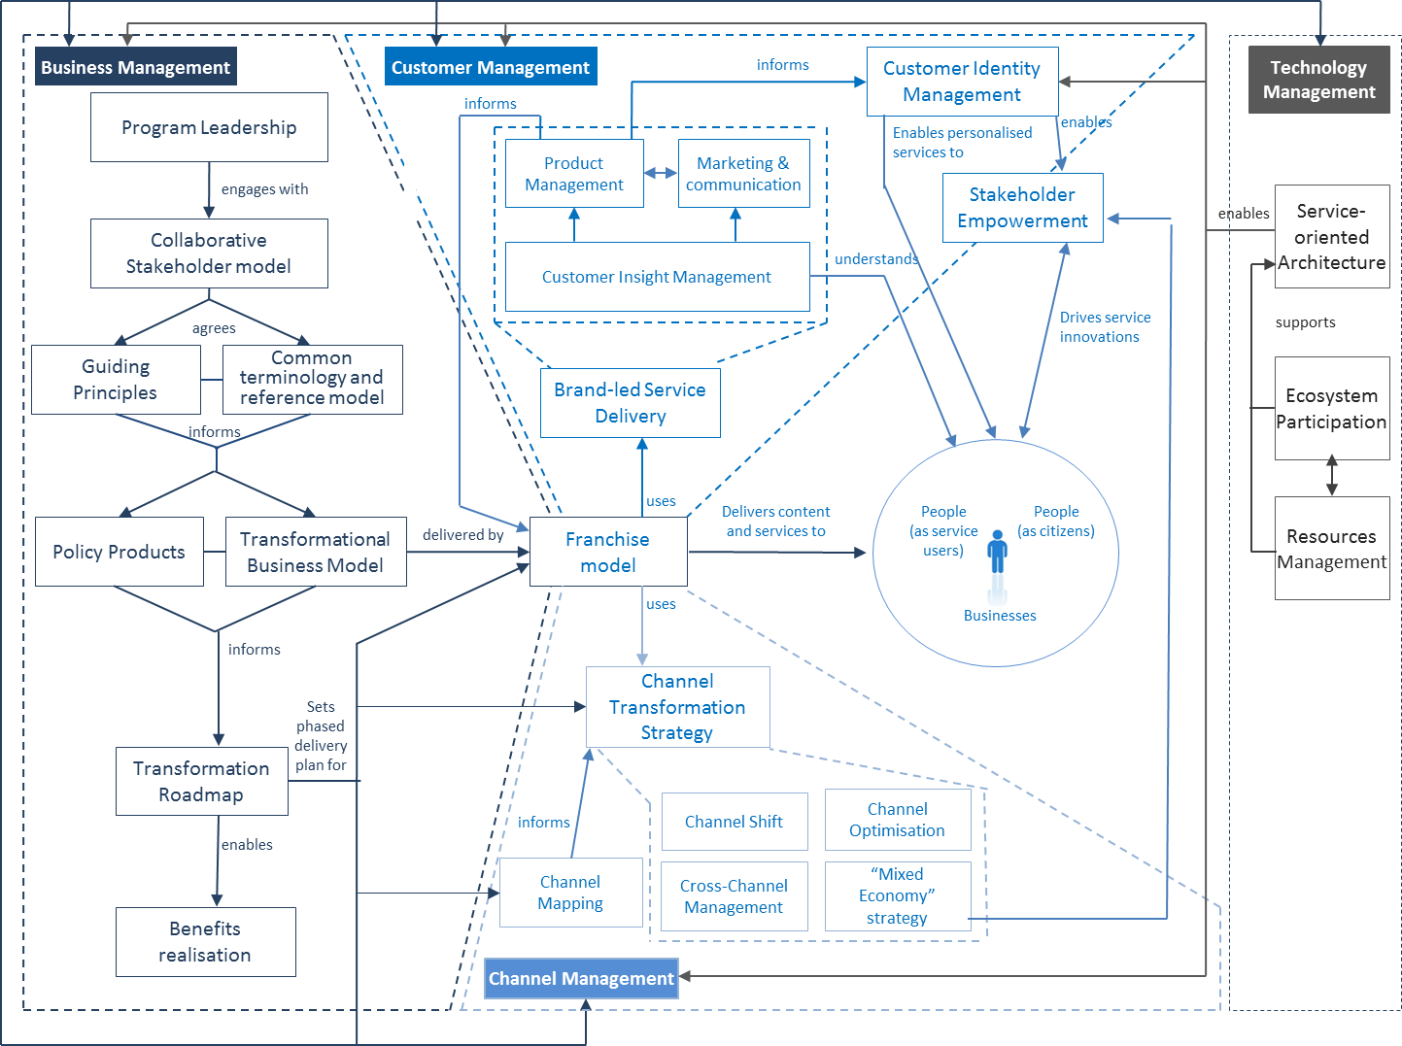
Figure 16: Relationships between the four Delivery Processes for Transformational Government

Business Management Framework
The Transformational Government Framework identifies six key aspects of business management which must be tackled at the whole-of-government level:
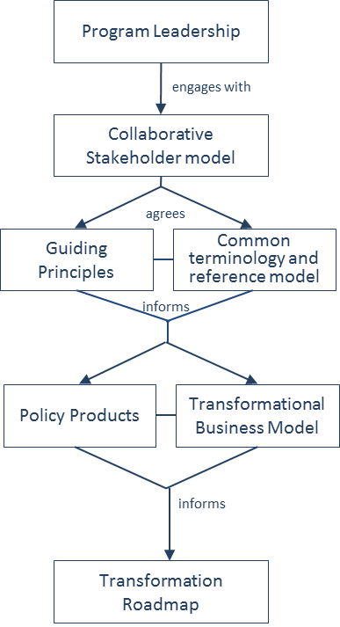
Figure 17: Overview of the Business Management Framework
- Transformational Government leadership: the key people and governance structures needed to develop and implement a Transformational Government program;
- A collaborative Stakeholder Governance Model: the process by which all key stakeholders are identified, engaged and buy-in to the transformation program;
- A common Terminology and Reference Model: ensuring that all stakeholders have a clear, consistent and common understanding of the key concepts involved in Transformational Government; how these concepts relate to each other; how they can be formally modeled; and how such models can be leveraged and integrated into new and existing information architectures;
- A Transformational Business Model: a new virtual business layer within government, focused round the needs of citizens and businesses (the “Franchise Marketplace”), which enables the existing silo-based structure of government to collaborate effectively in understanding and meeting user needs;
- The development and management of Policy Products: these documents formally define government-wide goals for achieving government transformation and thus constitute the documented commitment of any conformant agency to the transformational process;
- A Roadmap for Transformation: giving a four to five year view of how the program will be delivered, with explicit recognition of priorities and trade-offs between different elements of the program.

Customer Management Framework
There are three key parts to the TGF Customer Management Framework:
Brand-led Service Delivery: a user-focused framework for ensuring that:
- Detailed insight is gathered into citizen and business needs;
- This insight informs a brand-led product management process covering all stages of government service design and delivery;
- The brand values for Transformational Government then drive all aspects of marketing and communications for government services.
Identity Management: the business architecture, technical architecture, and customer-centric identity model needed to enable secure and joined-up services which citizens and businesses will trust and engage with; and
Stakeholder Empowerment: the internal cultural changes and external market-enabling actions which enable governments to engage with citizens and businesses as active co-creators of public services, rather than their passive recipients.
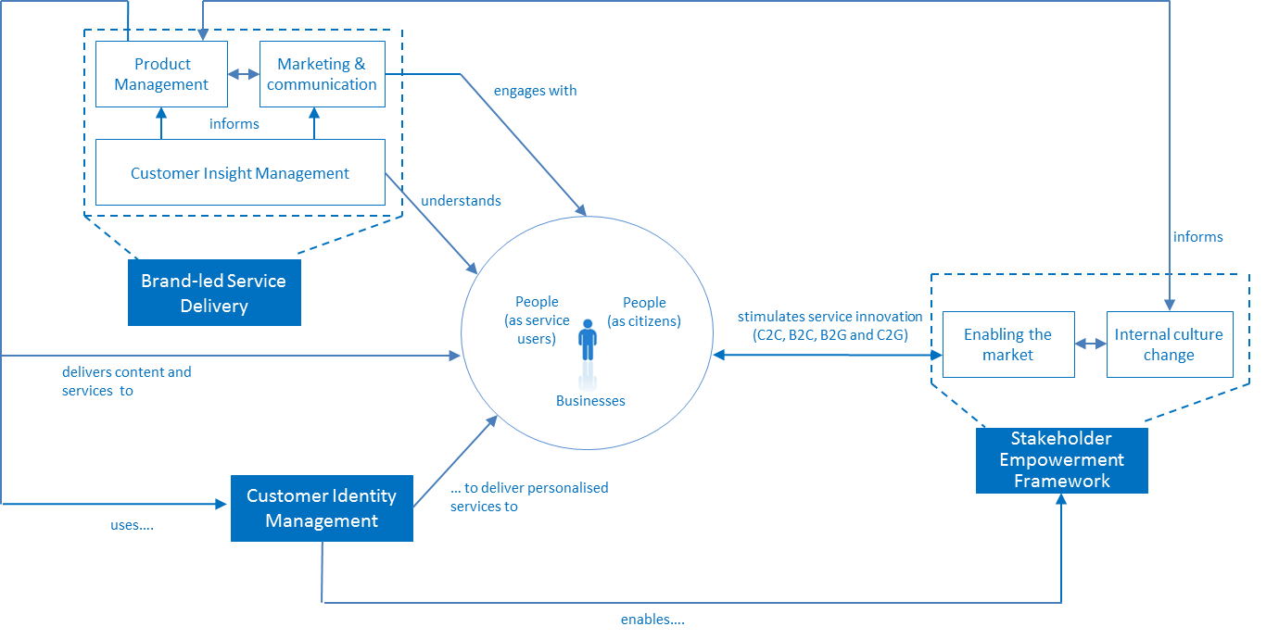
Figure 18: Overview of the Customer Management Framework

Technology Management Framework
The elements of the TGF Technology Management Framework are as follows:
Resources Management: the explicit identification and management of all information and technology resources;
Ecosystem Participation: a clear model and understanding of the stakeholders, actors and systems that comprise the overall service ecosystem and their relationships to each other;
Realisation and governance of ICT systems based on SOA principles.

Figure 20: Overview of the Technology Management Framework

- Revision History

Revision | Date | Editor(s) | Changes Made
01 | 22 Oct 2013 | John Borras  Peter Brown  Chris Parker | Initial draft

See the UK Government’s white paper “Transformational Government – enabled by technology”, Cabinet Office, 2005
The Association of Southeast Asian Nations
The Inter-American Development Bank
This is central to all multi-lingual thesauri, for example, where the core item of organisation is the concept, not the term.
“Terminology work – Vocabulary – Part 1: Theory and application” [ISO 1087-1:2000]
http://www.nist.gov/nstic/
Service Transformation: A better service for citizens and businesses, a better deal for taxpayers, see http://webarchive.nationalarchives.gov.uk/+/http://www.hm-treasury.gov.uk/media/4/F/pbr06_varney_review.pdf
‘Identity Management’ is correctly termed ‘Identity Information Management’ as identity itself is not technically managed but intrinsic to us as humans. It is often shortened to Identity Management, which will be used throughout.

