WG1 Study Group on Mapping of ISO/IEC 38500 and OASIS TGF Implications for Future Work

Table of Contents
WG1 Study Group on Mapping of ISO/IEC 38500 and OASIS TGF Implications for Future Work 1
Introduction 2
Recommendations of the Study Group 3
Abbreviations 3
Background 3
Outline of the standards 4
ISO/IEC 38500 Governance of IT for the Organization 4
OASIS Transformational Government Framework 5
High level comparison 7
Parts of TGF deliverables that relate to Governance of IT 9
Mapping of TGF Parts to 38500 9
Implications for 38500 15
Government IT 15
Governance of change 16
New Principles 16
Pattern Language structure 16
Recommendations for future work items in SC40 19
Implications for TGF (feedback to OASIS TGF TC) 20
Content and Scope of TGF 20
Possible PAS or similar submission from OASIS to ISO or JTC 1 20
Clarification of possible licensing issues regarding use of parts of the TGF in any JTC 1 work 21
TGF and ISACA 21
Recommendations 21

Introduction

This Study Group report is the output of Resolution 50 from the JTC 1/SC 40 Plenary in Sao Paulo, May 2015. This resolution and the call for participants is contained in ISO-IECJTC1-SC40_N0201_JTC_1SC_40_Call_for_participants. In summary, that resolution called for:

“…a Study Group within WG 1 on Mapping of ISO/IEC 38500 and OASIS TGF – Implications for future work, with the following terms of reference and timeline

- Identify those parts of the “Transformational Government Framework” (TGF) deliverables from OASIS that relate to governance of Information Technology;

- Map those parts to the six principles and three task profiles covered in ISO/IEC 38500

- Identity possible implications for the 38500 series from the use of TGF, as regards:

  - Content and scope of the 38500 series

  - The value of the “Pattern Language” structure for possible use in 38504

  - Recommendations for future work items in SC40

- Identify possible feedback to OASIS regarding:

  - Content and Scope of TGF

  - Possible PAS or similar submission from OASIS to ISO or JTC 1;

  - Clarification of possible licensing issues regarding use of parts of the TGF in any JTC 1 work

- Compare the TGF approach with the “Principles, Actions, and Outcomes” model of ISACA

- An Interim report and update is to be discussed in Dublin – September 2015 with a final report to be submitted to the SC40 Secretariat one month prior to the SC 40 Plenary meeting in 2016.”

The Study Group added some additional parameters to focus its work:

- Audience. The audience of this report is twofold:
  - Standards Users. These users would be current or potential users of ISO/IEC 38500 or OASIS TGF or both.
  - Standards Experts. These experts would be engaged in writing or amending the ISO/IEC 38500 series of standards or those engaged in writing or amending the OASIS TGF standard or related standards.
- Size of Project. We did not seek to deeply analyze both standards, but instead to add a new perspective to the users and experts of these standards. With that new perspective, those audiences can then investigate either standard in more detail and determine how it can be used to improve their governance or standards writing activities. Therefore, we aimed to keep this report fairly succinct.
- Integration/Homogenization of the standards. This report does not seek to integrate or homogenize the two standards. The SG believes that the two standards have different scopes and objectives and so should remain as separate standards. A standard user of one standard may benefit from applying the other standard – but the actual application will vary depending on the requirements of the standard user.

Recommendations of the Study Group

The recommendations of the Study Group are:
- Make this report publicly available.
- Pattern language structure should be considered in future standards work
- Refer the following topics to the Study Group on Future Work:
  - Examine new domains (for example Government, Health, Financial Services etc) for Governance of IT work,
  - Re-examine the 6 principles of 38500 in light of the above work, and
  - The application of Governance of IT to organizational change (including Benefits Realization).

The recommendations and the reasons leading to them are discussed below.

Abbreviations

SG ISO/IEC JTC 1/SC 40/WG 1 Study Group on Mapping of ISO/IEC 38500 and OASIS Transformational Government Framework – Implications for future work (unless otherwise stated)

PDTR Proposed Draft Technical Report

38500 ISO/IEC 38500:2015 Information technology -- Governance of IT for the organization

TGF OASIS Transformational Government Framework

Background

The original impetus for this work came from an expert contribution (Peter Brown, GB) for the June 2014 meeting. It stated in part:

The “Transformational Government Framework” (TGF) is a project of OASIS. The TGF tackles the high level issues of IT governance in several areas. In one part in particular, and although referred in the document as a “Technology Management Framework” it is clearly about technology governance, it considers:
- Governance of Information Technology resources;
- So-called “Ecosystem Governance”;
- Realisation and Governance of SOA-based ICT systems

Note: SOA is defined according to the “Reference Model for SOA” [3] as a “paradigm for organizing and utilizing distributed capabilities that may be under the control of different ownership domains”. This is relevant as the TGF underlines the key importance of IT governance across ownership domains.

The preparation of a Technical report would provide valuable insights into the relationship between the work conducted by OASIS and by JTC 1 and will help in the further discussions regarding future work in scope for this working group.

This contribution from OASIS resulted in a SC 40 Plenary Resolution 22: “JTC 1/SC 40 invites OASIS to submit a contribution on the “Mapping of ISO 38500 and OASIS TGF” to the General Study Group on Future Work.” OASIS duly submitted such a contribution as requested and the Study Group agreed that is was useful and should be progressed under SC 40/WG 1 and be presented at the Brazil Meeting (May 2015) along with any further contributions.

A further contribution was made (Geoff Clarke, AU) which recommended the creation of Technical Report to serve as a guide to TGF for users of the ISO/IEC 38500 series (and vice versa). However, instead of directly supporting the creation of a Technical Report, the Brazil meeting adopted resolution 50 as outlined above, which resulted in the “WG 1 Study Group on Mapping of ISO/IEC 38500 and OASIS TGF – Implications for future work” and a call for contributions.

Outline of the standards

This section gives a brief outline of both standards.

ISO/IEC 38500 Governance of IT for the Organization

ISO/IEC 38500 provides the guiding principles, definitions and a model for members of governing bodies of organizations on the effective, efficient and acceptable use of IT within their organizations.

It sets out six principles of good governance of IT:
- Responsibility
- Strategy
- Acquisition
- Performance
- Conformance
- Human Behaviour

It also describes a model for governing which consists of three main tasks:
- Evaluate the current and future use of IT
- Direct preparation and implementation of strategies and policies
- Monitor conformance to policies and performance against strategies.

The standard is applicable to all organizations, including commercial and public sector organizations. While it describes high level behaviours and tasks, it is not prescriptive in describing implementation. (The technical specification ISO/IEC TS 38501 does provide guidance on the implementation of governance of IT and an assessment scheme for that implementation.)

ISO/IEC 38500 is the cornerstone standard of the Governance of IT within JTC 1, but this standard has a number of related standards (herein referred to as “38500 series) that may help members of the governing body and other practitioners as shown below:

Designation | Title | Description
ISO/IEC 38500 | Governance of IT for the organization | Describes the principles, definition and model for the governance of IT
ISO/IEC TS 38501 | Governance of IT — Implementation guide | Provides guidance on the implementation of governance of IT within organizations.
ISO/IEC TR 38502 | Governance of IT — Framework and model | Clarifies the distinction between the concepts of governance and management in respect of IT.
ISO/IEC TR 38504  (to be published) | Guidance for Principles-based Standards in the Governance of Information Technology | Guidelines for the description of principles-based guidance.

OASIS Transformational Government Framework

The OASIS Transformational Government Framework is a practical, “How To” standard for the design and implementation of an effective program of technology-enabled change at national, state or local government level.

The underlying goal is to transform government from unconnected vertical silos of government functions to deliver services based on user needs.

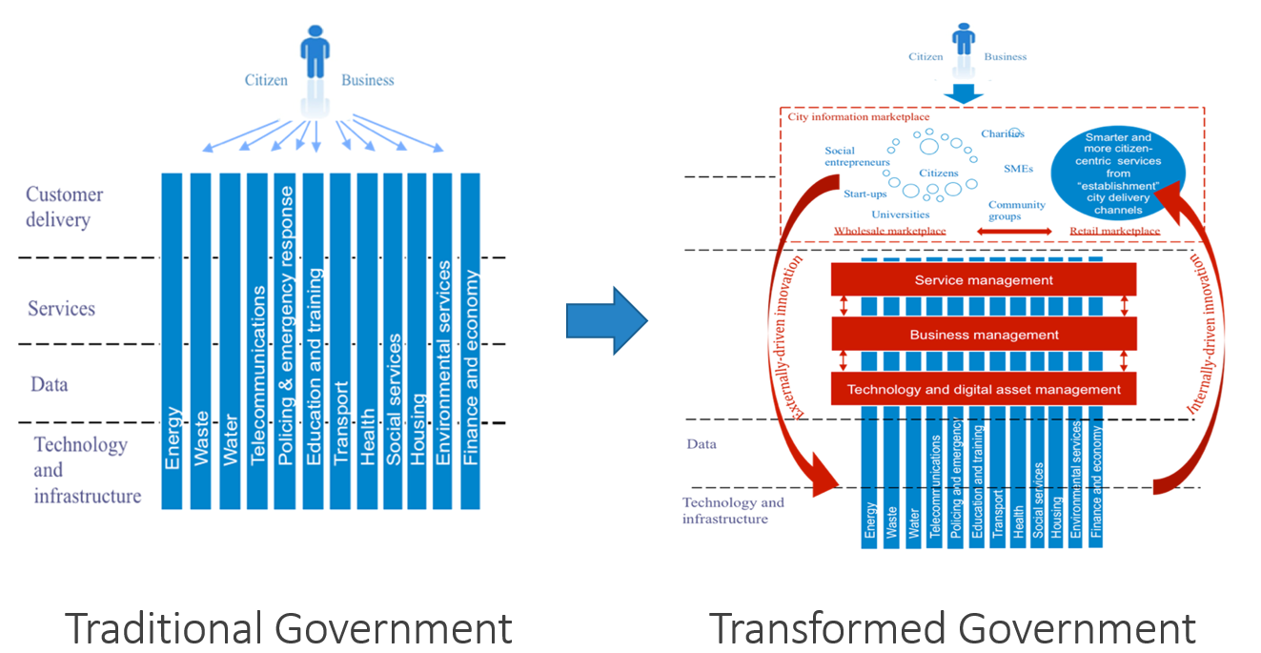

Figure 1. The goal of OASIS TGF is to transform government using IT

The standard is aimed primarily at political and administrative leaders responsible for shaping public sector reform and e-government strategies and policies (at national, state/regional and city/local levels).

It is structured as a series of “patterns” within a TGF “pattern language”. It consists of
- Guiding Principles
- Guidance on business management, service management and technology and digital assets management
- Benefit realization
- Critical success factors

There are a number of TGF supporting papers available via the OASIS website that will aid practitioners:

Designation | Description
TGF v2.0 Committee Specification | This is the latest version of the TGF work. Technically, it is currently a committee specification, not an OASIS standard.
TGF Executive Summary CN01 | A high-level overview of the Transformational Government Framework (TGF)
TGF eHealth Profile CN01 | This Committee Note contains detailed information and guidance on using the Transformational Government Framework (TGF) and other OASIS standards to support the work of the delivery of e-Health services provided in the home or in the community.
TGF Tools and Models for the Business Management Framework: Volume 1 Using the Policy Product Matrix CN01 v2.0 | This Committee Note and the associated Wiki resource contain detailed information and guidance on using the Policy Products matrix in the Business Management Framework.
TGF: Impact of the Internet of Things CN01 | Provides an impact assessment of the new opportunities becoming available through the development of the Internet of Things (IoT) on Transformational Government programs and the delivery of services by the public sector.
Mapping OASIS TGF to ISO 38500: An Introduction, CN01 | This note is intended to serve as a contribution to a discussion within ISO/IEC JTC 1/SC 40 (“IT Service Management and IT Governance”).

High level comparison

The following table gives a high level comparison of the focus areas of the two standards:

Dimension of comparison | ISO/IEC 38500 | OASIS TGF
Scope | Governance of IT | Governance and management of IT-enabled business change
Sectoral focus | Relevant to all sectors | Public sector
Unit of analysis | The individual organisation, and how IT can best be governed and by implication IT-enabled services provided to the organisation | Eco-systems of multiple organisations that collaborate to deliver public sector outcomes, and how IT-enabled change can best be managed across those eco-systems
Key target audience | Members of the governing body and their advisors. | Political and administrative leaders responsible for shaping public sector reform and e-government strategies and policies

Human Behavior and Culture

One important element in both 38500 and TGF is the human aspect – including the culture, ethics and behavior of the governing body, the implementers and the consumers.

Beyond the fact that 38500 series and TGF do not explicitly say the same with regard to culture, both of them consider organization culture (or more plainly, just “culture”) and its transformation, to be a fundamental element of change. The consideration of culture in each standard naturally leads to the analysis of stakeholders involved with influencing and being impacted by culture within the organization.

About 38500 series:
- ISO/IEC 38500 encourages a “culture of good governance”, and its 6th principle does refer to human behaviour. When we consider ISO/IEC TS 38501 (which focuses on the implementation of ISO/IEC 38500) such reference is made more clear, and it is logical: to implement the norm, you must take culture into account. TS 38501 states that governing bodies should know “what arrangements they need to have in place”, and implementation is highly dependent on the culture and tone of the organization at the top, and on organization culture and behaviours related to IT. It’s up to the governing body to realize organizational change readiness, in order to be able to establish any successful change program.

- ISO/IEC 38500 is concerned with the Governance of IT, which in turn is an integral part of corporate governance, and thus takes into account the organization’s culture. Sir Adrian Cadbury said that “the aim of corporate governance framework is to align as nearly as possible the interests of individuals, corporations and society”, and Demb and Neubauer agree: “Corporate governance is the process by which corporations are made responsive to the rights and wishes of stakeholders.” Bob Tricker says at more length that “Whether at the level of a country, a society, or a company, every culture incorporates a value system, which reflects the attitudes, beliefs and expected behaviour in that culture” and “Such a perspective [...] includes all of the stakeholders involved with the company, including the contractual stakeholders such as the shareholders, managers, and other employees, suppliers, customers, consumers, bankers, but also other stakeholders outside the company whose interests could be affected by corporate behaviour, including the local, national, and international societal interests.”

About TGF:
- TGF is a more practical “how-to” standard, and thus makes the culture angle much more explicit. TGF repeatedly refers to about “cultural and organizational changes”, “Internal culture changes”, and "organizational restructuring", as well as “behavior of citizens and businesses". With regard to stakeholder, TGF has a list for “Target audience”, and an “Stakeholder collaboration” activity as part of the “Critical success factors” component, in which the ecosystem is described.

- With regard to the scope of culture (within which stakeholders must be considered) TGF takes into account the public sector, government organizations (at national, state, or local level) and the relationships between the public sector and citizens and the private sector. TGF frequently refers to culture and its transformation, while ISO/IEC 38500 exclusively considers “IT users” (in the organization, or related to it) speaking about culture only in TS 38501.

In summary, ISO/IEC 38500 (and the 38500 series of standards), both through its “Human Behaviour” principle and its “Direct” task makes mention of culture – and TGF repeatedly refers to culture. Further, the background of 38500 and its inheritance of corporate governance amplifies the importance of culture to good governance, human behavior and change.

Parts of TGF deliverables that relate to Governance of IT

Since the OASIS TGF is a Management and Governance oriented framework, and the focus of this SG is Governance, a process to identify the deliverables, or parts, that are related to Governance of IT is the approach we have taken.

As outlined in the “Background” section above, the TGF tackles the high level issues of IT governance in several areas, although not always referred in the TGF document as governance mechanisms but rather as related management practices.

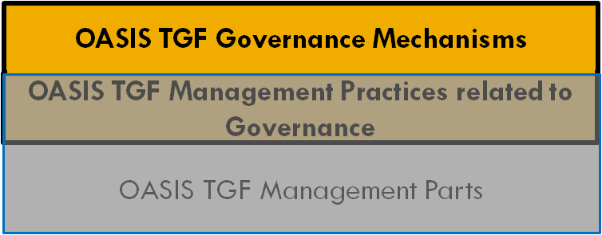
Identify the TGF related Governance Parts

Figure 2. Diagram of the OASIS TGF Parts (Governance and Management)

An assessment of the TGF documentation should be conducted in order to identify those parts that are related to governance, as it is shown in figure 2 above.

Mapping of TGF Parts to 38500

Both the OASIS TGF and the ISO/IEC 38500 Standards are high-level, principles-based advisory standards and both focus on the role of policy-making and governing bodies in determining how and where such technologies are introduced and deployed.

On the one hand, ISO/IEC 38500 provides a framework of principles for governing bodies to use when evaluating, directing and monitoring the use of information technology in their organizations. The six principles “express preferred behaviour to guide decision making.” It is centrally concerned by the governance of information technology, which includes planning for the future.

The OASIS TGF on the other hand is focused primarily with the transformation of the organization. Its scope however covers the public sector and more specifically with enabling the transformation of public sector services and the role played by information technologies in enabling such transformation. It is concerned with ensuring the management of information technology as a strategic asset.

Even without a detailed mapping of the entire Standards, an initial, cursory examination of the two shows already a high degree of overlap of the principles covered in both: The ISO Standard talks about “Responsibility” while the OASIS Standard talks about “Leadership”; Similarly for: “Strategy” (“Roadmap for Transformation”), “Acquisition” ( “Technology Development and Management”), “Performance” (“Critical Success Factors”), and “Human Behaviour” (“Stakeholder Collaboration”).

This is not to imply that the terms – nor the intended scope of their use – are identical: only to suggest that there is sufficient commonality of purpose that a mapping between the two standards may assist in their implementations or use within an organization.

Furthermore, it is important to highlight that the definition of “governance” is very similar in both standards, with TGF describing governance as “method or system by which an organization's strategy, policies and processes are directed, monitored and evaluated”.

For public sector governing bodies that are familiar with the 38500, the mapping may assist in a better understanding of TGF.

In order to show how TGF and 38500 could together apply to an organization, the approach shown in figure 3 is suggested.

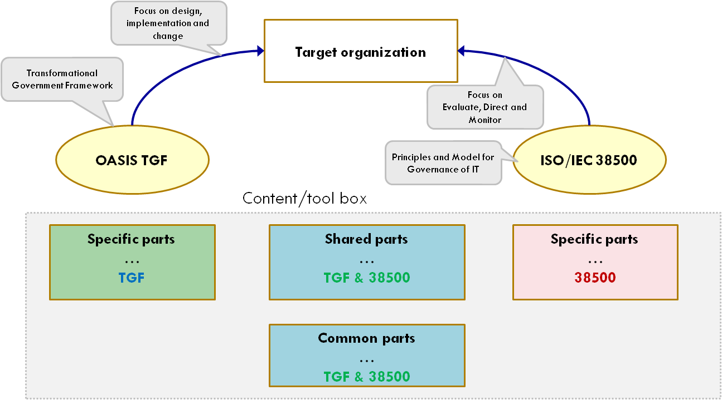

Composition of the TGF Governance Parts

Composition of the 38500 Parts

Map TGF and 38500 Common and Shared Governance of IT Parts

Figure 3. An approach for the composition of the TGF Governance Parts

Based on the diagram of figure 3, the content of both the TGF Governance Parts, and the 38500 Parts are composed by :

- Specific Parts (either TGF or 38500) – parts of the TGF, or 38500, that only apply to TGF, or 38500
- Shared Parts (both TGF & 38500) – parts that have similar topics between TGF and 38500, but take different perspectives
- Common Parts (both TGF & 38500) – parts that have similar topics and deal with them in very similar ways (ie interchangeable) between TGF and 38500

The application of the TGF Parts to 38500 ones will be obtained by making the intersection of the parts of the TGF and 38500 and identifying which are the shared and common parts among them, as shown in the figure 3.

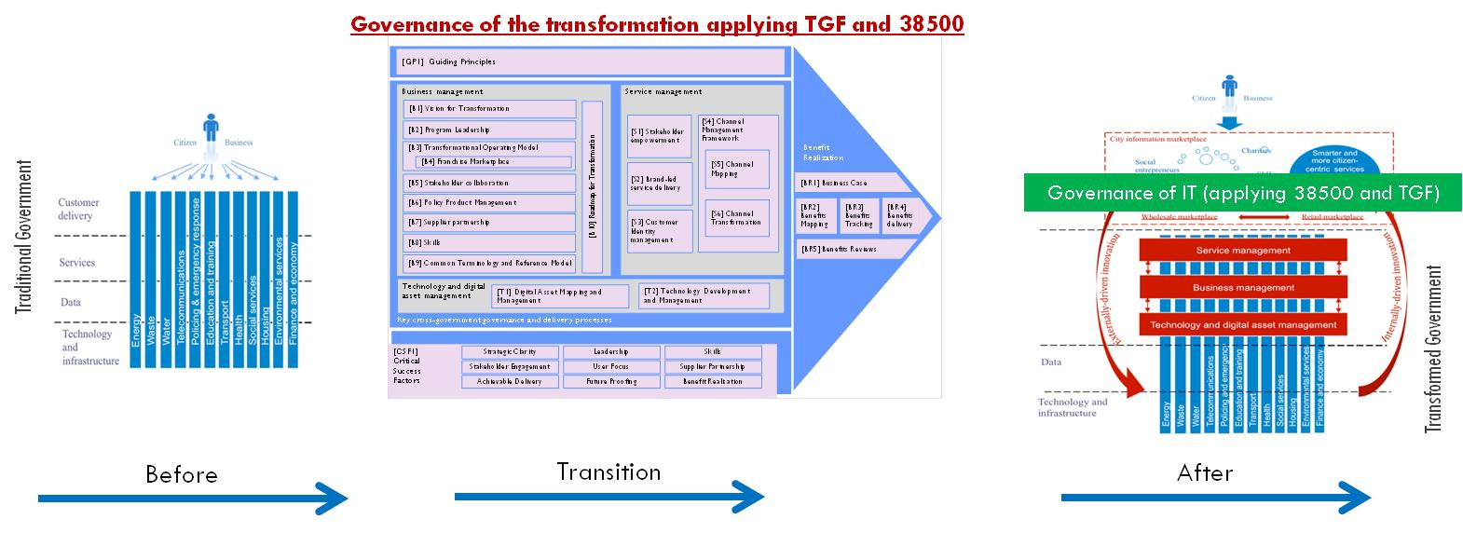

(Possible) implication of 38500 for TGF users

Figure 4. Using 38500 to ensure governance of IT during transformation.

Put simply, the map of OASIS TGF parts to ISO/IEC 38500 is not a 1-for-1 exercise as the utility of such a map will depend on the requirements of the organization and where are in the “transformation” journey. However, even if the organization is not a public sector one (which TGF assumes) the mapping could be a useful exercise to assist with both the process and governance of change within the organization as shown in figure 4.

(Possible) implication of TGF for 38500 users

Figure 5. Applying 38500 upon the completion of organizational transformation.

Upon the successful completion of the transformation, ongoing governance of the organization and its use of IT will place emphasis on the ISO/IEC 38500 perspective. This is shown in figure 5 above.

The following table gives the essence of the mapping between the two standards. It shows the patterns of TGF which may align to the principles and model of 38500. In both cases, the descriptions are merely summaries and the corresponding standards will need to be reviewed for the exact wording – and their application to a target organization and circumstances.

OASIS Transformational Government Framework | ISO/IEC 38500
[GP1] Guiding Principles  The term “principle” [means] an enduring statement of values which can used on a consistent basis to steer business decision by multiple stakeholders making over the long term, and which are:  - used to inform and underpin strategy;  - understood, agreed and owned by stakeholders. | Principles
[B2] Program Leadership  Development of a shared and compelling [B1] Vision for Transformation requires significant leadership and strategic clarity; delivery of the vision then requires that leadership to be sustained over a period of years. | Principle 1: Responsibility  ...understand and accept...responsibilities in respect of both supply of and demand for IT and have the authority to fulfill the responsibilities.
[B1] Vision for Transformation  First among the [GP1] Guiding Principles is the need for [B2] Program Leadership to develop a clear, compelling and shared vision for the transformation program.  [B10] Roadmap for Transformation  It is essential that the vision of the [B2] Program Leadership, and the associated [B3] Transformational Operating Model and process of [B6] Policy Product Management are translated into an effective Roadmap for Transformation.  [CSF1] Critical Success Factors  In delivering a [B10] Roadmap for Transformation, TGF programs should ensure that they are managing the major strategic risks effectively. Typically, these risks are not related to the technology itself – which is largely mature and proven – but rather to business and cultural changes. Such changes are integral to the business management, service management and technology management transformations required as part of a Transformational Government program. | Principle 2: Strategy  ...takes into account the current and future capabilities...and use...of IT...[for] the organization's business strategy.
[T2] Technology Development and Management  In order for [T1] Digital Asset Mapping and Management to be effective in aligning government technology and digital assets with the integrated, non-silo based approach set out in [B3] Transformational Operating Model, it is essential to have a top-level vision and architecture for future technology use across the government. | Principle 3: Acquisition  IT acquisitions are made for valid reasons [with] on-going analysis ...and transparent decision making.
[CSF1] Critical Success Factors  In delivering a [B10] Roadmap for Transformation, TGF programs should ensure that they are managing the major strategic risks effectively. Typically, these risks are not related to the technology itself – which is largely mature and proven – but rather to business and cultural changes. Such changes are integral to the business management, service management and technology management transformations required as part of a Transformational Government program. | Principle 4: Performance  IT is fit for purpose in supporting the organization...and future business requirements.
[BR3] Benefits Tracking  Benefits tracking involves planning and delivering the measurement systems needed to track progress against the business case. | Principle 5: Conformance  Compliance with legislation and policies.
[B5] Stakeholder Collaboration  Effective stakeholder collaboration is critical. Establishing a process of sustainable change requires a critical mass of actors inside and outside of the government to be both engaged and supportive. Delivering a [B1] Vision for Transformation cannot be done without meaningful stakeholder collaboration.  [CSF] Skills  Implementing a Transformational Government program and establishing [S2] Brand-Led Service Delivery involves taking a holistic, market-driven approach to service design and delivery, which in turn often requires new skills. | Principle 6: Human Behaviour  IT policies, practices and decisions account for human behaviour.  (See “Human Behavior and Culture” above.)
 | Model
[B1] Vision for Transformation  First among the [GP1] Guiding Principles is the need for [B2] Program Leadership to develop a clear, compelling and shared vision for the transformation program. | Task: Evaluate  Evaluate the current and future use of IT
[B10] Roadmap for Transformation  It is essential that the vision of the [B2] Program Leadership, and the associated [B3] Transformational Operating Model and process of [B6] Policy Product Management are translated into an effective Roadmap for Transformation. | Task: Direct  Direct preparation and implementation of strategies and policies to ensure that the use of IT meets business objectives.
Benefits Realization  TGF gives guidance on how to ensure that the intended benefits of a TGF program are clearly articulated, measured, managed, delivered and evaluated in practice. Benefits realization is an integral part of the [CSF1] Critical Success Factors. | Task: Monitor  Monitor conformance to policies, and performance against the strategies.

Implications for 38500

The examination of TGF unveils a number of potential implications for the standards writers within SC40 and the content and scope of 38500 and related standards:
- “Government IT” as a specialized subset of governance of IT.
- “Governance of change” as a potential subject area for SC40 investigation
- Potential new principles or change to existing principles
- The use of a pattern language as a potential way to structure standards

Government IT

TGF is focused solely on public sector organizations and how they can transform to become more citizen focused. 38500 on the other hand, has a broad focus of any organization.

There may be some interest in producing “governance of IT” standards that relate to a particular industry or segment. As is shown in TGF, government has some specific requirements and it is likely that other industry sectors such as health or manufacturing may have some interesting governance issues in relation to their use of IT that International Standards could address.

Governance of change

The principles and model of 38500 are applied to organizations in a “business as usual” kind of way. While this does include planning for the future, it offers minimal guidance when the organization is undergoing radical change or transformation. (It should be noted that ISO/IEC TS 38501 addresses the implementation of governance of IT, which is in itself a change. But it doesn’t focus on significant organizational or business change.)

On the other hand, TGF is focused on the organization undergoing a transformational change.

It may be useful to look at the governance of IT requirements of an organization that is undergoing significant change – and if any guidance in the form of International Standards would be helpful.

New Principles

38500 contains 6 principles. TGF contains a large number of topics and a further examination of that standard may reveal the need or desire for a change to existing principles in 38500 or new principles to be added.

For example, TGF examines the topics of
- Stakeholder Collaboration
- Benefits Realization
- Investment and enablers of business change

Some of these topics (or others within TGF) may highlight a need to re-examine the existing principles in 38500 and related standards in the 38500 series.

Pattern Language structure

The Terms of Reference for this Study Group ask for the possible implications for the 38500 series from the TGF including the “value of the ‘Pattern Language’ structure for possible use in 38504”.

Given that ISO/IEC TR 38504 is soon to be published, a restructure to account for the benefits of a pattern language approach is not an immediate option. However, the use of a pattern language structure for a future version of 38504 or other ISO/IEC standard is worth examining.

Why does TGF have a pattern language structure?

The OASIS TGF is explicitly structured using the paradigm of a “Pattern Language” with consistent internal structure for each pattern; relationship between the patterns; and process for developing new patterns.

The TGF is essentially a recipe for transforming governments from departmental silos to have more customer focused, efficient and effective service delivery. This recipe is in the shape of a process framework – and that framework is constructed with a number of building blocks or “guidance notes”.

The guidance notes themselves are constructed in a consistent pattern consisting of name, context, headline statement, body, recommended solution and linkages to more detail for extension or completion.

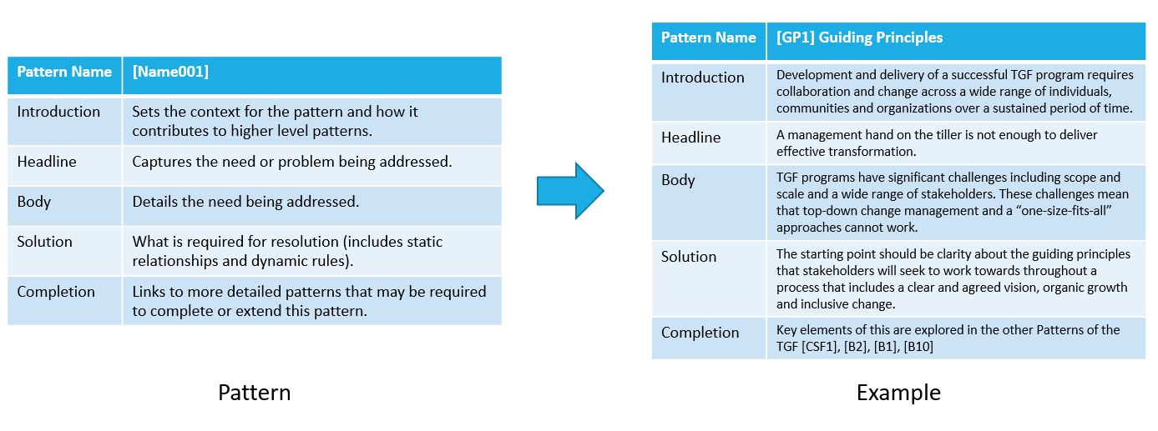
Figure 6. A pattern and an example instantiation.

Using these consistent patterns throughout the standard makes it easy to read, to understand the analysis and to construct and adapt the guidance (or part of it) to the required implementation. Additionally, this consistency lends itself to machine processing so that tools can be used to give different visualizations of the overall construction, to more consistently describe it and to test and verify its consistency.

Why might the pattern language structure be useful for standards?

Many standards in ISO and JTC 1 have recurring patterns within them. For example:
- JTC 1/SC 27 has many standards that describe security requirements in terms of “controls”.
- JTC 1/SC 38 describes cloud computing in terms of roles, activities, functional components
- JTC 1/SC 40 lists a number of principals

Each of these terms are used to describe a recurring pattern that includes a name, problem statement, solution and other details. In most cases, they also describe how an example of the pattern fits with or links to other patterns. In all cases, these patterns come together to build a solution – such as an Information Security Management System, a cloud service or a system of governance.

Recognizing the patterns within the standards, and making them more explicit and formal may make the standards editing process much simpler as well as provide a consistent approach or “pattern language” to their construction. Furthermore, such formalization could allow for easier consistency checks, verification of structure and improved understanding through visualization tools.

How hard would it be to implement a pattern language structure in a standard?

Implementing a pattern language structure in a JTC 1 standard would require:
- A document structure that allows or encourages such an approach,
- A clearly defined domain in which a pattern language is useful,
- A problem statement that lends itself to a pattern language approach,
- A process to apply a pattern language, and
- A willingness of experts and editors to adopt such a process.

Document structure

JTC 1 standards are written in conformance with the “ISO/IEC Directives Part 2 Rules for the structure and drafting of International Standards”. This gives the documents a consistent structure, formatting and style that ensures its comprehension and clarity. For example, the construction of lists, the title page, annexes and so on are all clearly defined.

Such an approach simplifies the editing of a standard because these editorial decisions have already been made. However, as stated in the Directives Part 2, “Documents are so diverse that no universally acceptable rules can be established for the subdivision of the subject matter.”

There are therefore strong guidelines for the overall structure and homogeneity of the document and a good deal of freedom in the construction of the underlying basic components or “clauses” of the document. This flexibility within a rigid framework forms a good basis for implementing a pattern language approach to the construction of a standards document. In the technical content part of the document, the patterns will be implemented as one or more clauses or sub-clauses upon which the document is built.

TGF uses this approach where its sub clauses (eg [B7] Supplier Partnership) describe a pattern, yet the standard also has clauses such as “Introduction” and “Overview” which might be found in many JTC 1 standards.

Clearly defined domain

As highlighted previously, there already exist clearly defined domains within JTC 1. These sub-committees and working groups are defined by their terms of reference and so the domain of the work is clearly understood.

Problem statement

Some of the main benefits of a pattern language approach to design is that it the solution, while being complete in itself, is extensible to further levels of detail, to different areas of specialization and potentially to wider applications.

We can see such problems in Governance of IT where new principles may be added, different applications (eg to specific industries) or more details (eg data) can be applied. Similarly, in the security domain, we can see a pattern of generic controls being extended to new sectors (eg healthcare) and new technologies (eg cloud computing).

Process

Although there is no prescriptive methodology for establishing a pattern language, several domain-specific languages have been created following the guidance provided by the concept’s original creator, Christopher Alexander. A specific pattern language is usually established for a particular subject matter domain (such as architecture, software engineering, organizational change, etc.) and individual patterns created as needed, often starting with a core set covering basic concepts and problems. Most pattern languages that have been created and are in use follow the recommended structure for both the language itself and the individual patterns.

Thus there is a large body of work to aid in the guidance of pattern language work. Additionally, as stated previously, a pattern language is extensible so that updates to the pattern language or template can be easily applied across the resulting standard. This allows updates and new learnings to be incorporated into the standard in a consistent manner. Because JTC 1 already has a clearly defined process for new work items, project work streams, editing, updates and revisions, it would seem that these processes could fit in well with the extensible nature of pattern language work.

Motivation

Given the defined document structure, clear domain boundaries and project processes, JTC 1 clearly has the right environment for an adoption of pattern languages into some of its projects such as standards, technical reports and so on. A pattern language approach will not apply to all projects – but it may be a good fit where the problem statement is initially contained and can or should be extended over time, detail or application.

Given the right problem statement, the motivation for adopting a pattern language approach would be to provide a better end product, be it standard, technical report or other work item. Additionally, as described above, the pattern language approach should provide a more efficient, consistent and extensible approach to the project.

Recommendations for future work items in SC40

In summary, the recommendations for future work items in SC40 are to examine the following areas for items of potential future work:

- New domains (for example Government, Health, Financial Services etc) for Governance of IT work
- Re-examine the 6 principles of 38500 in light of the above work.
- The application of Governance of IT to organizational change (including Benefits Realization)

Implications for TGF (feedback to OASIS TGF TC)

Content and Scope of TGF

An implication when considering a TGF project is that 38500 may assist in understanding and implementing good governance of IT which is essential for the on-going operation of the Transformed IT services.

The following table highlights some benefits that an organization can get by adopting and applying TGF and 38500 together:

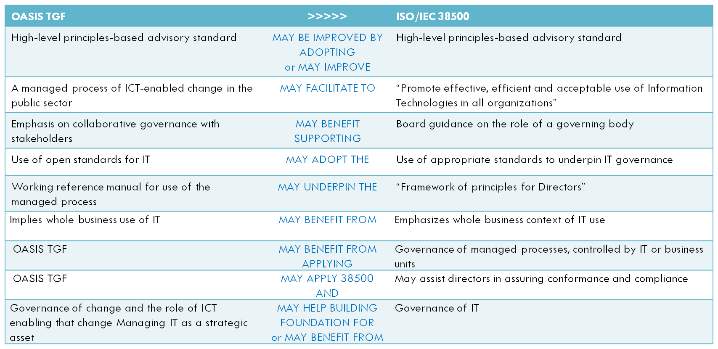

For the editors of the OASIS TGF, the focus of 38500 on the governing body may assist in adding material about engaging all stakeholders and in particular at the governing body level.

Additionally, the “one size fits all” approach of 38500 shows that the principles of governance of IT can apply to all industries and organization sizes. TGF may benefit from expanding its scope to cover transformation in industry sectors other than the public sector.

Possible PAS or similar submission from OASIS to ISO or JTC 1

Because OASIS has the status of a PAS Submitter, it is free to follow that process to effectively move its own standards into ISO or JTC 1. Such a submission could potentially broaden the audience of the TGF and thus benefit more organizations.

It should be noted that ISO/TC 268/WG4 is already in the process of receiving the Publicly Available Standard 181 “Strategies for smart cities and communities” as a submission from BSI. PAS 181 is built on the approach of the OASIS TGF and focused on its application to cities.

Clarification of possible licensing issues regarding use of parts of the TGF in any JTC 1 work

This topic was not able to be addressed within the study group.

TGF and ISACA

ISACA members did attend the Study Group, however ISACA was not able to provide input on this report.

Recommendations

The recommendations of the Study Group are:
- Make this report publicly available.
- Pattern language structure should be considered in future standards work
- Refer the following topics to the Study Group on Future Work:
  - Examine new domains (for example Government, Health, Financial Services etc) for Governance of IT work,
  - Re-examine the 6 principles of 38500 in light of the above work, and
  - The application of Governance of IT to organizational change (including Benefits Realization).

The study group acknowledges and thanks the expert members of JTC 1/SC 40/WG 1 for their efforts and for their contributions to this report.
----o----

ISO-IECJTC1-SC40_N0053_JTC_1SC_40_Meeting_June_2014_-_exper.pdf
ISO-IECJTC1-SC40-WG1_N0033_Mapping_OASIS_Transformational_Go.pdf
ISO-IECJTC1-SC40-WG1_N0054_Expert_Contribution_on_mapping_of.pdf
ISO-IECJTC1-SC40_N0201_JTC_1SC_40_Call_for_participants_and.docx
OASIS TGF is available at https://www.oasis-open.org/committees/tc_home.php?wg_abbrev=tgf
Corporate Governance: A Framework for Implementation, Magdi R. Iskander and Nadereh Chamlou, The World Bank Group, 2000
The Corporate Board: Confronting the Paradoxes, Ada Demb and F.-Friedrich Neubauer, Oxford Press, 1992
Corporate Governance, Principles, Policies, and Practices, Bob Tricker, Oxford Press, 2012
Based on ISO-IECJTC1-SC40-WG1_N0033_Mapping_OASIS_Transformational_Go.pdf
Based on ISO-IECJTC1-SC40-WG1_N0033_Mapping_OASIS_Transformational_Go.pdf
Based on ISO-IECJTC1-SC40-WG1_N0077_Slides_used_for_presentation_on__.pptx
ISO-IECJTC1-SC40-WG1_N0033_Mapping_OASIS_Transformational_Go.pdf
http://shop.bsigroup.com/forms/PASs/PAS181-2014/

