TOSCA Imperative workflows
  - Priya TG (Netcracker)
  - June 19, 2019

Problem Statement
TOSCA Imperative workflows in v1.3 of TOSCA Simple Profile YAML introduces support of custom workflow language. The workflow grammar supports referencing artifacts as illustrated in the example of v1.3 of the specification (see below).

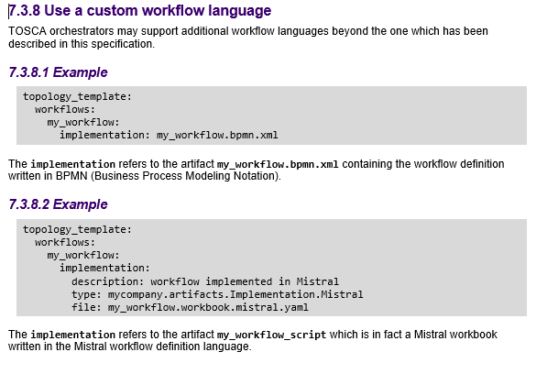
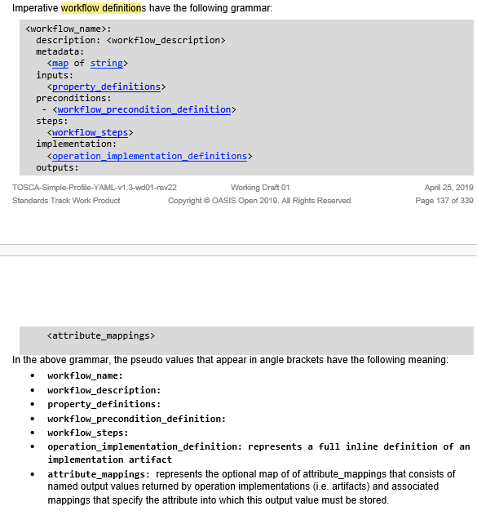

The following gap needs to be addressed in v1.3 grammar:

There is NO DEFINED INTERFACE regarding how information from the service template (e.g. node template properties) will be passed to external workflow. Thus, the external workflow remains disconnected from the service template.
To illustrate this, let us consider an example of Imperative workflows using native TOSCA grammar that allows for such input assignments. The highlighted text of the example below allows assignments from properties of node templates to workflow inputs.

tosca_definitions_version: tosca_simple_yaml_1_3

description: sample workflow snippet

node_types:
tosca.example.WebApplication:
derived_from: tosca.nodes.WebApplication
properties:
flavor_id:
type: string
required: true
image_id:
type: string
required: true
. . .
interfaces:
Standard:
create:
. . .

topology_template:

substitution_mappings:
node_type: tosca.example.WebApplication
. . .

node_templates:

web_db:
type: tosca.nodes.DBMS.MySQL
properties:
db_name: . . .
db_user: . . .
db_password: . . .
db_port: . . .
interfaces:
Standard:
create:
inputs:
db_user: { get_property: [ web_db, db_user] }
db_password: { get_property: [ web_db, db_password ] }

web_server:
type: tosca.nodes.WebServer.Apache
properties:
user_name:
. . .
interfaces:
standard:
create:
inputs:
web_user: { get_property [ web_server, user_name] }
web_port: { get_input: web_port }

workflows:
instantiate:
inputs:
db_user:
type: string
db_password:
type: string
web_user:
type: string
web_port:
type: string

steps:
step_1:
target: [web_db]
activities:
- call_operation:
operation: tosca.interface.standard.create
on_success: . . .
on_error: . . .

step_2:
target: [web_server]
activities:
- call_operation:
operation: tosca.interface.standard.create
on_success: . . .
on_error: . . .

When scripts are referenced from workflows, such input assignments are not possible because workflow grammar allows input definition , but not input assignment.
tosca_definitions_version: tosca_simple_yaml_1_3

description: sample workflow snippet

node_types:
tosca.example.WebApplication:
derived_from: tosca.nodes.WebApplication
properties:
flavor_id:
type: string
required: true
image_id:
type: string
required: true
. . .
interfaces:
Standard:
create:
. . .

topology_template:

substitution_mappings:
node_type: tosca.example.WebApplication
. . .

node_templates:

web_db:
type: tosca.nodes.DBMS.MySQL
properties:
db_name: . . .
db_user: . . .
db_password: . . .
db_port: . . .
. . .

web_server:
type: tosca.nodes.WebServer.Apache
properties:
user_name:
. . .
. . .

workflows:
instantiate:
inputs:
db_user:
type: string
db_password:
type: string
web_user:
type: string
web_port:
type: string

implementation:
primary:
file: artifacts/instantiate.workflow.yaml
type: tosca.artifacts.Implementation.nfv.Mistral
# outputs:
# <attribute_mappings>

Resolution

We discussed possible ways to address this:

- Allow intrinsic functions with default values of workflow inputs. The current v1.3 grammar is not very clear about the use of intrinsic functions for default values in workflow input definition.

workflows:
instantiate:
inputs:
db_user:
type: string
default: get_property: { [ web_db, db_user] }
db_password:
type: string
default: { get_property: [ web_db, db_password ] }
web_user:
type: string
default: { get_property [ web_server, user_name] }
web_port:
type: string
default: { get_input: web_port }

- Allow input assignments apart from input definitions for workflow inputs. However, this could be confusing since this is not consistent with the current workflow grammar.
workflows:
instantiate:
inputs:
db_user:
type: string
value: { get_property: [ web_db, db_user] }
db_password:
type: string
value: { get_property: [ web_db, db_password ] }
web_user:
type: string
value: { get_property [ web_server, user_name] }
web_port:
type: string
value : { get_input: web_port }

- Allow the workflow referencing external workflows to be described inline?

The second issue is: Such requirements of passing service template properties to external workflows need replication of almost the entire service template in workflow inputs. Can this be addressed in TOSCA grammar?

