Section 2.3.3, “Procurement”
The procurement process is mainly performed by 3 roles: the buyer, the economic operator and in case of public procurement the publication body.
It starts with the announcement of a procurement and ends with the final payment of a contract.
The process is traditionally split between the pre-award phase and the post award phase. The Contract signature is the event that creates the separation of the two phases as depicts the figure below:
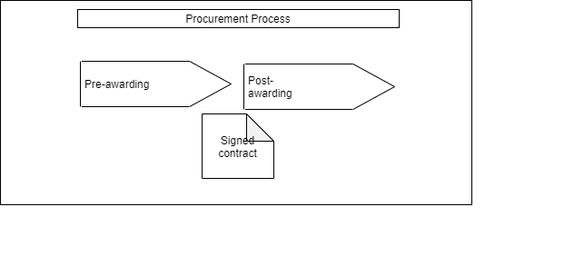

Section 2.3.3.1, “Pre-awarding”
The most used pre-award process in public procurement is schematized below:
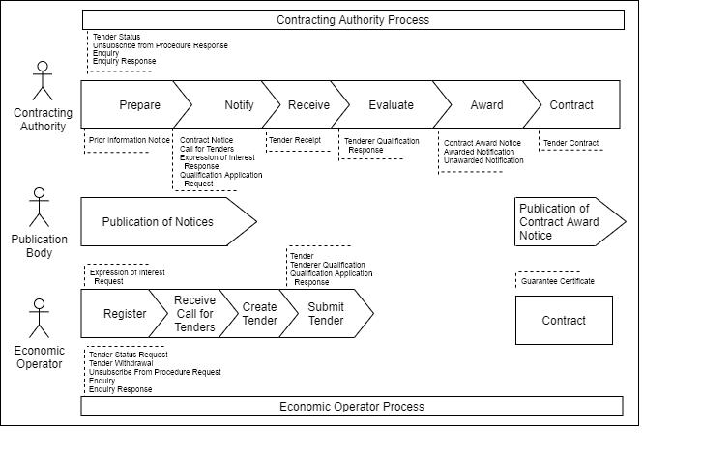
This schema reflects only a possible scenario. In particular, several sourcing patterns are possible to find tenderers and receive tenders.

Section 2.3.3.1.1, “Tendering Introduction”
The tendering subprocess aims at buyers receiving tenders from suppliers starting from a publication of a notice and where the interest of economic operators drives the sourcing.
A similar but less formally defined scenario involves quotation (see Section 2.3.3.3, “Quotation”) .

