The UN/CEFACT XML NDRs are a set of XML naming and design rules which can be applied to CCTS 2.01 compliant exchange syntax neutral message assemblies. This is clearly stated in the following key extract from Page 9 of our official CEFACT NDR v2.1 as published on the website:

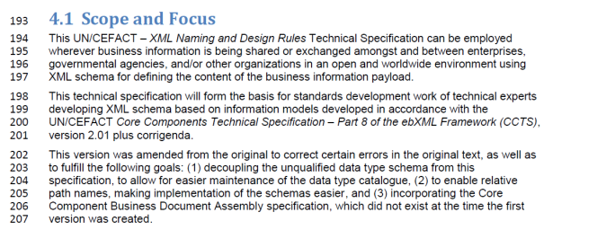

In fact, the ebXML project did not include any XML naming and design rules for generating XML schemas from CCTS compliant message structures. It was out of scope at that time as Core Component Libraries and message structures could not be developed until after the Core Component Technical Specification was fully developed after the ebXML project was completed.

UN/CEFACT certainly has no objections that UBL develop an NDR which might be applied to CCTS 2.01 compliant exchange syntax neutral message assemblies. And UN/CEFACT would have no objection to including a statement like the one we use above.

However, any organization which might claim a branding of either the CCTS or the ebXML in the title of an NDR will cause confusion in the international arena of other organizations which have their own NDR and which also base this on the CCTS and ebXML.