
Extensible Resource Identifier (XRI) Resolution V2.0
Working Draft 10 Editors Draft 04, 17 January 2006
Document identifier:
xri-resolution-V2.0-wd-10-ed-04-gmw
Location:
http://docs.oasis-open.org/xri/xri/V2.0
Editors:
Gabe Wachob, Visa International <gwachob@visa.com>
Drummond Reed, Cordance <drummond.reed@cordance.net>
Les Chasen, NeuStar <les.chasen@neustar.biz>
William Tan, NeuStar <william.tan@neustar.biz>
Steve Churchill, XDI.ORG <steven.churchill@xdi.org>
Contributors:
Dave McAlpin, Epok <dave.mcalpin@epok.net>
Chetan Sabnis, Epok <chetan.sabnis@epok.net>
Peter Davis, Neustar <peter.davis@neustar.biz>
Victor Grey, PlaNetwork <victor.grey@planetwork.org>
Mike Lindelsee, Visa International <mlindels@visa.com>
Abstract:
This document defines both a standard and a trusted HTTP-based resolution mechanism for Extensible Resource Identifiers (XRIs), specifically XRIs conforming to Extensible Resource Identifier (XRI) Syntax V2.0 [XRISyntax] or higher. For the set of XRIs defined to provide metadata about other XRIs, see the Extensible Resource Identifier (XRI) Metadata V2.0 [XRIMetadata]. For a basic introduction to XRIs, see the non-normative Introduction to XRIs [XRIIntro]. For a detailed guide to XRI implementation, see the non-normative XRI Implementor's Guide [XRIGuide].
Status:
This document was last revised or approved by the XRI Technical Committee on the above date. The level of approval is also listed above. Check the current location noted above for possible later revisions of this document. This document is updated periodically on no particular schedule.
Technical Committee members should send comments on this specification to the Technical Committee's email list. Others should send comments to the Technical Committee by using the "Send A Comment" button on the Technical Committee's web page at http://www.oasis-open.org/committees/xri.
For information on whether any patents have been disclosed that may be essential to implementing this specification, and any offers of patent licensing terms, please refer to the Intellectual Property Rights section of the Technical Committee web page (http://www.oasis-open.org/committees/xri/ipr.php.
The non-normative errata page for this specification is located at http://www.oasis-open.org/committees/xri.
Table of Contents
1 Introduction 5
1.1 The XRI Resolution Framework 5
1.2 XRI Implementor's Guide 5
1.3 Terminology and Notation 5
1.4 XML Namespaces 6
2 XRI Namespaces for XRI Resolution 7
2.1 XRIs Reserved for XRI Resolution 7
2.2 XRIs Assigned to XRI Resolution Service Types 7
3 XRDS Documents 8
3.1 XRDS and XRD Namespaces 8
3.2 XRD Elements 8
3.3 XRD Attributes and Processing Rules 12
3.3.1 ID Attribute 12
3.3.2 Version Attribute 12
3.3.3 Priority Attribute 12
3.4 XRI Encoding Requirements 13
4 Authority Resolution 14
4.1 Introduction 14
4.1.1 Assumptions 14
4.1.2 XRI vs. IRI Authorities 14
4.2 Input Processing 15
4.2.1 XRI Resolution Parameters 15
4.2.2 Processing Rules 15
4.3 XRI Authority Resolution 17
4.3.1 Service Type and Media Type 17
4.3.2 Protocol 18
4.3.3 Community Root XRDs 19
4.3.4 Qualified Subsegments 20
4.3.5 Lookahead Resolution 21
4.3.6 Construction of the Next Authority URI 21
4.3.7 Cross-References 22
4.4 IRI Authority Resolution 23
4.4.1 Service Type and Media Type 23
4.4.2 Protocol 23
4.4.3 Optional Use of HTTPS 23
4.5 Trusted Authority Resolution 24
4.5.1 Introduction 24
4.5.2 Service Type and Media Type 24
4.5.3 Protocol 24
4.5.4 Lookahead Resolution 25
4.5.5 Client Validation of XRDs 25
4.5.6 Correlation of ProviderID and KeyInfo Elements 26
4.6 Reference Processing 27
4.6.1 Introduction 27
4.6.2 Processing Rules 28
4.6.3 Nesting XRDS Documents 30
5 Service Endpoint Selection 31
5.1 Introduction 31
5.2 Determining the Service Endpoint Selection Process 31
5.3 Selection by Specified Type 33
5.4 Selection by Path 35
5.5 Selection by Default Type 37
5.6 Path Matching 39
5.7 Media Type Matching 41
5.8 Final Service Endpoint Selection 42
5.9 Construction of the Service Endpoint URI(s) 42
6 Proxy Resolution 44
6.1 Introduction 44
6.2 Service Type and Media Type 44
6.3 HXRIs 44
6.4 Input Parameters 45
6.5 Protocol 45
6.6 Differences Between Proxy Resolution Servers 45
7 Error Processing 46
7.1 Error Codes 46
7.2 Error Messages 47
7.3 Error Handling in Lookahead Resolution 47
7.4 Error Handling in Proxy Resolution 47
8 Use of HTTP(S) 48
8.1 HTTP Errors 48
8.2 HTTP Headers 48
8.2.1 Caching 48
8.2.2 Location 49
8.2.3 Content-Type 49
8.3 Other HTTP Features 49
8.4 Caching and Efficiency 49
9 Extensibility and Versioning 50
9.1 Extensibility 50
9.1.1 Extensibility of XRDs 50
9.1.2 Other Points of Extensibility 50
9.2 Versioning 51
9.2.1 Version Numbering 51
9.2.2 Versioning of the XRI Resolution Specification 51
9.2.3 Versioning of XRDs 51
9.2.4 Versioning of Protocols 52
10 Security and Data Protection 53
10.1 DNS Spoofing 53
10.2 HTTP Security 53
10.3 Caching Authorities 53
10.4 Lookahead and Proxy Resolution 53
10.5 SAML Considerations 53
10.6 Community Root Authorities 54
10.7 Denial-Of-Service Attacks 54
10.8 Limitations of Trusted Resolution 54
11 References 55
11.1 Normative 55
11.2 Informative 55
Appendix A. XML Schema for XRDS and XRD (Normative) 57
Appendix B. RelaxNG Compact Syntax Schema for XRDS and XRD (Informative) 59
Appendix C. Acknowledgments 60
Appendix D. Notices 61

Introduction

The XRI Resolution Framework
Extensible Resource Identifiers (XRIs) provide a uniform syntax for abstract identifiers as defined in [XRISyntax]. Because XRIs may be used across a wide variety of communities and applications (as Web addresses, messaging addresses, database keys, filenames, directory keys, object IDs, XML IDs, tags, etc.), no single resolution mechanism may prove appropriate for all XRIs. However, in the interest of promoting interoperability, this specification defines a standard framework for resolving XRIs using HTTP(S).
This framework includes the following major components:
- XRI Namespaces for XRI Resolution (section 2) specifies the XRI namespaces that are reserved for the XRI resolution framework.
- XRDS Documents (section 3) specifies a simple, flexible XML-based container for XRI resolution metadata or any other metadata describing a resource.
- Authority Resolution (section 4) specifies a simple resolution protocol for the authority segment of an XRI that uses HTTP/HTTPS as a transport. It includes a trusted resolution option that uses SAML assertions to create a chain of trust between the participating authorities.
- Service Endpoint Selection (section 5) specifies an optional second phase of resolution for selecting a set of URIs from an XRDS document.
- Proxy Resolution (section 6) specifies a format for expressing XRIs as HTTP URIs and using an HTTP(S) server as an XRI proxy resolver to perform authority resolution and URI selection. This provides backwards compatability with existing HTTP(S) infrastructure.
- Error Processing (section 7) specifies a set of error codes and error processing instructions for the XRI resolution framework.
- Use of HTTP(S) (section 8) specifies how the XRI resolution framework leverages features of the HTTP(S) protocol.
- Extensibility and Versioning (section 9) describes how the XRI resolution framework can be easily extended, and how new versions will be identified and accommodated.

XRI Implementor's Guide
To minimize non-normative material, this specification does not include sequence diagrams or extensive examples of resolution requests and responses. This material is available in the non-normative XRI Implementor's Guide [XRIGuide]. The Implementor's Guide is recommended for Internet developers, architects, network and directory administrators, and anyone else who builds, installs, maintains, or administers XRI infrastructure.

Terminology and Notation
The key words “MUST”, “MUST NOT”, “REQUIRED”, “SHALL”, “SHALL NOT”, “SHOULD”, “SHOULD NOT”, “RECOMMENDED”, “NOT RECOMMENDED”, “MAY”, and “OPTIONAL” in this document are to be interpreted as described in [RFC2119]. When these words are not capitalized in this document, they are meant in their natural language sense.
Other terms used in this document and not defined herein are defined in the glossary in Appendix C of [XRISyntax].
Formatting conventions used in this document:
Examples look like this.
XML elements and attributes that appear in text look like this.

XML Namespaces
Throughout this document, the following XML namespaces prefixes have the meanings defined in Table 1 whether or not they are explicitly declared in the example or text.
Prefix | XML Namespace | Reference
xs | http://www.w3.org/2001/XMLSchema | [XMLSchema]
saml | urn:oasis:names:tc:SAML:2.0:assertion | [SAML]
ds | http://www.w3.org/2000/09/xmldsig# | [XMLDSig]
xrds | xri://$xrds | Section 2.1 of this document
xrd | xri://$xrd*($v*2.0) | Section 2.1 of this document
Table 1: XML namespace prefixes used in this specification.

XRI Namespaces for XRI Resolution
As defined in section 2.2.1.2 of [XRISyntax], the GCS symbol “$” is reserved for special identifiers assigned by XRI TC specifications, other OASIS specifications, or other standards bodies. (See also [XRIMetadata].) This section specifies the $ namespaces reserved for XRI resolution.

XRIs Reserved for XRI Resolution
The XRIs in Table 2 are assigned by this specification for the purposes of XRI resolution and resource description.
XRI | Use | See Section
xri://$res | Namespace for XRI resolution service types | 2.2
xri://$xrds | Namespace for the generic XRDS (Extensible Resource Descriptor Set) schema (not versioned) | 3
xri://$xrd | Namespace for the XRD (Extensible Resource Descriptor) schema | 3
xri://$xrd*($v*2.0) | Version 2.0 of above | 3
Table 2: XRIs reserved for XRI resolution.

XRIs Assigned to XRI Resolution Service Types
The XRIs in Table 3 are assigned to the XRI resolution service types defined in this specification.
XRI | Use | See Section
xri://$res*auth | Authority resolution service | 4
xri://$res*auth*($v*2.0) | Version 2.0 of above | 4
xri://$res*local | Local resolution service | 5
xri://$res*local*($v*2.0) | Version 2.0 of above | 5
xri://$res*path | Path resolution service | 5
xri://$res*path*($v*2.0) | Version 2.0 of above | 5
xri://$res*proxy | HTTP(S) proxy resolution service | 6
xri://$res*proxy*($v*2.0) | Version 2.0 of above | 6
Table 3: XRIs assigned to identify XRI resolution service types.
Using the standard XRI extensibility mechanisms described in [XRISyntax], the “$res” namespace may extended by other authorities besides the XRI Technical Committee. See [XRIMetadata] for more information about extending “$” namespaces.

XRDS Documents
XRI resolution uses a simple, extensible XML document called an Extensible Resource Descriptor Set (abbreviated “XRDS”.) An XRDS document contains one or more XRD (Extensible Resource Descriptor) elements. While this specification defines only the XRD child elements necessary to support delegated resolution and redirection of XRIs, XRDs can easily be extended to publish any form of metadata about the resources they describe.

XRDS and XRD Namespaces
An XRDS document is intended to serve exclusively as an XML container document for XML schemas in other XML namespaces. Therefore it has only a single root element xrds:XRDS in its own XML namespace identified by the XRI “xri://$xrds”. It also has a single attribute, xrds:XRDS/@xrds:ref of type anyURI that identifies the resource described by the XRDS document. The formal XML schema definition of an XRDS document is provided in Appendix A.
The elements in the XRD schema are intended for generic resource description, including the metadata necessary for XRI resolution. Since the XRD schema has simple semantics that may evolve over time, the elements in the version defined in this specification are in the XML namespace “xri://$xrd*($v*2.0)”. This namespace is versioned using XRI version metadata as defined in [XRIMetadata]. The formal XML schema definition of an XRDS document is also provided in Appendix A.
This namespace architecture enables the XRDS namespace to remain constant while the allowing the XRD namespace (and the namespaces of other XML elements that may be included in XRDS document) to be versioned over time. See section 9.2 for more about versioning of the XRD schema.

XRD Elements
The following example XRDS instance document illustrates the elements and attributes defined in the XRD schema (see Appendix B for the formal XML schema definition):
<XRDS xmlns="xri://$xrds" ref="xri://(example.root)*foo">
<xrd:XRD xmlns:xrd="xri://$xrd*($v*2.0)" xml:id="1">
<xrd:Query>*foo</xrd:Query>
<xrd:Expires>2005-05-30T09:30:10Z</xrd:Expires>
<xrd:Synonym>xri://@example*bar</xrd:Synonym>
<xrd:Ref>xri://!!4!5!6</xrd:Ref>
<xrd:ProviderID>
urn:uuid:c9f812f3-6544-4e3c-874e-d3ae79f4ef7b
</xrd:ProviderID>
<xrd:Service>
<xrd:Type>xri://$res*auth*($v*2.0)</xrd:Type>
<xrd:URI xrd:priority=”10”>
http://resolve.example.com
</xrd:URI>
<xrd:URI xrd:priority=”15”>
http://resolve2.example.com
</xrd:URI>
<xrd:URI>https://resolve.example.com</xrd:URI>
<xrd:ProviderID>
urn:uuid:f0502a17-4503-4463-8516-f1225b330e4d
</xrd:ProviderID>
</xrd:Service>
<xrd:Service>
<xrd:Type>xri://$res*path*($v*2.0)</xrd:Type>
<xrd:Path>pictures</xrd:Path>
<xrd:MediaType>image/jpeg</xrd:MediaType>
<xrd:URI>http://pictures.example.com</xrd:URI>
</xrd:Service>
<xrd:Service>
<xrd:Type>xri://$res*path*($v*2.0)</xrd:Type>
<xrd:Path>videos</xrd:Path>
<xrd:MediaType>video/mpeg</xrd:MediaType>
<xrd:URI>http://movies.example.com</xrd:URI>
</xrd:Service>
<xrd:Service>
<xrd:Type>xri://$res*local*($v*2.0)</xrd:Type>
<xrd:URI>http://example.com/local</xrd:URI>
<xrd:ProviderID>
urn:uuid:f0502a17-4503-4463-8516-f1225b330e4d
</xrd:ProviderID>
</xrd:Service>
<xrd:Service>
<xrd:Type>http://example.com/some/service/v3.1</xrd:Type>
<xrd:URI>http://example.com/some/service/endpoint</xrd:URI>
</xrd:Service>
Other XRD elements here
</xrd:XRD>
Other XRDS elements here
</XRDS>
Following are the elements in the XRD schema:
xrd:XRD
Container element for all other XRD elements. Has an “xml:id” attribute to uniquely identify this element within the containing xrd:XRDS document. See section 3.3 for details of ID attribute processing.
xrd:XRD/xrd:Query
0 or 1 per xrd:XRD element. Expresses the XRI, IRI, or URI in URI normal form whose resolution results in this xrd:XRD element. For XRI authority resolution, this must be a qualified subsegment of the authority component of the query XRI.
xrd:XRD/xrd:Status
0 or 1 per xrd:XRD element. Contains a required attribute xrd:XRD/xrd:Status/@code of type xs:int that provides a numeric status code. The contents of the element are an optional human-readable message string describing the status of the response. For the XRI resolution framework, values of the Status element and code attribute are defined in section 7.
xrd:XRD/xrd:Expires
0 or 1 per xrd:XRD element. The date/time, in the form of xs:dateTime, after which this XRD cannot be relied upon. To promote interoperability, this date/time value SHOULD use the UTC "Z" time zone and SHOULD NOT use fractional seconds. A resolver using this XRD MUST NOT use the XRD after the time stated here. A resolver MAY discard this XRD before the time indicated in this result. If the HTTP transport caching semantics specify an expiry time earlier than the time expressed in this attribute, then a resolver MUST NOT use this XRD after the expiry time declared in the HTTP headers per section 13.2 of [RFC2616]. See section 8.2.1.
xrd:XRD/xrd:Synonym
0 or more per xrd:XRD element. Type xs:anyURI. Contains an equivalent XRI, IRI, or URI for the described resource assigned by the same authority producing the current XRD. May be absolute or relative; if relative, the base URI is the URI used to retrieve the containing XRD. Resolution of this synonym should produce the same XRD (with the exception of the xrd:Query, xrd:Expires, and xrd:Synonym elements.) This element also has the global priority attribute (see section 3.3.3).
xrd:XRD/xrd:Ref
0 or more per xrd:XRD element. Identical to xrd:XRD/xrd:Synonym except assigned by a different authority than the authority producing the current XRD. Resolution of this reference may produce a different XRD for the described resource (see section 4.6.)
xrd:XRD/xrd:ProviderID
0 or 1 per xrd:XRD. A unique identifier of type xs:anyURI for the authority producing this XRD. There MUST be negligible probability that the value of this element will be assigned as an identifier to any other authority. Note that for authority resolution in the XRI resolution framework, the authority identified by this element is the describing authority (the producer of the current XRD), not the authority described by the XRD. The latter is specified in the xrd:XRD/xrd:Service/xrd:ProviderID element for a resolution service endpoint (see below).
xrd:XRD/saml:Assertion
0 or 1 per xrd:XRD. Optional for generic authority resolution, but required for trusted authority resolution (section 4). A SAML assertion from the describing authority (the one producing the XRD) that asserts that the information contained in the enclosing XRD is authoritative. Because the assertion is digitally signed and the digital signature encompasses the containing xrd:XRD element, it also provides a mechanism for the recipient to detect unauthorized changes since the time the XRD was published.
Note that while a saml:Issuer element is required within a saml:Assertion element, this specification makes no requirement as to the value of the saml:Issuer element. It is up to the XRI community resolution root to place restrictions, if any, on the saml:Issuer element. A suitable approach is to use an XRI in URI-normal form that describes the community root authority. See section 4.3.3.
xrd:XRD/xrd:Service
0 or more. Describes a capability of the described resource, e.g., a network endpoint for performing further resolution, obtaining further metadata, or interacting directly with the described resource. This element also has the global priority attribute (see section 3.3.3).
xrd:XRD/xrd:Service/xrd:Type
0 or more per xrd:XRD/xrd:Service element. A unique identifier of type xs:anyURI that identifies the type of capability available at this service endpoint. See section 2.2 for the resolution service types defined in this specification.
xrd:XRD/xrd:Service/xrd:Path
0 or more per xrd:XRD/xrd:Service element. Of type xs:string. Contains a value meeting the xri-path production defined in section 2.2.3 of [XRISyntax]. If present, this element is used during the URI selection process – see section 5. It may appear multiple times to indicate all the paths supported at this service endpoint.
xrd:XRD/xrd:Service/xrd:MediaType
0 or more per xrd:XRD/xrd:Service element. The media type of content available at this service endpoint. The value of this element must be of the form of a media type defined in [RFC2046]. This element may appear multiple times to indicate all the media types available through this service endpoint. However the service endpoint MAY support additional media types not specified by instances of this element. If this element is not present, then a processor of the XRD SHOULD NOT make any assumption about the type of resource available at this service endpoint.

xrd:XRD/xrd:Service/xrd:URI
0 or more per xrd:XRD/xrd:Service element. Of type xs:anyURI. If present, it indicates a transport-level URI for access to the capabilitiy described by the parent Service element. For the XRI resolution service types defined in section 2.2, this URI MUST be an HTTP or HTTPS URI. Other services may use other transport protocols. This element has the global priority attribute (see section 3.3.3).
xrd:XRD/xrd:Service/xrd:ProviderID
0 or 1 per xrd:XRD/xrd:Service element. Optional for generic authority resolution (section 4.3), but required for trusted authority resolution (section 4.5). See the definition for xrd:XRD/xrd:ProviderID above. In trusted resolution, when a resolution request is made to the authority at this service endpoint, the contents of the xrd:XRD/xrd:ProviderID element in the response MUST match the content of this element for correlation. See section 4.5.6. The same usage MAY apply to other services not defined in this specification.
xrd:XRD/xrd:Service/ds:KeyInfo
0 or 1 per xrd:XRD/xrd:Service element. Optional for generic authority resolution, but required for trusted authority resolution (section 4.5). Provides the digital signature metadata needed to validate an XRD provided as a resolution response by the described authority. This element comprises the key distribution method for trusted authority resolution in the XRI resolution framework—see section 4.5.6.
The XRD schema (Appendix A) allows other elements and attributes from other namespaces to be added throughout. As described in section 9.1.1, these points of extensibility can be used to deploy new XRI resolution schemes, new service description schemes, or other metadata about the described resource.

XRD Attributes and Processing Rules

ID Attribute
To enable unique identification of multiple XRD elements within an XRDS document, the XRD element includes the xml:id attribute defined by the W3C XML ID specification [XMLID]. The value of this element MUST be unique for all XRDs that appear in the same XRDS document. Because an XRI resolver may assemble multiple XRDs received from different authority resolution services into one XRDS document, the value of the xrd:XRD/@xml:id attribute SHOULD be reasonably unique and SHOULD be generated by the following algorithm.
[Open Issue: xml:id assignment algorithm. xml:id attributes must start with a letter and essentially can contain only letters, digits, dots, and dashes. Proposal: should we use string “xrd-[long-int]” where [long-int] is randomly generated by the resolution server? And require that if there is ever a collision of xrd:XRD/@xml:id attribute values when assembling an XRDS, the resolver should repeat the request?]
The value of the xrd:XRD/@xml:id attribute MAY be generated by another algorithm that produces a reasonably globally unique value.
Note that when an XRI resolver is assembling multiple XRDs into a single XRDS document, the XRDs MUST be appear in the XRDS document order in the same order in which they were requested by the resolver according to the authority resolution protocol specified in section 4.

Version Attribute
[Open issue: Does XRD still need version attributes, or can we go completely with versioning of xmlns attributes? Note that this section should either reference or incorporate part of section 8.2].

Priority Attribute
During the XRI resolution process, certain XRD elements (Synonym, Ref, Service, and URI) may may be present multiple times. The global “priority” attribute enables XRI authorities to provide guidance to XRI clients in selection of one of these element instances. Like the priority attribute of DNS records, it accepts a non-negative integer value that can be used to provide redundancy.
The processing rules for the priority attribute are standard for all services in the XRI resolution framework. They apply whenever there is more than one instance of the desired element type in an XRD (if there is only one instance, the priority attribute is ignored.) The rules are:
- The client SHOULD select the element instance with the lowest numeric value of the priority attribute. For example, an element with priority attribute value of “10” should be selected before an element with a priority attribute value of “11”, and an element with priority attribute value of “11” should be selected before an element with a priority attribute value of “15”. Zero is the highest priority attribute value. Null is the lowest priority attribute value.
- If an element has no priority attribute, its priority attribute value is considered to be null.
- If two or more instances of the same element type have identical priority attribute values (including the null value), the client SHOULD select one of the instances at random. This client SHOULD NOT simply choose the first instance that appears in XML document order (this is important in order to support intentional round-robin behaviour).
- An element selected according to these rules is referred to as “the highest priority element”. If this element is subsequently disqualified from the set of qualified elements, the next element selected according to these rules is referred to as “the next highest priority element”. If a protocol operation specifying selection of the highest priority element fails, the client SHOULD attempt to select the next highest priority element unless otherwise specified. This process SHOULD be continued for all other element instances until success is achieved or all instances are exhausted.
When setting priority attributes, it is recommended that XRI authorities follow the practice common in DNS and set the default highest priority attribute value to “10”.

XRI Encoding Requirements
The W3C XML 1.0 specification [XML] requires values of XML elements of type xs:anyURI to be valid IRIs. This applies to the XRD Synonym, Ref, Type, URI, and ProviderID elements. However a further restriction applies to XRIs used in XRDS documents: because XRI resolution relies on HTTP or HTTPS as transport protocols, when an XRI is used as the value of an XRD element of type xs:anyURI, it MUST be in URI-normal form as defined in section 2.3 of [XRISyntax].
Note that the XRIs assigned in section 2 of this specification are composed entirely of valid URI characters that do not require escaping in the transformation to URI-normal form. However XRIs that use characters only valid in IRIs or that use certain XRI syntax delimiters may require percent encoding in the transformation to URI-normal form as explained in section 2.3 of [XRISyntax].

Authority Resolution

Introduction
In the XRI resolution framework, authority resolution is the process of iteratively requesting XRDS documents from each authority in the authority segment of an XRI the same way DNS resolvers iteratively request IP addresses in order to reach the next nameserver in a federated DNS name. Each XRDS document describes how to make a request of the next authority. The final XRD element will describe the final target authority and the service endpoints available for further interaction (if any.)
Besides the use of XML documents in responses, the other key contrast with DNS resolution is that XRI resolution uses HTTP/HTTPS as the transport protocol. (Note that future versions of this specification or specifications for other forms of XRI resolution may use other transport protocols.) The use of HTTP(S) enables XRI resolution to be easily deployed on the large installed base of public and private Web servers.

Assumptions
The generic authority resolution protocol makes the following minimal assumptions about the XRIs being resolved:
- The endpoints representing the top-level authority for any absolute XRI are identified by the authority segment (“xri-authority” or “i-authority” productions) of the XRI as defined in section 2.2.1 of [XRISyntax].
- Only absolute XRIs can be resolved using this authority resolution protocol. To resolve a relative XRI reference, it must be converted into an absolute XRI using the procedure defined in section 2.4 of [XRISyntax].
- The XRI being resolved has been converted into URI-normal form, following the rules in section 2.3.1 of [XRISyntax].
- A resource represented by a single XRI may be accessed by multiple protocols at multiple service endpoints. For example, it is possible that a resource represented by a single XRI may be accessed through multiple HTTP URIs, or through both HTTP and another network protocol. While only HTTP or HTTPS access to resources is defined by this specification, XRDS documents enable access to resources via URIs in any scheme.
- Each network endpoint associated with a resource identified by an XRI may present a different subset, type, or representation of data or metadata associated with the identified resource. For example, two separate HTTP URIs may be associated with a single XRI, one for data access and the other for metadata access. As described in section 3, XRDS documents allow XRI authorities to define multiple service types using extensible descriptor fields including service type, content type, XRI path, and URI.

XRI vs. IRI Authorities
As described in section 2.2.1 of [XRISyntax], XRI authorities and IRI authorities have different syntactic structures, partially due to the higher level of abstraction represented by XRI authorities. For this reason, XRI authorities are resolved to XRD descriptors one subsegment at a time, as described in section 4.3. IRI authorities, since they are based on DNS names or IP addresses, are resolved into an XRD through a special HTTP(S) request based on the DNS name or IP address identified by the IRI authority segment as described in section 4.4.

Input Processing

XRI Resolution Parameters
To ensure consistency among XRI resolver implementions (including XRI proxy resolvers, section 6), a query XRI (QXRI) MAY include resolution parameters encoded as part of the QXRI query component. These query parameters are defined in Table 4.
Parameter Name | Parameter Value | For Resolution Phase
xrd_res_type | Value of xrd:XRD/xrd:Service/xrd:MediaType element requested for authority resolution | Authority resolution
xrd_service_type | Value of xrd:XRD/xrd:Service/xrd:Type element requested for service endpoint selection | Service endpoint selection
xrd_media_type | Value of xrd:XRD/xrd:Service/xrd:MediaType element requested for service endpoint selection | Service endpoint selection
Table 4: Optional resolution parameters that may be included in a QXRI query component.
These parameters (and others specific to a client resolver implementation) MAY be also implemented through a local API, or via another interface such as the HTTP interface specified for XRI proxy resolution in section 6. Regardless of how they are supplied, these parameters MUST be subject to the processing rules in the following section.

Processing Rules
Figure 1 describes generic input processing of a query XRI (QXRI) by an XRI resolver. The error codes listed are further described in section 7.
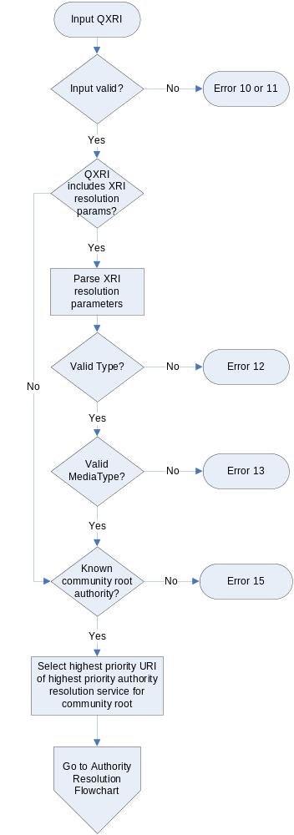
Figure 1: Input processing flowchart
The normative input processing rules for XRI resolution are:
- The QXRI MUST be a valid absolute XRI according to the ABNF defined in [XRISyntax]. To resolve a relative XRI reference, it must be converted into an absolute XRI using the procedure defined in section 2.4 of [XRISyntax].
- The XRI being resolved MUST be in URI-normal form as defined in section 2.3.1 of [XRISyntax].
- If the XRI resolution parameters defined in section 4.2.1 are specified in the QXRI, these parameters MUST appear in the query component of the QXRI. They SHOULD be appended after any existing query parameters in the QXRI and MUST be delimited from other parameters with an ampersand (“&”). Parameters specified in this manner SHOULD take precedence over the same parameters provided via any other interface (such as a local API or HTTP extension headers as described in section 6.4.)
- If the xrd_res_type parameter is specified as "application/xrds+xml", the generic authority resolution protocol specified in section 4.3 (for an XRI authority) or 4.4 (for an IRI authority) MUST be used during the authority resolution phase. If the xrd_res_type parameter is specified as "application/xrds-saml+xml", the trusted authority resolution protocol specified in section 4.5 MUST be used during the authority resolution phase. If the xrd_res_type parameter is absent or its value is null, either the generic or trusted authority resolution protocols MAY be used.
- A QXRI that does not meet these input requirements SHOULD produce the appropriate 1x error code specified in section 7.

XRI Authority Resolution

Service Type and Media Type
The resolution service defined in this section is identified by the xrd:XRD/xrd:Service/xrd:Type element value “xri://$res*auth*($v*2.0)” and the xrd:XRD/xrd:Service/xrd:MediaType value “application/xrds+xml”.

Protocol
After input validation, Figure 2 provides the logical flow of the generic authority resolution process followed by an XRI resolution client (called a “client resolver” for clarity). More details on each step are provided in the following sections.
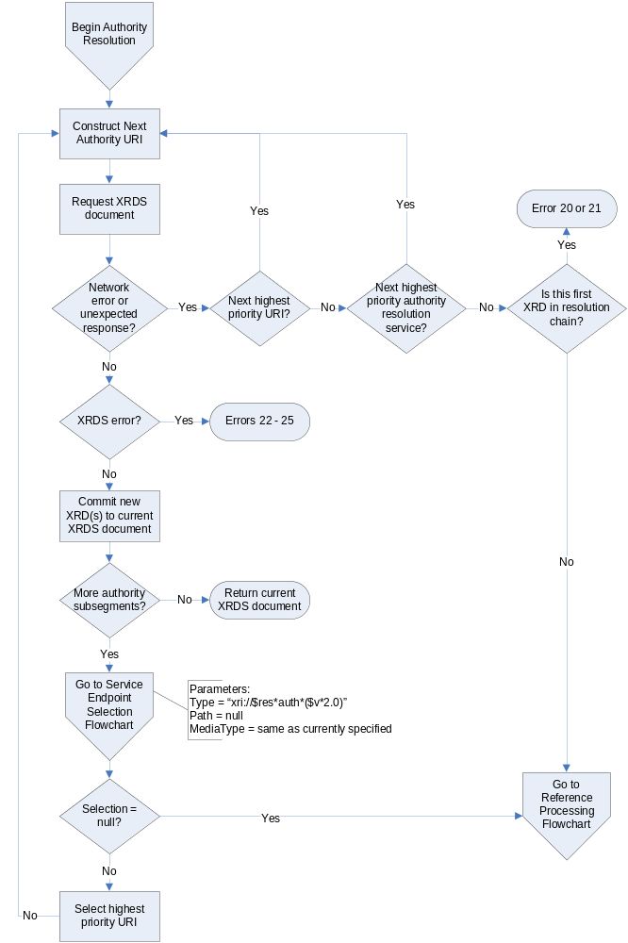
Figure 2: Authority resolution flowchart
Following are the normative requirements for behavior of an XRI client resolver and an XRI resolution service in generic authority resolution:
- The client resolver MUST be preconfigured with the XRD metadata (or a means of obtain such metadata) describing the community root authority for the XRI to be resolved as defined in section 4.3.3.
- Resolution by the client resolver of each authority subsegment after the community root subsegment MUST proceed in subsegment order (left-to-right) using fully qualified subsegment values as defined in section 4.3.4. The final XRDS document produced by a client resolver MUST contain one XRD for every subsegment successfully resolved by the resolver client. (Note that a separate nested XRDS document is produced for every reference followed—see section 4.6.)
- A client resolver MAY request lookahead resolution of multiple subsegments as defined in section 4.3.5.
- Each subsegment MUST be resolved via an HTTP or HTTPS GET request to a URI constructed as defined in section 4.3.6.
- The HTTP(S) request MUST contain an Accept header with the value of “application/xrds+xml”.
- Subsegments that use XRI cross-reference syntax MUST be resolved as defined in section 4.3.7.
- The ultimate HTTP(S) response from an authority resolution service to a successful resolution request MUST contain either: a) a 2XX response with a valid XRDS document (section 3), or b) a 304 response signifying that the cached version on the client resolver is still valid (depending on the client’s HTTP(S) request). There is no restriction on intermediate redirects (i.e., 3XX result codes) or other result codes (e.g., a 100 HTTP response) that eventually result in a 2XX or 304 response through normal operation of [RFC2616].
- Any ultimate response besides an HTTP 2XX or 304 SHOULD be considered an error in the resolution process and the client resolver SHOULD return the appropriate error code and message as specified in section 7. In lookahead resolution, such an error MUST be returned by the resolution server to the client resolver as specified in section 7.3. In proxy resolution, such an error MUST be returned by the resolution server to the client resolver as specified in section 7.4.
- A successful response that does not include the desired service endpoint in the XRD but includes one or more xrd:XRD:xrd:Ref elements MUST be processed as defined in section 4.6. Note that such processing, if successful, will result in a separate XRDS document describing the resolved reference nested inside the current XRDS document in the final output.
- All other use of HTTP(S) in this protocol MUST comply with the requirements in section 8. In particular, HTTP caching semantics SHOULD be leveraged to the greatest extent possible to maintain the efficiency and scalability of the HTTP-based resolution system. The recommended use of HTTP caching headers is described in more detail in section 8.2.1.

Community Root XRDs
Identifier management policies are defined on a community-by-community basis. With XRIs, the resolution community is specified by the first (leftmost) subsegment of the authority segment. This is referred to as the community root authority. When a resolution community chooses to create a new community root authority, it SHOULD define policies for assigning and managing identifiers under this authority. Furthermore, it SHOULD define what resolution protocol(s) may be used for resolving identifiers assigned by the authority.
With XRIs, a community root authority may be an XRI authority or an IRI authority as specified in section 2.2.1 of [XRISyntax]. For an XRI authority, the community root may be either a global context symbol (GCS) character or top-level cross-reference as specified in section 2.2.1.1 of [XRISyntax]. In either case, the corresponding root XRDS document (or its equivalent) specifies the top-level authority resolution service endpoints for that community.
This community root XRDS document, or its location, is known a priori and is part of the configuration of a resolver, similar to the specification of root DNS servers in a DNS resolver. Note that is not strictly necessary to publish this information in an XRDS document—it may be supplied in any format that enables configuration of the XRI resolvers in the community. However, providing an XRDS document at a known location simplifies this process. In addition, it is a recommended best practice in trusted resolution (section 4.5) for the community root authority to publish an XRDS document containing a valid self-signed SAML assertion.
If the first subsegment of an XRI authority is a GCS character and the following subsegment does not begin with a “*” (indicating a reassignable subsegment) or a “!” (indicating a persistent subsegment), then a “*” is implied and MUST be added when constructing the qualified subsegment as specified in section 4.3.6. Table 5 and Table 6 illustrate the differences between parsing a reassignable subsegment following a GCS character and parsing a cross-reference, respectively.
XRI | xri://@example*internal/foo
XRI Authority | @example*internal
Community Root Authority | @
First Qualified Subsegment Resolved | *example
Table 5: Parsing the first subsegment of an XRI that begins with a global context symbol.
XRI | xri://(http://www.example.com)*internal/foo
XRI Authority | (http://www.example.com)*internal
Community Root Authority | (http://www.example.com)
First Qualified Subsegment Resolved | *internal
Table 6: Parsing the first subsegment of an XRI that begins with a cross-reference.

Qualified Subsegments
A qualified subsegment is a subsegment as defined by the productions whose names start with “xri-subseg” in section 2.2.3 of [XRISyntax] including the leading syntactic delimiter (“*” or “!”). A qualified subsegment MUST include the leading syntatic delimiter even if it was optionally omitted in the original XRI (see section 2.2.3 of [XRISyntax]).
The first (or leftmost) subsegment of the XRI authority segment specifies the root of the identifier community. This subsegment is discussed above.
The qualified subsegment immediately to the right of the community root is resolved in the context of the root, and all subsequent subsegments MUST be resolved in the the context of the subsegment immediately to their left. XRI authority resolution is complete when an XRI client resolver has completed the chain of XRDs for all subsegments in the XRI authority segment. If the final output of XRI resolution is an XRDS document, this document MUST contain an ordered list of xrd:XRD elements (and xrd:XRDS elements if references are followed – see section 4.3.7), one for every subsegment successfully resolved by the resolver client. The list of xrd:XRD elements in an xrd:XRDS document MUST appear in the same order as the subsegments in the QXRI. In addition, any references followed MUST be represented by nested xrd:XRDS documents immediately following the xrd:XRD element containing the reference followed as defined in section 4.3.7.

Lookahead Resolution
Both generic and trusted authority resolution services allow a client resolver to request resolution of multiple authority subsegments in one transaction. This process is called lookahead resolution. If a client resolver makes such a request, the responding authority resolution service MAY perform the additional lookahead resolution steps requested. In this case the responding resolution service acts as a client resolver to the other authority resolution service endpoints that need to be queried for the lookahead subsegments. Alternatively, the responding authority resolution service may retrieve XRDs from its local cache until it reaches a subsegment whose XRD is not locally cached, or it may simply lookahead only as far as it is authoritative. Any of these behaviors are reasonable, as are others not described here.
If an authority resolution service performs any lookahead resolution, it MUST return an ordered list of xrd:XRD elements (and xrd:XRDS elements if references are followed) in an xrd:XRDS document for all subsegments resolved as defined in section 4.3.4.
The responding authority resolution service MAY resolve fewer subsegments than requested by the client resolver. The responding resolution service is under no obligation to resolve more than the first subsegment (for which it is, by definition, authoritative).
If the responding authority resolution service does not resolve the entire set of subsegments requested, the client resolver MUST continue the authority resolution process itself. At any stage, however, the client resolver MAY request that the next authority resolution service resolve any remaining unresolved subsegments.

Construction of the Next Authority URI
At each step in authority resolution, a URI must be constructed for the next HTTP(S) request. This URI is constructed by the XRI resolver from two strings—one representing the next authority resolution service endpoint selected from the current XRD, and one representing the next subsegment or group of subsegments in the authority segment being resolved.
The process for selecting the next authority resolution service endpoint from the current XRD is defined in section 5. For generic authority resolution, the process MUST select from the valid input parameters defined in Table 7:
Parameter Name | Valid Parameter Values
xrd_service_type | xri://$res*auth  xri://$res*auth*($v*2.0)
xrd_media_type | application/xrds+xml  application/xrds-saml+xml
Table 7: Input parameters for selection of authority resolution service.
The value of the xrd_media_type parameter MUST be “application/xrds+xml” if a generic authority resolution service endpoint is requested and “application/xrds-saml+xml” if a trusted authority resolution service endpoint is requested.
From the output of the service endpoint selection process, the client resolver MUST select the highest priority URI. If this service endpoint URI does not end with a forward slash (“/”), one MUST be appended before proceeding.
The second string is the QXRI. In authority resolution (both generic and trusted), the QXRI is supplied by the XRI client resolver and consists of either:
- The next fully qualified subsegment to be resolved (see section 4.3.4), or
- In the case of lookahead resolution, the next fully qualified subsegment plus the additional subsegments for which lookahead resolution is requested (see section 4.3.5).
The QXRI MUST be in URI-normal form as required in section 3.4.
The final step is to append the QXRI to the path component of the service endpoint URI. The resulting URI is called the next authority URI.
Construction of the next authority URI is more formally described in this pseudo-code for resolving a “subsegment-list” via an HTTP(S) service endpoint URI called “auth-res-uri”:
if (path portion of auth-res-uri does not end in “/”):
append “/” to path portion of auth-res-uri

if (subsegment-list is not preceded with “*” or “!” separator):
prepend “*” to subsegment-list

append uri-escape(subsegment-list) to path portion of auth-res-uri

Cross-References
Any subsegment within an XRI authority segment may be a cross-reference (see section 2.2.2 of [XRISyntax].) Cross-references are resolved identically to any other subsegment because the cross-reference is considered opaque by generic XRI resolution. In other words, the value of the cross-reference (including the parentheses) is the literal value of the subsegment for the purpose of authority resolution.
The one exception is a cross-reference rooted on the GCS dollar sign ("$"). The significance of such a cross-reference for resolution depends on the specification that defines the value of the identifier following the $ character. For the XRI suite of specifications, the significance of $ cross-references is defined by the XRI Metadata Specification [XRIMetadata].
For example, an annotation cross-reference that begins with “$-” is specified in [XRIMetadata] as insignificant, so this cross-reference and the delimiter that precedes it MUST be ignored entirely during resolution. On the other hand, a version cross-reference that begins with “$v” is specified in [XRIMetadata] as significant, so this should be treated as a standard cross-reference.
Table 8 provides several examples of resolving cross-references. In each example, subsegment “!b” resolves to a next resolution URI of “http://example.com/xri-authority/”, and lookahead resolution is not being requested.
Cross-reference type | Example XRI | Next Resolution URI after resolving “xri://@!a!b”
Absolute XRI | xri://@!a!b!(@!1!2!3)*e/f | http://example.com/xri-authority/!(@!1!2!3)
Absolute URI | xri://@!a!b*(mailto:jd@example.com)*e/f | http://example.com/xri-authority/*(mailto:jd@example.com)
Relative XRI | xri://@!a!b*(c*d)*e/f | http://example.com/xri-authority/*(c*d)
Relative URI | xri://@!a!b*(foo/bar)*e/f | http://example.com/xri-authority/*(foo%2fbar)
Metadata XRI (significant) | xri://@!a!b*($v/2.0)*e/f | http://example.com/xri-authority/*($v*2.0)
Metadata XRI (ignored) | xri://@!a!b*($-comment)*e/f | http://example.com/xri-authority/*e
Table 8: Examples of the Next Authority URIs constructed using different types of cross-references.

IRI Authority Resolution
From the standpoint of generic authority resolution, an IRI authority segment represents either a DNS name or an IP address at which an XRDS document describing the authority may be retrieved. Thus IRI authority resolution simply involves making an HTTP(S) GET request to a URI constructed from from the IRI authority segment. The resulting XRDS document can then be consumed in the same manner as one obtained using XRI authority resolution (including containing a reference as described in section 4.6.)
While the use of IRI authorities provides backwards compatibility with the large installed base of DNS- and IP-identifiable resources, IRI authorities do not support the additional layer of abstraction, delegation, and extensibility offered by XRI authority syntax. Therefore IRI authorities are not recommended for new deployments of XRI identifiers.
This section defines IRI authority resolution as a simple extension to the XRI authority resolution protocol defined in the preceeding section.

Service Type and Media Type
Because IRI authority resolution takes place at a level “below” XRI authority resolution, it cannot be described in an XRD, and thus there is no corresponding resolution service type or media type.

Protocol
Following are the normative requirements for IRI authority resolution that differ from generic XRI authority resolution:
- The next authority URI is constructed by extracting the entire IRI authority segment and prepending the string “http://”. See the exception in section 4.4.3.
- The HTTP GET request MUST include an HTTP Accept header containing only the following:
Accept: application/xrds+xml
- The HTTP GET request MUST have a Host: header (as defined in section 14.23 of [RFC2616]) containing the value of the IRI authority segment.
- An HTTP server acting as an IRI authority SHOULD respond with an XRDS document containing the XRD describing that authority.
- The responding server MUST use the value of the Host header to populate the xrd:XRD/xrd:Query element in the resulting XRD. For example:
Host: example.com
Note that because IRI authority resolution is required to process the entire IRI authority segment in a single step, lookahead resolution does not apply.

Optional Use of HTTPS
Section 4.5 of this specification defines trusted resolution only for XRI authorities. Trusted resolution is not defined for IRI Authorities. If, however, an IRI authority is known to respond to HTTPS requests (by some means outside the scope of this specification), then the client resolver MAY use HTTPS as the access protocol for retrieving the authority’s XRD. If the client resolver is satisfied, via transport level security mechanisms, that the response is from the expected IRI authority, the client resolver may place greater trust in the contents of this XRD.

Trusted Authority Resolution

Introduction
This section defines a service for performing trusted XRI authority resolution as an extension of the generic XRI authority resolution service defined in section 4.3.
In trusted resolution, the client resolver requests a content type of “application/xrds-saml+xml” and the authority resolution service responds with an XRDS document containing an XRD with an additional element—a digitally signed SAML [SAML] assertion that asserts the validity of the containing XRD. If the response does not contain a valid, digitally signed SAML assertion as defined in section 4.5.5, this is an error and trusted resolution must not proceed.
This trusted resolution protocol does not provide a means to encrypt the contents of resolution requests and responses, nor does it provide a means for a responder to provide different responses for different requestors. These services may be provided by other security protocols used in conjunction with this specification, but confidentiality and client-authentication are explicitly out of scope of this version of this specification.

Service Type and Media Type
The resolution service defined in this section is identified by the xrd:XRD/xrd:Service/xrd:Type element value “xri://$res*auth*($v*2.0)” and the xrd:XRD/xrd:Service/xrd:MediaType value “application/xrds-saml+xml”.

Protocol
This section normatively defines client resolver and authority resolution service behavior in trusted authority resolution.

Client Requirements
For a client resolver, trusted resolution is identical to the generic resolution protocol (section 4.3) with the addition of the following requirements:
- The client resolver SHOULD NOT request trusted resolution service from an authority unless an XRD describing the authority contains an xrd:Descriptor/xrd:Service/xrd:MediaType element with a value of “application/xrds-saml+xml”.
- In a resolution request, the client resolver MUST include an HTTP Accept header with the media type identifier “application/xrds-saml+xml”. Clients willing to accept either trusted or untrusted resolution descriptors may use a combination of “application/xrds-saml+xml” and “application/xrds+xml” in the Accept header as described in section 14.1 of [RFC2616]. Media type identifiers SHOULD be ordered according to the client’s preference for the media type of the response.
- A client resolver MAY request lookahead resolution of multiple subsegments as defined in section 4.3.5.
- The client resolver MUST individually validate each XRD in a resolution chain according to the rules defined in section 4.5.5. When xrd:XRD elements come both from freshly-retrieved XRD documents and from a local cache, a client resolver MUST ensure that these requirements are satisfied each time a resolution request is performed.

Server Requirements
For a resolution service, trusted resolution is identical to the generic resolution protocol (section 4.3) with the addition of the following requirements:
- The HTTP(S) response to a trusted resolution request MUST include a content type of “application/xrds-saml+xml”.
- The XRD returned by the resolution service MUST contain a saml:Assertion element as an immediate child of xrd:XRD that is valid per the processing rules described by [SAML].
- The SAML assertion MUST contain a valid enveloped digital signature as defined by [XMLDSig] and as constrained by section 5.4 of [SAML].
- The signature MUST apply to the xrd:XRD element that contains the signed SAML assertion. Specifically, the signature MUST contain a single ds:SignedInfo/ds:Reference element, and the URI attribute of this reference MUST refer to the xrd:XRD element that is the immediate parent of the signed SAML assertion. The URI reference MUST NOT be empty and it MUST refer to the identifier contained in the xrd:XRD/@xml:id attribute.
- In [SAML], the digital signature enveloped by the SAML assertion may contain a ds:KeyInfo element. If this element is included, it MUST describe the key used to verify the digital signature element. Because the signing key is known in advance by the resolution client, the ds:KeyInfo element SHOULD be omitted from the digital signature.
- The xrd:XRD/xrd:Query element MUST be present, and the value of this field MUST match the XRI authority subsegment requested by the client.
- The xrd:XRD/xrd:ProviderID element MUST be present and its value MUST match the value of the xrd:XRD/xrd:Service/xrd:ProviderID element in an XRD advertising availability of trusted resolution service from this authority as required in section 4.5.6.
- The xrd:XRD/saml:Subject/saml:NameID element MUST be present and equal to the xrd:XRD/xrd:Query element.
- The NameQualifier attribute of the xrd:XRD/saml:Assertion/saml:Subject/saml:NameID element MUST be present and MUST be equal to the xrd:XRD/xrd:ProviderID element.
- There MUST be exactly one saml:AttributeStatement present in the xrd:XRD/saml:Assertion element. It MUST contain exactly one saml:Attribute element with a Name attribute of “xri://$xrd*($v*2.0)”. This saml:Attribute element MUST contain exactly one saml:AttributeValue element whose text value is a URI reference to the xml:id attribute of the xrd:XRD element that is the immediate parent of the saml:Assertion element.

Lookahead Resolution
If a client resolver requests trusted resolution of multiple authority subsegments (see section 4.3.5), the responding authority resolution service SHOULD attempt to perform trusted resolution on behalf of the client resolver as described in this section. However if the resolution service is not able to obtain trusted XRDs for one or more additional lookahead subsegments, it SHOULD return only the trusted XRDs it has obtained and allow the client resolver to continue.

Client Validation of XRDs
For each XRD returned as part of a trusted resolution request, the client resolver MUST validate the XRD according to the rules defined in this section.
- The xrd:XRD/saml:Assertion element MUST be present.
- This assertion MUST valid per the processing rules described by [SAML].
- The saml:Assertion MUST contain a valid enveloped digital signature as defined by [XMLDSig] and constrained by Section 5.4 of [SAML].
- The signature MUST apply to the xrd:XRD element containing the signed SAML assertion. Specifically, the signature MUST contain a single ds:SignedInfo/ds:Reference element, and the URI attribute of this reference MUST refer to the xml:id attribute of the xrd:XRD element that is the immediate parent of the signed SAML assertion.
- If the digital signature enveloped by the SAML assertion contains a ds:KeyInfo element, the client resolver MAY reject the signature if this key does not match the signer’s expected key as specified by the ds:KeyInfo element present in the XRD Descriptor that was used to describe the current authority. See section 4.5.6.
- The value of the xrd:XRD/xrd:Query element MUST match the subsegment whose resolution resulted in the current XRD.
- The value of the xrd:XRD/xrd:ProviderID element MUST match the value of the xrd:XRD/xrd:Service/xrd:ProviderID element in any XRD advertising availability of trusted resolution service from this authority as required in section 4.5.6.
- The value of the xrd:XRD/xrd:ProviderID element MUST match the value of the NameQualifier attribute of the xrd:XRD/saml:Assertion/saml:Subject/saml:NameID element.
- The value of the xrd:XRD/xrd:Query element MUST match the value of the xrd:XRD/saml:Assertion/saml:Subject/saml:NameID element.
- There MUST exist exactly one xrd:XRD/saml:Assertion/saml:AttributeStatment with exactly one saml:Attribute element that has a Name attribute of “xri://$xrd*($v*2.0)”. This saml:Attribute element must have exactly one saml:AttributeValue element whose text value is a URI reference to the xml:id attribute of the xrd:XRD element that is the immediate parent of the signed SAML assertion.
If any of the above requirements are not met for an XRD in the trusted resolution chain, the result MUST NOT be considered a valid trusted resolution response as defined by this specification. Note that this does not preclude a client resolver from considering alternative resolution paths. For example, if an XRD advertising trusted resolution service has two or more xrd:XRD/xrd:Service/xrd:URI elements and the response from one service endpoint fails to meet the requirements above, the client MAY repeat the validation process using the second URI. If the second URI passes the tests, it MUST be considered a trusted resolution response as defined by this document and trusted resolution may continue.

Correlation of ProviderID and KeyInfo Elements
Each XRI authority participating in trusted authority resolution MUST be associated with at least one unique persistent service provider identifier expressed in the xrd:XRD/xrd:Service/xrd:ProviderID element of any XRD advertising trusted authority resolution service. This ProviderID value MUST NOT ever be reassigned to another XRI authority. A ProviderID may be any valid URI that meets these requirements of persistence and uniqueness. Examples of appropriate URIs include URNs as defined by [RFC2141] and fully persistent XRIs converted to URI-Normal Form as defined by [XRISyntax].
The purpose of ProviderIDs in XRI resolution is to enable client resolvers to correlate the metadata in an XRD advertising trusted authority resolution service with the response received from a trusted resolution service endpoint. If the signed XRD response contains the same ProviderID as the XRD used to advertise a service, and the client resolver has reason to trust the signature, the client resolver can trust that the XRD response has not been maliciously replaced with another XRD.
There is no defined discovery process for the ProviderID for a community root authority; it must be published in the community root XRD (or other equivalent description document—see section 4.3.3) and verified independently. Once the community root XRD is known, the ProviderID for XRI authorties within this community MAY be discovered using the xrd:XRD/xrd:Service/xrd:ProviderID element for all resolution services offer by an authority. This trust mechanism may also be used for other services offered by this authority.
In addition, the metadata necessary for trusted authority resolution or other SAML [SAML] interactions MAY be discovered using the ds:KeyInfo element (section 3.2.) Again, if this element is present in an XRD advertising trusted authority resolution service (or any other service), and the client has reason to trust this XRD, the client MAY use the associated ProviderID to correlate the contents of this element with a signed response.
To assist client resolvers in using this key discovery mechanism, it is important that trusted authority resolution services be configured to sign responses in such a way that the signature can be verified using the correlated ds:KeyInfo element. For more information, see [SAML].

Reference Processing

Introduction
The XRI resolution framework includes two mechanisms for expressing equivalence between XRIs that are not character-for-character equivalent, but which identify the same target resource.
The first is a synonym, represented by the xrd:XRD/xrd:Synonym element. A synonym is an XRI that identifies the same target resource as the QXRI and which is assigned by the same authority producing the current XRD (the authority identified by the xrd:XRD/xrd:ProviderID element of the XRD—see section 3.2.) A common example is a persistent XRI assigned to a resource that has one or more reassignable XRIs.
Resolution of a synonym SHOULD return the same XRD as the current query XRI (except for the value of the xrd:XRD/xrd:Query, xrd:XRD/xrd:Expires, and xrd:XRD/xrd:Synonym elements).
The second is a reference, represented by the xrd:XRD/xrd:Ref element. A reference is an XRI that identifies the same target resource as the QXRI but which is assigned by a different authority than the authority producing the current XRD.
Resolution of a reference MAY return a different XRD for the described resource, i.e., an XRD containing different synonyms, references, service endpoints, or other metadata describing the target resource. (Note that such an XRD MAY also include a reference back to the current QXRI, in which case the references will be circular.)
In both authority resolution and service endpoint selection, if the current XRD that does not contain xrd:XRD/xrd:Service elements advertising the requested service endpoints but contains at least one xrd:XRD/xrd:Ref element, a client resolver must follow these reference(s) according to the rules defined in this section.

Processing Rules
Figure 3 is an overview of the logical flow for XRI reference processing.
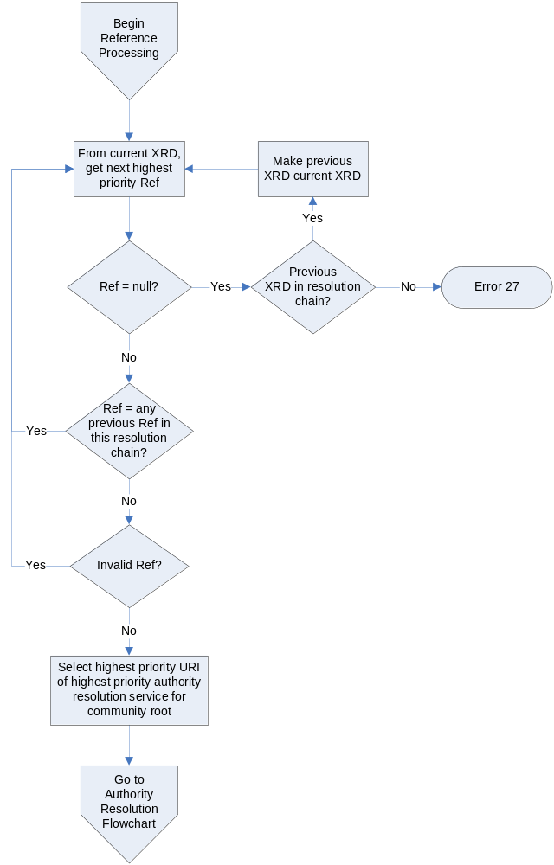
Figure 3: Flowchart for XRI reference processing.
Following are the normative rules that apply to reference processing:
- The client resolver MUST begin by selecting the highest priority xrd:XRD/xrd:Ref element in the current XRD. If it is not found, the client resolver SHOULD check to see if there is a previous XRD in the current resolution chain. If so, the client resolver SHOULD make the previous XRD the current XRD and repeat this step. Othewise, the client resolver SHOULD return an error 27 VALID_REF_NOT_FOUND as defined in section 7.
- If the contents of the selected xrd:XRD/xrd:Ref element is a relative XRI, the resolver MUST first convert it into an absolute XRI using the procedure defined in section 2.4 of [XRISyntax]. (Note that the base XRI is the XRI used to request the current XRD.)
- If the contents of the selected xrd:XRD/xrd:Ref element is an XRI that has been followed previously in this XRI resolution chain, it MUST be discarded and step 1 repeated. This prevents circular references.
- If the contents of the selected xrd:XRD/xrd:Ref element does not meet the input processing rules defined in section 4.2, it MUST be discarded and step 1 repeated.
- Using this new absolute XRI, the client resolver MUST begin resolution of a new XRDS document beginning starting with the community root authority as defined in section 4.3.2. For reference processing to complete successfully, the client resolver MUST complete resolution of all authority subsegments in this new absolute XRI as defined in section 4.3.4. If the new absolute XRI includes a local path and/or query component, the client resolver MUST also complete selection of a service endpoint as defined in section 5. In this case the highest priority service endpoint URI returned as defined in section 5.8 is the new authority resolution service endpoint URI.
- If step 5 results in a complete XRDS document whose final XRD describes the next requested service endpoint, the client resolver MUST include this XRDS document in the parent XRDS document as defined in section 4.6.3.
- The final XRDS document being constructed by the client resolver MUST include both the XRD containing the xrd:XRD/xrd:Ref element being following and the XRD returned as a result of resolving each additional authority subsegment appended in step 4 above. In this manner a consuming application may verify the complete chain of XRDs obtained to resolve the original XRI even if resolution traverses multiple references. Note that an XRD will not be included for the community root subsegment of a reference as this is part of the configuration of the client resolver.
Open issue: we are still working out the way in which the XRDs produced by following a reference are recorded in an XRDS document.

Nesting XRDS Documents
If an XRI reference is followed successfully, the XRDS document containing the source of the reference (the xrd:XRD element containing the xrd:XRD/xrd:Ref element being followed) MUST include the xrds:XRDS element describing the reference. This xrds:XRDS element MUST immediately follow the source the xrd:XRD element. In addition, the value of the xrds:XRDS/@xrds:ref attribute MUST be set to the value of the xrd:XRD/xrd:Ref element it describes.
This results in nested XRDS documents, with each nested XRDS document describing the reference that was followed. See the example below. It uses the following set of XRIs:
- The original XRI being resolved is “xri://@a*b*c”.
- “xri://@a*b” does not contain an authority resolution service endpoint but includes a reference to “xri://@x*y”.
<XRDS xmlns="xri://$xrds" ref="xri://@a*b*c">
<xrd:XRD xmlns:xrd="xri://$xrd*($v*2.0)" xml:id="xrd-123456">
<xrd:Query>*a</xrd:Query>
...
<xrd:Service>
<xrd:Type>xri://$res*auth*($v*2.0)</xrd:Type>
<xrd:URI>http://a.example.com</xrd:URI>
</xrd:Service>
</xrd:XRD>
<xrd:XRD xml:id="xrd-234567">
<xrd:Query>*b</xrd:Query>
...
<xrd:Ref>xri://@x*y</xrd:Ref>
<xrd:Service>
...no authority resolution service endpoint...
</xrd:Service>
</xrd:XRD>
<XRDS ref="xri://@x*y">
<xrd:XRD xml:id="xrd-345678">
<xrd:Query>*x</xrd:Query>
...
<xrd:Service>
<xrd:Type>xri://$res*auth*($v*2.0)</xrd:Type>
<xrd:URI>http://x.example.com</xrd:URI>
</xrd:Service>
</xrd:XRD>
<xrd:XRD xml:id="xrd-456789">
<xrd:Query>*y</xrd:Query>
...
<xrd:Service>
<xrd:Type>xri://$res*auth*($v*2.0)</xrd:Type>
<xrd:URI>http://y.example.com</xrd:URI>
</xrd:Service>
</xrd:XRD>
</XRDS>
<xrd:XRD xml:id="xrd-876543">
<xrd:Query>*c</xrd:Query>
...
<xrd:Service>
...final service endpoints described here...
</xrd:Service>
</xrd:XRD>
</XRDS>

Service Endpoint Selection

Introduction
If the authority resolution phase of the XRI resolution framework is successful, the output is an XRDS document describing the final authority. An optional second phase of the XRI resolution framework is for a client resolver to continue processing of this XRDS document to select a requested service endpoint. The successful output of this phase is an array of URIs representing the network address of the service endpoint.
In certain circumstances, this service endpoint selection phase is required, such as in XRI proxy resolution (section 6).

Determining the Service Endpoint Selection Process
Two of the XRI resolution parameters defined in section 4.2.1, (xri_service_type and xri_media_type) are used in the service endpoint selection phase. In this section the former is called the Type parameter and the latter the MediaType parameters. A third parameter, Path, is the path component of the QXRI, if present. All three parameters are optional.
Based on these parameters, Figure 4 illustrates the logical flow for determining the service endpoint selection process.
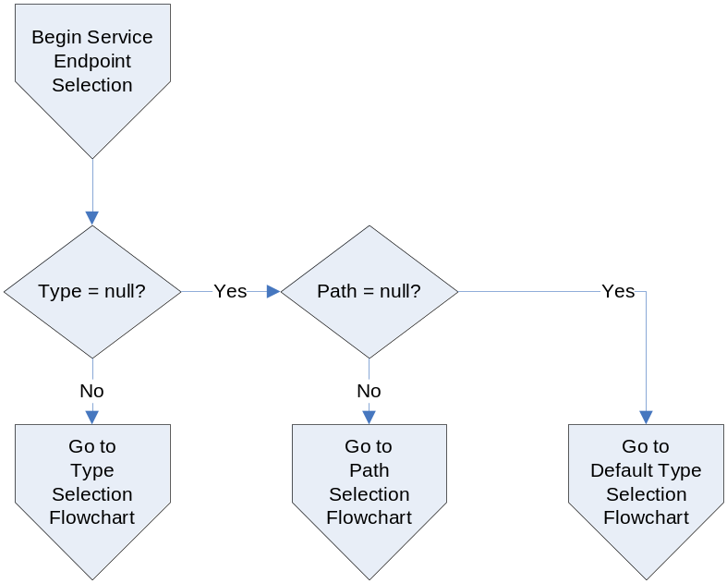
Figure 4: Flowchart for determing the service endpoint selection process.
Following are the normative rules governing this determination process:
- If the Type parameter is specified, the process defined in section 5.3 MUST be used. The result of this process MUST be either selection of a service endpoint of this type or an error. In this case, the Path and MediaType parameters if present MAY only be used to specify a preference if more than one service matches the Type. If both are specified, the Path parameter MUST take precedent over the MediaType parameter.
- If the Type parameter is not specified but the Path parameter is specified, the process defined in section 5.4 MUST be used. In this case, the MediaType parameter MAY be used to specify a preference if there is more than one matching service endpoint.
- If neither the Type or Path parameters are specified, the Type parameter is defaulted and the process defined in section 5.5 MUST be used. The result of this process MUST be either selection of a service endpoint of one of the two default types or an error. In this case, the MediaType parameter MAY be used to specify a preference if more than one service matches the default type.

Selection by Specified Type
This service endpoint selection process is used when a consuming application (or QXRI) knows the specific type of service it requires. Figure 5 illustrates the logical processing flow.
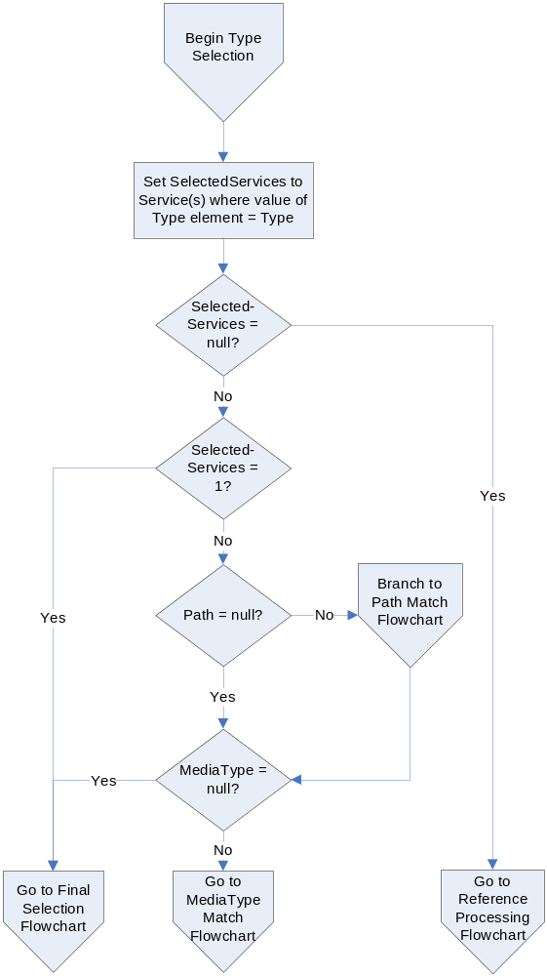
Figure 5: Flowchart for selecting a service endpoint by Type.
The normative rules for selection by specified type are:
- This service endpoint selection process MUST operate over all xrd:XRD/xrd:Service/xrd:Type elements in the current XRD.
- To match a service endpoint, the value of the Type parameter MUST be equivalent to the value of an xrd:XRD/xrd:Service/xrd:Type element. Both values SHOULD be normalized according to the requirements of their identifier scheme prior to input. XRI client resolvers MAY perform normalization of these values but MUST NOT be required to do so.
- If there is no match in the current XRD, the client resolver MUST perform reference processing to attempt to obtain another XRD as defined in section 4.6.
- If only a single match is found, the client resolver MUST perform the final service endpoint selection process defined in section 5.8.
- If more than one match is found and the Path parameter is present, the client resolver MUST perform the path matching process defined in section 5.6.
- If there is still more than one match after step 5 above, or if the MediaType parameter is present and the Path parameter is absent, the client resolver MUST perform the media type matching process defined in section 5.7.

Selection by Path
If the Type parameter is not specified, the Path parameter still provides a means to select a specific service endpoint. This logical processing flow is illustrated in Figure 6.
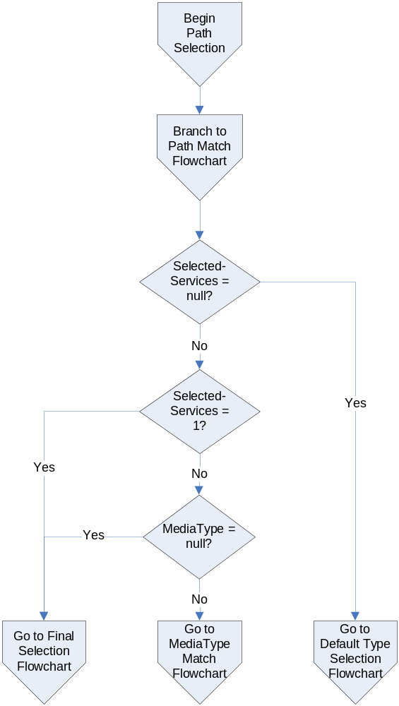
Figure 6: Flowchart for selecting a service endpoint by Path.
The normative rules for selection by path are:
- This selection endpoint selection process MUST operate over all xrd:XRD/xrd:Service/xrd:Path elements in the current XRD.
- To match a service endpoint, the client resolver MUST follow the process defined in section 5.6, Path Matching.
- If there is no path match, the client resolver MUST switch to the default type selection process defined in section 5.5
- If only a single match is found, the client resolver MUST perform the final service endpoint selection process defined in section 5.8.
- If more than one match is found and the MediaType parameter is present, the client resolver MUST perform the media type matching process defined in section 5.7.

Selection by Default Type
If both the Type and Path parameters are absent, or if the Path parameter did not produce a match, service endpoint selection proceeds using a default type. Figure 5 illustrates the logical processing flow.
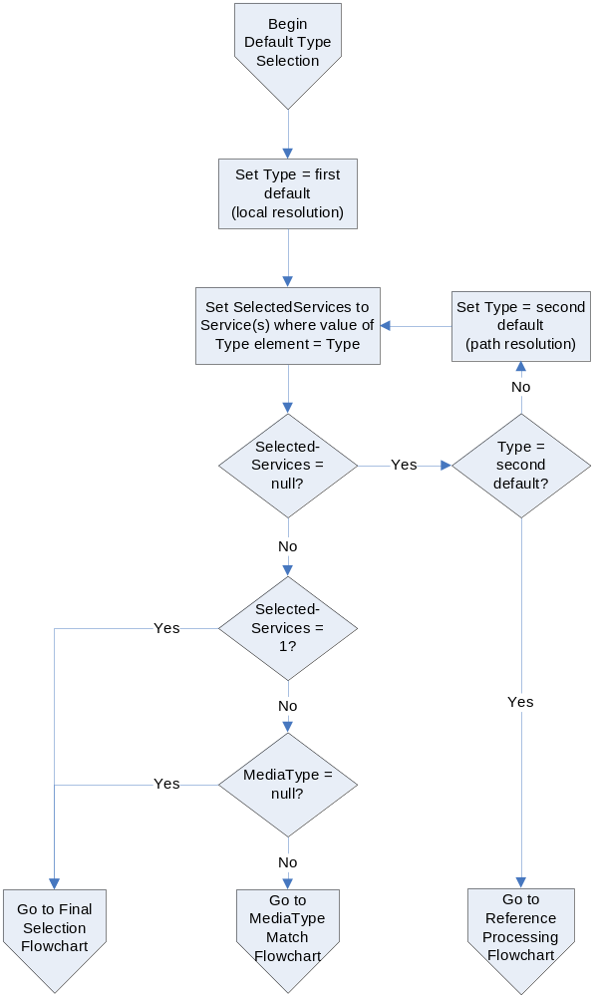
Figure 7: Flowchart for selecting a service endpoint by a default Type.
The normative rules for selection by default type are identical to those defined in section 5.3 with the following differences:
- Initially the value of the xri_service_type parameter MUST be set to the first default value of “xri://$res*local”.
- If there is no match, the client resolver MUST try again with the xri_service_type parameter set to the second default value of “xri://$res*path”.
- Since the Path parameter is absent, no path matching is necessary.

Path Matching
Path matching is provided to enable authorities to use the local path portion of an XRI to select a service endpoint. To make this option as simple and flexible as possible, a prefix matching algorithm is specified. The logical processing flow is illustrated in Figure 8.
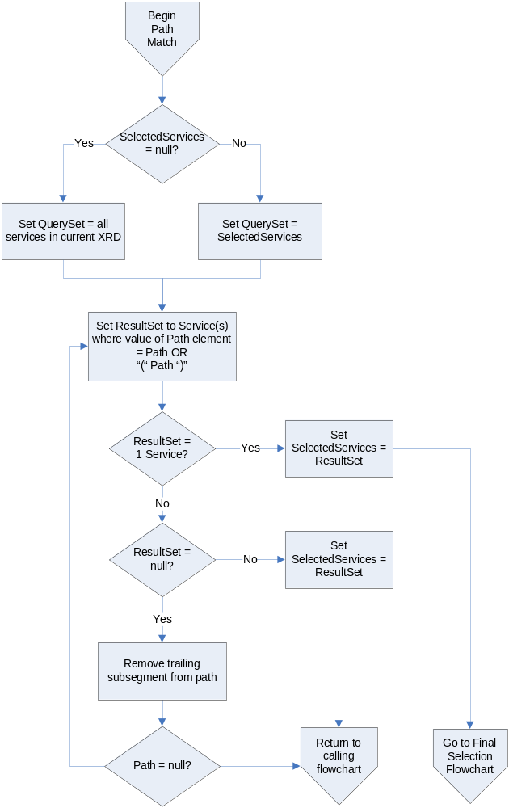
Figure 8: Flowchart for path matching algorithm.
The normative rules for this path matching algorithm are:
- If more than one service endpoint has been selected by the process defined in section 5.3, this algorithm MUST be applied only to these selected service endpoints. If no path match is found, the service endpoints selected prior to the path matching are still selected, and processing MUST proceed as defined in section 5.3.
- A client resolver MUST first normalize the value of the Path parameter and the value of any xrd:XRD/xrd:Service/xrd:Path element by removing any trailing space or delimiter.
- To match a service endpoint, value of the Path parameter MUST be equivalent to the value of an xrd:XRD/xrd:Service/xrd:Path element. This comparison MUST be case-insensitive.
- If there is no match, the client resolver MUST perform the same comparison after enclosing the current Path parameter in parentheses. (This eliminates the need for authorities to specify multiple xrd:XRD/xrd:Service/xrd:Path elements in order to match a path whose value is an XRI that may or may not be expressed as a cross-reference.)
- If there is no match, the client resolver MUST remove the final subsegment of the Path parameter (or the final segment if it contains only one subsegment) and its preceeding delimiter and repeat the process beginning with step 2 above.
- If only a single match is found, the client resolver MUST perform the final service endpoint selection process defined in section 5.8.
- If more than one match is found, the client resolver MUST set the selected services to this new set of selected service endpoints and proceed with processing as defined in the previous sections.
- If no match is found, the client resolver MUST NOT change the current set of selected service endpoints and must instead proceed with processing as defined in the previous sections.

Media Type Matching
The MediaType parameter may only be used as a preference to further select among multiple service endpoints that have already been selected by specified type, path, or default type. The logical flow for this process is illustrated in Figure 9.
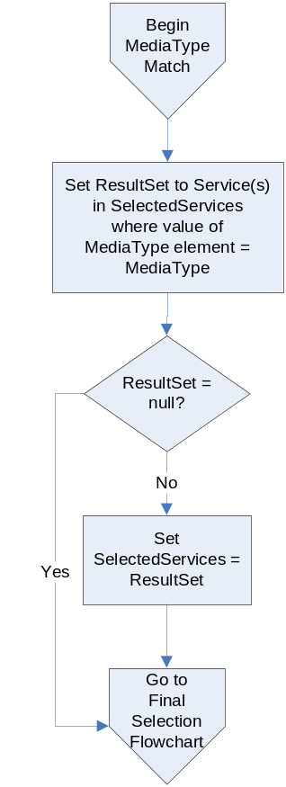
Figure 9: Flowchart for media type matching algorithm.
The normative rules for media type matching are:
- If more than one service endpoint has been selected by the processes defined in the preceeding sections, this algorithm MUST be applied only to these selected service endpoints. If no media type match is found, the service endpoints selected prior to the path matching are still selected, and processing MUST proceed as defined in the preceeding sections.
- To match a service endpoint, the value of the MediaType parameter MUST be equivalent to the value of an xrd:XRD/xrd:Service/xrd:MediaType element. This comparison MUST be case-insensitive.
- If a match is found, the client resolver MUST set the selected services to this new set of selected service endpoints and then perform the final service endpoint selection process defined in section 5.8.
- If no match is found, the client resolver MUST NOT change the current set of selected service endpoints and must instead proceed to perform the final service endpoint selection process defined in section 5.8.

Final Service Endpoint Selection
If the service endpoint selection processes defined in the preceeding sections have completed successfully, the final result is one or more service endpoints selected in the current XRD. Figure 10 illustrates the logical flow for the last step of selecting the final service endpoint.
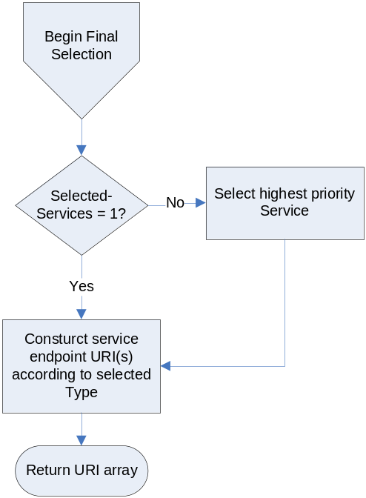
Figure 10: Flowchart for selecing the final service endpoint.
The normative rules for final service endpoint selection are:
- If more than one service endpoint is selection, the client resolver MUST select the highest priority xrd:XRD/xrd:Service element as defined in section 3.3.3.
- If the QXRI contains a path or query component, for each xrd:XRD/xrd:Service/xrd:URI element, the client resolver MUST construct the service endpoint URI as defined in section 5.9.
- The client resolver MUST return the final array of service endpoint URIs in priority order, i.e., in order from highest priority to lowest priority of the source xrd:XRD/xrd:Service/xrd:URI elements as defined in section 3.3.3. In the case where two or more of these elements have equal priority, the corresponding service endpoint URIs SHOULD be returned in random order.

Construction of the Service Endpoint URI(s)
If the QXRI contains a path or query component, the client resolver must construct the URI(s) to return. This process MUST be followed for each xrd:XRD/xrd:Service/xrd:URI element in the final service endpoint. Following are the normative rules for this URI construction process:
- If the value of the xrd:XRD/xrd:Service/xrd:URI element includes a query component, it MUST be removed before proceeding.
- If the result of step 1 does not end with a forward slash (“/”), one MUST be appended before proceeding.
- To the result of step 1, the client resolver MUST append the portion of the QXRI specified in Table 9 according to the value of the xrd:XRD/xrd:Service/xrd:Type element of the final service endpoint selected in section 5.8.
- If a query component was removed in step 1 above, it MUST be appended to the value produced in step 3. [Open issue: what do we do if the value in step 3 already includes a query component?]

Value of Type Element | Components of QXRI to Append
xri://$res*local | Entire QXRI
xri://$res*local*($v*2.0) | Entire QXRI
xri://$res*path | Local part only (path and/or query components)
xri://$res*path*($v*2.0) | Local part only (path and/or query components)
Any other value | Entire QXRI
Table 9: Determining construction of the service endpoint URI(s).

Proxy Resolution

Introduction
This section defines a service for performing HTTP(S) proxy resolution of an entire XRI (both the authority segment and the local part) by use of the generic XRI authority resolution protocol defined in section 4 and the service endpoint selection process defined in section 5. It also defines a standard syntax for expressing an XRI as an HTTP XRI, called an HXRI.
While proxy resolution may be used to request an XRDS document, it is primarily intended to return an HTTP(S) redirect to clients such as browsers that have no native understanding of XRIs or XRI resolution but can process HXRIs. This provides backwards compatability with the large installed base of existing HTTP clients.

Service Type and Media Type
The resolution service defined in this section is identified by the xrd:XRD/xrd:Service/xrd:Type element value “xri://$res*proxy*($v*2.0)”. It will accept either the xrd:XRD/xrd:Service/xrd:MediaType value “application/xrds+xml” or “application/xrds-saml+xml”.
It may appear to be of limited value to advertise proxy resolution service in an XRD if a client resolver needs to be able perform local XRI resolution in order to retreive the XRD. However advertising a proxy resolution service in the XRD for a community root authority can be useful to applications that need to automatically generate HXRIs for resolution by non-XRI-aware clients in that community. Those applications may obtain the current HXRI prefix for proxy resolution from the community root XRD. See sections 4.3.3 and 6.3.

HXRIs
Definition of a standard syntax for expressing an XRI as an HTTP XRI (HXRI) has two benefits:
- It allows XRIs to be used anyplace an HTTP URI can appear, including in Web pages, electronic documents, email messages, instant messages, etc.
- It allows XRI-aware processors and search agents to recognize an HXRI and extract the embedded XRI for direct processing and indexing.
To make this syntax as simple as possible for XRI-aware processors or search agents to recognize, an HXRI consists of a fully qualified HTTP or HTTPS URI authority segment that begins with the domain name “xri.”. The query XRI (QXRI) is then appended as the entire local path (and query component, if present.) In essence, the the proxy resolver URI including the terminating forward slash serves as a machine-readable prefix for an absolute XRI.
The normative ABNF for an HXRI is defined below based on the XRI and ireg-name productions defined in [XRISyntax]:
HXRI = proxy-resolver "/" QXRI
proxy-resolver = ( "http://" / "https://" ) proxy-reg-name
proxy-reg-name = "xri." ireg-name
QXRI = XRI
URI processors that recognize XRIs SHOULD interpret the local part of any HTTP or HTTPS URI that conforms to this ABNF as an XRI provided the domain name is at least three levels deep (e.g., “xri.example.com”.) If the URI conforms to this ABNF but the domain name is only two levels deep, URI processors SHOULD interpret the local part as an XRI only if the domain has explicitly declared that it functions as an XRI proxy resolver.
Publishers of XRIs that need to be understood by non-XRI-aware clients SHOULD publish them as HTTP URIs conforming to the HXRI production.

Input Parameters
[TODO – this section should explain the additional option of supplying the XRI resolution parameters xrd_res_type and xrd_service_type as HTTP X-headers. Note that xrd_media_type can already be supplied in the HTTP Accept header.]

Protocol
Following are the normative requirements for proxy resolution:
- The query XRI (QXRI) MUST be a valid XRI as specified in section 4.2.
- The proxy resolution service MUST first perform authority resolution as defined in section 4, including lookahead authority resolution as defined in section 4.3.5.
- If resolution is successful and the MediaType parameter is “application/xrds+xml” or “application/xrds-saml+xml”, the proxy resolution service MUST return the final XRD using the requested media type to the client.
- If resolution is successful and the MediaType parameter is absent, null, or any other value than those defined in step 3, the proxy resolution service MUST select the service endpoint as defined in section 5 and MUST return the highest priority final service endpoint URI as defined in section 5.8. This URI MUST be returned as an HTTP 3XX redirect.
- If resolution is not successful, the proxy resolution service MUST return an error as defined in section 7.4.
- Proxy resolvers are uniquely positioned to take advantage of caching and SHOULD use it to resolve the same XRIs or XRI components for multiple clients as defined in section 8.4.

Differences Between Proxy Resolution Servers
A proxy resolution request may be sent to any proxy resolution server that will accept the request. All proxy resolution servers SHOULD attempt to deliver uniform responses given the same QXRI. However because proxy resolution servers are required to perform XRI resolution as a client resolver, they must make decisions about priorities, reference processing, and trust policies on behalf of the client they are proxying. Since they decisions may be based on local policy or implementation, it is possible for different proxy resolution servers to return different results given the same QXRI.

Error Processing

Error Codes
The error codes in the XRI resolution framework are broken into five categories:
- 10-19: Input errors
- 20-29: Generic authority resolution errors
- 30-39: Trusted authority resolution errors
- 40-49: Service endpoint selection errors
- 99: Unknown errors

Code | Symbolic Error | Phase(S) | Description
0 | SUCCESS | Any | Operation was successful
10 | INVALID_INPUT | Input | Generic input error
11 | INVALID_XRI | Input | Input QXRI does not conform to XRI syntax
12 | INVALID_TYPE | Input | Input Service Type is invalid
13 | INVALID_MEDIA_TYPE | Input | Input Media Type is invalid
15 | UNKNOWN_ROOT | Input | Community root specified in QXRI is not configured in the resolver
20 | NETWORK_ERROR | Authority resolution | Generic error during authority resolution phase (includes uncaught exception, system error, network error)
21 | UNEXPECTED_RESPONSE | Authority resolution | When querying an authority resolution service, the SEP returned a non-200 HTTP status
23 | INVALID_XRDS | Authority resolution | Invalid XRDS received from an authority resolution SEP (includes malformed XML, truncated content, or wrong Content-type.)
24 | UNEXPECTED_XRD | Authority resolution | Value of the xrd:Query element does not match the subsegment requested
25 | SUBSEGMENT_NOT_FOUND | Authority resolution | Responding authority does not have an XRI matching the query
27 | REF_NOT_FOUND | Authority resolution | There are more authority subsegments to be resolved but the resolver is not able to locate an authority resolution service in the current returned XRD or via reference processing
31 | UNVERIFIED_SIGNATURE | Trusted authority resolution | Signature verification failed.
41 | TYPE_NOT_FOUND | Service selection | The specified service type could not be found in the current XRD or via reference processing
99 | UNKNOWN_ERROR | Any | Default if the error condition does not fit any of the above

Error Messages
[TODO – This section Steve has expressed strong opinions about, so he’s nominated to draft the text.]

Error Handling in Lookahead Resolution
In lookahead resolution, defined in section 4.3.5, an authority resolution service acts as a client resolver of other authority resolution service endpoints. If it receives intermediate errors in its role as a client resolver, it MAY ignore them and continue reference processing as defined in section 4.6.
However if the ultimate result of the lookahead resolution process is an error, the authority resolution service SHOULD return that error using the xrd:XRD/xrd:Status element of the final xrd:XRD element in the XRDS document returned to the client resolver. If so, the xrd:XRD/xrd:Status/@code attribute MUST be set to the applicable error code defined in section 7.1 and the value of the xrd:XRD/xrd:Status element SHOULD be set to an appropriate error message as defined in section 7.2.

Error Handling in Proxy Resolution
In proxy resolution, defined in section 6, an HTTP(S) server acts as a client resolver of other authority resolution service endpoints. If it receives intermediate errors in its role as a client resolver, it MAY ignore them and continue reference processing as defined in section 4.6.
However if the ultimate result of the proxy resolution process is an error, the proxy resolution service MUST return the appropriate error code and MAY return an accompanying error message string as plain text with the media type “text/plain”.
[Open issue: is there a better alternative? Should we further specify the plain text format so it is machine parseable? Should we also specify an HTTP header value so it is machine parseable? Or should return an XRDS document with the media type “text/plain” so it is human readable?]

Use of HTTP(S)

HTTP Errors
[TODO – This subsection must be reviewed thoroughly to determine if any changes should be made based on the rest of the XRI resolution error processing defined in the previous section. Also, we should decide if this subsection should be moved to section 7.]
Lookahead and proxy resolvers MUST “pass through” to the client resolver any HTTP error codes resulting from resolution if the proxy or lookahead resolver cannot proceed with resolution due to an HTTP error condition. For example, if, during resolution on behalf of a client, a proxy resolution server is returned a 404 error code by another authoritative resolution server, it must return that 404 code to its client.
Upon encountering an HTTP error code that halts the lookahead or proxy resolver’s ability to complete resolution, the proxy or lookahead resolver MUST return an xrd:XRDS document in the body of the HTTP error response. This xrd:XRDS document MUST contain the list of xrd:XRD elements corresponding to the subsegments successfully resolved or retrieved from cache. For example, if a proxy is asked to resolve @a*b*c, and successfully resolves @a*b, but receives a HTTP 404 on resolving *c, it will return an HTTP 404 response to its client that include xrd:XRD elements for @, *a, and *b. In this way, the resolver indicates to the client resolver that *c is the subsegment causing the 404 response.
This use of error codes, while slightly unusual, conforms to the requirements of [RFC2616], specifically sections 10.4 and 10.5, which state that “the server SHOULD include an entity containing an explanation of the error situation.” The combination of the error code and the list of successfully resolved xrd:XRD elements explains to the client exactly which subsegment caused the error. This should save both the client and the authority returning the error code an extra HTTP request/response cycle.
Even when given an HTTP error response, client resolvers SHOULD consider the xrd:XRD elements returned in the content of the HTTP response as valid cacheable responses. All other rules about XRDs, including those specified in Section 4.5 for trusted resolution, also apply.

HTTP Headers

Caching
The HTTP caching capabilities described by [RFC2616] should be leveraged for all types of XRI resolution service. Specifically, implementations SHOULD implement the caching model described in section 13 of [RFC2616], and in particular, the “Expiration Model” of section 13.2, as this requires the fewest round-trip network connections.
All XRI resolution servers SHOULD send the Cache-Control or Expires headers in their responses per section 13.2 of [RFC2616] unless there are overriding security or policy reasons to omit them.
Note that HTTP Cache headers SHOULD NOT conflict with expiration information in an XRD. That is, the expiration date specified by HTTP caching headers SHOULD NOT be later than any of the expiration dates for any of the xrd:XRD/xrd:Expires elements returned in the HTTP response. This implies that lookahead and proxy resolvers SHOULD compute the “soonest” expiration date for the XRDs in a resolution chain and ensure a later date is not specified by the HTTP caching headers for the HTTP response.

Location
During HTTP interaction, “Location” headers may be present per [RFC2616] (i.e., during 3XX redirects). Redirects SHOULD be made cacheable through appropriate HTTP headers, as specified in section 8.2.1.

Content-Type
For authority resolution, the “Content-type” header in the 2XX responses MUST contain the value “application/xrd+xml” or “application/xrd-saml+xml” specifying that the content is a generic XRD (section 4.3) or a trusted XRD (section 4.5) respectively.
For local resolution, clients and servers MAY negotiate content type using standard HTTP content negotiation features. Regardless of whether this feature is used, however, the server MUST respond with an appropriate media type in the “Content-type” header if the resource is found and an appropriate content type is returned.
To obtain a redirect in proxy resolution, clients MUST NOT use the media types defined for authority resolution.

Other HTTP Features
HTTP provides a number of other features including transfer-coding, proxying, validation-model caching, and so forth. All these features may be used insofar as they do not conflict with the required uses of HTTP described in this document.

Caching and Efficiency
In addition to HTTP-level caching, resolution clients are encouraged to perform caching at the application level. For best results, however, resolution clients SHOULD be conservative with caching expiration semantics, including cache expiration dates. This implies that in a series of HTTP redirects, for example, the results of the entire process SHOULD only be cached as long as the shortest period of time allowed by any of the intermediate HTTP responses.
Because not all HTTP client libraries expose caching expiration to applications, identifier authorities SHOULD NOT use cacheable redirects with expiration times sooner than the expiration times of other HTTP responses in the resolution chain. In general, all XRI deployments should be mindful of limitations in current HTTP clients and proxies.
The cache expiration time of an XRD may also be explicitly limited by the identifier authority. If the expiration time in xrd:XRD/xrd:Expires is sooner than the expiration time calculated from the HTTP caching semantics, the XRD MUST be discarded before the expiration time in xrd:XRD/xrd:Expires. Note also that the SAML assertion used in trusted resolution (section 4.5) may cause invalidation of a XRD even before HTTP caching semantics or the xrd:XRD/xrd:Expires element.
With both application-level and HTTP-level caching, the resolution process is designed to have minimal overhead. Resolution of each qualified subsegment of an XRI authority segment is a separate step described by a separate XRD, so intermediate results can typically be cached in their entirety. For this reason, resolution of higher-level (i.e., further to the left) qualified subsegments, which are common to more identifiers, will naturally result in a greater number of cache hits than resolution of lower-level subsegments.

Extensibility and Versioning

Extensibility

Extensibility of XRDs
The XRD schema in Appendix A use an an open-content model that is designed to be extended with other metadata. In most places, extension elements and attributes from namespaces other than “xri://$xrd*($v*2.0)” are explicitly allowed. These extension points are designed to simplify default processing using a “Must Ignore” rule. The base rule is that unrecognized elements and attributes, and the content and child elements of unrecognized elements, MUST be ignored. As a consequence, elements that would normally be recognized by a processor MUST be ignored if they appear as descendants of an unrecognized element.
Extension elements MUST NOT require new interpretation of elements defined in this document. If an extension element is present, a processor MUST be able to ignore it and still correctly process the XRD document.
Extension specifications MAY simulate “Must Understand” behavior by applying an “enclosure” pattern. Elements defined by the XRD schema in Appendix A whose meaning or interpretation is modified by extension elements can be wrapped in a extension container element defined by the extension specification. This extension container element SHOULD be in the same namespace as the other extension elements defined by the extension specification.
Using this design, all elements whose interpretations are modified by the extension will now be contained in the extension container element that will be ignored by clients or other applications unable to process the extension. The following example illustrates this pattern using an extension container element from an extension namespace (“other:SuperService”) that contains an extension element (“other:ExtensionElement”):
<XRD>
<other:SuperService>
<Service>
…
<other:ExtensionElement>…</other:ExtensionElement>
</Service>
</other:SuperService>
<Service>
…
</Service>
</XRD>
In this example, the other:ExtensionElement modifies the interpretation or processing rules for the parent xrd:Service element and therefore must be understood by the consumer for the proper interpretation of the parent xrd:Service element. To preserve the correct interpretation of the xrd:Service element in this context, the xrd:Service element is “wrapped” so only consumers that understand elements in the other:SuperService namespace will attempt to process the xrd:ProviderID element.

Other Points of Extensibility
The use of HTTP and XML in the design of XRDS documents, XRD elements, and the XRI resolution framework provides additional specific points of extensibility:
- Specification of new resolution service types or other service types using XRIs, IRIs, or URIs as values of the xrd:XRD/xrd:Service/xrd:Type element.
- HTTP negotiation of content types, language, encoding, etc.
- Use of HTTP redirects (3XX) or other response codes defined by [RFC2616].
- Use of cross-references within XRIs, particularly for associating new types of metadata with a resource.

Versioning
Versioning of the XRI specification set is expected to occur infrequently. Should it be necessary, this section describes versioning guidelines.

Version Numbering
[Open Issue – related to the Version Element open issue: Do we still need to define the formula below or, if we are going to use versioned XRIs, can we just default to the version metadata and version comparison algorithm defined in XRI Metadata 2.0?]
Specifications from the OASIS XRI Technical Committee use a Major and Minor version number expressed in the form Major.Minor. The version number MajorB.MinorB is higher than the version number MajorA.MinorA if and only if:
MajorB > MajorA OR ( ( MajorB = MajorA ) AND MinorB > MinorA )

Versioning of the XRI Resolution Specification
New releases of the XRI Resolution specification may specify changes to the resolution protocols and/or the XRD schema in Appendix A. When changes affect either of these, the resolution service type version number will be changed. Where changes are purely editorial, the version number will not be changed.
In general, if a change is backward-compatible, the new version will be identified using the current major version number and a new minor version number. If the change is not backward-compatible, the new version will be identified with a new major version number.

Versioning of XRDs
The xrd:XRDS document element is intended to be a completely generic container, i.e., to have no specific knowledge of the elements it may contain. Therefore it has no version element, and can remain stable indefinitely as there is no need to version its namespace.
The xrd:XRD element has an optional version attribute. When used, the value of this attribute MUST be the version value of the XRI Resolution specification to which its containing elements conform.
When new versions of the XRI Resolution specification are released, the namespace for the XRD schema may or may not be changed. If there is a major version number change, the namespace for the xrd:XRD schema is likely to change. If there is only a minor version number change, the namespace for the xrd:XRD schema may remain unchanged.
In general, maintaining namespace stability and adding to or changing the content of a schema are competing goals. While certain design strategies can facilitate such changes, it is difficult to predict how existing implementations will react to any given change, making forward compatibility difficult to achieve. Nevertheless, the right to make such changes in minor revisions is reserved. Except in special circumstances (for example, to correct major deficiencies or to fix errors), implementations should expect forward-compatible schema changes in minor revisions, allowing new messages to validate against older schemas.
Implementations SHOULD expect, and be prepared to deal with, new extensions and message types in accordance with the processing rules laid out for those types. Minor revisions may introduce new types that leverage the extension facilities described in section 9.1. Older implementations SHOULD reject such extensions gracefully when they are encountered in contexts with specific semantic requirements.

Versioning of Protocols
The protocols defined in this document may also be versioned by future releases of the XRI Resolution specification. If these protocols are not backward-compatible with older implementations, they will be assigned a new XRI for use in identifying their service type in XRDs. See section 2.2.
Note that it is possible for version negotiation to happen in the protocol itself. For example, HTTP provides a mechanism to negotiate the version of the HTTP protocol being used. If and when an XRI resolution protocol provides its own version-negotiation mechanism, the specification is likely to continue to use the same XRI to identify the protocol as was used in previous versions of the XRI Resolution specification.

Security and Data Protection
Significant portions of this specification deal directly with security issues, and these will not be summarized again here. In addition, basic security practices and typical risks in resolution protocols are well-documented in many other specifications. Only security considerations directly relevant to XRI resolution are included here.

DNS Spoofing
As the specified resolution mechanism is dependent on DNS, the accuracy of the XRI resolution response is dependent on the accuracy of the original DNS query. When trustworthy, unambiguous, authoritative responses are required, the trusted resolution protocol defined by this specification is recommended. Resolution results obtained using this protocol can be evaluated independently of DNS resolution results. While this does not solve the problem of DNS spoofing, it does allow the client to detect an error condition and reject the resolution result as untrustworthy. For environments that require higher confidence in the result of DNS resolution, DNSSEC [DNSSEC] is recommended as a supplement to trusted resolution as defined by this specification.

HTTP Security
Many of the security considerations set forth in HTTP/1.1 [RFC2616] apply to XRI Resolution protocols defined here. In particular, confidentiality of the communication channel is not guaranteed by HTTP. Server-authenticated HTTPS should be considered in cases where confidentiality of resolution requests and responses is desired.
Special consideration should be given to proxy and caching behaviors to ensure accurate and reliable responses from resolution requests. For various reasons, network topologies increasingly have transparent proxies, some of which may insert VIA and other headers as a consequence, or may even cache content without regard to caching policies set by a resource’s HTTP authority.
Implementations of XRI Proxies and caching authorities should also take special note of the security recommendations in HTTP/1.1 [RFC2616] section 15.7

Caching Authorities
In addition to traditional HTTP caching proxies, XRI resolution authority proxies may be a part of the resolution topology. Such proxies should take special precautions against cache poisoning, as these caching entities may represent trust decision points within a deployment’s resolution architecture.

Lookahead and Proxy Resolution
During proxy resolution, some or all of an XRI is provided to the proxy resolver. During lookahead resolution, subsegments of the XRI authority segment for which the resolving network endpoint is not authoritative may be revealed to that service endpoint.
In both cases, privacy considerations should be evaluated before disclosing such information.

SAML Considerations
Trusted resolution must adhere to the rules defined by the SAML 2.0 Core Specification. Particularly noteworthy are the XML Transform restrictions on XML Signature defined in SAML and the enforcement of the SAML Conditions element regarding the validity period.

Community Root Authorities
The XRI authority information for a community root needs to be well-known to the clients that request resolution within that community. For trusted resolution, this includes the URIs, the xrd:XRD/xrd:ProviderID, and the ds:KeyInfo information. An acceptable means of providing this information is for the community root authority to produce a self-signed XRD and publish it to a server-authenticated HTTPS endpoint. Special care should be taken to ensure the correctness of such an XRD; if this information is incorrect, an attacker may be able to convince a client of an incorrect result during trusted resolution.

Denial-Of-Service Attacks
XRI Resolution, including trusted resolution, is vulnerable to denial-of-service (DOS) attacks typical of systems relying on DNS and HTTP.

Limitations of Trusted Resolution
While the trusted resolution protocol specified in this document provides a way to verify the integrity of a successful XRI resolution, it does not provide a way to verify the integrity of a resolution failure. Reasons for this limitation include the prevalence of non-malicious network failures, the existence of denial-of-service attacks, and the ability of a man-in-the-middle attacker to modify HTTP responses when resolution is not performed over HTTPS.
Additionally, there is no revocation mechanism for the keys used in trusted resolution. Therefore, a signed resolution's validity period should be limited appropriately to mitigate the risk of an incorrect or invalid resolution.

References

Normative
[DNSSEC] D. Eastlake, Domain Name System Security Extensions, http://www.ietf.org/rfc/rfc2535, RFC 2535, March 1999.
[RFC2046] N. Borenstein, N. Freed, Multipurpose Internet Mail Extensions (MIME) Part Two: Media Types, http://www.ietf.org/rfc/rfc2046.txt, RFC 2046, November 1996.
[RFC2119] S. Bradner, Key words for use in RFCs to Indicate Requirement Levels, http://www.ietf.org/rfc/rfc2119.txt, RFC 2119, March 1997.
[RFC2141] R. Moats, URN Syntax, http://www.ietf.org/rfc/rfc2141.txt, IETF RFC 2141, May 1997.
[RFC2483] M. Meallling, R. Daniel Jr., URI Resolution Services Necessary for URN Resolution, http://www.ietf.org/rfc/rfc2483.txt, RFC 2483, January 1999.
[RFC2616] R. Fielding, J. Gettys, J. Mogul, H. Frystyk, L. Masinter, P. Leach, T. Berners-Lee, Hypertext Transfer Protocol -- HTTP/1.1, http://www.ietf.org/rfc/rfc2616.txt, RFC 2616, June 1999.
[SAML] S. Cantor, J. Kemp, R. Philpott, E. Maler, Assertions and Protocols for the OASIS Security Assertion Markup Language (SAML) V2.0, http://www.oasis-open.org/committees/security, March 2005.
[XML] T. Bray, J. Paoli, C. Sperberg-McQueen, E. Maler, F. Yergeau, Extensible Markup Language (XML) 1.0, Third Edition, World Wide Web Consortium, http://www.w3.org/TR/REC-xml/, February 2004.
[XMLDSig] D. Eastlake, J. Reagle, D. Solo et al., XML-Signature Syntax and Processing, World Wide Web Consortium, http://www.w3.org/TR/xmldsig-core/, February, 2002.
[XMLID] J. Marsh, D. Veillard, N. Walsh, xml:id Version 1.0, World Wide Web Consortium, http://www.w3.org/TR/2005/REC-xml-id-20050909, September 2005.
[XMLSchema] H. Thompson, D. Beech, M. Maloney, N. Mendelsohn, XML Schema Part 1: Structures Second Edition, World Wide Web Consortium, http://www.w3.org/TR/xmlschema-1/, October 2004.
[XRIMetadata] D. Reed, Extensible Resource Identifier (XRI) Metadata V2.0, http://docs.oasis-open.org/xri/xri/V2.0/xri-metadata-V2.0-cd-01.pdf, March 2005.
[XRISyntax] D. Reed, D. McAlpin, Extensible Resource Identifier (XRI) Syntax V2.0, http://docs.oasis-open.org/xri/xri/V2.0/xri-syntax-V2.0-cd-01.pdf, March 2005.

Informative
[REST] http://internet.conveyor.com/RESTwiki/moin.cgi/FrontPage
[XRIIntro] D. Reed, D. McAlpin, Introduction to XRIs, http://docs.oasis-open.org/xri/xri/V2.0/xri-intro-V2.0.pdf, Work-In-Progress, March 2005.
[XRIGuide] [Editors here], XRI Implementer's Guide v2.0, [link here], Work-In-Progress, October 2005.
[XRIReqs] G. Wachob, D. Reed, M. Le Maitre, D. McAlpin, D. McPherson, Extensible Resource Identifier (XRI) Requirements and Glossary v1.0, http://www.oasis-open.org/apps/org/workgroup/xri/download.php/2523/xri-requirements-and-glossary-v1.0.doc, June 2003.
- XML Schema for XRDS and XRD (Normative)
<?xml version="1.0" encoding="UTF-8"?>
<xs:schema targetNamespace="xri://$xrds" elementFormDefault="qualified" xmlns:xs="http://www.w3.org/2001/XMLSchema" xmlns:xrds="xri://$xrds">
<!-- Utility patterns -->
<xs:attributeGroup name="otherattribute">
<xs:anyAttribute namespace="##other" processContents="lax"/>
</xs:attributeGroup>
<xs:group name="otherelement">
<xs:choice>
<xs:any namespace="##other" processContents="lax"/>
<xs:any namespace="##local" processContents="lax"/>
</xs:choice>
</xs:group>
<!-- Patterns for elements -->
<xs:element name="XRDS">
<xs:complexType>
<xs:sequence>
<xs:group ref="xrds:otherelement" minOccurs="0" maxOccurs="unbounded"/>
</xs:sequence>
<xs:attributeGroup ref="xrds:otherattribute"/>
<xs:attribute name="ref" type="xs:anyURI" use="optional"/>
</xs:complexType>
</xs:element>
</xs:schema>

[Open Issues in the XRD schema (below): 1) we need to determine the correct way to specify use of the xml:id attribute, 2) we need to eliminate the version attribute if we are not going to use it, 3) we need to confirm that Gabe’s extensibility pattern has been correctly applied throughout.]

<?xml version="1.0" encoding="UTF-8"?>
<xs:schema targetNamespace="xri://$xrd*($v*2.0)" elementFormDefault="qualified" xmlns:xs="http://www.w3.org/2001/XMLSchema" xmlns:ds="http://www.w3.org/2000/09/xmldsig#" xmlns:xrd="xri://$xrd*($v*2.0)">
<!-- Utility patterns -->
<xs:attributeGroup name="otherattribute">
<xs:anyAttribute namespace="##other" processContents="lax"/>
</xs:attributeGroup>
<xs:group name="otherelement">
<xs:choice>
<xs:any namespace="##other" processContents="lax"/>
<xs:any namespace="##local" processContents="lax"/>
</xs:choice>
</xs:group>
<xs:complexType name="URIpattern">
<xs:simpleContent>
<xs:extension base="xs:anyURI">
<xs:attributeGroup ref="xrd:otherattribute"/>
</xs:extension>
</xs:simpleContent>
</xs:complexType>
<xs:complexType name="Stringpattern">
<xs:simpleContent>
<xs:extension base="xs:string">
<xs:attributeGroup ref="xrd:otherattribute"/>
</xs:extension>
</xs:simpleContent>
</xs:complexType>
<!-- Patterns for elements -->
<xs:element name="XRD">
<xs:complexType>
<xs:sequence>
<xs:element ref="xrd:Query" minOccurs="0"/>
<xs:element ref="xrd:Status" minOccurs="0"/>
<xs:element ref="xrd:Expires" minOccurs="0"/>
<xs:element ref="xrd:Synonym" minOccurs="0" maxOccurs="unbounded"/>
<xs:element ref="xrd:Ref" minOccurs="0" maxOccurs="unbounded"/>
<xs:element ref="xrd:ProviderID" minOccurs="0"/>
<xs:element ref="xrd:Service" minOccurs="0" maxOccurs="unbounded"/>
<xs:group ref="xrd:otherelement" minOccurs="0" maxOccurs="unbounded"/>
</xs:sequence>
<xs:attribute ref="xrd:id"/>
<xs:attribute ref="xrd:version"/>
<xs:attributeGroup ref="xrd:otherattribute"/>
</xs:complexType>
</xs:element>
<xs:element name="Query" type="xrd:Stringpattern"/>
<xs:element name="Status">
<xs:complexType>
<xs:simpleContent>
<xs:extension base="xrd:Stringpattern">
<xs:attribute name="code" type="xs:int" use="required"/>
<xs:attributeGroup ref="xrd:otherattribute"/>
</xs:extension>
</xs:simpleContent>
</xs:complexType>
</xs:element>
<xs:element name="Expires">
<xs:complexType>
<xs:simpleContent>
<xs:extension base="xs:dateTime">
<xs:attributeGroup ref="xrd:otherattribute"/>
</xs:extension>
</xs:simpleContent>
</xs:complexType>
</xs:element>
<xs:element name="Synonym" type="xrd:URIpattern"/>
<xs:element name="Ref" type="xrd:URIpattern"/>
<xs:element name="ProviderID" type="xrd:URIpattern"/>
<xs:element name="Service">
<xs:complexType>
<xs:sequence>
<xs:element ref="xrd:Type" minOccurs="0" maxOccurs="unbounded"/>
<xs:element ref="xrd:Path" minOccurs="0" maxOccurs="unbounded"/>
<xs:element ref="xrd:MediaType" minOccurs="0" maxOccurs="unbounded"/>
<xs:element ref="xrd:URI" minOccurs="0" maxOccurs="unbounded"/>
<xs:element ref="xrd:ProviderID" minOccurs="0"/>
<xs:group ref="xrd:otherelement" minOccurs="0" maxOccurs="unbounded"/>
</xs:sequence>
<xs:attributeGroup ref="xrd:otherattribute"/>
</xs:complexType>
</xs:element>
<xs:element name="Type" type="xrd:URIpattern"/>
<xs:element name="MediaType" type="xrd:Stringpattern"/>
<xs:element name="Path" type="xrd:Stringpattern"/>
<xs:element name="URI" type="xrd:URIpattern"/>
<xs:attribute name="priority" type="xs:nonNegativeInteger"/>
<xs:attribute name="version" type="xs:string" fixed="2.0"/>
<xs:attribute name="id" type="xs:ID"/>
</xs:schema>

- RelaxNG Compact Syntax Schema for XRDS and XRD (Informative)
[Need new version in RelaxNG format.]
- Acknowledgments
The editors would like to acknowledge the contributions of the OASIS XRI Technical Committee, whose voting members at the time of publication were:
- Geoffrey Strongin, Advanced Micro Devices
- Ajay Madhok, AmSoft Systems
- Jean-Jacques Dubray, Attachmate
- William Barnhill, Booz Allen and Hamilton
- Drummond Reed, Cordance Corporation
- Marc Le Maitre, Cordance Corporation
- Dave McAlpin, Epok
- Loren West, Epok
- Peter Davis, NeuStar
- Masaki Nishitani, Nomura Research
- Nat Sakimura, Nomura Research
- Tetsu Watanabe, Nomura Research
- Owen Davis, PlaNetwork
- Victor Grey, PlaNetwork
- Fen Labalme, PlaNetwork
- Mike Lindelsee, Visa International
- Gabriel Wachob, Visa International
- Dave Wentker, Visa International
- Bill Washburn, XDI.ORG
The editors also would like to acknowledge the following people for their contributions to previous versions of the OASIS XRI specifications (affiliations listed for OASIS members):
Thomas Bikeev, EAN International; Krishna Sankar, Cisco; Winston Bumpus, Dell; Joseph Moeller, EDS; Steve Green, Epok; Lance Hood, Epok; Adarbad Master, Epok; Davis McPherson, Epok; Chetan Sabnis, Epok; Phillipe LeBlanc, GemPlus; Jim Schreckengast, Gemplus; Xavier Serret, Gemplus; John McGarvey, IBM; Reva Modi, Infosys; Krishnan Rajagopalan, Novell; Tomonori Seki, NRI; James Bryce Clark, OASIS; Marc Stephenson, TSO; Mike Mealling, Verisign; Rajeev Maria, Visa International; Terence Spielman, Visa International; John Veizades, Visa International; Lark Allen, Wave Systems; Michael Willett, Wave Systems; Matthew Dovey; Eamonn Neylon; Mary Nishikawa; Lars Marius Garshol; Norman Paskin; Bernard Vatant.
- A special acknowledgement to Jerry Kindall (Epok) for a full editorial review.
- Notices
OASIS takes no position regarding the validity or scope of any intellectual property or other rights that might be claimed to pertain to the implementation or use of the technology described in this document or the extent to which any license under such rights might or might not be available; neither does it represent that it has made any effort to identify any such rights.
Information on OASIS's procedures with respect to rights in OASIS specifications can be found at the OASIS website. Copies of claims of rights made available for publication and any assurances of licenses to be made available, or the result of an attempt made to obtain a general license or permission for the use of such proprietary rights by implementors or users of this specification, can be obtained from the OASIS President.
OASIS invites any interested party to bring to its attention any copyrights, patents or patent applications, or other proprietary rights which may cover technology that may be required to implement this specification. Please address the information to the OASIS President.
Copyright © OASIS Open 2006. All Rights Reserved.
This document and translations of it may be copied and furnished to others, and derivative works that comment on or otherwise explain it or assist in its implementation may be prepared, copied, published and distributed, in whole or in part, without restriction of any kind, provided that the above copyright notice and this paragraph are included on all such copies and derivative works. However, this document itself does not be modified in any way, such as by removing the copyright notice or references to OASIS, except as needed for the purpose of developing OASIS specifications, in which case the procedures for copyrights defined in the OASIS Intellectual Property Rights document must be followed, or as required to translate it into languages other than English.
The limited permissions granted above are perpetual and will not be revoked by OASIS or its successors or assigns.
This document and the information contained herein is provided on an "AS IS" basis and OASIS DISCLAIMS ALL WARRANTIES, EXPRESS OR IMPLIED, INCLUDING BUT NOT LIMITED TO ANY WARRANTY THAT THE USE OF THE INFORMATION HEREIN WILL NOT INFRINGE ANY RIGHTS OR ANY IMPLIED WARRANTIES OF MERCHANTABILITY OR FITNESS FOR A PARTICULAR PURPOSE.

